Sona Systems, Ltd.
Experiment Management System

—

Researcher and Participant Manual
2015

About This Manual
This manual covers usage of the system from a variety of perspectives: Participant (Student), Researcher/Principal Investigator, Instructor, and Administrator. The manual is broken out into sections based on the type of user. In cases where the administrator has access to features also available to a researcher/PI, the functionality is documented in the Researcher/PI section of the documentation. Only administrator-specific features are covered in the Administrator section of the documentation.

As a user of the software, you are granted a right to copy this documentation, modify it, and distribute it within your organization. You may not distribute it outside of your organization without prior written permission from Sona Systems, Ltd.

You are encouraged to copy and modify this documentation to suit the needs of your organization. You will find this documentation covers every feature of the software, while you may have chosen to disable certain features in your implementation. Your users may prefer to read documentation that covers the system exactly as they will experience it, as opposed to this documentation, which may cover features that may not be enabled for them.

PARTICIPANT (STUDENT) DOCUMENTATION 8
Introduction 8
Getting Started 8
Requesting an Account 8
Logging In 9
Retrieving a Lost Password 11
Logging Out 11
Changing Your Password and Other Information 11
Email Address Options 12
Changing Courses 13
Unique ID Codes 13
Studies 13
Viewing Studies 14
Two-Part Studies 14
Online Survey Studies 14
Signing Up For Studies 15
Canceling a Sign-Up 17
Tracking Your Progress 18
Reassigning Credits 19
Online Prescreening 19
Frequently Asked Questions 20
RESEARCHER/P.I. DOCUMENTATION 22
Introduction 22
System Basics 22
Principal Investigator Special Note 22
Participant ID Codes Special Note 22
Getting Started 22
Logging In 23
Retrieving a Lost Password 24
Logging Out 24
Changing Your Password and Other Information 25
Email Address Options 26
Working with Studies 26
Web-Based (Online) Studies 26
Studies for Pay 27
Two-Part Studies 28
Two-Part Study Configuration Scenarios 28
Adding a Study 29
Updating a Study 41
Deleting a Study 42
Timeslot Usage Summary 43
Bulk Mail Summary 44
Prescreen Participation Restrictions 44
Inviting Qualified Participants to a Study 46
Viewing Your Studies 48
Participant Study View 48
Viewing Other Studies 48
Online External Studies 49
External Study Credit Granting 49
External Study Credit Granting with SurveyMonkey 51
External Study Credit Granting with Qualtrics 52
External Study Credit Granting with SurveyGizmo 52
External Study Credit Granting with LimeSurvey 53
External Study Credit Granting with Inquisit 54
External Study Credit Granting with QuestionPro 55
External Study Credit Granting with Fluidsurveys 55
Client-Side Completion URL Responses 56
Server-Side Completion URL Responses 57
Security Considerations 58
Using the SURVEY CODE Feature 59
Online Survey Studies 60
Introduction 60
Creating or Modifying a Survey 62
General Survey Information 62
Section List 64
Adding or Modifying a Section 66
Adding or Editing a Question 67
Copying a Section 70
Copying a Question 70
Saving Your Changes 70
Viewing a Survey as a Participant 70
Participant Withdrawal from a Survey 71
Viewing Survey Data Usage and Deleting Survey Data 72
Deleting a Single Participant’s Survey Responses 72
Analyzing Survey Responses 72
Frequently Asked Questions about Online Surveys 74
Working with Timeslots (Sessions) 76
Timeslot Usage Restrictions 76
Timeslots Linked to Specific Researchers 76
Creating Timeslots 77
Creating Multiple Timeslots 80
Modifying and Deleting Timeslots 80
Timeslot Change Tracking 81
Deleting Multiple Timeslots 81
Manual Sign-Up 82
Manual Cancellation 83
Viewing the Participant List 84
Viewing Prescreen Responses 85
Granting or Revoking Credit 86
Batch Credit Granting 87
Emailing Participants 88
Viewing Uncredited Timeslots 91
Analyzing Prescreen Responses 92
Prescreen Qualification Analysis 93
Frequently Asked Questions (FAQ) 93
Regulatory Compliance Guidelines 94
Introduction 94
Data Handling and Security Guidelines 95
Human Subjects/Privacy Policy Acknowledgment 96
INSTRUCTOR DOCUMENTATION 97
Introduction 97
Getting Started 97
Logging In 97
Course Reports 98
Granting Credits 99
Viewing Studies 99
Changing Your Password 100
Logging Out 101
ADMINISTRATOR DOCUMENTATION 102
Introduction 102
Getting Started 102
Main Menu and Dashboard 103
Typical Administrator Tasks 104
Start-of-Term Tasks 104
Ongoing Tasks 104
End-of-Term Tasks 104
General User Notes 104
User IDs 104
Duplicate User IDs – Users with Multiple Roles 105
Emails and User IDs 105
Participant Unique ID Codes 106
Importing Users 107
Preparation Tasks 107
Definitive List Import Option 108
Performing the Import 109
Adding and Editing Users 114
Overview 114
Finding Users 114
Editing Users 115
Adding Users 117
Deleting Users 119
Login Days Tracking 120
Limiting a Participant’s Access to the System 121
Removing a User’s Access to the System 121
New Participant Account Message 121
Bulk Email Usage 122
Principal Investigator (P.I.) Accounts 122
Principal Investigator Timeslot Usage Limit 122
Researcher Accounts 123
Researcher Timeslot Usage Limit 123
Administrator Accounts 123
Participant Account Self-Creation 124
Overview 124
Automatic Account Approval 125
Approving Accounts 126
Online Prescreening 126
Introduction 126
Privacy Protections 129
Prescreen Participation Credits 129
Creating or Modifying the Prescreen 129
General Prescreen Information 130
Section List 133
Adding or Modifying a Section 134
Adding or Editing a Question 135
Copying a Section 138
Copying a Question 138
Saving Your Changes 139
Viewing the Prescreen as a Participant 139
Admin Section 139
Introduction 139
Creating the Admin Section 140
Inserting Responses into the Admin Section 140
Download Prescreen Response Data 141
Deleting Prescreen Restrictions 141
Deleting a Prescreen 141
Generating Reports 142
Overview 142
Credit Completion Reports 143
No-Show Reports 144
Unassigned Credit Reports 144
Time Usage Reports 145
Study Attendance Reports 145
Credit Usage Report 145
Study Schedule Report 145
System Summary Report 146
Mass Email Report 149
Prescreen Status Reports 149
Course Credit History Report 150
Duplicate Participant Report 150
Emailing a Group of Users 150
Nightly Reminder Emails 153
Email Security Codes 153
Batch Operations 153
Automating Tasks - API 155
Granting Non-Study Credit 155
Course Maintenance 156
Location Maintenance and Scheduling 158
End-of-Semester Maintenance 159
Exporting Data 160
Clearing Out Old Data 161
Basic End-of-Semester Maintenance 162
Advanced End-of-Semester Maintenance 168
Monitoring Studies 171
Checking Study Configuration 171
Batch Study Updates 172
Batch Study Deletion 172
Updating System Text 173
Frequently Asked Questions Feature 175
Requesting Technical Support 176
Frequently Asked Questions (FAQ) 177
System Settings 179
Settings That You May Change at Any Time 180
Settings That May Only Be Changed when the System is Empty 194
No-Show Handling 203
Security Considerations 204
Password Storage 205
Account Lockouts 205
Security Audit 206
Data Transmission 206
System Limits 206
Data Limits 206
Foreign Language Support 207
Updating System Text for Foreign Languages 208
Potential Issues 208
Accessibility Information 208
Regulatory Compliance 209
Introduction 209
No-Show Penalties 209
Handling an Information Request 210
Data Handling and Security Guidelines 210
Strict IRB Mode 211
Human Subjects/Privacy Policy Acknowledgment 211

PARTICIPANT (STUDENT) DOCUMENTATION

Introduction
The Experiment Management System provides an easy method for you to sign up for studies, and track your progress throughout the term. Everything is done through the software’s web-based interface, so you can access the system at any time, from any computer, with a standard web browser.

It should be noted that this documentation covers all the features in the system, but your organization may have chosen to disable certain features. Do not be alarmed if the documentation covers options and features that are not visible on the system you are using.

Getting Started
Your interaction with the system will be minimal and hopefully as painless as possible. After you log in to the system, you can view a list of available studies and any restrictions, sign up for studies that interest you, and track your progress throughout the semester. The system will track when you receive credits for a study, so you can view this online as well.

The system works best if you use any popular web browser that is less than 2 years old, like Internet Explorer, Firefox, Safari, and Chrome. It will work with other web browsers, and with older versions of popular web browsers, however the layout may not be as clean. No functionality will be lost by using an older web browser. The software will work if you are using a screen reader or other assistive tools for those with disabilities.

This documentation assumes you have a basic knowledge of how to use the web. On this system, it is not necessary to use the Back button. You can always use the toolbar on the top of every screen to navigate anywhere on the site.

Requesting an Account
If you see a link on the front page of the site to request an account, then your organization has enabled the feature to allow you to request an account. Click the link, and you will be required to provide some very basic information. Depending on how your system is configured, you may receive an email notification immediately with your login information, or you may receive the notification only after the administrator has approved your account request. The email notification will include login instructions for the system. You will be assigned a default password, which you may be allowed to change after your first login. In many cases, you may also provide an alternate email address (after your first login) if you prefer to receive future notifications at another email address. The email will come from the administrator’s email address (typically listed on the request account page), so be sure to configure your junk mail filters to allow email from that address.

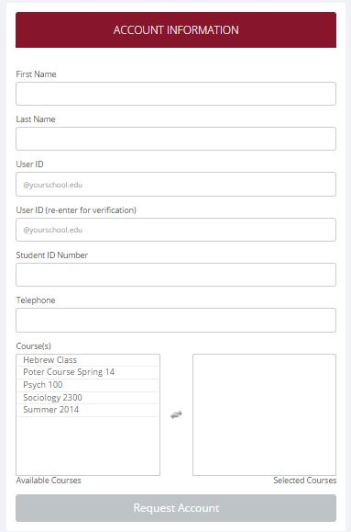
Figure 1 - Requesting an Account
If your organization has not enabled this feature, then your organization will create an account on your behalf. You will receive this account information, most likely by email.

If you did not receive your login information, please check your email program’s junk mail folder before contacting the administrator. The most common reason for not receiving login information is that an email program misclassified the email as junk mail.

Logging In
Once you have your login information, go to the front page of the site and enter your user ID and password to log in.
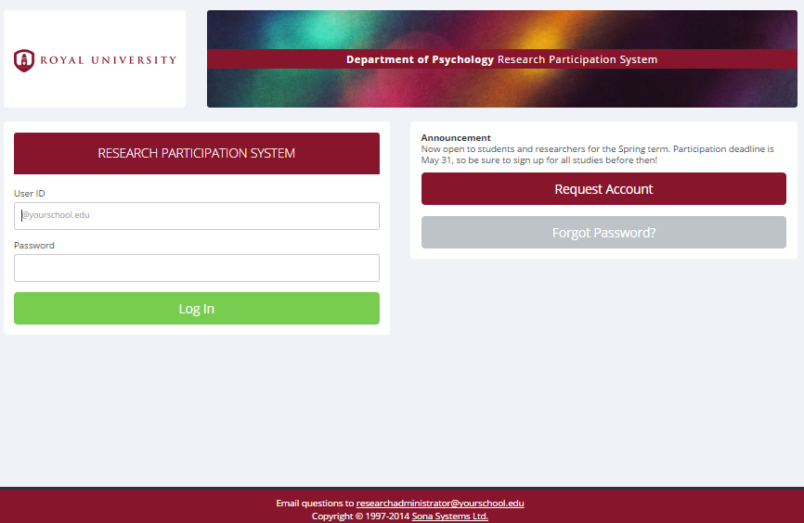
Figure 2 - Login Page
Once you log in, you may be asked to review and acknowledge your organization’s human subject and privacy policy for research. You will need to acknowledge this only once every 6 months. You may also be asked to participate in a prescreening. After you complete these tasks, you will see the Main Menu.

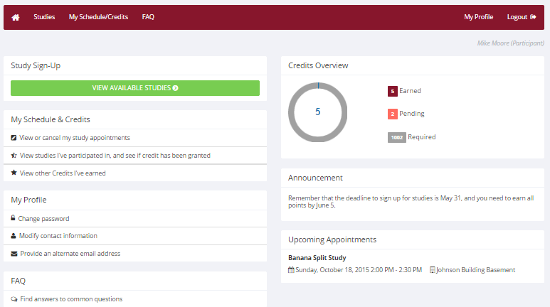
Figure 3 - Main Menu
Your login (also known as a session) will expire after a certain period of inactivity, usually 20 minutes, and the system will warn you a few minutes before the expiration. This is done for security purposes. If this happens, you can always log in again. When you are done using the system, it is better to explicitly log out, to prevent any problems that may arise if someone uses your computer before the session expires. This is especially important if you are using a public computer lab.

Retrieving a Lost Password
If you have forgotten or do not have your password, and the feature is enabled on the system, then you may choose to reset your password. You will see an option on the front login page if this feature is enabled. By choosing this option, a link to reset your password will be emailed to you shortly after you make the request. This link is valid for 24 hours, and if you click on it, a new password will be generated and emailed to you. If you provided an alternate email address (see the Email Address Options section of this documentation), it will be sent there. Otherwise, it will be sent to your main email address, which is derived from your user ID. If you requested a password reset and no email from the system has arrived after 30 minutes, then check in your email program’s junk mail folder in case the email was delivered there. Typically, the email is sent within a few seconds of the request, but sometimes there can be a delay on behalf of some recipient email servers.

Logging Out
When you are done using the system, choose Logout from the top toolbar on the right side to log out. You are now logged out. It is always a good security measure to close all your browser windows as well, especially if you are using a computer that is shared by others.

Changing Your Password and Other Information
If you would like to change your password or other information about yourself, choose My Profile from the top toolbar. If you would like to change your password (and the option is enabled), type your new password (twice, for confirmation) in the provided boxes. If you would not like to change your password, simply leave these boxes empty.

If you change your password, please be sure to select a password you do not use on any other systems or websites, which is a good computing practice.
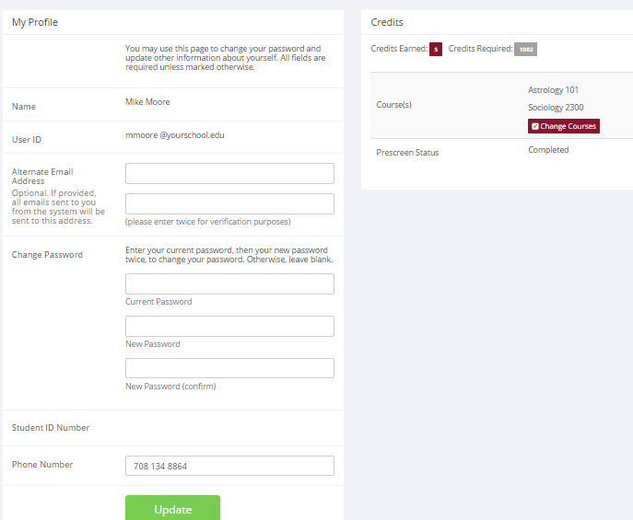
Figure 4 - Updating Your Profile

Email Address Options
There are certain events in the system which will cause an email notification to be sent to you. Most often, these are notifications that you have received credit for a study, or a confirmation that you have signed up for a study. If Unique ID codes are not enabled (see Unique ID codes), your email address is also displayed to the researcher when they view who has signed up for their study, in the event they need to contact you.

You may have two choices for your email address. When you update your profile, you will see a box where you may provide an alternate email address. If you provide such an address (this could be a Hotmail account, for instance), this is the address where any notifications will be sent, and this is also the address that will be displayed to researchers (if enabled).

If you do not supply an alternate email address, the system will derive your email address from your username. Typically, it will add your organization’s Internet domain (if there is one) to the end of your user ID to form the address, so if your user ID is “jsmith” and your organization’s Internet domain is “yourschool.edu” then it would derive your email address as “jsmith@yourschool.edu”.

In situations where the system is configured so you may enter an email address on this page, you will be asked to enter it twice when changing the address, to ensure it is typed correctly.

In some cases, depending on how the system is configured, you will be required to provide an email address (which will be listed as “Email Address” instead of “Alternate Email Address”) and all emails to you will go to that address.

On some systems, the Alternate Email Address option is not available. In other cases, it is listed but you are not allowed to change it, in which case you should contact the administrator if you need this changed.

Changing Courses
Depending on how the system is configured, you may see an option to change which courses you are in. If this is an option, then you will see a “Change Courses” option just below the list of courses you are in.

You may have the option to remove yourself from existing courses and add yourself to new courses, or you may only have the option to add yourself to new courses. If you remove yourself from a course, and you had credits assigned to that course, the credits will not be reassigned to another course. You will receive a warning about this and be taken to a page where you can reassign those credits. You can go to My Schedule/Credits at any time to assign unassigned credits to a course.

Unique ID Codes
If enabled, the system will automatically assign a unique, numeric ID code to you. You should continue to use your normal login ID to log in to the system. The purpose of the ID code is to identify you to researchers in a way that does not reveal your identity or compromise your privacy. If this feature is enabled, you will see this ID code when you go to view your profile, and in email confirmations and reminders about your upcoming study sessions. You should bring this ID code with you when you go to studies or when communicating with researchers, as they know you only by your ID code, and not your name.

Studies
With the system, you may view studies and sign up for those that interest you and where you meet any special eligibility restrictions. You may cancel your sign-up through the system as well.

You may see some studies that are online studies. You should read the details of these studies closely, but generally you may participate in them online without having to go to a lab. It is usually assumed you will participate in the study shortly after you sign up for it, though you have until the Participation Deadline Date to participate.

Viewing Studies
To view a list of studies, click on Studies from top toolbar. You will see a list of studies. A brief description of each study will be listed, as well as any special requirements that may restrict your eligibility to participate in the study.

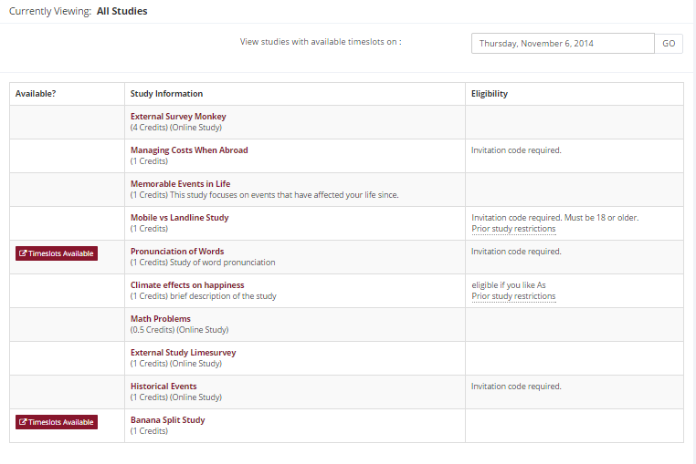
Figure 5 - Viewing Studies
Studies that currently have available participation times (timeslots) will have “TIMESLOTS AVAILABLE” listed next to the name of the study. If no studies have available timeslots, you may want to log on to the system a few days later to see if new timeslots have been added. You may also select a specific date to view studies with available timeslots on that date.

To view more information about a study, click on the name of the study.

Two-Part Studies
Some studies are two-part studies, where you must sign up for both parts of the study at once, and the two parts must be scheduled a certain number of days apart. These studies will be clearly marked, and the system will ensure you are only able to sign up for timeslots with the appropriate amount of time between the first and second part.

Online Survey Studies
Some studies may be online survey studies that are administered in the system. If you sign up for one of these studies, you will be taken immediately to the survey. As soon as you complete the survey, you will receive credit.

You may withdraw from the survey at any time, by clicking the Withdraw button on the top right corner of the screen. When you withdraw, you have an option to withdraw without the chance to receive credit, or with the chance to receive credit. The difference is that if you withdraw without the chance to receive credit, then your sign-up will be completely deleted from the system. This is useful if you simply changed your mind about participating in the survey, but might like to participate in it again at a later time.

If you choose to withdraw with the option to receive credit, then your sign-up will be logged and the researcher will be notified of the withdrawal, but you will not be granted credit immediately. The researcher may then choose to grant credit to you for your participation in the study. If this is done, you will not have the opportunity to participate in this study again (because you may not participate or receive credit for the same online survey study more than once). With this withdrawal option, you are not obligated to provide any explanation of why you are choosing to withdraw, but you may provide an explanation if you like, and this information will be sent to the researcher when they are notified of your withdrawal.

With either withdrawal option, all the survey responses you provided are permanently deleted at the time you withdraw.

Signing Up For Studies
To sign up to participate in a study, find the study you would like to participate in (see Viewing Studies in this documentation). Click on the study name for more information. You will see a list of any special restrictions or eligibility requirements, as well as a contact person if you have questions about the study. If the study has a principal investigator listed, you can click their name to view full contact details. In most cases, it is preferred that you contact the person listed as the researcher if you have specific questions.

Some restrictions are automatically enforced by the system. If the study has certain pre-requisites or disqualifiers (studies you must not have participated in to participate in this study), those may be listed, as well as a note about whether you meet those eligibility requirements. If you have signed up for a study with another study listed as a disqualifier study, then you will be prevented from signing up for the other study, since it is a disqualifier for a study you are currently signed up for.
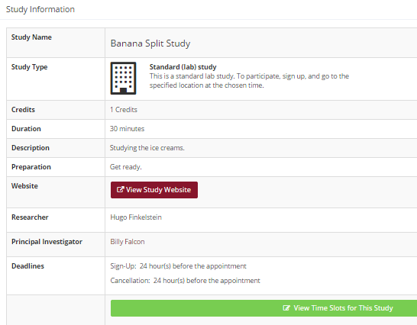
Figure 6 - Study Information
The study may have other restrictions listed as Eligibility Requirements. An example of an eligibility requirement is “Left-handed people only.” If listed, then the system does not enforce this restriction, but you should only sign up for the study if you meet this restriction. If you sign up for the study and you do not meet the restrictions, you will likely not receive credit for the study, and could face a penalty.

If the study is not an online study, then the sign-up and cancellation deadlines for the study will be listed, and those are based on the date of each timeslot.

If you are viewing a study which you have signed up for in the past and already participated, and are not allowed to sign up for it again, then you will not see the list of timeslots for the study.

Some studies require a special password (known as an Invitation Code) to sign up. If this is the case, it will be noted. The researcher should have given you this invitation code. It is not the same as the password you use to log in to the system. You will need to enter the invitation code just before you click the Sign Up button to sign up for a timeslot.

You may only sign up for a timeslot up until a certain time before that timeslot is scheduled to occur. The system will not show a Sign Up button for timeslots where it is too late to sign up. If you sign up for a timeslot and you already have another signup in the system that conflicts with that appointment time, the system will warn you of the scheduling conflict (though it will not prevent the sign-up).

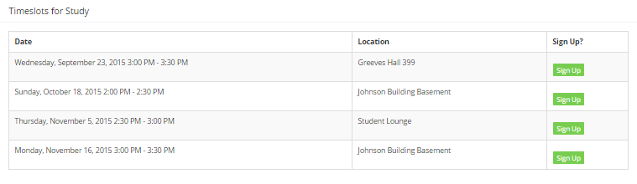
Figure 7 - Study Timeslots
Once you have determined you meet all the requirements, click on View Timeslots for This Study and you will see a list of available timeslots. Choose a timeslot that is convenient for you, and click Sign Up.

After you click Sign Up, you will see information displayed confirming the time and location of the study you plan to participate in. You may receive an email confirmation as well, depending on how your system is configured. You are now signed up for the study. To cancel your sign-up, see Canceling a Sign-Up in this documentation.

Canceling a Sign-Up
If you need to cancel a timeslot you have signed up for, you can do this from the My Schedule and Credits page. Choose the My Schedule/Credits option from top toolbar.

You will see listed all the studies you have signed up for, as well as those you have completed (see the Tracking Your Progress section of this documentation for more information).

Studies you have signed up for that you are allowed to cancel will have a Cancel button next to them. There is a time limit before the study is to occur, when it is too late to cancel. This restriction may be listed at the bottom of the page, or can be found by clicking on the study name and viewing the study details, depending on how cancellation deadlines are configured in your system.
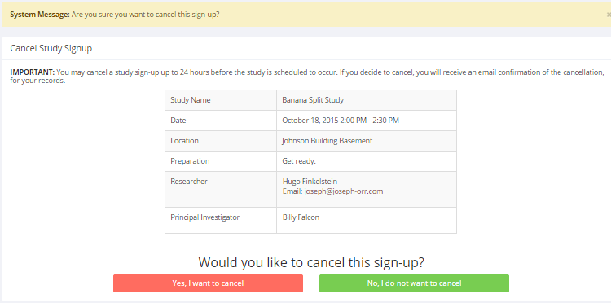
Figure 8 - Sign-Up Cancellation
Once you click Cancel to cancel your sign-up, you will see a confirmation page. You will also be warned if your cancellation might affect your ability to participate in other studies you have signed up for, due to pre-requisite restrictions. If the cancellation will affect your ability to participate in another study you are signed up for, it is your responsibility to deal with this issue (usually by canceling the dependent study as well). The system will warn you, but will not block the cancellation.

Click Yes to cancel your sign-up, and the sign-up will be cancelled immediately.

If you cancel the first part of a two-part study, the second part will also be cancelled. If you cancel the second part of a two-part study, the first part will not be cancelled, but you will need to ask the researcher to sign you up for the second part again, if you would like to participate in it at a later date.

Tracking Your Progress
You may track your progress at any time by choosing the My Schedule/Credits option from the top toolbar.

When you view this page, you will see at the top a list of the number of credits you are expected to earn, and how many you have earned so far. You may also have an option to view how many credits you have earned for each course. Below that, if you have signed up for any studies, those are listed as well. In the list of studies, you will see information about your credit status.

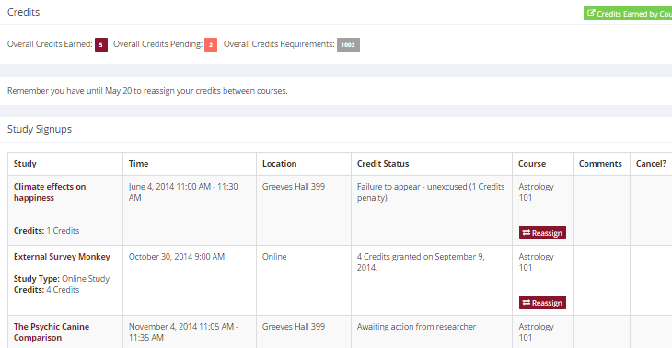
Figure 9 - Viewing Your Progress
If you failed to appear for a study, it is possible you were assessed a penalty. That will be displayed in your progress, and the penalty (if assessed) will either increase the number of credits you must earn, or be deducted from your current credit earnings, depending on how the system is configured. It is possible you might end up with a negative value for the number of credits you have earned. Next to each signup, you can also see any comments the researcher left regarding the study and your credit for it. In cases where the study was set up for monetary compensation and not credits, your participation will be noted as “participated.” This is done to ensure your eligibility for any studies where the study you just completed is a pre-requisite study.

Non-study credit is also listed, when applicable. Non-study credit is usually granted for writing a paper, completing the prescreen, or some other special situation.

It is possible that older records of your participation are in the system, but not displayed. If that is the case, you’ll see an option to view your older signups as well.

Reassigning Credits
If you belong to multiple courses, and the system is configured to allow it, you may reassign a credit from one course to another. To do this, simply use the Reassign link that appears when you view your progress. The link appears under the course entry for each item in your progress listing. You may not split a credit between two courses, for example by assigning 2 credits of a 3-credit study to one course, and 1 credit from that study to another course.

Online Prescreening
If enabled on your system, you may be asked to take an online prescreen before you use the system. Depending on how the prescreen is configured, you may have the option to opt out of the entire prescreen and/or individual questions. You should realize that declining to participate in the prescreen or certain questions may affect your eligibility for some studies, so participation is encouraged.

In some cases, you may earn credit for participating in the prescreen, and you may even earn credit if you decline to participate in the prescreen. If either case holds true, the system will inform you of this before you commence the prescreen.

The prescreen may consist of multiple sections. All questions are either multiple-choice or fill-in (free-entry) answer. At the end of the prescreen, you may have a chance to review and change any of your responses. After you save all your responses, you may not participate in the prescreen again (unless the administrator has allowed this or deleted your existing responses), so answer the prescreen carefully.

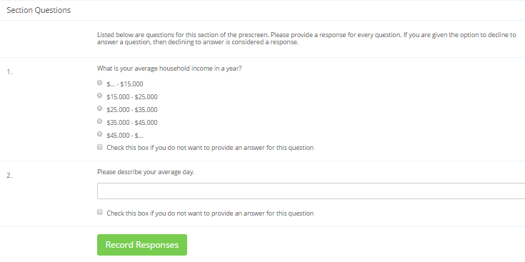
Figure 10 - Prescreen Questions

Frequently Asked Questions
Immediately after I login, as soon as I click on any menu option, I am taken back to the login page and I see a message that my authentication has expired. What does this mean?

Your web browser is not properly configured to accept cookies. You should turn on cookies in your web browser, use a different web browser (for example, try Firefox if you are currently using Internet Explorer), or try a different computer. Detailed instructions can be found if you go to the site and enter the url “cookie_help.aspx” in place of “default.aspx” in the address bar of the browser, when you are on the front page of the site.

Another easy thing to try is simply to use another computer. Usually the computers in university computer labs are configured correctly.

I participated in a study, but I have yet to receive credit. How do I receive credit?

The researcher must grant you credit. This is usually done shortly after your participation. If it has been some time and you have still not received credit, contact the researcher.

Who can see the information about my sign-ups? I don’t want everyone to know which studies I signed up for.

Only the researcher and principal investigator of the study may see that you have signed up for it, along with the site administrator. No other users, including other researchers or your instructor, may see this information.

How do I change the email address where email notifications from the system are sent?

Provide an Alternate Email address and notifications will be sent there. See the Email Address Options section of this documentation for more information. In some cases, this option may not be available.

I wrote a paper instead of participating in studies. How do I know I have completed my requirements?

View the My Schedule and Credits page and any non-study credit will also be listed there. See the Tracking Your Progress section of this documentation for more information.

I noticed that with some studies, I can sign up for them again even if I participated before, while others don’t allow for this. Why is this?

Researchers can choose if their studies allow you to participate more than once. Not all studies allow you to participate more than once.

I attempted to sign up for a study, and I was prevented from doing so because the study I was trying to sign up for is a disqualifier for another study I am scheduled to participate in. Why is this?

If you have signed up for a study that has disqualifiers (studies you must not have participated in to participate in that study), you may not then sign up for the studies that are listed as the disqualifier studies. You are allowed to sign up for the disqualifier studies if the disqualifier study will take place after the study with disqualifiers, or if you have already participated in (and received credit for) the study with disqualifiers. The easiest way to sign up for both studies is to schedule the disqualifier study at a time later than the study with disqualifiers.

RESEARCHER/P.I. DOCUMENTATION

Introduction
The Experiment Management System is used for the scheduling and management of research participants and the studies they participate in. Participants, researchers, principal investigators, and instructors all use the system for their respective purposes. As a researcher, you can set up your studies in the system, schedule the sessions (timeslots) when participants may participate, and grant or revoke credit after the session. All of this is handled through a simple web-based interface that you can access at any time, from any popular web browser.

The system is highly configurable by the administrator, to enforce the rules for the research participant pool exactly as your organization desires. It should be noted that the documentation herein may refer to features that are not enabled on your system. Contact your local administrator, whose contact information appears at the bottom of every page on the system, for more information.

System Basics
In the system, you create studies. Each study may have a number of timeslots, which are the times when you plan to run the study. Participants sign up for the timeslots by viewing a list of studies and available timeslots. You grant or revoke credit to participants after the session occurs.

Principal Investigator Special Note
This documentation applies to both researchers and principal investigators (P.I.s), when P.I. support is enabled by the administrator. A P.I. can perform all the same functions on a study as a researcher. This allows a P.I. to operate in an oversight role and monitor the progress of their studies, and step in on behalf of the researcher when necessary. Because the privileges are the same, throughout this documentation, the term “researcher” can be used interchangeably with “principal investigator” except where otherwise noted. If the P.I. feature is enabled, then all studies must have a P.I. specified. The main difference between a P.I. and researcher account is that researchers have the option to receive routine emails from the system about their study, like a notification any time a participant signs up or cancels, while the P.I. has no such option.

Participant ID Codes Special Note
If enabled by the administrator, the system will identify participants to you only by a unique, system-assigned ID code, and not by their name or email address, for privacy reasons. Participants are made aware of this, and they are reminded to bring this code along with them when participating in studies, since the researcher will not know them by their name.

Getting Started
The system works best if you use any popular web browser that is less than 2 years old, like Internet Explorer, Firefox, Chrome, and Safari. It will work with other web browsers, and with older versions of popular web browsers, however the layout may not be as clean. No functionality will be lost by using an older web browser.

Ask your system administrator if you need help with installing or using a web browser. This documentation assumes you have a basic knowledge of how to use the web. On this system, it is not necessary to use the Back button. You can always use the toolbar on the top to navigate to anywhere on the site.

Logging In
Your administrator will provide you with a username and password to login to the site, as well as the URL (web address). When you go to the front page of the site (the login page), you may see a link to request an account. This form is only for participants. Do not use this form to request an account, as participant accounts have an entirely different set of privileges, and the privileges are not appropriate for a researcher.

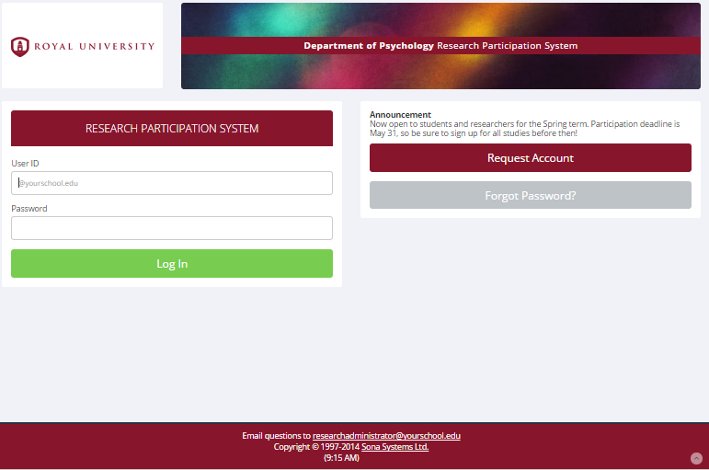
Figure 11 - Login Page
Once you log in, you may be asked to review and acknowledge your organization’s human subject policy. If required by the administrator, you will need to acknowledge this once every 6 months. You will see the Main Menu after you acknowledge the policy.
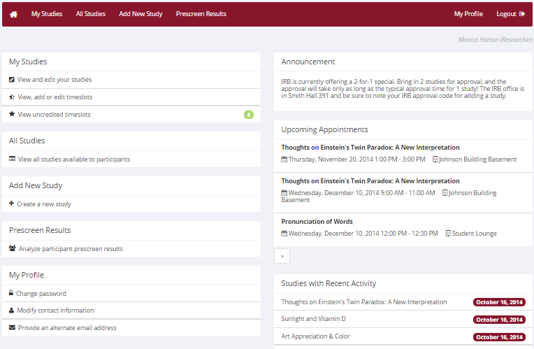
Figure 12 - Main Menu
Your login (also known as a session) will expire after a certain period of inactivity, usually 20 minutes, and you will be warned a few minutes before this expiration. This is done for security purposes. If this happens, you can always log in again. When you are done using the system, it is better to explicitly log out, to prevent any problems that may arise if someone uses your computer before the session expires.

Retrieving a Lost Password
If you have forgotten or do not have your password, and the feature is enabled on the system, then you may choose to reset your password. You will see an option on the front login page if this feature is enabled. By choosing this option, a link to reset your password will be emailed to you shortly after you make the request. This link is valid for 24 hours, and if you click on it, a new password will be generated and emailed to you. If you provided an alternate email address (see the Email Address Options section of this documentation), it will be sent there. Otherwise, it will be sent to your main email address, which is derived from your user ID. If you requested a password reset and no email from the system has arrived after 30 minutes, then check in your email program’s junk mail folder in case the email was delivered there. Typically, the email is sent within a few seconds of the request, but sometimes there can be a delay on behalf of some recipient email servers.

Logging Out
When you are done using the system, choose Logout from the top toolbar to log out. You are now logged out. It is always a good security practice to close all your web browser windows as well, especially if you are using a computer that is shared by others.

Changing Your Password and Other Information
If you would like to change your password or other information about yourself, choose My Profile from the top toolbar. If you would like to change your password, type your new password (twice, for confirmation) in the provided boxes. If you would not like to change your password, simply leave these boxes empty.

If you change your password, please be sure to select a password you do not use on any other systems or websites, which is a good computing practice.

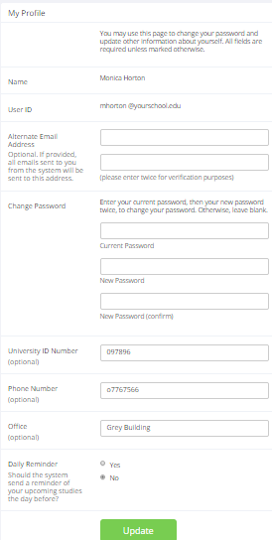
Figure 13 - Updating Your Profile
It is recommended you provide your phone number and office location, as this information will be made available to research participants who sign up for your studies. If you are a researcher, this contact information will be displayed to participants when they view information about the study. If you are a principal investigator, this contact information will be displayed if a participant explicitly chooses to view it (since the researcher is the primary point of contact for a study).

Researchers (but not PIs) may also choose to receive a daily reminder (by email) with information about all of their study sessions scheduled for the following day.

Email Address Options
There are certain events in the system, which will cause an email notification to be sent to you. Most often, these are notifications that a participant has signed up or cancelled their sign-up for your studies, but there are a few other cases where it may be used as well. The email address is also displayed to the participant when they view information about the study, in case they need to contact you with questions.

You have two choices for your email address. When you update your personal information, you will see a box where you may provide an alternate email address. If you provide such an address (this could be a Gmail account, for instance), this is the address where any notifications will be sent, and this is also the address that will be displayed to other users (including participants in your studies).

If you do not supply an alternate email address, the system will derive your email address from your username. Typically, it will add your organization’s Internet domain to the end of your user ID to form the address, so if your user ID is “jsmith” and your organization’s Internet domain is “yourschool.edu” then it would derive your email address as “jsmith@yourschool.edu”.

In situations where the system is configured so you may enter an email address on this page, you will be asked to enter it twice when changing the address, to ensure it is typed correctly.

In some cases, depending on how the system is configured, you will be required to provide an email address (which will be listed as “Email Address” instead of “Alternate Email Address”) and all emails to you will go to that address.

Working with Studies
Most of your time on the system will be spent, not surprisingly, using the study-related features of the system. Be sure to read this section closely, in its entirety, as there are special features and situations you should be aware of.

Web-Based (Online) Studies
If enabled, you may set up studies that are web-based (online), and these studies may be set up internally in the system (online survey study) or outside the system (online external study). The options will vary depending on how your system is configured.

There are a few things to note about web-based studies:

- Once you indicate to the system that the study is web-based, you will not be able to change it so that it is no longer web-based (but you can deactivate or delete the study). So, make this choice carefully
- Web-based studies are typically set up so there is one timeslot, and that timeslot contains the maximum number of participants you would like to participate, and the last date and time when they can participate (often, this is the end of the term). It is not recommended that you set up multiple timeslots for a web-based studies (it confuses participants), though the system will support it. It is acceptable to have multiple timeslots where more than one is not active at a time. For example, one could have had a deadline date of the end of the previous semester (and thus is currently in the past), while the current timeslot has a deadline date of the end of the current semester (i.e., in the future).
- It is generally assumed that participants will participate in an online study shortly after they sign up. Because of this, the system will expect you to grant credit to them soon after they sign up. If you are creating an online survey within the system, credit will be granted automatically, immediately after the participant completes the survey.
- In the case of an external web study, if you are using a survey product like Qualtrics, SurveyMonkey, LimeSurvey, SurveyGizmo, etc., then you may be able to set up credit granting so it occurs automatically as soon as the participant completes the study. See External Study Credit Granting for more information.

Throughout the sign-up process, participants are notified that the study is online.

If the study is not administered by the system (online external study), then participants are not given the URL for the study website until they have signed up, to ensure they complete a sign-up in the system for the study. They can see the URL after sign-up, and while the timeslot they signed up for is still in the future. Once the timeslot they have signed up for is in the past, they no longer have access to the study URL. There is also an option when setting up the study so that the URL will no longer be available as soon as the participant is marked as having participated in the study (regardless of the timeslot date). This restriction regarding viewing the study URL applies only to participants, and only to web-based studies administered outside the system. Online external studies are discussed in more detail in the section Online External Studies, later in this document.

Online survey studies (surveys administered by the system) are discussed in great detail in the section Online Survey Studies, later in this document. Please read it carefully before setting up an online survey study.

Studies for Pay
In cases where participants are compensated for their participation in the study, you may set it up as a paid study and specify the compensation amount. The payment field is text, so you do not need to type in an exact amount, but can type in anything like “Amazon Gift Card” or even indicate a variable payment based on performance.

If participants are compensated and they receive credit, you should set it up as a credit study and indicate additional compensation in the study’s information section.

Regardless of the type of study, after a participant participates in a study (including studies that are for pay only), you should still go into the system and indicate their participation by noting their participation or no-show when viewing their sign-up This allows the system to properly enforce certain restrictions on the participant and their studies, like pre-requisite and disqualifier study restrictions. It also ensures a proper record is kept in the system of their participation.

Two-Part Studies
You may create a two-part lab study in the system. Often, these are studies involving memory research, where the participant must return a specified number of days after the first session. When creating a study, you may specify the day range for the second part of the study (e.g. 7 to 10 days after the first part). Participants are required to sign up for both sessions at the same time, to reduce the chance they will forget to sign up for the second part. Each part of a two-part study may have a different credit value and duration, but each part must be the same type – either both parts are for credit or both parts are for compensation. Online studies may not be two-part studies because there is no concept of making an appointment to take an online study at a specific date and time. If one part of the study is an online study, simply create two separate studies (one for each part) and set the first study as a pre-requisite for the second study.

With two-part studies, you may specify that the second part of the study must be scheduled to take place at exactly the same time as the first part (on a different date), or at any time on the dates that are the specified number of days after the first part.

You should ensure there are enough available timeslots for both parts of the study, or participants will be prevented from signing up for either part. Participants may cancel either part of their sign-up if necessary. If they cancel the first part, the second part is automatically cancelled as well. If they cancel only the second part and the first part has already occurred, and they would like to participate in the second part later, you will need to manually sign them up for the second part (if you are allowed to do so), or ask the administrator to handle this.

If you grant a no-show for the first part of a two-part study, the second part of that participant’s sign-up will not be cancelled automatically, but you will be reminded of the situation in case you would like to cancel the second part. The cancellation is not automatic as there are some situations where automatic cancellation is not desirable.

Two-Part Study Configuration Scenarios
Listed below are some common scenarios, and how to configure them in the system:

Scenario | Configuration
Second part to take place a week later, at any time during that day. | Scheduling Range: 7 and 7  Scheduling Leniency: No
Second part to take place three days later, at exactly same the same time as part 1. | Scheduling Range: 3 and 3  Scheduling Leniency: Yes
Second part to take place one to two weeks later, at any time during the day. | Scheduling Range: 7 and 14  Scheduling Leniency: No
Second part to take place later on the same day as the first part. | Scheduling Range: 0 and 0  Scheduling Leniency: No

The system will enforce the configuration for the second part in terms of ensuring participants only sign up for timeslots that meet the two-part study restrictions. As the researcher, you also have additional control as you decide which timeslots to create for each part of the study. You should be careful to ensure that there are sufficient timeslots for each part. For example, if the study is set up so part 2 must occur exactly one day after part 1, and you have set up part 1 timeslots on Monday, then ensure you have some part 2 timeslots set up on Tuesday or participants will have trouble signing up for the Monday part 1 timeslots because there is no corresponding part 2 timeslot to sign up for.

Adding a Study
Some researchers choose to set up their studies in the system before they have received the proper approvals (usually from their IRB) to run the study. This is supported in the system. You can set up a study but specify that is it not visible to participants (this is the Approved setting). That way, as soon as your approval is received, you can simply make the study visible and everything else is already prepared. You can also post a study and make it visible immediately, if that is appropriate. Some systems will be configured in such a manner that only the administrator can approve the study, in which case you will need to contact the administrator to do so.

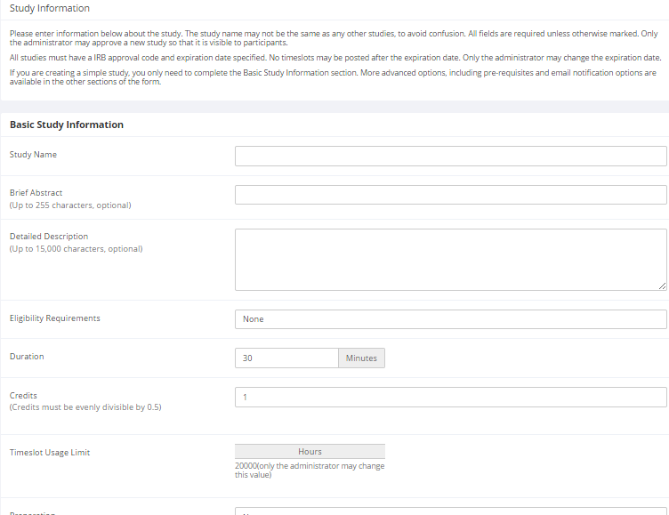
Figure 14 - Adding a New Study
To add a study, choose the Add New Study option from the top toolbar. You will need to pick from four possible types of studies, and may need to specify if the study is for credit or payment. Please choose these options carefully as you are not able to change them later.

After you choose the study type, you’ll see a form asking for more information. You will need to fill out a number of fields, which are explained in the following table. Some of the fields listed below may not appear, depending on how your system is configured and the type of study you selected. All fields in the Basic Study Information section must be filled out unless otherwise noted.

Basic Study Information
Field | Explanation
Study Name | A short name for the study. This is how the study is identified throughout the system. Most systems are configured so studies show in a random order to participants (choose Your Studies on the toolbar and it will state at the bottom of the resulting page if they are displayed in random order), so there is no advantage in choosing a study name that might put it at the top of an alphabetical list. You should consult with your administrator if there is a naming convention to be followed when naming studies. Study names must be unique, and you will be prevented from adding a study if there is already another study in the system with the same name. A study name may be up to 100 characters in length.
Brief Abstract (this feature might be disabled on your system) | This is a short one or two line description of the study. This short description will be displayed to participants when they view the entire list of studies, so you may want to list the most pertinent details here. Studies configured for payment often have the compensation information included here, particular if the payment varies based certain outcomes. This field may be optional, and can be up to 255 characters in length.
Detailed Description (this feature might be disabled on your system) | This can be a rather lengthy description about the study, and it will show if a participants clicks on the study to get more information, before they sign up. You may include basic HTML in this area, but please be sure you know what you are doing (ask your IT department for help if you are unsure). If you would like to add a carriage-return (paragraph break), simply type in “<p>” (without the quotes).This field may be optional. The maximum length of this field is 15,000 characters.
Eligibility Requirements | If there are any restrictions on who may participate (for instance, only those who are left-handed), list them here. Otherwise, leave the field as-is. If you list any restrictions, these will be displayed on the list of studies, when participants view a list of all available studies. Note the system does not enforce these restrictions, but it is expected a participant will only sign up for a study in which they are qualified, since they would otherwise fail to receive credit. In most cases, you will leave this field as-is and set prescreen participation restrictions instead (those are enforced automatically), which you can do after you add the study. This field may be up to 245 characters in length.
Duration | The amount of time, in minutes, that each study session will take. If you are setting up a 2-part study, then this setting applies to the first part of the study. For online studies, this should be an estimate of how long participants can expect the study to take, so that they can plan accordingly.
Credits (applies to credit studies only) | Enter the number of credits a participant will earn for the study. A value of 0 is acceptable, and may be desired in cases where the study is part of a set of studies, where only the final study is credit-earning. The credit value specified must be evenly divisible by the credit increment specified. For example, if the increment is 0.5, then the study can have credit values like 1 and 1.5, but not 0.75.  If you are setting up a 2-part study, this is the value for the first part of the study.  After a study has sign-ups, you may not change the credit value of the study. However, the administrator can still change the credit value of a study with pending sign-ups. If this is done, be sure to notify participants with pending sign-ups of the change, as the system will not notify them automatically.  A study may not be changed between a study for credit and for payment, after it has been created.
Payment (applies to paid studies only) | Enter the compensation for the study. This is a text field, so any text may be entered like “Amazon Gift Card” or “Up to $20” and so on. Please see the Studies for Pay section of this documentation for more information on how to fill out this field in the case of paid studies.  If you are setting up a 2-part study, this is the compensation for the first part of the study.  You can change the payment text at any time. If this is done, be sure to notify participants with pending sign-ups of the change, as the system will not notify them automatically.  The maximum length of this field is 30 characters.  A study may not be changed between a study for credit and for payment, after it has been created.
Timeslot Usage Limit | Depending on how your system is configured, you may see an item that specifies the maximum number of study session hours available to this study. This value is set by the administrator, and only the administrator can adjust it. To determine the current session usage for a study, go to the Add A Timeslot page for the study, or to Timeslot Usage Summary.
Preparation | Enter any advanced preparation a participant must do here (e.g. “do not eat 2 hours before session”). If there are no preparation requirements, leave this field as-is.
Researcher(s) | Select the researcher for this study. Most likely, this is you, and your name will automatically be selected. If you are a researcher, then you may not remove yourself as the researcher (the P.I. for the study, as well as the administrator, can change the researcher). Depending on how your system is configured, you may be able to specify multiple researchers for a study. If you specify multiple researchers, each researcher has full control over the study.  The selection box lists only users who are researchers.
Principal Investigator (this feature might be disabled on your system) | Select the Principal Investigator for this study. The person you select will have full access to the study. If you see this option, then you must select a P.I.  The selection box lists only users who are principal investigators.
IRB Approval Code | Enter the IRB approval code here. This field is displayed to the administrator to help them keep track of studies. This field may be required depending on how your system is configured. If it is required, then only the administrator can change the IRB approval code, once it has been entered.
IRB Approval Expiration Date | The date when IRB approval expires. This field may not appear if your system is not configured for it. If it does appear, you must provide a valid expiration date. The system will prevent you from adding new timeslots to take place after this date, and your study will become inactive (not approved and thus not visible to participants) after this date. You may not make a study active if the IRB approval has expired. Only the administrator can change the IRB approval expiration date, once it has been entered, which is why it defaults to blank to force you to choose a date. You may specify a date up to 5 years in the future.
Approved? | Select Yes if this study should show up on the list of studies which participants may sign up for. Ensure you have received the necessary approvals to run the study before choosing Yes. A study must be Approved and Active to show up on the list of studies which participants may sign up for.  If you select No, the study will not be visible to participants.  Some systems are configured such that only the administrator can approve a study. If that is the case, you should contact the administrator when you are ready to make the study visible to participants – and a handy form is provided on the page to do so. As a researcher, you can always make an approved study invisible to participants (by making it not approved), but you may need the administrator to make it visible again. In addition, if you change key items about the study, specifically the name or descriptions, the study will automatically be made invisible to participants, until the administrator reapproves it (if the system is configured this way). The reason for this is that many IRBs approve very specific language for study names and descriptions, so the administrator needs to ensure the study is in proper compliance.
Email Approval Notice? (visible to administrators only) | This Yes/No option will appear if the administrator is adding or updating the study, and it is not already approved. If they select Yes to Email Approval Notice and they approve the study (set Approved to Yes) at the same time, then an email will be sent to all researchers for the study, to notify them that their study was just approved.
Active Study? | Select Yes if this study is in progress. You must select Yes and the study must be Approved if you want the study to show up to participants so they can sign up for it.  If a study is Not Approved but is Active, then it does not show up (to participants) on the listing of studies, but it is accessible through other links if the participant has participated in it before and they are viewing their participation history (in case the participant has follow-up questions about the study). It will also show up on the study information page (for an individual study) when it is listed as a pre-requisite or disqualifier for a study.  The reason to select No is if the study is being kept for historical purposes, but should not show up to participants on the list of studies they may sign up for. Often, this is done so the system can enforce pre-requisites, where the inactive study is a pre-requisite for an active study.
Advanced Settings
Field | Explanation
Pre-Requisites (this feature might be disabled on your system) | If there are studies a participant must participate in before participating in your study, choose them here. You may select multiple studies if you like.  You may specify that participants must have participated in all of the studies you specify, or at least one of the studies specified.  The system will handle enforcement of the pre-requisites in a strict or lenient fashion depending on how your system is configured. In strict enforcement mode, the participant must have received credit for (participated in) the pre-requisite studies. In lenient enforcement mode, the participant must only be scheduled to participate in the pre-requisite studies (it is assumed they will go on to complete the pre-requisite studies). You can ask your administrator how this is configured, if it is of concern. If your system is in lenient enforcement mode, and a participant cancels a necessary pre-requisite for you study (they are warned of this situation), and you have configured your study so that the researcher will receive notifications of cancellations or sign-ups, then the researcher will receive notification of the pre-requisite problem and can contact the participant if necessary.  Depending on how your system is configured (Pre-Requisite/Disqualifier Display setting), participants may or may not see which studies you have specified as pre-requisites when they go to view your study.
Disqualifiers (this feature might be disabled on your system) | If there are any studies a participant must not have participated in, please select them here. You may select multiple studies if you like. The system will handle enforcements of the restriction, during the sign-up process. If a participant has signed up for or participated in at least one of the studies specified as a disqualifier, then they will not be eligible to sign up for your study.  Depending on how your system is configured (Pre-Requisite/Disqualifier Display setting), participants may or may not see which studies you have specified as disqualifiers when they go to view your study.
Course Restrictions | If you would only like participants enrolled in certain courses to participate in your study, select the eligible courses here. Participants who are not in at least one of the courses you selected will not see the study when they go to view the list of available studies. You may choose No Restrictions if you would like to make the study available to participants in any course.  There is a limit to how many courses can be listed as course restrictions for a study, and the limit is somewhere between 60 and 80 courses. The limit is variable depending on a few factors, and the system will simply not save the course restrictions for any courses which would take it over the limit.  Note that course restrictions do not function as a disqualifier but rather a qualifier. For example, if a participant is in both Course A and Course B, and the study is restricted to only those in Course A, the participant is eligible because they are in Course A, despite the fact Course B is not listed as a course restriction. In addition, using the same example above, the participant may assign the credit from the study to any of their courses, including those courses not listed in the course restriction (Course B in this example). Course Restrictions function solely to qualify participants for a study, and not to restrict their ability to assign credits to courses.
Invitation Code (this feature might be disabled on your system) | If you would like to have a special sign-up password for this study, enter it here. This is known as an invitation code, and applies just for this study. Participants must know the invitation code to sign up for this study. This is often used in cases where the researcher wants to personally select participants, so the researcher only provides the invitation code to the desired participants. Invitation codes are not case sensitive, and are in no way connected to any passwords users use to log in to the system.  If you do not need an invitation code, leave this field blank.
Is this a web-based study? (this feature might be disabled on your system) | This will list if the study is an online study, and the type of online study. This setting cannot be changed after a study is added.
Study URL | The URL (web address, usually starting with https://) for your study. This is only required for web-based studies administered outside the system.  If you are setting up a web-based study outside the system, and would like the system to pass a unique identifier in the URL so you may easily identify participants and even have the system grant credit automatically, add the text %SURVEY_CODE% in the URL where you would like the identifier to be placed. This feature is most commonly used with online survey products like Qualtrics, SurveyMonkey, LimeSurvey, SurveyGizmo, and similar products. This is discussed in further detail in the Web-Based (Online) Studies section of this documentation.
Study URL Display (external web studies only) | If set to Yes, then participants may still access the Study URL even after they have been marked as having participated in the study. If set to No, the URL will not be available to them.  In all cases for external web studies, the URL will not be displayed until they have signed up for the study. In addition, regardless of this setting, the URL will not be displayed after the timeslot is in the past.
Participant Sign-Up Deadline (this feature might be disabled on your system) | Enter the deadline before the study is to occur that the participant may sign up, in whole hours.
Should the Researcher receive an email notification when a participant signs up or cancels? | If set to Yes, the researcher for this study will receive an email notification whenever a participant signs up, or cancels their sign-up, for this study. The email notification will be sent to an email address based on the information the researcher has provided. See the Email Address Options section of this documentation for more information on how the email address is determined. Emails will contain the first 50 characters of the study name as part of the subject line, to make it easy to sort the emails with an email program that supports filtering based on subject line.  If set to Yes, researchers will also receive a notification if the system is in lenient pre-requisite enforcement mode and a participant cancels a study that was a pre-requisite for the current study. Read the section on Pre-Requisites in this table for more information about this situation.  Emails are sent to all researchers specified for the study, unless a specific researcher is assigned to the timeslot that the email notification is being sent about. See Timeslots Linked to Specific Researchers for more information.
Researchers at Timeslot-Level | If set to Yes, it will be possible (but not required) to assign a specific researcher from the list of researchers for the study to a timeslot. If set to No, then it is assumed that all researchers assigned to the study are responsible for all timeslots. See Timeslots Linked to a Specific Researcher for more information. This option only appears if the system is configured to allow multiple researchers per study.
Automatic Credit Granting | If set to Yes, timeslots that are more than a specified number of hours old and still in the Awaiting Action state will be changed to a credit grant. The check for timeslots in this situation is made only once per day. If an automatic credit grant is done, you may still change it later if necessary.  For online external web studies, the credit grant will take place the specified number of hours after the timeslot (participation deadline) has occurred (as opposed to being based on when the participant signed up), so this feature is generally not useful in this situation. This option will not appear for online survey studies (within the system) because credit granting generally occurs automatically, immediately after the participant completes the survey.
Can a participant sign up for this study more than once? (this feature might be disabled on your system) | If you would like to allow participant to sign up (and receive credit) for your study more than once (at different times), choose Yes. Otherwise, choose No.  If No is chosen, participants may only sign up for the study more than once if they previously failed to show up for the study (a no-show).
Shared Comments | This is an optional area where you may enter any comments or notes about the study, which are visible to any researchers and PIs in the system, but not to participants. This field is useful if you want to make the technique used in the study visible to other researchers, so they can set your study as a disqualifier if necessary. The maximum length of this field is 1,000 characters.
Private Comments | This is an optional area where you may enter any comments or notes about the study, which are only visible to the researchers (and PI) for this study, and not to participants, nor to other researchers or PIs in the system. The maximum length of this field is 3,000 characters.
Research Alternative? | If set to Yes, then this study is considered a research alternative study. Some participants, for various reasons (typically for accruing too many unexcused no-shows, or being unable to consent to participate in studies), may be restricted such that they can only sign up for research alternative studies. Only an administrator may change this value (the default is No).
Two-part Study Settings (only applies if you select Two-Part Standard Study on the Select Study Type page)
Field | Explanation
Is this a 2-part study? | Always set to Yes if you selected select Two-Part Standard Study on the Select Study Type page. Will not appear if you select another study type.
Credits, Part 2 (credit studies only) | Enter the number of credits for part 2 of the study, if this is a two-part study. A value of 0 is acceptable. The credit value specified must be evenly divisible by the credit increment specified. For example, if the increment is 0.5, then the study can have credit values like 1 and 1.5, but not 0.75.
Payment, Part 2 (paid studies only) | Enter the amount of compensation for part 2 of the study, if this is a two-part study.
Total Payment (paid studies only) | Enter the amount of total compensation for the study, typically the sum of the payment values for each part. The system cannot compute this automatically since it is possible to enter non-numeric values (e.g., “Amazon Gift Card”) in the other payment fields.
Part 2 Duration | The amount of time, in minutes, that part 2 of the study will take.
Part 2 Scheduling Range | Specify the number of days (as a range) after part 1 is scheduled, that part 2 should be scheduled. This setting only applies to two-part studies. The range may be the same value (e.g. “between 7 and 7 days”) if desired, but must be a whole number. See “Two-Part Studies” for more information.
Part 2 Scheduling Leniency | In some cases, you may want to ensure that the participant schedules the second part of the study to take place at exactly the same time (on a different date) as the first part. If so, choose Yes for this option. If there is some flexibility so they can sign up for any time within the Part 2 Scheduling range, choose No for this option.

Once you have filled out the appropriate information, save it and the system will be updated immediately with the information. If you would like to add participation restrictions based on prescreen responses, you can do so when you update the study (see Prescreen Participation Restrictions). Otherwise, your next step is likely to add timeslots (sessions). See the Working with Timeslots section of this documentation for more information.

If you need to update this study, see the Updating a Study section of this documentation.

Updating a Study
You may update any of your studies at any time. To do so, choose My Studies from the top toolbar, and you will see a list of your studies. Click on the desired study, and choose the Change Study Information link.

You will see a form remarkably similar to the one you used to add the study. A few options may no longer be changeable depending on the status of the study (e.g., if participants have already signed up for it). The fields shown are all the same as when you added the study. See the Adding a Study section of this documentation for an explanation of those fields.

The changes you make will be will be take effect immediately after they are saved. When changes are made, if administrator re-approval is required before a study is made visible to participants, then you should contact the administrator to request re-approval once you have made all your changes. Changing the following fields may require a re-approval: study name, brief abstract, detailed description, eligibility requirements (the text field, not specific restrictions like prescreen restrictions, study pre-requisites/disqualifiers, or course restrictions), duration, preparation, credit value (for credit studies only). There will be a notice on the Change Study Information to warn if re-approval may be required, and they system will also notify you, after making changes, if the study is now in need of re-approval. If re-approval is required and you are ready to request such approval, you may use the option to send such a request via the system – it’s the same function you would have used to request initial study approval.

If you need to change the credit value for a study, and there is no option to do so, this means the study already has at least one participant signed up for it. You cannot change the credit value when a study is in this situation because there is no easy way to handle past credits for the same study (e.g. should old credit grants for the same study be adjusted to reflect the new credit value, or kept the same?). If the study is nearing the end of its run, and variable credit granting is enabled, then the easiest solution is to grant the new credit value to participants who sign up in the future. If you prefer that the credit value is changed for the entire study, contact the administrator, who can make the change for you. Note that if the study’s credit value is changed while there are pending sign-ups, those participants are not notified of this change, so you will need to notify those participants of the change in credit value if necessary.

Deleting a Study
You may delete a study only if there are no pending sign-ups (awaiting action) nor active (non-zero) credits linked to it. If you need to delete a study which already has pending sign-ups or active credit grants, your better option may be to make it Inactive instead, if you do not want it to be visible to participants.

If you want to delete a study that has sign-ups and are unable to do so, please contact the administrator. The administrator can delete a study with sign-ups, but only if the sign-ups are all without credit values (this usually occurs when study participation history from a previous semester was retained, but credits were zeroed out). If the study has sign-ups where the sign-ups have (non-zero) credit values linked to them, then the administrator cannot delete the study until all those credit grants are changed to a 0 value (or the participants for the sign-ups are deleted). The reason for this restriction is to ensure that the credit count for participants where they have earned credits is accurate, which means that the studies which contributed to their credit earnings must be kept intact.

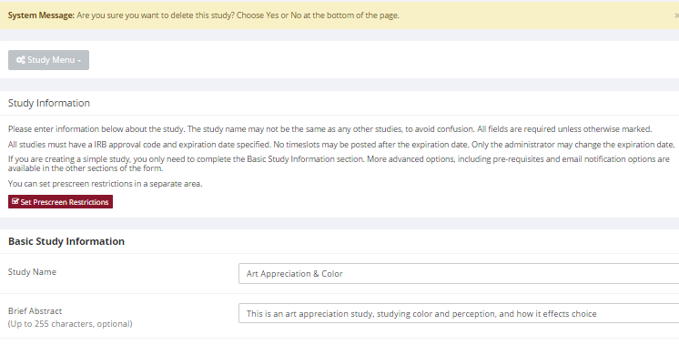
Figure 15- Deleting a Study
To delete a study, choose My Studies from top toolbar, click on the desired study, then choose the Delete Study option. You will see a confirmation page. Choose Yes (at the bottom of the page) to delete the study.

Once a study is deleted, it cannot be restored, so use this feature very carefully. If you delete an online survey study, the survey and all data collected will also be deleted.

Timeslot Usage Summary
The timeslot usage summary is available when viewing your study. This gives some basic information about timeslot utilization in the past and in the future, as well as some basic no-show information. It also gives information on timeslots for the study by location (if the study is not an online survey study or external web study), and by researcher (if the study is configured to allow researchers to be assigned to specific timeslots).

For credit studies, the system also provides a summary of how many credits were granted. This summary accurately computes credit usage, taking into account any variable credit grants (if Variable Credit Granting is enabled in System Settings), where some participants may have received credit in a different amount than the study’s listed credit value.

If timeslot usage limits are enabled, the system will provide an estimate of how many timeslots can be added. Note that if the study is a two-part study, it will estimate based on allocating all the limit to the first part or the second part (both estimates are provided), however in practice it’s more likely a researcher will want to add timeslots to both parts of the study, so this should be taken into account when viewing these estimates, especially if the first part and second part of a study have a different duration.

Bulk Mail Summary
The system tracks whenever any type of bulk email is sent (by a user) related to the study. This includes inviting qualified participants based on the study’s prescreen participation restrictions, or contacting those who have already signed up for the study. This information is kept for 6 months, and it is tracked to ensure that all users follow generally accepted Internet practices for responsible use of email. The administrator also has access to this information.

Prescreen Participation Restrictions
If enabled on your system, the system might contain an online prescreen that participants may (or must, depending on your system configuration) complete. You may place participation restrictions on your study based on prescreen responses. Participants are unaware that such restrictions are placed on the study. These restrictions are never listed to them. If they do not qualify to participate in a study because they do not meet the prescreen participation restrictions, then the study will simply not be listed to them. This is important to note – participants never know why a study was or was not listed to them, because they are unaware of the prescreen restrictions.

You may restrict a study on any question or questions on the prescreen that allowed for a multiple-choice answer where only one choice could be selected. You may also restrict a study based on a computed section sum or average score for a participant, if the prescreen was set up in such a manner. You may restrict to one choice or many choices for any question. If you restrict on multiple questions, it is the same as a logical “AND.” For example, if you setup the prescreen restrictions so that participants must have answered “Yes” to a “Do you wear glasses?” question and “Blue” or “Grey” to “What color are your eyes?”, then they must meet both requirements to participate. In other words, only participants who wear glasses and have either blue or grey eyes are eligible. There is no support for a logical “OR” restriction across multiple questions. The restrictions are inclusive, which means that if you select a choice as a restriction, then participants must have answered at least one of the choices selected for each question that is part of the restriction in order to see and participate in the study, as opposed to exclusive where checking the choice as a restriction would exclude them from participation.

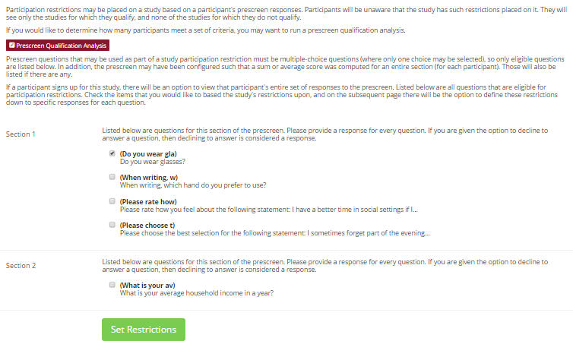
Figure 16 - Prescreen Restrictions Question Selection
To set participation restrictions, view (do not choose edit) your study and choose View/Modify Restrictions. You will see a list of eligible questions which you may use for your restrictions. If the study already has some restrictions, those will be checked, and you will see how many participants currently meet the restrictions. Choose the questions you would like to restrict upon (and keep the existing checked restrictions checked, unless you want to remove that restriction), and click on the Set Restrictions button. On the subsequent page, you can select each value that is acceptable for each question you have chosen. Once you have selected all the acceptable values, save your changes and they will take effect immediately. It is important to note that if you change the restrictions, it will not remove the study sign-ups for participants who qualified under the previous set of restrictions, because restrictions are enforced at the time the participant signs up for the study. For this reason, you should probably decide on your restrictions before making the study available to participants.

If you have restriction requirements where you would like to restrict participation to a percentage of the population (for instance, the responses that were chosen by the top 25% of people), but you are not sure which responses meet this requirement, you can use the prescreen response analysis feature to determine the valid responses. See Prescreen Response Analysis for more information. You may also use Analyzing Prescreen Responses to get an idea of how many participants are potential candidates for participation in your study, based on a specified set of restrictions.

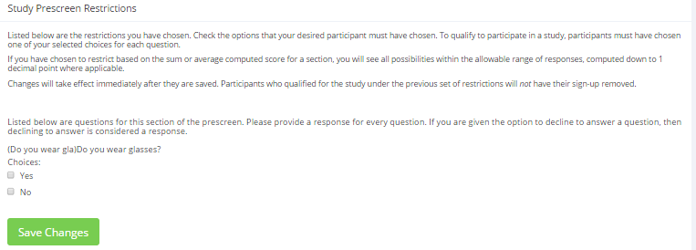
Figure 17 - Prescreen Response Restrictions

Inviting Qualified Participants to a Study
While viewing the list of prescreen restrictions currently set for a study, and the number of participants who meet those restrictions, you may see the option to Invite Qualified Participants. Using this option, you may craft an email to be sent to all qualified participants. You may choose to exclude those who have already signed up for or participated in any studies you specify, and this disqualifier list will be pre-populated based on any disqualifiers already set for the study. The system will automatically exclude all participants who have participated or are signed up for the current study (no-shows are not excluded though, since they may sign up again). If the study is not a research alternative study, the system will also automatically exclude participants with Limited accounts, as they are ineligible to participate in studies not marked as a research alternative study.

The system will pre-fill the email text with useful information like the name of the study and how many timeslots are currently open. You cannot include attachments in the email, so if you have a document you would like to include, you should post it on some other website and provide a link to the document in the email you send.

If you have set participation restrictions for the study based on course enrollment, those restrictions will be taken into consideration (i.e. abided by) when determining which participants receive the email.

There is also an option to choose a random percentage from the overall list of matching participants to email. It is important to note that the system does not keep track of which random percentage of the group of matching participants is sent to each time, so that if you send to a random 30% now, and a random 30% an hour later, it could very well be the case that many participants receive the email on both those occasions.

The From (sender) address on the email will be the administrator email address, which is done to prevent the email from being blocked by junk email filters. The “Reply To” address of the email will be that of the user who is actually sending the email, so when a participant chooses to reply to the email, the reply will be sent to that (the reply to) address.

Finally, there is an option to specify a delay in sending the email, based on the number of hours from when the emailing option is used. This is useful if you want to target a certain time of day (e.g., during the evenings) when the email will be sent. The emails are generated at the time you use the emailing facility, but are stored on the server’s outgoing email queue until the specified sending time. They cannot be removed from the queue once this emailing facility is used.

In some cases, the administrator may have imposed a limit on how many participants may be emailed. This is often done to prevent abuse of the system, such as cases where researchers invite too large a number of participants and this is not in accordance with generally accepted Internet principles for sending email. If there is such a limit, the system will look at the number of participants the researcher plans to email, and if that number is greater than the limit, it will block the sending entirely, as opposed to sending only enough emails up to the limit. To get around this limitation, the researcher can further restrict who they plan to send to (perhaps choosing a smaller random percentage of users, or more closely defined prescreen participation restrictions), or ask the administrator to send the email for them. The administrator is not subject to such limitations. Regardless, any use of this bulk email facility will be logged, and that information will be kept for approximately 6 months. The administrator can easily pull up a report of how many emails a specific researcher has sent, so it is wise to be careful about not abusing this feature. In addition, Sona Systems reserves the right to temporarily remove the right to login from a researcher if there are verifiable reports of abuse of this feature. Typically before doing so, the administrator will be notified by Sona Systems as it is preferred to have the administrator deal with such problems.

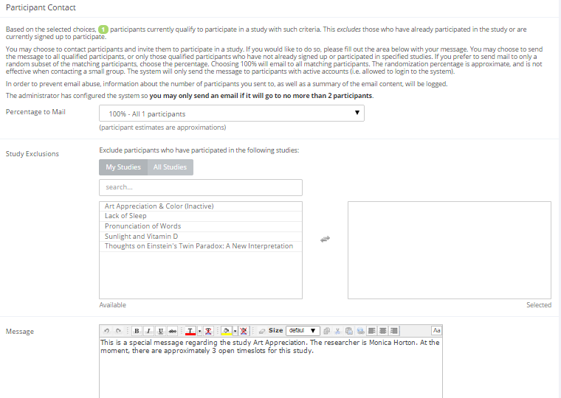
Figure 18 - Contacting Qualified Participants

Viewing Your Studies
To view your studies (and not the studies of others), choose the My Studies option on the top toolbar. The system will list all your studies in alphabetical order by study name, grouped by studies that are active, then inactive studies. You may use the tabs along the top to toggle among viewing all your studies, and only those that are active or inactive.

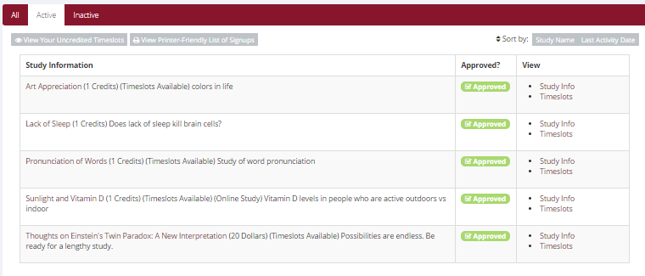
Figure 19 - Your Studies

Participant Study View
If you would like to see how your study appears when participants view it, find your study and choose the Participant Study View option. This will show exactly how the study appears to participants, with the exception that when a participant views a study, next to each pre-requisite and disqualifier study (for a study) is listed a status indicator about whether they have met that requirement. In Participant Study View, the pre-requisite and disqualifier studies are listed, but there is no status indicator next to each study in the list.

If for some reason you think your study is not visible to participants, it may be due to various restrictions you have set on the study, like prescreen participation restrictions, such that few (or none) of the participants in the pool qualify. You can ask the administrator to use the Check Study Configuration tool (available to them when they view your study) to provide advice on why your study may or may not be visible to participants. Administrators there also have an option to input a specific participant to see if that participant would qualify for your study.

Viewing Other Studies
To view all studies that are visible to participants, choose the All Studies option from the top toolbar.

You will see a list first of all Active studies. These studies will show up to participants on the list of available studies. The next group of studies (if there are any) is Inactive studies. These will not show up on the list of available studies (to participants), but participants can access information about these individual studies on links from the page with their progress (if they participated in the study) or if another study has the Inactive study listed as a pre-requisite or disqualifier.

Online External Studies
Online external studies are online studies which are not hosted within the system, but instead reside on some other website. This is different from online survey studies (detailed later in this documentation), where an online survey is set up directly in the system and no other website is involved.

For online external studies, you may want to develop some method of linking the participant’s sign-up in the system to your online study, so you know who to grant credit to. One way to do this is to ask the participant’s name (or some other identifying information) that will make it easy to locate their sign-up within the system and grant them credit once they have completed your online study. Another method of tracking, which reduces the chance of human error, is to use the Survey Code feature described later in this section. The most automated approach is to use the External Study Credit Granting feature, where the participant receives credit automatically as soon as they finish the study.

Note that if External Study Credit Granting is not used, the system will not automatically grant credit once the participant has finished the study, and the reason is that the system does not know when something occurred on a website outside the system. In this case, researchers should routinely login and grant credit as necessary.

External Study Credit Granting
With External Study Credit Granting, a participant can receive credit as soon as they finish the online external study. This is accomplished by having the external study notify the system that the participant has completed the study and thus deserves credit.

If you are using a popular commercial product like Qualtrics, SurveyMonkey, SurveyGizmo, LimeSurvey, FluidSurveys, or Inquisit, then skip this section and go to one of the following sections that provide specific instructions for each product. In addition, it may be easier to use the online integration instructions available for each product at http://www.sona-systems.com/help instead of this documentation. The reason is that those products may have been updated since this documentation was produced, and the online integration instructions are updated more frequently.

What follows in this section is a general description of the integration process if you are not using one of the commercial survey products listed above. If you are using one of those products, then skip to the relevant section (or the online integration instructions) instead.

The notification to the system is done by accessing the Completion URL for the study. A properly-configured study will have up to two Completion URLs:

- Client-Side Completion URL: If this URL is loaded, the participant will receive credit. Typically, this URL would be loaded by the participant clicking on a link in their browser, or the participant being redirected to this link after completing the study. This is the most common method used for commercial survey product where there is not already a built-in integration.
- Server-Side Completion URL: This URL would typically be loaded by the external study (not clicked by the end-user participant) and is a server-to-server communication between the external study and the system. The results are returned in XML format and may be parsed by the external study. This method would be used when you have full control over the external study, like if it is programmed from a Perl script. It also provides more control and security than the client-side method.

You should use only one completion URL to achieve credit granting. For most commercial online survey products, and also if you are not familiar with programming, then the client-side completion URL is likely the most appropriate option. To avoid confusion, the system will only display the client-side completion URL if a commercial survey product is being used and is known to support only the client-side completion URL.

To see the completion URLs for your study, first ensure the study is set up correctly as an online external study. Then, enter the URL for the external site in the Study URL field in Change Study Information, and save your changes. Next, click on Change Study Information again and modify the Study URL to include %SURVEY_CODE% in the URL in the appropriate place. If you entered the URL for a commercial product like SurveyMonkey, Qualtrics, or Inquisit, then the system will display help text just below the URL with a suggestion for how to include this. Save your changes, and the Completion URLs should now appear on the resulting study information page. In short, the Completion URLs will appear as long as there is %SURVEY_CODE% anywhere in the Study URL.

The client-side completion URL will look something like this:
https://yourschool.sona-systems.com/webstudy_credit.aspx?experiment_id=123&credit_token=9185d436e5f94b1581b0918162f6d7e8&survey_code=XXXX

The server-side completion URL will look something like this (if displayed):
https://yourschool.sona-systems.com/services/SonaAPI.svc/WebstudyCredit?experiment_id=123&credit_token=9185d436e5f94b1581b0918162f6d7e8&survey_code=XXXX

In the example above, the XXXX at the end is to show where the survey code number should be placed (in place of XXXX) by the external study website.

The next step is you’ll need to configure the online external study to receive the survey code number from the system at the start of the study, and also to load one of the completion URLs at the end of the study, while replacing XXXX with the survey code number and pass that to the system in the completion URL. Because this involves configuring the external study which is not part of the system, then how this is accomplished depends on the external study software. Usually it involves setting up the survey code number as some type of variable that is passed in via the URL, and then configuring a redirect URL at the end of the study to be loaded, with this variable in the URL.

As this is a complicated feature, the best method to test it is to actually login to the system as a fake participant. The entire credit granting process is not possible to test as a researcher, since researchers cannot sign up for studies. To ensure other (real) participants do not sign up for the study while you are testing it, add an Invitation Code to the study (you can remove it later).

The configuration directions for some popular survey products are below, based on information from those vendors.

External Study Credit Granting with SurveyMonkey
With SurveyMonkey, note that some of the features used within SurveyMonkey may vary depending on your subscription level with SurveyMonkey. In most cases, you will need to have their Gold or Platinum package in order to make use of the Custom Redirect feature necessary for study credit granting to work properly.

Here are the basic steps, which are subject to change (since the product is controlled by SurveyMonkey):

- In the system, change the Study URL so it includes %SURVEY_CODE% in the URL. So if the SurveyMonkey URL is http://www.surveymonkey.com/s/H2Y9H27 then change it to http://www.surveymonkey.com/s/H2Y9H27?c=%SURVEY_CODE%
- Having completed Step 1, the Study Information on your Sona Systems site now displays a URL labeled "SurveyMonkey Redirect to a URL". In SurveyMonkey, configure the survey to accept the survey code number, as a collector. Click on the "Collect Responses" tab.
- In SurveyMonkey, configure the Survey Completion option to “redirect to your own webpage”, and provide the SurveyMonkey Completion URL from the system. By doing this, SurveyMonkey will put in the survey_code number passed to the collector. If Steps 1 and 2 were completed correctly, then SurveyMonkey will add in the parameter automatically when it redirects the user. So if the SurveyMonkey Completion URL will look something like this: https://yourschool.sona-systems.com/webstudy_credit.aspx?experiment_id=170&credit_token=9185d436e5f94b1581b0918162f6d7e8

These features are described on SurveyMonkey’s site at the following URLs:
- http://help2.surveymonkey.com/articles/en_US/SurveyMonkeyArticleType/Can-I-pass-a-unique-ID-through-the-link-and-then-through-a-redirect-URL (“Can I pass a unique ID through the link and then through a redirect URL?”)
- http://help2.surveymonkey.com/articles/en_US/SurveyMonkeyArticleType/Can-I-redirect-respondents-to-a-different-website-upon-completion (“Can I redirect respondents to a different website upon completion?”)

The SurveyMonkey Completion URL provided by the system should be sufficient to paste directly into SurveyMonkey. If you prefer to derive the URL from the Client-Side Completion URL, then you simply need to remove the &c=XXXX from the end of Client-Side Completion URL and place the remaining text in SurveyMonkey.

External Study Credit Granting with Qualtrics
Here are the basic steps, which are subject to change (since the product is controlled by Qualtrics):
- In the system, change the Study URL so it includes &id=%SURVEY_CODE% in the URL. So if the Qualtrics URL (Anonymous Survey Link) is https://yourschool.qualtrics.com/SE/?SID=SV_b9ZD41hMZaqE then change it to https://yourschool.qualtrics.com/SE/?SID=SV_b9ZD41hMZaqE&id=%SURVEY_CODE%
- Having completed Step 1, the Study Information on your Sona Systems site now displays a URL labeled "Qualtrics Redirect to a URL". In Qualtrics, configure the survey to accept the survey code number, as an embedded data field named "id". Remember to use lower-case as this is case-sensitive. To do this, go to Survey Flow | Add a New Element | Embedded Data and type in "id" and save your changes.
- In Qualtrics, configure the Survey Options | Survey Termination | Redirect to a URL option, and provide the Qualtrics Redirect to a URL value from your Sona Systems site. (You may simply copy and paste the unaltered value from Sona into Qualtrics).

Note: If you have an End of Survey element set up in Survey Flow, you will need to add the URL there also. Go to Survey Flow | End of Survey | Customize and enter the Qualtrics Redirect URL value from the system into the Redirect to a URL field in Qualtrics.

These features are described on Qualtrics’ site at the following URL:
- http://www.qualtrics.com/university/researchsuite/developer-tools/api-integration/passing-information-through-query-strings/ (“Passing Information Through Query Strings”)

The Qualtrics Redirect to a URL provided by the system should be sufficient to paste directly into Qualtrics. If you prefer to derive the URL from the Client-Side Completion URL, then you simply need to change the &c=XXXX at the end of Client-Side Completion URL to ${e://Field/id}

External Study Credit Granting with SurveyGizmo
With SurveyGizmo, it is best to follow the URLs listed below that describe the process in detail on the SurveyGizmo website. In those documents, “panel company” refers to our system, and you will only need to focus on the Completed Surveys Link. The Over Quota and Disqualified links are not applicable or implemented in this situation. Note that some of the SurveyGizmo features described below may not be available to all SurveyGizmo subscription levels.

Here are the basic steps, which are subject to change (since the product is controlled by SurveyGizmo):
- In the system, change the Study URL so it includes %SURVEY_CODE% in the URL. So if the SurveyGizmo URL is http://www.surveygizmo.com/s3/12345/my-survey then change it to http://www.surveygizmo.com/s3/12345/my-survey?scode=%SURVEY_CODE%
- Having completed Step 1, the Study Information on your Sona Systems site now displays a URL labeled "SurveyGizmo Redirect to a URL". In SurveyGizmo, configure the survey to accept the survey code number, via a Hidden Field with a URL Variable named "scode". To do this, go to Build & Edit | Select Add Action on the first page of the survey. Pick the name "Sona Survey Code" for the action, and click on Add & Edit Action. In the Value section, first click on Insert Merge Code and choose URL Variable. Then, in the Value section, type in [url("scode")]
- In SurveyGizmo, configure the URL Redirect for completed surveys. On the Thank You page section, go to Add Action | URL Redirect (in Edit Text Elements). Pick some name for the action, and click on Add & Edit Action. In the URL field provide the SurveyGizmo Redirect URL from the system. The SurveyGizmo Redirect URL should look something like this: yourschool.sona-systems.com/webstudy_credit.aspx?experiment_id=170&credit_token=9185d436e5f94b1581b0918162f6d7e8
- Next, on that same page in SurveyGizmo, choose Add Field and choose the question named “Sona Survey Code” from the options and choose Add Field. Then, in the Variable Name textbox, type in survey_code and save your changes.

These features are described on SurveyGizmo’s site at the following URLs:
- http://surveygizmov4.helpgizmo.com/help/article/link/panel-integration (“Panel Integration”)
- http://surveygizmov4.helpgizmo.com/help/article/link/url-merge-codes (“Using URL Variables/Query Strings”)

The SurveyGizmo Redirect URL provided by the system should be sufficient to paste directly into SurveyGizmo. If you prefer to derive the URL from the Client-Side Completion URL, then you simply need to remove the &survey_code=XXXX from the end of Client-Side Completion URL and also the https:// (or http://) from the beginning, and place the remaining text in SurveyGizmo.

External Study Credit Granting with LimeSurvey
With LimeSurvey, the instructions below are for version 2.05+ and newer. At a minimum, be sure you are using version 2.0 build 130526 or newer. Earlier versions contain some bugs that will prevent things from working properly.

Here are the basic steps, which are subject to change (since the product is controlled by LimeSurvey):
- In the system, change the Study URL so it includes %SURVEY_CODE% in the URL. So if the LimeSurvey URL is http://limesurvey.yourschool.edu/index.php/651365/lang-en then change it to http://limesurvey.yourschool.edu/index.php/651365/lang-en?id=%SURVEY_CODE%

Note: In versions of LimeSurvey prior to 2.05+, the LimeSurvey URL format was different. If you see a / instead of a ? after index.php in the URL, then add ?id=%SURVEY_CODE% (so change the & to a ?) to the end of the URL when entering the Study URL.
- Having completed Step 1, the Study Information on your Sona Systems site now displays a URL labeled "LimeSurvey Redirect to a URL". In LimeSurvey, configure the survey to accept the survey code number, as URL Parameter named "id". To do this, go to General Settings | Panel Integration and add the URL parameter there, with no target question. Remember to use lower-case as this is case-sensitive, and be sure to click Save for both the new parameter and panel settings.
- In LimeSurvey, configure the End URL (in Edit Text Elements), and provide the LimeSurvey End URL from the system. The LimeSurvey URL should look something like this: https://yourschool.sona-systems.com/webstudy_credit.aspx?experiment_id=123&credit_token=4e48f9b638a&survey_code={PASSTHRU:id} If (and only if) you do not see a LimeSurvey End URL in the system, then proceed with the rest of this step. Otherwise, proceed to the next step.
In LimeSurvey, configure the End URL (in Edit Text Elements), and provide the Client-Side Completion URL from the system. However, you need to change the XXXX at the end of the URL, and instead have LimeSurvey put in the survey_code number passed as a pass-through variable. So if the client-side completion URL was https://yourschool.sona-systems.com/webstudy_credit.aspx?experiment_id=170&credit_token=9185d436e5f94b1581b0918162f6d7e8&survey_code=XXXX then enter it in LimeSurvey as https://yourschool.sona-systems.com/webstudy_credit.aspx?experiment_id=170&credit_token=9185d436e5f94b1581b0918162f6d7e8&survey_code={PASSTHRU:id}
- Note that if, after saving the End URL, you see an &amp; in place of & in the End URL field, then you need to instead set this value while logged into LimeSurvey as an administrator. This is due to a bug in LimeSurvey (bug 7827) that was fixed in version 130526.
- In LimeSurvey, set “Automatically load URL when survey complete?” to Yes on General Settings | Presentation & Navigation. This is due to a bug in LimeSurvey (bug 7826), where the survey code will not be properly passed through if this setting is set to No.

These features are described on LimeSurvey’s site at the following URL:
- http://manual.limesurvey.org/wiki/URL_fields (“URL Fields”)

External Study Credit Granting with Inquisit
Inquisit is a product offered by Millisecond Software, and the instructions below apply to Inquisit Web Edition only.

Here are the basic steps, which are subject to change (since the product is controlled by Millisecond):
- In the system, change the Study URL so it includes %SURVEY_CODE% in the URL. So if the Inquisit URL is http://research.millisecond.com/myexperiment.web then change it to http://research.millisecond.com/myexperiment.web ?survey_code=%SURVEY_CODE%
- Having completed Step 1, the Study Information on your Sona Systems site now displays a URL labeled "Inquisit Redirect to a URL". In Inquisit, use the web script registration wizard to configure the survey to accept the survey code number. On the part where it asks how to generate subject IDs, select Query Parameter and enter in "survey_code".
- In Inquisit, configure the Finish Page URL, and provide the Inquisit Finish Page URL from the system. The Inquisit Finish Page URL should look something like this: https://yourschool.sona-systems.com/webstudy_credit.aspx?experiment_id=170&credit_token=9185d436e5f94b1581b0918162f6d7e8

These features are described on Millisecond’s site at the following URL:
- http://www.millisecond.com/support/docs/v3/html/howto/interopsurveys.htm (“How to Interoperate Inquisit Web Edition with Online Survey Packages”)

The Inquisit Finish Page URL provided by the system should be sufficient to paste directly into Inquisit. If you prefer to derive the URL from the Client-Side Completion URL, then you simply need to remove the &c=XXXX from the end of Client-Side Completion URL and place the remaining text in Inquisit.

External Study Credit Granting with QuestionPro
Note that some of the features used within QuestionPro may vary depending on your subscription level with them. In most cases, you will need to have their Corporate Edition in order to make use of the Automatic Redirect feature necessary for study credit granting to work properly.

Here are the basic steps, which are subject to change (since the product is controlled by QuestionPro):
- On your Sona Systems site, change the Study URL so it includes ?custom1=%SURVEY_CODE% in the URL. So if the QuestionPro URL is: http://questionpro.com/t/AIZBjs6 then change it to http://questionpro.com/t/AIZBjs6?custom1=%SURVEY_CODE%
- Having completed Step 1, the Study Information on your Sona Systems site now displays a URL labeled "QuestionPro Automatic Redirect URL". In QuestionPro, configure the Finish option in Settings | Finish Options (like in the image below). Choose the Automatic Redirect Option, and provide the QuestionPro Automatic Redirect Website Address from the Sona system in the Website Address field. By doing this, QuestionPro will put in the survey_code number passed to it.
- If Steps 1 and 2 were completed correctly, then QuestionPro will add in the parameter automatically when it redirects the user. So if the QuestionPro Automatic Redirect Website Address will look something like this: https://yourschool.sona-systems.com/webstudy_credit.aspx?experiment_id=123&credit_token=4e48f9b638a&survey_code=${custom1}

These features are described on QuestionPro’s’s site at the following URL:
- http://www.questionpro.com/help/131.html (QPro custom variables in URLs)

External Study Credit Granting with Fluidsurveys
With FluidSurveys, note that some of the features used within FluidSurveys may vary depending on your subscription level with FluidSurveys. In most cases, you will need to have their Enterprise version in order to make use of the “Custom Variables in Publish URL” feature necessary for study credit granting to work properly.

Here are the basic steps, which are subject to change (since the product is controlled by Fluidsurveys):
- On your Sona Systems site, change the Study URL so it includes ?id=%SURVEY_CODE% in the URL. So if the Fluidsurveys URL is: http://fluidsurveys.com/surveys/abc/def/ then change it to http://fluidsurveys.com/surveys/abc/def/?id=%SURVEY_CODE%
- Having completed Step 1, the Study Information on your Sona Systems site now displays a URL labeled "FluidSurveys Redirect to a URL". On FluidSurveys, go to the Redirection settings and click on the "Pass through GET variables received from the survey entrance page". Then on Survey Complete Redirect, place the Survey Complete Redirect URL on there. It should look something like this: https://yourschool.sona-systems.com/webstudy_credit.aspx?experiment_id=123&credit_token=4e48f9b638a&survey_code={{GET_variable.id}}

More info on how to change these settings can be found here:
- http://help.fluidsurveys.com/hc/en-us/articles/201292424-Redirecting-Using-Advanced-Branching
- http://help.fluidsurveys.com/hc/en-us/articles/200132619-Setting-Redirection-Options

The Inquisit Finish Page URL provided by the system should be sufficient to paste directly into Inquisit. If you prefer to derive the URL from the Client-Side Completion URL, then you simply need to remove the &c=XXXX from the end of Client-Side Completion URL and place the remaining text in Inquisit.

Client-Side Completion URL Responses
For help in testing, listed below are the possible messages that the participant will see when they are redirected to the client-side completion URL. Note that if the system has a language enabled other than English, then the message will be displayed in the participant’s preferred language, instead of English (unless their language preference is English of course).
Status Message | Explanation
Web study credit successfully granted. | The credit was granted successfully.
No credit given, because you are not a participant, and therefore cannot sign up for this study. | A non-participant account (e.g., the researcher) accessed the URL, but the URL was accessed correctly. Usually this happens when a non-participant clicks on the Sample Link with Embedded ID Code link from the study.  This message will occur when testing the credit granting setup, and it’s a sign that everything is set up correctly.
Invalid experiment_id or credit_token. | The experiment_id or credit_token in the completion URL was invalid. As this does not change for each participant, this is most likely to occur if the completion URL was somehow incomplete or truncated.
Invalid survey_code. | The survey_code was not specified at all, or was blank. This may indicate the external study is not properly placing the survey_code in the completion URL.
Invalid survey_code. ## [some number] | The survey_code was provided, but is not valid for this study.
You have already received credit for this study. / You have already participated in this study. | The participant has already participated in this study and received credit/been marked as participated.
You are not eligible to participate in this study. | The participant has already signed up for this study, but has been marked as a no-show, and has no other signups for this study which are in Awaiting Action state.
Web study credit grant error. ## [some number] | Some other generic error. Please contact Technical Support for more information.

Server-Side Completion URL Responses
For help in testing, listed below are the possible messages that the system will give if the Server-Side Completion URL is loaded. This feature is documented using the same format as the general documentation for the API interface, for consistency. See Automating Tasks – API for information about how to locate the API documentation.

Input Parameters

Below are the following input parameters for use with the WebstudyCredit API function. These are included automatically when the system generates the Server-Side Completion URL. Note the parameters must be specified as part of the URL (an HTTP GET) and not via an HTTP POST request.

Parameter | Description / Possible Values
experiment_id | The Experiment ID of the study.
credit_token | The credit token used to identify/reference the study.
survey_code | The code that identifies the participant from the external web study.

Error Codes

Below are the possible error messages encountered and their respective descriptions. If the request was successful, there will not be an Error object returned, and only a Result object. See Sample Output for an example.

Error Type | Error Code | Description
Authentication failed | 0 | unspecified error
Invalid experiment_id | -1 | An invalid experiment_id value has been entered
Invalid credit_token | -2 | An invalid credit_token value has been entered
Participant already granted credit | -3 | The participant has already been granted credit
Participant already marked participated | -4 | The participant has already participated
Participant not eligible (no-show) | -5 | The participant is not eligible for credit
Invalid survey_code | -6 | An invalid survey_code value has been entered

Sample Input

https://yourschool.sonasystems.com/services/SonaAPI.svc/WebstudyCredit?experiment_id=123&credit_token=9185d436e5f94b1581b0918162e8&survey_code=XXXX

Sample Output

The output is in XML format, and an example is below of a successful request. Most of the Result object will contain null/empty values, as it is part of an object used for other API calls. There are two options to check that the credit grant was successful:

- The Result object exists
- The Result object exists and the credit_status field has a value of G

If there was an error, then the Errors object will contain data instead of being null.

<WebstudyCreditResponse>
<WebstudyCreditResult>
<a:Errors i:nil="true"/>
<a:Result>
<a:anon_id_code i:nil="true"/>
<a:credit_status>G</a:credit_status>
<a:email i:nil="true"/>
<a:first_name i:nil="true"/>
<a:last_name i:nil="true"/>
<a:phone i:nil="true"/>
<a:signup_id>123</a:signup_id>
<a:student_id_num i:nil="true"/>
<a:survey_code>XXXX</a:survey_code>
<a:user_id i:nil="true"/>
</a:Result>
</WebstudyCreditResult>
</WebstudyCreditResponse>

Security Considerations
There is one potential risk with using the client-side completion URL. Because the URL is typically accessed directly by the participant (their browser is redirected to it), then they have access to view the parameters in the URL. The completion URL contains a key specific to your study, as well as an ID (the survey code number) to indicate which participant should be granted credit.

The risk is that a participant could use this URL and start trying other ID (survey code numbers) to grant other participants credit. In order for this scheme to work, all of the following must be true:
- They must be able to guess an ID number used by another participant. The ID numbers are not necessarily sequential.
- The other participant must be signed up for this study.
- The other participant must not already have received credit for this study (i.e. they are in Awaiting Action state).

It’s fairly unlikely that all three situations will occur, and it’s also a lot of work for a participant to guess all possible ID numbers, though this can be automated. If this is a concern, the best option is to use the server-side completion URL, since that is a communication from server to server, and so participants will not see the communication. The drawback is that most commercial survey products do not support use of the server-side completion URL, so additional programming would be required.

Using the SURVEY CODE Feature
Note: If you are just interested in external study credit granting, then this section may not be applicable. This section describes how to use the survey code feature to link a sign-up in the system to data collected in the external study. However, it also describes the foundation for how the survey code feature works, which is useful in better understanding the external study credit grant feature.

For web-based studies which are administered outside the system, there is a special facility available for advanced users to track sign-ups in their web-based study while still preserving confidentiality. This feature applies only to web-based studies administered outside the system.

Before going further, it is important to note that this is an advanced feature and may require some programming skills. Sona Systems is unable to provide technical support for any programming questions.

The way this feature works is that if the text %SURVEY_CODE% is placed anywhere within the Study URL field, the system will automatically replace this text with a unique number for the participant. This unique number will also be displayed next to their sign-up within the system, so it’s easy to match sign-ups by this number. The number can be anywhere from 4-7 characters in length, and will not contain leading zeroes (1234 is possible, but 01234 is not).

The external study will then need to be set up to process this code and log it appropriately. Sona Systems cannot provide detailed technical support on how to program an external study, as that is code that is external to our software.

Here is an example of how this works. Let’s say the study URL is:
http://www.myschool.edu/mysurvey.html

If the Study URL is entered in the system as:
http://www.myschool.edu/mysurvey.html?id=%SURVEY_CODE%
then when a participant clicks on that URL, the system will replace %SURVEY_CODE% with a unique numeric value to identify the participant. For example, the URL may be changed to:
http://www.myschool.edu/mysurvey.html?id=30039

If that is the case, then on the page in the system listing sign-ups for this study (i.e., in the timeslot), the code 30039 will appear next to that participant’s sign-up.

If this code is parsed and handled by the external study, then the researcher can easily link up the sign-ups in the system with who they have collected data from within their external study, so they know who to credit. Note that the crediting still will not occur automatically. The purpose of this feature is to provide a way to identify participants without compromising privacy, since the system can then be configured so that names are not displayed next to sign-ups.

To help with setting this up, if a participant is not viewing the URL (for example, the researcher is viewing the URL), this special survey code text will simply be removed. Note this special text must be in all capital letters, and surrounded by percent signs. You may confirm it was entered correctly because a sample URL will be displayed when you go to view (not edit) the study, below the normal study website link.

If you provide a SurveyMonkey, Qualtrics, Inquisit, LimeSurvey, SurveyGizmo, or FluidSurveys URL in the Study URL field, then the system will provide guidance (after saving your changes) about how to use the survey code feature.

Online Survey Studies

Introduction
The system includes a rather extensive online survey feature (if enabled on your system). It allows you to set up an online survey as a study within the system, and participants who sign up for the study will be asked to immediately complete the survey. Upon their completion of the survey, they will be granted credit automatically by the system. You may then analyze their survey responses on an individual basis, or download the raw data across all participants who completed the survey, for further analysis. There is a slight chance that you may notice a discrepancy in the number of responses when analyzing a single question compared to downloading the entire set of responses. This can occur if a participant is currently taking the survey, but has not completed it. Their data is included in the single-question analysis (when available) but not in the full download of responses, as there is not a full set of data for an in-progress participant. The system will prevent participants from completing the survey more than once, so there is no risk of duplicate entries for the same participant.

To comply with research ethics guidelines, the participant is given the opportunity to withdraw from the survey at any time. See Participant Withdrawal from a Survey for more information.

There is a space to provide closing text for the survey, which is displayed to participants after they successfully complete the survey (after they have saved all their responses and cannot go back). This is an ideal place to include any relevant debriefing information.

The online survey feature is rather complex due to the many features it contains. In addition, your ability to modify the survey after participants have started to take the survey is quite limited. Because of this, you should plan out your survey well in advance, to make sure it is finalized before you make it available to participants. You may find it helpful to plan out the survey on paper before entering it into the system.

A survey may have an unlimited number of sections and an unlimited number of questions per section, though we recommend limiting surveys to fewer than 300 total questions, 15 sections, and 15 questions per section, to reduce participant fatigue and to ensure proper system performance. Participant fatigue can be an issue since they must complete the survey all at once. In addition, you should make participants aware that their session may time out because of inactivity, and usually this means they will be logged out after 15 minutes of inactivity. Inactivity would happen if they load up a section of questions but do not complete and save their responses for that section within that period of time. It is a good idea to structure sections accordingly, especially if a section contains lengthy text or complex questions. The system will warn participants a few minute prior to this inactivity logout, and provide them with the opportunity to extend their session.

Questions may be free-entry (requiring the participant to type in an answer) or multiple-choice (pick only one or pick many from the list of choices). You may also specify that the system computes a participant’s results for an entire section, as either a section sum or average score. This computed sum or average can be computed only for numeric, multiple-choice (pick only one) questions in the section. Such a computation is often useful when a participant’s aggregate score is more important, such as with a depression battery.

For free-entry questions where the participant is asked to enter a free-form text answer, the size of the entry field (as it is displayed) cannot be resized in terms of dimensions (only by length). Participants may enter up to 255 characters in their response.

Sections can be displayed in a specified order or random order, or a combination of both. Every section may contain introductory text introducing the section, and the survey itself may also have introductory text introducing the survey, as well as closing text that is displayed upon completion of the survey. You may specify that questions within a section are displayed in random order. If you do not specify random ordering for questions in a section, then the questions will be displayed (in each section) in the order they were entered and cannot be reordered later. Multiple choice questions can have their choices displayed in the entered order or random order (this is specified on a per-question basis). Multiple choice question choices can be displayed horizontally (across the page) or vertically (down the page).

It is important to realize that while the survey feature is quite extensive, there are some things it does not support. It cannot do question timings, where the speed of a participant’s response (typically in milliseconds) to each question needs to be measured. It also cannot do branching, where the questions being presented to a participant will vary depending on their answer to other questions within that same survey (an example being asking a question like “Do you smoke cigarettes?” and then presenting a different set of questions based on their response). The reason advanced features like this are not currently supported is that our software is primarily a participant pool software product that happens to have an online survey feature within it. We asked our customers which features in an online survey were most important to them, and those features exist within the product. There are numerous products on the market specifically for doing online surveys (with no subject pool component), which contain more advanced features, and can easily be linked to from the Sona Systems product by setting up your study as an online study conducted outside the system.

Creating or Modifying a Survey
To create a survey, first create an online survey study. After you create it, you will see the option Update Online Survey when you view the study information. You may not create 2-part online survey studies.

It is important to note that while you are making changes to a survey, it is deactivated so participants may not participate in it. When you go to the Finalize Survey option after you have finished your work with the survey, you will have the opportunity to save your changes and make the survey active (available to participants) or inactive (not available to participants). You should always choose the Finalize Survey option when you finish your work with the survey, as the system saves all changes and computes some other important data when you finalize the survey. If you would like to continue work on the survey at a later date, you should still choose the Finalize Survey option to ensure your changes during the current session are properly saved (most likely you would choose to keep the survey inactive in this situation).

General Survey Information
Choose the General Information option (if creating a new survey, this is the first page you will see) to provide some basic information about the survey. The fields are explained below:

Field | Description
Introductory Text | Optional, maximum 10,000 characters. Provide a set of text that will be displayed when a participant starts the survey. You may include HTML in this area, but please be sure you know what you are doing. If you would like to add a carriage-return (paragraph break), simply type in “<p>” (without the quotes). When you first create the online survey, the system may automatically insert some basic default text in this area. You may change any of this text as much as you like – the system will not change it back later as long as you save your changes.  This is a good place to place any text for informed consent purposes. You may view how this text is displayed to participants by saving it, then going to Preview Introductory Text, which is available from the Section List page.
Closing Text | Optional, maximum 7,000 characters. Provide a set of text that will be displayed after a participant completes the survey and saves their responses. This is an ideal place for debriefing information. You may include HTML in this area, but please be sure you know what you are doing. If you would like to add a carriage-return (paragraph break), simply type in “<p>” (without the quotes).  You may view how this text is displayed to participants by saving it, then going to Preview Closing Text, which is available from the Section List page.
Display sections in random order? | You may specify a specific ordering for sections, have the system randomize the order for all sections, or specify the order of some sections, and a random order for other sections. If you specify the order for only some sections, you may also specify, for each section, whether it should be displayed before or after the random-ordered sections. The system does not keep track of the random order sections were displayed for each participant.
Mobile Devices Allowed? | If set to Yes, the participants accessing the system using the mobile version (app) on a mobile device like a smartphone or tablet will be allowed to participate.  If the survey makes use of images or question and choice layout is very important, then it may be better to set this to No as the layout may be rendered differently on devices, especially smartphones with small screen sizes.  For technical reasons, there is no easy way to preview how questions will look on a mobile device except to login as a test participant using an actual mobile device.
Participant response review/change | If set to Yes, then participants may review and change their responses just before they complete the online survey. They are given this opportunity after they complete the last section of the survey, and before any closing text is shown. At this point, they can see all their responses and go back to any section to change their responses. Once they complete the online survey, they cannot go back at a later date and change any responses.  It may be useful to set this option to No (so that they are not allowed to review or change their responses at the end of the survey) if sections are somehow dependent on one another, such that allowing participants to change their responses may affect the integrity of data collection.
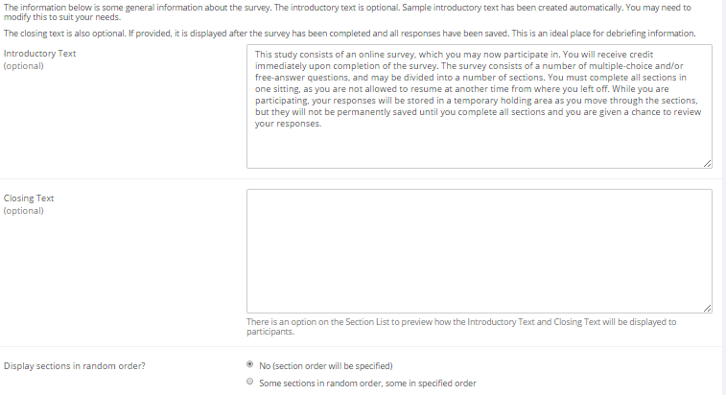
Figure 20 - Survey General Information

Section List
Depending on if you are adding or editing the survey, you will be taken to the list of sections for the survey. Here, you can change the order that sections will be displayed (if you have not enabled full random section ordering for the survey), and see a quick review of each question. From here, you can add a question to any section and edit any question. To add a new section, choose the Add a New Section choice at the bottom of the page.

If you have enabled partial random section ordering, then you can specify a section order for the sections you would like to be displayed in a specified order. For the sections you would like to be displayed in random order, leave the Section Order item blank. When you specify a section order, use each number once, and use the numbers 1-98 if you would like the section to be displayed before the random-ordered sections, and the numbers 100-199 if you would like the section to be displayed after the random-ordered sections. Be sure to use each number only once, or leave the number blank to make the section part of the random-ordered section. Sometimes it is useful to use partial random ordering if you want to ask basic (e.g. demographic) information in the first few sections, while asking more analytical questions in the random-ordered sections. Likewise, you may want to ask about the previous random-ordered sections after they are completed. It is not possible to intersperse ordered sections within the set of random sections, like having 2 ordered sections, then 3 random sections, the 1 ordered section, then 2 random sections, etc. The random sections are treated as an entire block of sections, and other sections cannot be placed at specific places within that block.

There is also a Preview Section option so you may preview the survey as participants will see it.
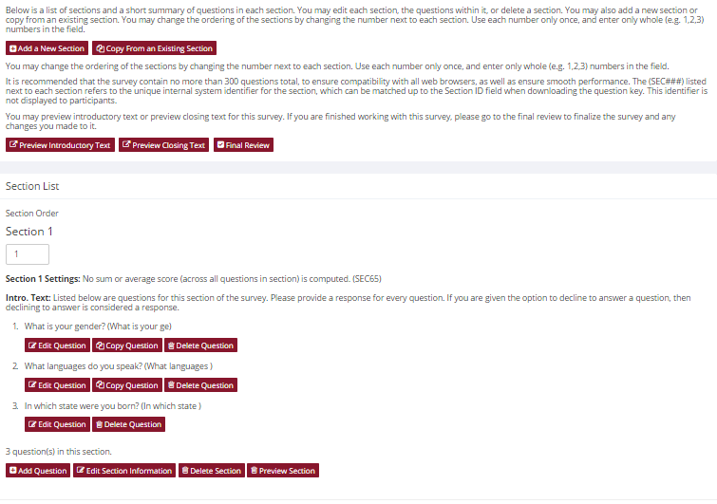
Figure 21 - Survey Section List

Adding or Modifying a Section
To add a new section, choose the Add New Section link at the bottom of the Section List page. To modify an existing section, choose the Edit Section Information link next to the section you would like to modify, from the Section List page.

There are three pieces of information you may provide for each section. First, you may specify some introductory text to be displayed at the beginning of the section. When participants take the survey, they view one section at a time, and all the questions in that section. The introductory text may be helpful in explaining the purpose or topic of the questions in that section. You may include HTML in this area, but please be sure you know what you are doing. If you would like to add a carriage-return (paragraph break), simply type in “<p>” (without the quotes). The introductory text is limited to 15,000 characters.

You may choose if the questions for that section are displayed in random order or the order in which they are entered.

You may also choose to have the system compute a section sum or average (for each participant) for the section. These scores are computed only for all the multiple-choice, numeric questions in a section, where only one choice may be chosen. Think carefully about setting this value, because you are very limited in your ability to change it after participants have started to take the survey.

Computed section sums or means are often useful when all the questions are using a unidimensional scale (1-5, for example), but a participant’s average score response to the section is more useful to account for their outlier responses.

Depending on if you are editing or adding a section, after you save your changes, you will be taken to a page to add a new question or to the section list.

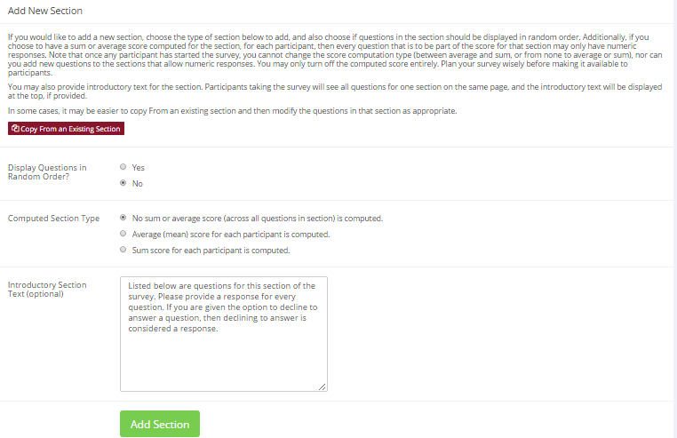
Figure 22 - Add New Section

Adding or Editing a Question
To add or edit a question, choose the appropriate choice from the Section List, next to the desired section. Questions will be displayed in the order they are added to a section, or in a random order, depending on the section settings. Questions cannot be reordered after they are added, so this should be planned carefully. Depending on the state of the section and if participants have taken the survey, some options will be automatically set for you, and not changeable. All fields must be filled out.

Field | Description
Question Text | The text for the question. This will be displayed above each question’s choices. Maximum 15,000 characters.
Abbreviated Question Name | A 15-character label for the question. This is not displayed to participants and is used to name the columns that appear when the data is exported in CSV format. Many statistical analysis programs limit column names to 15 characters.
Question Type | Multiple Choice (select one), Multiple Choice (select many) or Free Entry. If the section has a computed average or sum, you may be limited in your ability to add Multiple Choice (select one) non-numeric questions. Free entry choices may contain a response up to 255 characters in length.
Display length of Free-Entry field | Specifies the length (size) of a free-entry field when it is displayed. Acceptable values for this setting are 5-85, and the field will always allow participants to type in up to 255 characters. The height of the field cannot be adjusted, and this setting only applies to Free Entry questions.
Display choices in random order? | If set to Yes, the choices for this question will be displayed to participants in a random order. This option only applies to multiple choice questions.
How should the choices be displayed? | Horizontal (across the page) or vertical (down the page) are the two options for how the choices for a multiple-choice question should be displayed. Often, the horizontal display is effective when the question involves a scale. This setting applies only to multiple-choice questions.
Can participants decline to provide an answer for this question? | If set to Yes, participants will see a choice below this question that allows them to opt out of answering the question. If set to No, they must answer the question. The default when adding a new question (not copying an existing question or section) is set to Yes for ethical compliance.
Are all choices numeric? | If set to Yes, all choices must be numeric whole numbers (e.g. 1, -2, 10). This only applies to multiple choice questions. Sections with a computed section sum or average may not contain non-numeric multiple choice (select many) questions.
Display numeric value? | If set to No, the numeric value of the choice is not displayed to participants. This only applies to numeric, multiple-choice questions where each choice includes both a numeric value and associated text (e.g. “5 Strongly Agree”). This is useful when running a reverse scale.

If the question is a multiple choice question, you must also fill out the choices section that is part of the same form. A minimum of 1 choice must be provided for the question. Each choice may be up to 255 characters in length. If the question is specified as numeric, you must provide a numeric choice, and that choice must be a whole number (e.g. -5, 1, 0, 349). If you would like to provide descriptive text to accompany each numeric choice, you may do so by typing in the numeric choice and leaving one blank space after it, then typing in the descriptive text, for example: “5 Strongly Agree”. If you provide descriptive text along with the numeric choice, then you have the option of hiding the numeric value from participants, by choosing No to the “Display numeric value?” setting for the question. This is useful in reverse scale or other situations where the numeric value for the choices is not important.

If the choices you specify when adding a question do not conform to the configuration of the question (e.g. specifying a non-numeric choice for a numeric question), the system may change the question configuration to ensure that the choices are then valid.

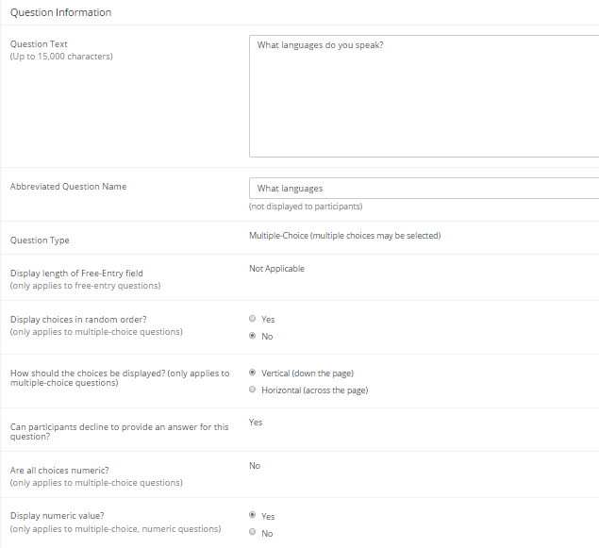
Figure 23 - Edit a Question

Copying a Section
You may copy a section from any of your own surveys into your current survey, by choosing Copy From an Existing Section in the Section List. You will see a list of eligible surveys to copy from. After you choose which survey to copy from, you will see a list of eligible sections in that survey. Once you choose a section, it will be copied into the survey you are currently editing. You may copy only one section at a time, because of the system performance impact when copying sections.

The administrator also has the ability to copy to or from the prescreen, so ask the administrator to do this for you, if you need it done.

Copying a Question
For multiple-choice questions, it is often the case that many questions have the same measures (choices). To make entry of similar questions easier, you may use the Copy Question feature to copy a question. Such an option is only available for multiple choice questions. To copy a question, select the question you would like to copy (when viewing the Section List). You will then be taken to a list of sections where you may copy this question to (the default is set to the section the question came from). After you decide which section you would like to copy the question to, you will be taken to a page where you can make any final changes to the copy of the question before saving it.

Saving Your Changes
When you are done, you should go to the Final Review and save your changes. Even if you plan to do further editing of the survey later, it is imperative that you go to the Final Review step, as the system needs to save certain special changes and make some computations. If you do not want participants to participate in the survey yet, you can save changes but keep the survey inactive. When you save your changes, it may take a moment to save all the changes, as the system is performing a number of computations on the survey. Please be patient, as these computations are done to make performance for participants as fast as possible. The system tracks which user last made the survey active or inactive and when they did this, and this is displayed on the setup page.

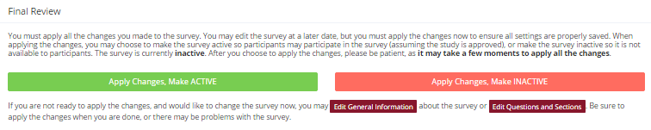
Figure 24 - Saving Survey Changes

Viewing a Survey as a Participant
If you would like to see how the survey will be displayed to participants, that can easily be done while setting up the survey. Next to each section (in the section list), there will be a Preview Section link so you can view the section exactly as participants would see it. You may also view how the introductory and closing text will appear to participants, by choosing the Preview Introductory Text and Preview Closing Text options which appear on the Section List page.

Participants will see a basic progress display on the top right corner of each page, listing the section they are on (ordinal counting), and how many sections total are in the survey. When using Preview Section, you will see this progress display as well, except the current section number will appear as “X” in preview mode since it is not an actual participant taking the survey (and randomization of section order may be involved).

If you find it necessary to go through the entire process as a real participant, you can do so by creating a test participant account. Set the online survey study so it has an invitation code, so no other participants can sign up (since they will not know this invitation code). Then, sign up with your test participant account and take the survey. You can remove the invitation code later if necessary.

Participant Withdrawal from a Survey
At any time while participating in the survey, participants have the option to withdraw from the survey. A Withdraw button will appear in the top right corner of each page.

When a participant withdraws, they have the option to withdraw without the option to receive credit, or with the option to receive credit.

If they choose to withdraw without the option to receive credit, all their survey responses as well as the record of their sign-up will be deleted. Participants are told that this option should be used if they want to later participate in the survey. In other words, it would likely be used when a participant starts a survey but realizes they won’t have sufficient time be to complete it at the moment, but would like the opportunity to participate later. No notification to researchers is sent in this scenario.

If they choose to withdraw with the option to receive credit, then all their survey responses will be deleted, but a record of their sign-up will be kept and it will be in awaiting action state. The researcher will receive an email about the withdrawal, as well as some basic information about how far along the participant was when they chose to withdraw (both in time spent and number of questions completed). This information is provided in case there is a policy of granting credit for early withdrawals based on time spent or percentage completion. Participants also have the option of including a message that will be sent to the researcher to explain their withdrawal, but such a message is not required. The researcher should then grant credit to the participant if necessary, by going to the timeslot and finding that sign-up.

Participants are informed that if they are unsure which of the withdrawal options to choose, that they should choose the withdraw option that retains their ability to receive credit.

The withdrawal option cannot be removed, as it is there to ensure compliance with research ethics guidelines.

Viewing Survey Data Usage and Deleting Survey Data
The system has a limited amount of storage space, and you are expected to download the survey data you have collected on a routine basis, and then delete it from the system. By going to View Survey Data Usage, you can see how much database space is being used. You can then download the survey data (a link is provided), and delete it from the system.

When you delete the data from the system, all survey data collected within the last 5 minutes will not be deleted, as a safety feature. This is to ensure you have had adequate time to download the survey data before deleting it (to account for the time between downloading the data and deleting it).

If you choose to delete the survey data in this manner, the record of participant sign-ups will be retained, so you can ensure they do not complete the same online survey again.

Deleting a Single Participant’s Survey Responses
On rare occasions, you may want to delete a participant’s survey responses, usually so they can participate again. To do this, cancel their sign-up and that will delete their responses. Note this will also remove any credit they earned. See Manual Cancellation for more information.

Analyzing Survey Responses
You may analyze a specific survey question on-screen by selecting the survey and choosing the Analyze Survey Responses option. From there, you may choose a specific question and view or download the response data. This will include data from participants who are still in the process of completing the survey, but have not yet completed it. The Download Survey Responses option, which provides the entire set of survey responses for all participants, includes only data from participants who have completed the survey, to ensure easier data analysis.

In rare cases, you may notice that a few responses for certain questions appear (or disappear from) the Analyze Survey Responses while never showing up in Download Survey Responses. What happens in this situation is that a participant started an online survey but never fully completed it or withdrew from it (they probably just closed their web browser). The system goes through all “orphaned” responses in this situation and clears them out once they are more than 2 days old.

More likely, you will want to analyze the survey data across all questions. In this case, you should choose the Download Survey Responses option.

To successfully analyze the data, you will need to download 2 sets of data. The first is the question key, which lists a unique numeric identifier for each question, along with the question text and abbreviated question name. It also includes the section number each question was in. Note the section number listed is merely a unique identifier for each section, and has no correspondence to the order in which sections were presented. Also note that section mean and sum values, if calculated, will normally be at the end of the list of questions. This data is in CSV format, and is available by clicking the Download Question Key link on the Download Survey Responses Page.

After you download the question key, you can download the survey data. The data may be separated into parts, if there is a lot of data to download. The system will adjust the size of each part based on how many questions are in the survey. A survey with a large number of questions will be broken into more parts, with fewer rows of data per part. The default option is to download the entire set of survey data (all parts) at once. If you receive an error when doing so, then download each part one at a time – there may be too much data in the combined download for the system to process.

You may also choose to limit the download based on date range, which is based on when the participant completed the survey. If you choose a date range, this merely filters each existing part of the download, so some parts may be empty if no participants whose responses would normally be included in that part completed the survey during the specified date range.

There are three options for downloading and viewing the data (both the question key and responses):
- Download as CSV File. This is the most popular option, and allows you to save the data on your computer and load it in your preferred data analysis tool.
- View On-Screen (CSV Format). This option lets you view the data on-screen instead of downloading it. The data is still displayed in CSV format, and it’s a good way to view the format of the data and ensure all the data you expect is there. Often with larger datasets, downloading and viewing the data with some tools (like Excel) may make it appear as if not all the data is there, when in reality it’s a limitation of the tool and not a problem with the data download. The on-screen option is also useful if data was collected in a language that uses Unicode character sets, like Hebrew.
- View On-Screen (Table Format). This option provides an easy way to view the data on-screen (to visually analyze the data) but is not very useful for purposes of loading the data into an analysis tool.

The data is presented as one row per respondent, with each of their responses in a different column. The first row includes the column headings, and the column heading maps to the abbreviated question name. Since there is no facility to specify an abbreviated question name for the computed section sum/mean item, the system automatically assigns a unique name to those columns. The naming convention is SECXXX where XXX maps to the system’s internal section identifier for that section (section_id). You can use the question key to determine which question maps to which column. The order of columns (questions) in the data download is not necessarily the same as the order of questions in the survey – it’s ordered based on how the data is stored internally in the system. The data also includes the exact time the participant started and completed the online survey. You can use any common data analysis tool to compute how long it took the participant to complete the survey, using this information. There is also a column listing how many minutes it took the participant to complete the survey, rounded to the nearest minute.

There will be an option to include only the numeric response portion of questions that are multiple-choice with numeric choices. This is useful if the numeric question was set up with associated text, but that text should not be included in the analysis file. One example would be where the response selected was “5 Strongly Agree” but only the number 5 (and not the associated text) is useful during analysis. If you choose this option and download data and find that the associated text is included with the numeric response, then have a closer look at the survey – most likely the question was not actually set up as a numeric question. The easiest way to deal with this downloaded data is to use a data analysis tool to do a search and replace to change the response in your downloaded data into a numeric format. Your IT department can provide assistance with such tools.

If your survey has a lot of questions (and thus columns in the output file), you may have trouble loading the data with some spreadsheet programs, which are not equipped to handle such large datasets. Your best option is to use a full-featured statistical analysis package, like SPSS or SAS. Those packages handle large CSV-format data imports with ease. Your IT department can help you to select the best tools. In particular, Excel has trouble dealing with datasets with more than 250 questions (columns).

Frequently Asked Questions about Online Surveys

Is it possible to have multiple versions of an online survey, with participants being
randomly assigned to one version of the survey at the start of the survey?

The best way to do this is to create multiple online surveys (you can easily copy questions between them with the Copy Section Feature, to save time), and use a prescreen participation restriction that is unrelated to your research. For example if there is a prescreen question asking for the last digit of the participant’s university ID number (assuming this is randomly distributed), then you can use that to easily break up the pool into random tenths by using that as a prescreen participation restriction for each version of the study.

Is there a way to post images, graphics, or videos in the online survey, so that participants can respond to questions referring to the image or video?

Yes. You will need to have the ability to post images on a webserver (most likely at your school), and know a small bit of HTML. Let's say your graphic is located at http://www.yourschool.edu/myimage.gif

Put this in the place where you want the image to be displayed:
<IMG SRC="http://www.yourschool.edu/myimage.gif">

If you're unfamiliar with HTML, you may want to ask someone in your IT department for assistance with this.

You can use a similar process to post videos, but you'll need to ask the person in charge of the webserver where you post the video for the best method (in HTML) for linking to it, as there are a few different methods to link to videos.

You cannot upload images or videos directly onto the Sona Systems server, but every university provides a facility to post content on webservers at the school, and this method is better for participants also as the data (images and videos are usually quite large) will be stored on the high-speed network within the university.

Can certain sections be presented for a specified period of time (e.g. 60 seconds)?

No. There are technical limitations and inaccuracies in how web browsers interact with web servers, as well as internet latency factors that make this difficult to do, so this feature is not offered.

Can I make an online study a two-part study?

Online studies cannot be two-part studies, and the reason has to do with what two-part studies are intended for. They are used when the researcher needs to ensure a fairly strict separation between each part. For example, in memory research, a researcher may want to set up the two parts exactly 14 days apart.

The issue with online studies is they are not scheduled to take place at a certain date and time, so it's impossible to enforce any kind of strict separation between each part.

If the goal is just a follow-up to a study, then the time separation probably isn't very important. In that case, the best solution is to set up two studies, and set the first study as a pre-requisite for participation in the second study.

Is there a method to upload a survey into the system (from Word, Excel, etc.)?

For online survey studies, there is no method to upload the data. We considered this, but there is no standard format for survey data representation, so there was no format we could really support for uploading.

In the online survey feature, there is the ability to copy questions and sections, which may make it easier to set up the survey if many questions have the same sets of choices, for example.

When a participant is taking an online survey study, when is their sign-up actually recorded in the system?

The system will not record completion (or even sign-up) of an online survey study until it is actually completed (or if the participant chooses to withdraw early). Participants are shown the closing text as the last step of the online survey study -- just after their responses have been saved and their sign-up is recorded.

When they start the online survey study, it is noted to participants that their responses are not fully saved until they complete the study, and only then will they be properly recorded. This is for both technical and IRB reasons.

I have created my online survey and participants cannot see it. I have ensured that all the prescreen restrictions, course restrictions, and pre-requisite/disqualifier restrictions are set correctly. Why is it not showing up?

You need to set up at least one timeslot (and the standard method for an online survey is to set up only one timeslot) for the survey, to specify the participation deadline. If you still have problems, contact the administrator and ask them to run Check Study Configuration on your study, and that will explain why a study is or is not showing up.

My online survey had 5 spaces in a timeslot, and somehow 6 people signed up and received credit. How did this happen?

This is a rare situation that occurs, usually with online surveys that take a long time to complete. What happens is that all 6 people (or at least the last 2 people) started the online survey at around the same time, and before any of them could finish it. The system checks at the point of sign-up to see if there are open spaces for the online survey, but does not consider someone who has started the online survey but not finished it as taking up one of those places (in case that person abandoned early without properly withdrawing). So, in this rare situation, there is no choice but to credit all participants who successfully completed the survey, as it is the only fair outcome for participants. Note that this situation is quite rare, and most likely occurs when the survey is lengthy, and there are many participants vying for a limited number of available timeslots in the system.

Working with Timeslots (Sessions)
Timeslots (also referred to as Sessions) are the available times when a participant may participate in the study. If you are setting up timeslots for a web-based study, please read the section in this documentation on Web-Based (Online) Studies for some special information.

Timeslots allow you to specify a date, time, location, maximum number of participants, and researcher for a session.

Timeslot Usage Restrictions
If enabled on your system, you may find there is a limit to the amount of time available for scheduling timeslots. This usage is computed by adding up all the past timeslots where credit was granted or is in awaiting action status, and then adding all timeslots in the future, regardless of credit status. You may find that the usage goes down over time, as time progresses and timeslots that were in the future which had no sign-ups are now in the past and no longer count towards usage (empty timeslots). The timeslot usage and limit is listed whenever you add a timeslot, if usage restrictions apply. It may also be listed when you view your profile, depending on how your system is configured.

Timeslots Linked to Specific Researchers
If your system is configured to allow multiple researchers per study, you will also have an option to link timeslots to a specific researcher. This is done primarily for organization purposes, and has no effect on who can view and modify the study, or any timeslots for that study.

This feature is useful when there are a number of researchers running a study, and researchers are responsible for running specific timeslots. If a timeslot has a specific researcher linked to it, then only that researcher will be listed as the contact point when a participant receives any emails related to their participation in that timeslot. Finally, only the researcher connected to that timeslot receives related notification emails, such as participant cancellation notification, and reminder emails (assuming such emails are enabled).

It is also possible to have some timeslots where a specific researcher is linked to them, and others where all researchers (who are assigned to the study) are responsible for the timeslot. It is not possible to link more than one, but not all of the researchers (for the study), to a specific timeslot. The options are to either link one researcher to the timeslot, or all of them.

If a researcher is removed from a study, then any timeslots that were linked to them for that study will be changed so all researchers (for the study) are now responsible for those timeslots.

To use this feature, the system must be configured to allow multiple researchers per study. Then, the study itself must be configured to allow researchers to be linked to specific timeslots. Finally, the study must have more than one researcher connected to it.

Creating Timeslots
To add a timeslot for a study, you must first choose the study that you would like to add a timeslot for. To view your studies, choose the My Studies option on the top toolbar. Click on the desired study, and choose the Timeslots choice.

You will see a list of any existing timeslots, and the Add A Timeslot option on the top of the page. Click on Add A Timeslot.

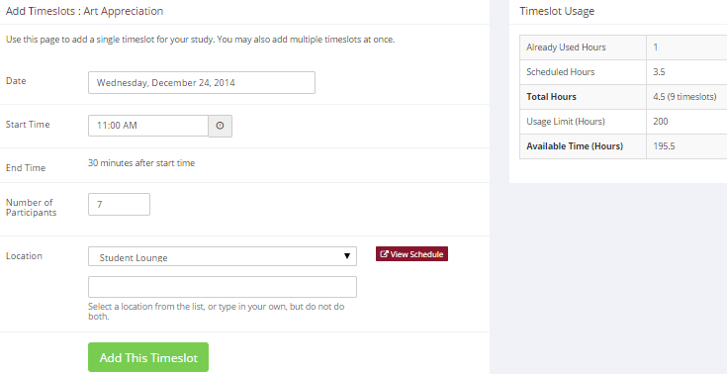
Figure 25 - Adding a Timeslot
The following table lists the information you may enter about a timeslot, along with an explanation. All fields are required.

Field | Explanation
Date | The date for the timeslot.
Start Time | The time for the timeslot. A sample time will be provided. If you want to change the time, please use the same format as the time you see presented. Note in particular how “a.m.” and “p.m.” are handled (if such a format is enabled on your system).
End Time | The time when the timeslot will end. This is computed automatically based on the duration you entered when you set up the study.
Number of Participants | The number of participants for this timeslot. This number is not visible to participants. They will only see whether the timeslot is full or not. The maximum number is 999.
Location | The physical location where the study will take place, for this timeslot. It will be automatically filled with the location of the previous timeslot, when available, to ease in data entry.  Depending on how your system is configured, you may see a list of pre-configured locations. You may choose any of those locations and click on View Schedule to see the schedule for a location. The system will automatically prevent you from adding a timeslot using a location that is already in use at the time you try to schedule the timeslot. If you do not see the location in the list that you plan to use, you can simply type in the location in the text field below it.  The location field does not apply for web-based studies.
Researcher | The researcher assigned to this specific timeslot. The list will contain a list of all researchers for the study. Choose ALL if all researchers (for the study) should be assigned to this timeslot. See Timeslots Linked to Specific Researchers for more information.

To ease data entry, the system will automatically fill in the date, time, and location based on the ending time of the last timeslot for this study. If applicable, your current timeslot usage will be listed, and you will be prevented from adding a timeslot that would exceed your timeslot usage time limit. A convenient calendar is provided next to the form, and you can click on any date and that date will be transferred to the form.

If you add a timeslot such that there is another timeslot (for any study) that occurs in the same time, at the same location, you will receive a warning (but the addition will be allowed), unless the location was chosen from the pulldown list of locations, in which case the addition will be blocked. If you add a timeslot that will take place outside of normal hours (for example, at 1:00 am), the system will provide a warning but will allow it to be scheduled. You may not schedule a timeslot to occur after the IRB expiration date for your study, if Strict IRB mode is enabled by the administrator. The system allows adding timeslots to a study that is not available to participants (not active or not approved), but it will give a warning because participants are not able to sign up for the timeslot.

If you are running a web-based (online study), you should create a single timeslot with the participation deadline equal to the last day you would like to run the study. For number of participants, specify the maximum number of participants who may participate. If you are running a web-based study and you plan to collect data from more than 999 participants (999 is the maximum allowed in one timeslot), then once that timeslot is close to filling up, create a second timeslot at a slightly different time and/or date as the first timeslot.

Creating Multiple Timeslots
If you would like to add multiple timeslots at once, choose the Add Multiple Timeslots link. You may choose to add a specified number of timeslots, or copy the timeslots from another week to a specified week. If you choose to copy, the system will copy the time, location, and number of participants for the specified week to the desired week, for each day of that week (starting with Monday).

If you choose to create a specified number of timeslots, you can choose the number of timeslots you would like to add, the start time and date, and the amount of time between each timeslot (to allow for breaks). You also may specify that timeslots that would occur outside normal business hours be shifted to the next business day, and specify when business hours occur. The system considers Monday-Friday to be business days.

On the subsequent page, you may change any of it to deal with special cases. Timeslots that you attempt to add, that either have errors or would result in exceeding the timeslot time usage limit, will not be added. This feature is not available for web-based (online) studies, as web-based studies rarely have more than one timeslot.

If you would do not want to add a specific timeslot that is listed, choose No in the Add This Timeslot? column.

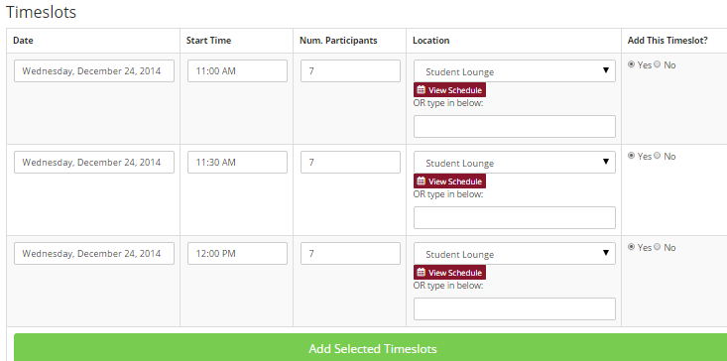
Figure 26 - Creating Multiple Timeslots

Modifying and Deleting Timeslots
To modify or delete a timeslot for a study, you must first choose the study that you would like to deal with. To view your studies, choose the My Studies link from the top toolbar. Choose the Timeslots option in the View column for the desired study. You will see a list of all recent timeslots. Recent timeslots in the past with no participants signed up will not be displayed. To work with timeslots more than a few days old and to see all timeslots, you will see a link to view all timeslots for the study. Select the timeslot you would like to deal with, and click the Modify button.

If the timeslot has no participants signed up for it, you will see a Delete button. You may not delete a timeslot that has participants signed up for it (you need to first cancel all existing signups for the timeslot). If you would like to delete the timeslot, click the Delete button, and you will see a confirmation page. Choose Delete again to delete the timeslot.

If you would like to modify the timeslot, modify the desired information and click the Update button just below the timeslot information. It should be noted that participants will not be notified (by email) of any changes you make to the timeslot, so you should contact them if information needs to be passed on to them (a link is provided on the same page to do so). If you change the date or time of the timeslot, you will be warned that this was changed in case the change was unintended. You may not update the size of the timeslot (number of participants) to a value lower than the current number of participants signed up for the timeslot. Generally, researchers only update timeslots with sign-ups to update the location, if it was not available when the timeslot was originally created.

If the study (or researcher) is subject to timeslot time usage restrictions, the system will enforce them and prevent you from making changes that would result in exceeding the timeslot usage limit, for example by increasing the number of participants.

Timeslot Change Tracking
The system automatically tracks certain changes that occur with a timeslot, including information about any time the timeslot’s key information (date, time, etc.) is changed, as well as any time a manual sign-up or cancellation is performed (but not a sign-up or cancellation done by the participant). This information is tracked for the last 3 months of changes for each timeslot.

To view this information, choose the Timeslot Modification Log when viewing a timeslot, and you will see this information.

Deleting Multiple Timeslots
If you would like to delete multiple timeslots at once, you may do that as well. Such a feature is only available for timeslots that have no participants signed up. To do so, select the desired study and choose Timeslots. At the top of the Timeslots page, you will see a Delete Multiple Timeslots option. The option may not appear in certain cases where such an option is not available because of a lack of available timeslots to delete.

After going to that page, you will see a list of timeslots eligible for deletion. Choose the timeslots you would like to delete, and choose Delete Selected Timeslots to proceed. If you would like to delete all empty timeslots, there is a Check All option at the bottom of this page that will automatically select all timeslots listed on the page for deletion. Click the Uncheck All button to revert the effect of choosing the Check All option.

The system routinely deletes all empty timeslots more than 3 months old to preserve database space.

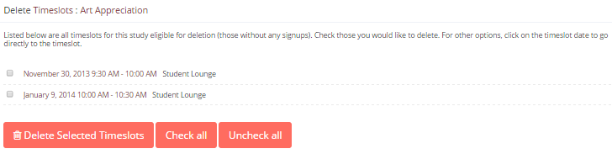
Figure 27 - Delete Multiple Timeslots

Manual Sign-Up
If enabled on your system, you may manually sign up participants for your study on their behalf. There are a number of situations where this is desirable. If the participant happens to show up for a timeslot they were not signed up for, and you elect to let them participate, you can sign them up on the spot for the timeslot. The participant in many cases cannot sign up on their own in this situation, because the sign-up deadline has passed. You may also sign up a participant for a study that has already occurred, if necessary.

Also, a manual sign-up overrides any restrictions you have placed on the study (e.g. pre-requisites), though you will be warned if you are overriding any restrictions. You may not sign up a participant for the same timeslot that they are already signed up for. You are allowed to sign them up for a study even if they are already signed up for a different timeslot for that same study, though you will receive a warning in this case. You may not sign up a participant for a study if it would cause them to exceed their maximum credit limit. If it is necessary to do so, please ask the administrator to do this, as they are allowed to do a manual sign-up even when it will exceed maximum credit earning limits.

You also may not sign up a participant whose account is Limited, if your study is not a research alternative study, as those participants are ineligible for your study (the administrator can still do this).

If the system is configured as such, the participant will receive a confirmation email when you sign them up for a study. In that case, you are also given the option to enter comments to be included in this email that may better explain to the participant why they were signed up. If you are signing up a participant for a timeslot more than one year old, a confirmation will not be sent despite the system configuration. This is to make it easier when transitioning from an existing system, as you may sign up old participants for the purposes of preventing them from signing up for the same study again in Sona. You may only sign up participants for your own study.

To sign up a participant for a timeslot, you must first find the desired study and timeslot. To view your studies, choose the My Studies option from the top toolbar. Click on Timeslots for the desired study, then select the timeslot you would like to deal with, and click the Modify button.

At the bottom of the page, you will see a Manual Sign-Up option, if it is enabled. Type in the participant’s User ID (you may have to ask them for this) and click Sign Up. If enabled, you may also choose to sign up a participant using their unique ID code. You may also have the choice to enter their last name and choose from a list of participants. In all cases, after proceeding, you will see a confirmation page that also lists any restrictions on the study. Choose Sign Up to complete the sign-up.

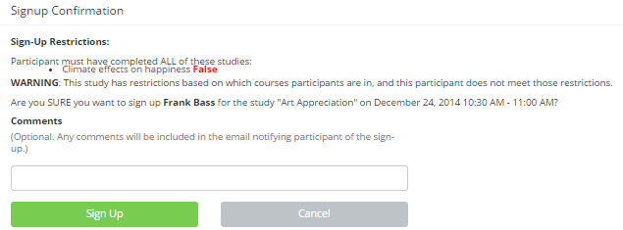
Figure 28 - Manual Sign-Up Confirmation
If you are subject to timeslot time usage restrictions, the system will enforce them and prevent you from signing up a participant in the timeslot if that would result in exceeding your timeslot usage limit.
If you are doing a manual sign-up for a two-part study, you must do a manual sign-up for each part separately. The system will overlook the scheduling range restrictions as well.

You cannot use the manual sign-up feature for online survey studies, because the sign-up for the study is integrated with the administration of the survey.

The manual sign-up feature will not appear for a researcher if the study requires approval by the administrator and it has not yet been approved. This is to ensure sign-ups cannot occur for a study that has not yet been approved, since research should not take place prior to approval.

Manual Cancellation
If enabled on your system, you may have the opportunity to cancel a participant’s sign-up. You may only cancel sign-ups that are in a No Action Taken state. To cancel a sign-up, find the desired timeslot and participant, and click Cancel next to their name. The participant will be sent an email about the cancellation (and who performed it), along with a confirmation code, and their sign-up will be immediately cancelled. The administrator may also receive a copy of this cancellation email, depending on how the system is configured.

You may cancel all participants for the same timeslot at one time, when applicable. The option will appear below the list of signups, in cases where there are two or more participants signed up for the timeslot who are eligible for cancellation (No Action Taken state).

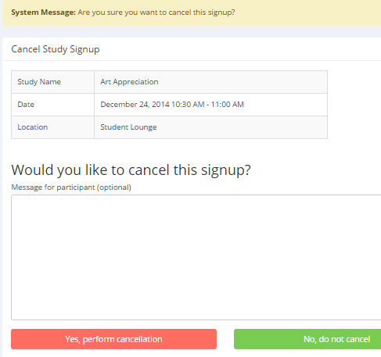
Figure 29 - Manual Cancellation

Viewing the Participant List
To view the list of participants who have signed up for your study, you must first select the study and timeslot you wish to see. To view your studies, choose the My Studies option from the top toolbar. Click on the timeslots link in the View column for the desired study, then select the timeslot you would like to see, and click the Modify button.

The list of participants, along with their email addresses, will be listed. If ID codes are enabled, you will only see an ID code and no name or email address for each participant, and the list will be sorted by ID code.

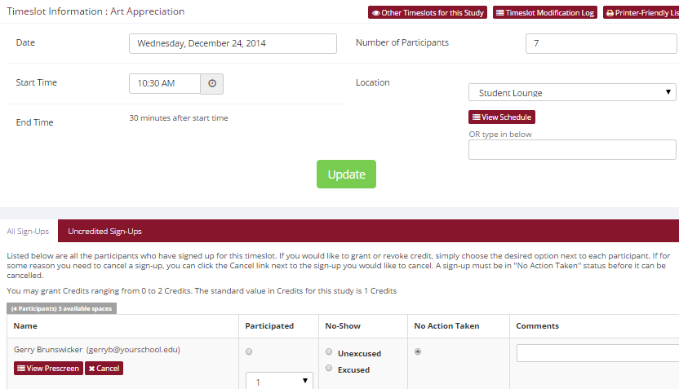
Figure 30 - Modifying a Timeslot / Participant List

Viewing Prescreen Responses
If online prescreening is enabled on your system, and you are also allowed to view an individual participant’s prescreen responses, then you will see a Prescreen link next to each participant’s name (or ID code) when you view the information for a timeslot. Click on that link to view the participant’s prescreen responses.

If you would like to download the prescreen data for all participants in your study, choose the Download Prescreen Responses option after clicking on your study (in the Study Menu). That will allow you to download all the data at once, in CSV (comma-separated) format, for further analysis. The download will not contain data for participants marked as a no-show.

If you would like to analyze responses in aggregate (across all participants in the system), see Analyzing Prescreen Responses in this documentation.
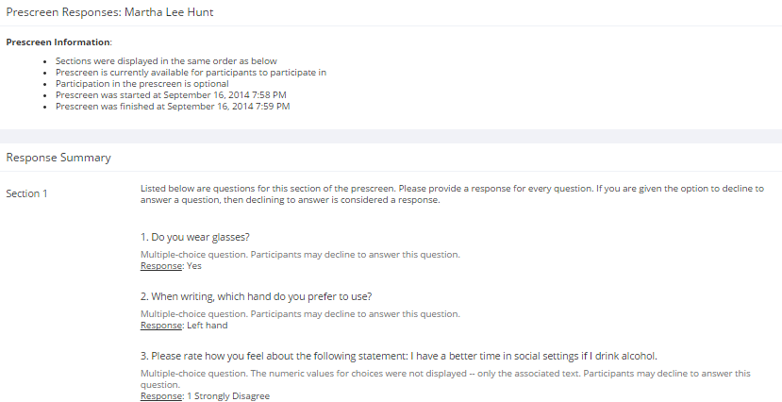
Figure 31 - Viewing Participant Prescreen Responses

Granting or Revoking Credit
At the completion of a session, you should promptly mark the attendance status of participants in the system, to ensure proper credit grants. The reason for the prompt handling of this situation is in the event your study is a pre-requisite for another study, and a few other situations. You do not want to hold up other studies that are waiting on your response to the study you just ran.

To grant or revoke credit for a timeslot, you must first find the desired study and timeslot. To view your studies, choose the My Studies option from the top toolbar. Click on the Timeslots link in the View column for the desired study, then select the timeslot you would like to see, and click the Modify button.

You will see a list of participants, identified either by name or ID code. If the participant properly participated in the study, click the radio button next to their name in the Participated column.

If the participant did not appear for the timeslot, you may choose to mark their no-show as excused or unexcused. Depending on how your system is configured, an unexcused no-show may result in a penalty being assessed for the participant (the system will compute this automatically), or their privileges to use the system may be restricted. You should ask your administrator for guidelines about when to grant an excused no-show or an unexcused no-show. Generally, excused no-shows are granted for extenuating circumstances, like if the participant was involved in a car accident on their way to the appointment. An unexcused no-show is generally used when the participant did not show up and had no reasonable excuse. For most schools, the majority of no-shows are unexcused and are due to carelessness on the part of participants.

Depending on how your system is configured, you may see an option to grant a credit value that is different from the standard credit grant. This is useful when you want to grant a participant a lower credit value because they left the study early (if they deserve a lower credit grant), or a higher credit value if the study ran longer than expected. The default value that is selected is the study’s standard credit value. If this is enabled, then you may also grant 0 credits. This is useful if you do not want to grant credits to the participant, but you also want to prevent them from participating in the study again. If a participant is granted 0 credits, and the study is set to prevent duplicate sign-ups, then the participant will not be able to sign up for that study again.

If desired, enter any comments about the session in the Comments section (generally, this is used to indicate the reason for denying credit). Participants will see anything you enter in the Comments section for their sign-up, and these comments will be included in the email sent to participants when a credit grant/revocation occurs, if notification emails are enabled on your system.

Click on the Update Sign-Ups button at the bottom of the list of sign-ups to save your changes. Credit will be granted or a penalty assessed as necessary. The participant(s) will be emailed about this if the system is configured in such a manner.

It is not recommended to leave any sign-up for a timeslot that has occurred in the “No Action Taken” stage. This is a credit “limbo” and the system will warn you upon your next login that the timeslot has not been dealt with properly. Note that if Manual Cancellation is enabled and you would like to cancel a participant’s sign-up, the sign-up must be in No Action Taken state.

Depending on how your system is configured, the system may automatically grant credit to participants for timeslots that are more than an administrator-specified number of hours old, and where the researcher has taken no action. You can always change the automatic credit grant later if it was in error. The automatic credit grant takes place once a day, usually overnight. Your administrator can let you know if such a feature is enabled on your system.

If you need to do a simple credit grant or no-show across many timeslots, see the Uncredited Timeslots section which offers such a feature.

Batch Credit Granting
In some cases, you may wish to automatically sign up and immediately credit a group of participants. This is often useful if you administered a study on an ad-hoc basis, and you want to credit participants after the fact.

To do so, go to the appropriate timeslot (you may want to create a timeslot specifically for this purpose), and click on Modify Timeslot. In the Manual Sign-Up section (if enabled), you will see a Batch Credit Grant link. Click that and you can provide the list of User IDs of users you would like to sign up and credit. Users will be signed up and credited immediately. This feature overrides any sign-up restrictions on the study, just as a normal manual sign-up does.
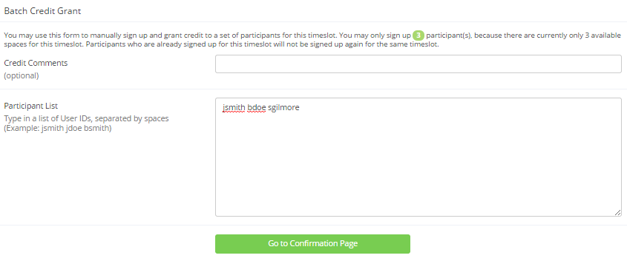
Figure 32 - Batch Credit Grant
The batch credit grant feature will not appear for a researcher if the study requires approval by the administrator and it has not yet been approved. This is to ensure sign-ups cannot occur for a study that has not yet been approved. You may provide a list of up to 50 participants, or as many participants as there are available spaces for the timeslot, whichever is less. Any participants listed past that limit will be ignored, but you can run the batch credit again with additional participants.

If you are signing up a participant for a timeslot more than one year old, a sign-up confirmation will not be sent despite the system configuration. This is to make it easier when transitioning from an existing system, as you may sign up past participants for the purposes of preventing them from signing up for the same study again in the system.

Emailing Participants
If you wish to contact participants in a particular timeslot for any reason, you may click on the Contact link that will appear next to each participant’s name (or ID code) to contact an individual participant. To email the group of participants for a particular timeslot, click the Contact All Participants choice at the bottom of the Modify Timeslot page for that timeslot.

You will be taken to a page where you can fill out a message that the system will send to the selected participants. The message is auto-filled with some basic information about the study, so participants are aware of which study you are referring to. You may remove this information if desired. You may choose to receive a copy of the email that you send.

Depending on how your system is configured, participants may already be receiving a reminder about upcoming studies the day before they are scheduled to participate. Ask your administrator for more information.

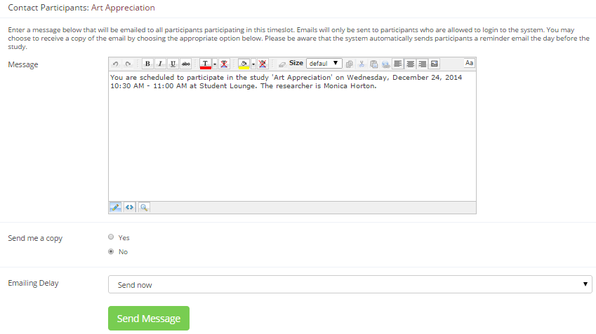
Figure 33 - Contacting Participants
In some cases, you may find it useful to contact all participants for the study, across all timeslots. This feature may be particularly useful if you are sending debriefing information when a study has concluded. To do so, go to My Studies, click Study Info next to the desired study, and choose the Contact Participants option (in the Study Menu). You will then be able to select which group of participants to send to, and a message to send. Messages will be sent in batches of 3,000 at a time, to avoid overloading email servers. You cannot include attachments in the email, so if you have a document you would like to include, you should post it on another website and provide a link to the document in the email you send.

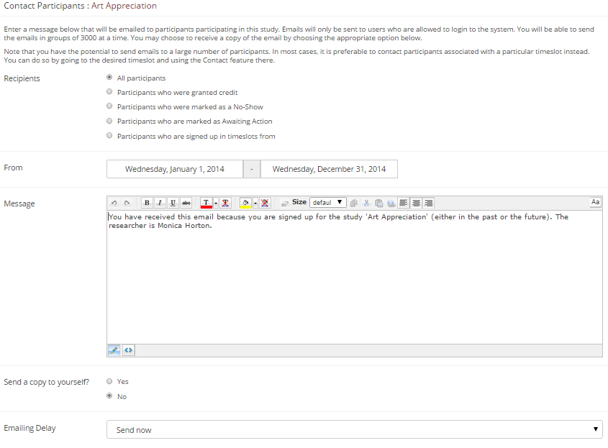
Figure 34 - Contact Participants
The From (sender) address on the email will be the administrator email address, which is done to prevent the email from being blocked by junk email filters. The “Reply To” address of the email will be that of the user who is actually sending the email, so when a user chooses to reply to the email, the reply will be sent to that (the reply to) address.

There is also the option to restrict the emails so they only go to participants who signed up for timeslots in a specified date range. The date range is based on the date of the timeslot, not when the participant signed up for, completed, or received credit for the study.

Finally, there is an option to specify a delay in sending the email, based on the number of hours from when the emailing option is used. This is useful if you want to target a certain time of day (e.g., during the evenings) when the email will be sent. The emails are generated at the time you use the emailing facility, but are stored on the email server queue until the specified sending time. These emails cannot be revoked once this emailing facility is used.

In most cases, summary information about the email you sent, and in particular to how many recipients it was sent to, will be logged and made available to the administrator. This is done to ensure there is no abuse of the email facility in the system, in compliance with generally accepted Internet practices for sending emails.

Viewing Uncredited Timeslots
When you login to the system, you will receive a warning if you have any timeslots that are more than two days old that haven’t been dealt with. You may view a list of all timeslots that have not been dealt with by choosing the View Uncredited Timeslots option from the My Studies page. The default view will show in-person studies with timeslots in the past, as well as all uncredited timeslots for online studies. Timeslots for online studies, including those in the future, are always considered in need of a response. See the Web-Based (Online) Studies section of this documentation for more information.

If you would like to do a simple credit grant (standard credit grant, no comments) or no-show (of either type), you may do so directly from this page. Select the desired sign-ups/timeslots, and then choose the desired option.

If you need to do something more complex, like add comments, or perform a special credit grant with a non-standard credit amount, you can easily click on the timeslot’s date and time, and go directly to that timeslot.

In cases where a study has timeslots linked to specific researchers, you will see the warning only for timeslots that are specifically linked to you, or to everyone in the study (i.e., not timeslots linked to someone else in the study). However, when you view uncredited timeslots, you will see all uncredited timeslots for your studies, even if someone else is linked to one of the timeslots for your study. This is done to make it easier to give your fellow researchers (for your studies) assistance in dealing with uncredited timeslots.
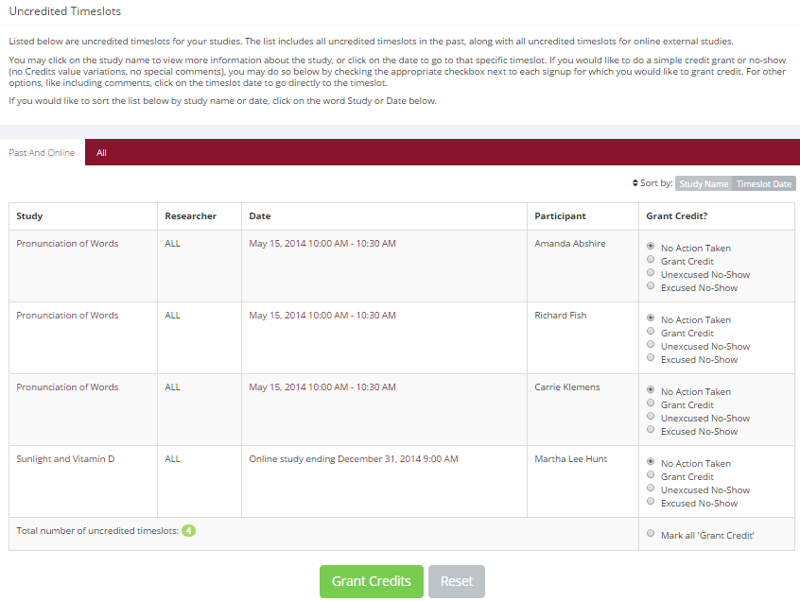
Figure 35 - Uncredited Timeslots

Analyzing Prescreen Responses
If online prescreening is enabled on your system, then you might also have the opportunity to analyze prescreen responses in aggregate or as raw data. Choose the Prescreen Results option from the top menu bar. You can then select which question you would like to analyze, and whether you would like to see summary data or raw data (in CSV format) for the selected question. The raw data will identify each participant only by a unique ID code, not by their name, for privacy reasons. If for some reason you need the participants’ real names, ask the Administrator to run the same analysis, as they can also pull the real names with their report. This gives you access to all prescreen data across all participants in the system.

If you would like to analyze the prescreen data for just those who participated in your study, select the Download Prescreen Responses after clicking on your study. See Viewing Prescreen Responses in this documentation for further information.
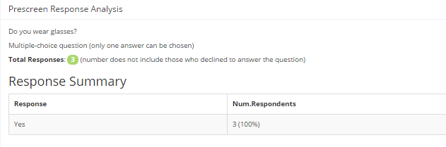
Figure 36 - Prescreen Response Analysis

Prescreen Qualification Analysis
If you would like to get an idea of how many participants meet a set of requirements (for help in setting prescreen restrictions on your study), use the Prescreen Qualification Analysis link from the Prescreen Responses page. Using this feature, you can select multiple questions (only questions that qualify for study participation restrictions are listed), and then the desired responses for those questions, and you will see how many participants meet that criteria.

If enabled, you may also contact participants and invite them to participate in any of your studies. See the Invite Qualified Participants to a Study section in this documentation for more information on how this works. The functionality is the same as the functionality described in that section, though a few options may be unavailable when not inviting directly from a study, because those options do not apply. Be sure to include information about how to sign up for the study in your communication to them, as a direct link to the study is not provided in the email.

Frequently Asked Questions (FAQ)

Why do I have to acknowledge the Human Subjects Policy?

Certain regulations and research guidelines either require or recommend it. You only need to do it once every 6 months, so it should not be too intrusive. You will not be asked to acknowledge the policy if this feature is disabled by your administrator.

I want to set up a study so that participants can choose to receive credit or payment. How do I set this up?

Set it up as a study for credit, and note in the study description that participants may opt to receive payment instead, and they should notify the researcher of this when they come to their appointment. If the participant at that time chooses to receive monetary compensation, the researcher should grant credit, but mark the credit as 0 credits (Variable Credit Granting must be enabled in System Settings by the administrator), and then note in the comments for the timeslot that payment was received.

The monetary compensation a participant receives for a study depends on decisions they make during the study. How do I indicate this?

You may type any value into the payment field when setting up the study, so you could type in a range of compensation values.

I want a participant to participate in an upcoming session, but the system says it is too late for them to sign up. What do I do?

If enabled, you can perform a manual sign-up. See the Manual Sign-Up section of this documentation. If not enabled, your administrator can still perform a manual sign-up.

Where are email notifications to me sent?

Email notifications (e.g. sign-up notices) are sent to either an address derived from your user ID or your alternate email address. See the Email Address Options section of this documentation for more information.

How do I deal with dyads?

A dyad is a study which requires a pair of people to participate, but often the second participant is not a “real” participant, but rather a colleague of the researcher who is “colluding” with the researcher as part of the study itself.

You do not need to deal with dyads in the system itself. Participants cannot see how many people have signed up for a timeslot, nor how many spaces are available for a timeslot. So, your “fake” participant can just act like a real participant and the real participant will be unaware of this.

I have finished running my study. What should I do?

So it does not clutter the list of studies for participants, you should make the study Inactive or delete it. See the Updating a Study section of this documentation for more information.

Who has access to my studies?

All users can see the information about your studies and the available timeslots. Administrators, the principal investigator (if applicable) and the researchers for the study are the only people who can see who has signed up, and modify the study.

Regulatory Compliance Guidelines

Introduction
This software complies with all major regulations governing human subject research and privacy of data stored online. The system complies with both HIPAA and Common Rule for customers in the United States. For customers in Canada, it complies with the Personal Information Protection and Electronic Documents Act as well as the Tri-Council Statement. For customers in the European Union or in countries that follow OECD rules, it complies with OECD privacy rules and the European Union Directive of Data Protection. Your organization may or may not need to comply with the relevant regulations. Your research administrator can advise you on this situation.

Even if you are not required to comply, compliance is still a good idea, as protecting sensitive data is always a good thing. Compliance in the context of this system is as simple as reading the remaining paragraphs of this section (that apply to your organization) and following the guidelines contained therein. The remaining compliance issues involving software, privacy and electronic data storage are all handled automatically by the software. You should still consult with your IRB or organization to learn about additional compliance rules you must follow outside of use of this software (the handling of the data you collect during your study would be one example).

Some regulations (particularly the US HIPAA regulations) are focused primarily on health data. You may think the system does not store confidential health data (in HIPAA terms, it is called PHI -- Protected Health Information), but depending on how your organization uses the software, there may very well be confidential data in the system. Consider the case of a study that requires that a participant come from a family that has a history of mental illness. Merely knowing who signed up for that study can be considered confidential because that type of information should not be revealed to the public. It may turn out that your studies are not of such a nature, but even more benign situations, like a study that requires that participants be regular contact lens wearers, can be construed as confidential information. Organizations typically err on the side of caution given the criminal and civil penalties for violation of these types of regulations.

Data Handling and Security Guidelines
In your role, you have access to your studies and you can see who has signed up for those studies. You may also have access to prescreen responses. Because of these privileges, you should follow these simple guidelines:

- Secure Your Account. Use a password that is difficult to guess. The most secure passwords contain a combination of letters and numbers, do not spell a real word, and are at least 8 characters long. Your university IT department can provide you with assistance on choosing a secure password.
- Secure Your Work Area. If you are logged into the system and you leave your computer, you should logout of the system or use a password lock on your computer. Ask your network administrator for help with setting up a password lock.
- Handle Paper Documents Carefully. Any printouts from the system should be kept reasonably secure. Store them in a locking desk drawer out of the public view. Documents you decide to discard should be shredded if possible.

Human Subjects/Privacy Policy Acknowledgment
Upon your first login to the system, and every 6 months thereafter, you may be required to acknowledge your organization’s policy on these matters, and this acknowledgement will be logged.

Ask your research administrator if you have any questions.

