

**Gender differences in the clinical presenttion, management, and short-term outcomes of patients with non-ST-elevation myocardial infarction**

**Tetiana Lunova**

**210646180**

**Academic advisor:**

**Prof. Trevor Sheldon**

**Abstract**

**Background:** Cardiovascular disease (CVD) is a major cause of death in men and women worldwide. It has been reported that significant gender differences in myocardial infarction exist, but the data has not been consistent.

This study aims to provide an overview of existing gender differences in the clinical presentation of non-ST-elevation myocardial infarction (NSTEMI), in-hospital management of NSTEMI with a focus on invasive treatment, and short-term outcomes of patients with NSTEMI. A particular emphasis will be put on analyzing the determinants that influence the decision of women to call the emergency when they feel unwell, the aspects that contribute to differences in the management of patients, and factors that impact their prognosis.

**Methods:** A systematic review and meta-analysis was be performed, according to the Preferred Reporting Items for Systematic Reviews and Meta-Analyses (PRISMA) guidelines. Odds ratios (ORs) of invasive treatment and short-term mortality were extracted from of 31 study (30 observational and 1 RCT) and pooled as outcomes of interest. Raw and adjusted ORs were analyzed separately to determine if gender could be considered an independent predictor of adverse prognosis. The statistical analysis was followed by the scrutiny of qualitative studies to investigate the behavioural patterns of women presenting with myocardial infarction as well as the impact of social determinants of health on the prognosis of female patients with myocardial infarction.

**Results:** Female patients presenting with NSTEMI were generally older than male patients and had a higher prevalence of comorbidities, such as diabetes mellitus, hypertension, and dyslipidemia. At the same time, they were less often smokers than men. In the pooled analysis of extracted articles, the OR of women vs. men treated invasively was 0.65, 95% CI 0.55, 0.77, (I2= 0.0%), which suggests of significant under-performance of PCI in the female population with NSTEMI.

The prescription of evidence-based medicines in patients with NSTEMI also differed between genders. In the pooled analysis of 6 studies, women had lower odds of receiving antiplatelets OR 0.81, 95% CI 0.59, 1.11 (I2= 0.0%), beta-blockers 0.87, 95% CI 0.66, 1.15 (I2= 0.0%), and statins 0.86, 95% CI 0.64, 1.17, (I2= 0.0%). At the same time, there was no gender difference in the prescription of ACE inhibitors 0.97, 95% CI 0.74, 1.26.

Women had higher unadjusted mortality rates than men OR 1.19, 95% CI 1.17, 1.21. However, the gender difference did not persist after adjustment for multiple covariates: 0.92, 95% CI 0.91, 0.93. Additionally, the pooled analysis of 4 studies showed that women had approximately 30% higher risk of bleeding complications during 30 days following the NSTEMI: 1.52, 95% CI 0.79, 2.91.

**Conclusions:** Significant gender differences exist in the clinical presentation, treatment, and outcomes of patients with non-ST-elevation myocardial infarction, with women receiving less guideline-recommended cardiovascular care and demonstrating higher short-term mortality and bleeding rates. However, this gender difference is more likely to be attributed to a multitude of biological, psychological, and socio-economic rather than female sex itself. A multifaceted and collaborative approach is needed to bridge the existing gender gaps in myocardial infarction.

**Chapter 1**

**Introduction**

Cardiovascular disease (CVD) is a major cause of adult mortality across the world (1). Evidence suggests that more than 55% of fatal cases in European women are related to CVD, of which 23% belong to coronary artery disease (CAD) and 18% to stroke (1). Similarly, CVD accounts for around 43% of male mortality, including CAD (21%) and stroke (11%) (1). This basically means that every 6 minutes, one woman dies in Europe because of acute coronary syndrome (ACS) or stroke. In the United States of America, CVD accounts for one out of three female deaths (2). Moreover, according to existing evidence, CVD was the underlying cause of death for 36.7% of women in the USA as for 2005 compared to 34.2% in men (2).

Such alarming statistics question the widely accepted notion that CVD is predominantly a "male" disease. For many decades, women were thought to be at lower risk of heart disease due to the cardio- and vasoprotective effects of sex hormones. This common misconception led to a severe lack of awareness about heart disease in society. A significant body of public health evidence suggests that a major proportion of the European and American female population mentioned breast cancer as the leading cause of women's mortality, being unaware that CVD kills more women than all cancers combined (3). Despite the fact that the knowledge of cardiovascular disease in females has substantially increased in recent years, it is still unacceptably low. For instance, in the USA, only 56% of women acknowledge coronary artery disease and stroke as their primary cause of death. The gap in awareness is the most tangible in younger women and women from ethnic minorities (4).

It is important to mention that gender bias exists not only at the patient but also at the hospital level. Existing evidence indicates that physicians often underestimate the risks of coronary heart disease in women, especially in relatively young patients without typical chest pain. Lack of physician awareness and the absence of clear guidelines on the treatment of female patients with acute coronary syndrome, that would take into account the gender-specific aspects of the disease, significantly contribute to the in-hospital delays incorrect treatment of women.

The disturbing mortality statistics of female patients with CVD started to raise concerns in the scientific society a few decades ago and spurred more active research in the field of gender cardiology. It also gave rise to some remarkable public health initiatives. For instance, 17 years ago, a national movement, "Go Red for Women, " was launched in the USA. The main aim of this project is to foster research on heart disease in women and increase awareness about this issue in public. Similarly, the European Society of Cardiology started an educational initiative, "Women at Heart," to outline the growing burden of cardiovascular disease in the female population as well as to promote better management of women in real clinical practice.

As for now, the existence of gender differences in the presentation, management, and prognosis of the acute coronary syndrome is clearly defined in the guidelines of the European Society of Cardiology with a Class I (B) recommendation that both genders should be treated in the same way (5). Nevertheless, the gender gaps in the management of patients persist. A significant body of evidence suggests that women less often than men receive evidence-based treatment when they need it (6,7).

Besides, the female population is underrepresented in medical research. The proportion of women in the patient sample of the clinical trials and observational studies is usually less than 30% (8). It can be argued that due to the insufficient inclusion of female patients in clinical research, the gender-specific aspects of heart disease intercourse are often overlooked. Hence, the reliability of existing management strategies of cardiovascular disease in women can be questioned as the clinical guidelines are mostly "male-oriented."

Existing research indicates that women more often delay seeking medical care as compared to men (9). In fact, statistics show that females are more likely to call the emergency for their husbands and fathers rather than for themselves, as they deem their male relatives to be at a greater risk of myocardial infarction (9). At the same time, the treatment delays occur not only at the pre-hospital but also at the hospital level, which results in longer total ischemic time (9).

Finally, and most importantly, mounting evidence reports that female patients with acute coronary syndrome have significantly worse mortality rates as compared to men (10,11). Besides, women also proved to be at higher risk of short-term and long-term major adverse cardiovascular outcomes (MACEs) following the hospitalization, i.e., higher incidence of recurrent stroke, myocardial infarction, and unstable angina. (12). However, the question of why women demonstrate worse prognosis remains controversial. Some scientists suggest that the female gender itself is an independent predictor of worse event-free survival (13). Other researchers argue that it could be due to older age and higher prevalence of comorbidities in female patients as well as a number of other factors, such as gender disparities in the management of ACS, social and economic factors, sex differences in the behavioural patterns of patients (14).

At the same time, it is vital to determine factors that contribute to the increased mortality of female patients the most as it will help deliver public health campaigns and incorporate relevant policies to bridge the existing gender gaps in cardiovascular disease.

Over recent years, gender differences in the outcomes of patients with acute cardiac ischemia have been widely studied. Since the data on the prognosis of men vs. women has always been arguable, several meta-analyses on this subject were conducted. For example, Shah et al. published their meta-analysis of gender differences in care and outcomes of patients with ST-segment elevation myocardial infarction (STEMI) in 2021, and Wang et al. did similar research on patients with non-ST-segment elevation acute coronary syndrome (15,16).

However, there is no meta-analysis that would look into gender differences in the prognosis of patients exclusively with non-ST-segment elevation myocardial infarction (NSTEMI). As is known, non-ST-segment elevation acute coronary syndrome is an umbrella term for both diagnoses: NSTEMI and unstable angina (UA), which are quite different in terms of pathophysiology, pathogenesis, treatment, and outcomes. Therefore, it would be reasonable to analyze the prognosis of patients with NSTEMI separately from those with UA.

This study aims to provide an extensive overview of existing gender gaps in such aspects: 1) gender-related differences in the clinical presentation of NSTEMI; 2) gender disparities in the treatment of NSTEMI with a focus on invasive treatment; 3) gender differences in short-term outcomes of patients with NSTEMI. A particular emphasis will be put on analyzing the determinants that influence the decision of women to call the emergency when they feel unwell, the aspects that contribute to differences in the management of patients, and factors that impact their prognosis. For this purpose, a systematic review and meta-analysis will be performed, followed by a scrutiny of the qualitative data.

**Chapter 2**

**Methods**

Data sources

This systematic review and meta-analysis were performed according to the Preferred Reporting Items for Systematic Reviews and Meta-Analyses (PRISMA) guidelines (17). A literature search was conducted via PubMed, EMBASE, and Cochrane library databases and was restricted to studies published over the last 20 years (between January 2002 and May 2022). There were no restrictions regarding the language and location of the studies. The literature search was performed using medical subject heading terms (MESH-terms) or keywords: ("gender differences" OR "gender disparities" OR "sex differences" OR "sex disparities" OR "sex gaps" OR "gender gaps") AND ("short-term outcomes" OR "short-term mortality" OR "in-hospital mortality" OR "30-day mortality") AND ("NSTEMI" OR "non-ST-segment elevation myocardial infarction). The reference lists of the extracted articles were hand searched to identify additional relevant studies.

Study inclusion and exclusion criteria

The studies were considered eligible if they responded to the following pre-established criteria

1. Study design: observational study or randomized controlled trial (RCT).
2. Population sample: included both men and women.
3. Observation period: studies that reported gender-related data with regard to short-term mortality (in-hospital and 30-day).
4. Diagnosis: only patients with an established diagnosis of NSTEMI were included. In this literature search, studies that reported data on patients with acute myocardial infarction (both STEMI and NSTEMI) and non-ST-segment elevation acute coronary syndrome (both NSTEMI and UA) were screened, but only data specific to the NSTEMI patients was extracted.
5. Outcome of interest: all-cause mortality was the outcome of interest in this study.

Studies were considered ineligible if they met the following exclusion criteria:

1. Study design: meta-analyses, editorials, case reposts, comments, conference briefings.
2. Population sample: a) not based on humans; b) based exclusively on female or male population (it would disable the comparative analysis of the outcomes between genders).
3. Observation period: studies that reported gender-related data with regard to long-term mortality (more than 30-days).
4. Diagnosis: studies that reported patients with stable ischemic heart disease and studies that reported data on patients with NSTEMI and UA together were excluded from the analysis.
5. Outcome of interest: studies that reported the incidence of major adverse cardiovascular outcomes (recurrent stroke, myocardial infarction, unstable angina) or studies that analysed unspecified repeated hospitalisations were excluded.

No restrictions with regard to the size of the patient sample, age of patients, and treatment strategy (percutaneous coronary intervention or thrombolysis) were introduced. In case of data overlapping, only the most relevant study was selected for inclusion.

Data extraction and quality assessment

Study selection and data extraction were made by two independent reviewers (T.L. and T.S.) according to pre-established inclusion and exclusion criteria, and all disagreements were resolved through discussion. The investigators screened all titles and abstracts of the studies using the Rayyan software and crosschecked for accuracy. The papers that were likely to be eligible were screened in full text. The data extracted from the studies included the study name, publication year, country of origin, study design, and the number of participants in the study. The outcome of interest for the analysis of sex differences in treatment strategies was the number (%) of women and men with confirmed NSTEMI that were treated invasively and the number (%) of women vs. men that received evidence-based medication for NSTEMI, including antiplatelets, beta-blockers, statins, ACE inhibitors. In some studies, data were presented as odds ratios (ORs) of women vs. men to receive invasive treatment. Coronary angiography, percutaneous coronary intervention (PCI), and coronary artery bypass surgery (CABG) were considered invasive treatments.

The measure of interest to examine the gender gaps in short-term outcomes of patients with NSTEMI was the rate of all-cause mortality among women vs. men in each study. Additionally, the incidence of bleeding in male and female patients was analyzed. In most studies, data on unadjusted mortality and the incidence of bleeding was represented as the proportion of patients (%) that experienced major bleeding complications in the hospital or up to 30 days after the discharge or the proportion of patients who died within the following time frame. In most studies, data on adjusted short-term mortality rates were represented as ORs of women vs. men experiencing primary end-point.

Data on both crude all-cause mortality rates and death rates, adjusted for multiple confounders, was extracted. The quality of included studies was evaluated using a Newcastle-Ottawa Quality Scale (NOS) according to the recommendations of the Cochrane Working Group (17). The scores ranged from 0 for the lowest quality to 9 for the highest (Table 1).

Statistical analysis

Statistical data were analyzed using the statistical software Stata 14.0 (Stata Corp LLC, Texas, USA). In case the odds ratios were not provided by a study, they were calculated using the available information, i.e., the proportion of male/female patients with and without a primary end-point. For all outcomes, dichotomous data were pooled as Mantel-Haenszel odds ratio (OR) with the corresponding 95% confidence interval (CI). Heterogeneity across studies was assessed with I2 test with I2 value of less than 25% considered low heterogeneity, 25-50% moderate, and greater than 50% - substantial heterogeneity. The p-values were reported for the test of I2, and a p-value < 0.1 was considered significant.

Subgroup analyses were performed to explore the source of significant heterogeneity if there was one. Firstly, included studies were analyzed by design (prospective vs. retrospective). Secondly, the studies were analyzed according to the country of origin (studies performed in the USA vs. studies conducted in Europe and Asia). Thirdly, the studies were analyzed by the publication date (published by 2010 vs. published after 2010). In the case of substantial heterogeneity, the random effects model was used.

Moreover, crude and adjusted odds ratios were pooled separately for the analyses of all-cause mortality to determine whether the female gender is indeed the independent predictor of adverse outcomes. The adjusted measures of association with mortality were also extracted and analyzed. Estimates for pooled analyses were illustrated in Forest plots.

The analysis of qualitative studies

Understanding the multifaceted causal links between the social determinants of health and the risk of CVD is vital in feasible and effective healthcare policymaking. Therefore, unlike many others, this study was not limited to statistical evaluation of patients' outcomes, as many contributing factors of heart disease can not be "pooled and counted," but also involved the analysis of qualitative research. In this study, a pragmatic research approach was used to offer a comprehensive vision of gender issues in myocardial infarction. In addition to meta-analysis of treatment and mortality data, the analysis of some qualitative studies was performed to assess the impact of socio-economic determinants, such as universal health coverage, access to treatment, levels of education, race and ethnicity, income, marital status, and deprivation, on survival of patients with NSTEMI. Apart from this, the analysis of qualitative data enhanced understanding of the factors that influenced the decision-making in women with ischemic heart disease (i.e., whether and when to call the emergency if unwell) and physicians (i.e., a choice of treatment strategy). Finally, analyzing qualitative studies offered a better notion of what socio-economic factors were associated with the non-performance of PCI. Qualitative studies were not included in the systematic review but were analyzed in the “Discussion” section, providing an additional insight into the subject.

**Chapter 3**

**Results**

Study Characteristics

The initial literature search identified 683 articles. A total of 127 were primarily extracted based on title and abstract review. Afterwards, 96 articles were excluded after the full-text scrutiny, and a final number of 31 studies was selected for inclusion in the meta-analysis.

Figure 1. Prisma flow chart of study selection

Records removed *before screening*:

Duplicate records removed (n = 135 )

Records removed for other reasons (n = 421)

Records identified from*:

Databases (n = 683)

**Identification**

Records screened

(n = 127)

Records excluded**

(n = 31)

**Screening**

Reports excluded:

Wrong population sample

(n =26)

Wrong design (n =20)

Wrong diagnosis (n =19)

etc.

Reports assessed for eligibility

(n = 96)

Studies included in review

(n = 31)

**Included**

*From:*  Page MJ, McKenzie JE, Bossuyt PM, Boutron I, Hoffmann TC, Mulrow CD, et al. The PRISMA 2020 statement: an updated guideline for reporting systematic reviews. BMJ 2021;372:n71. doi: 10.1136/bmj.n71

The study selection consisted mostly of observational studies. Among extracted articles, 22 were retrospective cohort studies (27,37,44,80,83,84,85,86,87,88,90,91,92,93,94,95,96,97,98,100,101) were prospective cohort studies (38,39,76,77,78,79,81,89), and 1 study was a randomized controlled trial (82). Seven studies were conducted in the USA, sixteen studies were performed in Europe, seven studies- in Asia, and 1 study in Australia. Twelve articles contained data on the use of invasive treatment (PCI) in men vs. women with NSTEMI. Evidence on all-cause mortality was extracted from thirty studies, and the data on bleeding incidence was collected from four articles.

Table 1. Study characteristics

|  |  |  |  |  |  |  |
| --- | --- | --- | --- | --- | --- | --- |
| № | Author | Location | Year | Study Design | Sample | Quality |
| 1 | Kinsara et al. | Arab/South Asian | 2021 | Observational  prospective | 762 | 7 |
| 2 | Piatek et al. | Europe | 2020 | Observational  retrospective | 66,667 | 7 |
| 3 | Hao et al. | China | 2019 | RCT | 31 993 | 8 |
| 4 | Edmunt-Anstey et al. | USA | 2016 | Observational  retrospective | 112 236 | 7 |
| 5 | Gupta et al. | USA | 2018 | Observational  retrospective | 4 765 739 | 8 |
| 6 | Kuehnemund et al. | Europe | 2021 | Observational  retrospective | 595 220 | 7 |
| 7 | Kalinauskiene et al. | Europe | 2015 | Observational  retrospective | 107 | 6 |
| 8 | Nanna et al. | USA | 2019 | Observational  retrospective | 1,572 | 7 |
| 9 | Langabeer et al. | USA | 2019 | Observational  retrospective | 18 539 | 8 |
| 10 | Radovanovic et al. | Europe | 2017 | Observational  prospective | 21 327 | 7 |
| 11 | Lee et al. | Asia (Malaysia) | 2021 | Observational  prospective | 9209 | 8 |
| 12 | Ram et al. | Asia (Israel) | 2021 | Observational  retrospective | 1308 | 7 |
| 13 | Stehli et al. | Australia | 2019 | Observational  prospective | 7020 | 8 |
| 14 | Ebbinghaus et al. | Europe | 2012 | Observational  prospective | 2808 | 7 |
| 15 | Sadowski et al. | Europe | 2015 | Observational  prospective | 338 | 7 |
| 16 | Huang et al. | Asia Taiwan | 2011 | Observational  retrospective | 343 | 7 |
| 17 | Janion-Sadowska et al. | Europe | 2011 | Observational  retrospective | 1219 | 7 |
| 18 | Heer et al. | Europe | 2006 | Observational  prospective | 6358 | 7 |
| 19 | Gnavi et al. | Europe | 2014 | Observational  retrospective | 2286 | 7 |
| 720 | Berthillot et al. | Europe | 2010 | Observational  retrospective | 479 | 7 |
| 21 | Romero et al. | USA | 2018 | Observational  retrospective | 839 | 7 |
| 22 | Alkhouli et al. | USA | 2020 | Observational  retrospective | 5 363 069 | 8 |
| 23 | Rodriguez-Padial et al. | Europe | 2021 | Observational  retrospective | 172 738 | 7 |
| 24 | Lopez de Andrez et al. | Europe | 2021 | Observational  retrospective | 67 852 | 7 |
| 25 | Freizinger et al. | Europe | 2018 | Observational  retrospective | 124 995 | 7 |
| 26 | Jäckel et al. | Europe | 2021 | Observational  retrospective | 78 803 | 7 |
| 27 | Johnston et al. | Europe | 2015 | Observational  retrospective | 10 904 | 7 |
| 28 | De Carlo et al. | Europe | 2015 | Observational  retrospective | 645 | 7 |
| 29 | Lee et al. | Asia | 2008 | Observational  prospective | 5624 | 8 |
| 30 | Guo et al. | Asia | 2022 | Observational  retrospective | 4611 | 7 |
| 31 | Champney et al. | USA | 2009 | Observational  retrospective | 235 257 | 8 |

Characteristics of the patient population

A total number of 11 698 885 patients were included. The female population constituted approximately 1/3 of the whole sample. Most studies reported that female patients presenting with NSTEMI were generally older than male patients. In most extracted articles, women had a higher prevalence of comorbidities, such as hypertension, dyslipidemia, and diabetes mellitus. At the same time, they were less often smokers than men.

Gender differences in the management of NSTEMI

Twelve studies reported data on the PCI performance in men and women with NSTEMI, 11 of which were observational studies, and 1 was the RCT. Female patients with NSTEMI received less guideline-recommended treatment during their hospital stay compared to their male counterparts. 43,4% of women vs. 53,2% of men received percutaneous coronary intervention for NSTEMI (Figure 2).

Figure 2. Rates of PCI in women vs. men with NSTEMI

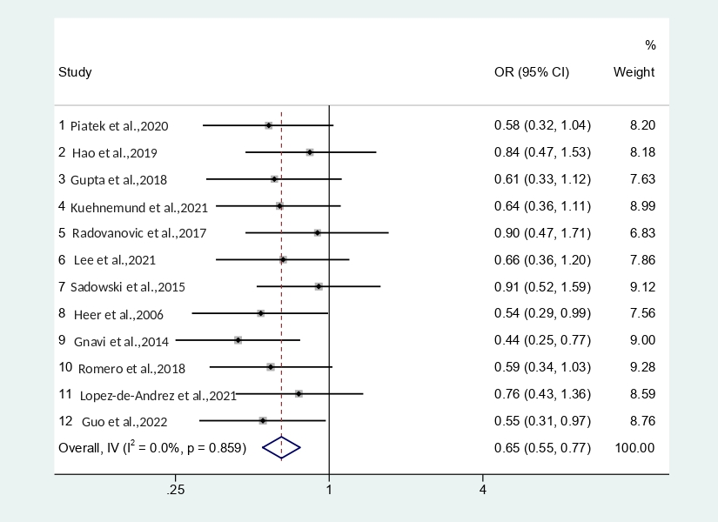

A total of 74,7% of women vs. 77,2% of men received beta blockers, and 79,04% of women were prescribed statins, compared to 81% of men (Figure 3,4).

Figure 3. Rates of beta blockers prescription in women vs. men with NSTEMI

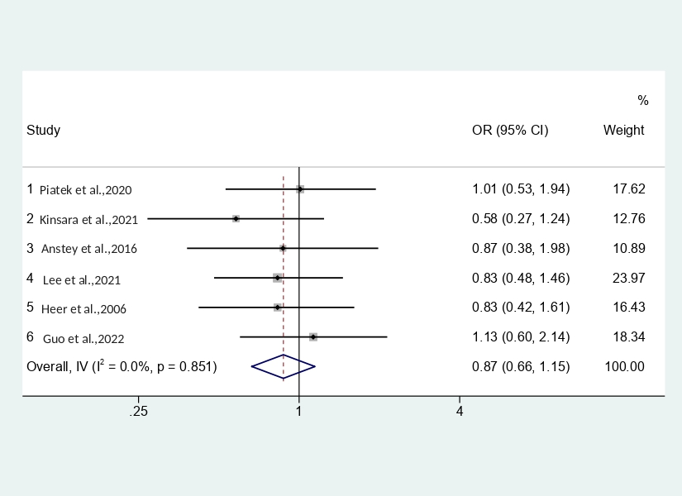

Figure 4. Rates of statins prescription in women vs. men with NSTEMI

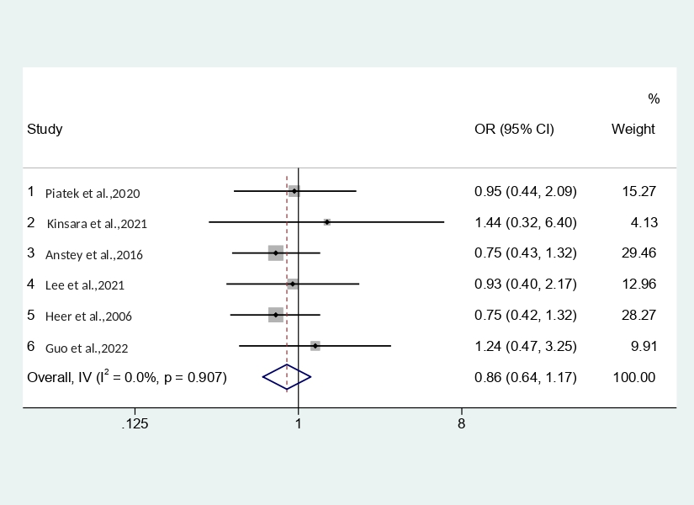

In the included studies, a total of 76,5% of women vs. 79,2% of men received antiplatelets (Figure 5).

Figure 5. Rates of antiplatelets prescription in women vs. men with NSTEMI

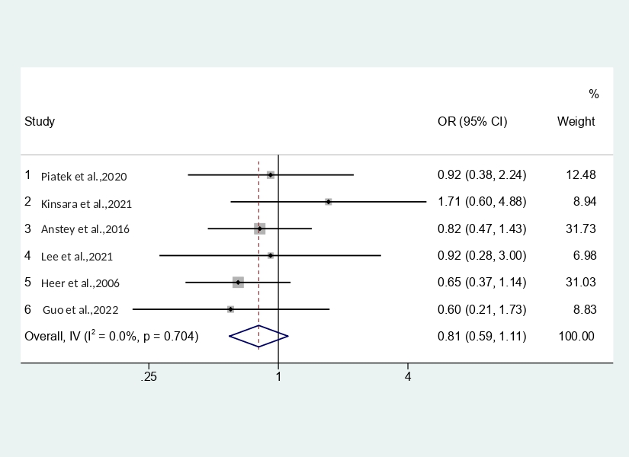

Finally, 64,5% of women and 66,4% of men were prescribed ACE inhibitors (Figure 6).

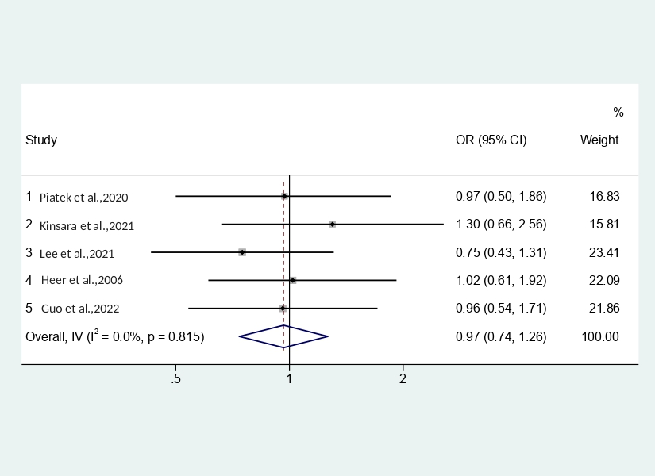

Figure 6. Rates of ACE inhibitors prescription in women vs. men with NSTEMI

The performance of PCI differed significantly across continents. The overall proportion of patients who received invasive treatment was notably higher in the USA and Europe, with more than 55% of people treated invasively, compared to generally 33% of PCI performance in Asia and the Middle East.

In the pooled analysis of extracted articles, the OR of women vs. men treated invasively was 0.65, 95% CI 0.55, 0.77, (I2= 0.0%), which suggests of significant under-performance of PCI in the female population with NSTEMI.

The prescription of evidence-based medicines in patients with NSTEMI also differed between genders. In the pooled analysis of 6 studies, women had lower odds of receiving antiplatelets OR 0.81, 95% CI 0.59, 1.11 (I2= 0.0%), beta-blockers 0.87, 95% CI 0.66, 1.15 (I2= 0.0%), and statins 0.86, 95% CI 0.64, 1.17, (I2= 0.0%). At the same time, there was no gender difference in the prescription of ACE inhibitors 0.97, 95% CI 0.74, 1.26.

Gender differences in the short-term all-cause mortality

Thirty extracted studies presented information on the incidence of all-cause mortality among male and female patients either in-hospital or during the following 30 days after the myocardial infarction. Among them, 27 articles reported data on unadjusted mortality and 12 studies on adjusted mortality. Pooled analysis of the studies that presented raw outcomes showed that female patients with NSTEMI had higher risks of unadjusted short-term mortality compared to male patients: OR 1.19, 95% CI 1.17, 1.21 (I2= 39.8%) (Figure 7). The heterogeneity was considered moderate and the obtained results stable and credible.

However, in the pooled analysis of adjusted outcomes, women with NSTEMI did not prove to have worse short-term survival compared to men. The pooled adjusted OR was 0.92, 95% CI 0.91, 0.93 (Figure 8). As the heterogeneity was considered high (>70%), a subgroup analysis was performed to identify the source of heterogeneity. The studies were analyzed by design (retrospective studies vs. observational studies and RCTs), by the year of publication (published before and after 2010), and the region. However, the source of heterogeneity could not be identified; hence the random effects model was used. Sensitivity analysis confirmed that the results were stable and credible.

Figure 7. Unadjusted short-term mortality in women vs. men with NSTEMI

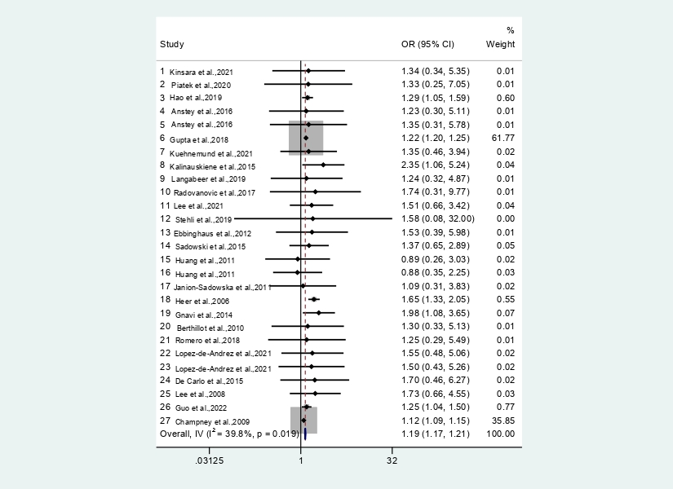

Figure 8. Adjusted short-term mortality in women vs. men with NSTEMI

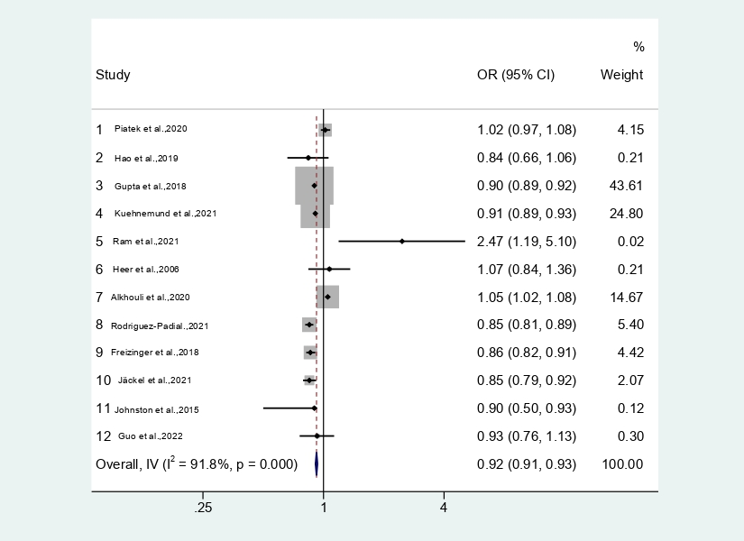

Finally, the pooled analysis of 4 studies showed that women had approximately 30% higher risk of bleeding complications during 30 days following the NSTEMI: 1.52, 95% CI 0.79, 2.91, (I2=0) (Figure 9). The heterogeneity was low and the results were considered reliable.

Figure 9. Rates of bleeding complications in women vs. men with NSTEMI

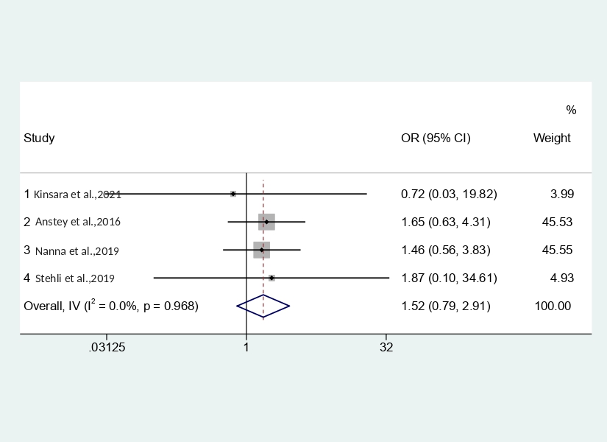

In this section, the statistical analysis of gender differences in the treatment and short-term outcomes (bleeding and all-cause mortality) of patients with non-ST-elevation myocardial infarction has been presented. Considering that most studies, included in the meta-analysis, did not provide information about the factors that impact the differences in management and outcomes of patients with NSTEMI, the next chapter will involve some additional studies (quantitative and qualitative) that discuss the impact of treatment delays, myocardial infarction symptom and diagnostic patterns, CVD awareness, and the role of social determinants of health (education, income, culture, religion, ethnicity) in the prognosis of women with CVD.

**Chapter 4**

**Discussion**

This systematic review and meta-analysis revealed that female patients with non-ST-segment elevation myocardial infarction have notably worse short-term mortality (in-hospital/30-day) as compared to their male counterparts. They also demonstrate a higher incidence of major bleeding following the myocardial infarction. Female patients with NSTEMI are much less often treated invasively than male patients and they are less often prescribed guideline-recommended medications, such as beta-blockers, antiplatelets, and statins. In this section, the possible reasons of such gender disparities will be discussed, and potential solutions to this problem will be provided.

Delays in the treatment of myocardial infarction

First, and one of the most critical aspects that are highly likely to impact the prognosis of patients with myocardial infarction is time to treatment. Evidence suggests that women with acute cardiac ischemia are more likely to experience a delay in time to treatment at both pre-hospital and in-hospital levels (9). This results in exceeding recommended time frames for reperfusion, longer total ischemic time, and higher chances of irreversible myocardial necrosis. Numerous studies indicate that a longer time to treatment substantially correlates with larger mortality (18).

Hudson et al. analysed the data of a randomized-controlled trial, APEX-AMI, that involved 5745 patients with acute myocardial infarction (19). In their work, the short-term and long-term prognosis of patients according to the degree of treatment delay. According to the obtained results, exceeding the recommended symptom-to-balloon (STB) and door-to-balloon (DTB) time frames was associated with higher 30-day and 90-day mortality after hospital discharge (19). More precisely, if an STB time was longer than the recommended 180 minutes but did not exceed 5 hours, the mortality of patients was 4,2%. If an STB time was longer than 5 hours, the risk of death in patients with acute myocardial infarction increased to 6,5% (p<0.0001). A significant correlation has also been observed between DTB time and mortality. If a time interval from the patient's hospitalization to the reperfusion exceeded the recommended 90 minutes frame by 30 minutes, mortality increased by 4,6%. If DTB time was more than 120 minutes, the risk of death grew up to 5,3% (p<0.007) (19).

Finally, and most importantly, according to this study, the female gender was associated with exceeding the recommended time frames for reperfusion. For example, only 42,1% of women with acute myocardial infarction received a PCI in less than 90 minutes since the time of hospitalization versus 47,5% of women who received delayed reperfusion (p<0.003) (19).

Guerchicoff et al. analyzed the results of a randomized controlled trial, INFUSE-AMI, that included patients with AMI who received PCI within 5 hours after the symptom onset and received abciximab vs. Placebo (20). The outcome of interest was the size of the myocardial necrosis according to the results of cardiac MRI. This study showed that treatment delay positively correlated with a bigger zone of affected myocardium and higher one-year mortality following the event (4% vs. 9,2%, p=0.02) (20). At the same time, more women than men received the treatment later than recommended (20).

Gibler et al. analyzed the data of patients involved in multinational, randomized trials GUSTO-I (n=41 021) and GUSTO-III (n=15 060) (21). In this study, pre-hospital delays were analyzed. According to the results, more women than men received delayed treatment (35% vs. 27%, р=0.001). Older age and diabetes were independently associated with patient delays in hospitalization. In turn, medical insurance, higher education, and professional occupation were associated with timely emergency calls (21).

Having retrospectively analysed the randomized controlled trial IMMEDIATE, Sullivan et al. reported that female patients much later call the emergency than male patients after the onset of symptoms of acute coronary syndrome (73 min vs. 45 min., p<0.01) (22). Apart from this, the DTB time was generally also longer in women (106.5 vs. 90.5 min, p=0.01) (22). The study also showed that delays at the patient level were caused by the lack of awareness about the possible clinical signs and symptoms of acute myocardial infarction (22). A significant proportion of female patients did not consider themselves at risk of heart disease (22).

Delayed treatment in female patients with acute coronary syndrome is a central concern nowadays. Despite all advances in cardiovascular care, women still experience significant pre- and in-hospital delays. This issue is immensely complex and multifaceted as it embraces a multitude of biological, psychological, and socio-economic determinants that often intersect with each other. These aspects will be discussed in the following sections.

Gender differences in the сlinical presentation of myocardial infarction symptoms

Existing evidence suggests that the symptom patterns of acute coronary ischemia vary significantly in female patients, while in men, they are almost always relatively straightforward. As is known, the most typical symptom of acute coronary syndrome is severe chest pain which is also often described as an intense pressure or squeezing sensation (23). The pain may also irradiate into the left arm or jaw (23).

However, apart from typical chest pain, women may experience multiple symptom clusters, which involve nausea, palpitations, extreme fatigue, and sweating (24). The localization of ischemic pain may also vary in females. Instead of the chest and left arm, the pain can be felt in the neck, stomach, and back (24).

An extensive meta-analysis performed by Oosterhout et al. provided a detailed overview of gender differences in the symptoms of acute myocardial ischemia (25). According to obtained results, women experience a "typical" chest pain less often than men (OR 0.70, 95% CI: 0.63–0.78) and more often have painful sensations in different localizations, such as neck (OR 1.83, 95% СІ: 1.60–2.10) and between shoulder blades (OR 2.15, 95% СІ: 1.95–2.37) (25). This study also reports that the female patients experience palpitations, nausea, and vomiting much more often than male patients: (OR 1.80, 95% СІ: 1.44–2.26) and (OR 1.64, 95% СІ: 1.48–1.82) respectively (25).

Finally, there is a proportion of women that present without chest pain with nausea or palpitations as the only symptom or even with no symptoms at all (26). In this case, it is particularly challenging to spot the myocardial infarction both for patients and clinicians. This pattern is most common in females with concomitant diabetes mellitus or frail patients.

As it can be seen, the symptom picture of myocardial infarction in the female patient is complicated and can be easily mistaken for fatigue, indigestion, radicular syndrome, or anxiety. Failure of women to correctly link their symptoms to myocardial infarction is one of the reasons for severe patient delays. Therefore, it is vital to inform the female population about possible symptoms of the acute coronary syndrome, which can be done via online and offline public health campaigns.

Laboratory and instrumental diagnosis of myocardial infarction

Existing evidence suggests that the laboratory and instrumental diagnosis in female patients is often more challenging compared to male patients. For example, the analysis of data from the prospective cohort study of patients with acute myocardial infarction, conducted by Gupta et al., showed that the ECG patterns in men and women with similar diagnoses differ, and it is much harder to perform topical diagnostics in the female patients (27). It was also mentioned that the unclear ECG results and the absence of pre-hospital ECG were positive predictors of delays in hospitalization (27). Barrabés et al. reported that the magnitude of ST-segment elevation was lower in women compared to men in their study (28). In patients with NSTEMI, negative T-waves were more often noted in women, which might sometimes complicate the differential diagnosis between NSTEMI and unstable angina (28).

Apart from unclear ECG pictures in women with myocardial infarction, there are some challenges in laboratory diagnostics as well. An extensive randomized-controlled trial, High-STEACS that was performed across ten hospitals in Scotland aimed to estimate the impact of using a high-sensitivity cardiac troponin I assay with sex-specific diagnostic thresholds, instead of the previously used alternative troponin test, in patients with suspected acute myocardial infarction (29). This study involved 48 272 patients, among which 47% were women. According to the obtained results, using a high-sensitivity assay with sex-specific thresholds enabled the identification of myocardial infarction additionally in 42% of women and 6% of men. In other words, this approach was highly gender-specific and identified five times more cases of myocardial infarction in women as compared to men (29). This study showed that if standard troponin tests are used, many women with myocardial infarction remain underdiagnosed, which is not the case in men.

Awareness of the cardiovascular disease

As it can be seen, the clinical presentation of myocardial infarction differs between genders. The multifaceted symptom patterns, along with difficulties in the clinical diagnostics, put the female patients at a disadvantage and may partly account for the reason why female patients are treated later than males. At the same time, these are not the only reasons for treatment delays- the roots of this problem run deep.

Davis et al. conducted interviews with the female survivors after the ACS and asked them to talk about their experiences. It was a very insightful qualitative study investigating different behavioural patterns of women having symptoms of myocardial infarction (30). The participants were divided into two groups: the "evolving myocardial infarction group," who experienced uncertainty about the symptoms of the disease, and the "immediately recognizable myocardial infarction group," which included women who had more explicit symptom pictures and labeled their symptoms early (30).

The first group of female patients described their symptoms variously. Some of them said they "suddenly started coughing a lot," "had the burning in the throat," or simply "just kinda felt strange" (30). The women in this group were using over-the-counter medication to find relief, discussed symptoms with their family or friends, and returned to their daily activities when they failed to recognize the symptoms (30). As their physical state continued to worsen, they finally sought medical help, but usually, someone else made this decision for them (30). In the larger social context, having somebody insist that they should seek medical care was not only helping to recognize that something was wrong with their body; most women perceived that as permission to leave their daily duties and obligations, as a decision that was made for them (30).

The female participants in the "immediately recognizable myocardial infarction group" presented with severe and abrupt chest pain as their main symptom and were able to label it as myocardial infarction correctly (30). At the same time, women tended to hide the true severity of their symptoms because they "did not want to make a big deal of it," "did not want to scare children," and "did not want to draw attention" (30). Despite knowing that hospitalization is inevitable, most women delayed as they were taking care of personal matters, which they felt they should do, e.g., showering, packing, finishing house/work duties, and preparing others for their departure (30). It took hours for some women to finally get to the hospital. Another important aspect is that the female patients preferred going to the hospital with their family members instead of being transported by ambulance (30). Some of them waited until there was a mutually convenient time for their children and husbands to take time off work and accompany them (30).

As it can be seen, unclear symptom picture in female patients with ACS is only a part of the problem. The more concerning issue nowadays is the lack of awareness about cardiovascular disease and the significant underestimation of risks among the female population. Despite some obvious progress in the public acknowledgment of CVD, a substantial gap in actual and perceived risk of CVD persists.

Evidence suggests that a significant proportion of women still mistakenly believe this is the disease of men or the elderly. Medical professionals dealing with female patients with myocardial infarction say that women are more probable to call the emergency for their male family members than for themselves (31).

In the study of Mosca et al., only half of women correctly named CVD as a leading cause of death in the female population, while more than half of questioned women cited cancer as the main killer (5). A qualitative study by Gooding et al. showed even more alarming results according to which only 10% of young women mentioned cardiovascular disease as the primary mortality cause in the female population, and more than 38% of young women said they were not concerned about CVD as they did not think they were at risk (34). Misperceptions of "gender" and "age" of heart disease, as well as social norms, were key factors of low CVD awareness (34). Thirty-five women at age 15-24 years that were surveyed in this study believed that heart disease was predominantly a disease of men ("I usually hear more about men suffering from heart problems than women") and older people ("I feel like those are things I associate with older people like 40") (34).

Existing evidence reports a significant ethnic gap, with black and Hispanic women having less knowledge of heart disease than white women (5). Low education levels, young age, lack of access to medical care, and being overweight also correlated with insufficient awareness of CVD in many studies (35).

The misconception about the "male gender" of heart disease must be addressed as soon as possible, and public health awareness campaigns introduced. It is important to note that the awareness of symptoms and risks of myocardial infarction in women has to be raised among doctors as well. Evidence indicates that physicians tend to underestimate the probability of ACS in female patients, especially young premenopausal women (32). For example, chest pain is more often considered a benign symptom in female rather than male patients (32). In the study of Liaudat et al., women had three times lower probability of being referred for further investigation to the cardiology department when presenting with chest pain in primary care compared to men, and this difference was not due to lower risk profiles or severity of symptoms (33). Finally, according to Mosca et al., relatively few women said they have ever had a discussion about heart disease prevention with their doctors (5).

To create and implement successful policies to tackle treatment delays in women at the patient level, a deep understanding of the psychological and social background of female behaviour is needed. It is in the female nature to take care of their children and partner, so when the symptoms occur, they do not wish to make their loved ones worry. Apart from that, modern women carry a lot of everyday duties: work, household, and childcare, which they feel they can not leave even in case of disease. They often need someone to push them to seek medical attention. Therefore, the role of partners and children is vital.

Raising awareness about CVD in women, providing widely accessible information about CVD prevention, possible symptoms of a heart attack in female patients, and the importance of timely treatment is also crucial.

Finally, raising physicians' awareness of myocardial infarction in women and improving the diagnostic algorithms in clinical practice is highly likely to decrease the extent of treatment delays at the hospital level and result in better treatment outcomes.

Gender differences in the management of NSTEMI

According to existing guidelines, all high-risk patients with NSTEMI should receive cardiac catheterization within 12-24 hours after hospital admission, with IB recommendation that both genders must be treated in the same way (6). Despite this, a significant gender gap in the treatment of NSTEMI persists. According to existing evidence, female patients not always receive guideline-recommended treatment when they need it.

In this meta-analysis, the female population with NSTEMI had significantly lower rates of percutaneous coronary intervention (PCI) compared to their male counterparts (up to 35%). Women were also less often prescribed evidence-based medicines, but the gender difference was not as significant. The findings of some included studies will be discussed further in more detail.

Gupta et al. performed an extensive analysis of data from National Inpatient Sample databases in the USA (2003-2014) with a total of 4 765 739 patients with NSTEMI 2 026 285 (42.5%) of which were women (36). In this study, among patients assigned to early invasive treatment, the proportion of female patients was much lower (64.1% versus 74.6%) (36). After adjustment for multiple covariates, the female sex remained an independent predictor of underperformance of PCI. Important to mention that age-stratified analysis showed a positive correlation between the age of women and the rate of PCIs, which suggests that younger women were at the highest risk of not receiving invasive treatment and older women at the lowest (36).

Piatek et al. performed a retrospective cohort study analysis of patient data from the Polish Registry of Acute Coronary Syndromes (PL-ACS), which covered 463 hospitals with a total of 66,667 patients (37). According to obtained results, women less often received invasive treatment of NSTEMI compared to similar-risk men (59.6% vs. 66.1% in men; p < 0.0001) (37). The gender gap in PCI utilization was particularly noticeable in patients younger than 55 years old (59.6% in women vs. 71.9 % in men; p < 0.0001) (37). The general rates of PCI were lower in patients older than 75 years old (37).

Negative trends regarding evidence-based treatment in women with NSTEMI were observed not only in Europe and the USA but also in Asia. In their study, Lee et al. presented data from a multi-center, observational prospective registry of patients with ACS (i.e., STEMI, NSTEMI, and UA) (38). In the selected cohort, women with STEMI and NSTEMI were less likely to be prescribed beta-blockers, ACE-Is, and statins (38). Instead, they were more likely to receive other medication which was not directly relevant to myocardial infarction: diuretics, insulin, and oral hypoglycaemic agents (38).

Female patients with NSTEMI were less likely to undergo coronary angiography (28% vs. 37%, p< 0.001) and PCI (16.43% vs. 21.55%, p<0.001) compared to their male counterparts (38).

Gender differences in the management of NSTEMI were also reported by Heer et al. (39). Within the first 48 hours after the symptom onset, PCI was performed in 24.5% of women and 37.6% of men. Adjusting for age slightly reduced the difference between genders but not significantly (39). Further adjustment for baseline characteristics in the multiple logistic regression model did not eliminate the gender gap in the utilization of PCI (OR 0.72, 95% CI 0.64 to 0.81) (39). In this study, women were also less likely to receive antiplatelet and anticoagulant medications, such as clopidogrel (0.77, 95% CI 0.69 to 0.86), glycoprotein IIb/IIIa antagonists (0.80, 95% CI 0.71 to 0.90), and unfractionated heparin (70.3% of women and 75.1% of men) (39). The gender difference persisted even after adjustment for multiple covariates (39).

In the univariate analysis, the prescription rates of beta blockers and statins differed between genders (with a negative tendency for female patients). However, the gender difference was attenuated in the multiple logistic regression model (39).

As it can be seen, female patients are at risk of not receiving guideline-recommended invasive treatment of NSTEMI even if there are no contraindications to the procedure. At the same time, it has been reported that a non-performance of PCI is strongly associated with worse event-free survival of patients (41). Conversely, timely revascularization improves the prognosis of patients, both male, and female (42). Better outcomes after PCI have been observed even in elderly patients. Data from the Italian Elderly ACS Study, FAST-MI Registry, and EXAMINATION trial suggests that patients undergoing revascularization had lower short- and long-term mortality rates compared to patients who only received conservative treatment (43).

Identifying the gender gap in the evidence-based treatment of myocardial infarction is crucial. At the same time, even more important is to determine the reasons for such disparities. It is not yet clear why women still do not receive proper treatment when they need it despite all advances in cardiovascular care.

Guo et al. analysed potential factors influencing the utilization of invasive strategy (44). In their study, a significant correlation between the performance of PCI and high mini-GRACE risk scores was found (44). Women with higher scores were less often referred to coronarography and stenting compared to men with similar risk scores (44).

There is a great number of other reasons that are highly likely to impact the frequency of PCI in female patients with NSTEMI. First of all, women wait longer to call the emergency in case of symptoms than men and experience significant delays in time to treatment. This results in exceeding the recommended time frames for reperfusion and makes female patients ineligible for invasive treatment.

As is known, the best results can be achieved if the PCI is performed within 180 minutes since the onset of symptoms (symptom-to-balloon time) or within 90 minutes since the hospitalization (door-to-balloon time). However, it has been confirmed that women exceed these time corridors significantly more often than men. As Davis et al. revealed, some women wait not just a few more hours but days to finally seek medical attention (30). According to the clinical guidelines, revascularization should be performed within the first 12 hours since the beginning of symptoms (IA). The invasive treatment within 12-48 hours is still recommended in patients with persistent symptoms and relatively stable patients (but the strength of recommendation in this group is lower: IIaB). The PCI is not recommended if more than 48 hours have passed since the onset of symptoms and the patient is stable as the myocardial injury has already taken place and became irreversible.

Other important factors that may account for existing gender disparities in the management of myocardial infarction are older age and higher comorbidity in female patients, which may prevent physicians from more radical treatment strategies and make them choose conservative management instead (41). The unclear symptom patterns and difficulties in the laboratory/instrumental diagnosis in women with myocardial infarction often lead to false diagnoses and contribute to gender differences in management (41).

Some researchers mentioned implicit physician bias as an avoidable determinant of gender differences in the treatment of myocardial infarction. For example, Daugherty et al. reported that clinicians were more likely to identify coronarography as advantageous in male rather than female patients regardless of the estimated baseline risk of their patients (46). In addition, most medical professionals interviewed in the study perceived men as more resilient to risks inherent with invasive procedures (46).

Lastly, females, especially those of a younger age, are known to have non-obstructive CAD more frequently than males, with a high prevalence of coronary spasm and endothelial dysfunction. In such cases, PCI is not a method of choice (47).

However, apart from the abovementioned biological aspects of gender differences in myocardial infarction, socio-economic factors should also be considered. It can be argued that inequalities in social position, income, and levels of education significantly correlate with disparities in healthcare.

Matetic et al. analyzed the impact of socio-economic status on the management and outcomes of patients with myocardial infarction (40). A total of 6,603,709 cases were analyzed, and patients were stratified by median household income into four quartiles (from poorest to richest) (40). The logistic regression revealed the differences in the utilization of invasive treatment between the lowest and the highest median household income quartiles (40). The poorest patients were less likely to undergo coronary angiography (63.4% vs. 64.3%, p <0.001) and PCI (40.4% vs. 44.3%, p <0.001) compared to the wealthiest patients, which was associated with worse clinical outcomes (40).

Finally, it can be assumed that differences in health systems and healthcare functioning also play an important role in cardiovascular care performance. According to existing evidence, issues in the utilization of invasive treatment in patients with myocardial infarction exist even in high-income countries, where cardiovascular care is advanced, with a wide network of hospitals, cutting-edge technologies, and highly-qualified human resources (45).

Cram et al. conducted a retrospective cohort study across six high-income countries (United Kingdom, USA, Taiwan, Canada, Netherlands, and Israel) to analyze the treatment and outcomes of patients with myocardial infarction (both STEMI and NSTEMI) (45). These countries were selected as they all had advanced healthcare systems but differed in performance, financing, and organization; hence, the impact of these aspects could be well-investigated (45). The outcomes of interest were: the proportion of patients who received invasive treatment of myocardial infarction (PCI or CABG), the proportion of patients who died within 30 days or one year after hospitalization, and measures of healthcare efficiency (the frequency of readmissions, mean length of hospital stay) (45).

The results revealed notable disparities in the management of myocardial infarction across countries, indicative of underuse of PCI in the UK and overuse of CABG in the USA (45). Cram et al. suggest that differences in PCI performance could be explained by prioritization, maintenance, and funding of primary PCI programmes in Canada, Israel, and the US and the absence of such in the UK and the Netherlands (45). In turn, the higher utilization of CABG was attributed to a "permissive regulatory environment" in the USA, along with considerable Medicare reimbursement for this procedure (45). Finally, models of hospital payment (e.g., episode-based vs. global budgeting), physician payment (e.g., salaried vs. fee for service), and input costs (drugs and devices) might also account for differences in the management of patients with myocardial infarction (45).

Gender differences in short-term mortality of patients with NSTEMI

In this meta-analysis, women with confirmed NSTEMI had higher unadjusted odds of all-cause death during the hospital stay and over the following 30 days after the hospital discharge. However, the gender difference did not persist after adjustment for multiple covariates. In most studies, the multivariate model included age, TIMI risk scores, comorbidities (heart failure, DM, CAD, hypertension, renal failure, cerebrovascular disease), medical insurance, time to treatment and treatment strategy. Women also showed a much higher incidence of major bleeding complications compared to men, but the number of studies reporting this data was relatively small.

The difference in unadjusted (OR 1.19, 95% CI 1.17, 1.21) and adjusted (0.93, 95% CI 0.91, 0.93) mortality rates is a relevant point for further investigation. Basically, this suggests that the female gender itself is not an independent predictor of adverse outcomes, and there is a multitude of other factors that contribute to higher mortality in women.

To look at the bigger picture of gender gaps in heart disease and understand the reasons for them, two aspects of women's health should be considered: sex differences inherent to biological features of the female organism and gender disparities originating from the broader social, economic, community, and environmental factors.

Biological determinants

From a biological perspective, women have smaller coronary arteries, different thrombotic activity, and endothelial function. All of these factors might at some point impact the success of revascularization. For example, evidence suggests that due to specific features of coronary anatomy, female patients have a higher incidence of complications and higher rates of repeated revascularizations for target lesion or target vessel failure (48,49). Interestingly, a study by Hiteshi et al. showed that the diameter of coronary arteries does not depend on a body habitus or left ventricular mass but is solely a sex-specific feature of the female organism (50). Differences in hemostasis between male and female patients might also account for a higher incidence of bleeding complications (and, consequently, higher mortality) in women with acute ischemic events.

As is widely known, myocardial infarction strikes women on average ten years later than men, which is generally attributed to the cardioprotective effects of female sex hormones. It should not be taken as a rule, though, as emerging data reports more young women being diagnosed with myocardial infarction over the last decades (47). Besides, it has been proven that female patients with myocardial infarction younger than 65 years old have twice higher mortality and incidence of rehospitalization compared to male patients of similar age (47). A hazard to young women is most likely caused by a lack of CVD awareness, underestimation of myocardial infarction risks, delays in treatment, and misdiagnosis.

Female patients with myocardial infarction (including NSTEMI) have a higher prevalence of comorbid conditions, such as arterial hypertension, heart failure, and diabetes mellitus. Clustering of comorbidities in women is, undoubtedly, one of the reasons for the variety of complications and increased mortality. Besides, concomitant diseases, together with older age, impact the baseline risks of female patients, often preventing them from receiving the percutaneous coronary intervention or, especially, open heart surgery (i.e., CABG).

The impact of sex hormones, the unique pathophysiology of atherosclerosis, as well as many other biological factors potent to impact the prognosis of women with myocardial infarction are yet to be studied.

Most studies included in this meta-analysis cited atrial fibrillation, multivessel CAD, cardiogenic shock on admission, WBC count>11*109/L, anemia, severe renal failure, and blood glucose level >198 mg/dL. to have a significant impact on mortality of patients with NSTEMI, but whether this influence is gender-specific remains a relevant point to investigate.

Social determinants

The burden of heart disease in the female population is not just a medical issue, but it also involves a wide range of socio-economic, psychological, religious, cultural, ethnic, environmental and community, political, policy, and health systems factors on a local and global level.

Education

A significant body of evidence suggests that levels of education inversely correlate with mortality after myocardial infarction. In their large prospective study involving 53 hospitals in China, Huo et al. revealed that lower educational attainment (primary school or illiterate) was significantly associated with a higher incidence of adverse outcomes in the year after hospital discharge (60).

Low levels of education not only correlate with the risk of adverse outcomes after acute cardiovascular events but also with the risk of CVD itself. An extensive case-control study INTERHEART, that involved 262 medical centres in 52 low, middle and high-income countries showed that among all socio-economic determinants, low levels of education were most significantly associated with an increased hazard of myocardial infarction across the world (61).

Schultz et al. suggest that levels of education have a multifaceted impact on human health. First of all, people with low educational attainment usually have more CVD risk factors, such as smoking, obesity, hypodynamia, and bad diet. Secondly, general education has a direct influence on health literacy, which means that individuals in the lowest education cohorts are less likely to be aware of symptoms, risk factors, and prevention of various diseases as well as they are often non-compliant with prescribed medications or use them unproperly. Low educational attainment, which generally manifests in poor reading skills and insufficient understanding of medical matters, is highly likely to have an indirect impact on the risk of CVD de-novo as well as the prognosis of patients with diagnosed ischemic heart disease. People with low education levels represent a vulnerable group at significantly higher risk of harm from medication use compared with sufficiently educated individuals. This should be taken into account in health policymaking, especially when choosing the population groups to target.

Income and employment

Income and employment have been cited as one of the most impactful determinants of the risk of heart disease, quality of medical care, and outcomes of patients. Raparelli et al. conducted a cohort study of patients with acute myocardial infarction to evaluate the quality of in-hospital and outpatient care in the USA and Canada (51). The multivariate analysis showed that social determinants of health (SDOH) that reflected the vulnerability of an individual were associated with lower quality of cardiovascular care both in-hospital and outpatient (51). Among all SDOH, unemployment most significantly correlated with low-quality health services (51).

Employment issues of individuals seeking care for myocardial infarction impact not only the quality of health services provided but also the long-term outcomes of these patients. For instance, László et al. analyzed non-fatal myocardial infarction cases from Stockholm Heart Epidemiology Program (52). According to obtained results, job insecurity was the strongest predictor of cardiac mortality and repeated myocardial infarction during the observation period (52).

Indeed, being unemployed often makes people feel stigmatized, not to mention severe difficulties with money unemployment is usually inherent in. This can be a significant stress factor that impacts one's psychological and, as a result, cardiovascular health. Besides, in the countries with no universal healthcare, people who are employed have better access to quality healthcare via social or private insurance.

Apart from employment itself, income disparities, in general, have a critical impact on the cardiovascular health and the survival of patients. The analysis of one of the largest databases of hospital inpatient stays in the US, National Inpatient Sample (NIS), performed by Patlolla et al., showed that people in the lowest income quartile most often had "do-not-resuscitate" status and lower rates of palliative care consultations compared to higher quartiles (53). Participants with low income also had reduced mechanical circulatory support device implantation rates and higher in-hospital mortality (53). The rates of coronary revascularization are also lower in patients with low-income levels, which was confirmed in the Women's Health Initiative Study (54).

One of the suggested reasons for such disparity is the perception that low-income patients will be less likely to follow the critical post-PCI medical therapy (antiplatelets, beta-blockers, statins) (55). Low-income patients were also less often offered more expensive treatments (like drug-eluting stent implantation) as they were perceived as such who could not afford it (55).

Even in countries with universal healthcare (e.g., France and Taiwan), inequalities in access to primary care and the rates of coronary revascularization between low- and high-income areas persist (56, 57). The mortality of patients with myocardial infarction was also reported higher in the low-income cohorts (56, 57).

It can be assumed that people with lower income levels are more predisposed to bad habits, which may impact long-term mortality after the myocardial infarction episode. However, a comprehensive analysis of population-based data from Finland and the US, performed by Kucharska-Newton et al., showed that people in low-income cohorts had higher risks of repeated myocardial infarction and sudden cardiac death even after adjustment for alcohol consumption and smoking (58).

As is known, females constitute the largest proportion of the population living in poverty and are, therefore, disproportionately affected by inequalities in access to medical care, distribution of wealth, income, and other factors that impact the overall health and quality of life (59). According to WISE study, women in the low-income cohort were less likely to have medical insurance than women in the high-income cohort. Besides, they had higher out-of-pocket costs and higher rates of rehospitalization.

The role of socioeconomic status was discussed in a qualitative study by Gooding et al. (34). In their interviews, most female participants mentioned the connection between health and money ("We gotta pay more to be healthy") (34). High income has been cited not only as a determinant of a better quality of cardiovascular care but also as a healthy lifestyle (34). Most interviewed women linked income to a healthy diet, access to community resources, and gym utilization ("Income plays a big role in health (34). I've read many studies about how people of color are more obese than white people in suburban areas") (34). Considering that women generally have lower income than men, they more often struggle to fund gym, swimming pool, maintain a healthy organic diet as well as other healthy lifestyle activities that usually require investments; not to mention such basic but vital benefits as medical insurance and safe accommodation which women are often unable to provide for themselves.

Culture, religion, and ethnicity

Culture, race, and ethnicity have an undeniable impact not only on the genetic predisposition to CVD but also on the lifestyle of individuals and their behaviours, the role of which is not less significant. The prevalence of CVD varies substantially across cultures and nationalities, with a multitude of factors contributing to such variation. In their work, Winkleby et al. investigated the impact of ethnicity and socioeconomic factors on the hazard of CVD (65). According to obtained results, ethnic minority women exhibited more CVD risk factors and, consequently, suffered a higher burden of heart disease compared to white women (65). As an initial hypothesis, it was assumed that such differences were attributed to higher levels of deprivation, lower income, and education levels (65). However, even after adjustment for age and SES, black and Mexican American women had significantly higher BMI, physical inactivity, and blood pressure than white women (65). Moreover, in this study, groups of white, African American, and Mexican American women with similarly low SES were compared, which confirmed a strong influence of ethnicity on the risk of CVD (65).

Dietary patterns and bad habits were cited as one of the most crucial determinants of ethnic disparities in CVD that should be considered when launching CVD prevention campaigns. According to Chaturvedi et al., an emphasis on smoking cessation might be less relevant in South Asian women who do not smoke much, while significant effort should be put into tackling the high consumption of ghee in this ethnic population (66). As is known, some cuisines, such as the Mediterranean, are quite beneficial for cardiovascular health while others (e.g., American) are not. The popularization of healthy alternative recipes tailored to various ethnic cuisines might be a valid public health intervention to decrease the burden of CVD in the multi-ethnic population.

Cultural and religious norms also impact the lives of individuals to a great extent, determining their lifestyle choices and behaviours. For instance, Islam prohibits alcohol and pork ingestion, both of which have detrimental effects on cardiovascular health (67). Hinduism promotes a sattvic diet that mainly consists of fruits, nuts, seeds, dairy products, ripe vegetables, whole grains, and non-animal-based proteins (68). Sikhism prohibits smoking, alcohol use, and encourages yoga and meditation (69).

A significant body of evidence report found a relationship between religious affiliation and risk of CVD (70,71). Religious individuals were significantly more likely to have good health habits and fewer cardiovascular risk actors, such as smoking, alcohol overuse, and for some religions- lower stress levels (70). Such tendency was observed across countries (70,71). On the other hand, the religion of certain patients may impact their decisions regarding treatment and not always in a safe way. For example, the spiritual beliefs of some people make them refuse blood transfusions even in critical situations, which is a real challenge for healthcare professionals.

Another important point to reflect on, which directly applies to the female population, is the role of culture and religion in the ability of women to make independent decisions about their health and bodies. Studies that would investigate the female decision-making autonomy across cultures are scarce, so this subject requires further investigation.

Implementing religion and culture-specific treatment strategies is highly likely to enhance patient-doctor communication and trust and build a framework for patient-centered medical care. Behavioral interventions targeting religion-specific lifestyle choices and decision-making factors regarding preventive and in-hospital treatment are vital in tackling CVD in vulnerable patient groups.

Community and environment

It has been proven that cardiovascular health is significantly affected by the neighbourhood an individual lives in (62). According to existing evidence, residing in disadvantaged areas independently correlates with higher risks of CVD, even after adjusting for such potential confounders as income, education, and employment status. First of all, poor neighbourhoods do not offer the same number of green spaces and recreational zones as more privileged areas. The transportation network and availability of medical resources are often limited in deprived areas. This has often been cited as “geographic maldistribution” of healthcare services. Secondly, there is a number of social attributes that impact the health of citizens, such as crime and safety, community support and cohesion, and healthy lifestyle promotion. In the study of Remigio-Baker et al., living in poorly-rated neighbourhoods (according to the infrastructure facilities, aesthetics, availability of essential services, and community support) was often associated with depressive and eating disorders (62). Access to healthy food is also an issue in disadvantaged communities. It has been proven that low-income neighbourhoods have fewer food markets offering fresh fruits, vegetables, and seafood (62). At the same time, deprived areas have a significantly higher number of fast-food cafes and bistros.

Unhealthy behaviours are also more common in deprived neighbourhoods. Sundquist et al. suggest that the prevalence of smoking, alcohol overuse, and adynamia is significantly higher in disadvantaged areas (64). Considering that these factors are among the most critical lifestyle determinants of CVD, the prevalence of this disease in low-income communities is understandable.

Another important point to consider is gender and environmental injustice. As is known, the female population carries an inequitable burden of environmental harm and is less likely to avoid environmental issues than the male population (63). When living in deprived areas, women are much more predisposed to its detrimental effects. For instance, due to the nature of generally accepted female duties, i.e., doing laundry (hand washing in rivers/ponds), cooking (often with the use of solid fuel cookers), cleaning (using cheap and harmful detergents), women are subject to indoor air pollution and more tangibly experience the harms of water contamination (63). Unlike men, women are more likely to stick to the household and are less likely to leave the neighbourhood in the pursuit of job opportunities and are, therefore, less able to avoid extreme climate conditions and environmental harms in some areas (63). It has also been proven that in poor households, women more often make food sacrifices and are less likely to drive a car, using public transport instead (63). Being generally poorer than men, women are more likely to live in damp and badly insulated accommodations and often do not have money to transform their homes to reduce the impact of heatwaves or extreme colds (63). All of these aspects impact the CVD burden in the female population as well as the event-free survival of women recovering after acute ischemic events.

Female-specific risk factors of CVD

As has been discovered, despite males and females sharing some traditional risk factors of CVD, such as smoking, obesity, lack of exercise, and dyslipidemia, there is a number of gender-specific risk factors that are only relevant in female patients (72). As is known, the female organism undergoes a series of transformations during the life cycle that does not happen in men: menstruation, pregnancy, and menopause. It has been proven that complex biological, physiological, and hormonal changes that take place in the female body during the transition from one cycle to another have a tangible impact on cardiovascular health (72,73). Pregnancy, for instance, can be considered as a сertain kind of “crush-test” for the female cardiovascular system. A growing body of evidence suggests that pregnancy complications, such as gestational diabetes, hypertensive disorders, preterm delivery, and placental abruption, significantly increase the risk of future cardiovascular disease (73). Similarly, the incidence of cardiovascular events rises dramatically in women with the beginning of menopause (74).

Apart from that, there is a number of female-specific lifestyle factors that might contribute to the risks of CVD. For example, the use of combined oral contraceptives (COCs) is associated with 2-fold to 4-fold increased risks of arterial and venous thromboembolism (75). Furthermore, using COCs by women who smoke is related to a 10-fold risk of myocardial infarction (75).

Some authors also indicate that the relative importance of traditional CVD risk factors differs between genders. For instance, the detrimental effect of smoking is much greater in women than men, especially in individuals over 50 years old (72).

All of these aspects should be considered when planning public health interventions aimed at reducing the burden of CVD in the female population.

**Limitations**

Although the overall results were considered reliable, there are some limitations of this meta-analysis. First of all, the included studies were conducted in different countries, so there might be variations in socio-economic factors, health systems, and standards of care that may have influenced the results. Second, despite heterogeneity being generally low to moderate in most pooled analyses, high heterogeneity was detected when pooling the adjusted odds ratios of short-term mortality in patients with NSTEMI, so the random effects model was applied. Finally, the number of women was significantly lower in most of the studies, which might have been a reason for some inaccuracy of the results.

**Novelty and implications**

Firstly, as far as is known, there has been no systematic review and meta-analysis that would investigate the gender differences in the clinical presentation, treatment, and outcomes of patients with NSTEMI. Wang et al. conducted a meta-analysis of gender differences in patients with non-ST-segment elevation ACS, but it pooled data of patients with both unstable angina and NSTEMI, which, despite some similarities, are still entirely different diagnoses.

Secondly, in this meta-analysis, raw and adjusted odds ratios were analyzed separately, which enabled a better investigation of the credibility of the female gender as an independent predictor of adverse outcomes vs. other factors.

Finally, this research work combined statistical data analysis and the following analysis of qualitative studies. Such approach enabled statistical processing of data regarding the frequency of invasive treatment and gender differences in all-cause short-term mortality of patients with NSTEMI, while the analysis of qualitative data yielded insight into the reasons for these differences. As a result, a more complex view of the problem of gender gaps in CVD has been provided.

**Conclusions**

Significant gender differences exist in the clinical presentation, treatment, and outcomes of patients with non-ST-segment elevation myocardial infarction. According to the results obtained in this meta-analysis, female patients with NSTEMI significantly less often receive timely guideline-recommended invasive treatment of myocardial infarction as compared to their male counterparts. The pooled analysis of 12 studies showed that female patients had almost 40% lower chances of being referred to percutaneous coronary intervention (PCI) than men. The prescription of beta blockers, antiplatelets, and statins was also slightly lower in women compared to men with NSTEMI, but no such difference has been observed for ACE inhibitors. In the pooled analysis of 30 studies, women demonstrated higher unadjusted short-term all-cause mortality than men. However, after adjustment for multiple covariates, the gender difference in all-cause mortality was attenuated in most included studies. The female patients with NSTEMI still had significantly higher chances of major bleeding complications, but since the number of studies reporting this data was relatively small, this subject should be investigated further with larger samples.

There is a multitude of biological, socio-economic, environmental, and community factors that impact the survival of women with NSTEMI, as well as the burden of CVD in the general population. According to existing evidence, low education levels, low income, and unemployment substantially increase the probability of CVD and the risk of death in women with already diagnosed myocardial infarction. Besides, most included studies reported significant delays in hospitalization among women with symptoms indicative of myocardial infarction both on patient and physician levels. Most researchers believe the delayed cardiovascular care can be attributed to a significant lack of awareness about heart disease in women as well as female-specific symptom patterns of the acute coronary syndrome, which are often unclear and pose a diagnostic challenge for both patients and doctors. Delays in hospitalization have a tangible impact on the outcomes of patients and the choice of the treatment strategy.

Among all included studies, the female population constituted approximately one-third of the total patient sample. Underrepresentation of women in clinical research is a concerning issue as it may directly impact the relevance and credibility of existing treatment guidelines for female patients.

Bridging the existing gender gaps in heart disease requires a multifaceted and collaborative approach that would focus on identifying the most vulnerable female patient groups, reducing delays in hospitalization among women with myocardial infarction, and raising patient and physician awareness about heart disease in females. Particular emphasis should be put on improving the diagnostic pathways and treatment strategies of female patients with myocardial infarction taking into account all gender-specific aspects.

Finally, targeting social determinants of cardiovascular health in women, i.e., improving levels of female education and health literacy, enhancing living conditions, infrastructure, and access to healthy food products in poor neighbourhoods, tackling poverty and unemployment requires a joint effort of the governments, NGOs, businesses, civil society, and other stakeholders, and is vital in addressing the burden of CVD.

**References**

1. Polewczyk A, Janion M, Polewczyk M. Acute Coronary Syndromes in Women-Gender Specific Changes in Coronarography. 2013.

2. Taqueti VR. Sex Differences in the Coronary System. Adv Exp Med Biol. 2018;1065:257-78.

3. Zhang Y. Cardiovascular diseases in American women. Nutr Metab Cardiovasc Dis. 2010;20(6):386-93.

4. Virani SS, Alonso A, Aparicio HJ, Benjamin EJ, Bittencourt MS, Callaway CW, et al. Heart Disease and Stroke Statistics-2021 Update: A Report From the American Heart Association. Circulation. 2021;143(8):e254-e743.

5. Mosca L, Hammond G, Mochari-Greenberger H, Towfighi A, Albert MA. Fifteen-year trends in awareness of heart disease in women: results of a 2012 American Heart Association national survey. Circulation. 2013;127(11):1254-63, e1-29.

6. Chieffo A, Buchanan GL, Mauri F, Mehilli J, Vaquerizo B, Moynagh A, et al. ACS and STEMI treatment: gender-related issues. EuroIntervention. 2012;8 Suppl P:P27-35.

7. Shehab A, Al-Dabbagh B, AlHabib KF, Alsheikh-Ali AA, Almahmeed W, Sulaiman K, et al. Gender disparities in the presentation, management and outcomes of acute coronary syndrome patients: data from the 2nd Gulf Registry of Acute Coronary Events (Gulf RACE-2). PLoS One. 2013;8(2):e55508.

8. Alfredsson J, Stenestrand U, Wallentin L, Swahn E. Gender differences in management and outcome in non-ST-elevation acute coronary syndrome. Heart. 2007;93(11):1357-62.

9. Toyota T, Furukawa Y, Ehara N, Funakoshi S, Morimoto T, Kaji S, et al. Sex-based differences in clinical practice and outcomes for Japanese patients with acute myocardial infarction undergoing primary percutaneous coronary intervention. Circ J. 2013;77(6):1508-17.

10. Numasawa Y, Inohara T, Ishii H, Kuno T, Kodaira M, Kohsaka S, et al. Comparison of Outcomes of Women Versus Men With Non-ST-elevation Acute Coronary Syndromes Undergoing Percutaneous Coronary Intervention (from the Japanese Nationwide Registry). Am J Cardiol. 2017;119(6):826-31.

11. Benamer H, Tafflet M, Bataille S, Escolano S, Livarek B, Fourchard V, et al. Female gender is an independent predictor of in-hospital mortality after STEMI in the era of primary PCI: insights from the greater Paris area PCI Registry. EuroIntervention. 2011;6(9):1073-9.

12. Koh Y, Stehli J, Martin C, Brennan A, Dinh DT, Lefkovits J, et al. Does sex predict quality of life after acute coronary syndromes: an Australian, state-wide, multicentre prospective cohort study. BMJ Open. 2019;9(12):e034034.

13. Heer T, Hochadel M, Schmidt K, Mehilli J, Zahn R, Kuck KH, et al. Sex Differences in Percutaneous Coronary Intervention-Insights From the Coronary Angiography and PCI Registry of the German Society of Cardiology. J Am Heart Assoc. 2017;6(3).

14. Birkemeyer R, Schneider H, Rillig A, Ebeling J, Akin I, Kische S, et al. Do gender differences in primary PCI mortality represent a different adherence to guideline recommended therapy? a multicenter observation. BMC Cardiovasc Disord. 2014;14:71.

15. Shah T, Haimi I, Yang Y, Gaston S, Taoutel R, Mehta S, et al. Meta-Analysis of Gender Disparities in In-hospital Care and Outcomes in Patients with ST-Segment Elevation Myocardial Infarction. Am J Cardiol. 2021;147:23-32.

16. Wang Y, Zhu S, Du R, Zhou J, Chen Y, Zhang Q. Impact of gender on short-term and long-term all-cause mortality in patients with non-ST-segment elevation acute coronary syndromes: a meta-analysis. Internal and Emergency Medicine. 2018;13(2):273-85.

17. Moher D, Liberati A, Tetzlaff J, Altman DG. Preferred reporting items for systematic reviews and meta-analyses: the PRISMA statement. PLoS Med. 2009;6(7):e1000097.

18. Ferraz-Torres M, Belzunegui-Otano T, Marín-Fernandez B, Martinez-Garcia Ó, Ibañez-Beroiz B. Differences in the treatment and evolution of acute coronary syndromes according to gender: what are the causes? J Clin Nurs. 2015;24(17-18):2468-77.

19. Hudson MP, Armstrong PW, O'Neil WW, Stebbins AL, Weaver WD, Widimsky P, et al. Mortality implications of primary percutaneous coronary intervention treatment delays: insights from the Assessment of Pexelizumab in Acute Myocardial Infarction trial. Circ Cardiovasc Qual Outcomes. 2011;4(2):183-92.

20. Guerchicoff A, Brener SJ, Maehara A, Witzenbichler B, Fahy M, Xu K, et al. Impact of delay to reperfusion on reperfusion success, infarct size, and clinical outcomes in patients with ST-segment elevation myocardial infarction: the INFUSE-AMI Trial (INFUSE-Anterior Myocardial Infarction). JACC Cardiovasc Interv. 2014;7(7):733-40.

21. Gibler WB, Armstrong PW, Ohman EM, Weaver WD, Stebbins AL, Gore JM, et al. Persistence of delays in presentation and treatment for patients with acute myocardial infarction: The GUSTO-I and GUSTO-III experience. Ann Emerg Med. 2002;39(2):123-30.

22. Sullivan AL, Beshansky JR, Ruthazer R, Murman DH, Mader TJ, Selker HP. Factors associated with longer time to treatment for patients with suspected acute coronary syndromes: a cohort study. Circ Cardiovasc Qual Outcomes. 2014;7(1):86-94.

23. Arora G, Bittner V. Chest pain characteristics and gender in the early diagnosis of acute myocardial infarction. Curr Cardiol Rep. 2015;17(2):5.

24. Araújo C, Laszczyńska O, Viana M, Melão F, Henriques A, Borges A, et al. Sex differences in presenting symptoms of acute coronary syndrome: the EPIHeart cohort study. BMJ Open. 2018;8(2):e018798.

25. van Oosterhout REM, de Boer AR, Maas A, Rutten FH, Bots ML, Peters SAE. Sex Differences in Symptom Presentation in Acute Coronary Syndromes: A Systematic Review and Meta-analysis. J Am Heart Assoc. 2020;9(9):e014733.

26. DeVon HA, Mirzaei S, Zègre-Hemsey J. Typical and Atypical Symptoms of Acute Coronary Syndrome: Time to Retire the Terms? J Am Heart Assoc. 2020;9(7):e015539.

27. Gupta A, Barrabes JA, Strait K, Bueno H, Porta-Sánchez A, Acosta-Vélez JG, et al. Sex Differences in Timeliness of Reperfusion in Young Patients With ST-Segment-Elevation Myocardial Infarction by Initial Electrocardiographic Characteristics. J Am Heart Assoc. 2018;7(6).

28. Barrabés JA, Gupta A, Porta-Sánchez A, Strait KM, Acosta-Vélez JG, D'Onofrio G, et al. Comparison of Electrocardiographic Characteristics in Men Versus Women ≤ 55 Years With Acute Myocardial Infarction (a Variation in Recovery: Role of Gender on Outcomes of Young Acute Myocardial Infarction Patients Substudy). Am J Cardiol. 2017;120(10):1727-33.

29. Lee KK, Ferry AV, Anand A, Strachan FE, Chapman AR, Kimenai DM, et al. Sex-Specific Thresholds of High-Sensitivity Troponin in Patients With Suspected Acute Coronary Syndrome. J Am Coll Cardiol. 2019;74(16):2032-43.

30. Davis LL, Mishel M, Moser DK, Esposito N, Lynn MR, Schwartz TA. Thoughts and behaviors of women with symptoms of acute coronary syndrome. Heart Lung. 2013;42(6):428-35.

31. Higginson R. Women's help-seeking behaviour at the onset of myocardial infarction. Br J Nurs. 2008;17(1):10-4.

32. Steingart RM, Packer M, Hamm P, Coglianese ME, Gersh B, Geltman EM, et al. Sex differences in the management of coronary artery disease. Survival and Ventricular Enlargement Investigators. N Engl J Med. 1991;325(4):226-30.

33. Clerc Liaudat C, Vaucher P, De Francesco T, Jaunin-Stalder N, Herzig L, Verdon F, et al. Sex/gender bias in the management of chest pain in ambulatory care. Womens Health (Lond). 2018;14:1745506518805641.

34. Gooding HC, Brown CA, Revette AC, Vaccarino V, Liu J, Patterson S, et al. Young Women's Perceptions of Heart Disease Risk. J Adolesc Health. 2020;67(5):708-13.

35. Thanavaro JL, Moore SM, Anthony MK, Narsavage G, Delicath T. Predictors of poor coronary heart disease knowledge level in women without prior coronary heart disease. J Am Acad Nurse Pract. 2006;18(12):574-81.

36. Gupta T, Kolte D, Khera S, Agarwal N, Villablanca PA, Goel K, et al. Contemporary Sex-Based Differences by Age in Presenting Characteristics, Use of an Early Invasive Strategy, and Inhospital Mortality in Patients With Non-ST-Segment-Elevation Myocardial Infarction in the United States. Circ Cardiovasc Interv. 2018;11(1):e005735.

37. Piątek Ł, Wilczek K, Kurzawski J, Gierlotka M, Gąsior M, Poloński L, et al. Gender-related disparities in the treatment and outcomes in patients with non-ST-segment elevation myocardial infarction: results from the Polish Registry of Acute Coronary Syndromes (PL-ACS) in the years 2012-2014. Arch Med Sci. 2020;16(4):781-8.

38. Lee CY, Liu KT, Lu HT, Mohd Ali R, Fong AYY, Wan Ahmad WA. Sex and gender differences in presentation, treatment and outcomes in acute coronary syndrome, a 10 year study from a multi-ethnic Asian population: The Malaysian National Cardiovascular Disease Database-Acute Coronary Syndrome (NCVD-ACS) registry. PLoS One. 2021;16(2):e0246474.

39. Heer T, Gitt AK, Juenger C, Schiele R, Wienbergen H, Towae F, et al. Gender Differences in Acute Non–ST-Segment Elevation Myocardial Infarction. The American Journal of Cardiology. 2006;98(2):160-6.

40. Matetic A, Bharadwaj A, Mohamed MO, Chugh Y, Chugh S, Minissian M, et al. Socioeconomic Status and Differences in the Management and Outcomes of 6.6 Million US Patients With Acute Myocardial Infarction. Am J Cardiol. 2020;129:10-8.

41. Hao K, Takahashi J, Ito K, Miyata S, Nihei T, Nishimiya K, et al. Clinical Characteristics of Patients With Acute Myocardial Infarction Who Did Not Undergo Primary Percutaneous Coronary Intervention- Report From the MIYAGI-AMI Registry Study. Circ J. 2015;79(9):2009-16.

42. Moosvi AR, Khaja F, Villanueva L, Gheorghiade M, Douthat L, Goldstein S. Early revascularization improves survival in cardiogenic shock complicating acute myocardial infarction. Journal of the American College of Cardiology. 1992;19(5):907-14.

43. Donataccio MP, Puymirat E, Parapid B, Steg PG, Eltchaninoff H, Weber S, et al. In-hospital outcomes and long-term mortality according to sex and management strategy in acute myocardial infarction. Insights from the French ST-elevation and non-ST-elevation Myocardial Infarction (FAST-MI) 2005 Registry. Int J Cardiol. 2015;201:265-70.

44. Guo W, Du X, Gao Y, Hu S, Lu Y, Dreyer RP, et al. Sex Differences in Characteristics, Treatments, and Outcomes Among Patients Hospitalized for Non-ST-Segment-Elevation Myocardial Infarction in China: 2006 to 2015. Circ Cardiovasc Qual Outcomes. 2022:101161circoutcomes121008535.

45. Cram P, Hatfield LA, Bakx P, Banerjee A, Fu C, Gordon M, et al. Variation in revascularisation use and outcomes of patients in hospital with acute myocardial infarction across six high income countries: cross sectional cohort study. Bmj. 2022;377:e069164.

46. Daugherty SL, Blair IV, Havranek EP, Furniss A, Dickinson LM, Karimkhani E, et al. Implicit Gender Bias and the Use of Cardiovascular Tests Among Cardiologists. J Am Heart Assoc. 2017;6(12).

47. Mehta LS, Beckie TM, DeVon HA, Grines CL, Krumholz HM, Johnson MN, et al. Acute Myocardial Infarction in Women: A Scientific Statement From the American Heart Association. Circulation. 2016;133(9):916-47.

48. Russ MA, Wackerl C, Zeymer U, Hochadel M, Kerber S, Zahn R, et al. Gender based differences in drug eluting stent implantation - data from the German ALKK registry suggest underuse of DES in elderly women. BMC Cardiovasc Disord. 2017;17(1):68.

49. Kim C, Redberg RF, Pavlic T, Eagle KA. A systematic review of gender differences in mortality after coronary artery bypass graft surgery and percutaneous coronary interventions. Clin Cardiol. 2007;30(10):491-5.

50. Hiteshi AK, Li D, Gao Y, Chen A, Flores F, Mao SS, et al. Gender differences in coronary artery diameter are not related to body habitus or left ventricular mass. Clin Cardiol. 2014;37(10):605-9.

51. Raparelli V, Pilote L, Dang B, Behlouli H, Dziura JD, Bueno H, et al. Variations in Quality of Care by Sex and Social Determinants of Health Among Younger Adults With Acute Myocardial Infarction in the US and Canada. JAMA Network Open. 2021;4(10):e2128182-e.

52. László KD, Engström K, Hallqvist J, Ahlbom A, Janszky I. Job insecurity and prognosis after myocardial infarction: the SHEEP Study. Int J Cardiol. 2013;167(6):2824-30.

53. Patlolla SH, Kanwar A, Belford PM, Applegate RJ, Zhao DX, Singh M, et al. Influence of Household Income on Management and Outcomes of Acute Myocardial Infarction Complicated by Cardiogenic Shock. The American Journal of Cardiology. 2022.

54. Tertulien T, Roberts MB, Eaton CB, Cene CW, Corbie-Smith G, Manson JE, et al. Association between race/ethnicity and income on the likelihood of coronary revascularization among postmenopausal women with acute myocardial infarction: Women's health initiative study. Am Heart J. 2022;246:82-92.

55. Yong CM, Abnousi F, Asch SM, Heidenreich PA. Socioeconomic inequalities in quality of care and outcomes among patients with acute coronary syndrome in the modern era of drug eluting stents. Journal of the American Heart Association. 2014;3(6):e001029.

56. Yu T-H, Hou Y-C, Chung K-P. Do low-income coronary artery bypass surgery patients have equal opportunity to access excellent quality of care and enjoy good outcome in Taiwan? International journal for equity in health. 2014;13(1):1-10.

57. Gusmano MK, Weisz D, Rodwin VG, Lang J, Qian M, Bocquier A, et al. Disparities in access to health care in three French regions. Health Policy. 2014;114(1):31-40.

58. Kucharska-Newton AM, Harald K, Rosamond WD, Rose KM, Rea TD, Salomaa V. Socioeconomic indicators and the risk of acute coronary heart disease events: comparison of population-based data from the United States and Finland. Annals of epidemiology. 2011;21(8):572-9.

59. Schultz WM, Kelli HM, Lisko JC, Varghese T, Shen J, Sandesara P, et al. Socioeconomic Status and Cardiovascular Outcomes: Challenges and Interventions. Circulation. 2018;137(20):2166-78.

60. Huo X, Khera R, Zhang L, Herrin J, Bai X, Wang Q, et al. Education level and outcomes after acute myocardial infarction in China. Heart. 2019;105(12):946-52.

61. Rosengren A, Subramanian SV, Islam S, Chow CK, Avezum A, Kazmi K, et al. Education and risk for acute myocardial infarction in 52 high, middle and low-income countries: INTERHEART case-control study. Heart. 2009;95(24):2014-22.

62. Remigio-Baker RA, Diez Roux AV, Szklo M, Crum RM, Leoutsakos JM, Franco M, et al. Physical environment may modify the association between depressive symptoms and change in waist circumference: the multi-ethnic study of atherosclerosis. Psychosomatics. 2014;55(2):144-54.

63. Bell K. Bread and Roses: A Gender Perspective on Environmental Justice and Public Health. Int J Environ Res Public Health. 2016;13(10).

64. Sundquist J, Malmström M, Johansson SE. Cardiovascular risk factors and the neighbourhood environment: a multilevel analysis. Int J Epidemiol. 1999;28(5):841-5.

65. Winkleby MA, Kraemer HC, Ahn DK, Varady AN. Ethnic and socioeconomic differences in cardiovascular disease risk factors: findings for women from the Third National Health and Nutrition Examination Survey, 1988-1994. Jama. 1998;280(4):356-62.

66. Chaturvedi N. Ethnic differences in cardiovascular disease. Heart. 2003;89(6):681-6.

67. Micha R, Michas G, Mozaffarian D. Unprocessed red and processed meats and risk of coronary artery disease and type 2 diabetes--an updated review of the evidence. Curr Atheroscler Rep. 2012;14(6):515-24.

68. Gerson S. The Ayurvedic Guide to Diet & Weight Loss: The Sattva Program: Lotus Press; 2002.

69. Priya G, Kalra S, Dardi IK, Saini S, Aggarwal S, Singh R, et al. Diabetes Care: Inspiration from Sikhism. Indian J Endocrinol Metab. 2017;21(3):453-9.

70. Kobayashi D, Shimbo T, Takahashi O, Davis RB, Wee CC. The relationship between religiosity and cardiovascular risk factors in Japan: a large-scale cohort study. J Am Soc Hypertens. 2015;9(7):553-62.

71. Michgelsen J, Boateng D, Meeks KAC, Beune E, Addo J, Bahendeka S, et al. Association between Practising Religion and Cardiovascular Disease Risk among Ghanaian Non-Migrants and Migrants in Europe: The RODAM Study. Int J Environ Res Public Health. 2021;18(5).

72. Keteepe-Arachi T, Sharma S. Cardiovascular Disease in Women: Understanding Symptoms and Risk Factors. Eur Cardiol. 2017;12(1):10-3.

73. Parikh NI, Gonzalez JM, Anderson CAM, Judd SE, Rexrode KM, Hlatky MA, et al. Adverse Pregnancy Outcomes and Cardiovascular Disease Risk: Unique Opportunities for Cardiovascular Disease Prevention in Women: A Scientific Statement From the American Heart Association. Circulation. 2021;143(18):e902-e16.

74. Rosano GM, Vitale C, Marazzi G, Volterrani M. Menopause and cardiovascular disease: the evidence. Climacteric. 2007;10 Suppl 1:19-24.

75. Kaminski P, Szpotanska-Sikorska M, Wielgos M. Cardiovascular risk and the use of oral contraceptives. Neuro Endocrinol Lett. 2013;34(7):587-9.

1. Polewczyk A, Janion M, Polewczyk M. Acute Coronary Syndromes in Women-Gender Specific Changes in Coronarography. 2013.

2. Taqueti VR. Sex Differences in the Coronary System. Adv Exp Med Biol. 2018;1065:257-78.

3. Zhang Y. Cardiovascular diseases in American women. Nutr Metab Cardiovasc Dis. 2010;20(6):386-93.

4. Virani SS, Alonso A, Aparicio HJ, Benjamin EJ, Bittencourt MS, Callaway CW, et al. Heart Disease and Stroke Statistics-2021 Update: A Report From the American Heart Association. Circulation. 2021;143(8):e254-e743.

5. Mosca L, Hammond G, Mochari-Greenberger H, Towfighi A, Albert MA. Fifteen-year trends in awareness of heart disease in women: results of a 2012 American Heart Association national survey. Circulation. 2013;127(11):1254-63, e1-29.

6. Chieffo A, Buchanan GL, Mauri F, Mehilli J, Vaquerizo B, Moynagh A, et al. ACS and STEMI treatment: gender-related issues. EuroIntervention. 2012;8 Suppl P:P27-35.

7. Shehab A, Al-Dabbagh B, AlHabib KF, Alsheikh-Ali AA, Almahmeed W, Sulaiman K, et al. Gender disparities in the presentation, management and outcomes of acute coronary syndrome patients: data from the 2nd Gulf Registry of Acute Coronary Events (Gulf RACE-2). PLoS One. 2013;8(2):e55508.

8. Alfredsson J, Stenestrand U, Wallentin L, Swahn E. Gender differences in management and outcome in non-ST-elevation acute coronary syndrome. Heart. 2007;93(11):1357-62.

9. Toyota T, Furukawa Y, Ehara N, Funakoshi S, Morimoto T, Kaji S, et al. Sex-based differences in clinical practice and outcomes for Japanese patients with acute myocardial infarction undergoing primary percutaneous coronary intervention. Circ J. 2013;77(6):1508-17.

10. Numasawa Y, Inohara T, Ishii H, Kuno T, Kodaira M, Kohsaka S, et al. Comparison of Outcomes of Women Versus Men With Non-ST-elevation Acute Coronary Syndromes Undergoing Percutaneous Coronary Intervention (from the Japanese Nationwide Registry). Am J Cardiol. 2017;119(6):826-31.

11. Benamer H, Tafflet M, Bataille S, Escolano S, Livarek B, Fourchard V, et al. Female gender is an independent predictor of in-hospital mortality after STEMI in the era of primary PCI: insights from the greater Paris area PCI Registry. EuroIntervention. 2011;6(9):1073-9.

12. Koh Y, Stehli J, Martin C, Brennan A, Dinh DT, Lefkovits J, et al. Does sex predict quality of life after acute coronary syndromes: an Australian, state-wide, multicentre prospective cohort study. BMJ Open. 2019;9(12):e034034.

13. Heer T, Hochadel M, Schmidt K, Mehilli J, Zahn R, Kuck KH, et al. Sex Differences in Percutaneous Coronary Intervention-Insights From the Coronary Angiography and PCI Registry of the German Society of Cardiology. J Am Heart Assoc. 2017;6(3).

14. Birkemeyer R, Schneider H, Rillig A, Ebeling J, Akin I, Kische S, et al. Do gender differences in primary PCI mortality represent a different adherence to guideline recommended therapy? a multicenter observation. BMC Cardiovasc Disord. 2014;14:71.

15. Shah T, Haimi I, Yang Y, Gaston S, Taoutel R, Mehta S, et al. Meta-Analysis of Gender Disparities in In-hospital Care and Outcomes in Patients with ST-Segment Elevation Myocardial Infarction. Am J Cardiol. 2021;147:23-32.

16. Wang Y, Zhu S, Du R, Zhou J, Chen Y, Zhang Q. Impact of gender on short-term and long-term all-cause mortality in patients with non-ST-segment elevation acute coronary syndromes: a meta-analysis. Internal and Emergency Medicine. 2018;13(2):273-85.

17. Moher D, Liberati A, Tetzlaff J, Altman DG. Preferred reporting items for systematic reviews and meta-analyses: the PRISMA statement. PLoS Med. 2009;6(7):e1000097.

18. Ferraz-Torres M, Belzunegui-Otano T, Marín-Fernandez B, Martinez-Garcia Ó, Ibañez-Beroiz B. Differences in the treatment and evolution of acute coronary syndromes according to gender: what are the causes? J Clin Nurs. 2015;24(17-18):2468-77.

19. Hudson MP, Armstrong PW, O'Neil WW, Stebbins AL, Weaver WD, Widimsky P, et al. Mortality implications of primary percutaneous coronary intervention treatment delays: insights from the Assessment of Pexelizumab in Acute Myocardial Infarction trial. Circ Cardiovasc Qual Outcomes. 2011;4(2):183-92.

20. Guerchicoff A, Brener SJ, Maehara A, Witzenbichler B, Fahy M, Xu K, et al. Impact of delay to reperfusion on reperfusion success, infarct size, and clinical outcomes in patients with ST-segment elevation myocardial infarction: the INFUSE-AMI Trial (INFUSE-Anterior Myocardial Infarction). JACC Cardiovasc Interv. 2014;7(7):733-40.

21. Gibler WB, Armstrong PW, Ohman EM, Weaver WD, Stebbins AL, Gore JM, et al. Persistence of delays in presentation and treatment for patients with acute myocardial infarction: The GUSTO-I and GUSTO-III experience. Ann Emerg Med. 2002;39(2):123-30.

22. Sullivan AL, Beshansky JR, Ruthazer R, Murman DH, Mader TJ, Selker HP. Factors associated with longer time to treatment for patients with suspected acute coronary syndromes: a cohort study. Circ Cardiovasc Qual Outcomes. 2014;7(1):86-94.

23. Arora G, Bittner V. Chest pain characteristics and gender in the early diagnosis of acute myocardial infarction. Curr Cardiol Rep. 2015;17(2):5.

24. Araújo C, Laszczyńska O, Viana M, Melão F, Henriques A, Borges A, et al. Sex differences in presenting symptoms of acute coronary syndrome: the EPIHeart cohort study. BMJ Open. 2018;8(2):e018798.

25. van Oosterhout REM, de Boer AR, Maas A, Rutten FH, Bots ML, Peters SAE. Sex Differences in Symptom Presentation in Acute Coronary Syndromes: A Systematic Review and Meta-analysis. J Am Heart Assoc. 2020;9(9):e014733.

26. DeVon HA, Mirzaei S, Zègre-Hemsey J. Typical and Atypical Symptoms of Acute Coronary Syndrome: Time to Retire the Terms? J Am Heart Assoc. 2020;9(7):e015539.

27. Gupta A, Barrabes JA, Strait K, Bueno H, Porta-Sánchez A, Acosta-Vélez JG, et al. Sex Differences in Timeliness of Reperfusion in Young Patients With ST-Segment-Elevation Myocardial Infarction by Initial Electrocardiographic Characteristics. J Am Heart Assoc. 2018;7(6).

28. Barrabés JA, Gupta A, Porta-Sánchez A, Strait KM, Acosta-Vélez JG, D'Onofrio G, et al. Comparison of Electrocardiographic Characteristics in Men Versus Women ≤ 55 Years With Acute Myocardial Infarction (a Variation in Recovery: Role of Gender on Outcomes of Young Acute Myocardial Infarction Patients Substudy). Am J Cardiol. 2017;120(10):1727-33.

29. Lee KK, Ferry AV, Anand A, Strachan FE, Chapman AR, Kimenai DM, et al. Sex-Specific Thresholds of High-Sensitivity Troponin in Patients With Suspected Acute Coronary Syndrome. J Am Coll Cardiol. 2019;74(16):2032-43.

30. Davis LL, Mishel M, Moser DK, Esposito N, Lynn MR, Schwartz TA. Thoughts and behaviors of women with symptoms of acute coronary syndrome. Heart Lung. 2013;42(6):428-35.

31. Higginson R. Women's help-seeking behaviour at the onset of myocardial infarction. Br J Nurs. 2008;17(1):10-4.

32. Steingart RM, Packer M, Hamm P, Coglianese ME, Gersh B, Geltman EM, et al. Sex differences in the management of coronary artery disease. Survival and Ventricular Enlargement Investigators. N Engl J Med. 1991;325(4):226-30.

33. Clerc Liaudat C, Vaucher P, De Francesco T, Jaunin-Stalder N, Herzig L, Verdon F, et al. Sex/gender bias in the management of chest pain in ambulatory care. Womens Health (Lond). 2018;14:1745506518805641.

34. Gooding HC, Brown CA, Revette AC, Vaccarino V, Liu J, Patterson S, et al. Young Women's Perceptions of Heart Disease Risk. J Adolesc Health. 2020;67(5):708-13.

35. Thanavaro JL, Moore SM, Anthony MK, Narsavage G, Delicath T. Predictors of poor coronary heart disease knowledge level in women without prior coronary heart disease. J Am Acad Nurse Pract. 2006;18(12):574-81.

36. Gupta T, Kolte D, Khera S, Agarwal N, Villablanca PA, Goel K, et al. Contemporary Sex-Based Differences by Age in Presenting Characteristics, Use of an Early Invasive Strategy, and Inhospital Mortality in Patients With Non-ST-Segment-Elevation Myocardial Infarction in the United States. Circ Cardiovasc Interv. 2018;11(1):e005735.

37. Piątek Ł, Wilczek K, Kurzawski J, Gierlotka M, Gąsior M, Poloński L, et al. Gender-related disparities in the treatment and outcomes in patients with non-ST-segment elevation myocardial infarction: results from the Polish Registry of Acute Coronary Syndromes (PL-ACS) in the years 2012-2014. Arch Med Sci. 2020;16(4):781-8.

38. Lee CY, Liu KT, Lu HT, Mohd Ali R, Fong AYY, Wan Ahmad WA. Sex and gender differences in presentation, treatment and outcomes in acute coronary syndrome, a 10 year study from a multi-ethnic Asian population: The Malaysian National Cardiovascular Disease Database-Acute Coronary Syndrome (NCVD-ACS) registry. PLoS One. 2021;16(2):e0246474.

39. Heer T, Gitt AK, Juenger C, Schiele R, Wienbergen H, Towae F, et al. Gender Differences in Acute Non–ST-Segment Elevation Myocardial Infarction. The American Journal of Cardiology. 2006;98(2):160-6.

40. Matetic A, Bharadwaj A, Mohamed MO, Chugh Y, Chugh S, Minissian M, et al. Socioeconomic Status and Differences in the Management and Outcomes of 6.6 Million US Patients With Acute Myocardial Infarction. Am J Cardiol. 2020;129:10-8.

41. Hao K, Takahashi J, Ito K, Miyata S, Nihei T, Nishimiya K, et al. Clinical Characteristics of Patients With Acute Myocardial Infarction Who Did Not Undergo Primary Percutaneous Coronary Intervention- Report From the MIYAGI-AMI Registry Study. Circ J. 2015;79(9):2009-16.

42. Moosvi AR, Khaja F, Villanueva L, Gheorghiade M, Douthat L, Goldstein S. Early revascularization improves survival in cardiogenic shock complicating acute myocardial infarction. Journal of the American College of Cardiology. 1992;19(5):907-14.

43. Donataccio MP, Puymirat E, Parapid B, Steg PG, Eltchaninoff H, Weber S, et al. In-hospital outcomes and long-term mortality according to sex and management strategy in acute myocardial infarction. Insights from the French ST-elevation and non-ST-elevation Myocardial Infarction (FAST-MI) 2005 Registry. Int J Cardiol. 2015;201:265-70.

44. Guo W, Du X, Gao Y, Hu S, Lu Y, Dreyer RP, et al. Sex Differences in Characteristics, Treatments, and Outcomes Among Patients Hospitalized for Non-ST-Segment-Elevation Myocardial Infarction in China: 2006 to 2015. Circ Cardiovasc Qual Outcomes. 2022:101161circoutcomes121008535.

45. Cram P, Hatfield LA, Bakx P, Banerjee A, Fu C, Gordon M, et al. Variation in revascularisation use and outcomes of patients in hospital with acute myocardial infarction across six high income countries: cross sectional cohort study. Bmj. 2022;377:e069164.

46. Daugherty SL, Blair IV, Havranek EP, Furniss A, Dickinson LM, Karimkhani E, et al. Implicit Gender Bias and the Use of Cardiovascular Tests Among Cardiologists. J Am Heart Assoc. 2017;6(12).

47. Mehta LS, Beckie TM, DeVon HA, Grines CL, Krumholz HM, Johnson MN, et al. Acute Myocardial Infarction in Women: A Scientific Statement From the American Heart Association. Circulation. 2016;133(9):916-47.

48. Russ MA, Wackerl C, Zeymer U, Hochadel M, Kerber S, Zahn R, et al. Gender based differences in drug eluting stent implantation - data from the German ALKK registry suggest underuse of DES in elderly women. BMC Cardiovasc Disord. 2017;17(1):68.

49. Kim C, Redberg RF, Pavlic T, Eagle KA. A systematic review of gender differences in mortality after coronary artery bypass graft surgery and percutaneous coronary interventions. Clin Cardiol. 2007;30(10):491-5.

50. Hiteshi AK, Li D, Gao Y, Chen A, Flores F, Mao SS, et al. Gender differences in coronary artery diameter are not related to body habitus or left ventricular mass. Clin Cardiol. 2014;37(10):605-9.

51. Raparelli V, Pilote L, Dang B, Behlouli H, Dziura JD, Bueno H, et al. Variations in Quality of Care by Sex and Social Determinants of Health Among Younger Adults With Acute Myocardial Infarction in the US and Canada. JAMA Network Open. 2021;4(10):e2128182-e.

52. László KD, Engström K, Hallqvist J, Ahlbom A, Janszky I. Job insecurity and prognosis after myocardial infarction: the SHEEP Study. Int J Cardiol. 2013;167(6):2824-30.

53. Patlolla SH, Kanwar A, Belford PM, Applegate RJ, Zhao DX, Singh M, et al. Influence of Household Income on Management and Outcomes of Acute Myocardial Infarction Complicated by Cardiogenic Shock. The American Journal of Cardiology. 2022.

54. Tertulien T, Roberts MB, Eaton CB, Cene CW, Corbie-Smith G, Manson JE, et al. Association between race/ethnicity and income on the likelihood of coronary revascularization among postmenopausal women with acute myocardial infarction: Women's health initiative study. Am Heart J. 2022;246:82-92.

55. Yong CM, Abnousi F, Asch SM, Heidenreich PA. Socioeconomic inequalities in quality of care and outcomes among patients with acute coronary syndrome in the modern era of drug eluting stents. Journal of the American Heart Association. 2014;3(6):e001029.

56. Yu T-H, Hou Y-C, Chung K-P. Do low-income coronary artery bypass surgery patients have equal opportunity to access excellent quality of care and enjoy good outcome in Taiwan? International journal for equity in health. 2014;13(1):1-10.

57. Gusmano MK, Weisz D, Rodwin VG, Lang J, Qian M, Bocquier A, et al. Disparities in access to health care in three French regions. Health Policy. 2014;114(1):31-40.

58. Kucharska-Newton AM, Harald K, Rosamond WD, Rose KM, Rea TD, Salomaa V. Socioeconomic indicators and the risk of acute coronary heart disease events: comparison of population-based data from the United States and Finland. Annals of epidemiology. 2011;21(8):572-9.

59. Schultz WM, Kelli HM, Lisko JC, Varghese T, Shen J, Sandesara P, et al. Socioeconomic Status and Cardiovascular Outcomes: Challenges and Interventions. Circulation. 2018;137(20):2166-78.

60. Huo X, Khera R, Zhang L, Herrin J, Bai X, Wang Q, et al. Education level and outcomes after acute myocardial infarction in China. Heart. 2019;105(12):946-52.

61. Rosengren A, Subramanian SV, Islam S, Chow CK, Avezum A, Kazmi K, et al. Education and risk for acute myocardial infarction in 52 high, middle and low-income countries: INTERHEART case-control study. Heart. 2009;95(24):2014-22.

62. Remigio-Baker RA, Diez Roux AV, Szklo M, Crum RM, Leoutsakos JM, Franco M, et al. Physical environment may modify the association between depressive symptoms and change in waist circumference: the multi-ethnic study of atherosclerosis. Psychosomatics. 2014;55(2):144-54.

63. Bell K. Bread and Roses: A Gender Perspective on Environmental Justice and Public Health. Int J Environ Res Public Health. 2016;13(10).

64. Sundquist J, Malmström M, Johansson SE. Cardiovascular risk factors and the neighbourhood environment: a multilevel analysis. Int J Epidemiol. 1999;28(5):841-5.

65. Winkleby MA, Kraemer HC, Ahn DK, Varady AN. Ethnic and socioeconomic differences in cardiovascular disease risk factors: findings for women from the Third National Health and Nutrition Examination Survey, 1988-1994. Jama. 1998;280(4):356-62.

66. Chaturvedi N. Ethnic differences in cardiovascular disease. Heart. 2003;89(6):681-6.

67. Micha R, Michas G, Mozaffarian D. Unprocessed red and processed meats and risk of coronary artery disease and type 2 diabetes--an updated review of the evidence. Curr Atheroscler Rep. 2012;14(6):515-24.

68. Gerson S. The Ayurvedic Guide to Diet & Weight Loss: The Sattva Program: Lotus Press; 2002.

69. Priya G, Kalra S, Dardi IK, Saini S, Aggarwal S, Singh R, et al. Diabetes Care: Inspiration from Sikhism. Indian J Endocrinol Metab. 2017;21(3):453-9.

70. Kobayashi D, Shimbo T, Takahashi O, Davis RB, Wee CC. The relationship between religiosity and cardiovascular risk factors in Japan: a large-scale cohort study. J Am Soc Hypertens. 2015;9(7):553-62.

71. Michgelsen J, Boateng D, Meeks KAC, Beune E, Addo J, Bahendeka S, et al. Association between Practising Religion and Cardiovascular Disease Risk among Ghanaian Non-Migrants and Migrants in Europe: The RODAM Study. Int J Environ Res Public Health. 2021;18(5).

72. Keteepe-Arachi T, Sharma S. Cardiovascular Disease in Women: Understanding Symptoms and Risk Factors. Eur Cardiol. 2017;12(1):10-3.

73. Parikh NI, Gonzalez JM, Anderson CAM, Judd SE, Rexrode KM, Hlatky MA, et al. Adverse Pregnancy Outcomes and Cardiovascular Disease Risk: Unique Opportunities for Cardiovascular Disease Prevention in Women: A Scientific Statement From the American Heart Association. Circulation. 2021;143(18):e902-e16.

74. Rosano GM, Vitale C, Marazzi G, Volterrani M. Menopause and cardiovascular disease: the evidence. Climacteric. 2007;10 Suppl 1:19-24.

75. Kaminski P, Szpotanska-Sikorska M, Wielgos M. Cardiovascular risk and the use of oral contraceptives. Neuro Endocrinol Lett. 2013;34(7):587-9.

76. Kinsara AJ, Ismail YM. Gender differences in patients presenting with non-ST segment elevation myocardial infarction in the STAR registry. Egypt Heart J. 2021;73(1):54.

77. Radovanovic D, Seifert B, Roffi M, Urban P, Rickli H, Pedrazzini G, et al. Gender differences in the decrease of in-hospital mortality in patients with acute myocardial infarction during the last 20 years in Switzerland. Open Heart. 2017;4(2):e000689.

78. Stehli J, Martin C, Brennan A, Dinh DT, Lefkovits J, Zaman S. Sex Differences Persist in Time to Presentation, Revascularization, and Mortality in Myocardial Infarction Treated With Percutaneous Coronary Intervention. J Am Heart Assoc. 2019;8(10):e012161.

79. Ebbinghaus J, Maier B, Schoeller R, Schühlen H, Theres H, Behrens S. Routine early invasive strategy and in-hospital mortality in women with non-ST-elevation myocardial infarction: results from the Berlin Myocardial Infarction Registry (BMIR). Int J Cardiol. 2012;158(1):78-82.

80. Janion-Sadowska A, Sielski J, Gierlotka M, Nowalany-Kozielska E, Janion M, Poloński L. Gender-related differences in clinical course, therapeutic approach and prognosis in patients with non-ST segment elevation myocardial infarction. Kardiol Pol. 2011;69(8):784-92.

81. Lee KH, Jeong MH, Ahn YK, Kim JH, Chae SC, Kim YJ, et al. Gender differences of success rate of percutaneous coronary intervention and short term cardiac events in Korea Acute Myocardial Infarction Registry. Int J Cardiol. 2008;130(2):227-34.

82. Hao Y, Liu J, Liu J, Yang N, Smith SC, Jr., Huo Y, et al. Sex Differences in In-Hospital Management and Outcomes of Patients With Acute Coronary Syndrome. Circulation. 2019;139(15):1776-85.

83. Edmund Anstey D, Li S, Thomas L, Wang TY, Wiviott SD. Race and Sex Differences in Management and Outcomes of Patients After ST-Elevation and Non-ST-Elevation Myocardial Infarct: Results From the NCDR. Clin Cardiol. 2016;39(10):585-95.

84. Kuehnemund L, Koeppe J, Feld J, Wiederhold A, Illner J, Makowski L, et al. Gender differences in acute myocardial infarction-A nationwide German real-life analysis from 2014 to 2017. Clin Cardiol. 2021;44(7):890-8.

85. Kalinauskiene E, Gerviene D, Sabeckyte I, Naudziunas A. Characteristics and Outcomes of Patients with Acute Myocardial Infarction at Non-PCI Capable Hospitals in 2007 and in 2014. Biomed Res Int. 2015;2015:359372.

86. Langabeer JR, Champagne-Langabeer T, Fowler R, Henry T. Gender-based outcome differences for emergency department presentation ofnon-STEMI acute coronary syndrome. The American Journal of Emergency Medicine. 2019;37(2):179-82.

87. Ram E, Sternik L, Moshkovitz Y, Iakobishvili Z, Zuroff E, Peled Y, et al. Coronary Artery Bypass Grafting Following Acute Coronary Syndrome: Impact of Gender. Semin Thorac Cardiovasc Surg. 2021.

88. Huang S-S, Chen Y-H, Lu T-M, Wu T-C, Charng M-J, Chen J-W, et al. Effect of invasive strategy on different genders of chinese patients with non-ST-elevation myocardial infarction. Catheterization and Cardiovascular Interventions. 2012;79(6):946-55.

89. Sadowski M, Gutkowski W, Raczyński G, Janion-Sadowska A, Gierlotka M, Poloński L. Acute myocardial infarction due to left main coronary artery disease in men and women: does ST-segment elevation matter? Arch Med Sci. 2015;11(6):1197-204.

90. Nanna MG, Hajduk AM, Krumholz HM, Murphy TE, Dreyer RP, Alexander KP, et al. Sex-Based Differences in Presentation, Treatment, and Complications Among Older Adults Hospitalized for Acute Myocardial Infarction: The SILVER-AMI Study. Circ Cardiovasc Qual Outcomes. 2019;12(10):e005691.

91. Gnavi R, Rusciani R, Dalmasso M, Giammaria M, Anselmino M, Roggeri DP, et al. Gender, socioeconomic position, revascularization procedures and mortality in patients presenting with STEMI and NSTEMI in the era of primary PCI. Differences or inequities? Int J Cardiol. 2014;176(3):724-30.

92. Berthillot C, Stephan D, Chauvin M, Roul G. In-hospital complications after invasive strategy for the management of Non STEMI: women fare as well as men. BMC Cardiovasc Disord. 2010;10:31.

93. Romero T, Greenwood KL, Glaser D. Sex Differences in Acute Myocardial Infarction Hospital Management and Outcomes: Update From Facilities With Comparable Standards of Quality Care. J Cardiovasc Nurs. 2018;33(6):568-75.

94. Alkhouli M, Alqahtani F, Jneid H, Al Hajji M, Boubas W, Lerman A. Age-Stratified Sex-Related Differences in the Incidence, Management, and Outcomes of Acute Myocardial Infarction. Mayo Clin Proc. 2021;96(2):332-41.

95. Rodríguez-Padial L, Fernández-Pérez C, Bernal JL, Anguita M, Sambola A, Fernández-Ortiz A, et al. Differences in in-hospital mortality after STEMI versus NSTEMI by sex. Eleven-year trend in the Spanish National Health Service. Rev Esp Cardiol (Engl Ed). 2021;74(6):510-7.

96. Freisinger E, Sehner S, Malyar NM, Suling A, Reinecke H, Wegscheider K. Nationwide Routine-Data Analysis of Sex Differences in Outcome of Acute Myocardial Infarction. Clin Cardiol. 2018;41(8):1013-21.

97. Jäckel M, Kaier K, Rilinger J, Wolf D, Peikert A, Roth K, et al. Outcomes of female and male patients suffering from coronary artery disease: A nation-wide registry of patients admitted as emergency. Medicine (Baltimore). 2021;100(38):e27298.

98. Johnston N, Jönelid B, Christersson C, Kero T, Renlund H, Schenck-Gustafsson K, et al. Effect of Gender on Patients With ST-Elevation and Non-ST-Elevation Myocardial Infarction Without Obstructive Coronary Artery Disease. Am J Cardiol. 2015;115(12):1661-6.

99. De Carlo M, Morici N, Savonitto S, Grassia V, Sbarzaglia P, Tamburrini P, et al. Sex-Related Outcomes in Elderly Patients Presenting With Non-ST-Segment Elevation Acute Coronary Syndrome: Insights From the Italian Elderly ACS Study. JACC Cardiovasc Interv. 2015;8(6):791-6.

100. Champney KP, Frederick PD, Bueno H, Parashar S, Foody J, Merz CN, et al. The joint contribution of sex, age and type of myocardial infarction on hospital mortality following acute myocardial infarction. Heart. 2009;95(11):895-9.

101. Lopez-de-Andres A, Jimenez-Garcia R, Hernández-Barrera V, de Miguel-Yanes JM, Albaladejo-Vicente R, Villanueva-Orbaiz R, et al. Are there sex differences in the effect of type 2 diabetes in the incidence and outcomes of myocardial infarction? A matched-pair analysis using hospital discharge data. Cardiovasc Diabetol. 2021;20(1):81.

**Word count: 11 172**