Quick Snips in Sub-Saharan Africa: Concerns and Critiques of Voluntary Medical Male Circumcision (VMMC) Strategies —A Critical Discourse Analysis

Presented in partial fulfillment of the degree in:
MSc, Global
Health and Policy



Centre for Public Health and Policy
Wolfson Institute of Population Health
Queen Mary, University of London

Submitted by:
Grace Cooney
Student Number: 200016711

Supervisor:
Dr. Heather McMullen

Word Count: 11,753
(excl. abstract, tables, figures, footnotes, references, and appendices)

Acknowledgements

I would like to thank my advisor, Heather McMullen, for her guidance throughout this project. Her feedback and support was invaluable.

Thank you also to the lecturers of the MSc Global Health and Policy program, who lent their expertise and pushed me beyond what I ever thought I could achieve.

Sit, be still and listen
For you are drunk
And we are at the edge of the roof
-Rumi

People know what they do, frequently they know why they do what they do, but what they don’t know is what what they do does
-Michel Foucault

Abstract

Background In 2007, the voluntary medical male circumcision (VMMC) program was rolled out in fourteen target countries across sub-Saharan Africa to circumcise adult men in order to reduce the spread of HIV. The intervention continues to be endorsed and implemented by a strong coalition of global health actors including the WHO, UNAIDS, and the Gates Foundation. Initially praised as a “magic bullet” prevention strategy, the program has faced challenges of slow uptake and community resistance, bolstered by growing concerns around bodily autonomy and patterns of coloniality. Given the weighty nature of the critiques, these ethical considerations merit investigation of the attitudes and beliefs of the global health players spearheading the efforts. This led to the question: how is VMMC as an HIV prevention strategy presented by the implementors of the intervention?

Aims and Objectives Following from the research question, the overall aim of this study was two-fold: to critically analyze the dominant themes in VMMC materials to evaluate the underlying dynamics of power and provide an anticolonial perspective to situate the intervention within larger cultural and historical contexts. To meet these aims, I employed a critical discourse analysis (CDA) methodology to illuminate common themes and discourses in the VMMC materials and used these findings to assess potential consequences for the communities being targeted. My final objective was to provide common texts to act as a basis for a more nuanced and productive conversation around the intervention.

Methods I selected 12 text pieces generated around the VMMC program as the materials for the CDA. In an effort to represent the range of voices present in the discourse, a mix of three types of documents were included: policy documents, internal materials, and promotional materials. Each piece was analyzed individually based on the six components of the Johnstone (2008) framework and then coded by hand.

Findings The codes were organized into five key themes that formed the basis of the discussion:
- “Man Up”
- “I am a winner!”: The Characterization of VMMC
- The Communication Manifesto
- Quick Snips and the Argument for Efficiency
- A Woman’s World
The discussion explored two tensions with the help of several conceptual frameworks that emerged in the discourse. First, the balance between the individual and collective was coupled with Foucault’s biopower to illustrate how power can be consolidated—even subconsciously—through the control of populations. The dynamics that emerge from the broad Global North offering aid in the form of VMMC echoes the history of coloniality on the African continent and warn implementors of the need for reflexivity in their work.

Conclusions In a broad sense, this study demonstrated the ability of language to reveal, explore, and confront structures of hegemonic power. More specifically, it raised important questions around the role of colonial attitudes and mechanisms of biopower that could be at play in the VMMC campaign and the potential consequences for targeted communities. The extent to which the program is good or bad is not the primary interest of this project, rather it serves as a case study in the historical and cultural considerations that are the responsibility of any global health implementor. It has opened the door for more research and discussion in the areas of building community coalitions and adjusting program expectations based on local needs.
Table of Contents
Abstract 3
List of Abbreviations 7
List of Figures 8
List of Tables 8
Background 9
Introduction 9
Historical Context 10
Cultural Implications of VMMC in SSA 12
Critiques and Conversations Around VMMC 14
The Question of Coloniality 18
Foucault and Biopower 21
Rationale 22
Research Question, Aims, and Objectives 23
Methodology 24
Language, Discourse, and Power 24
Critical Discourse Analysis Framework 25
Material Selection 28
Data Collection 35
Acknowledgment of Perspective 37
Results and Analysis 38
Introduction of Themes 38
“Man Up” 39
“I am a winner!”: The Characterization of VMMC 41
The Communication Manifesto 43
Quick Snips and the Argument for Efficiency 45
A Woman’s World 46
Discussion 49
The Individual Versus the Collective 49
Fitting Global Health Solutions into sub-Saharan Traditions 52
Limitations 54
Implications for Future Research 54
Policy Recommendations 55
Conclusion 57
References 59
Appendices 65
Appendix 1: Compendium of data analysis charts 1-12 65
Appendix 2: Coding Samples 82

List of Abbreviations

AIDS | Acquired Immunodeficiency Syndrome
ARVs | Antiretrovirals
CDA | Critical Discourse Analysis
CDC | U.S Centers for Disease Control and Prevention
FGC | Female Genital Cutting
HIV | Human Immunodeficiency Virus
MoH | Ministry of Health
MOVE | Models to Optimize Volume and Efficiency
NGO | Nongovernmental Organization
PEPFAR | President’s Emergency Plan For AIDS Relief
RCT | Randomized Control Trial
SSA | Sub-Saharan Africa
STI | Sexual Transmitted Infection
UNAIDS | Joint United Nations Program on HIV and AIDS
USAID | U.S Agency for International Development
VMMC | Voluntary Medical Male Circumcision
WHO | The World Health Organization

List of Figures

Figure 1: Six components of the Johnstone analysis, adapted by author 27
Figure 2: Concept map of themes and sub-themes 38
Figure 3: Promotional Material 2 40
Figure 4: Promotional Material 5 41
Figure 5: Promotional Material 6 48
Figure 6: Mock flyer from Internal Material 2 48

List of Tables

Table 1: Inclusion criteria and justifications 31
Table 2: Policy Documents 32
Table 3: Internal Materials 33
Table 4: Promotional Materials 34
Table 5: Johnstone analysis of Policy Document 1 35

Background

Introduction
Voluntary medical male circumcision (VMMC) is the surgical removal of foreskin, which some studies have shown can reduce female-to-male HIV transmission by 60% (Gray et al., 2007, Auvert et al., 2005, Bailey et al., 2007). Since its adoption in the early 2000s as a viable prevention option, voluntary medical male circumcision has remained a cornerstone of the HIV/AIDS transmission prevention strategy in sub-Saharan Africa (SSA), touted as a “magic bullet” in the fight against HIV (Upton, 2014). However, in the intervening years, the conversation has turned contentious as it considered questions of bodily manipulation, cultural insensitivity, and colonial attitudes, all of which will be explored later. The purpose of this paper is not to judge the VMMC program as wholly good or bad, but rather use materials written by the implementors as texts to unpack how VMMC is being discussed by those in positions of power within the program and what that reveals about the structures of public health governance.
After all, the actors at the forefront of implementation provide the discursive origin of VMMC and in many ways continue to shape its perception. After assessing the program from its historic roots, I will turn to consider the cultural implications for the local populations that are targeted by the intervention. The sub-Saharan region is often treated as a monolith, so it is valuable to consider the distinct and diverse cultural reactions to the program. Finally, the critical lenses of coloniality and Foucault’s biopower will be explored to provide a theoretical basis for the research question and objectives. It is exceedingly helpful to have a clear understanding of this landscape before wading into more granular analysis of discourse. These critiques will also resurface as we see them reflected in the discursive themes.

Historical Context
The initial justification for the rollout of the VMMC program in sub-Saharan Africa was based on three RCTs run between 2005 and 2007. All three studies reported a reduction in female-to-male sexual transmission of HIV by 50-60% (Auvert et al., 2005, Bailey et al., 2007, Gray et al., 2007). All three were also terminated prematurely because it was deemed unethical to withhold circumcision from the control arm in the face of such significant results (Bell, 2015).
Based on these findings, two global health organizations, the WHO and UNAIDS, held a joint summit to review the evidence for VMMC as a potential HIV prevention strategy. The resulting report concluded that VMMC should be considered as an additional means of prevention in areas where the burden of disease is high, circumcision is low, and heterosexual transmission is a primary means of infection (Dowsett and Couch, 2007). In addition to this recommendation, they emphasized that VMMC is not a sufficient solution on its own and needs to be used in conjunction with other methods including STI testing, consistent condom use, and limited sexual partners (WHO and UNAIDS, 2007).
The endorsement of VMMC was timely—sub-Saharan Africa was shouldering more than 70% of the HIV/AIDS burden and public health officials were eager to introduce programming that could prevent infection for millions of people (Avert.org, 2020). The excitement around the initiative was buoyed by the fact that it is a one-time surgical intervention, easy to understand and more straightforward to implement than educational programs or treatment regimens (Fish et al., 2020). One study likened it to “as good as the HIV vaccine we’ve been waiting for” (Klausner et al., 2008). The enthusiasm (interpreted by one academic as “panic”) to curb the epidemic in Africa was an effective means of shutting down voices of dissent (Fish et al., 2020, p. 5). It was argued that if circumcision could save lives, it was unethical to not utilize it (Fish et al., 2020).
Target countries, namely those with low circumcision rates, were identified for the initial rollout in southern and eastern Africa. The goal was to reach and maintain an 80% circumcision rate among HIV-negative men ages 15-49 (Thirumurthy et al., 2014). Sexually active adult men, rather than infants, were targeted to produce a more immediate effect. Millions of dollars were allocated, clinics were built, support staff hired, and robust recruitment strategies were implemented to circumcise sub-Saharan Africa.
Since 2007, the program has been expanded and now includes 14 target countries: South Africa, Namibia, Botswana, Lesotho, Eswatini (formerly Swaziland), Zambia, Zimbabwe, Mozambique, Malawi, Tanzania, Uganda, Rwanda, Ethiopia, and Kenya (Luseno et al., 2021). In 2011, WHO and UNAIDS jointly released their plan to scale up efforts over the next five years, including more funds to reach to new areas and younger boys (WHO and UNAIDS, 2011). Key stakeholders were listed in the report, reflecting the breadth of support the VMMC program enjoys from the biggest global players. The Bill and Melinda Gates Foundation, the CDC, USAID, and PEPFAR all provide “technical and financial support” (WHO and UNAIDS, 2011). This means that funding, executive planning, and resource allocation—most of the VMMC operation— are in the hands of Global North-based organizations, despite the intervention being based in the Global South.
The report acknowledged that high uptake was necessary to see significant results, citing that between 5-15 circumcisions are needed to prevent one HIV infection in areas with high prevalence (WHO and UNAIDS, 2011). It estimated that reaching 80% circumcision coverage across the target countries would avert 3.4 million new infections (about 22% of the anticipated incidence) and result in a net savings of $16.5 billion (WHO and UNAIDS, 2011). At the time of the report in 2011, less than 3% of the “necessary” circumcisions to hit that threshold had been performed (WHO and UNAIDS, 2011). Slow uptake continues to be an obstacle in ongoing VMMC efforts today and the primary focus of implementors. The consequences of this myopic perspective will be discussed in the next section.

Cultural Implications of VMMC in SSA
The initial report endorsing VMMC stated that the “socio-cultural context should inform male circumcision programming”, noting various religious perspectives and that “male circumcision has strong cultural importance in some communities” (WHO and UNAIDS, 2007, p. 4). This language raises important considerations, but fails to truly understand the cultural realities for individuals in the target countries in any meaningful way. Circumcision was (and is) treated like a simple medical procedure by those implementing the program while it “carries with it a whole host of social meanings” for those undergoing the surgery (Aggleton, 2007, p. 15). The removal of foreskin speaks to gender norms, religious ideals, aesthetic preferences, ethnic identification, and beliefs about sexuality (Aggleton, 2007). As Fish et al. (2020) concludes, “circumcision is therefore not simply an act of healthcare” (p. 2). As an introduction to the campaign in the Global Public Health journal, Parker et al. (2015) state that “it would be naïve to think” VMMC and other simple medical interventions can be successfully used

without consideration of the meanings they carry to people and the social context in which they are implemented—a fact that many of their proponents understand and respect, but sometimes chose to downplay in order to highlight how their supposed simplicity makes them superior to seemingly more complex and less efficacious alternatives. This simplification...carries serious risks, since it tends to silence and even erase a concern with, and understanding of, this wide range of social, cultural, economic, and political factors that need to be engaged in order to successfully implement such approaches to the real world. (p. 549)

This gap between implementors viewing circumcision as a biomedical solution while local communities experience it as a weighted cultural phenomenon is an ongoing source of friction that will reappear in the data and discussion.
It is worth noting that while, on the whole, the VMMC campaign struggled to hit its targets in the prescribed timeframes, there are some areas where uptake has been significant. In Kenya, the circumcision rates varied wildly by region with some as high as 90% while others hovered around 50% (Galbraith et al., 2014). The VMMC program targeting the Nyanza region specifically saw the proportion of circumcised males increase 18% between 2007 and 2012 (Galbraith et al., 2014). The reasons for the uptick are difficult to parse, but this case study is often cited as a great success in the VMMC rollout (WHO and UNAIDS, 2011). It is possible that given the right communication strategies and community involvement, circumcision was appropriately utilized in this context to reduce HIV transmission. However, the distinction between seeing good uptake and concluding that the community has “accepted” the intervention is important. To expand on this point, we will explore the friction between hesitant communities and the VMMC campaign.
In many communities targeted by VMMC, issues arose not because the program was culturally blind, but that local tradition and beliefs were treated as barriers to be eliminated. The Luo tribe, a non-circumcising group spread among several countries, was offered a payout from USAID to welcome VMMC (Fish et al., 2020). Oral traditions tell of the seeds of division that led to intratribal conflict (Fish et al., 2020). During Kenyan elections in 2017, a Luo candidate was threatened with forcible circumcision by his opponent, exposing the ongoing threat of conflict between circumcising and non-circumcising groups (Ndungu, 2017). Perhaps the most overt example of overstepping cultural bounds is the recruitment of young boys for the program at schools. One study estimated that more than 35,000 cases of youth circumcision took place without parental permission over three years in a single region in Kenya (Luseno et al., 2019). Those interviewed speak on themes of erosion of identity, intergenerational conflict, and social repercussions (Luseno et al., 2019).

Critiques and Conversations Around VMMC
The biological basis for why male circumcision reduces female-to-male sexual transmission is not fully understood. It has been proposed that the foreskin has more Langerhans cells which act as an entry point for the virus or that the foreskin provides a favorable environment in which to trap the virus (Bell, 2015, Van Howe and Storms, 2011). Even in the “objective” world of biology, the research is ongoing and sometimes contradictory so the debate remains unresolved. Without clear answers, opponents and proponents alike weaponize data to prove their perspective. For example, it is often cited that five of the countries targeted with VMMC had higher rates of HIV among circumcised than uncircumcised men at the outset of the program (Mishra, 2009), which undermines the basis of the intervention. At the same time, the original three RCTs on VMMC point to dramatic risk reduction following circumcision (Auvert et al., 2005, Bailey et al., 2007, Gray et al., 2007). For every argument, there is so-called “objective” data to reinforce certain claims, which speaks to the difficulty of applying data across diverse cultural and social settings in an area like sub-Saharan Africa.
This point is further highlighted in the fierce debate around the three randomized control trials that together justified VMMC. Since their publication, they have been subject to intense scrutiny, with critics citing selection bias, poor tracking of infection sources, short duration of experiments, and significant participant loss as some of the flaws (Arrington, 2016, Collier, 2012a, Boyle and Hill, 2011, Dowsett and Couch, 2007). An abundance of literature around VMMC is dedicated to the critiques, counterresponses, and critiques to the counterresponses regarding the validity of these studies, sometimes taking quite emotional and vitriolic tones (Collier, 2012b). At a conference calling for the end of VMMC, German pediatrician Ulrich Fegeler commented that the studies “were as scientifically holey as Swiss cheese” (Fish, 2019, p. 85), while Professor Brian Morris maintains that anti-circumcision groups “should really be regarded as a cult devoted to worship of the foreskin” (Collier, 2012b, p. E25). For every literature review that concludes an overall decreased risk of transmission among circumcised men (Sharma et al., 2018), there is an RCT finding that circumcision increases HIV risk (Wawer et al., 2009). This discord points to the possibility that VMMC could be appropriate and effective in specific settings, but cannot be broadly applied across fourteen countries. The overemphasis of the program as a “magic bullet” leads to a laser-like focus on implementation that proves detrimental to local communities.
The initial WHO and UNAIDS (2007) joint report stressed that VMMC is not completely protective on its own and “should always be considered as part of a comprehensive HIV prevention package” (p. 4). In practice, many VMMC sites offer these additional services, but it is unclear the extent to which they are used independently of VMMC. As a response, there is a growing dialogue around the overpromotion of VMMC, with Van Howe and Storms (2011) stating that it is “a wasteful distraction that takes resources away from more effective, less expensive, [and] less invasive alternatives” (p. 11). Ten years on from the start of the program, the Ugandan president Yoweri Museveni went so far as to criticize VMMC for reversing safe sex practices, blaming the false belief that circumcision grants men immunity from HIV. He went on to endorse safe sex practices as the best prevention method (Aine, 2018). It is true that misconceptions about the protective benefits of VMMC have led to increasing HIV rates in some areas, once again highlighting that VMMC does not exist as a medical procedure in a cultural vacuum (Arrington, 2016, Van Howe and Storms, 2011). It is telling that as HIV prevention technologies have advanced in recent years, the VMMC program (along with its substantial funding and resources) remains resolute in pursuing male circumcision as the best intervention.
An argument commonly used by proponents, specifically those involved in implementation, is that VMMC is the most economically efficient option. It was touched on previously that the WHO/UNAIDS team recognized a potential $16 billion in savings in “averted healthcare costs” associated with treatment (Njeuhmeli et al., 2011, para 2). However, these are net savings compared to the cost of an individual contracting HIV and requiring treatment, not the cost differential among other methods of prevention. This framing elevates VMMC as the “best” choice simply on a financial basis without regard for the opinions, experiences, and realities of local African men. The centering of the VMMC conversation around notions of efficiency is seen in the following excerpt from the WHO (2010) handbook “Models to Optimize Volume and Efficiency (MOVE)”:

The scale-up of male circumcision will require a vast pool of trained and competent health personnel to achieve the requisite scale and pace of service delivery. It is therefore necessary to rationalize and maximize the use and time of such personnel. Conventional surgical models where one doctor works with one assistant per client only allow an individual surgeon to do an average of 8–10 male circumcisions per day. At this pace, performing the high numbers of male circumcisions required to make an impact on the epidemic and achieving rapid scale-up is highly improbable. In order to reach a large number of boys and men with comprehensive male circumcision services, careful orchestration of skills, commodities and infrastructure will be required. (p. 8)

It is evident from this text that the governing organizations conceptualize VMMC as a tool to be implemented rather than a socio-cultural action with similar impacts. As Fish et al. (2020) observe, “the Global North’s enthusiasm for VMMC as a response to the HIV crisis in SSA reflects a preference among funders for one-off, permanent, generalizable solutions” (p. 13). To be clear, fidelity to financial considerations are not inherently bad—every global health initiative is beholden to questions of funding, resource allocation, and a desire to minimize waste. Issues arise, however, when those considerations overshadow the individuals subject to the intervention.
It would be remiss to discuss the attitudes, justifications, and conversations around VMMC on the African continent without acknowledging the existence of female genital cutting (FGC) practices in the same areas. This is not to exonerate the practice of FGC, but rather complicate the narrative that circumcision is a simple hygienic or epidemiological decision when it is also a form a genital cutting and a permanent physical alteration. It is not my intention to draw a direct parallel between the practices, but it is clear that “western observers have little difficulty in labeling...[FGC] as a violent human rights violation, yet they have trouble objectively analyzing their own practice, male circumcision” (Darby and Svoboda, 2007, p. 315). This “double standard of morality” defends circumcision practices (with its Judeo-Christian roots) and demonizes FGC in the same breath, while failing to recognize that both carry a host of diverse opinions from those that experience either practice. It would seem that only genital cutting sanctioned by the Global North is appropriate. This cultural blindness prevents the West from imagining a reality where circumcision and FGC co-exist as forms of genital cutting that should be treated as the culturally weighted practices they are (Darby and Svoboda, 2007).
There is an inherent disconnect between the Western perspective of the implementors that sees VMMC as an effective public health measure and the reality on the ground that includes social, cultural, economic, historical, and racial implications. This contradiction is the root of many critiques surrounding the practice. It may very well be an effective tool in particular contexts, but the treatment of circumcision as a culturally neutral intervention is harmful and actually undermines the success of the program.

The Question of Coloniality
In the broadest sense, coloniality describes the web of lingering political, linguistic, economic, and racial hierarchies of oppression that persist in the structures of former colonies despite the period of “decolonization” and achievement of nationhood (Richardson, 2019, Quijano, 2000). It continues to echo across the African continent “through the construction of narratives that produce Africans as racial subjects and sites of savage exteriority, setting them up for moral disqualification and practical instrumentalization” (Richardson, 2019, p. 2).
In her TedTalk, Chimamanda Ngozi Adiche (2009) lays out “the problem of a single story” and the simplification of Africa around “the persistent representation of people living in particular circumstances, having particular characteristics, behaving in particular ways” (Mkhwanazi, 2016, p. 194). A narrative has been crafted around health-seeking behavior in Africa that “creates stereotypes, and the problem with stereotypes is not that they are untrue, but that they are incomplete. They make one story become the only story” (Adiche, 2009). These biases are reflected in the perception of Africans (treated as a homogenous group) as uneducated and “backward” (Fish et al., 2020).
In addressing the burden of HIV on the African continent, there was always the potential that these beliefs would influence public health efforts. In the documentary Fire in the Blood, activist James Love explains that many American AIDS activists resisted providing antiretrovirals (ARVs) to Africa in the early 2000s because they worried the medication would be misused and lead to drug resistance (Gray, 2013). The head of USAID at the time Andrew Natsios asserted that “[Africans] don’t know what watches and clocks are...they do not use Western means of telling time”, implying that they could not comply with the regimented medication schedule (Herbert, 2001, Gray, 2013). To clarify, these statements are in regards to the most effective treatment option for the region most burdened by HIV/AIDS globally. The gatekeeping of treatment on the basis of colonial attitudes reinforces the Global North as a “benevolent dictator” that decides the value of the lives in the Global South (Shahvisi, 2019). And in fact, when ARVs were introduced at more reasonable prices in Africa, compliance rates were higher than in the U.S (McNeil Jr., 2003, Tassie et al., 2003).
Scrutiny of the VMMC program introduces questions of a similar line of colonial thinking. The stereotype of the hypersexual promiscuous Black man that cannot be trusted to use a condom underscores the attachment to VMMC as a one-time intervention (Fish et al., 2020). Berer (2007) wrote that “there was an unstated assumption in the WHO/UNAIDS consultation [on VMMC] that unprotected, unsafe sex on the part of men in sub-Saharan Africa cannot be changed” (p. 46). There is a relief that comes from an intervention that does not rely on the continued cooperation of individual African men.
The long colonial legacy of Global North-based organizations in Africa is often cited by critics to situate VMMC in a larger historical pattern of abuse. As Kenyan bishop Cleophas Matete states “Africa was targeted, and it is still being targeted. It is used as a continent to experiment” (Fish, 2019, p. 30). Despite the WHO/UNAIDS encouragement of “community engagement”, the stakeholders in the VMMC program are predominately based in the Global North, which perpetuates a paternalistic approach to implementation (WHO and UNAIDS, 2011). One Ministry of Health official in Swaziland described the rollout of VMMC in his country as entirely controlled by Western organizations while the ministry’s job was to convince cabinet members “that this was the way to go” (Mkhwanazi, 2016, p. 1). Local community members are included not as decision makers, but as social liaisons to recruit participants. As Fish et al. (2020) observe, “the inclusion of African men and women in decision making regarding their own bodies, cultures, and health was—and remains—overshadowed by a Western hegemonic model promising HIV reduction to African men through circumcision” (p. 9). This “cultural imperialism”, taken with the resistance of certain communities previously discussed, paints a concerning picture of the attitudes around VMMC (Fish et al., 2020).

Foucault and Biopower
Foucault’s notion of biopower provides a useful framework to understand the root of many of the critiques around VMMC. Coined and developed across several of Foucault’s works (1975, 1978), biopower describes the “numerous and diverse techniques for achieving the subjugation of bodies and the control of bodies” (Foucault, 1978, p. 140). Foucault submitted that historically governments have shifted from using the threat of death as a mechanism of control to concerning themselves with the maintenance of life (Paakkanen, 2019).
The desire to uphold a certain level of health of the population can work along two poles: the anatomo-politics of the body and the biopolitics of the population (Foucault, 1975, Roach, 2009). He warns that the former results in “docile bodies” wherein individuals are seen as machines to be “subjected, used, transformed, and improved” (Foucault, 1980, p. 136), while the latter institutionalizes the governmental ideology that prioritizes the best population outcomes through the “management of life...and death” (Rabinow and Rose, 1954, p. 24). With these concepts Foucault recognizes an alternative system of governance that runs invisible and parallel to the more traditional channels of power in the legal and political spheres (Genel, 2006).
Given the conversation on the echoes of coloniality in the VMMC structure, it is critical to acknowledge that biopower may also play a role in the VMMC intervention. When dealing with a permanent, invasive procedure already so fraught with potential landmines, it bears a critical appraisal of the methods and motivations of the implementors. The exercise of control over African bodies via medical aid is a historic pattern thought to be well past so any apprehension must be treated with the seriousness equivalent to the harm it can perpetuate. Especially because this matrix of biopower is active and pervasive whether consciously employed or not. The possibility that VMMC could be weaponized to those ends merits investigation.

Rationale
Although many critiques of VMMC have been levelled thus far, the purpose of this thematic analysis is not to indict specific players or cast a judgment on the program as a whole. Rather, the concerns raised up to this point aim to problematize the initiative and reveal important questions around public health interventions such as: how much does an intervention need to “work” in order to be used? How should implementors balance epidemiological data versus financial constraints versus cultural considerations? It is difficult to answer these questions with the existing literature because opponents and proponents in the VMMC space are often not concerned with the same issues. Questions of increasing uptake seem paramount to those on the ground and irrelevant to those that refute the basis of the intervention. Often, the debate centers around whether the program should exist, which forgets that harmful consequences that continue to bear out on African communities in the meantime.
The hope is that by providing common texts to evaluate, thoughtful analysis can confront the matrices of power within comfortable parameters to foster productive conversation. As Foucault (1988) states “a critique is not a matter of saying that things are not right as they are. It is a matter of pointing out on what kinds of assumptions, what kinds of familiar, unchallenged, unconsidered modes of thought the practices that we accept rest” (p. 154). These hegemonic attitudes by definition reside subconsciously and are reflected in tone, word choice, and patterns of rhetoric that reveal themselves upon close reading and coding. The discussion around coloniality and biopower elucidated the potential mechanisms of power that must be challenged in order for all parties to mutually recognize the existence and influence of hegemonic attitudes in the VMMC program. The research question, aims, and objectives presented below reflect a desire to tease out and confront these embedded webs of power.

Research Question, Aims, and Objectives

Question
How is voluntary medical male circumcision (VMMC) as an HIV prevention strategy in sub-Saharan Africa presented by the implementors of the intervention?

Aims
- To critically analyze the dominant themes in VMMC materials and evaluate the underlying ideologies and dynamics of power
- Provide an anticolonial perspective to situate the intervention within larger cultural and historical contexts

Objectives
- Employ a critical discourse analysis (CDA) methodology to illuminate common themes and discourses in press releases, internal handbooks, and local promotional materials circulated by implementors of the program
- Use these findings to assess potential consequences for the communities being targeted
- Provide common texts to act as a basis for a more nuanced and productive conversation around the intervention

Methodology

Language, Discourse, and Power
Given the interdisciplinary and multifaceted nature of VMMC, it is a subject suited to a variety of methods of inquiry. The question, then, is why language has been selected as the unit of analysis for this dissertation and why critical discourse analysis in particular. The latter question will be addressed in a later section, but the former will be discussed now, building on the earlier discussion of Foucault’s biopower.
Because power is itself invisible, it can only be traced through its manifestations in other forms. Language can be a vessel for power, a place where it can be reflected, embedded, conferred, and implied (Wodak and Meyer, 2015). As Jørgensen and Phillips (2002) observe, “our ways of talking do not neutrally reflect our world, identities, and social relations, but, rather, play an active role in creating and changing them” (p. 1). Analyzing the associations, experiences, and power dynamics that orbit around language can reveal patterns of belief and action that shape discourse (Johnstone, 2008).
Discourse can be seen as an extension of language that acknowledges the reality in which it is taking place. Foucault (1972) referred to discourse as “a fragment of history” (p. 117) and subscribed to the idea that reality is not just reflected in the discursive act, but can in fact be made by it (Jørgensen and Phillips, 2002). The work of Fairclough and Wodak (1997) emphasize this point, recognizing that discourse “helps sustain and reproduce to the status quo...and it contributes to transforming it” (p. 258). By focusing this dissertation on the discourse within VMMC materials, we can identify common themes and analyze the power relations and ideologies that may be present but not explicit. Additionally, these texts can be a site of discourse struggle as they are rarely created by a single person. Negotiations around motivations, social hierarchies, biases, and status are often being made within the text and are reflected in the discourse (Wodak and Meyer, 2015).
In this conversation it is important to distinguish between the terms ‘discourse’ and ‘text’, as both will be used throughout this paper. Text is “a stretch of language interpreted formally, without context” (Cook, 1989, p. 158), while discourse is situated within context (Nunan, 1993). As Nunan (1993) succinctly states, “discourse is language in action” (p. 6). For the purposes of this project, ‘text’ will refer to the words as they are written in the materials (simply the words on the page) and ‘discourse’ will refer to the wider conversation being unpacked, taking into consideration the audience, motivation, and events not explicitly stated. Both textual and discourse analysis will be used in the methodology. As discussed later, the specific CDA framework being applied relies on text analysis as one component in exploring the larger discourse.

Critical Discourse Analysis Framework
Discourse analysis (setting aside the ‘critical’ aspect momentarily) is itself a broad research tool that does not adhere to a specific methodology, but encompasses an interdisciplinary approach to evaluating particular worldviews (Jørgensen and Phillips, 2002). The addition of a critical lens moves the research aim past evaluation to action. It reorients social theory towards critiquing and changing society, rather than simply understanding or explaining it (Wodak and Meyer, 2015). ‘Critical’ despite its connotation does not necessarily mean the critique must be negative, more so that it should challenge the status quo (Wodak and Meyer, 2015). The resulting conglomeration—Critical Discourse Analysis—is a framework that invites close reading and analysis of key texts to discern underlying power dynamics, constructed truths, and other mechanisms that perpetuate a social reality through language (DeCarlo, 2018).
Critical Discourse Analysis—like it’s umbrella term ‘discourse analysis’—is not defined by a singular methodology. In the 1990s one of its “founders” referred to CDA as a school of methodologies, approaches, theories for the “empirical study of the relations between discourse and social and cultural developments in different social domains” (Wodak and Meyer, 2015, Jørgensen and Phillips, 2002, p. 60). Many formalized styles have been developed by leading CDA scholars that provide more explicit guidelines based on particular research questions (Wodak and Meyer, 2015).
Despite their divergences, all the approaches are unified around three core principles:
- The approaches are problem-oriented and thus interdisciplinary in nature
- They shared a vested interest in “de-mystifying” ideology and power through language
- Researchers employing CDA make their interests and positions known while remaining self-reflective throughout the research process
(Wodak and Meyer, 2015)

Given the principles of CDA outlined above, it follows that this project is couched within the interpretivist research paradigm. The central tenet of interpretivist epistemology is the focus on the understanding and interaction of social realities constructed by people rather than the pursuit of objective truth (Grix, 2004). This lends itself to a much more nuanced and complex exploration of truth-making while holding space for the inconsistencies and contradictions inherent in the human experience. While this flexibility is key to unpacking the research question, it means that the results that follow from this paradigm are inherently subjective (Mack, 2010). As the researcher, it is important to acknowledge the reflection of personal biases within this project because they cannot be eliminated. My own positionality within this research will be discussed in more detail in a later section.
The analysis will follow the CDA framework developed by Barbara Johnstone (2008), which outlines the six components that shape discourse and offer them as sites of analysis. Each aspect serves as a constraint and an opportunity for the material. The primary characteristic of this particular framework is the focus on the discourse revealing itself, rather than allowing preconceived hypotheses to influence the direction of analysis. In the same way, the structure allows for a great deal of flexibility as there are no fixed “steps”. This orients the methodology around exploration and problematization rather than explanation and singular truth-seeking.

Figure 1: Six components of the Johnstone analysis, adapted by author
Critical discourse analysis methodology is appropriate in this context because the purpose of this dissertation is not to uncover an objective truth that radicalizes the space of voluntary medical male circumcision. As Jørgensen and Phillips note, the purpose of research for a discourse analyst is not “to find out what people really mean when they say this or that” (2002, p. 21). The grounding of this project in CDA rejects the assumption that we are seeking clear answers. I am not trying to decide if VMMC is “good” or “bad” because it is not wholly one or the other. But, by “exploring patterns in and across statements and identifying the social consequences of different discursive representations of reality”, it is possible to provide a deeper understanding of the conversation around VMMC. It is my goal to provide a starting point for further discussion rather than offer definitive conclusions.

Material Selection
The main challenge in selecting the pieces for analysis was the sheer amount of materials available. As discussed in the background, the VMMC program in sub-Saharan Africa spans decades and was (and continues to be) endorsed and associated with many global health agencies, governments, NGOs, and scientific entities. This has created a large accumulation of texts of every kind—website materials, press releases, billboards, newspaper articles, blog posts, documentaries, interviews, and the list goes on.
The potential pieces were narrowed by my decision to trace the discourse from the highest level of messaging down to the communication used with local African communities. As the partners that initiated the VMMC program, WHO and UNAIDS hold a degree of authority and thus provide the origin of official discourse. However, the design and execution of the VMMC program invited a large number of additional actors that exerted their own influence through roles in funding, marketing, and country ownership. I am interested in investigating the evolution of the messaging from the board rooms in the Global North to the flyers hung in local villages. The original messaging is also likely to be copied, altered, or transformed throughout the fifteen years of the campaign.
This purview allows for a contextual analysis—how the discourse changes based on the author and audience—as well as temporal analysis—how the language and themes have changed over time. Consideration was taken to select a sample representative of the diverse materials available. It would be impossible to consider all the voices in the VMMC conversation, but this analytical frame allows the complexity of VMMC implementation to be represented while remaining focused on the primary discourses in the materials.
Because of the volume of information publicly available, Google was more than sufficient as a search tool. I was also interested in analyzing texts that were readily accessible because those discourses have a direct influence on public opinion. As I compiled materials, they naturally sorted themselves into three categories.
The first type of material is the press releases and progress updates released directly from the supervising organizations (WHO and UNAIDS) to the general public. These have a mostly Global North-facing audience and speak to those not directly involved with the program. Nonetheless, they provide important updates on the intervention and offer the “official” messaging framed for the general public.
The second category is internal materials written by the wider body of global health organizations involved in implementation including USAID and PEPFAR. These handbooks mostly center on marketing strategies to increase demand and are circulated to local employees to aid with rollout. Critically, they acknowledge obstacles and outline explicit strategies to engage with local communities.
The final category is the promotional materials used in local African contexts to advertise the service and encourage uptake. These are presented in a variety of mediums including newspaper cuttings, radio ads, and pamphlets. The materials were often created by local implementors in partnership with African-based marketing companies and Ministries of Health, a fact reflected in the unique and diverse designs and messages. A database archiving all official promotional materials with filters based on language, country, medium, and year made sourcing quite simple (Clearinghouse on Male Circumcision for HIV Prevention, 2022). Efforts were made to select a cross section of campaign materials representative of different countries, sponsoring organizations, and messages.
I decided to include a selection of each type of materials so that I can trace the evolution of messaging through different stakeholders over time. I am interested in exploring how the discourse shifts as they discuss presumably the same topic—voluntary medical male circumcision—in different contexts with different people. Analyzing more than one channel of communication will hopefully paint a fuller picture of the overarching conversation.

A full list of the inclusion criteria is provided in Table 1 along with justifications.

Inclusion Criteria | Justification
Subject Matter  Only pieces related to VMMC in sub-Saharan Africa | The aim of this dissertation is to analyze the discourse around the implementation of VMMC in sub-Saharan Africa. Anything outside this subject matter is irrelevant given the scope of the project.
Author  Pieces reflective of the wider material library | In line with the body of materials available, the policy documents are all authored in conjunction with WHO/UNAIDS. The internal materials reflect the introduction of other organizations that provided logistical support and circulated their own messaging handbooks. Finally, the wide range of styles and publishers of the promotional materials is representative of the diverse stakeholders and more direct partnership with local governments.
Language  The text must be written or translated into English | In order to be analyzed, the material needed to be available in English. This proved to not be a substantial barrier as most materials were written in English and translations were available for the African-based promotional materials.
Date of Publication  Must be published between the launch of the program in March 2007 to present | The materials needed to be published within this timeframe in order to be relevant to the VMMC program. To allow for a temporal analysis and discussion of current discourse, no end date was specified as the intervention is ongoing.
Table 1: Inclusion criteria and justifications

Tables 2-4 describe the selected pieces are grouped by material type, including brief descriptions and reasons for their inclusion. A total of twelve pieces were selected for the critical discourse analysis. Promotional materials are more heavily represented because of the small amount of text on each.

Table 2: Policy Documents
Reference | Title | Publisher & Year | Type of Material | Target Audience | Reason for Inclusion
PD1 | New data on male circumcision and HIV prevention: Policy and program implications | WHO/UNAIDS, 2007 | Policy Brief | General Public | As the original policy brief endorsing VMMC, it provides the “root” of the discourse and original framing of key issues and considerations.
PD2 | International partners call for accelerated access to VMMC in eastern and southern Africa | UNAIDS/PEPFAR, 2011 | Press Release | General Public | The press release summarizes the progress of the program since inception and reiterates the primary justifications for the program several years on. It also reflects the scale-up efforts occurring at the time.
PD3 | Preventing HIV through safe VMMC for adolescent boys and men in generalized epidemics: Recommendations and key considerations | WHO, 2020 | Progress Brief | General Public | This recent brief highlights the core accomplishments and future goals for the program, which provides an opportunity for temporal analysis in relation to the other two policy documents.

Promotional Materials
Table 3: Internal Materials
Reference | Title | Publisher & Year | Type of Material | Target Audience | Reason for Inclusion
IM1 | UNAIDS Guidance Note on Developing a Communication Strategy for Male Circumcision | UNAIDS, 2010 | Handbook | Implementors | The handbook provides a comprehensive framing of the intervention for individuals in the field. The detailed discussion of communication strategies allows for analysis of the conscious language employed in local contexts.
IM2 | Print Ad Templates from Demand Creation Toolkit | PEPFAR, 2014 | Toolkit | Implementors | The templates are a section of a much larger technical handbook circulated by PEPFAR to increase demand. This specific section was chosen because it outlines several messaging frames for local promotional materials and offers examples of campaign posters. It provides a point of comparison between these suggested promotional materials and those actually rolled out (see below).

Table 4: Promotional Materials
Reference | Title | Publisher & Year | Type of Material | Target Audience | Reason for Inclusion
PM 1 | “I’m glad I went for male circumcision” campaign | USAID/PEPFAR/ Kenyan MoH, 2011 | Billboard | Kenyan Men | *
PM 2 | “Will you be next?” campaign | SFH Zambia, 2014 | Campaign Poster | Zambian Men | *
PM 3 | “I am a winner” campaign | Zimbabwe MoH, 2009 | Campaign Poster | Zimbabwean Men | *
PM 4 | “I am proud” campaign | Ugandan MoH, 2014 | Campaign Poster | Ugandan Women | *
PM 5 | “It’s a question of health” campaign | USAID/Kenyan MoH, 2011 | Billboard | Kenyan Men | *
PM 6 | “Psst, did you know” campaign | USAID/PEPFAR/ South African MoH, 2019 | Campaign Poster | South African Men | *
PM 7 | “Team Up” campaign | PEPFAR, PSI, 2011 | Campaign Poster | Botswanan Men | *

*As discussed above, these promotional materials were selected on the basis of diversity of message, style, publisher, and target country. Given the large quantity of local campaign materials available, these particular posters were selected to serve as a holistic set when taken together.

Data Collection
To familiarize myself with the materials and consider what they offer individually, I first performed a detailed analysis based on the six Johnstone components. This step provided a foundation for the coding and thematic analysis process that followed. An example of one analysis table is provided below and the remaining eleven are included in Appendix 1.
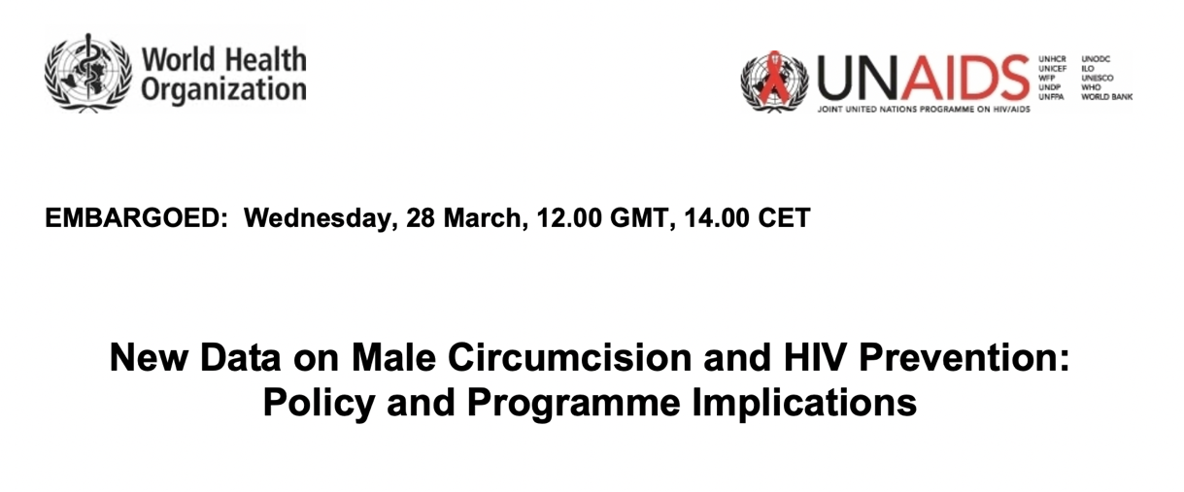

Title | Publisher & Year | Type of Material | Target Audience
New data on male circumcision and HIV prevention: Policy and program implications | WHO/UNAIDS, 2007 | Policy Brief | General Public

Table 5: Johnstone analysis of Policy Document 1
Purpose | The joint WHO and UNAIDS announcement endorses voluntary medical male circumcision and acts as a guide for the wider global health community as to the justifications and limitations of the intervention.
Participant | The direct and technical tone of the piece implies that it was written for a professional global health audience, specifically those in the HIV program implementation spaces. It aims to communicate information clearly to the relevant global health players, with little regard for the rhetorical or marketing strategies employed in other materials.
Medium | As a publicly available policy brief, it may be read by laypeople, but as an official WHO/UNAIDS report, it is likely to be consumed by policy makers and organizations concerned with HIV prevention. The lack of visual elements or engaging formatting reflects the purpose of the document as primarily informational rather than a marketing tool.
Language | The text mostly reflects the official nature of the missive, but some wording that may have been innocuous in 2007 is concerning in the current context. It is emphasized that the messaging around VMMC must be “culturally appropriate”, but it goes on to specify that it should use “local symbols” and be “the appropriate level of development and understanding for the population”. This language choice is odd given that the brief never explicitly states that VMMC is to be rolled out in Africa, but it is made very clear to the reader with these characterizations of local settings. It is not only derogatory but dismissive in its vagueness.  The existing health systems are continuously referred to as “weak” with unclean, untrained practitioners that will hinder the success of VMMC. This is an important consideration—surgical procedures must be sanitary and standardized to prevent adverse events, but the pervasive notion that SSA health systems are inept is harmful. Language like this, repeated over and over in other VMMC materials, provided justification for the Global North to import their own infrastructure rather than building the capacity of the existing systems.
World | The implication throughout the brief is that VMMC is applicable to the African setting where transmission is high and circumcision is low, but that assumption is never explicitly discussed. Given the location of the studies and the broad understanding of the HIV landscape, perhaps it was obvious to professionals why that decision was made. Still, it seems misguided that the first comprehensive brief on VMMC does not consider its use in other areas and assumes that it is appropriate to use across all of sub-Saharan Africa. This oversight within the document implies that the worldview of the actors was equally limited and paternalistic.
Intertextuality | As the first document with international weight to endorse the rollout of VMMC, the tone and message, although reserved, feel very much in line with the opinions of that time. Buzz around the promising three studies (mentioned frequently throughout the brief) conveyed the feeling that VMMC could be the simple and effective program the world was searching for to curb the African endemic.

After establishing an overview for each piece, I coded the over 80 pages of text and seven promotional materials line-by-line. The choice was made to code the materials by hand given that the promotional materials rely on visual components and insinuations more often than plain text meaning. Samples of the coding process are provided in Appendix 2. The codes were then organized into sub-themes and prioritized based on frequency and consistency across different pieces. The five themes that emerged will be explored fully in the results section. My understanding of the discursive landscape was also bolstered by the reading of hundreds of pages of additional materials not included in the formal CDA.

Acknowledgment of Perspective
As mentioned in the key tenets of critical discourse analysis, reflexivity is paramount. As a researcher, I strive to eliminate bias and subjectivity in my work, but my experiences will inform the project in ways that cannot be mitigated. I do not reside outside the social hierarchy of power that I am examining, so it is important to acknowledge my complicity in that (Wodak and Meyer, 2015). I am a cis-white HIV-negative heterosexual woman from the Global North. All of these identities are intertwined with my worldview and may be reflected in the framing, discussion, and conclusions drawn from the analysis. The knowledge produced in this paper cannot be separated from the author who compiled, synthesized, and interpreted it. In lieu of being able to eliminate my influence, I am claiming the power that comes from naming my positionality.
The schema theory recognizes that we are conditioned to organize our knowledge and previous experiences into patterns and assumptions in order to arrive at answers more quickly (Nunan, 1993). Therefore, not only are we trained to find answers, our brains encourage us to jump to conclusions. Richardson (2019) speaks to the danger of ignoring hegemonic structures, noting “these types of ‘scientific’ analysis draw from a mental map whose contours are shaped by coloniality” (p. 103). My own mental map is shaped by biases that I cannot fully know. However, the use of CDA is intentional in not prioritizing answers, but rather picking apart the discourse to problematize aspects that have gone unnoticed.

Results and Analysis

Introduction of Themes
The concept map below (Figure 2) outlines the five overarching themes and highlights the sub-themes that comprise them. This section will introduce and explore these themes as a basis of the dominant discourses evident in the materials.
Figure 2: Concept map of themes and sub-themes

“Man Up”
The role of masculine duty in effective marketing campaigns cannot be overstated. In the materials that speak directly to local men, this theme is by far the most universal as it is found in every promotional material and all sixteen of the mock flyers provided in the second internal material. Of course, it is employed with varying degrees of subtlety, but they all frame the decision to get circumcised as fulfilling a masculine duty.
This strategy relies on traditional African family structures and gender norms wherein the man is the protector and decision maker of the family unit or couple. Some of the sample flyers provided in IM 2 are grouped around emphasizing the “family benefits”, which frames VMMC as “a choice consistent with the masculine ideal of family protection” (IM 2). The power of this messaging is convincing a man that “he can better fulfill his role as a supportive husband or partner and father” by getting circumcised (IM 2). Actual promotional materials carry this forward by highlighting the agency of the African man to make the “right” choice with language encouraging men to “face the challenges” (PM 2), “stand proud” (PM 4), and “go for medical male circumcision today!” (PM 6).
The supporting narrative to this discourse is the characterization of circumcised men as empowered and strong individuals. Circumcised men are continually painted as leaders taking control, which effectively implies the opposite for uncircumcised men and creates a moral divide on the basis of circumcision status. The preface to the “leadership and responsibility” templates asserts that “the messaging reinforces that VMMC is a responsible choice and that men who undergo VMMC can serve as role models and “leaders” among men” (IM 2). Some promotional flyers go a step further by creating a sense of comradery among circumcised men to foster a sense of exclusion strong enough to motivate a man to seek VMMC services, as seen in Figure 3.
Figure 3: Promotional Material 2

This theme is central to the discourse around VMMC and yet is only found in promotional materials. It was constructed for the narrow audience of uncircumcised local men, which while the primary target of promotional materials, are not the main readership of the policy documents and internal guidebooks. All the materials included in the CDA discuss the same topic, but they deal with widely varying aspects from conception to implementation to marketing. At the level of local marketing, tapping into the male psyche is deemed critical to the persuasion of African men.

“I am a winner!”: The Characterization of VMMC
How VMMC is portrayed, discussed, and marketed in the materials provides a foundation for both how implementors viewed their own intervention and how they wished it to be perceived by outside parties and potential patients.
Perhaps the most expected yet consistent message was simply that VMMC reduces the chance of an HIV infection. This was a prevalent refrain across all three types of materials, but notably it was present in all but one promotional material. It speaks to the weight placed on the message that it was consistent across a diverse grouping promotional materials—a medium where words are limited and therefore carefully selected. Figure 4, the promotional flyer with the least amount of text says in full, “It’s a question of health, help reduce HIV by getting circumcised today” (PM 5). Regardless of the various marketing ploys used—sports analogies, emotional appeals—the effectiveness of VMMC in preventing HIV infection remained the primary focus based on coding frequency. It is evident that publishers viewed it as either the most compelling argument to sway individuals or a necessary fact to include from an epidemiological perspective.

Figure 4: Promotional Material 5

Although it remained a central tenet in the other two material types—policy and internal guides—the increased length allowed for the explanation of caveats. For example, it is made clear in all three policy documents that circumcision only reduces female-to-male transmission or is effective in “heterosexual couples” (PD3). Some give greater emphasis and more comprehensive explanations than others, but the acknowledgement itself is significant considering this caveat is not specified in any of the promotional materials. Perhaps it was thought that the technicalities would muddle the central message or undermine the masculine sense of duty that so many flyers relied on. It is true that promotional materials were used as first points of contact to get men into clinics where they would then receive a full overview of the procedure. But given the amount of text and detail included on some of the posters, it feels like a stark omission when placed side-by-side with how often the qualification is repeated in policy documents.
The most common provision found in both policy and promotional documents is the statement that VMMC is only partially protective against HIV. This sentiment has various permutations: emphasizing the importance of other HIV prevention methods, mentioning that VMMC is part of a package of prevention efforts, and clearly stating that VMMC only provides partial protection. Some variation of this messaging is found in four promotional materials, but it is mentioned repeatedly in the longer form documents, like the policy document that underscores the point twelve times in nine pages (PM 1). The fidelity to this particular caveat is critically important to all implementors that do not wish to mischaracterize the effects of VMMC and potentially drive up HIV rates by encouraging feelings of invincibility among circumcised men.
Of course, VMMC is described in other ways, though not as consistently as those discussed above. At various points, the procedure is referred to as safe, hygienic, easy, and free to access, all of which contribute to a positive image of the invention as a whole. In some policy and internal documents, VMMC is defined in opposition to female genital cutting, which is unilaterally rejected by implementors of VMMC. A guide on communication strategies emphasized the need to “distinguish clearly between male circumcision and female genital cutting, which must be discouraged as a harmful practice with no health benefits” (IM 1). It is also openly acknowledged that male circumcision has religious and cultural roots in certain African communities and may be occurring alongside VMMC. The guidance on traditional male circumcision is mixed, ranging from none (PD 3) to rejection (IM 1). Although not a primary focus of the campaign, it was clear that traditional forms of both female and male genital cutting were to be at least monitored and at most discouraged in favor of VMMC.
The internal materials—those circulated to people directly involved in the intervention—notably do not characterize VMMC in any meaningful way. They work under the knowledge that the audience is already familiar and supportive of the intervention and therefore require no education on the exact parameters of the procedure. Instead, they focus on logistical issues of rollout and uptake, mostly omitting discussion of the intervention itself.

The Communication Manifesto
The analysis revealed that the overarching VMMC communication strategy is organized around three guiding principles: the messaging should be clear, culturally aware, and tailored for local communities. These objectives are, of course, instructional and aspirational, outlined most explicitly in the internal documents written by executives not in the field. The extent to which actual communication campaigns achieved these aims in their local settings is variable. Nevertheless, it is valuable to explore the high-level priorities of the sponsoring organizations as reflected in the discourse around messaging.
The need for clear, consistent communication has been previously discussed in relation to the mantra that VMMC is only partially protective. The motivation for maintaining clear channels of communication is in service of mitigating confusion among local men. It is of course beneficial to the potential patients, who should not be misled in the details and outcomes of the procedure, but it also protects the interests of the implementors, who are constantly squashing rumors—both positive and negative—about the intervention. It is explicitly stated in several documents that combatting “misconceptions” through strong communication is rooted in the belief that it will increase uptake (PD 1, PD 3, IM 1).
In outlining particular considerations of the program, both internal documents (IM 1, IM 2) and two policy documents (PD 1, PD 3), recommend adapting to local populations using language like “tailoring”, “targeted”, “appropriate”, and “culturally sensitive” when discussing messaging strategies. The internal handbook that provides print ad templates prefaces the posters with, “messages should be adapted to the local context and pre-tested to ensure they are appropriate and meaningful for intended audiences” (IM 2). Because both the policy and internal documents engage such a wide and disparate audience, there is little to no specific advice. Rather, the agency to perform “audience research” is given to local implementors to conduct as they see fit, which is reflected in the diverse formatting, language, and visual elements of the promotional materials.

Quick Snips and the Argument for Efficiency
In discussing the merits of VMMC, the discourse repeatedly turns to consideration of the program as an economic investment. A press release touts that “VMMC offers excellent value for money”, framing the program as a wholly financial consideration (PD 2). However, this and other similar passages expand very little on why precisely VMMC is deemed fiscally prudent. Whether the cost is in comparison to no intervention or alternative preventative measures is not clarified.
What is specified, and in fact uses the argument of “cost-effectiveness” as a rhetorical spring board, is that the program must be expanded. Phrasing such as “for maximum population-level benefit and cost effectiveness, male circumcision needs to be scaled up rapidly” (IM 1), neatly argues that the sound financial decision is to expand the program to increase uptake. So, low uptake, the weakness that plagues most VMMC efforts across the continent, is taken as an indication that the program has simply not gone far enough. This framing argues that the best use of funds is to continue to scale up efforts in order to see a maximum return on investment in the form of reduced infection rates. The original policy brief acknowledges that “a population level impact of male circumcision on HIV transmission in such settings is not likely until a large proportion of men are circumcised” (PD 1). This mindset has the potential to become a reinforcing cycle wherein poor uptake demands more money rather than a critical appraisal of the effectiveness of the intervention.
The focus on maximizing monetary and other resources provided by the Global North stands in opposition to the perception of African health systems by sponsoring organizations. It is quite bluntly stated that “health systems in developing countries are weak and there is a shortage of skilled health professionals” (PD 1), which may be true to an extent, but that assessment in no way offers the nuance needed to appreciate the challenges on the ground. The same document goes on to state that circumcisions “performed in clinical settings under aseptic conditions, by well trained and adequately equipped health care personnel” are very safe while those “provided by untrained, poorly equipped providers and in some traditional settings” have high rates of complications. The implication is that the weak “African” medical services must be replaced with equipment, protocols, and employees from the Global North. These passing remarks made in the context of a much longer document perform a disservice because in their brevity they miss the opportunity for capacity building. Hiring and training local individuals, using local clinics as circumcision sites, and collaborating with local organizations were strategies likely used, but they are not mentioned in any of the materials I reviewed. If the only characterizations of the existing health systems are to warn VMMC providers of their inadequacy, it reflects and perpetuates a harmful and limited view of health care in sub-Saharan Africa.

A Woman’s World
Although VMMC is necessarily a male-oriented intervention, the discourse illustrates the various supplementary roles women play in the program. First, implementors recognize the power of a man’s partner in persuading him to seek medical circumcision. In fact, it is one of the clear threads of communication strategy that runs through the materials both as the program ages and as promotional campaigns are implemented in increasing local settings.
The first policy document offers very little in the way of communication strategy and yet recommends that messaging be directed “at both men and women” (PD 1). A 2020 progress brief reiterates this stance, citing research that “effective coverage of VMMC” is benefitted by an “engaged partner” (PD 3). The print ad templates provided by PEPFAR include three flyers under the theme “Benefits for Women”, which prefaces the mock posters by explaining that “women, as wives and sexual partners, are highly influential in men’s decisions to undergo VMMC” and thus merit specific marketing campaigns (IM 2).
There are two primary arguments made regarding women: the medical benefits of the procedure and the sexual benefits. Because VMMC only reduces the chance of HIV infection for men, the promotional materials (both mock and real) appeal to women by highlighting other medical benefits, including a lower risk of cervical cancer and STIs. Additionally, the wording and format of the posters often lightly obscure the fact that male circumcision only reduces the man’s HIV risk. One woman on a promotional flyer says, “we have lower chances of getting HIV” (PM 4), which maintains a technical truth while sacrificing clarity.
If the health outcomes are not compelling enough, templates targeting so-called “additional benefits” allude to improved sexual relations “through subtle, tasteful imaging and text” (IM 2). One couple stares into each other’s eyes while telling the reader to “enjoy all the benefits” by “encourag[ing] your man to get circumcised” (IM 2). However, while these posters play with innuendo, they are careful to not explicitly promise sexual benefits. The introduction to this frame explains that “the perception of increased sexual pleasure [is a] powerful motivator for men to undergo VMMC and for women to encourage their partners to do so” (IM 2). Without clear evidence on the effect of circumcision on sexual pleasure, implementors are happy to utilize a potentially erroneous belief as part of larger a marketing strategy.
Often, campaign posters capitalize on the benefits of male circumcision for woman by using a female voice to speak directly to men. One such promotional flyer has an image of a couple embracing next to the text “Psst, did you know? Many women say that they prefer a circumcised partner” (PM 6). Figure 6 below features a women looking coyly over her shoulder tells men to “protect the one you love” because “she will thank you” (IM 2), which uses the female perspective to evoke a sense of masculine duty.
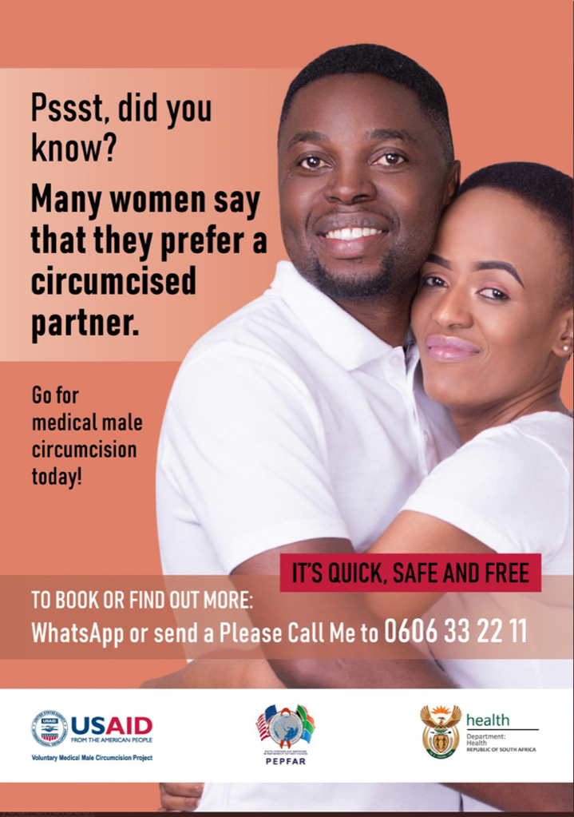
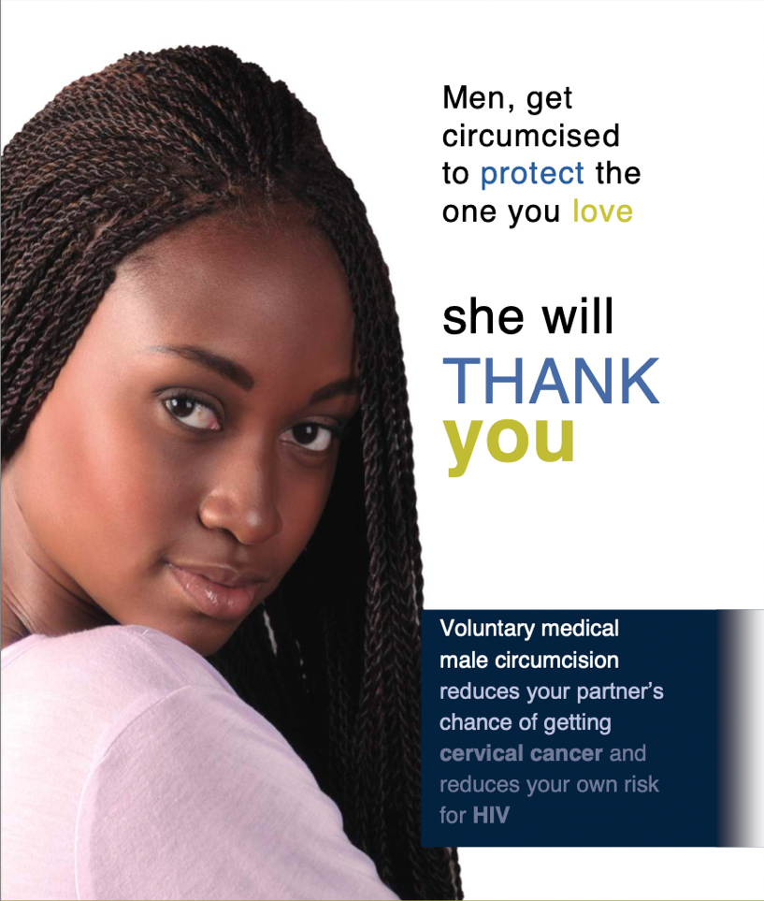
Figure 5: Promotional Material 6
Figure 6: Mock flyer from Internal Material 2

Discussion

The themes, while helpful to analyze separately, offer new insights when considered in conversation with one another. Allowing the results to speak to each other not only points back to Johnstone’s principle of intertextuality, but it allows for a more accurate rendering of the discourse, which pushes the rhetorical themes to overlap and interact. In doing so, two thematic tensions emerge: (1) weighing the individual against the collective and (2) navigating the role of traditional health practices in a Global North driven intervention. These discussion points are further elucidated by two conceptual frameworks first introduced in the background—biopower and coloniality, which speak to the two tensions respectively. This section uses the tensions in conjunction with the conceptual frameworks as a means of agitating the conversation around VMMC and identifying the challenges and opportunities for the program both now and in the future.

The Individual Versus the Collective
Because of the nature of the intervention—spanning fourteen countries with the explicit goal of enacting population-level change—it is expected that the individual is sacrificed for the benefit of the collective of sub-Saharan Africa. This mindset, however, is a sliding scale, meaning it can be used as a justification to various degrees. For example, the repeated verbiage in the texts around hitting quotas, reaching targets, and increasing uptake is a side effect of prioritizing the bigger picture over the individual experience of a local man. The theme “Quick Snips and the Argument for Efficiency” highlights how easily numbers can replace people in the rationale for expanding the program. Given the ambition of the implementors, however, this is perhaps an understandable approach.
What is problematic is if (or when) this balance tips too far in favor of the “common good” and completely eclipses the rights of individuals. It brings to mind the report of young boys being recruited and circumcised at school in Kenya without parental consent (Luseno et al., 2019). At that point, the desire to circumcise has been divorced from the desire to do what is best for the people. Feierman (2011) warns of this mentality, “it is as though they [public health officials] are flying above the earth in a spacecraft, surveying the whole globe, and looking for knowledge, or actions, that will have a positive effect on the greatest number of people, wherever they may be” (p. 175). This is not necessarily a bad perspective, after all, shouldn’t public health endeavor to bring the most good to the most people possible? The concept of biopower is helpful in illustrating how an intervention at the population level—even one with good intentions—can be a tool in exercising control and consolidating power. Because VMMC concerns bodily autonomy, it especially merits this discussion.
As introduced in the background, Foucault’s biopower is concerned with the “regulation of human life at the level of the population and the individual” (Chhibber, 2022). Rooted in “the art of the living”, we saw that it can use docile bodies or biopolitics to optimize the health of people and populations, respectively (Roach, 2009, p. 157, Foucault, 1978, Foucault, 1975). The “state” control over health and life can be overt or subtle, but weaponized to meet various ends nonetheless (Foucault, 1978). In the case of VMMC, preventing HIV transmission through medical circumcision is a potential avenue to exercising power over its target population. It is alarming to unpick the implication that the intervention could be perverted in that way, but the program asks African men to permanently alter their body, sometimes in discordance with their socio-cultural norms. It does force the question: why are the global health governing structures so insistent that sub-Saharan Africa be circumcised, especially in the face of immense challenges and external rebuke?
If the VMMC campaign was developed and executed by the governments of the target countries, the mechanisms of biopower would still be at play because of the power dynamics between people and their government. However, the fact that the Western-facing organizations (specifically the U.S) have championed and implemented this intervention adds an additional aspect of control that comes from a “developed” country embedding themselves in the health systems of developing nations. At its most pernicious, this line of thought concludes that the continual medical aid to Africa is in fact a means of keeping the population healthy just so the Global North can continue to exert control over the continent. The coding results show that building the capacity of local health systems is not a priority for VMMC implementors, which allows those systems to remain weak and thus justifies a continued presence that stunts African autonomy. Using biopower to unravel the webs of power around VMMC quickly turns a public health service into a sinister colonial plot, which is exactly why it merits investigation. It is worrying that biopower and its various mechanisms can work without the explicit acknowledgement or intention of those in power. It can be so embedded in a social discourse that it is virtually impossible to recognize, which is why close textual analysis is helpful in interrupting the pattern. Exercising control over people’s bodies as a means of impacting the health of a population is a dangerous line to walk, even if it is for their benefit on an epidemiological level. Therefore, VMMC implementors have a responsibility to evaluate their own motivations and methods, given the risks and implications of failing to do so.

Fitting Global Health Solutions into sub-Saharan Traditions
The second tension emerges in the discord between the global health actors’ biomedical solution of circumcision and the cultural practice of circumcision among certain sub-Saharan communities. It is made clear in the materials that traditional genital cutting—both male and female—are counterproductive to the VMMC program goals and are to be discouraged . From a standardization and safety perspective, it is absolutely necessary to ensure that all procedures performed in the program are done in a clean environment and in accordance with specific guidelines. However, for an intervention to enter a culturally diverse region with wildly different attitudes towards circumcision and rebuke those that resist as “unclean” and those that practice as “unsafe” alienates everyone. This approach clarifies that implementors are not promoting circumcision, but medical circumcision, funded and performed by the global health organizations. The privileging of medical circumcision as “correct” is what Foucault (1980) called subjugated knowledge and is simply another way of exercising power. Historically, it is a means of dismissing local and indigenous established forms of knowledge as “beneath the required level of cognition or scientificity” (Foucault, 1980, p. 80, Hartman, 2000). The implication is that there is a right and wrong way to remove foreskin so local circumcision traditions are not integrated into the formal knowledge systems (White et al., 1990).
At best this attitude is paternalistic, at worse it is a repetition of colonial patterns via a medical intervention. As discussed in the background, there is a long history of abuse on the African continent and asking men to permanently alter their bodies is a landscape full of potential landmines. Mkhwanazi (2016) summarizes the experience of Swazi men with VMMC:

In this story, Swazi men were unquestionably expected to line up and accept having skin removed. They were supposed to do this in order to not be a danger to others in the country, the region, and ultimately the world. They were supposed to do this for the greater good. It is a story that evokes a time when medical missionaries, military doctors, and anthropologists worked hand in hand with colonial officials to pacify, civilize, and subjugate whole populations. (p. 200)

The key oversight is that the VMMC program is offering what they perceive to be a biomedical solution to an epidemiological problem, when in fact circumcision is heavy with cultural meaning (Aggleton, 2007). To paint with broad strokes, accepting aid from the Global North is heavy with historical wrongdoings. So while implementors are concerned with quotas, uptake, and driving down HIV, the local people must grapple with feelings of mistrust, cultural erosion, and even domination. The quote above was written from the African perspective; if the same narrative was written by implementors it would read along the lines:

The WHO and other sponsoring organizations have dedicated considerable financial resources and manpower to rolling out a medical circumcision program in fourteen sub-Saharan countries in their commitment to reduce HIV transmission across Africa.

Having read and analyzed hundreds of pages of VMMC materials, I can confirm that the interpretation of the VMMC program is always in the spirit and tone of the latter quote because they are all written by those rolling out the program, not those receiving it. It is simply a fact that the historical landscape on the African continent is fraught with instances of violence—physical, political, and otherwise. To enter into that space with the best of intentions is not sufficient given the potentially damaging effects. There is certainly role for developed nations to play in offering medical expertise and resources, but introducing a quasi-permanent public health intervention requires a very considered approach that does not seem evident. Even if implementors do not view circumcision with the same cultural gravity, it is their responsibility to reflect on the wider social, historical, and religious implications for their patients.

Limitations
The primary limitation of this project is that my scope cannot hope to capture the magnitude of the VMMC program. Every effort was made to carefully review and select a diverse grouping of materials, but I recognized at the outset that I could not do a large enough analysis to fully encapsulate the nuances of the intervention. Breadth was sacrificed for depth, which I believe was the right decision given my methodology. Because of that, I painted with relatively broad strokes, often referring to “the VMMC program”, which is comprised of many sponsorships, funding streams, and executive organizations and has evolved over its fifteen years. All my findings and assertations remain true based on my analysis, but perhaps are not applicable to every component of the program.

Implications for Future Research
One of the common codes in my analysis was the call for more research in particular areas. Medical circumcision touches so many fields from HIV, epidemiology, viral pathways, medical ethics, bodily autonomy, genital cutting, health promotion—it is hardly at a shortage for new questions to answer. To pick up a thread from an earlier section, very little of this knowledge production is being done by African academics or in partnership with the communities that are targeted by VMMC.
Shumba and Lubombo (2017) provide an excellent example of working with tribal communities to bridge the gap with VMMC services. They conducted in-depth interviews with the traditionally circumcising VaRemba community in Zimbabwe to determine why they were resistant to VMMC. The goal was not increase uptake but “renegotiate culturally insensitive structures so that they are aligned with the unique needs of their culture” (Shumba and Lubombo, 2017, p. 169). It provides a blueprint in true partnership between local communities and implementors that does not see cultural practices as obstacles to overcome, but a way to learn and collaborate on a common goal. As research continues in the male circumcision space, it should be centered on a meaningful coalition with local people, which in turn protects against the abuse of power.

Policy Recommendations
The objective of this paper was not to pass down a verdict on whether the VMMC is good or bad or should be continued or stopped. Because the current dialogue is so heated, I thought it would be helpful to ground criticisms in actual VMMC materials to begin a constructive conversation around a third course of action. My probing of VMMC discourse with a colonial lens has highlighted the potential for harmful practices, which can only be addressed through reevaluating the program. It is possible for male circumcision to have a place in HIV prevention, but it can be scaled up and scaled back based on specific geographic and cultural considerations, and perhaps restructured to focus on the agency and capacity of African countries. It must be reconceptualized to acknowledge the harm it has done and the role it may have played in perpetuating colonial acts on the bodies of Africans. Continuing to push forward with no critical reflexivity is not an acceptable option given the concerns presented here.
On a more tangible level, I have provided several specific suggestions for inviting feedback on VMMC practices from communities, which could be a beneficial starting point in integrating the perspectives of local people:
- Marketing strategies and materials should be co-produced with local communities, specifically men who have undergone circumcision so they are based on personal accounts and beliefs rather than perceived effective messaging.
- VMMC infrastructure—clinics, staffing, logistics—should be installed with as much local collaboration as possible, with a mind towards building the capacity of local health systems and people.
- The so-called “quotas” should be determined at the local level based on communities’ needs and attitudes rather than applied unilaterally across all target countries to prevent an overemphasis of procedure counting rather than collaboration.

Conclusion

This dissertation sought to answer the question: How is voluntary medical male circumcision (VMMC) as an HIV prevention strategy in sub-Saharan Africa presented by the implementors of the intervention? Per the stated aims, it highlighted the dominant discursive themes around the program and explored the cultural implications through a colonial lens. A critical discourse analysis was carried out to identify the themes and unpack any underlying ideologies. There is no “smoking gun” of explicit colonial attitudes within the official materials I analyzed, which is to be expected. However, the results and discussion that followed indicate that these motivations are perhaps more pernicious when covert or subconscious. The conceptual frameworks of biopower, subjugated knowledge, and coloniality helped extrapolate seemingly innocuous patterns found in the discourse to their possible, perhaps dark, conclusions. The concepts situated the findings in wider historical contexts to illustrate exactly what is at stake if appropriate execution is not carefully considered, which was one of the aims at the outset. This exercise was not meant to fear-monger, rather it illustrated the hegemonic mechanisms of power that can exist directly in front of us without a second thought. It forces implementors to consider the intervention’s role in perpetuating channels of domination through medical aid to the Global South.
Perhaps is it unsatisfying to conclude without a clear verdict on the intentions of the VMMC program, but that is the nature of CDA: it can only tell you what is being said but not why it is being said. That does not negate the importance of the messages because “the knowledge that circulates in discourse is employed in everyday interaction in relations of submission and domination” (Parker, 1989, p. 63). Close careful attention can force introspection, as is necessary with the VMMC program. We have established that the problem is not necessarily with the intervention, it is with the blind and non-reflexive manner in which it continues to be supported, funded, and championed without critical reevaluation—especially with the advent of new HIV treatments. If the intention remains to protect people in sub-Saharan Africa from HIV, they deserve to know that VMMC is the best intervention available and not another chapter in the history of mistreatment.

References

ADICHE, C. 2009. The danger of a single story [Online]. Available: https://www.ted.com/talks/chimamanda_ngozi_adichie_the_danger_of_a_single_story?language=en [Accessed March 3 2022].
AGGLETON, P. 2007. “Just a snip”?: a social history of male circumcision. Reproductive health matters, 15, 15-21.
AINE, B. 2018. Museveni castigtes circumcision as away [sic] to prevent HIV/AIDS [Online]. Available: https://www.pmldaily.com/news/2018/10/museveni-castigates-circumcision-as-away-to-prevent-hiv-aids.html [Accessed March 8 2022].
ARRINGTON, A. N. 2016. Mass Circumcision Campaigns in Sub-Saharan Africa: A Disaster in Disguise. Indon. J. Int'l & Comp. L., 3, 779.
AUVERT, B., TALJAARD, D., LAGARDE, E., SOBNGWI-TAMBEKOU, J., SITTA, R. & PUREN, A. 2005. Randomized, controlled intervention trial of male circumcision for reduction of HIV infection risk: the ANRS 1265 Trial. PLoS medicine, 2, e298.
AVERT.ORG. 2020. HIV and AIDS in East and Southern Africa regional overview [Online]. Avert. Available: https://www.avert.org/professionals/hiv-around-world/sub-saharan-africa/overview [Accessed 5 March 2022].
BAILEY, R. C., MOSES, S., PARKER, C. B., AGOT, K., MACLEAN, I., KRIEGER, J. N., WILLIAMS, C. F., CAMPBELL, R. T. & NDINYA-ACHOLA, J. O. 2007. Male circumcision for HIV prevention in young men in Kisumu, Kenya: a randomised controlled trial. The lancet, 369, 643-656.
BELL, K. 2015. HIV prevention: Making male circumcision the ‘right’tool for the job. Global Public Health, 10, 552-572.
BERER, M. 2007. Male circumcision for HIV prevention: Perspectives on gender and sexuality. Reproductive health matters, 15, 45-48.
BOYLE, G. J. & HILL, G. 2011. Sub-Saharan African randomised clinical trials into male circumcision and HIV transmission: methodological, ethical and legal concerns. Journal of law and medicine, 19, 316.
CHHIBBER, A. 2022. Biopower [Online]. Global Social Theory. Available: https://globalsocialtheory.org/concepts/biopower/ [Accessed May 29 2022].
CLEARINGHOUSE ON MALE CIRCUMCISION FOR HIV PREVENTION 2022. Resource Library. FIH 360.
COLLIER, R. 2012a. The studies that launched a thousand snips. Can Med Assoc.
COLLIER, R. 2012b. Ugly, messy and nasty debate surrounds circumcision. Canadian Medical Association Journal, 184, E25-E26.
COOK, G. 1989. Discourse, Oxford University Press.
DARBY, R. & SVOBODA, J. S. 2007. A rose by any other name: Rethinking the similarities and differences between male and female genital cutting. Medical anthropology quarterly, 21, 301-323.
DECARLO, M. 2018. 6.2 Paradigms, theories, and how they shape a researcher’s approach. Scientific Inquiry in Social Work.
DOWSETT, G. W. & COUCH, M. 2007. Male circumcision and HIV prevention: is there really enough of the right kind of evidence? Reproductive health matters, 15, 33-44.
FAIRCLOUGH, N. & WODAK, R. 1997. Critical Discourse Analysis. In: DIJK, T. A. V. (ed.) Discourse as Social Interaction. London: SAGE.
FEIERMAN, S. 2011. When physicians meet: local medical knowledge and global public goods. Evidence, ethos and experiment: the anthropology and history of medical research in Africa, 171-96.
FISH, M. 2019. Circumcision campaigns: African opposition and human rights [UN report]. The VMMC Experience Project.
FISH, M., SHAHVISI, A., GWAAMBUKA, T., TANGWA, G. B., NCAYIYANA, D. & EARP, B. D. 2020. A new Tuskegee? Unethical human experimentation and Western neocolonialism in the mass circumcision of African men. Developing World Bioethics, 21, 211-226.
FOUCAULT, M. 1972. Archaeology of knowledge, New York, Routledge.
FOUCAULT, M. 1975. Discipline and Punish,(trans. A. Sheridan) New York: Pantheon.
FOUCAULT, M. 1978. The history of sexuality: Vol. 1. An introduction (R. Hurley, Trans.). New York: Pantheon.
FOUCAULT, M. 1980. Power/knowledge: Selected interviews and other writings 1972-1977, New York, Pantheon: .
FOUCAULT, M. 1988. Michel Foucault: politics, philosophy, culture, New York, Routledge.
GALBRAITH, J. S., OCHIENG, A., MWALILI, S., EMUSU, D., MWANDI, Z., KIM, A. A., RUTHERFORD, G., MAINA, W. K., KIMANGA, D. O. & CHESANG, K. 2014. Status of voluntary medical male circumcision in Kenya: findings from 2 nationally representative surveys in Kenya, 2007 and 2012. Journal of acquired immune deficiency syndromes (1999), 66, S37.
GENEL, K. 2006. The question of biopower: Foucault and Agamben. Rethinking Marxism, 18, 43-62.
Fire in the Blood, 2013. Directed by GRAY, D. M. India.
GRAY, R. H., KIGOZI, G., SERWADDA, D., MAKUMBI, F., WATYA, S., NALUGODA, F., KIWANUKA, N., MOULTON, L. H., CHAUDHARY, M. A. & CHEN, M. Z. 2007. Male circumcision for HIV prevention in men in Rakai, Uganda: a randomised trial. The Lancet, 369, 657-666.
GRIX, J. 2004. The Foundations of Research Palgrave Macmillan.
HARTMAN, A. 2000. In search of subjugated knowledge. Journal of Feminist Family Therapy, 11, 19-23.
HERBERT, B. 2001. In America; refusing to save Africans. New York Times, June 11, 2001, p.17.
JOHNSTONE, B. 2008. Discourse analysis, Malden, MA, Blackwell Pub.
JØRGENSEN, M. W. & PHILLIPS, L. J. 2002. Discourse analysis as theory and method, Sage.
KLAUSNER, J. D., WAMAI, R. G., BOWA, K., AGOT, K., KAGIMBA, J. & HALPERIN, D. T. 2008. Is male circumcision as good as the HIV vaccine we’ve been waiting for? Future HIV Therapy, 2, 1-7.
LUSENO, W. K., FIELD, S. H., IRITANI, B. J., RENNIE, S., GILBERTSON, A., ODONGO, F. S., KWARO, D., ONGILI, B. & HALLFORS, D. D. 2019. Consent challenges and psychosocial distress in the scale-up of voluntary medical male circumcision among adolescents in Western Kenya. AIDS and behavior, 23, 3460-3470.
LUSENO, W. K., RENNIE, S. & GILBERTSON, A. 2021. A review of public health, social and ethical implications of voluntary medical male circumcision programs for HIV prevention in sub-Saharan Africa. International Journal of Impotence Research.
MACK, L. 2010. The philosophical underpinnings of educational research. Polyglossia, 19, 5-11.
MCNEIL JR., D. 2003. Africans outdo U.S patients in following AIDS therapy. New York Times, p.1.
MISHRA, V. K. 2009. Levels and spread of HIV seroprevalence and associated factors: evidence from national household surveys, Macro International.
MKHWANAZI, N. 2016. Medical anthropology in Africa: the trouble with a single story. Medical anthropology, 35, 193-202.
NDUNGU, T. 2017. Raila Odinga talks about the circumcision slur on his Mera tour [Online]. Tuko News. Available: https://www.tuko.co.ke/232201-raila-odinga-talks-circumcision-slur-meru-tour.html [Accessed 5 March 2022].
NJEUHMELI, E., FORSYTHE, S., REED, J., OPUNI, M., BOLLINGER, L., HEARD, N., CASTOR, D., STOVER, J., FARLEY, T. & MENON, V. 2011. Voluntary medical male circumcision: modeling the impact and cost of expanding male circumcision for HIV prevention in eastern and southern Africa. PLoS medicine, 8, e1001132.
NUNAN, D. 1993. Introducing discourse analysis, Penguin Group.
PAAKKANEN, E. K. 2019. Entitled, empowered or victims–an analysis of discourses on male and female circumcision, genital mutilation/cutting and genital cosmetic surgery. The International Journal of Human Rights, 23, 1494-1520.
PARKER, I. 1989. Discourse and power. In: GERGEN, J. S. K. J. (ed.) Texts of identity. London: Sage Publications.
PARKER, R., AGGLETON, P. & ROCHEL DE CAMARGO JR, K. 2015. Circumcision and HIV prevention: Emerging debates in science, policies and programmes. 10, 549-551.
QUIJANO, A. 2000. Coloniality of power, eurocentrism, and Latin American, en Nepantla. Views from South.
RABINOW, P. & ROSE, N. 1954. Foucault today. The essential Foucault: Selections from the essential works of Foucault, 1984, 1-30.
RICHARDSON, E. T. 2019. On the coloniality of global public health. Medicine Anthropology Theory, 6.
ROACH, T. J. 2009. Sense and Sexuality: Foucault, Wojnarowicz, and Biopower. Nebula, 6, 155-174.
SHAHVISI, A. 2019. Tropicality and abjection: What do we really mean by “Neglected Tropical Diseases”? Developing world bioethics, 19, 224-234.
SHARMA, S. C., RAISON, N., KHAN, S., SHABBIR, M., DASGUPTA, P. & AHMED, K. 2018. Male circumcision for the prevention of human immunodeficiency virus (HIV) acquisition: a meta‐analysis. BJU international, 121, 515-526.
SHUMBA, K. & LUBOMBO, M. 2017. Cultural competence: a framework for promoting voluntary medical male circumcision among VaRemba communities in Zimbabwe. African Journal of AIDS Research, 16, 165-173.
TASSIE, J.-M., SZUMILIN, E., CALMY, A., GOEMAERE, E. & FRONTIÈRES, O. B. O. M. S. 2003. Highly active antiretroviral therapy in resource-poor settings: the experience of Médecins Sans Frontières. AIDS, 17, 1995-1997.
THIRUMURTHY, H., MASTERS, S. H., RAO, S., BRONSON, M. A., LANHAM, M., OMANGA, E., EVENS, E. & AGOT, K. 2014. Effect of providing conditional economic compensation on uptake of voluntary medical male circumcision in Kenya: a randomized clinical trial. Jama, 312, 703-711.
UPTON, R. Violence or Voluntary (Male Circumcision): The Colonial Ideology and Contemporary Irony of Hiv/Aids Prevention in Botswana. ASA 2014 Annual Meeting Paper, 2014.
VAN HOWE, R. S. & STORMS, M. R. 2011. How the circumcision solution in Africa will increase HIV infections. Journal of public health in Africa, 2.
WAWER, M. J., MAKUMBI, F., KIGOZI, G., SERWADDA, D., WATYA, S., NALUGODA, F., BUWEMBO, D., SSEMPIJJA, V., KIWANUKA, N. & MOULTON, L. H. 2009. Circumcision in HIV-infected men and its effect on HIV transmission to female partners in Rakai, Uganda: a randomised controlled trial. The Lancet, 374, 229-237.
WHITE, M., WIJAYA, M. & EPSTON, D. 1990. Narrative means to therapeutic ends, WW Norton & Company.
WHO 2010. Considerations for implementing models for optimizing the volume and efficiency of male circumcision services.
WHO & UNAIDS 2007. New Data on Male Circumcision and HIV Prevention: Policy and Programme Implications. Male Circumcision and HIV Prevention: Research Implications for Policy and Programming. Montreux, Switzerland.
WHO & UNAIDS 2011. Joint Strategic Action Framework to Accelerate the Scale-Up of Voluntary Medical Male Circumcision for HIV Prevention in Eastern and Southern Africa.
WODAK, R. & MEYER, M. 2015. Methods of critical discourse studies, Sage.

Appendices

Appendix 1: Compendium of data analysis charts 1-12

Provided below are the data tables for each of the twelve materials as analyzed with the Johnstone (2008) components: purpose, participant, medium, language, world and intertextuality. The pieces are split by type of material—they are in the same groups and order as found in Tables 1, 2, and 3 in the results section. This means they are loosely grouped by publisher, intended audience, format, and basic messaging, which makes for a comprehensive overview of the documents. This framing also highlights how the discourse shifts as certain variables change. The sixth component of intertextuality, which speaks to the interaction of the pieces with each other, is considered where relevant, but is explored more fully in the thematic discussion.

Policy Document 1

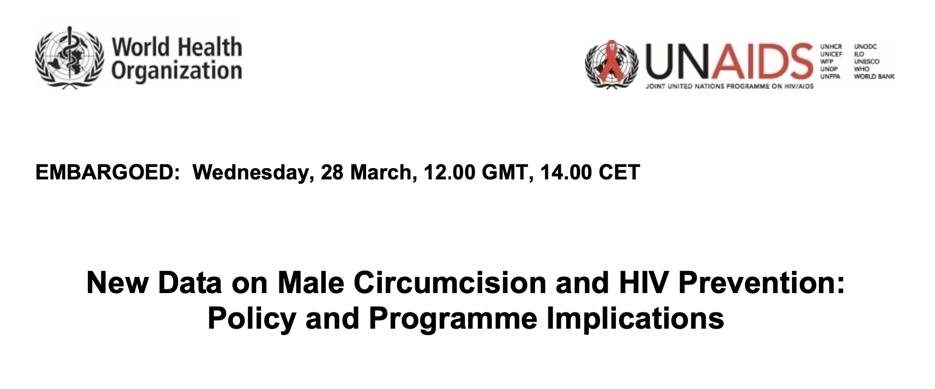

Title | Publisher & Year | Type of Material | Target Audience
New data on male circumcision and HIV prevention: Policy and program implications | WHO/UNAIDS, 2007 | Policy Brief | General Public

Purpose | The joint WHO and UNAIDS announcement endorses voluntary medical male circumcision and acts as a guide for the wider global health community as to the justifications and limitations of the intervention.
Participant | The direct and technical tone of the piece implies that it was written for a professional global health audience, specifically those in the HIV program implementation spaces. It aims to communicate information clearly to the relevant global health players, with little regard for the rhetorical or marketing strategies employed in other materials.
Medium | As a publicly available policy brief, it may be read by laypeople, but as an official WHO/UNAIDS report, it is likely to be consumed by policy makers and organizations concerned with HIV prevention. The lack of visual elements or engaging formatting reflects the purpose of the document as primarily informational rather than a marketing tool.
Language | The text mostly reflects the official nature of the missive, but some wording that may have been innocuous in 2007 is concerning in the current context. It is emphasized that the messaging around VMMC must be “culturally appropriate”, but it goes on to specify that it should use “local symbols” and be “the appropriate level of development and understanding for the population”. This language choice is odd given that the brief never explicitly states that VMMC is to be rolled out in Africa, but it is made very clear to the reader with these characterizations of local settings. It is not only derogatory but dismissive in its vagueness.  The existing health systems are continuously referred to as “weak” with unclean, untrained practitioners that will hinder the success of VMMC. This is an important consideration—surgical procedures must be sanitary and standardized to prevent adverse events, but the pervasive notion that SSA health systems are inept is harmful. Language like this, repeated over and over in other VMMC materials, provided justification for the Global North to import their own infrastructure rather than building the capacity of the existing systems.
World | The implication throughout the brief is that VMMC is applicable to the African setting where transmission is high and circumcision is low, but that assumption is never explicitly discussed. Given the location of the studies and the broad understanding of the HIV landscape, perhaps it was obvious to professionals why that decision was made. Still, it seems misguided that the first comprehensive brief on VMMC does not consider its use in other areas and assumes that it is appropriate to use across all of sub-Saharan Africa. This oversight within the document implies that the worldview of the actors was equally limited and paternalistic.
Intertextuality | As the first document with international weight to endorse the rollout of VMMC, the tone and message, although reserved, feel very much in line with the opinions of that time. Buzz around the promising three studies (mentioned frequently throughout the brief) conveyed the feeling that VMMC could be the simple and effective program the world was searching for to curb the African endemic.

Policy Document 2
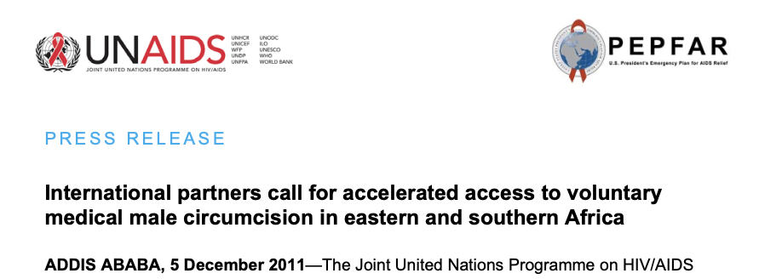

Title | Publisher & Year | Type of Material | Target Audience
International partners call for accelerated access to VMMC in eastern and southern Africa | UNAIDS/PEPFAR, 2011 | Press Release | General Public

Purpose | This press release announces the scaling up of VMMC efforts in SSA. It aims to reassert the value and importance of VMMC to justify the expansion of the program.
Participant | Unlike most of the other materials, this piece is not intended to inform implementors directly involved with the program or participants in Africa, it is geared towards those unfamiliar or loosely aware of the program. The assumption is that the reader is likely from the Global North and has no prior knowledge of the program.
Medium | As a press release, the document is aware that it is an external-facing material that must create a positive impression in a concise manner. While it must convey facts regarding the progress and obstacles of the rollout, it must frame them in a way that garners support for its expansion. There are no visual elements.
Language | From the start, the focus (and credit for the “framework”) is given to the international actors that are listed and thanked for their contribution. It is added that it was done “in consultation with national Ministries of Health”, but that is the extent of the acknowledgement of African collaboration. The text touches on issues of slow uptake, but then pivots to the need for “country ownership and accountability”, the effect of which is to imply that lack of national engagement is to blame for poor results.
World | Given that we know much of the friction on the ground was a result of a lack of cultural and social sensitivity, it is interesting to see the impression that is cultivated through the press release. The rhetorical strategy paints a picture of a benevolent international community that is trying to help African countries control HIV transmission by providing funding, resources, and technical knowledge, but the countries are not lending enough support to ensure the success of the program. It is an elevation of the Global North as a generous savior and a distortion of the reality in local settings.
Intertextuality | The key messages are very much in line with those repeated across other materials, namely strong emphasis of the cost effectiveness of the intervention coupled with issues around uptake. The conversation is the same across this document and the internal handbooks being circulated around this time.

Policy Document 3

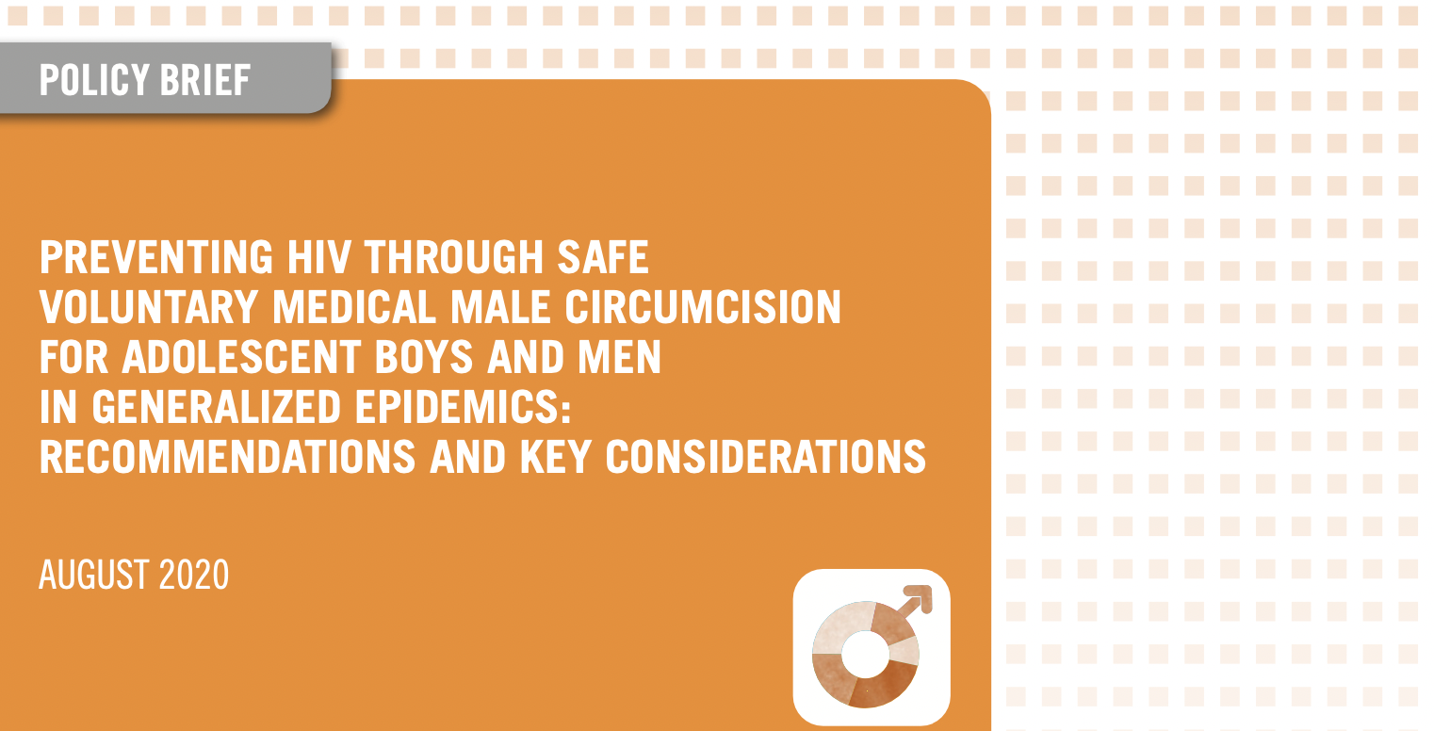

Title | Publisher & Year | Type of Material | Target Audience
Preventing HIV through safe VMMC for adolescent boys and men in generalized epidemics: Recommendations and key considerations | WHO, 2020 | Progress Brief | General Public

Purpose | This in-depth policy brief provides updates on the program’s progress, identifies barriers, and offers solutions to improve outcomes going forward.
Participant | The level of detail and technical analysis speaks to the audience as global health professionals. It was not written for internal circulation among those directly involved in the program because it opens with an introduction and justification of VMMC.
Medium | This document makes a major departure from the previous two policy documents in that it heavily incorporates images, graphs, and engaging formatting choices to engage the reader. Perhaps this speaks to a recognition of the importance of aesthetics and design as marketing tools as the program has developed.
Language | Overall the language is very clinical—it is clear that perception is less of a concern than in the press release.  There is discord within the text about the role of traditional circumcision practices. It is acknowledged in passing, but not fleshed out in a meaningful way that explains the nuances of the cultural practice. It also fails to mention that some communities choose not to circumcise as a matter of tradition. No clear stance is taken on how best to incorporate these practices, but the importance of “clean, competent, trained professionals” is asserted over and over. Without saying so explicitly, the implication is that non-medical circumcisions are not to be endorsed, but the authors do not provide the understanding or tools to breach that issue with local groups.
World | Even though this document was published in 2020, 13 years after the initial policy brief, it relies on the same justifications for implementing VMMC. The cycle of evidence is very self-affirming in that the WHO/UNAIDS brief endorses those three RCTs and that brief is the foundation for every policy thereafter, which creates many supporting materials all based on the same pieces of evidence. The lack of reflexivity and critical evaluation perpetuates the image of an infallible intervention.
Intertextuality | This piece crosses a bridge between the concise press releases intended for public consumption and the lengthier technical handbooks pertinent for employees in field settings.

Internal Materials 1
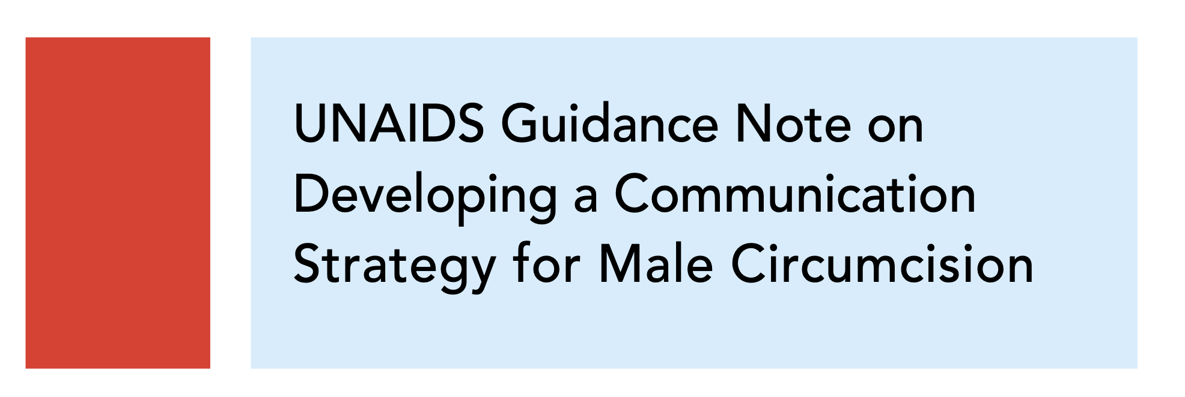

Title | Publisher & Year | Type of Material | Target Audience
UNAIDS Guidance Note on Developing a Communication Strategy for Male Circumcision | UNAIDS, 2010 | Handbook | Implementors

Purpose | Internal document circulated by UNAIDS to staff directly involved with decision-making in local contexts to outline helpful communication strategies to aid with uptake.
Participant | The audience is explicitly stated in the booklet—policy decision makers in governments, international collaborators, and communication strategists. The content is assumed to be applicable to a broad geographic area because it is not tailored to any specific region.
Medium | Although the piece is branded as “internal communication”, it was distributed to a wide audience across a variety of settings, which necessitates the maintenance of a positive image even while discussing obstacles.
Language | Many of the key talking points highlighted in the policy documents are refrained and even repeated word-for-word on issues like female genital cutting and the need for sanitary procedures.  It does provide the most meaningful acknowledgment of traditional circumcision in that it recognizes it as an important cultural practice that demands respect. It is still vague and much too short, but it recognizes the flawed tendency of implementors to try to sway men with data and scientific arguments without any cultural awareness.
World | The sum of the advice in the handbook is to say that the issues with uptake and the shortcomings in hitting specific targets can be fixed with better communication strategies. This could be true, but the information provided is vague enough to be unhelpful, as it provides no substantive strategies that are specific to the African or even VMMC context. On a generic level, the urgings to engage the community, work with local groups, and build trust are valid, but they gloss over the complex challenges and sociocultural friction happening on the ground.
Intertextuality | N/A

Internal Materials 2

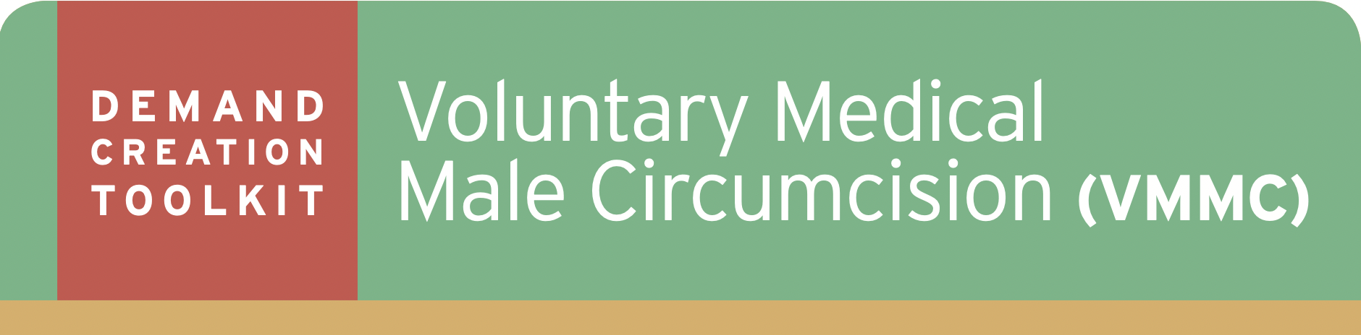

Title | Publisher & Year | Type of Material | Target Audience
Print Ad Templates from Demand Creation Toolkit | PEPFAR, 2014 | Toolkit | Implementors

Purpose | This section of the “Demand Creation Toolkit” provides sample promotional materials to be adapted for local use based on what administrators believe will be effective messages.
Participant | The target audience is those very directly involved with the communication arm of the VMMC rollout. It is assumed they are familiar with the intervention and are looking for ideas for promotional materials.
Medium | This serves as the practical application section of the handbook, where concrete examples are provided to illustrate the suggested strategies. The format is small amounts of text explaining the particular message followed by several iterations of mock flyers.
Language | A warning precedes each flyer that states that these materials have not been pre-tested in community settings and they should be adapted to local contexts before dissemination.  All four messages—family benefits, leadership and responsibility, benefits for women, and other benefits—are based on emotional appeals and contain little factual information on them. This may be a more effective marketing strategy, but it fails to combat the mistrust and disinformation that plagues many VMMC efforts.
World | After reading through all the lengthy policy materials and handbooks, it is almost jarring to see the complex messaging distilled into several words on a poster. The barriers that were carefully considered and outlined are mostly omitted in favor of more stylistic phrasing and visual elements. The goal of these flyers is simply to motivate bodies into clinics so that more comprehensive education can begin (hopefully), so it is interesting to see what is deemed most critical to include when space and words are limited.
Intertextuality | These mock-up materials provide an opportunity to compare and contrast the messaging suggested here and what was actually rolled out in local communities.

Promotional Materials 1

Title | Publisher & Year | Type of Material | Target Audience
“I’m glad I went for male circumcision” campaign | USAID/PEPFAR/ Kenyan MoH, 2011 | Billboard | Kenyan Men

Purpose | To convince Kenyan men to seek VMMC services based on the positive experience of a “local” man.
Participant | The message is framed as if one man is speaking directly to another. It is a powerful strategy meant to assure potential participants through a positive first-hand experience of another African man.
Medium | As a billboard, this piece would have a wide indiscriminate audience. From a Western marketing perspective, there is a large amount of small text that would usually be discouraged, but the text must have been deemed important enough to include. The image of a well-dressed presumably Kenyan man delivering the message confers a level of respectability and trust.
Language | The use of “I/you” language creates the feeling of a intimacy and trust that comes from a direct personal appeal. In the main body of text, “of course” is added before listing other means of HIV prevention to clue the reader into adopting those behaviors as well.  The mandate to “visit any health facility” does not provide any specific information about the local services available, reinforcing that the same messaging was applied across regions.  The final phrase “if I can do it, you can do it” is meant to empower men to take action and it creates a sense of comradery amongst men who choose VMMC.
World | The overall effect of the poster is to create the feeling that VMMC is the correct and easy choice and those that opt out simply do not understand the benefits. The logos across the bottom reminds the audience of the international sponsors involved to increase the validity of the program.
Intertextuality | N/A

Promotional Materials 2

Title | Publisher & Year | Type of Material | Target Audience
“Will you be next?” campaign | SFH Zambia, 2014 | Campaign Poster | Zambian Men
Purpose | To convince Zambian men to get circumcised by creating a sense of exclusion if they resist.
Participant | The appeal is directed at men, specifically those who want to “find the right partner” and “chase success” as the men pictured have done, in addition to getting circumcised.
Medium | As a campaign poster, it can be strategically positioned in locations that are chosen by the local marketing team. The bottom half of the poster is left blank for local implementors to provide area-specific information, which decreases the barriers to action for the audience. Only the logo of the local partner is included on the flyer and no international partnership is mentioned.
Language | The reference to the men pictured as “these men” creates a divide between circumcised and uncircumcised men. Those that have been circumcised are characterized as “facing life’s challenges”, implying that uncircumcised men are not empowered decision-makers, which plays on typical masculine ideals. The largest piece of text asks “Male Circumcision, will you be next?”, which has a threatening connotation that may, at first glance, frame VMMC as something negative to avoid.
World | The visual of the men’s smiling faces creates a reality in which VMMC is a positive decision. The quantity of faces communicates that there is a large membership of circumcised men and to remain uncircumcised is to be excluded.  The effectiveness of this promotional material lies in whether the reality represented on the paper mirrors the reality experienced by the audience. If everyone in a man’s life is committed to remaining uncircumcised and are skeptical of the VMMC program, this particular message will likely not break through. However, if a man has several friends who have undergone the procedure and recommend it, this flyer could be a powerful nudge in the direction of circumcision.
Intertextuality | N/A

Promotional Materials 3

Title | Publisher & Year | Type of Material | Target Audience
“I am a winner” campaign | Zimbabwe MoH, 2009 | Campaign Poster | Zimbabwean Men

Purpose | To convince Zimbabwean men to get circumcised by framing it as winning a football match.
Participant | The target audience is men, with the assumption that they understand and appreciate football.
Medium | There is a lack of specific information for the community in which is has been placed, such as the location and hours of the clinic and the appropriate contact details.  There is no mention of the role of international organizations.
Language | The tag line “I am a winner” very explicitly positions circumcised men as superior to uncircumcised men in a game against HIV. The unspoken response is that uncircumcised men are losers in this metaphor. The mandate to “defend yourself” continues the football metaphor and underscores the agency of African men to protect themselves as if it is common sense. The concluding phrase “get circumcised” mimics the brusque command of a coach giving directions. In between, however, the language shifts to a clinical discussion of what male circumcision entails in a very direct manner. Clearly, there is a need to balance attention-grabbing framing with factual explanations.
World | The visual element of a young handsome football player being cheered on by an enthusiastic crowd plays on desire for glory and success, implying that an individual’s decision to get circumcised will be met with adulation from the community.
Intertextuality | N/A

Promotional Materials 4
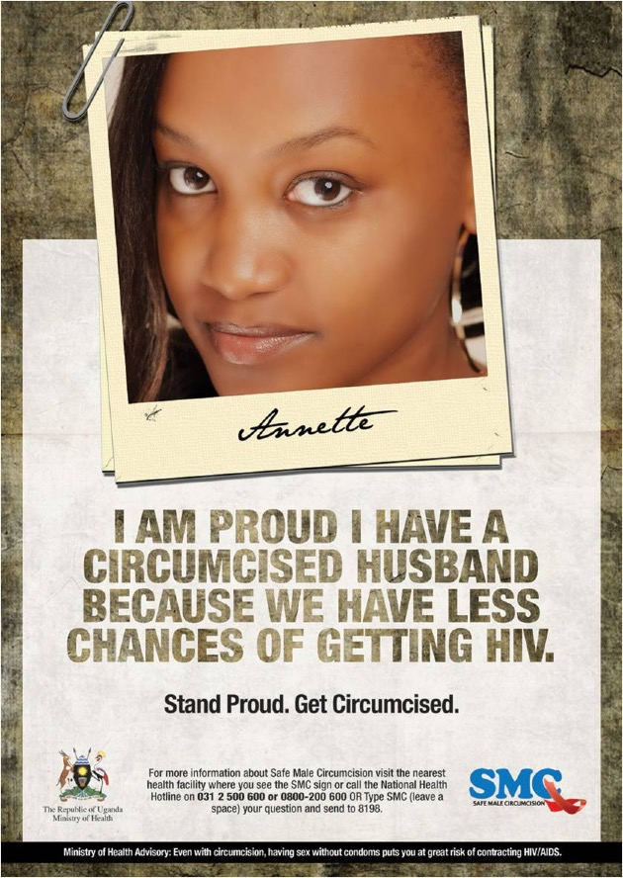

Title | Publisher & Year | Type of Material | Target Audience
“I am proud” campaign | Ugandan MoH, 2014 | Campaign Poster | Ugandan Women

Purpose | To convince Ugandan men to get circumcised by appealing to the positive female perception of the procedure.
Participant | The messaging has the dual capacity to appeal directly to men by calling on the opinions of their female partners while also perhaps convincing women to speak with their male partners about VMMC.
Medium | Most of the poster is an image of a young women framed to look like a polaroid clipped to a stack of photos. Her name “Annette” is included underneath in a font meant to mimic handwriting. The staging makes it look like a personal memento, evoking thoughts of the audience’s own partners.
Language | The amount of text on this flyer is small, but it is very impactful. The “I am proud” declaration touches on the masculine need to be respected by their partners. The statement that “we have less chances of getting HIV” following circumcision is factual incorrect, but it confers a sense of duty to the man to protect both of them. The messaging relies less on what is communicated to the audience and more on what is felt by those that read it.
World | This piece taps into the gender norms of men as the head of households and key decision-makers by emphasizing their ability to protect their female partners. Even though circumcision is only protective for female-to-male transmission, the messaging implies that the man has the power to protect both parties. There are also a variety of HIV prevention methods that can be employed and negotiated by either gender, but this poster only offers VMMC as a solution.
Intertextuality | N/A

Promotional Materials 5

Title | Publisher & Year | Type of Material | Target Audience
“It’s a question of health” campaign | USAID/Kenyan MoH, 2011 | Billboard | Kenyan Men

Purpose | To convince Kenyan men to get circumcised because it is a smart medical decision.
Participant | The message is aimed at men and it assumes that they have a positive relationship with the Kenyan health system and trust the opinion of a doctor.
Medium | The design and text are very simple because it is a billboard to be consumed quickly by a passing audience. The image of a kind doctor making direct eye contact is meant to build a sense of trust and responsibility with the viewer. There is also the implication that he himself is circumcised. Given the medical tone, the inclusion of international sponsor logos along the bottom add a level of credibility that speak subconsciously to the audience without text.
Language | Ironically the main text “it’s a question of health” is phrased as a statement of fact rather than a question, which supports the cultivated image of VMMC as the intelligent and obvious choice. The only supporting sentence asks men to “help reduce HIV”, framing VMMC as a community effort against the disease rather than an individual choice with individual risks and benefits.
World | The simplistic and clinical design of the poster creates the illusion that VMMC is a simple, straightforward decision. It is implied that all the information needed is on the poster, when in fact there is very little information at all. The image of the doctor figure is very much in line with that of a traditional Western physician, which may or may not be a local man’s experience in his healthcare system, but it is used as a touchpoint nonetheless.
Intertextuality | Although the style used in this billboard is distinct from the previous billboard example, both were rolled out in Kenya in the same year by the same sponsoring organizations.

Promotional Materials 6
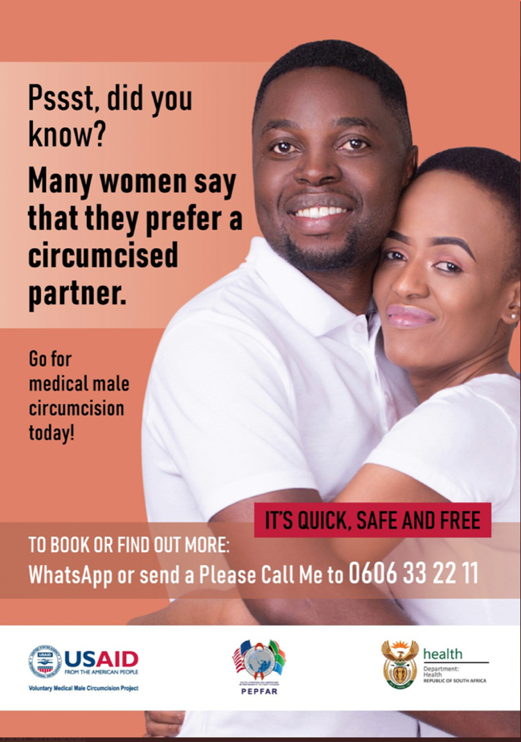

Title | Publisher & Year | Type of Material | Target Audience
“Psst, did you know” campaign | USAID/PEPFAR/ South African MoH, 2019 | Campaign Poster | South African Men

Purpose | To convince South African men to get circumcised on the basis that their female partner prefers it.
Participant | The message is directed at men, but it invites women into the conversation, which is a specific tactic not usually employed. The poster assumes that men value the opinion and input of their female sexual partner.
Medium | The image of the man and women embracing supports the assertion that women prefer a circumcised man just based on their physical closeness. The women smirking also suggests sexual undertones that are implied in the text as circumcision providing more sexual pleasure for both parties. At the same time, they are both dressed in white tops, which ties circumcision to cleanliness.
Language | Opening with “pssst” creates a sense of intrigue and intimacy, as if the poster is sharing a secret with the reader. There is an ambiguous meaning to the assertion that women “prefer” circumcision, which could mean for HIV protection or for sexual pleasure. Interestingly, HIV is not mentioned on the poster at all. By divorcing VMMC from its health benefits, the message frames it as an aesthetic or sexual choice.
World | The overall effect of the promotional material is to paint a world where circumcision brings a couple closer together because it is mutually beneficial (although the poster does not specify how). In a way, it encourages VMMC almost as if it is a gift for a man’s partner, completely separate from the irreversible surgical procedure that it is. It works to subvert circumcision as a cultural taboo and attempts to reverse the belief that it inhibits sexual pleasure.
Intertextuality | As the second piece to frame VMMC around the opinion of women, it is clear that certain strategies, like touching on gender roles and playing on a man’s sense of duty, are particular effective. This poster employs a more playful, casual angle using sexual innuendo, while the previous one relied on more medical-based persuasion. Both, however, underscore the value of the female perception in a man’s decision to pursue VMMC.

Promotional Materials 7
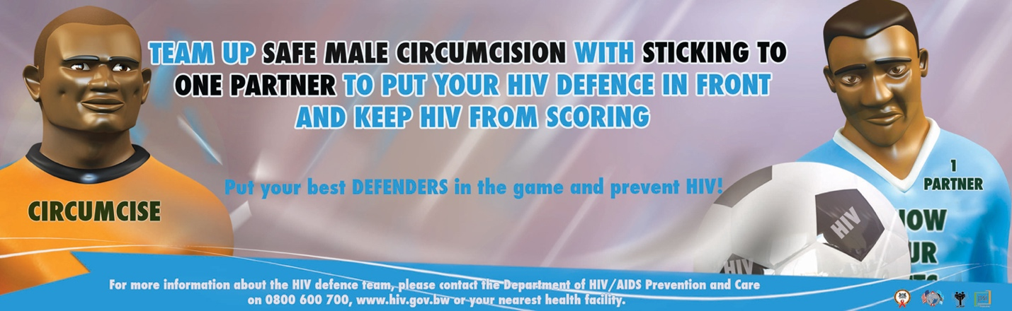

Title | Publisher & Year | Type of Material | Target Audience
“Team Up” campaign | PEPFAR, PSI, 2011 | Campaign Poster | Botswanan Men

Purpose | To convince Botswanan men to get circumcised by framing it and other HIV strategies as a smart defensive strategy akin to a football match.
Participant | The poster relies on men’s assumed affinity for football to explain the role of different HIV prevention methods.
Medium | Two animated figures appear to be on the same “team” with the goal of preventing HIV from “scoring”. The text implies that circumcision should be used in conjunction with other methods, but the images show circumcision dressed as a smiling goal keeper, while the player representing other prevention methods looks worriedly at an oncoming ball marked “HIV”. To the reader, the images potentially undermine the factual information provided by implying that circumcision is the most (or only) effective prevention method.
Language | The metaphor employed is quite elaborate, asking men to “team up” VMMC with only having one sexual partner to form a strong HIV defense. The implication is that HIV prevention is a game in which the opponent scoring means infection. The commitment to the metaphor in the visual elements and texts muddles the HIV messaging and fails to explain the relationship between various prevention methods. It is technically stated that VMMC is partial protective and should be used alongside other methods, but the overall effect elevates circumcision as more effective than other means.
World | The poster creates an alternate reality around a football match so that men can understand HIV prevention better, as if explaining it in plain text is too confusing. The text supports the idea of using multiple methods of protection, but a cursory read seems to imply that circumcision is the last line of defense because other methods are not as effective.
Intertextuality | In contrast to the other poster that employed a football metaphor, this piece focuses on the tactical aspect of “using your best defenders” and simply not losing, while the previous piece touched on elements of pride and success that come with circumcision. This piece, however flawed, did acknowledge the role of other prevention methods.

Appendix 2: Coding Samples

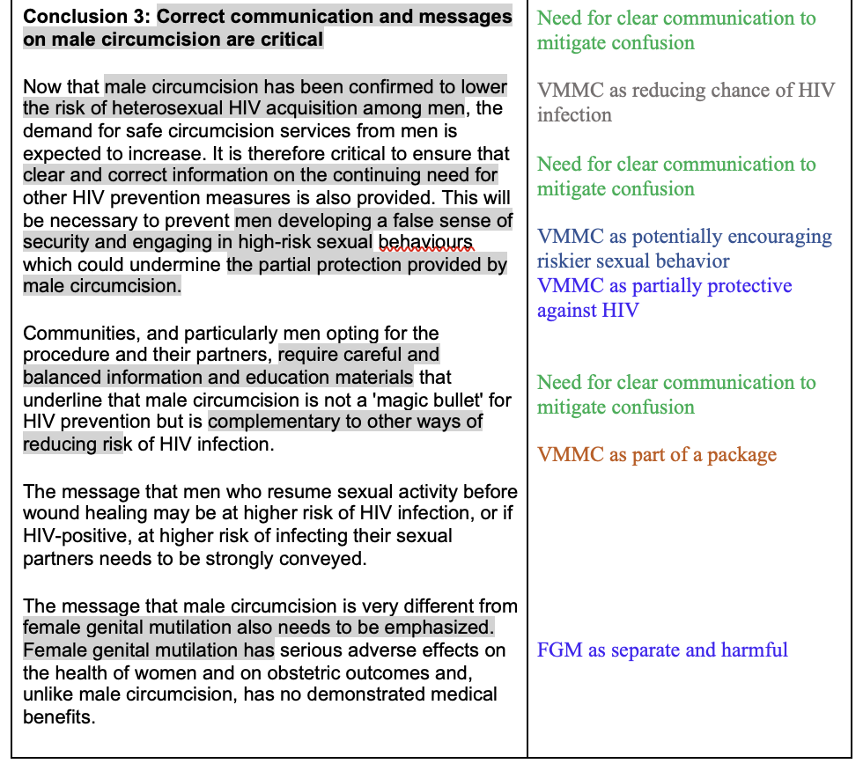
A section of coding from PD 1

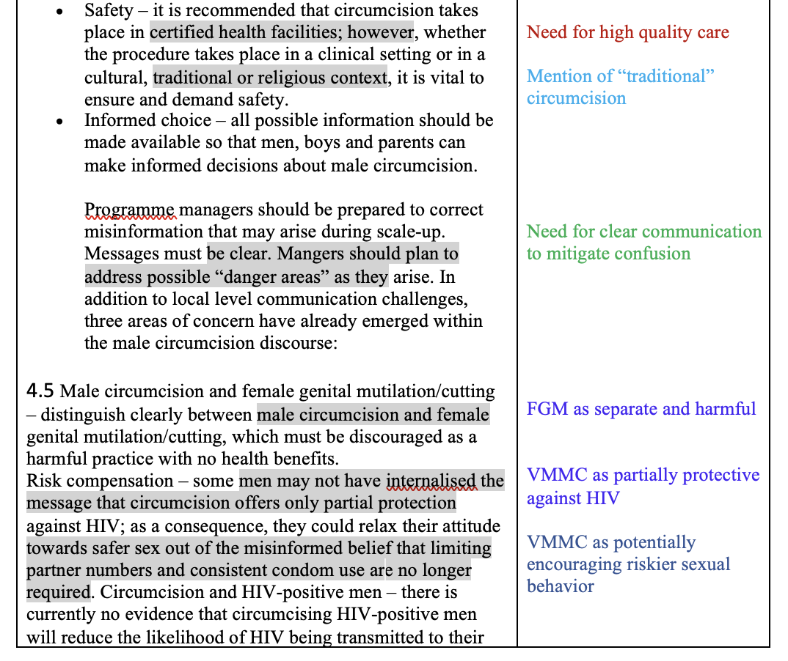
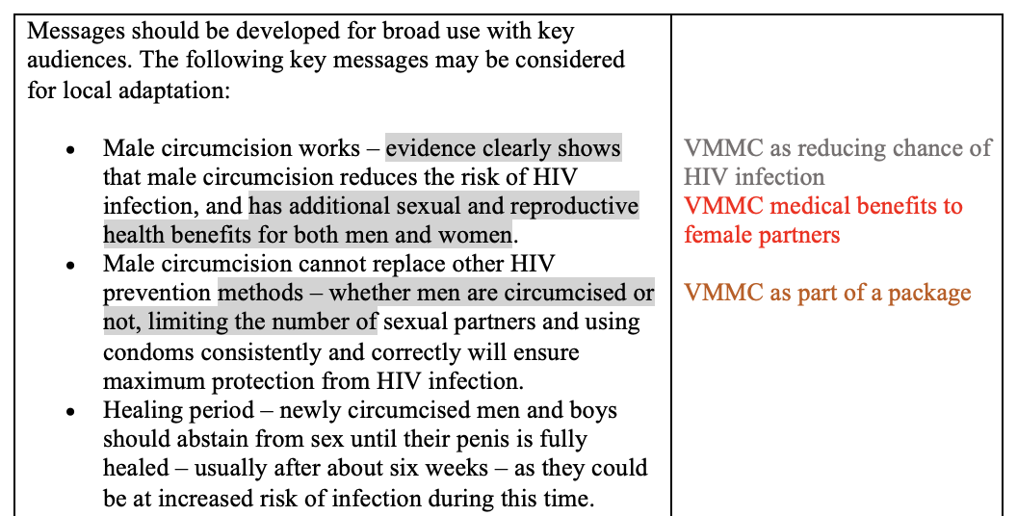
A section of coding from IM 1

I will refer to the region of “sub-Saharan Africa” throughout this paper. I recognize that this area contains many distinct and diverse countries and cultures and is not a monolith. My language is simply a reflection of VMMC verbiage that groups the entire area together. At times, there are specific anecdotes or statistics that are attributed to specific countries or tribes, but the VMMC intervention on the whole was applied unilaterally across the region. The repercussions of that decision will be discussed later on.
Although the gender-neutral “partner” is often used in policy and internal documents, it is implied that partners are female given the benefit of VMMC to heterosexual couples. This is made explicit in the promotional materials which use images of women when marketing to partners.
Emphasis added by author
“Traditional” is the euphemistic way implementors refer to cultural circumcision. It is considered counterproductive because not all ceremonial circumcisions result in the complete removal of foreskin, which is necessary to confer HIV protection.

