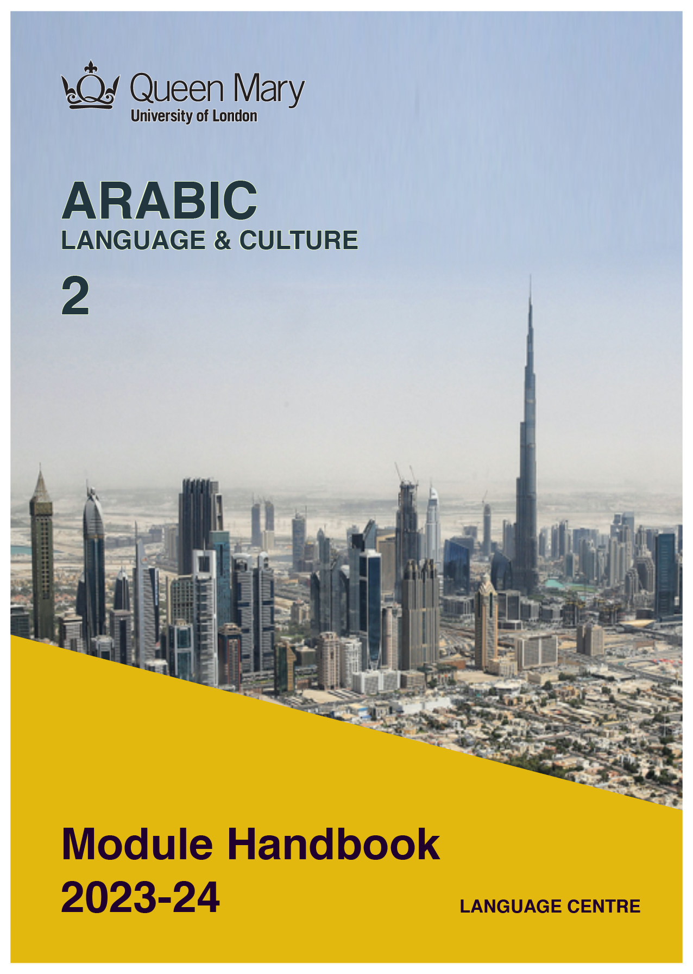

WELCOME TO LEARNING ARABIC

Welcome to the Learn a Language programme of Queen Mary. Language learning broadens the mind – you learn how different cultures and societies organize the world through language, you acquire a new vocabulary, new concepts, cultural knowledge, and become more interculturally aware. You can connect with people in another society in their language, a connection that is likely to be closer than if you make them speak your language or you communicate in a third language, such as English. You can use your language skills in your future career – employers consistently ask for better language skills in graduates. And, finally, language learning has cognitive benefits – studies show that bilinguals are more perceptive and have better memory. Speaking another language makes you more aware of language structure in general, and a better communicator.

MODERN ARABIC

Arabic is spoken by about 400 million people, is an official language in over 20 countries, and is one of the five most widely spoken languages in the world. Speakers of Arabic are in high demand. Knowledge of the language can help you in a government career, but it will also be of benefit in business and in industries such as engineering, medical, and in the non-profit and international relations sectors. Speaking Arabic can help you build relationships with business people in wealthy Middle Eastern countries like Qatar, the United Arab Emirates, and Saudi Arabia.

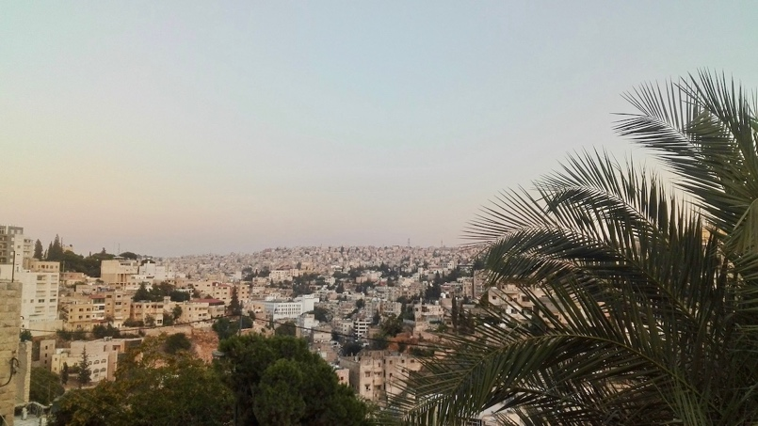

MODULE AIMS AND LEARNING OUTCOMES

Module Aims
The overall aims of this module are to help you to develop a sound foundation of knowledge of the Arabic language, and an ability to approach communication in the language in a confident and competent manner. You will move from no knowledge, or very rudimentary knowledge of the language, to become someone who is able to function effectively at a basic level when using language occurring in everyday situations relating to practical matters, and be able to understand basic as well as slightly more complicated t texts, including news and brief reports (equivalent to level A2 of the Common European Framework of Reference, CEFR).
You will learn the language through tasks designed to develop your skills in speaking and writing. You will also read and listen to simple texts, to develop your receptive skills. The aim is to achieve a balance between fluency and accuracy, which means grammar and structure are an integral part of this course.

How is the module structured and how will it be taught?
You will have two timetabled sessions (of two hours each) per week, over two semesters (4 hours over 22 weeks). The module is taught in-person, on campus. This means you will get 88 hours of tutor-led learning. The total learning hours for this module are 300 hours, which means that in addition to the 88 tutor-led hours, you need to invest an additional 212 hours through independent study. You will do this by doing homework set by your tutor, completing tasks online on QMplus and in the course book, revising class materials and vocabulary, preparing for assessments, and using other opportunities to speak, listen to and read Arabic outside the classroom.

The in-person and online sessions will be mainly used for interactive tasks and skills development (speaking, listening, writing), while explanations of grammar and introduction of new material will be delivered mainly via recorded video clips.
This means you will sometimes be asked to watch a video, go over a PowerPoint presentation, or read a text in preparation for a class, as well as completing exercises and tasks after sessions, for consolidation (e.g, exercises in the course book, on QMplus, recording yourself, etc.).

Module Learning Outcomes

You should develop the following outcomes related to academic content:
A1 | To achieve effective communication in Modern Arabic at level B1/B2 CEFR with competent speakers of the language.
A2 | To exploit, for a variety of purposes, a range of materials, written and spoken, in Modern Arabic level B1/B2 CEFR.
A3 | To demonstrate a knowledge and understanding of the structures, registers and, as appropriate, varieties of Modern Arabic at level B1/B2 CEFR.
A4 | To demonstrate a knowledge and understanding of Arabic cultures and societies gained through the study of basic written and aural texts and other cultural products in the target language.

You should develop the following disciplinary skills:
B1 | To analyze aspects of the target language and make use of them in a broadly professional context.
B2 | To gather and process information related to Arabic language and cultures from a variety of paper, audiovisual and electronic sources and communicate this information, both orally and in writing.
B3 | To use ICT effectively both as a means of communication and as an aid to learning.
B4 | To demonstrate some ability as an independent learner of the language in order to take further the study of Arabic language and cultures.

You should develop the following general attributes:
C1 | To be able to operate in more than one language, develop a global perspective and use the knowledge acquired to increase employability and engage with the professional world.
C2 | To apply analytical skills to investigate unfamiliar problems and to use the knowledge acquired to enrich research.
C3 | To be able to work effectively in diverse communities.
C4 | To work individually and in collaboration with others reflecting upon and assessing one's progress in learning the Target Language.

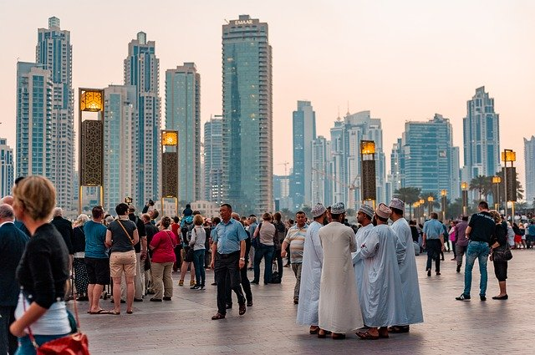

EXPECTED STUDY TIME

If you are taking this module for credit, you will get 30 credits, which equals 300 learning hours. 88 of those will be tutor-led through synchronous sessions, the rest you are expected to invest between the weekly sessions, in your own time, via guided learning, using resources on QMplus, in your course book, and other material as advised by your tutor. Even if you are not taking the module for credit, you should invest the same amount of time in order to make progress as expected.

30 credit module – 300 learning hours
Tutor-led learning | 88 hours
Interactive classes
Self-directed learning | 212 hours
Preparations for synchronous sessions | 44
Completing set homework | 44
Self-study after class (QMplus, course book, etc.) | 88
Preparation for assessments | 36
Total | 300

CONTACT DETAILS AND OFFICE HOURS OF YOUR TUTOR

 | Module tutor | Office | Email | Office hours
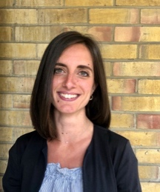 | Silvia Lodi | Bancroft 1.36 | s.lodi@qmul.ac.uk | Wednesday  2-3pm

You can use tutors’ office hours to get advice and feedback. Please email your tutor to book an appointment.

LEARNING PLAN

SEMESTER 1
week | main topic | LEARNING OUTCOMES |  | LANGUAGE FOCUS | CULTURE | SELF-STUDY (qm+)
 | What is the main topic of the week? | What will I be able to do with the language I am learning this week |  | What particular language features will be covered? | What cultural information will I learn this week? | What am I expected to do outside class from one week to the next?
1 | Introducing yourself | Introducing yourself and asking others  Saying where you live, study or work  Giving your nationality  Saying how old someone is  Greetings and leave-taking |  | Present verb tense (revision)  Nisba adjectives  Question forms | Geography of the Middle East: countries and capital cities
2 | Comparing things | Making comparisons |  | Comparatives and superlatives  Verbs: to be (past form)  Irregular verbs | Video: an Egyptian man talks about the Egypt of his youth | Introduce yourself and your family
3 | Family and Childhood | Describing people: appearance and character  Making comparisons  Talking about childhood and past events |  | Personal pronouns  Possessive adjectives  Numbers 1-100  Comparatives and superlatives Past verb tense  Inna and ‘its sisters’  Case endings: the nominative and the accusative case | Umm Kulthoum and Kairokee  Music in Egypt | Write about your childhood  Write a short biography of your favourite singer
4 | Education | Talking about education at university |  | Broken plurals: Pattern 5 | Video: a Tunisian girl talks about her studies  Algerian education system
5 | Business | Talking about business and politics |  | Word order and verbs  Past tense negative form | Al-Jazeera
6 | Future plans | Talking about future plans and holidays |  | Months of the year  Future verb tense | Video: an Egyptian man talks about his future plans
7 | Study Week: Please complete the tasks on QMPlus during Study Week / Writing Project of 275-325 words
8 | Daily routine | Telling the time  Describing your typical day |  | Months  Present verb tense  Adverbs of frequency  Irregular verbs | The Islamic calendar  The Arab world: Arabic in Syria  Video: an Egyptian man describes his daily routine | Describe your plans for next week
9 | House and home | Describing your house: floors, rooms and furniture  Understanding real estate advertisements |  | Connectors  Plurals  Case endings: the genitive case | Words to describe dwellings  Arabic traditional buildings | Describe your house
10 | Work | Talking about housework  Writing a CV |  | Broken plurals: Patterns 1-5  Irregular verbs | The Arab world: Arabic in Saudi Arabia
11 | Test / Sports and leisure interests | Listening Test  Talking about sport and leisure interests  Saying what you enjoy and not enjoy doing  Giving reasons |  | Verbal noun  Active and passive participle  Connectors | The Arab world: Arabic in Morocco | Describe your favourite sport or leisure activity
12 | Test | Reading, Grammar and Writing test  Listening test
SEMESTER 2
week | main topic | OBJECTIVES |  | LANGUAGE FOCUS | CULTURE | SELF-STUDY (qm+)
 | What is the main topic of the week? | What will I be able to do with the language I am learning this week |  | What particular language features will be covered? | What cultural information will I learn this week? | What am I expected to do outside class from one week to the next?
1 | Travel | Asking the way and understanding directions |  | Imperative verb tense  Verbs: to be (past form) | The pilgrimage | Describe your last holiday
2 | Tourism | Saying where you’ve been on holiday  Talking about future plans and holidays |  | The jussive  Past tense negative forms  Future tense negative forms | The Arab world: Arabic in Tunisia  Tourism in the Middle East
3 | Food | Buying food  Describing flavours and ingredients  Ordering a meal in a restaurant |  | Verbs: The 9 derived forms | The Arab world: Arabic in Lebanon  The month of Ramadan | Write the recipe of your favourite dish
4 | At the clothes shop | Describing the outfit  Buying clothes  Describing colour |  | Verbs: The 9 derived forms  Relative pronouns | The Arab world: Arabic in Iraq  Arabic traditional clothing  Bargaining | Role-play: shop assistant and customer
5 | Health and happiness | Talking about the body  Talking about fitness |  | Verbs: The 9 derived forms | The Arab world: Arabic in Sudan | Role-play: doctor and patient
6 | News and media | Talking about the news  Comparing media |  | Formal Arabic | The Arab world: Arabic in the Gulf and Yemen  Al-Jazeera | Watch a daily news video and make notes
7 | Study Week: Please complete the coursework during Study Week: Writing Project of 275-325 words
8 | Arts | Talking about cultural activities  Talking about past habits |  | Kana and past verb tense | The Arab world: Jordan and Palestine
9 | Cinema | Talking about film genres  Reviewing books and films |  | Dual verbs | Ghassan Kanafani: films adapted from books | Write about your favourite film
10 | Weather | Talking about weather and climate  Understanding weather forecasts |  | Conditional sentences | The Arab world: Arabic in the Emirates | Choose a city, watch a weather forecast video for the week and make notes
11 | Environment | Talking about tourism and the environment  Talking about possibilities |  | Conditional sentences
12 | Test | Oral test

SEMESTER DATES 2023-24

Semester 1 | Dates
Teaching Weeks 1 to 6 | 25 Sep – 5 Nov 2023
Study Week (Week 7) | 6 Nov – 10 Nov 2023
Teaching Weeks 8 to 12 | 13 Nov – 15 Dec 2023
January exam period | 4 – 19 January 2024
Semester 2 | Dates
Teaching Weeks 1 to 6 | 22 Jan – 1 Mar 2024
Study Week (Week 7) | 4 Mar – 8 Mar 2024
Teaching Weeks 8 to 12 | 11 Mar – 12 Apr 2024
Exam period | 2 May – 31 May 2024
Summer Resit period | August 2024

LEARNING MATERIALS

 | Course book | ISBN | Notes
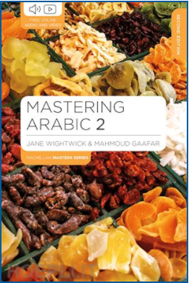 | Jane Wightwick and Mahmoud Gafaar (2020) Mastering Arabic 2 (2nd edition) | 9781352008500 | You can buy the hard copy or you can buy the book as an e-book.  The hard copy costs £32 and gives you access to online materials. Check for second-hand options, which will be cheaper.

OTHER RESOURCES:
- Reading list - Click here to see the list of Arabic language textbooks and grammars in the QMUL Library, plus podcasts and web resources. Via this link you can directly view and read the resources online if they are held as e-books in the Library.
- See the ‘Online resources’ Tab on QMplus
- Online Resources for Mastering Arabic 1 - link
- Online Resources for Mastering Arabic 2 - link
- Online dictionary - link
- Al-Jazeera - link
- Podcast on Middle East - link
- Baraem TV (Arabic cartoons) - link

Cultural resources in London related to Arabic:

The British Library, Arabic collections - link
The British Museum, The Albukhary Foundation Gallery of the Islamic world, Rooms 42-43 - link
The British Museum, Egyptian Sculpture - link
Leighton House Museum - link
P21 Gallery, Art Exhibitions - link
Victoria and Albert Museum, Islamic Middle East, Room 42, The Jameel Gallery - link

QMplus Module page

The QMplus module page is the place to go to regularly before and after class, to prepare for the weekly sessions and find resources for self-study. Here you will find the materials used in class in addition to the course book, and additional resources and activities that help you consolidate and extend the material covered in class. You will also find links to web resources and videos on the language and cultural information.

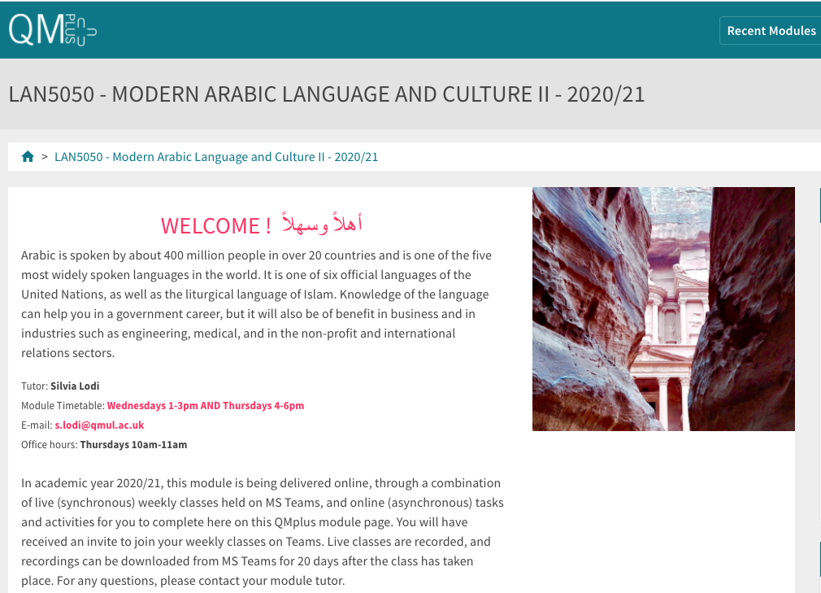

Free Language Speaking Practice

Language learners within the Queen Mary community can book 30-minute online speaking sessions with native or proficient speakers, for 15+ languages, for free. You can practise your speaking skills in the language you're learning, in an informal way. Sessions are offered by volunteers – QMUL students and staff who enjoy helping others learn. It’s a great way to practise the language, and get to know Queen Mary students from different schools and different backgrounds.

More information and booking link

FEEDBACK

- How can you check your progress throughout the module?
- What feedback can you expect from your tutor?

Language classes are highly interactive and participative, which means your tutor will give you regular instant feedback on your participation in class. Your tutor will also give you feedback on your submitted homework, and on activities that you complete on QMplus, if there is no automated feedback.

You will get feedback on the draft (formative submission) of your Writing Assignment, and will then have the opportunity to improve your writing before you submit it for summative assessment (counting towards your mark).

Your tutor is available during Feedback & Advice hours (check the times in the Tutor profile above), which you can use for a one-to-one meeting to discuss your progress. Please email your tutor beforehand.

ASSESSMENT INFORMATION

Assessment if you take the module FOR credit

If you are taking this module for credit, you need to complete and pass the assessments in order to gain the credits. The credits will count towards the total number of credits you need in each academic year (120 per year for undergraduate students).

Assessment if you take the module NOT for credit

If you are taking this module as a non-credit bearing module, it will not count towards your programme and you will not receive credits. However, if you complete and pass the module, you will receive a Certificate of Completion stating that you have passed the module, and with what grade. The requirements are that you:

- Have attended at least 65% of the taught sessions
- Take and pass the module assessment for non-credit seeking students to show that you have achieved the learning outcomes of the module
If you do not take the module assessment but meet the attendance requirement, you will receive a Certificate of Attendance, without a grade.

Assessment is carried out through formal and informal reading, writing, listening and speaking tasks. The assessment structure depends on whether you are taking the module for credit or not, and whether you take the year-long or the one-semester option. Check your module code and note the assessment structure relevant to you, below:

Assessment structure:

FOR CREDIT

LAN5050: Arabic Language & Culture 2: Students taking the module for credit, year-long (30 credits)
LAN5050  Assessment Title | Weight towards final grade % | Length | Due Date
Coursework
- Reading &Listening Test | 10% |  | Semester 1, Week 11 (December)
- Writing Assignment | 20% | 240-280 words | Submission (formative):  Semester 2, Week 7  Feedback given in Week 8  Submission (summative):  Semester 2, Week 9
- Oral exam | 30% |  | Semester 2, Week 12
Written exam | 40% | 2 hours | May Examination period

LAN 5051: Arabic Language & Culture 2a: Students taking the module for credit, Semester A only (15 credits)
LAN5051  Assessment Title | Weight towards final grade % | Length | Due Date
Coursework
- Reading &Listening Test | 10% |  | Semester 1, Week 11 (December)
- Writing Assignment | 20% | 220-260 words | Submission (formative):  Week 9  Feedback given in Week 10  Submission (summative):  First week in January
Oral exam | 30% |  | Semester 1, Week 12
Written exam | 40% | 2 hours | January Examination period

LAN 5052: Arabic Language & Culture 2b: Students taking the module for credit, Semester B only (15 credits)
LAN5052  Assessment Title | Weight towards final grade % | Length | Due Date
Coursework
- Reading &Listening Test | 10% |  | Semester 2, Week 11
- Writing Assignment | 20% | 240-280 words | Submission (formative):  Semester 2, Week 7  Feedback given in Week 8  Submission (summative):  Semester 2, Week 9
Oral exam | 30% |  | Semester 2, Week 12
Written exam | 40% | 2 hours | May Examination period

NOT FOR CREDIT

LAN5055/LAN5056/LAN5057: Arabic Language & Culture 2, 2a, 2b: Students taking the module NOT for credit, year-long. In order to get a Certificate of Completion, you need to pass the following assessments:
LAN5055/LAN5056/LAN5057  Assessment Title | Weight towards final grade % | Due Date
Coursework
- Reading &Listening Test | 20% | Week 11
- Writing Assignment | 30% | Submission (formative): Week 7  Feedback given in Week 8  Submission (summative): Week 9
- Oral test | 50% | Last week of the module

Your tutor will give you assessment briefs for each of the assessments.

MARKING CRITERIA FOR ASSESSMENT OF WRITING SKILLS

Task achievement | - How fully has the task brief been achieved? Does the text have the required length?*  - How fully, and in what breadth, has the topic been covered?  - If the task consists of description, how comprehensive is the description?  - If the task consists of argumentation, has the topic been considered from different angles?  - Have different aspects of the topic been elaborated?  - How relevant, and how correct, is the information included?
Organisation, Coherence and cohesion | - How clear is the text, and how logical is its structure?  - How appropriate, and how varied, are the connectors and cohesive devices used to link sentences?  - How well is paragraphing used, and how well are paragraphs connected to achieve a coherent text? Does the text read smoothly, or are there jumps?
Range  (Grammar, Syntax, Vocabulary) | - Are the sentence and grammatical structures appropriate for the level? (at lower levels, simple sentences will be fine, while at higher levels, the inclusion of more complex structures will be expected)  - How wide is the range of vocabulary used in the text? (simple and frequent lexical items will be fine at lower levels, while at higher levels, more varied vocabulary, use of nuance, and use of idiomatic expressions will be expected)
Accuracy (Grammar, Syntax, Vocabulary) | - How accurate are the grammar and sentence structures? If there are errors, are they minor, or do they impact the communication more severely? To what extent does the reader have to make an effort to understand what you are trying to communicate?  - How good is your command of the vocabulary? Do the words you have chosen have the right meaning to express what you want to say? If there are errors, do they just make the passage sound somewhat clumsy or do they obscure the meaning of the sentence and hinder communication?  - How well are lexical collocations used? (that is, words that normally go together, e.g. we say ‘to take a picture’ and not ‘to make a picture’, ‘to make a mistake’ and not ‘to do a mistake’, ‘to do someone a favour’ but not ‘to make someone a favour’)
*If you submit work significantly under the word limit, marks will be deducted.

MARKING CRITERIA FOR ASSESSMENT FOR SPEAKING SKILLS

Task achievement | - Have you completed the task that has been set? Have you completed it fully or only partially?
Range of vocabulary and structures | - How wide is the range of vocabulary that you use? Is it quite simple and basic, or do you master the full range of vocabulary that has been covered in the module?  - What kind of sentence structures do you use? Are they simple (such as a list of short main clauses), or are they more complex (using longer sentence structures with subordinate clauses that are well connected by conjunctions)?
Accuracy of vocabulary and grammatical structures | - How accurate is the vocabulary you are using? Are you using words with the right meaning to express what you want to say? How often do you pick words that don’t quite fit?  - How accurate are the grammar and the sentence structures that you are using? How frequently do you make mistakes? Are the mistakes minor or do they make it hard for your conversation partner to understand what you are trying to say?
Pronunciation | - How well do you pronounce the words and sounds in the target language? Is your pronunciation smooth and clear, with the correct word stress and sentence intonation, or is it difficult for the listener to recognise some of the words you produce?
Fluency | - How natural is the speed of your speech? (Note that slight hesitations, restarting a sentence, pausing to find the right word, etc., is part of natural speech). Are there many, long and ‘unnatural’, pauses and hesitations? Is there a breakdown of communication? Can you repair gaps by paraphrasing a word that you cannot find, or by reformulating a sentence?
Interactional skills | - How well can you use conversational norms when interacting with someone else: For example, opening a conversation, maintaining it, asking for clarification, giving appropriate responses to prompts from your conversation partner, taking turns in the conversation, closing (ending) the conversation.

