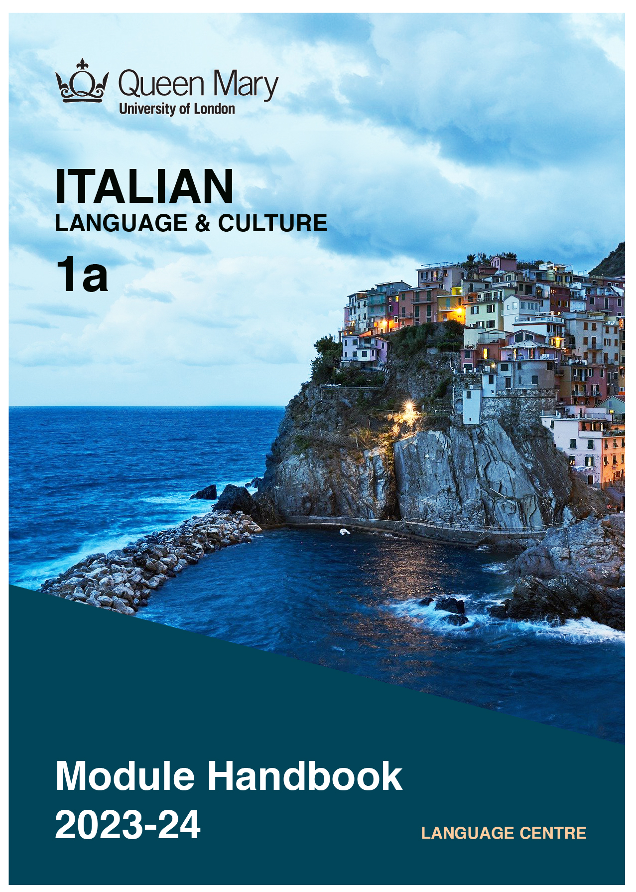

WELCOME TO LEARNING ITALIAN

Welcome to the Learn a Language programme of Queen Mary. Language learning broadens the mind – you learn how different cultures and societies organize the world through language, you acquire a new vocabulary, new concepts, cultural knowledge, and become more interculturally aware. You can connect with people in another society in their language, a connection that is likely to be closer than if you make them speak your language or you communicate in a third language, such as English. You can use your language skills in your future career – employers consistently ask for better language skills in graduates. And, finally, language learning has cognitive benefits – studies show that bilinguals are more perceptive and have better memory. Speaking another language makes you more aware of language structure in general, and a better communicator.

ITALIAN LANGUAGE

Knowledge of Italian is very useful in the fields of art and culture, music, business and design. The Italian language is key to study and research in the fields of art history, literature, archaeology and philosophy. Mentioning Dante and La Divina Commedia never hurts …
Italy has been a favourite travel destination for centuries. A UNESCO report states that over 60% of the world’s art treasures are to be found in Italy, and Italy is the country with the highest number of UNESCO cultural heritage sites.
Knowing Italian enables you to better appreciate and enjoy classical music. Musicians and opera singers consider it a key professional skill. With Italian designers such as Versace, Gucci, Armani, Benetton, and Prada, Italy is also the home of fashion and design.

MODULE AIMS AND LEARNING OUTCOMES

Module Aims
The overall aims of this module are to help you to develop a sound foundation of knowledge of the Italian language, and an ability to approach communication in the language in a confident and competent manner. You will move from no knowledge, or very rudimentary knowledge of the language, to become someone who is able to function effectively at a basic level when using language occurring in everyday situations relating to practical matters, and be able to understand basic texts (equivalent to level A1 of the Common European Framework of Reference, CEFR).
You will learn the language through tasks designed to develop your skills in speaking and writing. You will also read and listen to simple texts, to develop your receptive skills. The aim is to achieve a balance between fluency and accuracy, which means grammar and structure are an integral part of this course.

How is the module structured and how will it be taught?
You will have one timetabled session (of two hours) per week, over two semesters (2 hours over 22 weeks). The module will be taught in-person, on campus.

This means you will get 44 hours of tutor-led learning. The total learning hours for this module are 150 hours, which means that in addition to the 44 tutor-led hours, you need to invest an additional 106 hours through independent study. You will do this by doing homework set by your tutor, completing tasks online on QMplus and in the course book, revising class materials and vocabulary, preparing for assessments, and using other opportunities to speak, listen to and read Italian outside the classroom.

The in-person and online sessions will be mainly used for interactive tasks and skills development (speaking, listening, writing), while explanations of grammar and introduction of new material will be delivered mainly via recorded video clips.
This means you will sometimes be asked to watch a video, go over a PowerPoint presentation, or read a text in preparation for a class, as well as completing exercises and tasks after sessions, for consolidation (e.g, exercises in the course book, on QMplus, recording yourself, etc.).

Module Learning Outcomes

You should develop the following outcomes related to academic content:
A1 | To achieve effective communication in Italian at level A1 CEFR with competent  speakers of the language.
A2 | To exploit, for a variety of purposes, a range of materials, written and spoken, in Italian level A1 CEFR.
A3 | To demonstrate a knowledge and understanding of the structures, registers and, as appropriate, varieties of Italian at level A1 CEFR.
A4 | To demonstrate a knowledge and understanding of Italian culture and society gained through the study of basic written and aural texts and other cultural products in the target language.

You should develop the following disciplinary skills:
B1 | To analyze aspects of the target language and make use of them in a broadly professional context.
B2 | To gather and process information related to Italian language and cultures from a variety of paper, audiovisual and electronic sources and communicate this information, both orally and in writing.
B3 | To use ICT effectively both as a means of communication and as an aid to learning.
B4 | To demonstrate some ability as an independent learner of the language in order to take further the study of Italian language and cultures.

You should develop the following general attributes:
C1 | To be able to operate in more than one language, develop a global perspective and use the knowledge acquired to increase employability and engage with the professional world.
C2 | To apply analytical skills to investigate unfamiliar problems and to use the knowledge acquired to enrich research.
C3 | To be able to work effectively in diverse communities.
C4 | To work individually and in collaboration with others reflecting upon and assessing one's progress in learning the Target Language.

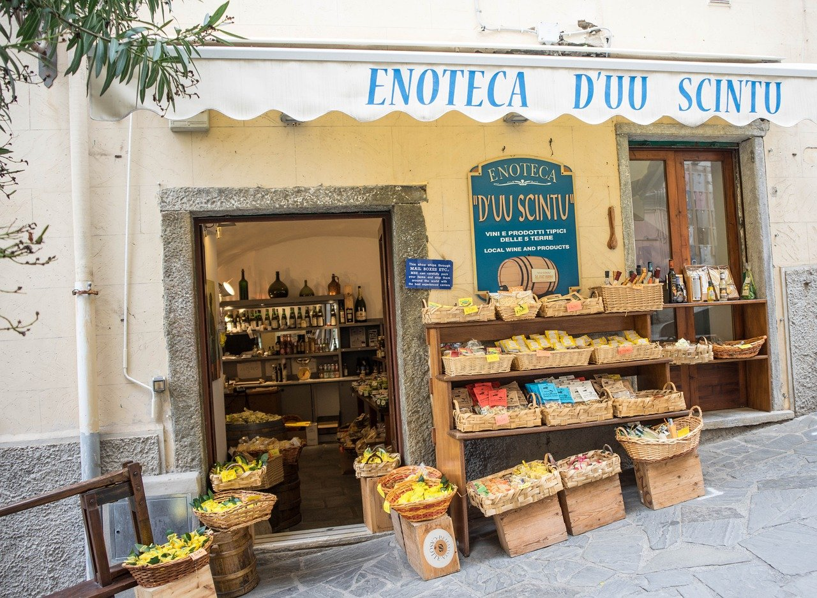

EXPECTED STUDY TIME

If you are taking this module for credit, you will get 15 credits, which equals 150 learning hours. 44 of those will be tutor-led through synchronous sessions, the rest you are expected to invest between the weekly sessions, in your own time, via guided learning, using resources on QMplus, in your course book, and other material as advised by your tutor. Even if you are not taking the module for credit, you should invest the same amount of time in order to make progress as expected.

15 credit module – 150 learning hours
Tutor-led learning | 44 hours
Interactive classes
Self-directed learning | 106 hours
Preparations for synchronous sessions | 22
Completing set homework | 22
Self-study after class (QMplus, course book, etc.) | 44
Preparation for assessments | 18
Total | 150

CONTACT DETAILS AND OFFICE HOURS OF YOUR TUTOR

 | Module tutor | Office | Email | Online office hours
 | Silvia Lodi | Bancroft 1.36 | s.lodi@qmul.ac.uk | Wednesday  1-2 pm

You can use tutors’ office hours to get advice and feedback. Please email your tutor to book an appointment.

LEARNING PLAN

SEMESTER 1
week | main topic | learning outcomes | language focus | cuLTURE | SELF-STUDY (qm+)
 | What is the main topic of the week? | What will I be able to do with the language I am learning this week | What particular language features will be covered? | What cultural information will I learn this week? | What am I expected to do outside class from one week to the next?
1 | The Alphabet & Greetings | Introducing yourself and asking others  Greetings and leave-taking | Italian letters and sounds | ‘Made in Italy’
2 | Introducing yourself | Communicating in class  Introducing yourself and asking others | Vocabulary of the classroom  Personal pronouns  Indefinite articles | Titles used in Italian: signora/e/ina | Write a paragraph introducing yourself
3 | Myself and others | Saying how old someone is  Saying what you study or work and where | Numbers 0-30  Present tense: to be | Hand gestures
4 | Nationality and countries | Giving your nationality  Saying where you were born | Adjectives of nationality Negative form
5 | Jobs and professions | Speak/ask about one's job | Gender in nouns  Demonstrative Pronouns  Present tense: verbs to ‘have’, to 'do' | Famous Italian people
6 | Introducing others | Saying where you live and who with | Present tense: verbs to 'be called', to 'live' | Speak in both informal and formal ways (tu vs. Lei)
7 | STUDY WEEK: Please complete the following work during Study Week: See QM+
8 | Italian cities | Learning about famous Italian cities | Numbers 30-100  Interrogative Pronouns |  | Describe where you live in London
9 | City life | Vocabulary of the city (public places and types of stays)  Asking for information | There is/are vs. to be
10 | Travelling | Planning a trip  Booking a hotel room | Prepositions 'from', 'to' Definite articles  Agreements for names and adjectives | The most visited places in Italy | Describe a stay abroad in Rome
11 | Reading and Listening Test  Time, days, and months | Revision  Asking/Telling the time | Days of the week  Pronunciation: Double consonants |  | Revision for end-of-term test
12 | Festivities and Celebrations in Italy Revision | Learning about festivities and traditions | Months and Cardinal numbers (1st, 2nd, 3rd,…) | Festivities and Celebrations in Italy

SEMESTER 2
week | main topic | LEARNING OUTCOMES | LANGUAGE FOCUS | CULTURE | SELF-STUDY (qm+)
 | What is the main topic of the week? | What will I be able to do with the language I am learning this week | What particular language features will be covered? | What cultural information will I learn this week? | What am I expected to do outside class from one week to the next?
1 | Daily routine | Describing your typical day | Present tense: verbs in 'are'  Reflexive verbs |  | Describe your typical week
2 | Daily routine | Describing your typical day | Adverbs of frequency
3 | Leisure time and Weekends | Talking about your leisure interests | Present tense: verbs in 'ere' | Italian Music | Describe your favourite sport or leisure activity
4 | Family | Describing your family | Possessive adjectives | I Cesaroni & Un medico in famiglia - TV series | Describe a family picture of yours in few sentences
5 | Sport | Talking about sport | Prepositions
6 | Going out | Talking about going out  Inviting someone to do something | Present tense: verbs in 'ire' | Where to eat out in Italy
7 | STUDY WEEK: Please complete the following work during Study Week: See QM+
8 | Food & Drinks | Describing flavours and ingredients  Ordering a meal in a restaurant | Asking politely (potere vs. volere)  Partitive articles | Italian food products
9 | Likes and dislikes | Expressing likes and dislikes | Present tense: imperative  Present tense: to 'like'
10 | Directions | Asking the way and understanding directions Describing a place and saying where it is located | Present tense: dovere
11 | Transportation | Saying how you travel to university/work  Buying a ticket  Asking about times and platforms | Colours  Irregular verbs | Song by Modà: Come un pittore | Role-play: travel agent and traveller
12 | Oral Test

SEMESTER DATES 2023-24

Semester 1 | Dates
Teaching Weeks 1 to 6 | 25 Sep – 5 Nov 2023
Study Week (Week 7) | 6 Nov – 10 Nov 2023
Teaching Weeks 8 to 12 | 13 Nov – 15 Dec 2023
January exam period | 4 – 19 January 2024
Semester 2 | Dates
Teaching Weeks 1 to 6 | 22 Jan – 1 Mar 2024
Study Week (Week 7) | 4 Mar – 8 Mar 2024
Teaching Weeks 8 to 12 | 11 Mar – 12 Apr 2024
Exam period | 2 May – 31 May 2024
Summer Resit period | August 2024

LEARNING MATERIALS

 | Course book | ISBN | Notes
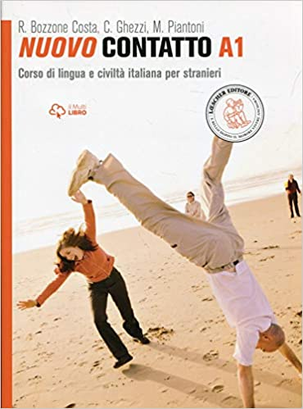 | Ghezzi, C., Bozzone Costa, R. and Piantoni, M. (2014) Nuovo Contatto. Volume A1. Torino: Loescher Coedizioni | 9788858308608

OTHER RESOURCES:
- QMPlus
- Reading List

- Online dictionaries:
  - Dizionario Cambridge Inglese-Italiano
  - Vocabolario monolingue Treccani

Cultural resources in London related to Italian:

Istituto Italiano di Cultura - link
Cinema Italia UK, in Genesis Cinema (Mile End Rd) and in Regent Street Cinema - link
Italian art (including Leonardo da Vinci, Michelangelo, Raffaello) at the National Gallery
Italian art at the Courtauld Gallery
Estorick Collection of Modern Italian Art
Mercato Metropolitano (Food and Wine market) in Elephant&Castle and Mayfair - link
Eataly London (Restaurant and Food market) in Liverpool Street - link

QMplus Module page

The QMplus module page is the place to go to regularly before and after class, to prepare for the weekly sessions and find resources for self-study. Here you will find the materials used in class in addition to the course book, and additional resources and activities that help you consolidate and extend the material covered in class. You will also find links to web resources and videos on the language and cultural information.

Free Language Speaking Practice

Language learners within the Queen Mary community can book 30-minute online speaking sessions with native or proficient speakers, for 15+ languages, for free. You can practise your speaking skills in the language you're learning, in an informal way. Sessions are offered by volunteers – QMUL students and staff who enjoy helping others learn. It’s a great way to practise the language, and get to know Queen Mary students from different schools and different backgrounds.

More information and booking link

FEEDBACK

- How can you check your progress throughout the module?
- What feedback can you expect from your tutor?

Language classes are highly interactive and participative, which means your tutor will give you regular instant feedback on your participation in class. Your tutor will also give you feedback on your submitted homework, and on activities that you complete on QMplus, if there is no automated feedback.

You will get feedback on the draft (formative submission) of your Writing Assignment, and will then have the opportunity to improve your writing before you submit it for summative assessment (counting towards your mark).

Your tutor is available during Feedback & Advice hours (check the times in the Tutor profile above), which you can use for a one-to-one meeting to discuss your progress. Please email your tutor beforehand.

ASSESSMENT INFORMATION

Assessment if you take the module FOR credit

If you are taking this module for credit, you need to complete and pass the assessments in order to gain the credits. The credits will count towards the total number of credits you need in each academic year (120 per year for undergraduate students).

Assessment if you take the module NOT for credit

If you are taking this module as a non-credit bearing module, it will not count towards your programme and you will not receive credits. However, if you complete and pass the module, you will receive a Certificate of Completion stating that you have passed the module, and with what grade. The requirements are that you:

- Have attended at least 65% of the taught sessions
- Take and pass the module assessment for non-credit seeking students to show that you have achieved the learning outcomes of the module
If you do not take the module assessment but meet the attendance requirement, you will receive a Certificate of Attendance, without a grade.

Assessment is carried out through formal and informal reading, writing, listening and speaking tasks. The assessment structure depends on whether you are taking the module for credit or not, and whether you take the year-long or the one-semester option. Check your module code and note the assessment structure relevant to you, below:

Assessment structure:

NOT FOR CREDIT

LAN4176: Italian Language & Culture 1a: Students taking the module NOT for credit, year-long.
In order to get a Certificate, you need to pass the following assessments:
LAN4176  Assessment Title | Weight towards final grade % | Length | Due Date
Coursework
- Reading & Listening Test | 20% |  | Semester 1, Week 11 (December)
- Writing Assignment | 30% | 175-225 words | Submission (formative):  Semester 2, Week 7  Feedback given in Week 8  Submission (summative):  Semester 2, Week 9
- Oral test | 50% |  | Semester 2, Week 12

Your tutor will give you assessment briefs for each of the assessments.

FOR CREDIT

LAN4171: Italian Language & Culture 1a: Students taking the module for credit, year-long (15 credits)
LAN4171  Assessment Title | Weight towards final grade % | Length | Due Date
Coursework
- Reading &Listening Test | 10% |  | Semester 1, Week 11 (December)
- Writing Assignment | 20% | 175-225 words | Submission (formative):  Semester 2, Week 7  Feedback given in Week 8  Submission (summative):  Semester 2, Week 9
Oral exam | 30% |  | Semester 2, Week 12
Written exam | 40% | 2 hours | Examination period

MARKING CRITERIA FOR ASSESSMENT OF WRITING SKILLS

Task achievement | - How fully has the task brief been achieved? Does the text have the required length?*  - How fully, and in what breadth, has the topic been covered?  - If the task consists of description, how comprehensive is the description?  - If the task consists of argumentation, has the topic been considered from different angles?  - Have different aspects of the topic been elaborated?  - How relevant, and how correct, is the information included?
Organisation, Coherence and cohesion | - How clear is the text, and how logical is its structure?  - How appropriate, and how varied, are the connectors and cohesive devices used to link sentences?  - How well is paragraphing used, and how well are paragraphs connected to achieve a coherent text? Does the text read smoothly, or are there jumps?
Range  (Grammar, Syntax, Vocabulary) | - Are the sentence and grammatical structures appropriate for the level? (at lower levels, simple sentences will be fine, while at higher levels, the inclusion of more complex structures will be expected)  - How wide is the range of vocabulary used in the text? (simple and frequent lexical items will be fine at lower levels, while at higher levels, more varied vocabulary, use of nuance, and use of idiomatic expressions will be expected)
Accuracy (Grammar, Syntax, Vocabulary) | - How accurate are the grammar and sentence structures? If there are errors, are they minor, or do they impact the communication more severely? To what extent does the reader have to make an effort to understand what you are trying to communicate?  - How good is your command of the vocabulary? Do the words you have chosen have the right meaning to express what you want to say? If there are errors, do they just make the passage sound somewhat clumsy or do they obscure the meaning of the sentence and hinder communication?  - How well are lexical collocations used? (that is, words that normally go together, e.g. we say ‘to take a picture’ and not ‘to make a picture’, ‘to make a mistake’ and not ‘to do a mistake’, ‘to do someone a favour’ but not ‘to make someone a favour’)
*If you submit work significantly under the word limit, marks will be deducted.

MARKING CRITERIA FOR ASSESSMENT FOR SPEAKING SKILLS

Task achievement | - Have you completed the task that has been set? Have you completed it fully or only partially?
Range of vocabulary and structures | - How wide is the range of vocabulary that you use? Is it quite simple and basic, or do you master the full range of vocabulary that has been covered in the module?  - What kind of sentence structures do you use? Are they simple (such as a list of short main clauses), or are they more complex (using longer sentence structures with subordinate clauses that are well connected by conjunctions)?
Accuracy of vocabulary and grammatical structures | - How accurate is the vocabulary you are using? Are you using words with the right meaning to express what you want to say? How often do you pick words that don’t quite fit?  - How accurate are the grammar and the sentence structures that you are using? How frequently do you make mistakes? Are the mistakes minor or do they make it hard for your conversation partner to understand what you are trying to say?
Pronunciation | - How well do you pronounce the words and sounds in the target language? Is your pronunciation smooth and clear, with the correct word stress and sentence intonation, or is it difficult for the listener to recognise some of the words you produce?
Fluency | - How natural is the speed of your speech? (Note that slight hesitations, restarting a sentence, pausing to find the right word, etc., is part of natural speech). Are there many, long and ‘unnatural’, pauses and hesitations? Is there a breakdown of communication? Can you repair gaps by paraphrasing a word that you cannot find, or by reformulating a sentence?
Interactional skills | - How well can you use conversational norms when interacting with someone else: For example, opening a conversation, maintaining it, asking for clarification, giving appropriate responses to prompts from your conversation partner, taking turns in the conversation, closing (ending) the conversation.

