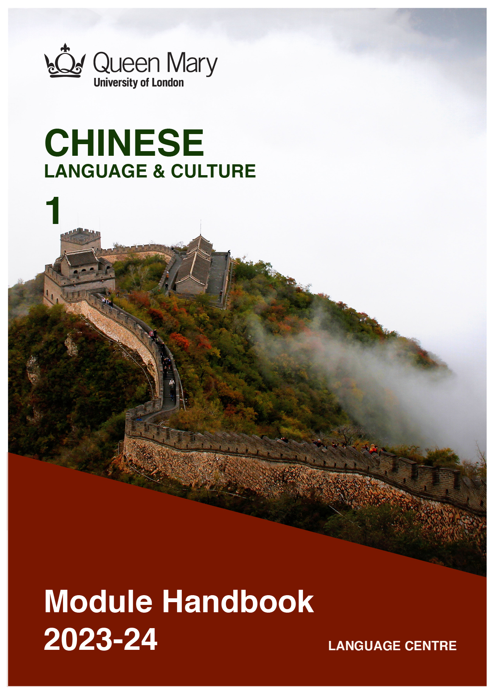

WELCOME TO LEARNING CHINESE

Welcome to the Learn a Language programme of Queen Mary. Language learning broadens the mind – you learn how different cultures and societies organize the world through language, you acquire a new vocabulary, new concepts, cultural knowledge, and become more interculturally aware. You can connect with people in another society in their language, a connection that is likely to be closer than if you make them speak your language or you communicate in a third language, such as English. You can use your language skills in your future career – employers consistently ask for better language skills in graduates. And, finally, language learning has cognitive benefits – studies show that bilinguals are more perceptive and have better memory. Speaking another language makes you more aware of language structure in general, and a better communicator.

MANDARIN CHINESE
Mandarin Chinese is offered in collaboration with Queen Mary’s Confucius Institute.
Chinese is spoken by about 1.6 billion people, with one fifth of the world's population now
using it as their mother tongue. Chinese has become more and more popular for language learners, and with the economic development of China and its overseas investments, speakers of Chinese are in high demand. Knowledge of the language can help you in a government career, but it will also be of benefit in business and in industries such as engineering, medical, and in the non-profit and international relations sectors. Speaking Chinese can help you build relationships with people in China and overseas Chinese communities.
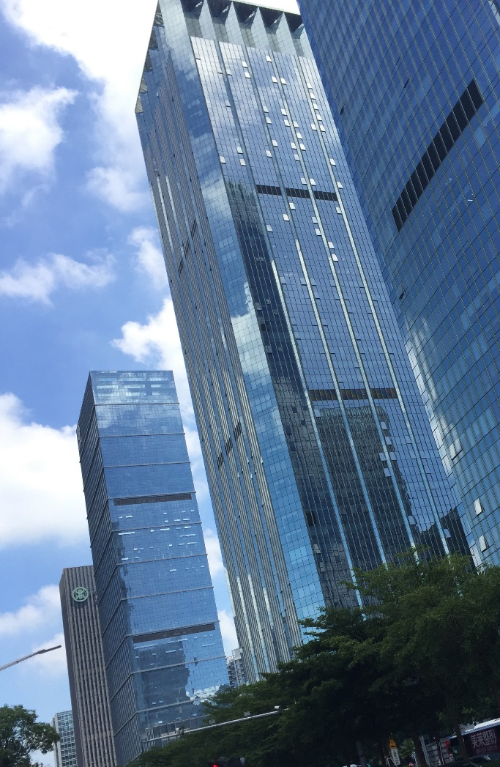

Picture by Kirsty Stage, student of Chinese 1b, 2019/20

MODULE AIMS AND LEARNING OUTCOMES

Module Aims
The overall aims of this module are to help you to develop a sound foundation of knowledge of the Chinese language, and an ability to approach communication in the language in a confident and competent manner. You will move from no knowledge, or very rudimentary knowledge of the language, to become someone who is able to function effectively at a basic level when using language occurring in everyday situations relating to practical matters, and be able to understand basic as well as slightly more complicated t texts, including news and brief reports (equivalent to level A2 of the Common European Framework of Reference, CEFR).
You will learn the language through tasks designed to develop your skills in speaking and writing. You will also read and listen to simple texts, to develop your receptive skills. The aim is to achieve a balance between fluency and accuracy, which means grammar and structure are an integral part of this course.

How is the module structured and how will it be taught?
You will have two timetabled sessions (of two hours each) per week, over two semesters (4 hours over 22 weeks). The module is taught in-person, on campus. This means you will get 88 hours of tutor-led learning. The total learning hours for this module are 300 hours, which means that in addition to the 88 tutor-led hours, you need to invest an additional 212 hours through independent study. You will do this by doing homework set by your tutor, completing tasks online on QMplus and in the course book, revising class materials and vocabulary, preparing for assessments, and using other opportunities to speak, listen to and read Mandarin Chinese outside the classroom.

The classroom-based sessions will be mainly used for interactive tasks and skills development (speaking, listening, writing), while explanations of grammar and introduction of new material will be delivered mainly via recorded video clips.
This means you will sometimes be asked to watch a video, go over a PowerPoint presentation, or read a text in preparation for a class, as well as completing exercises and tasks after sessions, for consolidation (e.g, exercises in the course book, on QMplus, recording yourself, etc.).

Module Learning Outcomes

You should develop the following outcomes related to academic content:
A1 | To achieve effective communication in Chinese at level A2 CEFR with competent speakers of the language.
A2 | To exploit, for a variety of purposes, a range of materials, written and spoken, in Chinese level A2 CEFR.
A3 | To demonstrate a knowledge and understanding of the structures, registers and, as appropriate, varieties of Chinese at level A2 CEFR.
A4 | To demonstrate a knowledge and understanding of Chinese cultures and societies gained through the study of basic written and aural texts and other cultural products in the target language.

You should develop the following disciplinary skills:
B1 | To analyze aspects of the target language and make use of them in a broadly professional context.
B2 | To gather and process information related to Chinese language and cultures from a variety of paper, audiovisual and electronic sources and communicate this information, both orally and in writing.
B3 | To use ICT effectively both as a means of communication and as an aid to learning.
B4 | To demonstrate some ability as an independent learner of the language in order to take further the study of Chinese language and cultures.

You should develop the following general attributes:
C1 | To be able to operate in more than one language, develop a global perspective and use the knowledge acquired to increase employability and engage with the professional world.
C2 | To apply analytical skills to investigate unfamiliar problems and to use the knowledge acquired to enrich research.
C3 | To be able to work effectively in diverse communities.
C4 | To work individually and in collaboration with others reflecting upon and assessing one's progress in learning the Target Language.

Picture by Shruthii Muthappan, student of Chinese 2a, 2019/20

EXPECTED STUDY TIME

If you are taking this module for credit, you will get 30 credits, which equals 300 learning hours. 88 of those will be tutor-led through synchronous sessions, the rest you are expected to invest between the weekly sessions, in your own time, via guided learning, using resources on QMplus, in your course book, and other material as advised by your tutor. Even if you are not taking the module for credit, you should invest the same amount of time in order to make the expected progress.

30 credit module – 300 learning hours
Tutor-led learning | 88 hours
Interactive classes
Self-directed learning | 212 hours
Preparations for taught sessions | 44
Completing set homework | 44
Self-study after class (QMplus, course book, etc.) | 88
Preparation for assessments | 36
Total | 300

CONTACT DETAILS AND ADVICE & FEEDBACK HOURS OF YOUR TUTOR

 | Module tutor | Office | Email | Advice & feedback hours
 |  | Bancroft building 1.36 |  | Tuesday  5:00-6:00PM

You can use your tutor’s Advice & feedback hours for questions and feedback. Please email your tutor beforehand.

LEARNING PLAN
SEMESTER 1
Week | Main topic | Phonetics | Language focus | Key sentence | Objectives | Culture focus | Self-study
1 | Self-introduction (1): I am  Greeting: Hello!  How are you?  Numbers 0-10 | Introduction of Chinese pinyin  Tones (Sheng diao) | Sentence structure:  S+Adj  S+Adj+吗(ma)  S+V+O | Hello!  How are you?  I am……  You are…… | Students will be able to introduce their names, greeting each other and count from 0-10 in Chinese.  Students will be able to read and write characters 0-10. | Capital city,  Chinese characters | Nihao Song
 | Thank you.  Sorry.  Goodbye!  Numbers 11-100 | Chinese pinyin  Finals  Review tones (Sheng diao)  4+1 | Sentence  structure:  S+V+O  S+Adv.+Adj. | Daily expressions:  Thank you.  --You’re welcome.  Sorry. --It’s OK.  Goodbye! | Students should be able to express  “Thank you, sorry, goodbye, how are you” and know how respond these in Chinese;  Students should be able to read and write the new sentences. | Numbers and the cultural meanings | Song of numbers
2 | Self-introduction(2):  My surname is  My name is …… | Chinese pinyin  Review the finals | Sentence structure:  S+V+O  S+Adv.+Adj. | What’s your surname?  May I know your surname?  What’s your name? | Students should be able to ask each other’s name and surname in Chinese, and learn to answer them.  Students should be able to read and write the new sentences, and exchange their writing to find out mistakes. | Answer exit card questions | Sorry, my Chinese is not good (song)  Check learning resources on QMplus
 | Self- introduction (3): | Review the finals  Spelling Practice | Sentence  structure:  S+adv.+V+O  Pron.+呢？  S+ V + QW? | Hello, everyone, my name is …. my surname is…. and my given name is….  I come from… | Students should be able to ask each other’s name and surname in Chinese, and learn to answer them.  Students should be able to write a few sentences to introduce themselves. | Answer exit card questions | Check learning resources eon QMplus
3 | Self- introduction (4):  Nationality | Tone practice and review | S+是+QW+N?  S+Adv（不)+是+N  S+是不是+(N)？  S+V+compliment/object | Where do you come from?  I come from…  I live in……  Who is that?  Is Mr. Wang English? | Students should be able to ask each other’s nationality in Chinese and learn to answer.  Students should be able to read and write the new sentences. | Answer exit card questions | Check learning resources eon QMplus
 | Self- introduction (4):  Nationality | Listening exercise to distinguish tones and similar pronunciations | Practice to review sentence structures. | Practice activity to review sentence structures. | Students should be able to ask each other’s nationality in Chinese and learn to answer.  Students should be able to read and write the new sentences. | Answer exit card questions | Check learning resources eon QMplus
4 | Self- introduction (5):  Age | Listening exercise to distinguish tones and similar pronunciations | S+ Num.岁？  S+QW(多大）？ | Different ways of asking “How old are you? ” in Chinese.  I am ** years old. | Students should be able to ask each other’s age in Chinese and learn to answer.  Students should be able to read and write the new sentences. | Answer exit card questions | Check learning resources eon QMplus
5 | Occupation | Chinese pinyin  Pronunciation corrected through class activities | S+是+N  这是李小姐。  S+Adv+是+N  他不是老师。  S+是不是+(N)  你是不是中国人？ | S+Adv. (都)+是+N  Pronouns as modifier(+的） | Students should be able to talk about occupation.  Students should be able to read and write the new sentences. | Answer exit card questions | Check learning resources eon QMplus
 | Occupation | Review & Tasks & Practice;  Pronunciation corrected through class activities | What do you do?  I am a ……  Where do you work?  I work in …… | 我想做…… | Students should be able to talk about dream jobs.  Students should be able to read and write the new sentences. | Answer exit card questions | Check learning resources eon QMplus
 | Review & Tasks & Practice:
6 | Addresses | Review & Tasks & Practice;  Pronunciation corrected through class activities | Word order of Chinese address | What’s your address?  What’s your email address? | Students should be able to ask for and give information about address, respond to a text message, and should be able to read and write the new sentences. | Answer exit card questions | Check learning resources eon QMplus
 | Contact number | Review & Tasks & Practice;  Pronunciation corrected through class activities | Question word “多少” | What's your phone number?  What’s your room number? | Students should be able to ask for and give information about contact numbers, respond to a text message, and should be able to read and write the new sentences. | Answer exit card questions | Check learning resources eon QMplus
7 | Study Week: learning materials will be available on QMplus.
8 | Date | Review & Tasks & Practice;  Pronunciation corrected through class activities | 今天是……  今天几月几号？  你的生日是几月几号？ | What's the date today?  When is your birthday?  How old are you?  Sorry, I don't know.  Happy birthday to you! | Students should be able to ask the date in Chinese, and learn to answer them, and should be able to read and write the new sentences. | Answer exit card questions | Check learning resources eon QMplus
 | Activities | Review & Tasks & Practice;  Pronunciation corrected through class activities | S+ 要+ Num+ Measure Word+  N | Waiter, may I have the menu, please.  I'd like a... .  It's 180 yuan in total. | Students should be able to order food and pay the bill in Chinese, and should be able to read and write the new sentences. | Answer exit card questions | Check learning resources eon QMplus
9 | Daily schedule | Review & Tasks & Practice;  Pronunciation corrected through class activities | Location+在哪儿？  Unit+ 有+ 几/多少+MW+ N? | How many people are there in your family?  Who's in your family?  Where is your home?  My home is in … . | Introduce their family members in Chinese,  read and write the new sentences. | Answer exit card questions | Check learning resources eon QMplus
 | Invitation | Review & Tasks & Practice;  Pronunciation corrected through class activities | Sentences without verbs  请……. | May I invite you to… | Students should be able to make invitations;  Students should be able to create personal calendars. | Answer exit card questions | Check learning resources eon QMplus
10 | People’s appearances | Review & Tasks & Practice;  Pronunciation corrected through class activities | 真/很+adj. | 他/她怎么样？  他/她真高。 | Students will be able to describe people’s appearance and personality. | Answer exit card questions | Check learning resources eon QMplus
 | People’s appearances;  Favorites | Review & Tasks & Practice;  Pronunciation corrected through class activities | 又……又……  Both … and…  Adverbs of degree：a little bit, very,  relatively | My brother is tall, handsome and clever. | Students should be able to describe a person in Chinese, their appearance, their personality…  Students should be able to read and write the new sentences. | Answer exit card questions | Check learning resources eon QMplus
11 | Family | Review & Tasks & Practice;  Pronunciation corrected through class activities | Pron+谁的+N？  S+ V+ QW+O? | Whose pen is this?  What do you do?  My father is a teacher. | Students should be able to describe their family: family members’ occupation, age, hobbies and appearance.  Students should be able to read and write the new sentences. | Answer exit card questions | Check learning resources eon QMplus
 | Family | Review & Tasks & Practice;  Pronunciation corrected through class activities | 这是……  我…….每天都……  我…..喜欢……  我……很…… | This is my family. ….is years old. … is a … ; … does … each day. | Students should be able to deliver a small speech about their family.  Students should be able to read and write the new sentences. | Answer exit card questions | Check learning resources eon QMplus
12 | Review & Tasks & Practice  Reading, speaking, listening and writing practice to review what’s learnt in the semester.

Semester 2
Week | Main topic | Language focus | Objective | Culture focus | Self-study
1 | Chinese new year | I wish you ...  When is ...?  The ... falls on according to the lunar calendar | Students should be able to talk about Chinese new year;  Students should be able to talk about China’s traditional festivals and their dates;  Students should be able to talk about China’s lunar calendar | Chinese people’s entertainment mode | Chinese pinyin  Sentence practise  Write an article about your new year experience
 | Chinese couplets | I wish... | Students should be able to write down their festival wishes with brush | Chinese couplet | Watching movie:  “Anchoring in Seattle”  and write down your impression.
2 | Review & Tasks & Practice: | Numbers  Self-introduction  Date  Hobbies  Hometown  Job... | Students should be able to talk about Numbers;  Students should be able to talk about dates;  Students should be able to talk about hobbies;  Students should be able to talk about their hometown;  Students should be able to dictate. | Chinese university life | Chinese pinyin  Tongue twister  Translation practise
 | Time | When will you ... on ...? | Students should be able to talk about time  Students should be able to talk about their class time | How the ancient Chinese told time | Write about personal schedule.
3 | See you at eight | I will ... at...  I plan to...  How about doing...? | Students should be able to talk about their plans  Students should be able to read and write the new sentences. | Daily routines recommended by traditional Chinese doctors | Chinese pinyin  Tongue twister  Translation practise
 | Making appointments | When will you ... on ...? | Students should be able to make appointments  Students should be able to talk about their weekend plans  Students should be able to write their schedules and daily activities | Ways to make appointments in China | Watching the film  “Kongfu panda”  And write down your expression.
4 | How much is it? | How much is it?  It costs ...  I want to buy...  May i ask what do you want to buy? | Students should be able to identify clothes, colours, and prices | Comparing the prices in China and Britain | Write an article:  One day’s journey  Tell how did you get to somewhere, what modes of transport did you use.
 | Bargaining | Expressing past tense using了  Measure words | Students should be able to ask for items, prices and bargain when shopping  Students should be able to write a blog | Online platforms in China | Extra Reading
5 | Class activity: second hand market | The price of ... is...  Can I buy ... at a discount?  I’d better... | Students will bring their second-hand items and sell to the class; the rest students ask for prices and bargain | Second hand markets in Chinese universities | Extra Reading
 | Review 2 | Measures words  The usage of 了  I live in...  My email is ...  I like... | Learn to express different expressions of “like”,  Learn to express all kinds of sports | Cultural Note  The fascinating character “天” | Additional Vocabulary  Sports (with action verb  打)， and sports (with other action verbs)
6 | It’s not far | Expressing existence using 有  Asking questions using 有没有 | Students should be able to describe locations  Students should be sable to ask for and give directions | China’s regional differences | Translation practise  Grammar Practise
 | It’s not far | Expressing locations with the verb 在  Directions , places and types of student housing | Students should be able to write an advertisement for a house or flat | China’s cities | Read the map of a Chinese city  Read the subway map of Beijing
7 | Study week: learning materials will be available on QMPlus.
8 | Let’s take the train | Alternative questions with 还是  Questions ending with 好吗  Expressing | Students should be able to talk about types of transport  Students should be able to discuss which types of transport to take | China’s public transportation | Write a sitcom where a bunch of old friends just meet.
 | Let’s take the train | superlatives with最  Using the particle 吧  Modes of transport and holiday activities | Students should be able to make their travel plans  Students should be able to complete an email invitation  Students should be able to talk about a trip and how to prepare for it. | Car plate lottery system in Beijing | Listening Practise  Grammar Practise  Matching exercise  Translation  Reading exercise
9 | I can dance | Using modal verbs 可以and 会  Pivotal sentences | Students should be able to ask and answer questions about sports  Students should be able to talk about likes and dislikes | Chinese dance / square dance | Watching the film “Mulan”  And talk about you impression.
 | I can dance | Talking about past actions with 过  Types of sports, abilities | Students should be able to answer a questionnaire  Students should be able to describe one’s recreational activities | Leisure activities in China
10 | We are going to the Beijing opera | Expressing alternatives using 或者 and 还是 | Students should be able to ask and answer questions about holiday plans | Chinese opera 1 | Matching exercise  Draw a school map in Chinese  Listen to the recording and draw a map.
 | We are going to the Beijing opera | Expressing regular events with 每......都..... | Students should be able to identify preferences for holiday plans  Students should be able to respond to an online chat message | Chinese opera 2 | Watching the film “white snake” and write down your reflection.
11 | Communication activity: make holiday plans | 那么.......吧 | Learn some common sentences about preferences, plans, and tell your reason.. | Popular tourist attractions in China | Make an appointment with any three people in your class  And fill a form.
 | Small talk | 每......都.....  那么.......吧  ...... | Learn to make small talk in Chinese ，talking about the weather, hobbies, and how is it going recently. | Popular topics when Chinese people make small talk | Reading the material and draw and retell.  Draw your room and describe what you have in your room.
12 | Communication activity: make appointments | 可以.....吗？  我们.......吧 | Students will be able to learn how to contact people, and how to make proper inquiries and appointments. And what to say in a particular situation. | The role of WeChat in Chinese people’s life | Please interview two students in the class and compare them on a chart. Record their time of day and their activities.
 | Review |  | Review key sentence structures, vocabulary, etc.. | How do Chinese students prepare for exams | Listening practice  Translation exercise

SEMESTER DATES 2023-24

Semester 1 | Dates
Teaching Weeks 1 to 6 | 25 Sep – 5 Nov 2023
Study Week (Week 7) | 6 Nov – 10 Nov 2023
Teaching Weeks 8 to 12 | 13 Nov – 15 Dec 2023
January exam period | 4 – 19 January 2024
Semester 2 | Dates
Teaching Weeks 1 to 6 | 22 Jan – 1 Mar 2024
Study Week (Week 7) | 4 Mar – 8 Mar 2024
Teaching Weeks 8 to 12 | 11 Mar – 12 Apr 2024
Exam period | 2 May – 31 May 2024
Summer Resit period | August 2024

LEARNING MATERIALS

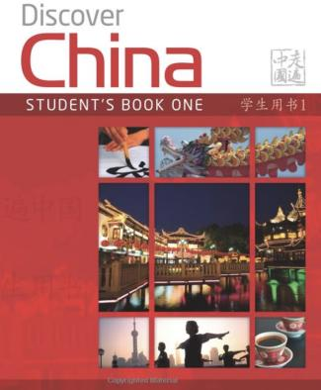 | Discover China Student Book One (Discover China Chinese Language Learning Series) | 978-0230405950 | The hard copy costs £33.10. Check for second- hand options, which will be cheaper.

- Audio of the book is available at:
http://www.mydiscoverchina.com/resources/mp3-audio-files-of-discover-china-students-books-and-workbooks/

- E-version of the book is available at:
https://archive.org/details/discover-china-students-book-vl-01/mode/2up?view=theater

- There will also be supplementary resources and materials in class.

OTHER RESOURCES:

  - Online dictionary: https://dict.naver.com/linedict/zhendict/#/cnen/home

  - Youtube channels: https://www.youtube.com/channel/UCSXriUqkzZmAQklQ0N9XFVw
https://www.youtube.com/c/cnliziqi
https://www.youtube.com/channel/UC_HW6aVLpyvPIhc7w8YA8Ag
https://www.youtube.com/c/JasonLightfootLivinginChina/featured

- For reading and listening:
https://www.duchinese.net/lessons
https://www.thechairmansbao.com/

- For grammar:
https://resources.allsetlearning.com/chinese/grammar/Main_Page

- Learn Chinese song:
https://www.echinesesong.com

  - APP: pleco (dictionary), anki (flashcard), skritter (Write Chinese)

  - Reading list for Chinese modules: https://qmul.rl.talis.com/search.html?q=chinese

  - Cultural events in London in 2022/23 related to Chinese: Please follow the Confucius Institute website or facebook @QMULCI

  - Practice with volunteer students:
  - https://www.qmul.ac.uk/sllf/language-centre/language-learning/speaking-practice/

QMplus Module page

The QMplus module page is the place to go to regularly before and after class, to prepare for the weekly sessions and find resources for self-study. Here you will find the materials used in class in addition to the course book, and additional resources and activities that help you consolidate and extend the material covered in class. You will also find links to web resources and videos on the language and cultural information.

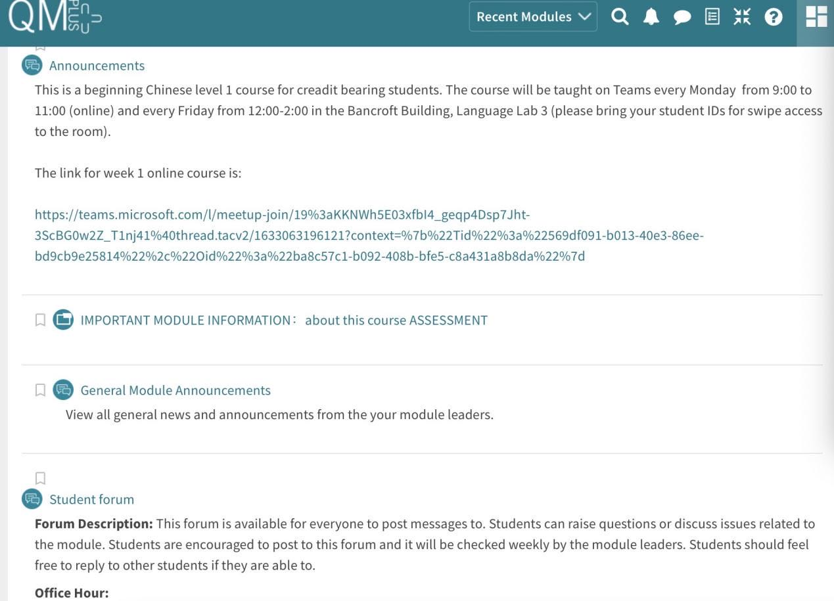

Free Language Speaking Practice

Language learners within the Queen Mary community can book 30-minute online speaking sessions with native or proficient speakers, for 15+ languages, for free. You can practise your speaking skills in the language you're learning, in an informal way. Sessions are offered by volunteers – QMUL students and staff who enjoy helping others learn. It’s a great way to practise the language, and get to know Queen Mary students from different schools and different backgrounds.

More information and booking link

FEEDBACK

- How can you check your progress throughout the module?
- What feedback can you expect from your tutor?

Language classes are highly interactive and participative, which means your tutor will give you regular instant feedback on your participation in class. Your tutor will also give you feedback on your submitted homework, and on activities that you complete on QMplus, if there is no automated feedback.

You will get feedback on the draft (formative submission) of your Writing Assignment, and will then have the opportunity to improve your writing before you submit it for summative assessment (counting towards your mark).

Your tutor is available during Feedback & Advice hours (check the times in the Tutor profile above), which you can use for a one-to-one meeting to discuss your progress. Please email your tutor beforehand.

ASSESSMENT INFORMATION

Assessment if you take the module FOR credit

If you are taking this module for credit, you need to complete and pass the assessments in order to gain the credits. The credits will count towards the total number of credits you need in each academic year (120 per year for undergraduate students).

Assessment if you take the module NOT for credit

If you are taking this module as a non-credit bearing module, it will not count towards your programme and you will not receive credits. However, if you complete and pass the module, you will receive a Certificate of Completion stating that you have passed the module, and with what grade. The requirements are that you:

- Have attended at least 65% of the taught sessions
- Take and pass the module assessment for non-credit seeking students to show that you have achieved the learning outcomes of the module
If you do not take the module assessment but meet the attendance requirement, you will receive a Certificate of Attendance, without a grade.

Assessment is carried out through formal and informal reading, writing, listening and speaking tasks. The assessment structure depends on whether you are taking the module for credit or not. Check your module code and note the assessment structure relevant to you, below:

Assessment structure:

FOR CREDIT

LAN4080: Chinese Language & Culture 1: Students taking the module for credit, year-long (30 credits)
LAN4080  Assessment Title | Weight towards final grade % | Length | Due Date
Coursework
- Reading &Listening Test | 10% |  | Semester 1, Week 11 (December)
- Writing Assignment | 20% | 150-200 characters | Submission (formative):  Semester 2, Week 7  Feedback given in Week 8  Submission (summative):  Semester 2, Week 9
- Oral exam | 30% |  | Semester 2, Week 12
Written exam | 40% | 2 hours | May Examination period

LAN 4081: Chinese Language & Culture 1a: Students taking the module for credit, Semester A only (15 credits)
LAN4081  Assessment Title | Weight towards final grade % | Length | Due Date
Coursework
- Reading &Listening Test | 10% |  | Semester 1, Week 11 (December)
- Writing Assignment | 20% | 120 characters | Submission (formative):  Week 9  Feedback given in Week 10  Submission (summative):  First week in January
Oral exam | 30% |  | Semester 1, Week 12
Written exam | 40% | 2 hours | January Examination period

Study Abroad & Visiting Students taking LAN4081: Chinese Language & Culture 1a for credit, Semester A only (15 credits)
LAN4081  Assessment Title | Weight towards final grade % | Length | Due Date
Coursework
- Reading &Listening Test | 20% |  | Semester 1, Week 11 (December)
- Writing Assignment | 30% | 120 characters | Submission (formative):  Week 9  Feedback given in Week 10  Submission (summative):  First week in January
Oral exam | 50% |  | Semester 1, Week 12

LAN 4082: Chinese Language & Culture 1b: Students taking the module for credit, Semester B only (15 credits)
LAN4082  Assessment Title | Weight towards final grade % | Length | Due Date
Coursework
- Reading &Listening Test | 10% |  | Semester 2, Week 11
- Writing Assignment | 20% | 150-200 characters | Submission (formative):  Semester 2, Week 7  Feedback given in Week 8  Submission (summative):  Semester 2, Week 9
Oral exam | 30% |  | Semester 2, Week 12
Written exam | 40% | 2 hours | May Examination period

NOT FOR CREDIT

LAN4085/LAN4086/LAN4087: Chinese Language & Culture 1, 1a, 1b: Students taking the module NOT for credit, year-long. In order to get a Certificate of Completion, you need to pass the following assessments:
LAN4085/LAN4086/LAN4087  Assessment Title | Weight towards final grade % | Due Date
Coursework
- Reading &Listening Test | 20% | Week 11
- Writing Assignment | 30% | Submission (formative): Week 7  Feedback given in Week 8  Submission (summative): Week 9
- Oral test | 50% | Last week of the module

Your course teacher will give detailed instructions in advance of assessments.

MARKING CRITERIA FOR ASSESSMENT OF WRITING SKILLS

Task achievement | - How fully has the task brief been achieved? Does the text have the required length?*  - How fully, and in what breadth, has the topic been covered?  - If the task consists of description, how comprehensive is the description?  - If the task consists of argumentation, has the topic been considered from different angles?  - Have different aspects of the topic been elaborated?  - How relevant, and how correct, is the information included?
Organisation, Coherence and cohesion | - How clear is the text, and how logical is its structure?  - How appropriate, and how varied, are the connectors and cohesive devices used to link sentences?  - How well is paragraphing used, and how well are paragraphs connected to achieve a coherent text? Does the text read smoothly, or are there jumps?
Range  (Grammar, Syntax, Vocabulary) | - Are the sentence and grammatical structures appropriate for the level? (at lower levels, simple sentences will be fine, while at higher levels, the inclusion of more complex structures will be expected)  - How wide is the range of vocabulary used in the text? (simple and frequent lexical items will be fine at lower levels, while at higher levels, more varied vocabulary, use of nuance, and use of idiomatic expressions will be expected)
Accuracy (Grammar, Syntax, Vocabulary) | - How accurate are the grammar and sentence structures? If there are errors, are they minor, or do they impact the communication more severely? To what extent does the reader have to make an effort to understand what you are trying to communicate?  - How good is your command of the vocabulary? Do the words you have chosen have the right meaning to express what you want to say? If there are errors, do they just make the passage sound somewhat clumsy or do they obscure the meaning of the sentence and hinder communication?  - How well are lexical collocations used? (that is, words that normally go together, e.g. we say ‘to take a picture’ and not ‘to make a picture’, ‘to make a mistake’ and not ‘to do a mistake’, ‘to do someone a favour’ but not ‘to make someone a favour’)
*If you submit work significantly under the word limit, marks will be deducted.

MARKING CRITERIA FOR ASSESSMENT FOR SPEAKING SKILLS

Task achievement | - Have you completed the task that has been set? Have you completed it fully or only partially?
Range of vocabulary and structures | - How wide is the range of vocabulary that you use? Is it quite simple and basic, or do you master the full range of vocabulary that has been covered in the module?  - What kind of sentence structures do you use? Are they simple (such as a list of short main clauses), or are they more complex (using longer sentence structures with subordinate clauses that are well connected by conjunctions)?
Accuracy of vocabulary and grammatical structures | - How accurate is the vocabulary you are using? Are you using words with the right meaning to express what you want to say? How often do you pick words that don’t quite fit?  - How accurate are the grammar and the sentence structures that you are using? How frequently do you make mistakes? Are the mistakes minor or do they make it hard for your conversation partner to understand what you are trying to say?
Pronunciation | - How well do you pronounce the words and sounds in the target language? Is your pronunciation smooth and clear, with the correct word stress and sentence intonation, or is it difficult for the listener to recognise some of the words you produce?
Fluency | - How natural is the speed of your speech? (Note that slight hesitations, restarting a sentence, pausing to find the right word, etc., is part of natural speech). Are there many, long and ‘unnatural’, pauses and hesitations? Is there a breakdown of communication? Can you repair gaps by paraphrasing a word that you cannot find, or by reformulating a sentence?
Interactional skills | - How well can you use conversational norms when interacting with someone else: For example, opening a conversation, maintaining it, asking for clarification, giving appropriate responses to prompts from your conversation partner, taking turns in the conversation, closing (ending) the conversation.

