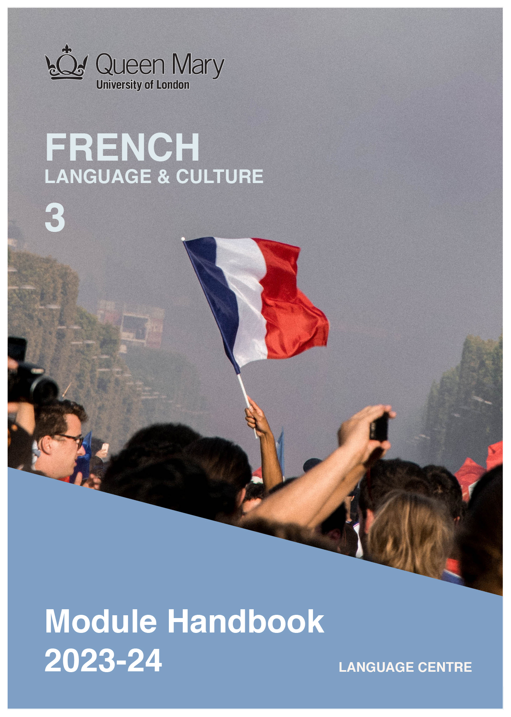

WELCOME TO LEARNING FRENCH

Welcome to the Learn a Language programme of Queen Mary. Language learning broadens the mind – you learn how different cultures and societies organize the world through language, you acquire a new vocabulary, new concepts, cultural knowledge, and become more interculturally aware. You can connect with people in another society in their language, a connection that is likely to be closer than if you make them speak your language or you communicate in a third language, such as English. You can use your language skills in your future career – employers consistently ask for better language skills in graduates. And, finally, language learning has cognitive benefits – studies show that bilinguals are more perceptive and have better memory. Speaking another language makes you more aware of language structure in general, and a better communicator.

FRENCH LANGUAGE
French is the official language in 29 countries and is spoken by some 274 million people, of which 76 million are native speakers. French is a Romance language (derived from Latin) and shares its origins with Spanish, Italian and Portuguese. French has a long history as an international language of literature, diplomacy and scientific standards, and is a primary or second language in many international organisations, including the UN, EU, NATO and the WTO. The British Council report Languages for the Future (2017) lists French as the third most important language for the UK. Speaking French will give you access to business opportunities in countries in Europe, Africa and North America.

Arkadiusz Zarzecki

MODULE AIMS AND LEARNING OUTCOMES

Module Aims
The overall aims of this module are to help you to further develop your knowledge of the French language, and develop your ability to approach communication in the language in a confident and competent manner. You will develop a high command of the language and develop your ability to function effectively and competently dealing with language occurring in more demanding and challenging situations, within a general or a professional context (equivalent to level C1 of the Common European Framework of Reference, CEFR).
You will improve your competence towards an advanced level through tasks designed to develop your skills in speaking and writing. You will also develop your receptive skills, by reading and listening to complex texts. The aim is to achieve a balance between fluency and accuracy, which means grammar and structure are an integral part of this course.

How is the module structured and how will it be taught?
You will have two timetabled sessions (of two hours each) per week, over two semesters (4 hours over 22 weeks). The module is taught in-person, on campus. This means you will get 88 hours of tutor-led learning. The total learning hours for this module are 300 hours, which means that in addition to the 88 tutor-led hours, you need to invest an additional 212 hours through independent study. You will do this by doing homework set by your tutor, completing tasks online on QMplus and in the course book, revising class materials and vocabulary, preparing for assessments, and using other opportunities to speak, listen to and read French outside the classroom.

The in-person and online sessions will be mainly used for interactive tasks and skills development (speaking, listening, writing), while explanations of grammar and introduction of new material will be delivered mainly via recorded video clips.
This means you will sometimes be asked to watch a video, go over a PowerPoint presentation, or read a text in preparation for a class, as well as completing exercises and tasks after sessions, for consolidation (e.g, exercises in the course book, on QMplus, recording yourself, etc.).

Module Learning Outcomes

You should develop the following outcomes related to academic content:
A1 | To achieve effective communication in French at level C1 CEFR with competent speakers of the language.
A2 | To exploit, for a variety of purposes, a range of materials, written and spoken, in French level C1 CEFR.
A3 | To demonstrate a knowledge and understanding of the structures, registers and, as appropriate, varieties of French at level C1 CEFR.
A4 | To demonstrate a knowledge and understanding of Francophone cultures and societies gained through the study of more complex written and aural texts and other cultural products in the target language.

You should develop the following disciplinary skills:
B1 | To analyze aspects of the target language and make use of them in a broadly professional context.
B2 | To gather and process information related to French language and cultures from a variety of paper, audiovisual and electronic sources and communicate this information, both orally and in writing.
B3 | To use ICT effectively both as a means of communication and as an aid to learning.
B4 | To demonstrate some ability as an independent learner of the language in order to take further the study of French language and cultures.

You should develop the following general attributes:
C1 | To be able to operate in more than one language, develop a global perspective and use the knowledge acquired to increase employability and engage with the professional world.
C2 | To apply analytical skills to investigate unfamiliar problems and to use the knowledge acquired to enrich research.
C3 | To be able to work effectively in diverse communities.
C4 | To work individually and in collaboration with others reflecting upon and assessing one's progress in learning the Target Language.

EXPECTED STUDY TIME

If you are taking this module for credit, you will get 30 credits, which equals 300 learning hours. 88 of those will be tutor-led through synchronous sessions, the rest you are expected to invest between the weekly sessions, in your own time, via guided learning, using resources on QMplus, in your course book, and other material as advised by your tutor. Even if you are not taking the module for credit, you should invest the same amount of time in order to make progress as expected.

30 credit module – 300 learning hours
Tutor-led learning | 88 hours
Interactive classes
Self-directed learning | 212 hours
Preparations for synchronous sessions | 44
Completing set homework | 44
Self-study after class (QMplus, course book, etc.) | 88
Preparation for assessments | 36
Total | 300

CONTACT DETAILS AND ADVICE & FEEDBACK HOURS OF YOUR TUTOR

 | Module tutor | Office | Email | Advice & feedback hours
 | Viviane Blanchard | Bancroft 1.36 | v.blanchard@qmul.ac.uk | By appointment

You can use tutors’ office hours to get advice and feedback. Please email your tutor to book an appointment.

LEARNING PLAN

SEMESTER 1

week | main topic | LEARNING OUTCOMES | MAIN LANGUAGE FOCUS | CULTURE | SELF-STUDY (qm+)
 | What is the main topic of the week? | What will I be able to do with the language I am learning this week | What particular language features will be covered? | What cultural information will I learn this week? | What am I expected to do outside class from one week to the next?
1 | Presentation of the course (QM+ syllabus, material)  Getting to know each other. | Assessment of grammar and fluency, listening and speaking practice, understand video, audio, text on stereotypes, discuss your culture and clichés associated with it. | Assessment of grammar and fluency, listening and speaking practice | Cultural stereotypes, French stereotypes, daily annoyances | Practice your French, explore French learning resources online and in London, revise tenses and conjugations
2 | Origins | Revise past tense, understand how to use perfect and imperfect in a narrative, discuss your origins and cultural diversity | Talk about your origins using past tenses, expressing opposition and concession | French history  Cultural diversity  History of immigration | Practice your French, read and listen to the news, watch a film or a series related to this week’s theme, revise past tenses uses and conjugations
3 | Life stories  Biography of francophone artists | Consolidate past tense, understand how to use perfect, imperfect and pluperfect in a biography, introduce someone else and present their personal/professional story | Use various past tenses to narrate a story, improve your presentation skills, slang in French songs | French artists | Practice your French, read and listen to the news, listen to French songs, watch a film or a series related to this week’s theme, revise all past tenses uses and conjugations
4 | Ecological awareness  Presentations of an ecological cause close to one’s heart | Understand a news article on ecological awareness, discuss a press cartoon | Expressing opinions I | Ecology and activism in France | Extend your vocabulary, expressions of opinions, revise subjunctive mood
5 | Ecology in the global world | Understand a reportage, give your views and reflect on food production and consumption in the age of globalisation | Expressing opinions II  Slang expressions to express feelings | Food, globalisation and carbon footprint | Extend your vocabulary, expressions of opinions, read and listen to the news, listen to French, watch a film or a series related to this week’s theme, consolidate subjunctive mood
6 | Education and inclusion | Analyse the links between education and inclusion, discuss your educational and professional goals | Expressing aim | French education system | Read an article on the French education system, listen to the news related to the French job market, learn with tv5monde.fr
7 | STUDY WEEK: Complete any unfinished exercises or activities from QM+.
8 | Education and gender discrimination  L’Atelier B2 p.121- 124 | Analyse a literary extract, understand an article in a cultural magazine, discuss your position and differences between various countries | Revise the future tenses and the conditional present, revise the subjunctive mood (opinion, other uses) | French education,  Feminine condition in France | Listen to the news related to politics in France, learn with RFI.org
9 | Work | Discuss your first steps into the job market, your job interviews, listen to a reportage on a professional sector, understand the political situation around employment in France | Expressing hypotheses using the conditional tenses | French job market | Research news and the wider web including YouTube and TikTok: Prepare a short oral presentation on PowerPoint or similar on a personality which serves a role model for your professional career.
10 | The world of influencers | Discuss addiction to the digital world, social networks, new jobs related to the digital world and one’s place within it | Structures expressing time (before/after/while)  Verbs used to introduce direct speech | Influencers | Watch a film to be discussed in class in week 12.
11 | Traveling | Understand an article on travelling and making travelling plans, present a holiday destination, write the script of a video reportage, describe your dream holiday | Learn how to locate a place  Improve your presentation skills | French tourist destinations | Revise grammar and vocabulary from preceding weeks, complete all unfinished activities on QM+.
12 | Alternative travels | Understand a trailer, discuss a film, give one’s opinions on a film, write a review | Revise grammar and vocabulary from preceding weeks | Favorite and alternative holiday destination for French people | Choose a short French novel or play to read OR select a film or series to watch – write a review (to be handed after the Christmas break)

SEMESTER 2
week | main topic | LEARNING OUTCOMES |  | MAIN LANGUAGE FOCUS | CULTURE | SELF-STUDY (qm+)
 | What is the main topic of the week? | What will I be able to do with the language I am learning this week |  | What particular language features will be covered? | What cultural information will I learn this week? | What am I expected to do outside class from one week to the next?
1 | The media landscape in France | Explore the news in France and beyond, express one’s opinion on the media, its access, inclusion and diversity, analyse a specific media/news channel in France |  | Indefinite adjectives and pronouns, expressing indefinite entities | The French and their access to information | Practice your French, explore French learning resources online and in London, revise tenses and conjugations
2 | Media and fake news | Discuss the news, explore the fakes news global phenomenon and its consequences |  | Nominalisation, make a list or a chronology of events | Critical attitudes to the media | Explore the various French news channel and media. Practice your French, read and listen to the news, watch a film or a series related to this week’s theme.
3 | The future of the body | Discuss the body’s (dis)abilities, the revolutions in biotechnics and augmented reality and their effects on the body and society, understand a graphic novel |  | Using expressions of time  Create emphasis and nuance in your speech using the structure of mise en relief | French health system | Explore various French graphic novels/cartoons online. Practice your French, read and listen to the news, watch a film or a series related to this week’s theme.
4 | The individual and the collective today | Explore how architecture and co-living arrangements affect physical and mental health, discuss one’s living arrangements and personal space |  | Using the passive voice | French architecture | Present a building, park, neighbourhood etc in your city that you find attractive and explore the reasons why with the class using our class’s forum.
5 | The French language: accents and identity | Explore various slangs and youth’s expressions, accents and geography, the phenomenon of glottophoby, relate to one’s own experience |  | Contemporary expressions, slang and Verlan | French accents | Explore Listening comprehension exercises. Listen to various French accents and write about your experience and feelings.
6 | The future of the French language | Debate the pros and cons of language reforms |  | Past participle agreements, introduction to inclusive writing | French language | Practice your French, read and listen to the news, watch a film or a series related to this week’s theme, especially the francophone programmes on tv5monde.fr and rfi.org
7 | STUDY WEEK: Complete any unfinished exercises or activities from QM+.
8 | The future: progress in question | Talking about the future, about changes to come, scrutinize the notion of progress, have a debate on the various meanings of progress in our advanced societies |  | Using future tenses to express various degrees of (in)certainty | French attitudes to technological progress
9 | The future: technology | Express feelings and anxieties regarding technology, discover and imagine new design and development |  | Express various ways of doing something using adverbs of manner.  Revision of subjunctive mood | French design
10 | Art and emotions | Express one’s feelings in front of works of arts, understand a reportage on various art movements and artists, pay a virtual visit to a museum |  | Revise structures followed by indicative, subjunctive and infinitive | French art movements and artists | Find an event in London to look, learn, discuss about French art mouvements and/or artists. Make a review and share on our class’s forum.
11 | Art and money | Give one’s opinion on the relationship between art and money |  | Complex relative pronouns | French museums  and art market
12 | General revisions | Review of the course’s main themes |  | General revisions | Review of the course’s main cultural information

SEMESTER DATES 2023-24

Semester 1 | Dates
Teaching Weeks 1 to 6 | 25 Sep – 5 Nov 2023
Study Week (Week 7) | 6 Nov – 10 Nov 2023
Teaching Weeks 8 to 12 | 13 Nov – 15 Dec 2023
January exam period | 4 – 19 January 2024
Semester 2 | Dates
Teaching Weeks 1 to 6 | 22 Jan – 1 Mar 2024
Study Week (Week 7) | 4 Mar – 8 Mar 2024
Teaching Weeks 8 to 12 | 11 Mar – 12 Apr 2024
Exam period | 2 May – 31 May 2024
Summer Resit period | August 2024

LEARNING MATERIALS

The course will be based on Edito B2 and teacher’s own materials. All essential course materials will be posted on QM+. A grammar reference (hard copy or online) i.e. Grammaire Progressive du Français, niveau avancé is highly recommended.

 | Course book | ISBN | Notes
 | Edito B2  4e édition  Didier |  | You can buy the hard copy or you can buy the book as an e-book.  The hard copy costs £20 and gives you access to online materials. Check for second-hand options, which will be cheaper.

 | Grammar book | ISBN | Notes
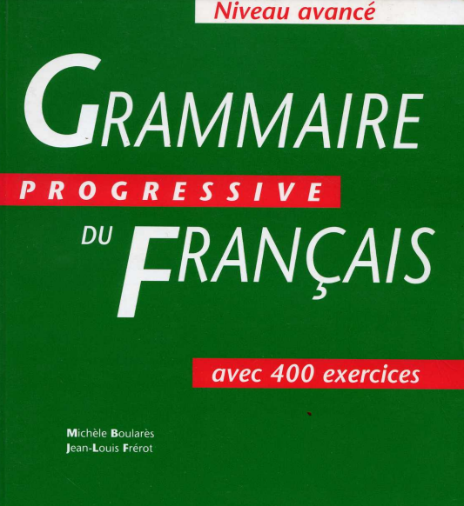 | Grammaire Progressive du Français, Niveau avancé |  | You can buy the hard copy or you can use the pdf attached.  If you want a hard copy, check for second-hand options (currently less than £5 on Wob.com)
https://lefabuleuxdestindemonsieurjestin.files.wordpress.com/2013/09/grammaire-progressive-de-francais-avancc3a9.pdf

OTHER RESOURCES
Online dictionaries:
https://www.larousse.fr/dictionnaires/francais
https://dictionnaire.lerobert.com
https://wordreference.com
https://www.collinsdictionary.com/dictionary/english-french
https://www.cnrtl.fr/

Online grammar:
https://francais.lingolia.com/fr/grammaire
https://fr.tsedryk.ca/
https://www.lepointdufle.net/p/grammaire.htm

Institutions and events in London related to French Language and Culture:

Institut Français https://www.institut-francais.org.uk/
Ciné Lumière https://www.institut-francais.org.uk/about/about-us/room-hire/cine-lumiere/
Impressionists and Post Impressionists at The Courtauld Gallery https://courtauld.ac.uk/gallery/
Impressionists at The National Gallery https://www.nationalgallery.org.uk/
Statue of Charles de Gaulle (Carlton Grdns, SW7 5PF)
Librairie La Page (7 Harrington Rd, SW7 3ES) https://www.librairielapage.com/

QMplus Module page

The QMplus module page is the place to go to regularly before and after class, to prepare for the weekly sessions and find resources for self-study. Here you will find the materials used in class in addition to the course book, and additional resources and activities that help you consolidate and extend the material covered in class. You will also find links to web resources and videos on the language and cultural information.

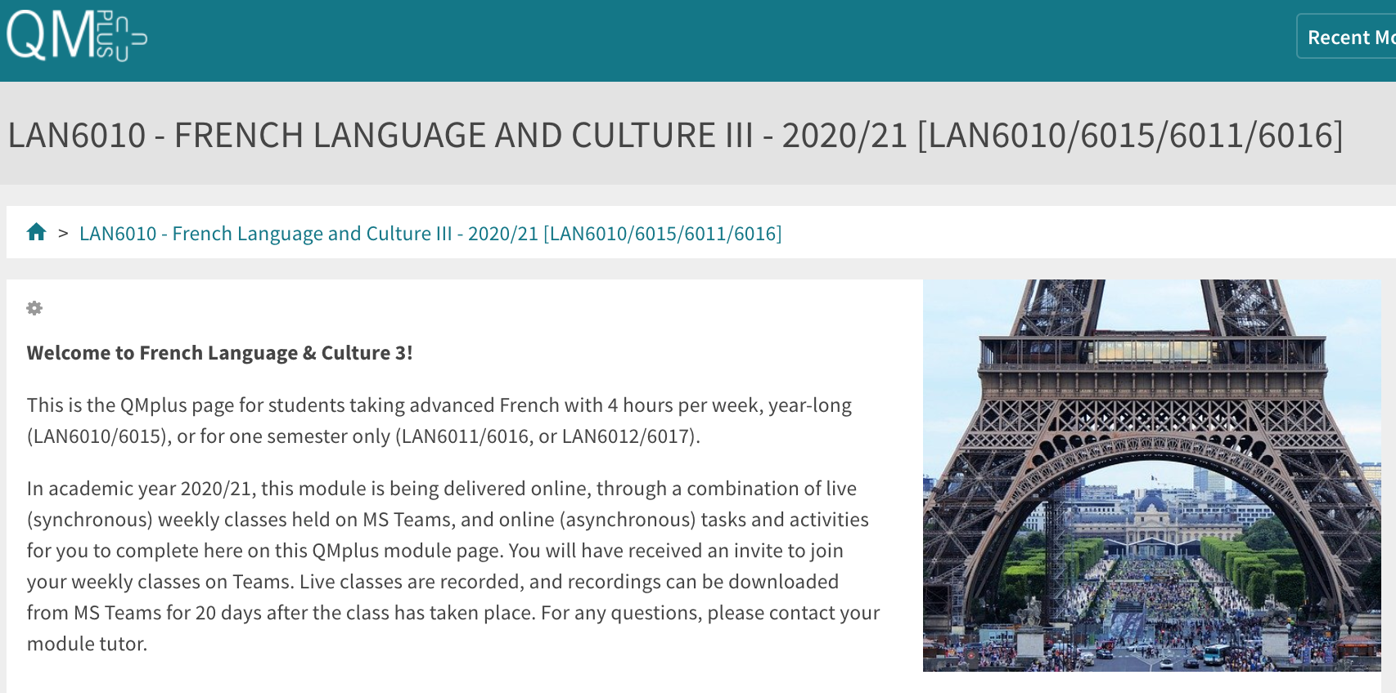

Free Language Speaking Practice

Language learners within the Queen Mary community can book 30-minute online speaking sessions with native or proficient speakers, for 15+ languages, for free. You can practise your speaking skills in the language you're learning, in an informal way. Sessions are offered by volunteers – QMUL students and staff who enjoy helping others learn. It’s a great way to practise the language, and get to know Queen Mary students from different schools and different backgrounds.

More information and booking link

FEEDBACK

- How can you check your progress throughout the module?
- What feedback can you expect from your tutor?

Language classes are highly interactive and participative, which means your tutor will give you regular instant feedback on your participation in class. Your tutor will also give you feedback on your submitted homework, and on activities that you complete on QMplus, if there is no automated feedback.

You will get feedback on the draft (formative submission) of your Writing Assignment, and will then have the opportunity to improve your writing before you submit it for summative assessment (counting towards your mark).

Your tutor is available during Feedback & Advice hours, which you can use for a one-to-one meeting to discuss your progress. Please email your tutor beforehand.

ASSESSMENT INFORMATION

Assessment if you take the module FOR credit

If you are taking this module for credit, you need to complete and pass the assessments in order to gain the credits. The credits will count towards the total number of credits you need in each academic year (120 per year for undergraduate students).

Assessment if you take the module NOT for credit

If you are taking this module as a non-credit bearing module, it will not count towards your programme and you will not receive credits. However, if you complete and pass the module, you will receive a Certificate of Completion stating that you have passed the module, and with what grade. The requirements are that you:

- Have attended at least 65% of the taught sessions
- Take and pass the module assessment for non-credit seeking students to show that you have achieved the learning outcomes of the module
If you do not take the module assessment but meet the attendance requirement, you will receive a Certificate of Attendance, without a grade.

Assessment is carried out through formal and informal reading, writing, listening and speaking tasks. The assessment structure depends on whether you are taking the module for credit or not, and whether you take the year-long or the one-semester option. Check your module code and note the assessment structure relevant to you, below:

Assessment structure:

FOR CREDIT

LAN6010: French Language & Culture 3: Students taking the module for credit, year-long (30 credits)
LAN6010  Assessment Title | Weight towards final grade % | Length | Due Date
Coursework
- Reading &Listening Test | 10% |  | Semester 1, Week 11 (December)
- Writing Project | 20% | 450-500 words | Submission (formative):  Semester 2, Week 7  Feedback given in Week 8  Submission (summative):  Semester 2, Week 9
- Oral exam | 30% |  | Semester 2, Week 12
Written exam | 40% | 2 hours | May Examination period

LAN 6011: French Language & Culture 3a: Students taking the module for credit, Semester A only (15 credits)
LAN6011  Assessment Title | Weight towards final grade % | Length | Due Date
Coursework
- Reading &Listening Test | 10% |  | Semester 1, Week 11 (December)
- Writing Project | 20% | 400-450 words | Submission (formative):  Week 9  Feedback given in Week 10  Submission (summative):  First week in January
Oral exam | 30% |  | Semester 1, Week 12
Written exam | 40% | 2 hours | January Examination period

LAN 6012: French Language & Culture 3b: Students taking the module for credit, Semester B only (15 credits)
LAN6012  Assessment Title | Weight towards final grade % | Length | Due Date
Coursework
- Reading &Listening Test | 10% |  | Semester 2, Week 11
- Writing Project | 20% | 450-500 words | Submission (formative):  Semester 2, Week 7  Feedback given in Week 8  Submission (summative):  Semester 2, Week 9
Oral exam | 30% |  | Semester 2, Week 12
Written exam | 40% | 2 hours | May Examination period

NOT FOR CREDIT

LAN6015/LAN6016/LAN6017: French Language & Culture 3, 3a, 3b: Students taking the module NOT for credit, year-long. In order to get a Certificate of Completion, you need to pass the following assessments:
LAN6015/LAN6016/LAN6017  Assessment Title | Weight towards final grade % | Due Date
Coursework
- Reading &Listening Test | 20% | Week 11
- Writing Project | 30% | Submission (formative): Week 7  Feedback given in Week 8  Submission (summative): Week 9
- Oral test | 50% | Last week of the module

Your tutor will give you assessment briefs for each of the assessments.

MARKING CRITERIA FOR ASSESSMENT OF WRITING SKILLS

Task achievement | - How fully has the task brief been achieved? Does the text have the required length?*  - How fully, and in what breadth, has the topic been covered?  - If the task consists of description, how comprehensive is the description?  - If the task consists of argumentation, has the topic been considered from different angles?  - Have different aspects of the topic been elaborated?  - How relevant, and how correct, is the information included?
Organisation, Coherence and cohesion | - How clear is the text, and how logical is its structure?  - How appropriate, and how varied, are the connectors and cohesive devices used to link sentences?  - How well is paragraphing used, and how well are paragraphs connected to achieve a coherent text? Does the text read smoothly, or are there jumps?
Range  (Grammar, Syntax, Vocabulary) | - Are the sentence and grammatical structures appropriate for the level? (at lower levels, simple sentences will be fine, while at higher levels, the inclusion of more complex structures will be expected)  - How wide is the range of vocabulary used in the text? (simple and frequent lexical items will be fine at lower levels, while at higher levels, more varied vocabulary, use of nuance, and use of idiomatic expressions will be expected)
Accuracy (Grammar, Syntax, Vocabulary) | - How accurate are the grammar and sentence structures? If there are errors, are they minor, or do they impact the communication more severely? To what extent does the reader have to make an effort to understand what you are trying to communicate?  - How good is your command of the vocabulary? Do the words you have chosen have the right meaning to express what you want to say? If there are errors, do they just make the passage sound somewhat clumsy or do they obscure the meaning of the sentence and hinder communication?  - How well are lexical collocations used? (that is, words that normally go together, e.g. we say ‘to take a picture’ and not ‘to make a picture’, ‘to make a mistake’ and not ‘to do a mistake’, ‘to do someone a favour’ but not ‘to make someone a favour’)
*If you submit work significantly under the word limit, marks will be deducted.

MARKING CRITERIA FOR ASSESSMENT FOR SPEAKING SKILLS

Task achievement | - Have you completed the task that has been set? Have you completed it fully or only partially?
Range of vocabulary and structures | - How wide is the range of vocabulary that you use? Is it quite simple and basic, or do you master the full range of vocabulary that has been covered in the module?  - What kind of sentence structures do you use? Are they simple (such as a list of short main clauses), or are they more complex (using longer sentence structures with subordinate clauses that are well connected by conjunctions)?
Accuracy of vocabulary and grammatical structures | - How accurate is the vocabulary you are using? Are you using words with the right meaning to express what you want to say? How often do you pick words that don’t quite fit?  - How accurate are the grammar and the sentence structures that you are using? How frequently do you make mistakes? Are the mistakes minor or do they make it hard for your conversation partner to understand what you are trying to say?
Pronunciation | - How well do you pronounce the words and sounds in the target language? Is your pronunciation smooth and clear, with the correct word stress and sentence intonation, or is it difficult for the listener to recognise some of the words you produce?
Fluency | - How natural is the speed of your speech? (Note that slight hesitations, restarting a sentence, pausing to find the right word, etc., is part of natural speech). Are there many, long and ‘unnatural’, pauses and hesitations? Is there a breakdown of communication? Can you repair gaps by paraphrasing a word that you cannot find, or by reformulating a sentence?
Interactional skills | - How well can you use conversational norms when interacting with someone else: For example, opening a conversation, maintaining it, asking for clarification, giving appropriate responses to prompts from your conversation partner, taking turns in the conversation, closing (ending) the conversation.

