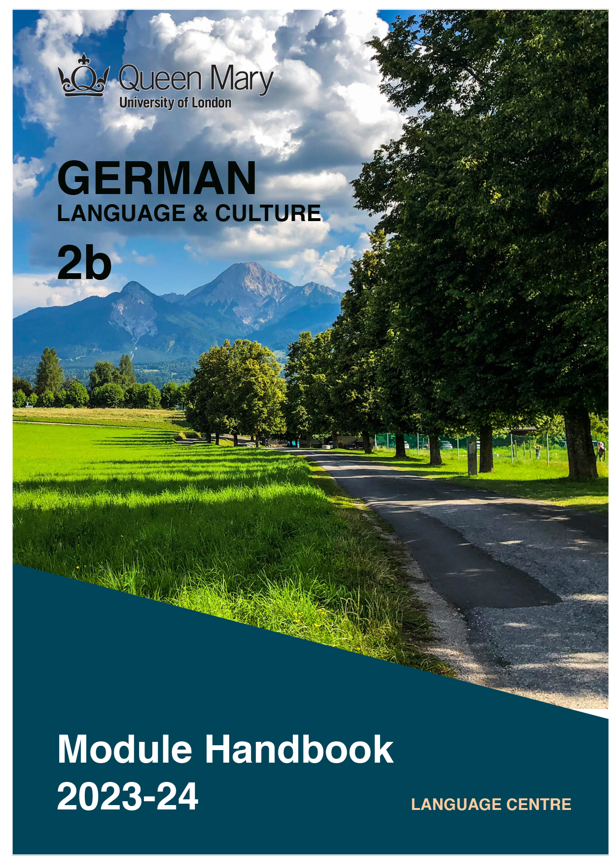

WELCOME TO LEARNING GERMAN

Welcome to the Learn a Language programme of Queen Mary. Language learning broadens the mind – you learn how different cultures and societies organize the world through language, you acquire a new vocabulary, new concepts, cultural knowledge, and become more interculturally aware. You can connect with people in another society in their language, a connection that is likely to be closer than if you make them speak your language or you communicate in a third language, such as English. You can use your language skills in your future career – employers consistently ask for better language skills in graduates. And, finally, language learning has cognitive benefits – studies show that bilinguals are more perceptive and have better memory. Speaking another language makes you more aware of language structure in general, and a better communicator.

GERMAN LANGUAGE

With over 100 million speakers, German is spoken as a native language by more people than any other language in Europe. It is an official language of Germany, Austria, Switzerland, Luxembourg, and Liechtenstein. In addition to that, around 20 million people are learning German as a foreign language worldwide. Germany is one of the largest exporters globally, and the largest national economy in Europe. Two-thirds of the world's leading international trade fairs take place in Germany. Speaking German will give you access to opportunities working for, or doing business with, companies in the German-speaking countries.

MODULE AIMS AND LEARNING OUTCOMES

Module Aims
The overall aims of this module are to help you to further develop your knowledge of the German language, and develop your ability to approach communication in the language in a confident and competent manner. You will move from intermediate to an upper intermediate level of knowledge of the language, and develop your ability to function effectively and competently dealing with language occurring in more demanding and challenging situations, within a general or a professional context (equivalent to level B1/B2 of the Common European Framework of Reference, CEFR).
You will improve your competence towards an upper intermediate level through tasks designed to develop your skills in speaking and writing. You will also develop your receptive skills, by reading and listening to more complex texts. The aim is to achieve a balance between fluency and accuracy, which means grammar and structure are an integral part of this course.

How is the module structured and how will it be taught?
You will have one timetabled session (of two hours) per week, over two semesters (2 hours over 22 weeks). The module will be taught in-person, on campus. This means you will get 44 hours of tutor-led learning. The total learning hours for this module are 150 hours, which means that in addition to the 44 tutor-led hours, you need to invest an additional 106 hours through independent study. You will do this by doing homework set by your tutor, completing tasks online on QMplus and in the course book, revising class materials and vocabulary, preparing for assessments, and using other opportunities to speak, listen to and read German outside the classroom.

The classroom-based sessions will be mainly used for interactive tasks and skills development (speaking, listening, writing), while explanations of grammar and introduction of new material will be delivered mainly via recorded video clips.
This means you will sometimes be asked to watch a video, go over a PowerPoint presentation, or read a text in preparation for a class, as well as completing exercises and tasks after sessions, for consolidation (e.g, exercises in the course book, on QMplus, recording yourself, etc.).

Module Learning Outcomes

You should develop the following outcomes related to academic content:
A1 | To achieve effective communication in German at level B1/B2 CEFR with competent speakers of the language.
A2 | To exploit, for a variety of purposes, a range of materials, written and spoken, in German level B1/B2 CEFR.
A3 | To demonstrate a knowledge and understanding of the structures, registers and, as appropriate, varieties of German at level B1/B2 CEFR.
A4 | To demonstrate a knowledge and understanding of German-speaking cultures and societies gained through the study of more complex written and aural texts and other cultural products in the target language.

You should develop the following disciplinary skills:
B1 | To analyze aspects of the target language and make use of them in a broadly professional context.
B2 | To gather and process information related to German language and German-speaking cultures from a variety of paper, audiovisual and electronic sources and communicate this information, both orally and in writing.
B3 | To use ICT effectively both as a means of communication and as an aid to learning.
B4 | To demonstrate some ability as an independent learner of the language in order to take further the study of German language and German-speaking cultures.

You should develop the following general attributes:
C1 | To be able to operate in more than one language, develop a global perspective and use the knowledge acquired to increase employability and engage with the professional world.
C2 | To apply analytical skills to investigate unfamiliar problems and to use the knowledge acquired to enrich research.
C3 | To be able to work effectively in diverse communities.
C4 | To work individually and in collaboration with others reflecting upon and assessing one's progress in learning the Target Language.

EXPECTED STUDY TIME

If you are taking this module for credit, you will get 15 credits, which equals 150 learning hours. 44 of those will be tutor-led through synchronous sessions, the rest you are expected to invest between the weekly sessions, in your own time, via guided learning, using resources on QMplus, in your course book, and other material as advised by your tutor. Even if you are not taking the module for credit, you should invest the same amount of time in order to make progress as expected.

15 credit module – 150 learning hours
Tutor-led learning | 44 hours
Interactive classes
Self-directed learning | 106 hours
Preparations for synchronous sessions | 22
Completing set homework | 22
Self-study after class (QMplus, course book, etc.) | 44
Preparation for assessments | 18
Total | 150

CONTACT DETAILS AND ADBICE & FEEDBACK HOURS OF YOUR TUTOR

 | Module tutor | Office | Email | Advice & feedback hours
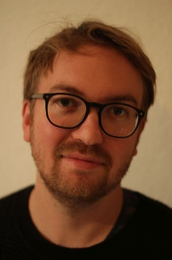 | Dr Tim Lindemann | online | t.lindemann@qmul.ac.uk | Thursdays 1-2 pm

You can use tutors’ Advice & Feedback hours to get advice and feedback. Please email your tutor to book an appointment.

LEARNING PLAN

SEMESTER 1: Studio B2.1
week | main topic | LEARNING OUTCOMES |  | LANGUAGE FOCUS | CULTURE | SELF-STUDY (qm+)
 | What is the main topic of the week? | What will I be able to do with the language I am learning this week |  | What particular language features will be covered? | What cultural information will I learn this week? | What am I expected to do outside class from one week to the next?
1 | Einführung  Kennenlernen  Nachrichten | Kursüberblick, Materialien,  sich vorstellen, über Gespräche und Nachrichten berichten |  | Grammatik Wiederholung:  Regelmäßige und unregelmäßige Verben, Vergangenheitsformen | Zeitungsartikel: aktuelle Ereignisse aus Deutschland verstehen, Presse & Sprache | Kursbuch kaufen  Aufgaben auf QMPlus
2 | Märchen  Schlösser  Biografien | über Märchen sprechen  Biografien lesen und Notizen machen |  | Präteritum, Perfekt, Plusquamperfekt | Gebrüder Grimm und die deutsche Sprache,  Kaiserin Sissi, Schlösserland Sachsen | Kapitel 1:  Kursbuch Seite 14-22  Übungen Seite 110-119  Aufgaben auf QMPlus
3 | Rechte und Pflichten,  Beschwerden | Vermutungen äußern, sich beschweren, einen Rat geben |  | Infinitiv mit und ohne ‚zu‘  Konjunktiv II | das deutsche Grundgesetz  die Grundrechte | Kapitel 2:  Kursbuch Seite 24-32  Übungen Seite 120-129  Aufgaben auf QMPlus
4 | Digitale Welt  Medien  Internet-Gemeinschaften | über Mediennutzung sprechen, eine Grafik auswerten und kommentieren, Nachricht schreiben |  | Finalsätze: um …zu, damit  Nominalisierung ‚zum‘ | Netzwerke im Internet  Telenovelas | Kapitel 3:  Kursbuch Seite 34-42  Übungen Seite 130-139  Aufgaben auf QMPlus
5 | Lebensmittel und  Essen, telefonische Bestellungen  Geschäftsessen | über Lebensmittel und Essen sprechen, Aussagen kommentieren |  | Partizip I und Partizip II  Wortstellung: Nebensätze | Das Erste Wiener Gemüseorchester: Essen als Klangerlebnis | Kapitel 4:  Kursbuch Seite 44-52  Übungen 140-149  Aufgaben auf QMPlus
6 | Natur als Lebensraum  Nationalparkidee | einen Standort beschreiben,  über Urlaubsziele sprechen,  über Ausbildungsinhalte sprechen |  | Satzglieder erkennen,  Verben und Ergänzungen | Nationalpark ‚Bayerischer Wald‘, Tobias Heinemann – Nationalpark-Ranger | Kapitel 5:  Kursbuch Seite 62-70  Übungen 152-161  Aufgaben auf QMPlus
7 | STUDY WEEK: Prüfungsvorbereitung: Kursbuch, Seite 150-151
8 | Arbeit, Lebenslauf, Bewerbung, Stellenanzeigen | über Stellenanforderungen diskutieren, Anrede am Arbeitsplatz,  ein Bewerbungsschreiben verfassen |  | Präpositionaladverbien,  Reflexivpronomen | Anrede am Arbeitsplatz, Anzeigen in der deutschen Presse | Kapitel 6:  Kursbuch Seite 73-80  Übungen Seite 162-171  Aufgaben auf QMPlus
9 | Beziehungen zu Gegenständen und Menschen | über Beziehungen sprechen, Eindrücke beschreiben, eine Kritik schreiben |  | indirekte Rede | Film: Mitte Ende August  Goethes Roman neu erzählt  die Prinzen | Kapitel 7:  Kursbuch Seite 82-90  Übungen Seite 172-181  Aufgaben auf QMPlus
10 | Bücherwelt,  Autoren,  Kurzgeschichten | eine Diskussion zu Lesegewohnheiten führen, eine Kurzgeschichte präsentieren |  | konzessive und konsekutive Konnektoren und Präpositionen | deutschsprachige Autoren lesen und diskutieren | Kapitel 8:  Kursbuch Seite 14-22  Übungen Seite 182-191  Aufgaben auf QMPlus
11 | Kunst und Kultur  Welterbestätten  Subkulturen | über Kunstobjekte sprechen,  Welterbestätten kennenlernen,  Subkultur-Projekte recherchieren |  | Temporale Konnektoren und Präpositionen | Kunst und Kultur in D-A-CH | mündliche Präsentation
12 | Prüfungsvorbereitung

SEMESTER 2: Studio B2.2
week | main topic | LEARNING OUTCOMES | LANGUAGE FOCUS | CULTURE | SELF-STUDY (qm+)
 | What is the main topic of the week? | What will I be able to do with the language I am learning this week | What particular language features will be covered? | What cultural information will I learn this week? | What am I expected to do outside class from one week to the next?
1 | Extremes Verhalten  Extreme Berufe  Gedächtnisrekorde | über Ungewöhnliches berichten  Texte zusammenfassen,  Gefühle ausdrücken | historisches Präsens erkennen  Irreale Vergleiche: als ob, als wenn | Falco Trabers Weltrekorde  Quotenhit: Wetten, dass … | Kapitel 1:  Kursbuch Seite 8-16  Übungen Seite 104-113  Aufgaben auf QMPlus
2 | 125 Jahre Auto  Technische Entwicklungen  Experimente im Alltag | Begriffe definieren  zeitliche Abläufe beschreiben  technischen Text verstehen  Experimente bewerten | Präpositionen: dank, wegen  Passiv und Ersatzformen | Geschichte von Daimler Benz | Kapitel 2:  Kursbuch Seite 18-26  Übungen Seite 114-123  Aufgaben auf QMPlus
3 | Modetrends  Magazinthemen  Frauen-Männer-Berufe | über Magazinthemen sprechen  schriftlich Stellung nehmen  etwas bewerten und empfehlen | es – im Satz  Negation durch Präfix oder Suffix | Trends in der Erziehung | Kapitel 3:  Kursbuch Seite 28-36  Übungen Seite 124-133  Aufgaben auf QMPlus
4 | Messen – Produkte – Erfolge, Produktvergleiche,  Markennamen | Produkte beschreiben und präsentieren, Gespräche am Messestand führen, über Erfahrungen sprechen | Präpositionaladverbien 1  Verbindungsadverbien  pronominale Ersetzungen | Messen in D-A-CH  deutsche Produkte im Ausland | Kapitel 4:  Kursbuch Seite 38-46  Übungen Seite134-143  Aufgaben auf QMPlus
5 | Ehrenamtliche Arbeit, Soziale Projekte | Standpunkte verstehen und wiedergeben,  über freiwillige Arbeit berichten | Präpositionaladverbien 2  Konditionalsätze | Ehrenamtliche Organisationen und Arbeit in D-A-CH | Kapitel 5:  Kursbuch Seite 56-64  Übungen Seite 146-155  Aufgaben auf QMPlus
6 | Bauen im 20. Und 21. Jahrhundert,  Innovationen und Visionen | über Architektur sprechen  eine Biografie recherchieren und vorstellen, Begriffe erklären | Modalverben,  subjektiver Gebrauch der Modalverben | Das Bauhaus: Wiege der modernen Architektur | Kapitel 6:  Kursbuch Seite 66-74  Übungen Seite 156-165  Aufgaben auf QMPlus
7 | STUDY WEEK: Modelltest Kursbuch, Seite 188-196
8 | Soziale Milieus in Deutschland,  der Durchschnitts-deutsche | über typische Merkmale der Deutschen sprechen, statistische Daten wiedergeben | indirekte Rede,  indirekte Fragen und Sätze | Milieulandschaft Deutschland | Kapitel 7:  Kursbuch Seite 76-84  Übungen Seite 166-177  Aufgaben auf QMPlus
9 | Straßen und Geschichten,  der Weg ist das Ziel | über historische Ereignisse berichten, Vermutungen anstellen,  Inhalte erfragen und interpretieren | Reflexivpronomen  Präpositionen mit Genitiv, Konjunktionen: indem, sofern, Relativpronomen im Genitiv, | Fluchtweg und Mahnmal – die Bernauer Straße in Berlin | Kapitel 8:  Kursbuch Seite 86-94  Übungen Seite 176-185  Aufgaben auf QMPlus
10 | Geschichte und Zukunft, Ruhrpott –im Wandel, Gebäude und Ihre Geschichte | historische Entwicklungen beschreiben, eine Präsentation zur Gebäudeumnutzung verstehen, ein Gebäude / eine Region vorstellen | temporale Adverbien: Zeitpunkt, Zeitdauer, | Gebäude / Regionen in D-A-CH im Wandel der Zeit | Modelltest  Kursbuch Seite 196-200
11 | Prüfungsvorbereitung
12 | Mündlicher Test

SEMESTER DATES 2023-24

Semester 1 | Dates
Teaching Weeks 1 to 6 | 25 Sep – 5 Nov 2023
Study Week (Week 7) | 6 Nov – 10 Nov 2023
Teaching Weeks 8 to 12 | 13 Nov – 15 Dec 2023
January exam period | 4 – 19 January 2024
Semester 2 | Dates
Teaching Weeks 1 to 6 | 22 Jan – 1 Mar 2024
Study Week (Week 7) | 4 Mar – 8 Mar 2024
Teaching Weeks 8 to 12 | 11 Mar – 12 Apr 2024
Exam period | 2 May – 31 May 2024
Summer Resit period | August 2024

LEARNING MATERIALS

 | Course book |  |  | ISBN |  | Notes
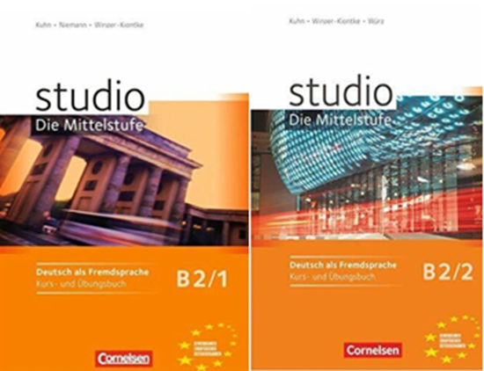 | Studio B1/1  Kurs- und Übungsbuch  Kuhn, C.,  Winzer-Kiontke, B.  Cornelsen Verlag,  2010 |  | 978-3-06-020094-8 |  | You can buy the course book on AMAZON and other bookstores. Check for second-hand options which will be cheaper.
 | Studio B1/1  Kurs- und Übungsbuch  Kuhn, C.,  Winzer-Kiontke, B.  Cornelsen Verlag,  2010 | 978-3-06-020074-0 |  |  | You can buy the course book on AMAZON and other bookstores. Check for second-hand options which will be cheaper.

OTHER RESOURCES:

DICTIONARIES.
http://en.pons.com/translate
www.dict.cc
https://dict.leo.org/german-english/
https://www.wordreference.com/
https://dictionary.cambridge.org/dictionary/english-german/

GRAMMAR:
https://german.net/
https://grammar.yourdictionary.com
https://learngerman.dw.com/en/grammar
https://mein-deutschbuch.de/grammatik.html

VIDEOS/LISTENING
Easy German Youtube channel: https://www.youtube.com/channel/UCbxb2fqe9oNgglAoYqsYOtQ
Deutsche Welle: https://www.dw.com/en/learn-german/s-2469
News, read slowly in German:
https://www.dw.com/de/07102020-langsam-gesprochene-nachrichten/a-55183615

BOOKS:
Macgregor, N. (2015) Germany, Penguin. ISBN-13 : 978-0141979786

QMplus Module page

The QMplus module page is the place to go to regularly before and after class, to prepare for the weekly sessions and find resources for self-study. Here you will find the materials used in class in addition to the course book, and additional resources and activities that help you consolidate and extend the material covered in class. You will also find links to web resources and videos on the language and cultural information.

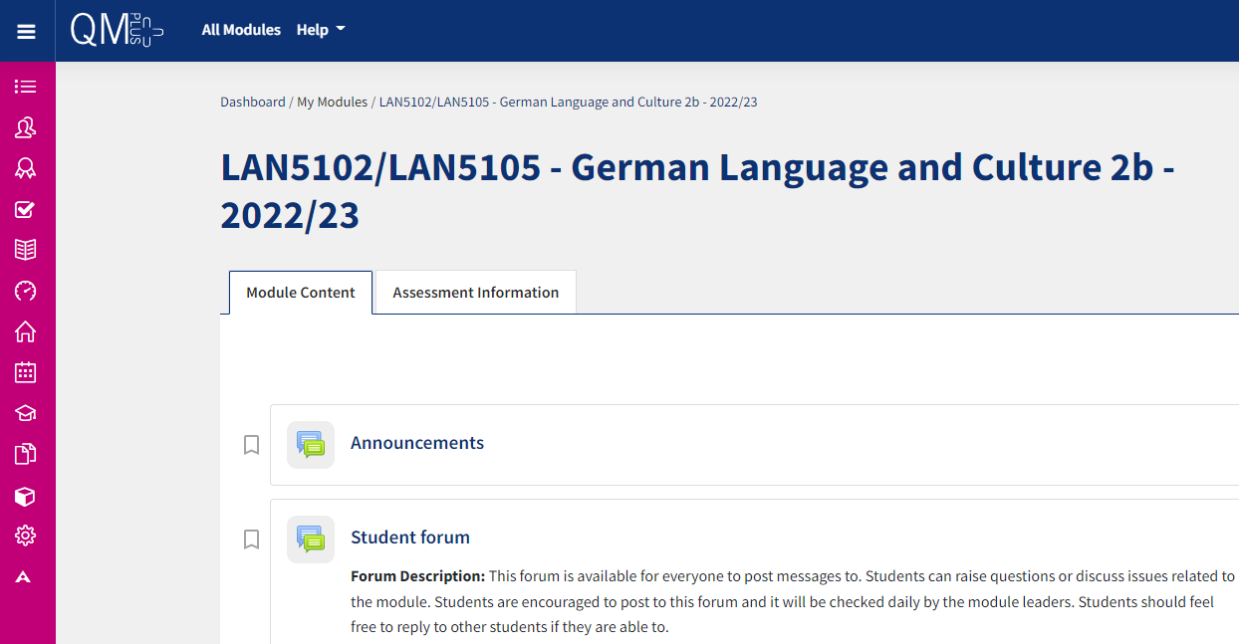

Free Language Speaking Practice

Language learners within the Queen Mary community can book 30-minute online speaking sessions with native or proficient speakers, for 15+ languages, for free. You can practise your speaking skills in the language you're learning, in an informal way. Sessions are offered by volunteers – QMUL students and staff who enjoy helping others learn. It’s a great way to practise the language, and get to know Queen Mary students from different schools and different backgrounds.

More information and booking link

FEEDBACK

- How can you check your progress throughout the module?
- What feedback can you expect from your tutor?

Language classes are highly interactive and participative, which means your tutor will give you regular instant feedback on your participation in class. Your tutor will also give you feedback on your submitted homework, and on activities that you complete on QMplus, if there is no automated feedback.

You will get feedback on the draft (formative submission) of your Writing Assignment, and will then have the opportunity to improve your writing before you submit it for summative assessment (counting towards your mark).

Your tutor is available during Feedback & Advice hours (check the times in the Tutor profile above), which you can use for a one-to-one meeting to discuss your progress. Please email your tutor beforehand.

ASSESSMENT INFORMATION

Assessment if you take the module FOR credit

If you are taking this module for credit, you need to complete and pass the assessments in order to gain the credits. The credits will count towards the total number of credits you need in each academic year (120 per year for undergraduate students).

Assessment if you take the module NOT for credit

If you are taking this module as a non-credit bearing module, it will not count towards your programme and you will not receive credits. However, if you complete and pass the module, you will receive a Certificate of Completion stating that you have passed the module, and with what grade. The requirements are that you:

- Have attended at least 65% of the taught sessions
- Take and pass the module assessment for non-credit seeking students to show that you have achieved the learning outcomes of the module
If you do not take the module assessment but meet the attendance requirement, you will receive a Certificate of Attendance, without a grade.

Assessment is carried out through formal and informal reading, writing, listening and speaking tasks. The assessment structure depends on whether you are taking the module for credit or not. Check your module code and note the assessment structure relevant to you, below:

Assessment structure:

NOT FOR CREDIT

LAN5105: German Language & Culture 2b: Students taking the module NOT for credit, year-long
In order to get a Certificate, you need to pass the following assessments:
LAN5105  Assessment Title | Weight towards final grade % | Length | Due Date
Coursework
- Reading &Listening Test | 20% |  | Semester 1, Week 11 (December)
- Writing Assignment | 30% | 300-350 words | Submission (formative):  Semester 2, Week 7  Feedback given in Week 8  Submission (summative):  Semester 2, Week 9
- Oral test | 50% |  | Semester 2, Week 12

Your tutor will give you assessment briefs for each of the assessments.

FOR CREDIT

LAN5102: German Language & Culture 2b: Students taking the module for credit, year-long (15 credits)
LAN5102  Assessment Title | Weight towards final grade % | Length | Due Date
Coursework
- Reading &Listening Test | 10% |  | Semester 1, Week 11 (December)
- Writing Assignment | 20% | 300-350 words | Submission (formative):  Semester 2, Week 7  Feedback given in Week 8  Submission (summative):  Semester 2, Week 9
- Oral exam | 30% |  | Semester 2, Week 12
Written exam | 40% | 2 hours | May Examination period

Your tutor will give you assessment briefs for each of the assessments.

MARKING CRITERIA FOR WRITING SKILLS

Task achievement | - How fully has the task brief been achieved? Does the text have the required length?*  - How fully, and in what breadth, has the topic been covered?  - If the task consists of description, how comprehensive is the description?  - If the task consists of argumentation, has the topic been considered from different angles?  - Have different aspects of the topic been elaborated?  - How relevant, and how correct, is the information included?
Organisation, Coherence and cohesion | - How clear is the text, and how logical is its structure?  - How appropriate, and how varied, are the connectors and cohesive devices used to link sentences?  - How well is paragraphing used, and how well are paragraphs connected to achieve a coherent text? Does the text read smoothly, or are there jumps?
Range  (Grammar, Syntax, Vocabulary) | - Are the sentence and grammatical structures appropriate for the level? (at lower levels, simple sentences will be fine, while at higher levels, the inclusion of more complex structures will be expected)  - How wide is the range of vocabulary used in the text? (simple and frequent lexical items will be fine at lower levels, while at higher levels, more varied vocabulary, use of nuance, and use of idiomatic expressions will be expected)
Accuracy (Grammar, Syntax, Vocabulary) | - How accurate are the grammar and sentence structures? If there are errors, are they minor, or do they impact the communication more severely? To what extent does the reader have to make an effort to understand what you are trying to communicate?  - How good is your command of the vocabulary? Do the words you have chosen have the right meaning to express what you want to say? If there are errors, do they just make the passage sound somewhat clumsy or do they obscure the meaning of the sentence and hinder communication?  - How well are lexical collocations used? (that is, words that normally go together, e.g. we say ‘to take a picture’ and not ‘to make a picture’, ‘to make a mistake’ and not ‘to do a mistake’, ‘to do someone a favour’ but not ‘to make someone a favour’)
*If you submit work significantly under the word limit, marks will be deducted.

MARKING CRITERIA FOR ASSESSMENT FOR SPEAKING SKILLS

Task achievement | Have you completed the task that has been set? Have you completed it fully or only partially?
Range of vocabulary and structures | How wide is the range of vocabulary that you use? Is it quite simple and basic, or do you master the full range of vocabulary that has been covered in the module?  What kind of sentence structures do you use? Are they simple (such as a list of short main clauses), or are they more complex (using longer sentence structures with subordinate clauses that are well connected by conjunctions)?
Accuracy of vocabulary and grammatical structures | How accurate is the vocabulary you are using? Are you using words with the right meaning to express what you want to say? How often do you pick words that don’t quite fit?  How accurate are the grammar and the sentence structures that you are using? How frequently do you make mistakes? Are the mistakes minor or do they make it hard for your conversation partner to understand what you are trying to say?
Pronunciation | How well do you pronounce the words and sounds in the target language? Is your pronunciation smooth and clear, with the correct word stress and sentence intonation, or is it difficult for the listener to recognise some of the words you produce?
Fluency | How natural is the speed of your speech? (Note that slight hesitations, restarting a sentence, pausing to find the right word, etc., is part of natural speech). Are there many, long and ‘unnatural’, pauses and hesitations? Is there a breakdown of communication? Can you repair gaps by paraphrasing a word that you cannot find, or by reformulating a sentence?
Interactional skills | How well can you use conversational norms when interacting with someone else: For example, opening a conversation, maintaining it, asking for clarification, giving appropriate responses to prompts from your conversation partner, taking turns in the conversation, closing (ending) the conversation.

