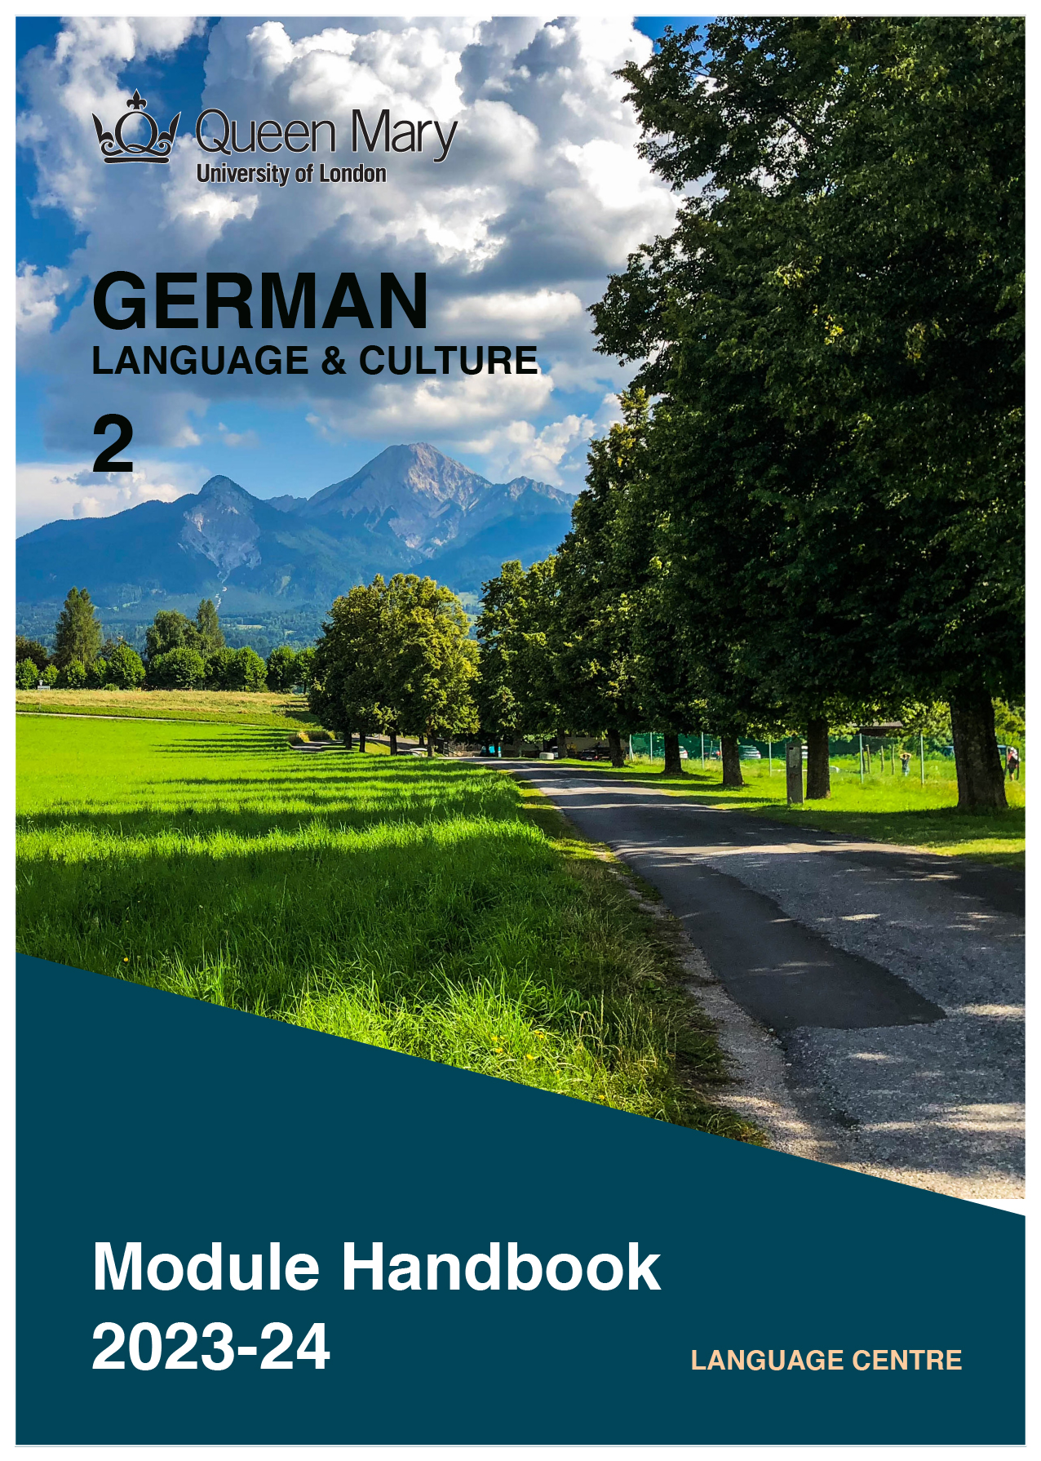

WELCOME TO LEARNING GERMAN

Welcome to the Learn a Language programme of Queen Mary. Language learning broadens the mind – you learn how different cultures and societies organize the world through language, you acquire a new vocabulary, new concepts, cultural knowledge, and become more interculturally aware. You can connect with people in another society in their language, a connection that is likely to be closer than if you make them speak your language or you communicate in a third language, such as English. You can use your language skills in your future career – employers consistently ask for better language skills in graduates. And, finally, language learning has cognitive benefits – studies show that bilinguals are more perceptive and have better memory. Speaking another language makes you more aware of language structure in general, and a better communicator.

GERMAN LANGUAGE

With over 100 million speakers, German is spoken as a native language by more people than any other language in Europe. It is an official language of Germany, Austria, Switzerland, Luxembourg, and Liechtenstein. In addition to that, around 20 million people are learning German as a foreign language worldwide. Germany is one of the largest exporters globally, and the largest national economy in Europe. Two-thirds of the world's leading international trade fairs take place in Germany. Speaking German will give you access to opportunities working for, or doing business with, companies in the German-speaking countries.

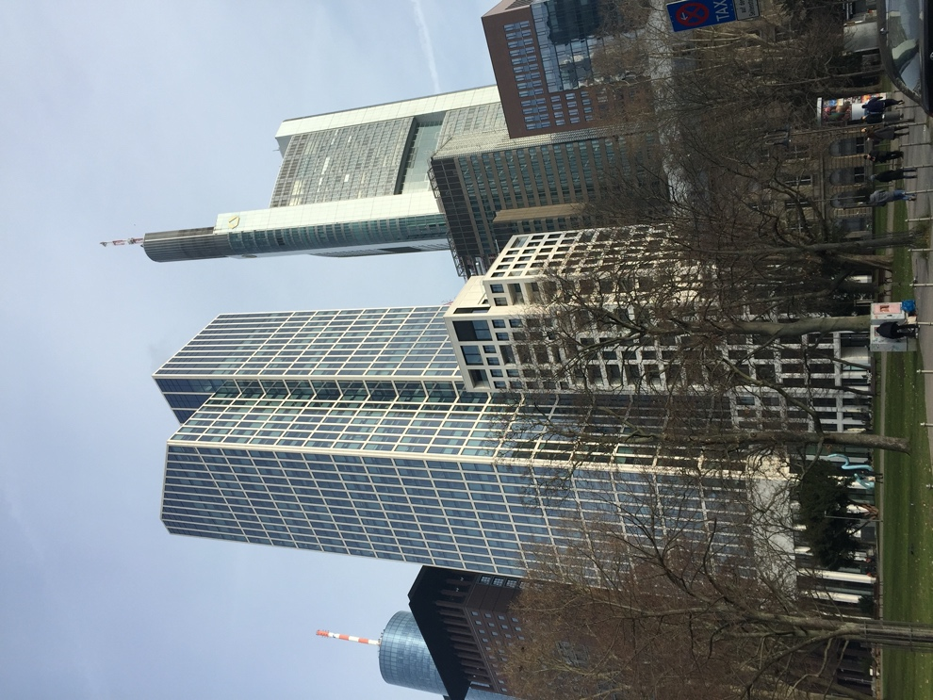

MODULE AIMS AND LEARNING OUTCOMES

Module Aims
The overall aims of this module are to help you to further develop your knowledge of the German language, and develop your ability to approach communication in the language in a confident and competent manner. You will move from a lower intermediate to a higher intermediate level of knowledge of the language, and develop your ability to function effectively and competently dealing with language occurring in more demanding and challenging situations, within a general or a professional context (equivalent to a level between B1 and B2 of the Common European Framework of Reference, CEFR).
You will improve your competence towards a higher intermediate level through tasks designed to develop your skills in speaking and writing. You will also develop your receptive skills, by reading and listening to more complex texts. The aim is to achieve a balance between fluency and accuracy, which means grammar and structure are an integral part of this course.

How is the module structured and how will it be taught?
You will have two timetabled sessions (of two hours each) per week, over two semesters (4 hours over 22 weeks). The module is taught in-person, on campus. This means you will get 88 hours of tutor-led learning. The total learning hours for this module are 300 hours, which means that in addition to the 88 tutor-led hours, you need to invest an additional 212 hours through independent study. You will do this by doing homework set by your tutor, completing tasks online on QMplus and in the course book, revising class materials and vocabulary, preparing for assessments, and using other opportunities to speak, listen to and read German outside the classroom.

The in-person and online sessions will be mainly used for interactive tasks and skills development (speaking, listening, writing), while explanations of grammar and introduction of new material will be delivered mainly via recorded video clips.
This means you will sometimes be asked to watch a video, go over a PowerPoint presentation, or read a text in preparation for a class, as well as completing exercises and tasks after sessions, for consolidation (e.g, exercises in the course book, on QMplus, recording yourself, etc.).

Module Learning Outcomes

You should develop the following outcomes related to academic content:
A1 | To achieve effective communication in German at level B1/B2 CEFR with competent speakers of the language.
A2 | To exploit, for a variety of purposes, a range of materials, written and spoken, in German level B1/B2 CEFR.
A3 | To demonstrate a knowledge and understanding of the structures, registers and, as appropriate, varieties of German at level B1/B2 CEFR.
A4 | To demonstrate a knowledge and understanding of German-speaking cultures and societies gained through the study of more complex written and aural texts and other cultural products in the target language.

You should develop the following disciplinary skills:
B1 | To analyze aspects of the target language and make use of them in a broadly professional context.
B2 | To gather and process information related to German language and German-speaking cultures from a variety of paper, audiovisual and electronic sources and communicate this information, both orally and in writing.
B3 | To use ICT effectively both as a means of communication and as an aid to learning.
B4 | To demonstrate some ability as an independent learner of the language in order to take further the study of German language and German-speaking cultures.

You should develop the following general attributes:
C1 | To be able to operate in more than one language, develop a global perspective and use the knowledge acquired to increase employability and engage with the professional world.
C2 | To apply analytical skills to investigate unfamiliar problems and to use the knowledge acquired to enrich research.
C3 | To be able to work effectively in diverse communities.
C4 | To work individually and in collaboration with others reflecting upon and assessing one's progress in learning the Target Language.

EXPECTED STUDY TIME

If you are taking this module for credit, you will get 30 credits, which equals 300 learning hours. 88 of those will be tutor-led through synchronous sessions, the rest you are expected to invest between the weekly sessions, in your own time, via guided learning, using resources on QMplus, in your course book, and other material as advised by your tutor. Even if you are not taking the module for credit, you should invest the same amount of time in order to make progress as expected.

30 credit module – 300 learning hours
Tutor-led learning | 88 hours
Interactive classes
Self-directed learning | 212 hours
Preparations for synchronous sessions | 44
Completing set homework | 44
Self-study after class (QMplus, course book, etc.) | 88
Preparation for assessments | 36
Total | 300

CONTACT DETAILS AND ADVICE & FEEDBACK HOURS OF YOUR TUTOR

 | Module tutor | Office | Email | Advice & feedback hours
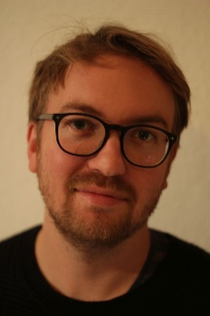 | Dr Tim Lindemann | online | t.lindemann@qmul.ac.uk | Thursdays 1-2pm

You can use tutors’ Advice & Feedback hours to get advice and feedback. Please email your tutor to book an appointment.

LEARNING PLAN

SEMESTER 1
week | main topic |  | LEARNING OUTCOMES |  | LANGUAGE FOCUS | CULTURE | SELF-STUDY (qm+)
 | What is the main topic of the week? |  | What will I be able to do with the language I am learning this week |  | What particular language features will be covered? | What cultural information will I learn this week? | What am I expected to do outside class from one week to the next?
1 | Sense of time  The Branden-burger Tor |  | Introducing oneself and others. Talking about how long something takes  Talking about daily routine and time. |  | Expressing duration. Nominalisation with zum  Use of während. Präteritum | The history of the Brandenburger Tor | Record an introductory video. Write a text on your language profile.  Complete activities on QMplus
2 | Time – Everyday life  Stress and the workplace |  | Describing historical events. Talking about problems and stressful situations. Giving reasons  Talking about stress. Giving advice. |  | Präteritum. Conjunctions deshalb, darum ,deswegen  Konjunktiv II (Präsens) of können, müssen, sollen | Reporting an incident  Politeness. Work-life balance | Übungen in the course book. Complete activities on QMplus
3 | Men and women – cliché or fact?  Couples and relationships |  | Talking about clichés. Male and female professions.  Talking about relationships and problems. Describing pictures |  | Agreeing and disagreeing in a debate  Infinitive + zu | Gender relations in Ger, Aus, Swi.  Gender relations in Ger, Aus, Swi. | Übungen in the course book. Complete activities on QMplus  Übungen in the course book. Complete activities on QMplus
4 | Das Ruhrgebiet: the changing world of work  Presentations |  | Describing places and regions, comparing past and present  Describing a region. Preparing a presentation. |  | Adjectives  Adjectives, adjective endings | The Ruhrgebiet  Different regions | Übungen in the course book. Complete activities on QMplus  Present a region (video presentation). Complete activities on QMplus
5 | School and education |  | Talking about school and learning. Talking about your own time at school. |  |  | The German education system | Übungen in the course book. Complete activities on QMplus
6 | Jobs in education. |  | Talking about what you wish |  | Konjunktiv II (Präsens): wäre, würde, hätte, könnte (subjunctive hypothetical)
7 | STUDY WEEK | Complete any unfinished exercises from the Übungen sections of units 1-5. Complete ‘Zertifikatstraining’ at the end of units.
8 | Climate and the weather  Climate change |  | Talking about the weather, describe environmental problems  Making predictions, talking about the future |  | wegen + genitive  Future tense: werden + infinitive | Attitudes to climate change. | Übungen in the course book. Complete activities on QMplus
9 | Environmental action, Extinction Rebellion  Rules of behaviour, social norms |  | Holding a debate. Agreeing and disagreeing.  Apologising, talking about embarrassing situations |  | Sentences with weil  Sentences with obwohl | Environmental politics in Germany  Social norms in Ger, Aus, Swi | Übungen in the course book. Complete activities on QMplus
10 | Inter-cultural norms  Generations |  | Talking about customs and norms in other countries, making comparisons  Talking about different periods in life, talking about a literary text |  | Past perfect tense | Social and cultural norms in German-speaking and other countries  Family structure and social structure in Germany | Übungen in the course book. Complete activities on QMplus
11 | Discussing problems.  Migration |  | Discussing problems, speculating  Talking about migration and reasons to migrate |  | Role play. weder … noch, nicht nur … sondern auch  Lassen + Infinitive | The history of migration in Germany | Übungen in the course book. Complete activities on QMplus  Report on migration in own country. Complete activities on QMplus.
12 | Migration  Test preparation |  | Talking about migration and reasons to migrate. Talking about feeling as a stranger |  | Relative clauses  man | Multicultural Germany and Austria | Übungen in the course book. Complete activities on QMplus
SEMESTER 2
week | main topic |  | OBJECTIVES |  | LANGUAGE FOCUS | CULTURE | SELF-STUDY (qm+)
 | What is the main topic of the week? |  | What will I be able to do with the language I am learning this week |  | What particular language features will be covered? | What cultural information will I learn this week? | What am I expected to do outside class from one week to the next?
1 | Einladungen, Gastgeschenke, Schlösser |  | Einladungen annehmen/ablehnen |  | Revision der B1-Grammatik | Hostess‘ gifts and castles in Germany, fairy tales | Übungen in the course book. Complete activities on QMplus
2 | Lebensmittel, Essen telefonisch bestellen |  | Etwas aushandeln, bestätigen, bestellen |  | Temporale Konjunktionen, Partizip I mit Verb oder Nomen |  | Übungen in the course book. Complete activities on QMplus
3 | Die digitale Welt |  | Wissen und Nichtwissen ausdrücken |  |  | Online communities in D-A-CH | Übungen in the course book. Complete activities on QMplus
4 | Medien |  | Eine Nachricht auf einer Mailbox hinterlassen |  | Komparativ, Superlativ, Nominalisierung | TV phenomena in D-A-CH | Übungen in the course book. Complete activities on QMplus
5 | Arbeitswelt |  | Über die Arbeit diskutieren, Bewerbungen schreiben, Lebenslauf schreiben |  | Präpositionaladverbien, Reflexivpronomen | Working conventions in D-A-CH, Du or Sie | Übungen in the course book. Complete activities on QMplus
6 | Extremes Verhalten  Ein extremer Beruf  Extreme Wetten  Gedächtnisrekorde |  | - über ungewöhnliche/extreme Ereignisse und Erlebnisse sprechen  - Texte zusammenfassen  - etwas positiv/negativ bewerten, Verständnis zeigen  - Erstaunen, Bewunderung und Ablehnung ausdrücken  - etwas vergleichen |  | historisches Präsens erkennen  Konjunktiv II in irrealen Verglei­ chen: als, als ob, als wenn | Records – an international comparison | Übungen in the course book. Complete activities on QMplus
7 | STUDY WEEK: Please complete the following work during Study Week: Prepare the Writing Project
8 | Vorbild Natur  125 Jahre Auto  Wie funktioniert ein Motor?  Faszination Auto  Experimente im Alltag |  | - über die Natur als Vorbild für technische Entwicklungen sprechen  - Begriffe definieren  - zeitliche Abläufe, Vorgänge und Handlungen beschreiben  - eine technische Beschreibung verstehen  - um Stellungnahme bitten, widersprechen, einwilligen  - Experimente durchführen und bewerten |  | Präpositionen dank und wegen  Passiv und Passiversatzformen | The German car industry | Übungen in the course book. Complete activities on QMplus
9 | Modetrends in Magazinen Frauen – Männer – Berufe Wohnwelten |  | - über Magazinthemen sprechen: Mode, Erziehung, Berufe, Wohnen  - etwas bewerten  - etwas empfehlen  - schriftlich Stellung nehmen |  | es im Satz  Negation durch  Präfix oder Suffix | Gender roles in D-A-CH | Übungen in the course book. Complete activities on QMplus
10 | Freiwilliges Engagement: Ehrenamt in Deutschland und  Österreich  Was bringt ein Ehrenamt? Ehrenamt als Lebenswerk |  | - über ehrenamtliches Engagement sprechen  - jemanden überzeugen, überreden über etwas berichten  - einen Bewerbungsbrief schreiben Standpunkte verstehen und wieder­  - geben |  | haben + zu, (nicht) brauchen + zu  irreale Konditionalsätze (Kon­ junktiv II) | Voluntary work in D-A-CH | Übungen in the course book. Complete activities on QMplus
11 | Bauen im 20. und 21. Jh. Das Bauhaus: Wiege der modernen Architektur  Architektur von morgen – Innovation und Vision  Soziale Milieus in Deutschland |  | - über Architektur sprechen Begriffe erklären  - die Position einer anderen Personwiedergeben  - eine Biografie recherchieren und vorstellen  - über „Typisch deutsch“ und Deutschlandbilder sprechen |  | subjektiver Gebrauch der Modalverben  indirekte Rede verwenden | German society and the perception of Germany  Architecture in German-speaking countries | Übungen in the course book. Complete activities on QMplus
12 | Prüfungsvorbereitung

SEMESTER DATES 2023-24

Semester 1 | Dates
Teaching Weeks 1 to 6 | 25 Sep – 5 Nov 2023
Study Week (Week 7) | 6 Nov – 10 Nov 2023
Teaching Weeks 8 to 12 | 13 Nov – 15 Dec 2023
January exam period | 4 – 19 January 2024
Semester 2 | Dates
Teaching Weeks 1 to 6 | 22 Jan – 1 Mar 2024
Study Week (Week 7) | 4 Mar – 8 Mar 2024
Teaching Weeks 8 to 12 | 11 Mar – 12 Apr 2024
Exam period | 2 May – 31 May 2024
Summer Resit period | August 2024

LEARNING MATERIALS

 | Course book | ISBN | Notes
 | Studio 21 - Deutschbuch B1 mit DVD-ROM  Funk–Kuhn–Nielsen–Winzer-Kiontke | 9783065205993 | You can buy the hard copy or you can buy the book as an e-book.  The hard copy costs about £30 and gives you access to online materials. Check for second-hand options, which will be cheaper.
 | studio d B2/1: Kurs- und Übungsbuch  studio d B2/2: Kurs- und Übungsbuch Funk–Niemann–Winter-Kiontke–Chromcak | 9783060200948  9783060200740

OTHER RESOURCES:
Online dictionary: https://dict.leo.org/german-english/
Youtube: Easy_German

Video/Listening
Easy German Youtube channel: https://www.youtube.com/channel/UCbxb2fqe9oNgglAoYqsYOtQ

Deutsche Welle: https://www.dw.com/en/learn-german/s-2469

News, read slowly in German:
https://www.dw.com/de/07102020-langsam-gesprochene-nachrichten/a-55183615
Books:
Macgregor, N. (2015) Germany, Penguin. ISBN-13 : 978-0141979786

QMplus Module page

The QMplus module page is the place to go to regularly before and after class, to prepare for the weekly sessions and find resources for self-study. Here you will find the materials used in class in addition to the course book, and additional resources and activities that help you consolidate and extend the material covered in class. You will also find links to web resources and videos on the language and cultural information.

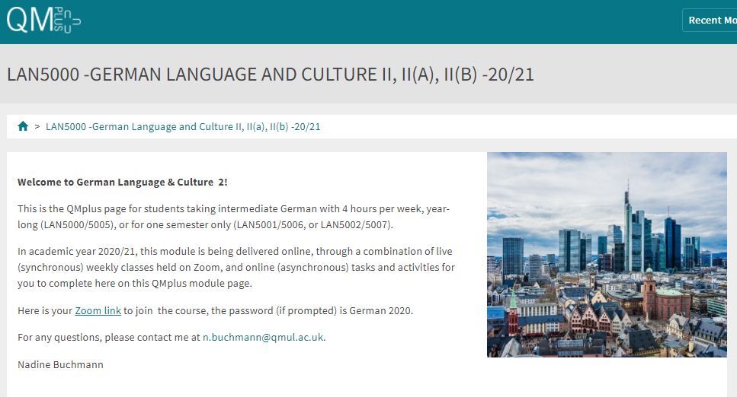

Free Language Speaking Practice

Language learners within the Queen Mary community can book 30-minute online speaking sessions with native or proficient speakers, for 15+ languages, for free. You can practise your speaking skills in the language you're learning, in an informal way. Sessions are offered by volunteers – QMUL students and staff who enjoy helping others learn. It’s a great way to practise the language, and get to know Queen Mary students from different schools and different backgrounds.

More information and booking link

FEEDBACK

- How can you check your progress throughout the module?
- What feedback can you expect from your tutor?

Language classes are highly interactive and participative, which means your tutor will give you regular instant feedback on your participation in class. Your tutor will also give you feedback on your submitted homework, and on activities that you complete on QMplus, if there is no automated feedback.

You will get feedback on the draft (formative submission) of your Writing Assignment, and will then have the opportunity to improve your writing before you submit it for summative assessment (counting towards your mark).

Your tutor is available during Feedback & Advice hours (check the times in the Tutor profile above), which you can use for a one-to-one meeting to discuss your progress. Please email your tutor beforehand.

ASSESSMENT INFORMATION

Assessment if you take the module FOR credit

If you are taking this module for credit, you need to complete and pass the assessments in order to gain the credits. The credits will count towards the total number of credits you need in each academic year (120 per year for undergraduate students).

Assessment if you take the module NOT for credit

If you are taking this module as a non-credit bearing module, it will not count towards your programme and you will not receive credits. However, if you complete and pass the module, you will receive a Certificate of Completion stating that you have passed the module, and with what grade. The requirements are that you:

- Have attended at least 65% of the taught sessions
- Take and pass the module assessment for non-credit seeking students to show that you have achieved the learning outcomes of the module
If you do not take the module assessment but meet the attendance requirement, you will receive a Certificate of Attendance, without a grade.

Assessment is carried out through formal and informal reading, writing, listening and speaking tasks. The assessment structure depends on whether you are taking the module for credit or not, and whether you take the year-long or the one-semester option. Check your module code and note the assessment structure relevant to you, below:

Assessment structure:

FOR CREDIT

LAN5000: German Language & Culture 2: Students taking the module for credit, year-long (30 credits)
LAN5000  Assessment Title | Weight towards final grade % | Length | Due Date
Coursework
- Reading &Listening Test | 10% |  | Semester 1, Week 11 (December)
- Writing Assignment | 20% | 300-350 words | Submission (formative):  Semester 2, Week 7  Feedback given in Week 8  Submission (summative):  Semester 2, Week 9
- Oral exam | 30% |  | Semester 2, Week 12
Written exam | 40% | 2 hours | May Examination period

LAN 5001: German Language & Culture 2a: Students taking the module for credit, Semester A only (15 credits)
LAN5001  Assessment Title | Weight towards final grade % | Length | Due Date
Coursework
- Reading &Listening Test | 10% |  | Semester 1, Week 11 (December)
- Writing Assignment | 20% | 275-325 words | Submission (formative):  Week 9  Feedback given in Week 10  Submission (summative):  First week in January
Oral exam | 30% |  | Semester 1, Week 12
Written exam | 40% | 2 hours | January Examination period

LAN 5002: German Language & Culture 2b: Students taking the module for credit, Semester B only (15 credits)
LAN5002  Assessment Title | Weight towards final grade % | Length | Due Date
Coursework
- Reading &Listening Test | 10% |  | Semester 2, Week 11
- Writing Assignment | 20% | 300-350 words | Submission (formative):  Semester 2, Week 7  Feedback given in Week 8  Submission (summative):  Semester 2, Week 9
Oral exam | 30% |  | Semester 2, Week 12
Written exam | 40% | 2 hours | May Examination period

NOT FOR CREDIT

German Language & Culture 2 (not for credit: LAN5006)
German Language & Culture 2a (not for credit: LAN5007)
German Language & Culture 2b (not for credit: LAN5005)
Students taking the module NOT for credit, year-long. In order to get a Certificate of Completion, you need to pass the following assessments:
LAN5006/LAN5007/LAN5005  Assessment Title | Weight towards final grade % | Due Date
Coursework
- Reading &Listening Test | 20% | Week 11
- Writing Assignment | 30% | Submission (formative): Week 7  Feedback given in Week 8  Submission (summative): Week 9
- Oral test | 50% | Last week of the module

Your tutor will give you assessment briefs for each of the assessments.

MARKING CRITERIA FOR ASSESSMENT OF WRITING SKILLS

Task achievement | - How fully has the task brief been achieved? Does the text have the required length?*  - How fully, and in what breadth, has the topic been covered?  - If the task consists of description, how comprehensive is the description?  - If the task consists of argumentation, has the topic been considered from different angles?  - Have different aspects of the topic been elaborated?  - How relevant, and how correct, is the information included?
Organisation, Coherence and cohesion | - How clear is the text, and how logical is its structure?  - How appropriate, and how varied, are the connectors and cohesive devices used to link sentences?  - How well is paragraphing used, and how well are paragraphs connected to achieve a coherent text? Does the text read smoothly, or are there jumps?
Range  (Grammar, Syntax, Vocabulary) | - Are the sentence and grammatical structures appropriate for the level? (at lower levels, simple sentences will be fine, while at higher levels, the inclusion of more complex structures will be expected)  - How wide is the range of vocabulary used in the text? (simple and frequent lexical items will be fine at lower levels, while at higher levels, more varied vocabulary, use of nuance, and use of idiomatic expressions will be expected)
Accuracy (Grammar, Syntax, Vocabulary) | - How accurate are the grammar and sentence structures? If there are errors, are they minor, or do they impact the communication more severely? To what extent does the reader have to make an effort to understand what you are trying to communicate?  - How good is your command of the vocabulary? Do the words you have chosen have the right meaning to express what you want to say? If there are errors, do they just make the passage sound somewhat clumsy or do they obscure the meaning of the sentence and hinder communication?  - How well are lexical collocations used? (that is, words that normally go together, e.g. we say ‘to take a picture’ and not ‘to make a picture’, ‘to make a mistake’ and not ‘to do a mistake’, ‘to do someone a favour’ but not ‘to make someone a favour’)
*If you submit work significantly under the word limit, marks will be deducted.

MARKING CRITERIA FOR ASSESSMENT FOR SPEAKING SKILLS

Task achievement | - Have you completed the task that has been set? Have you completed it fully or only partially?
Range of vocabulary and structures | - How wide is the range of vocabulary that you use? Is it quite simple and basic, or do you master the full range of vocabulary that has been covered in the module?  - What kind of sentence structures do you use? Are they simple (such as a list of short main clauses), or are they more complex (using longer sentence structures with subordinate clauses that are well connected by conjunctions)?
Accuracy of vocabulary and grammatical structures | - How accurate is the vocabulary you are using? Are you using words with the right meaning to express what you want to say? How often do you pick words that don’t quite fit?  - How accurate are the grammar and the sentence structures that you are using? How frequently do you make mistakes? Are the mistakes minor or do they make it hard for your conversation partner to understand what you are trying to say?
Pronunciation | - How well do you pronounce the words and sounds in the target language? Is your pronunciation smooth and clear, with the correct word stress and sentence intonation, or is it difficult for the listener to recognise some of the words you produce?
Fluency | - How natural is the speed of your speech? (Note that slight hesitations, restarting a sentence, pausing to find the right word, etc., is part of natural speech). Are there many, long and ‘unnatural’, pauses and hesitations? Is there a breakdown of communication? Can you repair gaps by paraphrasing a word that you cannot find, or by reformulating a sentence?
Interactional skills | - How well can you use conversational norms when interacting with someone else: For example, opening a conversation, maintaining it, asking for clarification, giving appropriate responses to prompts from your conversation partner, taking turns in the conversation, closing (ending) the conversation.

