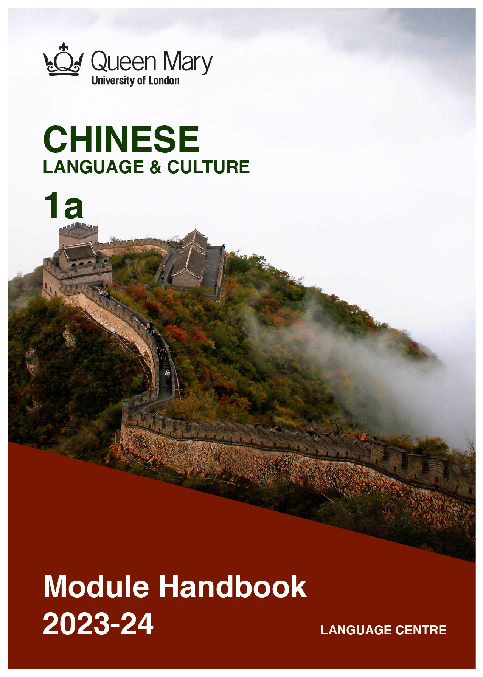

WELCOME TO LEARNING CHINESE

Welcome to the Learn a Language programme of Queen Mary. Language learning broadens the mind – you learn how different cultures and societies organize the world through language, you acquire a new vocabulary, new concepts, cultural knowledge, and become more interculturally aware. You can connect with people in another society in their language, a connection that is likely to be closer than if you make them speak your language or you communicate in a third language, such as English. You can use your language skills in your future career – employers consistently ask for better language skills in graduates. And, finally, language learning has cognitive benefits – studies show that bilinguals are more perceptive and have better memory. Speaking another language makes you more aware of language structure in general, and a better communicator.

MANDARIN CHINESE
Mandarin Chinese is offered in collaboration with Queen Mary’s Confucius Institute.
Chinese is spoken by about 1.6 billion people, with one fifth of the world's population now
using it as their mother tongue. Chinese has become more and more popular for language learners, and with the economic development of China and its overseas investments, speakers of Chinese are in high demand. Knowledge of the language can help you in a government career, but it will also be of benefit in business and in industries such as engineering, medical, and in the non-profit and international relations sectors. Speaking Chinese can help you build relationships with people in China and overseas Chinese communities.

(Picture by Kirsty Stage, student of Chinese 1b,2019/20)

MODULE AIMS AND LEARNING OUTCOMES

Module Aims
The overall aims of this module are to help you to develop a sound foundation of knowledge of the Chinese language, and an ability to approach communication in the language in a confident and competent manner. You will move from no knowledge, or very rudimentary knowledge of the language, to become someone who is able to function effectively at a basic level when using language occurring in everyday situations relating to practical matters, and be able to understand basic texts (equivalent to level A1 of the Common European Framework of Reference, CEFR).
You will learn the language through tasks designed to develop your skills in speaking and writing. You will also read and listen to simple texts, to develop your receptive skills. The aim is to achieve a balance between fluency and accuracy, which means grammar and structure are an integral part of this course.

How is the module structured and how will it be taught?
You will have one timetabled session (of two hours) per week, over two semesters (2 hours over 22 weeks). The module will be taught in-person, on campus. This means you will get 44 hours of tutor-led learning. The total learning hours for this module are 150 hours, which means that in addition to the 44 tutor-led hours, you need to invest an additional 106 hours through independent study. You will do this by doing homework set by your tutor, completing tasks online on QMplus and in the course book, revising class materials and vocabulary, preparing for assessments, and using other opportunities to speak, listen to and read Chinese outside the classroom.

The classroom-based sessions will be mainly used for interactive tasks and skills development (speaking, listening, writing), while explanations of grammar and introduction of new material will be delivered mainly via recorded video clips.
This means you will sometimes be asked to watch a video, go over a PowerPoint presentation, or read a text in preparation for a class, as well as completing exercises and tasks after sessions, for consolidation (e.g, exercises in the course book, on QMplus, recording yourself, etc.).

Module Learning Outcomes

You should develop the following outcomes related to academic content:
A1 | To achieve effective communication in Chinese at level A1 CEFR with competent speakers of the language.
A2 | To exploit, for a variety of purposes, a range of materials, written and spoken, in Chinese level A1 CEFR.
A3 | To demonstrate a knowledge and understanding of the structures, registers and, as appropriate, varieties of Mandarin Chinese at level A1 CEFR.
A4 | To demonstrate a knowledge and understanding of Chinese cultures and societies gained through the study of basic written and aural texts and other cultural products in the target language.

You should develop the following disciplinary skills:
B1 | To analyze aspects of the target language and make use of them in a broadly professional context.
B2 | To gather and process information related to Chinese language and cultures from a variety of paper, audiovisual and electronic sources and communicate this information, both orally and in writing.
B3 | To use ICT （information and communication technology）effectively both as a means of communication and as an aid to learning.
B4 | To demonstrate some ability as an independent learner of the language in order to take further the study of Chinese language and cultures.

You should develop the following general attributes:
C1 | To be able to operate in more than one language, develop a global perspective and use the knowledge acquired to increase employability and engage with the professional world.
C2 | To apply analytical skills to investigate unfamiliar problems and to use the knowledge acquired to enrich research.
C3 | To be able to work effectively in diverse communities.
C4 | To work individually and in collaboration with others reflecting upon and assessing one's progress in learning the Target Language.

(Picture by Shruthii Muthappan, student of Chinese 2a, 2019/20)

EXPECTED STUDY TIME

If you are taking this module for credit, you will get 15 credits, which equals 150 learning hours. 44 of those will be tutor-led through synchronous sessions, the rest you are expected to invest between the weekly sessions, in your own time, via guided learning, using resources on QMplus, in your course book, and other material as advised by your tutor. Even if you are not taking the module for credit, you should invest the same amount of time in order to make progress as expected.

15 credit module – 150 learning hours
Tutor-led learning | 44 hours
Interactive classes
Self-directed learning | 106 hours
Preparations for synchronous sessions | 22
Completing set homework | 22
Self-study after class (QMplus, course book, etc.) | 44
Preparation for assessments | 18
Total | 150

CONTACT DETAILS AND ADVICE & FEEDBACK HOURS OF YOUR TUTOR

 | Module tutor | Office | Email | Advice & feedback hours
 | Wan Li | Bancroft  Building 1.36 | li.wan@qmul.ac.uk | Friday  2:00PM-3:00PM

You can use tutor’s Advice & feedback hours for questions and feedback. Please email your tutor beforehand.

LEARNING PLAN
SEMESTER 1
Week | Main topic | Phonetics | Language focus | Key sentence | Objectives | Culture focus | Self-study
1 | Introduction of module handbook;  Introduction of Chinese language  Greeting | Introduction of Chinese pinyin and four tones | Introduction to Chinese characters; Sentence structure:  S+Adj. | Hello! | Students should be able to identify the four tones and greet each other. | Class expressions | (Hello,hello) Song
2 | Self-introduction (1): I am……  Greeting: Hello!  How are you?  Numbers 0-10 | Initials (Sheng mu) and Finals (Yun mu)  Tones (Sheng diao) | Sentence structure:  S+Adj.  S+Adj.+吗(ma)  S+V+O | Hello!  How are you?  I am……  You are…… | Students will be able to introduce their names, greeting each other  Students should be able to read and write their name. | Lucky numbers in China | Song of numbers
3 | Thank you.  Sorry.  Goodbye! | Review the finals  Spelling Practice | Sentence structure:  S+V+O  S+Adv.+Adj. | Daily expressions:  Thank you.  --You’re welcome.  Sorry. --It’s OK.  Goodbye! | Students should be able to express “Thank you, sorry, goodbye, and know how respond these in Chinese;  Students should be able to read and write the new sentences. | Lucky numbers in China | Sorry, my Chinese is not good(song)
4 | Self-introduction (2):  Surname  Given name | Spelling Practice | Sentence  structure:  S+adv.+V+O  Pron.+呢？  S+ V + QW? | Good morning  /evening/ afternoon. | Students should be able to ask each other’s name and surname in Chinese, and learn to answer them.  Students should be able to read and write the new sentences. | Common Chinese surname
5 | Self- introduction (3): |  | Sentence  structure:  S+ V + QW? | What’s your surname?  May I know your honourable surname?  What’s your name? | Students should be able to ask each other’s name and surname in Chinese, and learn to answer them. | How does Chinese address each other?
6 | Self- introduction (4):  Nationality  Age | Tone changes:  When two third tone be together | S+是+QW+N?  S+Adv（不)+是+N  S+是不是+(N)？  S+V+compliment/object | Where do you come from?  I come from…  I live in……  Who is that?  Is Mr. Wang English? | Students should be able to ask each other’s nationality in Chinese and learn to answer.  Students should be able to read and write the new sentences. | Chinese lucky signs  Unlucky signs | Curry curry(song)
7 | Reading week
8 | Review & Tasks & Practice:
9 | Self- introduction (5):  Age | Tone changes:  When two third tone be together | S+ Num.岁？  S+QW(多大）？ | How old are you?  I am ** years old. | Students should be able to ask each other’s age in Chinese and learn to answer.  Students should be able to read and write the new sentences.
10 | Family members | Neutral tone | Unit+ 有+ 几/多 | How many people are there in your family | Students should be able to ask each other’s family members and learn to answer.  Students should be able to read and write the new sentences.
11 | Occupation |  | S+Adv. (都)+是+N  Pronouns as modifier(+的） | What do you do?  I am a ……  What does your ……do?  …… is a ……  Where do you work?  I work in …… | Students should be able to ask each other’s occupation and workplace, and learn to answer them.  Students should be able to read and write the new sentences. | “Iron rice bowl” (A lifelong secure job) in China | Where is  My friends(song)
12 | Review & Tasks & Practice:

SEMESTER 2
Week | Main topic | Phonetics | Language focus | Key sentence | Objectives | Culture focus | Self-study
1 | Chinese Spring Festival  Chinese Zodiac |  | New Year’s greetings | 新年快乐！  春节吉祥！ | Students will be able to talk about some customs on Chinese Spring Festival, and make New Year’s greetings to each other. | Chinese Spring Festival  Chinese Zodiac
2 | Date  Birthday | The pronunciation of the number “1” | S+(是）+day/date  S+TW+QW+N | What's the date today?  Today is ……  When is your birthday?  My birthday is ……  Happy birthday to you! | Students should be able to ask the date and birthday in Chinese, and answer them, and should be able to read and write the new sentences. | Chinese Zodiac | Twelve Zodiacs（song)
3 | Date |  | Making invitations using “请” | He invites me to his birthday party. | Students will be able to make invitations.
4 | Time | Chinese pinyin  When “i”, “u”, at the beginning of a Pinyin | ……点……分 | What time is it now? | Students should be able to ask for and tell the time in Chinese. Students should be able to read and write the new sentences.
5 | Time  Appointments |  | S+TW+V+O  ……，怎么样？ | What are you doing on Saturday?  How about we go to the movies tonight? | Students should be able to ask for and tell the time in Chinese, and answer them, and make appointments. Students should be able to read and write the new sentences. | Too later or too early?
6 | Invitation |  | Expressing future tense with “要”  Daily activities | When do you ……? | Students should be able to ask for and tell the time in Chinese, and answer them, and make invitations. Students should be able to read and write the new sentences.
7 | Reading Week
8 | Review & Tasks & Practice:
9 | Address | Chinese pinyin  abbreviations  “ui” “un” | Word order of Chinese address | What’s your address?  What’s your email address? | Students should be able to ask for and give information about address, respond to a text message, and should be able to read and write the new sentences.
10 | Contact number | Chinese pinyin  abbreviations  “iu” “ün” | Question word “多少” | What's your phone number?  What’s your room number? | Students should be able to ask for and give information about contact numbers, respond to a text message, and should be able to read and write the new sentences. | The Chinese way of thinking: from large to small
11 | People’s appearance and personality | Finals: ao,uei, en | 真/很+adj. | 他/她怎么样？  他/她真高。 | Students will be able to describe people’s appearance and personality.
12 | Review & Tasks & Practice:

SEMESTER DATES 2023-24

Semester 1 | Dates
Teaching Weeks 1 to 6 | 25 Sep – 5 Nov 2023
Study Week (Week 7) | 6 Nov – 10 Nov 2023
Teaching Weeks 8 to 12 | 13 Nov – 15 Dec 2023
January exam period | 4 – 19 January 2024
Semester 2 | Dates
Teaching Weeks 1 to 6 | 22 Jan – 1 Mar 2024
Study Week (Week 7) | 4 Mar – 8 Mar 2024
Teaching Weeks 8 to 12 | 11 Mar – 12 Apr 2024
Exam period | 2 May – 31 May 2024
Summer Resit period | August 2024

LEARNING MATERIALS

 | Course book | ISBN | Notes
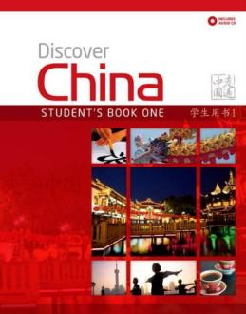 | Ding Anqi, Lily Jing, Xin Chen (2010)  Discover China (Student Book 1) | 978-0230405950 | You can buy the hard copy or download the book here:  http://www.mydiscoverchina.com/resources/

OTHER RESOURCES:

  - Online dictionary: https://dict.naver.com/linedict/zhendict/#/cnen/home

  - Youtube channels: https://www.youtube.com/channel/UCSXriUqkzZmAQklQ0N9XFVw
https://www.youtube.com/c/cnliziqi
https://www.youtube.com/channel/UC_HW6aVLpyvPIhc7w8YA8Ag
https://www.youtube.com/c/JasonLightfootLivinginChina/featured

- For reading and listening:
https://www.duchinese.net/lessons
https://www.thechairmansbao.com/
https://mandarinbean.com/

- For grammar:
https://resources.allsetlearning.com/chinese/grammar/Main_Page

- Learn Chinese song:
https://www.echinesesong.com

  - APP: pleco (dictionary), anki (flashcard), skritter (Write Chinese), HSK study and Exam (for HSK test)

  - Reading list for Chinese modules: https://qmul.rl.talis.com/search.html?q=chinese

  - Cultural events in London in 2022/23 related to Chinese: Please follow the Confucius Institute website or facebook @QMULCI

QMplus Module page

The QMplus module page is the place to go to regularly before and after class, to prepare for the weekly sessions and find resources for self-study. Here you will find the materials used in class in addition to the course book, and additional resources and activities that help you consolidate and extend the material covered in class. You will also find links to web resources and videos on the language and cultural information.

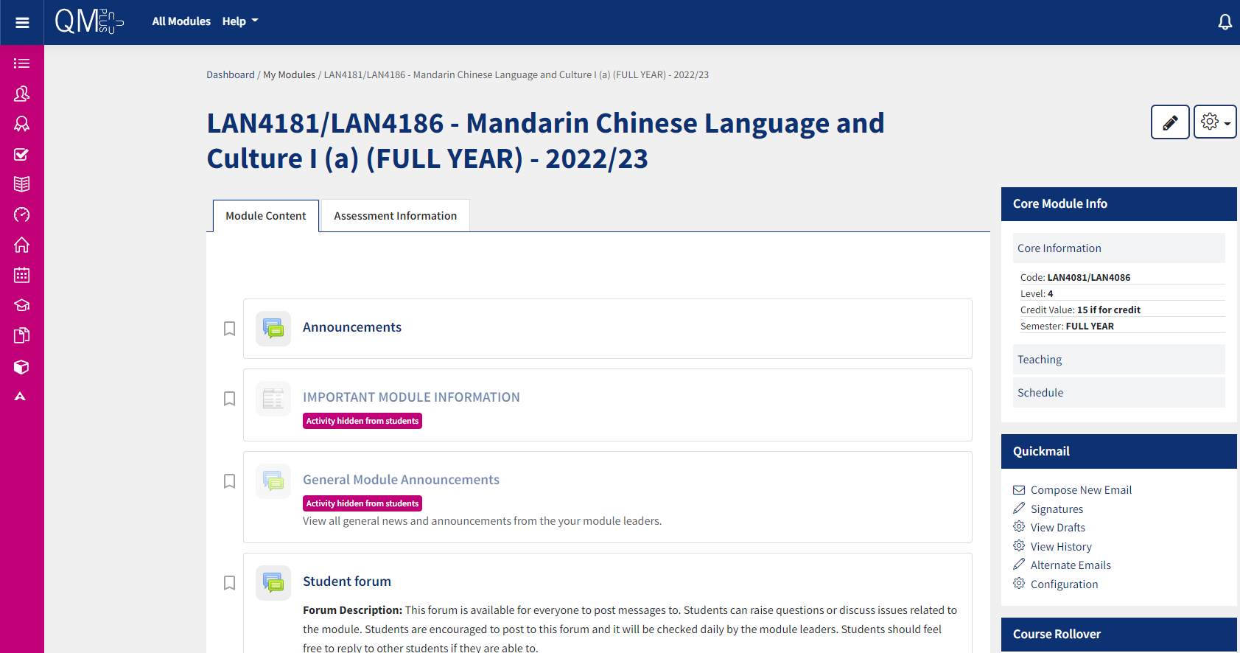

Free Language Speaking Practice

Language learners within the Queen Mary community can book 30-minute online speaking sessions with native or proficient speakers, for 15+ languages, for free. You can practise your speaking skills in the language you're learning, in an informal way. Sessions are offered by volunteers – QMUL students and staff who enjoy helping others learn. It’s a great way to practise the language, and get to know Queen Mary students from different schools and different backgrounds.

More information and booking link

FEEDBACK

- How can you check your progress throughout the module?
- What feedback can you expect from your tutor?

Language classes are highly interactive and participative, which means your tutor will give you regular instant feedback on your participation in class. Your tutor will also give you feedback on your submitted homework, and on activities that you complete on QMplus, if there is no automated feedback.

You will get feedback on the draft (formative submission) of your Writing Assignment, and will then have the opportunity to improve your writing before you submit it for summative assessment (counting towards your mark).

Your tutor is available during Feedback & Advice hours (check the times in the Tutor profile above), which you can use for a one-to-one meeting to discuss your progress. Please email your tutor beforehand.

ASSESSMENT INFORMATION

Assessment if you take the module FOR credit

If you are taking this module for credit, you need to complete and pass the assessments in order to gain the credits. The credits will count towards the total number of credits you need in each academic year (120 per year for undergraduate students).

Assessment if you take the module NOT for credit

If you are taking this module as a non-credit bearing module, it will not count towards your programme and you will not receive credits. However, if you complete and pass the module, you will receive a Certificate of Completion stating that you have passed the module, and with what grade. The requirements are that you:

- Have attended at least 65% of the taught sessions
- Take and pass the module assessment for non-credit seeking students to show that you have achieved the learning outcomes of the module
If you do not take the module assessment but meet the attendance requirement, you will receive a Certificate of Attendance, without a grade.

Assessment is carried out through formal and informal reading, writing, listening and speaking tasks. The assessment structure depends on whether you are taking the module for credit or not. Check your module code and note the assessment structure relevant to you below:

Assessment structure:

NOT FOR CREDIT

LAN4186: Chinese Language & Culture 1a: Students taking the module NOT for credit, year-long.
In order to get a Certificate, you need to pass the following assessments:
LAN4186  Assessment Title | Weight towards final grade % | Length | Due Date
Coursework
- Reading &Listening Test | 20% |  | Sem 1 Week 11/12 (Dec)
- Written Assignment | 30% | Chinese: 120 characters | Submission (formative):  Semester 2, Week 7  Feedback given in Week 8  Submission (summative):  Semester 2, Week 9
- Oral Examination | 50% |  | Sem 2 Week 12 (April)

Your tutor will give you assessment briefs for each of the assessments.

FOR CREDIT

LAN4181: Chinese Language & Culture 1a: Students taking the module for credit, year-long (15 credits)
LAN4181  Assessment Title | Weight towards final grade % | Length | Due Date
Coursework
- Reading &Listening Test | 10% |  | Sem 1 Week 11/12 (Dec)
- Written Assignment | 20% | Chinese: 120 characters | Submission (formative):  Semester 2, Week 7  Feedback given in Week 8  Submission (summative):  Semester 2, Week 9
- Oral Examination | 30% |  | Sem 2 Week 12 (April)
- Written Examination | 40% |  | May exam period

Your course teacher will give detailed instructions in advance of assessments.

MARKING CRITERIA FOR ASSESSMENT OF WRITING SKILLS

Task achievement | - How fully has the task brief been achieved? Does the text have the required length?*  - How fully, and in what breadth, has the topic been covered?  - If the task consists of description, how comprehensive is the description?  - If the task consists of argumentation, has the topic been considered from different angles?  - Have different aspects of the topic been elaborated?  - How relevant, and how correct, is the information included?
Organisation, Coherence and cohesion | - How clear is the text, and how logical is its structure?  - How appropriate, and how varied, are the connectors and cohesive devices used to link sentences?  - How well is paragraphing used, and how well are paragraphs connected to achieve a coherent text? Does the text read smoothly, or are there jumps?
Range  (Grammar, Syntax, Vocabulary) | - Are the sentence and grammatical structures appropriate for the level? (at lower levels, simple sentences will be fine, while at higher levels, the inclusion of more complex structures will be expected)  - How wide is the range of vocabulary used in the text? (simple and frequent lexical items will be fine at lower levels, while at higher levels, more varied vocabulary, use of nuance, and use of idiomatic expressions will be expected)
Accuracy (Grammar, Syntax, Vocabulary) | - How accurate are the grammar and sentence structures? If there are errors, are they minor, or do they impact the communication more severely? To what extent does the reader have to make an effort to understand what you are trying to communicate?  - How good is your command of the vocabulary? Do the words you have chosen have the right meaning to express what you want to say? If there are errors, do they just make the passage sound somewhat clumsy or do they obscure the meaning of the sentence and hinder communication?  - How well are lexical collocations used? (that is, words that normally go together, e.g. we say ‘to take a picture’ and not ‘to make a picture’, ‘to make a mistake’ and not ‘to do a mistake’, ‘to do someone a favour’ but not ‘to make someone a favour’)
*If you submit work significantly under the word limit, marks will be deducted.

MARKING CRITERIA FOR ASSESSMENT FOR SPEAKING SKILLS
Task achievement | - Have you completed the task that has been set? Have you completed it fully or only partially?
Range of vocabulary and structures | - How wide is the range of vocabulary that you use? Is it quite simple and basic, or do you master the full range of vocabulary that has been covered in the module?  - What kind of sentence structures do you use? Are they simple (such as a list of short main clauses), or are they more complex (using longer sentence structures with subordinate clauses that are well connected by conjunctions)?
Accuracy of vocabulary and grammatical structures | - How accurate is the vocabulary you are using? Are you using words with the right meaning to express what you want to say? How often do you pick words that don’t quite fit?  - How accurate are the grammar and the sentence structures that you are using? How frequently do you make mistakes? Are the mistakes minor or do they make it hard for your conversation partner to understand what you are trying to say?
Pronunciation | - How well do you pronounce the words and sounds in the target language? Is your pronunciation smooth and clear, with the correct word stress and sentence intonation, or is it difficult for the listener to recognise some of the words you produce?
Fluency | - How natural is the speed of your speech? (Note that slight hesitations, restarting a sentence, pausing to find the right word, etc., is part of natural speech). Are there many, long and ‘unnatural’, pauses and hesitations? Is there a breakdown of communication? Can you repair gaps by paraphrasing a word that you cannot find, or by reformulating a sentence?
Interactional skills | - How well can you use conversational norms when interacting with someone else: For example, opening a conversation, maintaining it, asking for clarification, giving appropriate responses to prompts from your conversation partner, taking turns in the conversation, closing (ending) the conversation.

