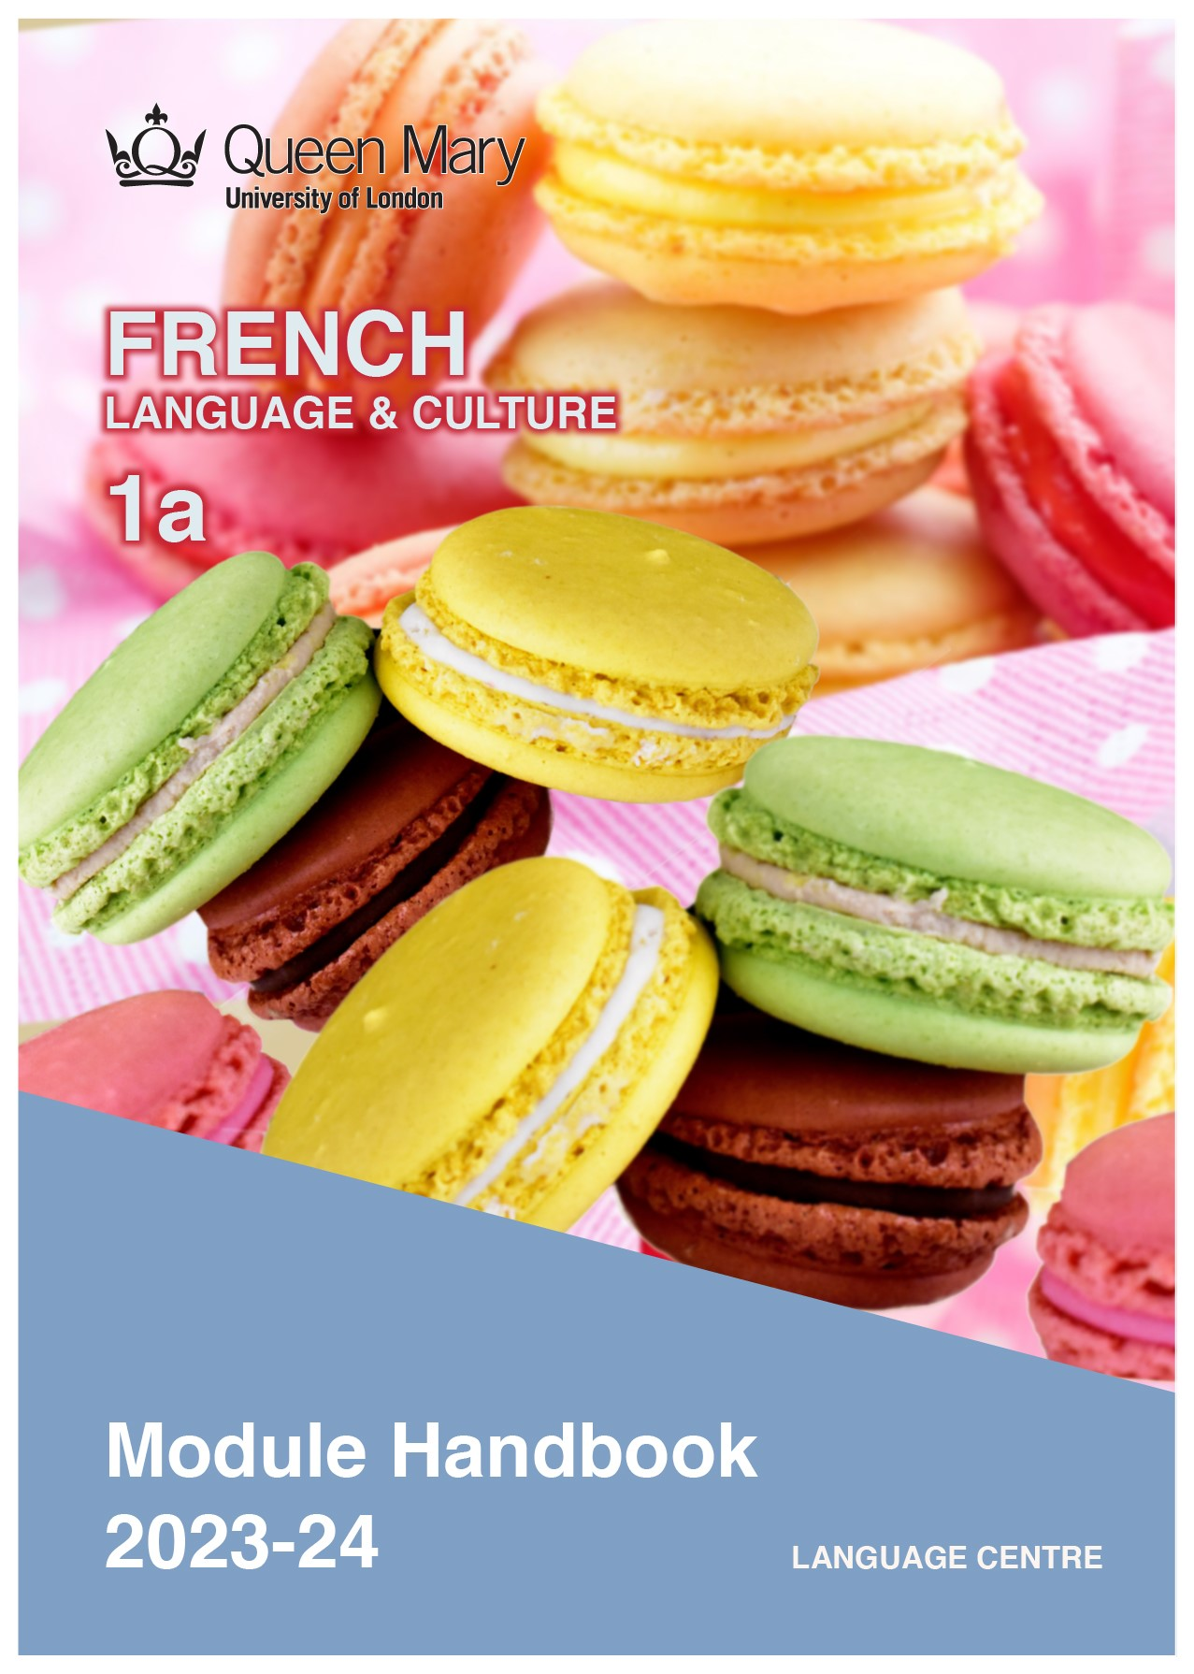

WELCOME TO LEARNING FRENCH

Welcome to the Learn a Language programme of Queen Mary. Language learning broadens the mind – you learn how different cultures and societies organize the world through language, you acquire a new vocabulary, new concepts, cultural knowledge, and become more interculturally aware. You can connect with people in another society in their language, a connection that is likely to be closer than if you make them speak your language or you communicate in a third language, such as English. You can use your language skills in your future career – employers consistently ask for better language skills in graduates. And, finally, language learning has cognitive benefits – studies show that bilinguals are more perceptive and have better memory. Speaking another language makes you more aware of language structure in general, and a better communicator.

FRENCH LANGUAGE
French is the official language in 29 countries and is spoken by some 274 million people, of which 76 million are native speakers. French is a Romance language (derived from Latin) and shares its origins with Spanish, Italian and Portuguese. French has a long history as an international language of literature, diplomacy and scientific standards, and is a primary or second language in many international organisations, including the UN, EU, NATO and the WTO. The British Council report Languages for the Future (2017) lists French as the third most important language for the UK. Speaking French will give you access to business opportunities in countries in Europe, Africa and North America.

Arkadiusz Zarzecki

MODULE AIMS AND LEARNING OUTCOMES

Module Aims
The overall aims of this module are to help you to develop a sound foundation of knowledge of the French language, and an ability to approach communication in the language in a confident and competent manner. You will move from no knowledge, or very rudimentary knowledge of the language, to become someone who is able to function effectively at a basic level when using language occurring in everyday situations relating to practical matters, and be able to understand basic texts (equivalent to level A1 of the Common European Framework of Reference, CEFR).
You will learn the language through tasks designed to develop your skills in speaking and writing. You will also read and listen to simple texts, to develop your receptive skills. The aim is to achieve a balance between fluency and accuracy, which means grammar and structure are an integral part of this course.

How is the module structured and how will it be taught?
You will have one timetabled session (of two hours) per week, over two semesters (2 hours over 22 weeks). The module will be taught in-person, on campus.

This means you will get 44 hours of tutor-led learning. The total learning hours for this module are 150 hours, which means that in addition to the 44 tutor-led hours, you need to invest an additional 106 hours through independent study. You will do this by doing homework set by your tutor, completing tasks online on QMplus and in the course book, revising class materials and vocabulary, preparing for assessments, and using other opportunities to speak, listen to and read French outside the classroom.

The classroom-based sessions will be mainly used for interactive tasks and skills development (speaking, listening, writing), while explanations of grammar and introduction of new material will be delivered mainly via recorded video clips.
This means you will sometimes be asked to watch a video, go over a PowerPoint presentation, or read a text in preparation for a class, as well as completing exercises and tasks after sessions, for consolidation (e.g, exercises in the course book, on QMplus, recording yourself, etc.).

Module Learning Outcomes

You should develop the following outcomes related to academic content:
A1 | To achieve effective communication in French at level A1 CEFR with competent  speakers of the language.
A2 | To exploit, for a variety of purposes, a range of materials, written and spoken, in French level A1 CEFR.
A3 | To demonstrate a knowledge and understanding of the structures, registers and, as appropriate, varieties of French at level A1 CEFR.
A4 | To demonstrate a knowledge and understanding of Francophone cultures and societies gained through the study of basic written and aural texts and other cultural products in the target language.

You should develop the following disciplinary skills:
B1 | To analyze aspects of the target language and make use of them in a broadly professional context.
B2 | To gather and process information related to French language and cultures from a variety of paper, audiovisual and electronic sources and communicate this information, both orally and in writing.
B3 | To use ICT effectively both as a means of communication and as an aid to learning.
B4 | To demonstrate some ability as an independent learner of the language in order to take further the study of French language and cultures.

You should develop the following general attributes:
C1 | To be able to operate in more than one language, develop a global perspective and use the knowledge acquired to increase employability and engage with the professional world.
C2 | To apply analytical skills to investigate unfamiliar problems and to use the knowledge acquired to enrich research.
C3 | To be able to work effectively in diverse communities.
C4 | To work individually and in collaboration with others reflecting upon and assessing one's progress in learning the Target Language.

EXPECTED STUDY TIME

If you are taking this module for credit, you will get 15 credits, which equals 150 learning hours. 44 of those will be tutor-led through synchronous sessions, the rest you are expected to invest between the weekly sessions, in your own time, via guided learning, using resources on QMplus, in your course book, and other material as advised by your tutor. Even if you are not taking the module for credit, you should invest the same amount of time in order to make progress as expected.

15 credit module – 150 learning hours
Tutor-led learning | 44 hours
Interactive classes
Self-directed learning | 106 hours
Preparations for synchronous sessions | 22
Completing set homework | 22
Self-study after class (QMplus, course book, etc.) | 44
Preparation for assessments | 18
Total | 150

CONTACT DETAILS AND ADVICE & FEEDBACK HOURS OF YOUR TUTOR

 | Module tutor | Office | Email | Advice & feedback hours
 | Philip France | Bancroft 1.36 | p.france@qmul.ac.uk | Mon 1 – 3 pm  Tues 3 – 4 pm  Wed 1 – 2 pm
 | Viviane Blanchard | Bancroft 1.36

You can use tutors’ office hours to get advice and feedback. Please email your tutor to book an appointment.

LEARNING PLAN
SEMESTER 1
week | main topic | LEARNING OUTCOMES |  | LANGUAGE FOCUS | CULTURE | SELF-STUDY (qm+)
 | What is the main topic of the week? | What will I be able to do with the language I am learning this week |  | What particular language features will be covered? | What cultural information will I learn this week? | What am I expected to do outside class from one week to the next?
1 | Introducing yourself | Saying your name, your age, masc/fem genders. |  | Counting 1-20  Regular verbs  Irregular auxiliary verbs: être/avoir, alphabet. | Titles used in French: monsieur, madame, mademoiselle | Practise your French  Franglish, introducing yourself, les chiffres
2 | Greetings, use of tu and vous | To greet, to part, to ask for personal information. |  | Numbers 21-70  Possessive adjectives, negative ne … pas. | Linguistic similarities | Verb conjugation
3 | Nationalities, countries | Saying where you live |  | Numbers 71-100  Negative form | Nationality | Revise numbers 1-100, time.
4 | Greetings, telling the time | Telling the time |  | Time, days of the week |  | Expressions of frequency, accommodation
5 | Talk about your town. | To understand description of a town |  | Prepositions for describing locations, furniture | Typical French town | Agreement of ‘de’, describe your room.
6 | Directions | Giving and understanding directions |  | Directions lexis, imperative form |  | Describe where you live in London
7 | STUDY WEEK: Please complete the following work during Study Week: Look at exercises and information on QM+
8 | Book accommodation  Directions | Describing a place and saying where it is located. |  | There is/there are  Negative form  Prepositions of place | Reserving a hotel room
9 | Family | Talk your family |  | Family lexis, possessive adjectives | Family | Revise family lexis
10 | Hobbies | Talk about hobbies |  | Writing a postcard | French pastimes | Write about what you like and dislike doing.
11 | Daily routine | Describing your typical day |  | Adverbs of frequency  Present verb tense (-ir)  Reflexive verbs | Reading about a French person’s typical week | Revise daily routine and time
12 | Personality | Describe a person’s character |  | Announcing family events | Family events | Describe your/a friend’s character
SEMESTER 2
week | main topic | OBJECTIVES |  | LANGUAGE FOCUS | CULTURE | SELF-STUDY (qm+)
 | What is the main topic of the week? | What will I be able to do with the language I am learning this week |  | What particular language features will be covered? | What cultural information will I learn this week? | What am I expected to do outside class from one week to the next?
1 | Habits and chores | Saying what you enjoy doing, what you can and can’t do |  | Chores lexis, adverbs of frequency | Chores | Describe who does what at home.
2 | Making an appointment | Arranging to go out |  | Inviting, accepting and refusing | Invitations | Revise future proche
3 | Talking about the past | To be able to talk about past events |  | Passé composé |  | Revise past tense
4 | Talking about the past | Understanding a questionnaire |  | Past daily routine | Typical day | Describe what you did last weekend
5 | Holiday rituals | Describing holiday rituals |  | Verbs: can, must, to want | French holidays | Revise future and past tenses
6 | Telephone | How to talk on the phone |  | Common telephone expressions | Médecins sans Frontières | Role-play: phone conversation
7 | STUDY WEEK: Please complete the following work during Study Week: a 2-minute oral presentation coursework
8 | Giving advice | Give travel advice |  | Verbs: vouloir, devoir, pouvoir | Travel | Role-play: asking/giving advice
9 | People | Describing people: appearance and character  Making comparisons |  | Comparatives | Les célébrités – French celebrities | Compare two French celebrities’ appearance
10 | 5 senses | Talking about sensations |  | Months, seasons  Future verb tense: future simple | Radio France | Choose a city, watch a weather forecast video for the week and make notes
11 | Revision |  |  |  |  | Revision for end-of-module test
12 | Revision |  |  |  |  | Revision for end-of-module test

LEARNING MATERIALS

 | Course book | ISBN | Notes
 | Alter Ego + A1  by A. Berthet, E. Daill, C. Hugot, V.M. Kizirian, M. Waendendries | 9782011558107 | You can buy the hard copy or you can buy the book as an e-book.  The hard copy costs £20 and gives you access to online materials. Check for second-hand options, which will be cheaper.

OTHER RESOURCES:
QMPlus
Online dictionaries: Larousse - https://www.larousse.fr/dictionnaires/francais
Collins - https://www.collinsdictionary.com/dictionary/english-french
Le Point du FLE https://www.lepointdufle.net/p/apprendre_le_francais.htm

SEMESTER DATES 2023-24

Semester 1 | Dates
Teaching Weeks 1 to 6 | 25 Sep – 5 Nov 2023
Study Week (Week 7) | 6 Nov – 10 Nov 2023
Teaching Weeks 8 to 12 | 13 Nov – 15 Dec 2023
January exam period | 4 – 19 January 2024
Semester 2 | Dates
Teaching Weeks 1 to 6 | 22 Jan – 1 Mar 2024
Study Week (Week 7) | 4 Mar – 8 Mar 2024
Teaching Weeks 8 to 12 | 11 Mar – 12 Apr 2024
Exam period | 2 May – 31 May 2024
Summer Resit period | August 2024

Institutions and events in London related to French Language and Culture:

Institut Français https://www.institut-francais.org.uk/
Ciné Lumière https://www.institut-francais.org.uk/about/about-us/room-hire/cine-lumiere/
Impressionists and Post Impressionists at The Courtauld Gallery https://courtauld.ac.uk/gallery/
Impressionists at The National Gallery https://www.nationalgallery.org.uk/
Statue of Charles de Gaulle (Carlton Grdns, SW7 5PF)
Librairie La Page (7 Harrington Rd, SW7 3ES) https://www.librairielapage.com/

QMplus Module page

The QMplus module page is the place to go to regularly before and after class, to prepare for the weekly sessions and find resources for self-study. Here you will find the materials used in class in addition to the course book, and additional resources and activities that help you consolidate and extend the material covered in class. You will also find links to web resources and videos on the language and cultural information.

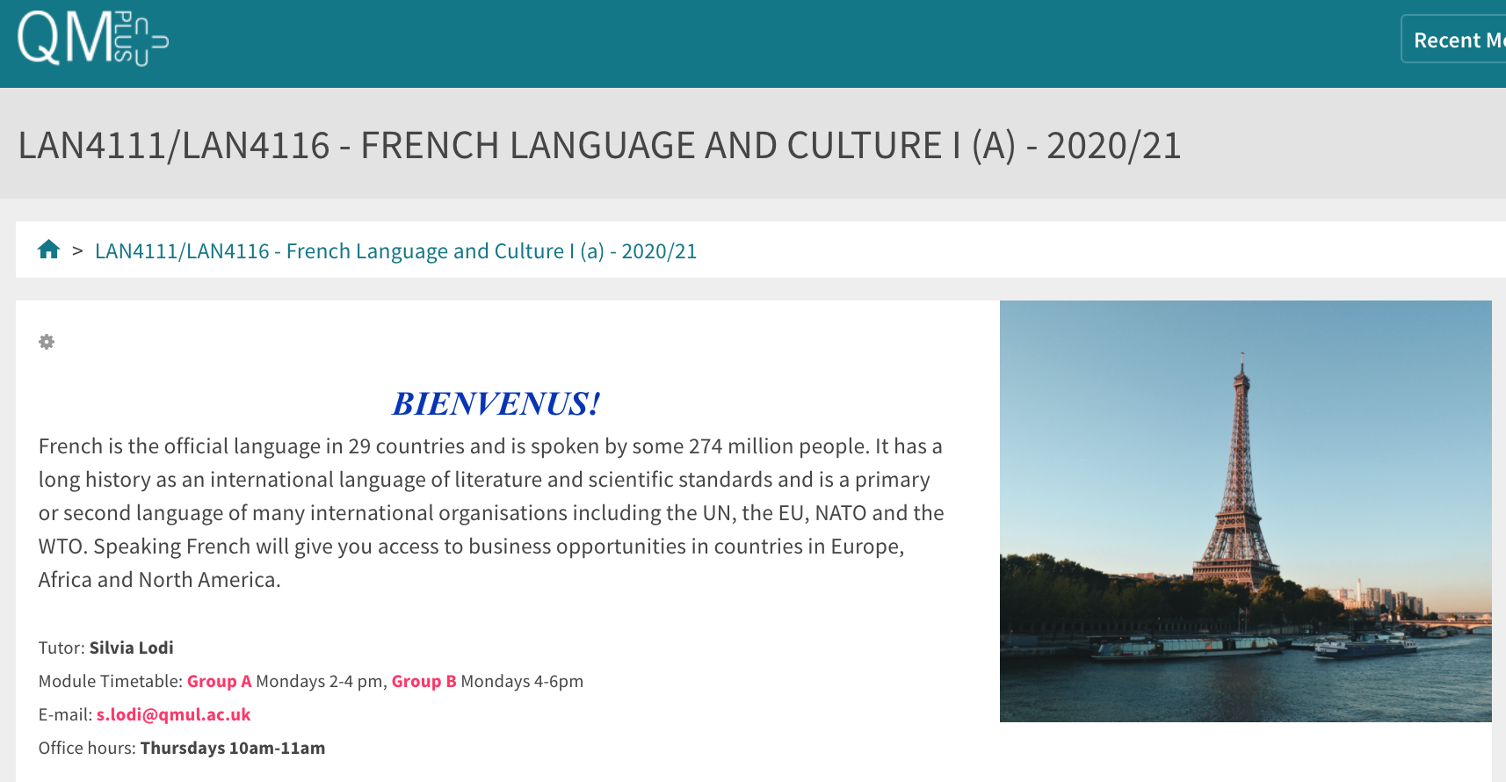

Free Language Speaking Practice

Language learners within the Queen Mary community can book 30-minute online speaking sessions with native or proficient speakers, for 15+ languages, for free. You can practise your speaking skills in the language you're learning, in an informal way. Sessions are offered by volunteers – QMUL students and staff who enjoy helping others learn. It’s a great way to practise the language, and get to know Queen Mary students from different schools and different backgrounds.

More information and booking link

FEEDBACK

- How can you check your progress throughout the module?
- What feedback can you expect from your tutor?

Language classes are highly interactive and participative, which means your tutor will give you regular instant feedback on your participation in class. Your tutor will also give you feedback on your submitted homework, and on activities that you complete on QMplus, if there is no automated feedback.

You will get feedback on the draft (formative submission) of your Writing Assignment, and will then have the opportunity to improve your writing before you submit it for summative assessment (counting towards your mark).

Your tutor is available during Feedback & Advice hours (check the times in the Tutor profile above), which you can use for a one-to-one meeting to discuss your progress. Please email your tutor beforehand.

ASSESSMENT INFORMATION

Assessment if you take the module FOR credit

If you are taking this module for credit, you need to complete and pass the assessments in order to gain the credits. The credits will count towards the total number of credits you need in each academic year (120 per year for undergraduate students).

Assessment if you take the module NOT for credit

If you are taking this module as a non-credit bearing module, it will not count towards your programme and you will not receive credits. However, if you complete and pass the module, you will receive a Certificate of Completion stating that you have passed the module, and with what grade. The requirements are that you:

- Have attended at least 65% of the taught sessions
- Take and pass the module assessment for non-credit seeking students to show that you have achieved the learning outcomes of the module
If you do not take the module assessment but meet the attendance requirement, you will receive a Certificate of Attendance, without a grade.

Assessment is carried out through formal and informal reading, writing, listening and speaking tasks. The assessment structure depends on whether you are taking the module for credit or not, and whether you take the year-long or the one-semester option. Check your module code and note the assessment structure relevant to you, below:

Assessment structure:

NOT FOR CREDIT

LAN4116: French Language & Culture 1a: Students taking the module NOT for credit, year-long.
In order to get a Certificate, you need to pass the following assessments:
LAN4116  Assessment Title | Weight towards final grade % | Length | Due Date
Coursework
- Reading &Listening Test | 20% |  | Semester 1, Week 11 (December)
- Writing Assignment | 30% | 175-225 words | Submission (formative):  Semester 2, Week 7  Feedback given in Week 8  Submission (summative):  Semester 2, Week 9
- Oral test | 50% |  | Semester 2, Week 12

Your tutor will give you assessment briefs for each of the assessments.

FOR CREDIT

LAN4111: French Language & Culture 1a: Students taking the module for credit, year-long (15 credits)
LAN4111  Assessment Title | Weight towards final grade % | Length | Due Date
Coursework
- Reading &Listening Test | 10% |  | Semester 1, Week 11 (December)
- Writing Assignment | 20% | 175-225 words | Submission (formative):  Semester 2, Week 7  Feedback given in Week 8  Submission (summative):  Semester 2, Week 9
- Oral exam | 30% |  | Semester 2, Week 12
Written exam | 40% | 2 hours | Examination period

MARKING CRITERIA FOR ASSESSMENT OF WRITING SKILLS

Task achievement | - How fully has the task brief been achieved? Does the text have the required length?*  - How fully, and in what breadth, has the topic been covered?  - If the task consists of description, how comprehensive is the description?  - If the task consists of argumentation, has the topic been considered from different angles?  - Have different aspects of the topic been elaborated?  - How relevant, and how correct, is the information included?
Organisation, Coherence and cohesion | - How clear is the text, and how logical is its structure?  - How appropriate, and how varied, are the connectors and cohesive devices used to link sentences?  - How well is paragraphing used, and how well are paragraphs connected to achieve a coherent text? Does the text read smoothly, or are there jumps?
Range  (Grammar, Syntax, Vocabulary) | - Are the sentence and grammatical structures appropriate for the level? (at lower levels, simple sentences will be fine, while at higher levels, the inclusion of more complex structures will be expected)  - How wide is the range of vocabulary used in the text? (simple and frequent lexical items will be fine at lower levels, while at higher levels, more varied vocabulary, use of nuance, and use of idiomatic expressions will be expected)
Accuracy (Grammar, Syntax, Vocabulary) | - How accurate are the grammar and sentence structures? If there are errors, are they minor, or do they impact the communication more severely? To what extent does the reader have to make an effort to understand what you are trying to communicate?  - How good is your command of the vocabulary? Do the words you have chosen have the right meaning to express what you want to say? If there are errors, do they just make the passage sound somewhat clumsy or do they obscure the meaning of the sentence and hinder communication?  - How well are lexical collocations used? (that is, words that normally go together, e.g. we say ‘to take a picture’ and not ‘to make a picture’, ‘to make a mistake’ and not ‘to do a mistake’, ‘to do someone a favour’ but not ‘to make someone a favour’)
*If you submit work significantly under the word limit, marks will be deducted.

MARKING CRITERIA FOR ASSESSMENT FOR SPEAKING SKILLS

Task achievement | - Have you completed the task that has been set? Have you completed it fully or only partially?
Range of vocabulary and structures | - How wide is the range of vocabulary that you use? Is it quite simple and basic, or do you master the full range of vocabulary that has been covered in the module?  - What kind of sentence structures do you use? Are they simple (such as a list of short main clauses), or are they more complex (using longer sentence structures with subordinate clauses that are well connected by conjunctions)?
Accuracy of vocabulary and grammatical structures | - How accurate is the vocabulary you are using? Are you using words with the right meaning to express what you want to say? How often do you pick words that don’t quite fit?  - How accurate are the grammar and the sentence structures that you are using? How frequently do you make mistakes? Are the mistakes minor or do they make it hard for your conversation partner to understand what you are trying to say?
Pronunciation | - How well do you pronounce the words and sounds in the target language? Is your pronunciation smooth and clear, with the correct word stress and sentence intonation, or is it difficult for the listener to recognise some of the words you produce?
Fluency | - How natural is the speed of your speech? (Note that slight hesitations, restarting a sentence, pausing to find the right word, etc., is part of natural speech). Are there many, long and ‘unnatural’, pauses and hesitations? Is there a breakdown of communication? Can you repair gaps by paraphrasing a word that you cannot find, or by reformulating a sentence?
Interactional skills | - How well can you use conversational norms when interacting with someone else: For example, opening a conversation, maintaining it, asking for clarification, giving appropriate responses to prompts from your conversation partner, taking turns in the conversation, closing (ending) the conversation.

