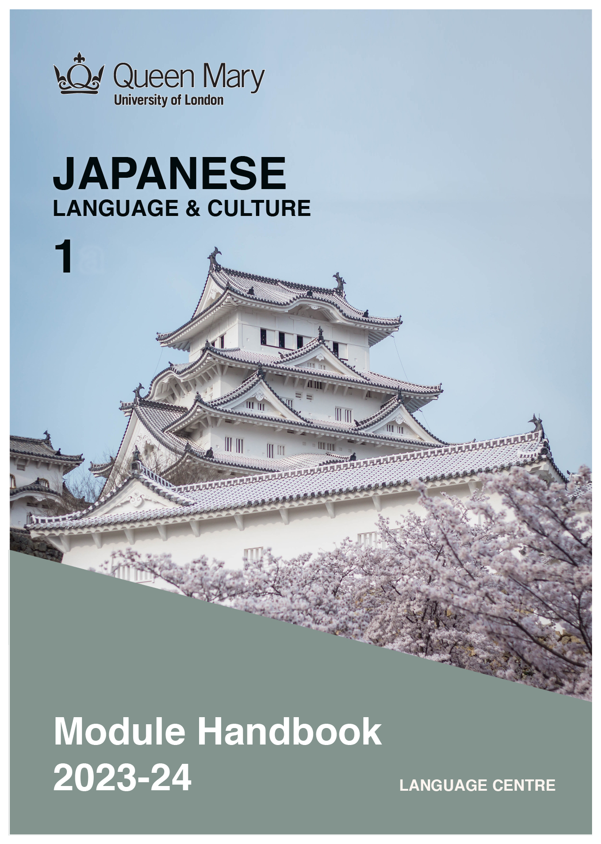

WELCOME TO LEARNING JAPANESE

Welcome to the Learn a Language programme of Queen Mary. Language learning broadens the mind – you learn how different cultures and societies organize the world through language, you acquire a new vocabulary, new concepts, cultural knowledge, and become more interculturally aware. You can connect with people in another society in their language, a connection that is likely to be closer than if you make them speak your language or you communicate in a third language, such as English. You can use your language skills in your future career – employers consistently ask for better language skills in graduates. And, finally, language learning has cognitive benefits – studies show that bilinguals are more perceptive and have better memory. Speaking another language makes you more aware of language structure in general, and a better communicator.

JAPANESE

Japan is the world’s third-largest economy, and many of the world’s top business organisations are Japanese. Japan is one of the largest exporters and importers globally and has a large financial sector. Japan has a distinct culture, with Japanese popular culture, including anime and manga, being popular around the world, but having particular influence in East and Southeast Asia.

MODULE AIMS AND LEARNING OUTCOMES

Module Aims
The overall aims of this module are to help you to develop a sound foundation of knowledge of the Japanese language, and an ability to approach communication in the language in a confident and competent manner. You will move from no knowledge, or very rudimentary knowledge of the language, to become someone who is able to function effectively at a basic level when using language occurring in everyday situations relating to practical matters, and be able to understand basic as well as slightly more complicated t texts, including news and brief reports (equivalent to level A2 of the Common European Framework of Reference, CEFR).
You will learn the language through tasks designed to develop your skills in speaking and writing. You will also read and listen to simple texts, to develop your receptive skills. The aim is to achieve a balance between fluency and accuracy, which means grammar and structure are an integral part of this course.

How is the module structured and how will it be taught?
You will have two timetabled sessions (of two hours each) per week, over two semesters (4 hours over 22 weeks). The module is taught in-person, on campus. This means you will get 88 hours of tutor-led learning. The total learning hours for this module are 300 hours, which means that in addition to the 88 tutor-led hours, you need to invest an additional 212 hours through independent study. You will do this by doing homework set by your tutor, completing tasks online on QMplus and in the course book, revising class materials and vocabulary, preparing for assessments, and using other opportunities to speak, listen to and read Japanese outside the classroom.

The classroom-based sessions will be mainly used for interactive tasks and skills development (speaking, listening, writing), while explanations of grammar and introduction of new material will be delivered mainly via recorded video clips.
This means you will sometimes be asked to watch a video, go over a PowerPoint presentation, or read a text in preparation for a class, as well as completing exercises and tasks after sessions, for consolidation (e.g, exercises in the course book, on QMplus, recording yourself, etc.).

Module Learning Outcomes

You should develop the following outcomes related to academic content:
A1 | To achieve effective communication in Japanese at level A2 CEFR with competent  speakers of the language.
A2 | To exploit, for a variety of purposes, a range of materials, written and spoken, in Japanese level A2 CEFR.
A3 | To demonstrate a knowledge and understanding of the structures, registers and, as appropriate, varieties of Japanese at level A2 CEFR.
A4 | To demonstrate a knowledge and understanding of Japanese cultures and societies gained through the study of basic written and aural texts and other cultural products in the target language.

You should develop the following disciplinary skills:
B1 | To analyze aspects of the target language and make use of them in a broadly professional context.
B2 | To gather and process information related to Japanese language and culture from a variety of paper, audiovisual and electronic sources and communicate this information, both orally and in writing.
B3 | To use ICT effectively both as a means of communication and as an aid to learning.
B4 | To demonstrate some ability as an independent learner of the language in order to take further the study of Japanese language and culture.

You should develop the following general attributes:
C1 | To be able to operate in more than one language, develop a global perspective and use the knowledge acquired to increase employability and engage with the professional world.
C2 | To apply analytical skills to investigate unfamiliar problems and to use the knowledge acquired to enrich research.
C3 | To be able to work effectively in diverse communities.
C4 | To work individually and in collaboration with others reflecting upon and assessing one's progress in learning the Target Language.

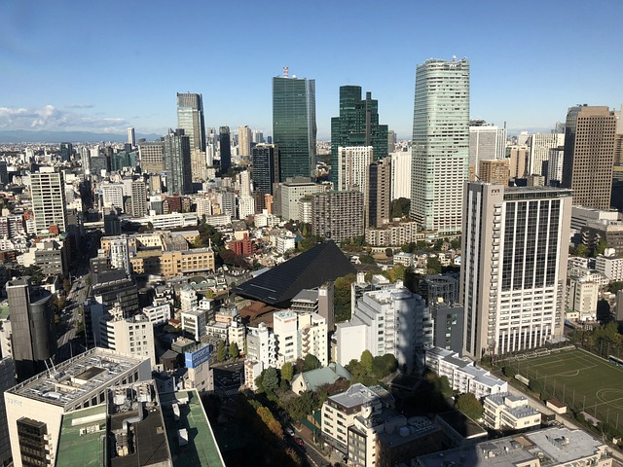

EXPECTED STUDY TIME

If you are taking this module for credit, you will get 30 credits, which equals 300 learning hours. 88 of those will be tutor-led through synchronous sessions, the rest you are expected to invest between the weekly sessions, in your own time, via guided learning, using resources on QMplus, in your course book, and other material as advised by your tutor. Even if you are not taking the module for credit, you should invest the same amount of time in order to make progress as expected.

30 credit module – 300 learning hours
Tutor-led learning | 88 hours
Interactive classes
Self-directed learning | 212 hours
Preparations for synchronous sessions | 44
Completing set homework | 44
Self-study after class (QMplus, course book, etc.) | 88
Preparation for assessments | 36
Total | 300

CONTACT DETAILS AND ADVICE & FEEDBACK HOURS OF YOUR TUTOR

 | Module tutor | Office | Email | ONLINE Office hours
 | Name | Bancroft 1.36 | name@qmul.ac.uk | FILL IN

You can use tutors’ office hours to get advice and feedback. Please email your tutor to book an appointment.

LEARNING PLAN
SEMESTER 1
week | main topic | LEARNING OUTCOMES |  | LANGUAGE FOCUS | CULTURE | SELF-STUDY (qm+)
 | What is the main topic of the week? | What will I be able to do with the language I am learning this week |  | What particular language features will be covered? | What cultural information will I learn this week? | What am I expected to do outside class from one week to the next?
1 | Introducing yourself  Name, nationality, job  Time, telephone number | Pronunciation  Writing system: Hiragana, Katakana & Kanji  Introducing yourself  Greetings  Telling the time and working hours  Describing your family |  | X is Y  Question marker:か  Yes,はい noいいえ  Numbers 0-100  Time: from からtoまで  Question word "what""what time""what number"  Ending particle | Japanese greeting : bowing | Learning Hiragana :a-so  Learning Hiragana :ta-ho  Your name & nationality
2 | Introducing yourself  Age, school year, family and friend  shopping | Saying & asking age, school year.  Saying your family members  Asking price and shopping |  | Am not are not is notじゃないです Numbers 100,1000,1000  Question word "how much"  Demonstrative | Japanese song : ten little Indians  Counting people | Learning Hiragana :ma-n  Write a sentence about yourself Learning Hiragana:  Voiced consonant: g,z,d,b,p  contracted sound
3 | Shopping & eating out  Daily routine 1 | Ordering food & drink  Simple direction  Talking about daily activities |  | Demonstrative fro places  Verb: masu-form,&dictionary- form  Verb present tense  Particle: object, place of action, time | Introducing Japanese food culture | Learning Hiragana: syllabic nasal  "n"&"m"  Learning Hiragana: long vowel
4 | Daily routine 2  Weekend  Holidays  Invitation | Saying where you are going, coming & returning  Talking about your weekend plan  Making your holiday plan  Invite your friend to do something with you |  | Verb: go come return  Time words: days of week, dates, month  Adverbs of frequency  Question words | Refusal in Japanese way | Learning Katakana: a-so  Learning Katakana: ta-ho
5 | Location 1  Schedule  possession  Location 2 | Describe a town  Talking and asking the schedule of the week  Telling & asking the location |  | Verb:あります・います  There is something /someone in the place Location words  X is the position of the place. | Introducing Japanese cultural events | Learning Katakana: ma-n  Learning Katakana: special combination
6 | Explanation of the concept of Kanji Holidays  Events in the past | Verb with two objects indirect object ,direct object  Talking about holidays and events in the past |  | Verb past tense  duration |  | Revision of Hiragana & Katakana  Learning kanji: pictograph
7 | STUDY WEEK: Please complete the following work during Study Week:
8 | My childhood  My town  Holidays  Your student life | Describe your childhood & your town using adjectives  Describe your holidays in the past  Telling your student life |  | was, were:でした  adjectives present tense:  i-adjective, na-adjective  adjective modifying noun form  adjectives past tense:  i-adjective, na-adjective | Festivals in Japan | Learning kanji: numbers  Write your holiday  Learning kanji: days of week
9 | Like dislike  Activity suggestion  Request | Telling & asking what you like or dislike  Suggesting some activity and answering  Polite request : Please do |  | Verb te-form +ください |  | Learning kanji: verbs 1  Learning kanji: adjectives 1
10 | Asking permission  prohibition Consecutive action  Reason  Offering service | Asking permission & telling what you can't do  Talking about the regulations in class and your house  Talking your daily activities  Asking the reason and answering |  | verb te-form + もいいです（か）verb te-form + は いけません  te-form + masu-form  どうして ・－からです | Pictograms | Write about your favourite book  Learning Kanji: direction  Learning kanji: people 1  Writing like dislike with reason
11 | Direction 1  Direction 2  Revision | Telling & asking direction on foot  Telling & asking direction using transport |  | Words: crossing, corner, traffic light, The first ,second etc.  Words: to get in, get off, transfer | Tokyo underground network &  Tokyo geographical explanation  Japanese new year: food & games | Writing direction  Revision for end-of-module test
12 | End-of-term test |  |  |  | Japanese new year's card
 | SEMESTER 2
week | main topic | OBJECTIVES |  | LANGUAGE FOCUS | CULTURE | SELF-STUDY (qm+)
 | What is the main topic of the week? | What will I be able to do with the language I am learning this week |  | What particular language features will be covered? | What cultural information will I learn this week? | What am I expected to do outside class from one week to the next?
1 | Revision I  My town  Family  Activities at the moment | Describe your town geographically Describing your family:  Explaining where they live, marital state, where you work for |  | Grammar learned for I(a)  Verb te-form + います | Simple geography of Japan | Making a presentation about your town
2 | Description of people  Appearance, clothes Describe object  purpose | Describe person's appearances, clothes Describing object with two or more adjectives  Telling you go to the place for some purpose. |  | Words: body parts  Names of clothes  colour  Verb: to ware  i-adjective(くて)  na-adjective(で)+ adjective  place にverb masu form stemに Verbs(go,come ,return | Japanese pop culture : cosplay | Write a paragraph about yourself and your family  Learning Kanji
3 | Informal speech 1  Opinion & thought 1 Reported speech 1  Negative request | Making a conversation informal style present tense  Telling your opinion , thought present tense  Reporting someone's speech  Asking "please don't do it" |  | Verbs: dictionary form present tense  Verb: to think  Verb: to say  Verb dictionary negative form +で  ください |  | Describe your plans for the winter holidays
4 | Hobby  Informal speech 2  Opinion & thought 2 | Saying about your hobby  Making a conversation informal style past tense  Telling your opinion , thought about past |  | Gerund: verb dictionary form present tense + の、こと  Verbs dictionary form past tense |  | Read the report about survey  Create the questionnaire  Learning Kanji
5 | Describe people  Qualifying noun  Reason  Comparative  Superlative | Describe the person who is doing something now  Reasoning 2  Telling your preference between two options |  | Verbs te-form + いる人  Sub clause with a reasonから、  main clause  X はYより+ adjective  Xのほうが+ adjective  Xが いちばん+ adjective | Simple history & geography quiz about Japan | Learning Kanji  Reading &Writing a diary  Revision for end-of-term test
6 | Intention  change state | Telling your intention ,plan  Express changing the state |  | Verb dictionary present tense +  つもり・よてい です  Verb: to become | Japanese old tale | Learning kanji  Read a Japanese old tale
7 | STUDY WEEK: Please complete the following work during Study Week: a 3-minute oral presentation coursework
8 | Your holiday  Hope | Asking to do anything  Answering  Planning your holiday Express your hope ,desire |  | Words: something, somewhere,  Someone  Anything, anywhere, anyone Sociolinguistic varieties of the French language |  | Learning kanji
9 | Do this, do that Experiences  Your future dream | Picking activities as an example  Saying what you have done  Telling your dream in future |  | Verb dictionary past tense +り  Verb dictionary past tense +り  するVerb dictionary past tense +ことがある  Word: dream ゆめ | Japanese traditional activities | Learning kanji
10 | Experiences  Your future dream Health  Giving advice | Saying what you have done  Telling your dream in future Express pain in your part of the body  Express your problem  Asking & telling advices |  | Verb dictionary past tense +ことがある  Word: dream ゆめVerb, adjective + んです  Advice: better to do, not better to do | Japanese traditional activities | Learning kanji  Read personal ad  Write a reply to the ad
11 | Have to do  Universal reasoning weather | Talking what you have to do  Other way to telling reason  Telling the weather, temperature  Understanding dimple weather focus |  | Have to do  Sub clause +ので, main clause Words for the weather  Word for probability:でしょう | The rules of the students hall in Japan | Learning kanji  Read a Japanese story
12 | End-of-term module test

SEMESTER DATES 2023-24

Semester 1 | Dates
Teaching Weeks 1 to 6 | 25 Sep – 5 Nov 2023
Study Week (Week 7) | 6 Nov – 10 Nov 2023
Teaching Weeks 8 to 12 | 13 Nov – 15 Dec 2023
January exam period | 4 – 19 January 2024
Semester 2 | Dates
Teaching Weeks 1 to 6 | 22 Jan – 1 Mar 2024
Study Week (Week 7) | 4 Mar – 8 Mar 2024
Teaching Weeks 8 to 12 | 11 Mar – 12 Apr 2024
Exam period | 2 May – 31 May 2024
Summer Resit period | August 2024

LEARNING MATERIALS

 | Course book | ISBN | Notes
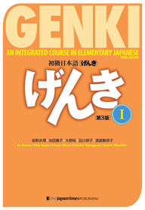 | GENKI I (3rd edition)  AN INTEGRATED COURSE IN ELEMENTARY JAPANESE, The Japan times (2020) | 9784789017305 | The hard copy costs around £42 and gives you access to online materials. There is a kindle edition as well. It costs around £26. Check for second-hand options, which will be cheaper.

OTHER RESOURCES:

GENKI 3rd edition website: https://genki3.japantimes.co.jp/
Web Japan: https://web-japan.org/
Japan Foundation London: https://jpf.org.uk/index.php
Embassy of Japan London: https://www.uk.embjapan.go.jp/japanuk150/events/art/index.html
YouTube channel on GENKI 1: https://www.youtube.com/watch?v=bDcteScYF5I&t=16s
Useful apps: anki, Memrise
Dictionary: Oxford Beginner’s Japanese Dictionary (paper) ISBN9780199298525
Online dictionaries: RomajiDesu http://www.romajidesu.com/, jisho.org https://jisho.org/
Online dictionary free apps: ALC Eijiro (for iPhone, iPad)

Institutions and events in London related to Japanese Language and Culture:

See the Japan Foundation London “Upcoming Events” at https://www.jpf.org.uk

QMplus Module page

The QMplus module page is the place to go to regularly before and after class, to prepare for the weekly sessions and find resources for self-study. Here you will find the materials used in class in addition to the course book, and additional resources and activities that help you consolidate and extend the material covered in class. You will also find links to web resources and videos on the language and cultural information.

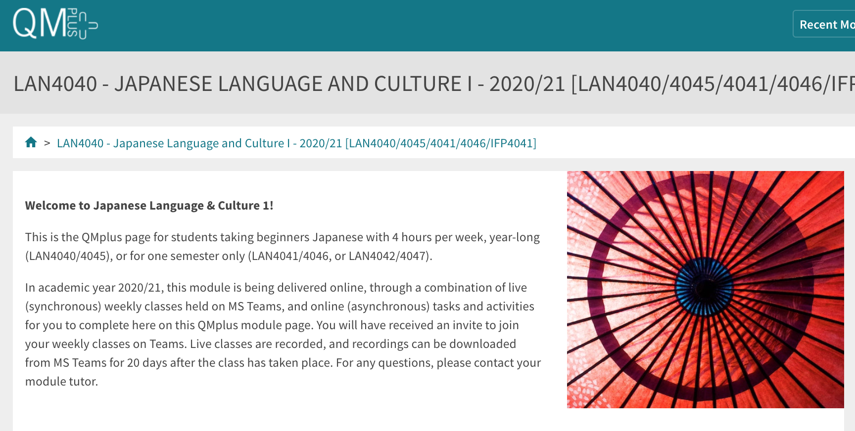

Free Language Speaking Practice

Language learners within the Queen Mary community can book 30-minute online speaking sessions with native or proficient speakers, for 15+ languages, for free. You can practise your speaking skills in the language you're learning, in an informal way. Sessions are offered by volunteers – QMUL students and staff who enjoy helping others learn. It’s a great way to practise the language, and get to know Queen Mary students from different schools and different backgrounds.

More information and booking link

FEEDBACK

- How can you check your progress throughout the module?
- What feedback can you expect from your tutor?

Language classes are highly interactive and participative, which means your tutor will give you regular instant feedback on your participation in class. Your tutor will also give you feedback on your submitted homework, and on activities that you complete on QMplus, if there is no automated feedback.

You will get feedback on the draft (formative submission) of your Writing Assignment, and will then have the opportunity to improve your writing before you submit it for summative assessment (counting towards your mark).

Your tutor is available during Feedback & Advice hours (check the times in the Tutor profile above), which you can use for a one-to-one meeting to discuss your progress. Please email your tutor beforehand.

ASSESSMENT INFORMATION

Assessment if you take the module FOR credit

If you are taking this module for credit, you need to complete and pass the assessments in order to gain the credits. The credits will count towards the total number of credits you need in each academic year (120 per year for undergraduate students).

Assessment if you take the module NOT for credit

If you are taking this module as a non-credit bearing module, it will not count towards your programme and you will not receive credits. However, if you complete and pass the module, you will receive a Certificate of Completion stating that you have passed the module, and with what grade. The requirements are that you:

- Have attended at least 65% of the taught sessions
- Take and pass the module assessment for non-credit seeking students to show that you have achieved the learning outcomes of the module
If you do not take the module assessment but meet the attendance requirement, you will receive a Certificate of Attendance, without a grade.

Assessment is carried out through formal and informal reading, writing, listening and speaking tasks. The assessment structure depends on whether you are taking the module for credit or not, and whether you take the year-long or the one-semester option. Check your module code and note the assessment structure relevant to you, below:

Assessment structure:

Please check your module code and then look for the assessment pattern that corresponds to your code, that assessment structure will apply to you.

FOR CREDIT

LAN4040: Japanese Language & Culture 1: Students taking the module for credit, year-long (30 credits)
LAN4040  Assessment Title | Weight towards final grade % | Length | Due Date
Coursework
- Reading &Listening Test | 10% |  | Semester 1, Week 11 (December)
- Writing Assignment | 20% | 150-200 letters | Submission (formative):  Semester 2, Week 7  Feedback given in Week 8  Submission (summative):  Semester 2, Week 9
- Oral exam | 30% |  | Semester 2, Week 12
Written exam | 40% | 2 hours | May Examination period

LAN 4041: Japanese Language & Culture 1a: Students taking the module for credit, Semester A only (15 credits)
LAN4041  Assessment Title | Weight towards final grade % | Length | Due Date
Coursework
- Reading &Listening Test | 10% |  | Semester 1, Week 11 (December)
- Writing Assignment | 20% | 100-125 letters | Submission (formative):  Week 9  Feedback given in Week 10  Submission (summative):  First week in January
Oral exam | 30% |  | Semester 1, Week 12
Written exam | 40% | 2 hours | January Examination period

IFP4041: Japanese Language & Culture 1a: Foundation Year and Pre-Masters Students taking the module for credit, Semester A only (15 credits), AND
Study Abroad & Visiting Students taking LAN4041: Japanese Language & Culture 1a for credit, Semester A only (15 credits)
IFP4041, LAN4041 (Study Abroad)  Assessment Title | Weight towards final grade % | Length | Due Date
Coursework
- Reading & Listening Test | 20% |  | Semester 1, Week 11 (December)
- Writing Assignment | 30% | 100-125 letters | Submission (formative):  Week 9  Feedback given in Week 10  Submission (summative):  First week in January
Oral exam | 50% |  | Semester 1, Week 12

LAN 4042: Japanese Language & Culture 1b: Students taking the module for credit, Semester B only (15 credits)
LAN4042  Assessment Title | Weight towards final grade % | Length | Due Date
Coursework
- Reading &Listening Test | 10% |  | Semester 2, Week 11
- Writing Assignment | 20% | 150-200 letters | Submission (formative):  Semester 2, Week 7  Feedback given in Week 8  Submission (summative):  Semester 2, Week 9
Oral exam | 30% |  | Semester 2, Week 12
Written exam | 40% | 2 hours | May Examination period

NOT FOR CREDIT

LAN4045/LAN4046/LAN4047: Japanese Language & Culture 1, 1a, 1b: Students taking the module NOT for credit, year-long. In order to get a Certificate of Completion, you need to pass the following assessments:
LAN4045/LAN4046/LAN4047  Assessment Title | Weight towards final grade % | Due Date
Coursework
- Reading & Listening Test | 20% | Week 11
- Writing Assignment | 30% | Submission (formative): Week 7  Feedback given in Week 8  Submission (summative): Week 9
- Oral test | 50% | Last week of the module

Your tutor will give you assessment briefs for each of the assessments.

MARKING CRITERIA FOR ASSESSMENT OF WRITING SKILLS

Task achievement | - How fully has the task brief been achieved? Does the text have the required length?*  - How fully, and in what breadth, has the topic been covered?  - If the task consists of description, how comprehensive is the description?  - If the task consists of argumentation, has the topic been considered from different angles?  - Have different aspects of the topic been elaborated?  - How relevant, and how correct, is the information included?
Organisation, Coherence and cohesion | - How clear is the text, and how logical is its structure?  - How appropriate, and how varied, are the connectors and cohesive devices used to link sentences?  - How well is paragraphing used, and how well are paragraphs connected to achieve a coherent text? Does the text read smoothly, or are there jumps?
Range  (Grammar, Syntax, Vocabulary) | - Are the sentence and grammatical structures appropriate for the level? (at lower levels, simple sentences will be fine, while at higher levels, the inclusion of more complex structures will be expected)  - How wide is the range of vocabulary used in the text? (simple and frequent lexical items will be fine at lower levels, while at higher levels, more varied vocabulary, use of nuance, and use of idiomatic expressions will be expected)
Accuracy (Grammar, Syntax, Vocabulary) | - How accurate are the grammar and sentence structures? If there are errors, are they minor, or do they impact the communication more severely? To what extent does the reader have to make an effort to understand what you are trying to communicate?  - How good is your command of the vocabulary? Do the words you have chosen have the right meaning to express what you want to say? If there are errors, do they just make the passage sound somewhat clumsy or do they obscure the meaning of the sentence and hinder communication?  - How well are lexical collocations used? (that is, words that normally go together, e.g. we say ‘to take a picture’ and not ‘to make a picture’, ‘to make a mistake’ and not ‘to do a mistake’, ‘to do someone a favour’ but not ‘to make someone a favour’)
*If you submit work significantly under the word limit, marks will be deducted.

MARKING CRITERIA FOR ASSESSMENT FOR SPEAKING SKILLS

Task achievement | - Have you completed the task that has been set? Have you completed it fully or only partially?
Range of vocabulary and structures | - How wide is the range of vocabulary that you use? Is it quite simple and basic, or do you master the full range of vocabulary that has been covered in the module?  - What kind of sentence structures do you use? Are they simple (such as a list of short main clauses), or are they more complex (using longer sentence structures with subordinate clauses that are well connected by conjunctions)?
Accuracy of vocabulary and grammatical structures | - How accurate is the vocabulary you are using? Are you using words with the right meaning to express what you want to say? How often do you pick words that don’t quite fit?  - How accurate are the grammar and the sentence structures that you are using? How frequently do you make mistakes? Are the mistakes minor or do they make it hard for your conversation partner to understand what you are trying to say?
Pronunciation | - How well do you pronounce the words and sounds in the target language? Is your pronunciation smooth and clear, with the correct word stress and sentence intonation, or is it difficult for the listener to recognise some of the words you produce?
Fluency | - How natural is the speed of your speech? (Note that slight hesitations, restarting a sentence, pausing to find the right word, etc., is part of natural speech). Are there many, long and ‘unnatural’, pauses and hesitations? Is there a breakdown of communication? Can you repair gaps by paraphrasing a word that you cannot find, or by reformulating a sentence?
Interactional skills | - How well can you use conversational norms when interacting with someone else: For example, opening a conversation, maintaining it, asking for clarification, giving appropriate responses to prompts from your conversation partner, taking turns in the conversation, closing (ending) the conversation.

