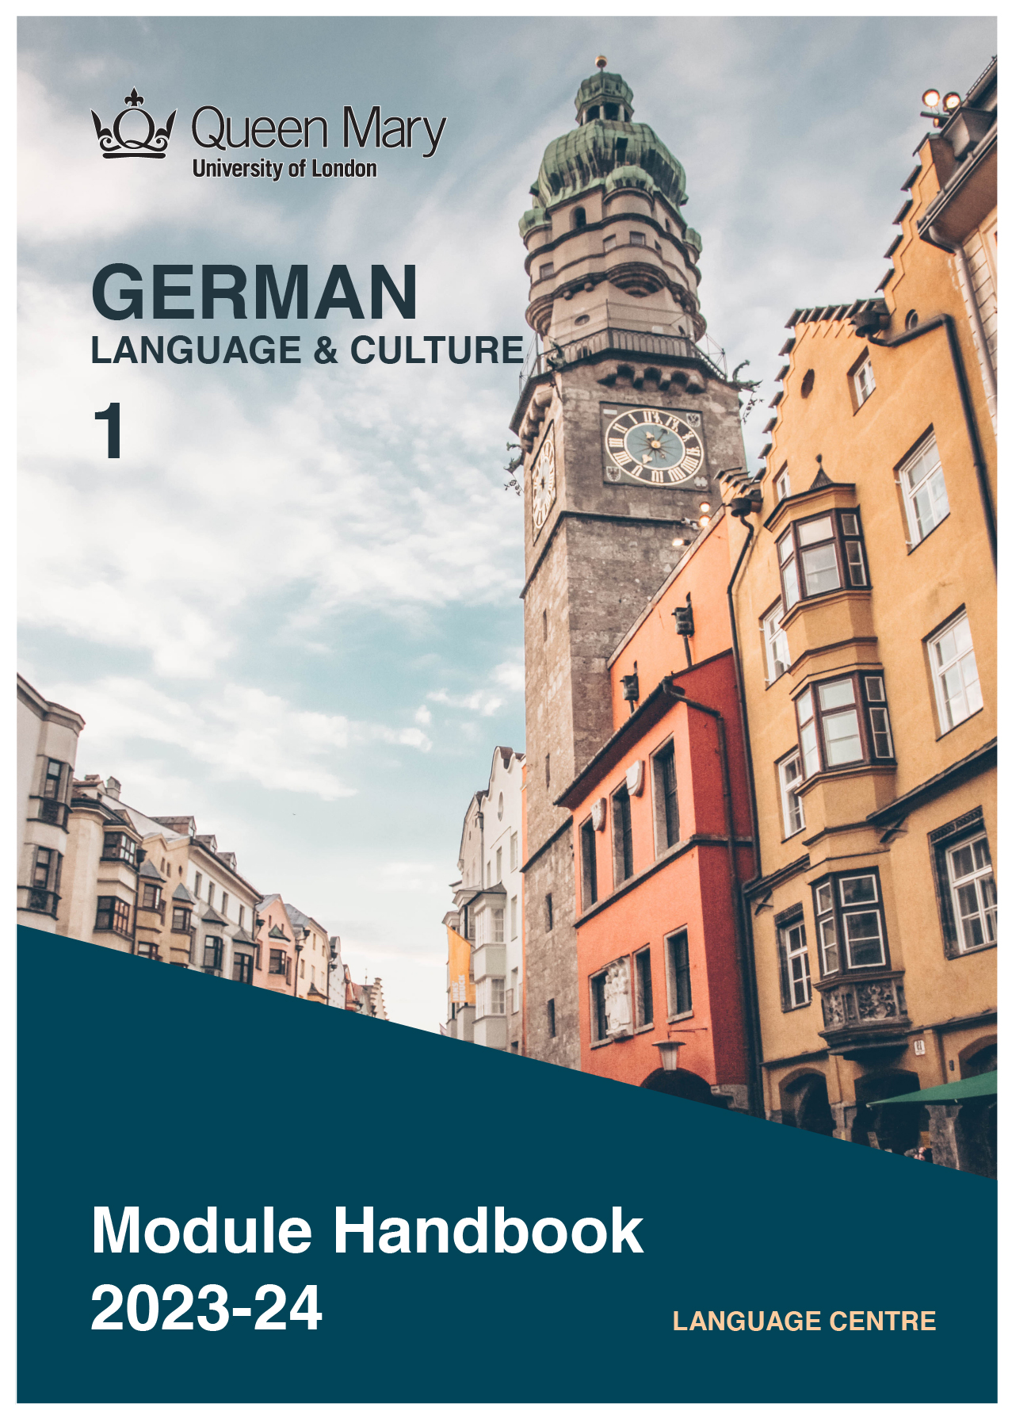

WELCOME TO LEARNING GERMAN

Welcome to the Learn a Language programme of Queen Mary. Language learning broadens the mind – you learn how different cultures and societies organize the world through language, you acquire a new vocabulary, new concepts, cultural knowledge, and become more interculturally aware. You can connect with people in another society in their language, a connection that is likely to be closer than if you make them speak your language or you communicate in a third language, such as English. You can use your language skills in your future career – employers consistently ask for better language skills in graduates. And, finally, language learning has cognitive benefits – studies show that bilinguals are more perceptive and have better memory. Speaking another language makes you more aware of language structure in general, and a better communicator.

GERMAN LANGUAGE

With over 100 million speakers, German is spoken as a native language by more people than any other language in Europe. It is an official language of Germany, Austria, Switzerland, Luxembourg, and Liechtenstein. In addition to that, around 20 million people are learning German as a foreign language worldwide. Germany is one of the largest exporters globally, and the largest national economy in Europe. Two-thirds of the world's leading international trade fairs take place in Germany. Speaking German will give you access to opportunities working for, or doing business with, companies in the German-speaking countries.

MODULE AIMS AND LEARNING OUTCOMES

Module Aims
The overall aims of this module are to help you to develop a sound foundation of knowledge of the language, and an ability to approach communication in the language in a confident and competent manner. You will move from no knowledge, or very rudimentary knowledge of the language, to become someone who is able to function effectively at a basic level when using language occurring in everyday situations relating to practical matters, and be able to understand basic as well as slightly more complicated texts, including news and brief reports (equivalent to level A2 of the Common European Framework of Reference, CEFR).
You will learn the language through tasks designed to develop your skills in speaking and writing. You will also read and listen to simple texts, to develop your receptive skills. The aim is to achieve a balance between fluency and accuracy, which means grammar and structure are an integral part of this course.

How is the module structured and how will it be taught?
You will have two timetabled sessions (of two hours each) per week, over two semesters (4 hours over 22 weeks). The module is taught in-person, on campus. This means you will get 88 hours of tutor-led learning. The total learning hours for this module are 300 hours, which means that in addition to the 88 tutor-led hours, you need to invest an additional 212 hours through independent study. You will do this by doing homework set by your tutor, completing tasks online on QMplus and in the course book, revising class materials and vocabulary, preparing for assessments, and using other opportunities to speak, listen to and read German outside the classroom.

The classroom-based sessions will be mainly used for interactive tasks and skills development (speaking, listening, writing), while explanations of grammar and introduction of new material will be delivered mainly via recorded video clips.
This means you will sometimes be asked to watch a video, go over a PowerPoint presentation, or read a text in preparation for a class, as well as completing exercises and tasks after sessions, for consolidation (e.g, exercises in the course book, on QMplus, recording yourself, etc.).

Module Learning Outcomes

You should develop the following outcomes related to academic content:
A1 | To achieve effective communication in German at level A2 CEFR with competent speakers of the language.
A2 | To exploit, for a variety of purposes, a range of materials, written and spoken, in German level A2 CEFR.
A3 | To demonstrate a knowledge and understanding of the structures, registers and, as appropriate, varieties of German at level A2 CEFR.
A4 | To demonstrate a knowledge and understanding of German-speaking cultures and societies gained through the study of basic written and aural texts and other cultural products in the target language.

You should develop the following disciplinary skills:
B1 | To analyze aspects of the target language and make use of them in a broadly professional context.
B2 | To gather and process information related to German language and cultures from a variety of paper, audiovisual and electronic sources and communicate this information, both orally and in writing.
B3 | To use ICT effectively both as a means of communication and as an aid to learning.
B4 | To demonstrate some ability as an independent learner of the language in order to take further the study of German language and cultures.

You should develop the following general attributes:
C1 | To be able to operate in more than one language, develop a global perspective and use the knowledge acquired to increase employability and engage with the professional world.
C2 | To apply analytical skills to investigate unfamiliar problems and to use the knowledge acquired to enrich research.
C3 | To be able to work effectively in diverse communities.
C4 | To work individually and in collaboration with others reflecting upon and assessing one's progress in learning the Target Language.

EXPECTED STUDY TIME

If you are taking this module for credit, you will get 30 credits, which equals 300 learning hours. 88 of those will be tutor-led through synchronous sessions, the rest you are expected to invest between the weekly sessions, in your own time, via guided learning, using resources on QMplus, in your course book, and other material as advised by your tutor. Even if you are not taking the module for credit, you should invest the same amount of time in order to make progress as expected.

30 credit module – 300 learning hours
Tutor-led learning | 88 hours
Interactive classes
Self-directed learning | 212 hours
Preparations for synchronous sessions | 44
Completing set homework | 44
Self-study after class (QMplus, course book, etc.) | 88
Preparation for assessments | 36
Total | 300

CONTACT DETAILS AND ADVICE & FEEDBACK HOURS OF YOUR TUTOR

 | Module tutors | Office | Email | Advice & feedback hours
 | Josef Mueller | Bancroft 1.31 | Josef.mueller@qmul.ac.uk | Thu 2-3 pm

You can use tutors’ Advice & Feedback hours to get advice and feedback. Please email your tutor to book an appointment.

LEARNING PLAN

SEMESTER 1
week | main topic | LEARNING OUTCOMES |  | LANGUAGE FOCUS | CULTURE | SELF-STUDY (qm+)
 | What is the main topic of the week? | What will I be able to do with the language I am learning this week |  | What particular language features will be covered? | What cultural information will I learn this week? | What am I expected to do outside class from one week to the next?
1 | Introductions | Introducing yourself and others, asking questions about others |  | Question words, verb conjugation | Greetings in German | Record an introductory video, complete tasks on QMplus
2 | Numbers, Ordering drinks | Formal and informal address, counting, spelling words, ordering and paying, saying telephone numbers |  | German alphabet, numbers | Distinguishing between formal and informal situations. German names, restaurant etiquette | Complete tasks on QMplus, and exercises in the coursebook.
3 | Asking questions in class | Asking questions in class, using dictionaries |  | Definite and indefinite article, plural nouns, negation with kein |  | Complete tasks on QMplus, and exercises in the coursebook.
4 | Geography: Countries, cities  and languages | Talking about countries and cities. Saying where something is located, saying where you have been  Asking questions |  | Names of countries  Präteritum of sein, W-questions, ‘yes/no’ questions | Cities in Germany, Austria, Switzerland  German as a foreign language. | Complete tasks on QMplus, and exercises in the coursebook.
5 | Houses and flats, furniture | Describing flats and houses. Describing rooms in a house, describing furniture. |  | Possessive pronouns. Articles in the accusative.  Adjectives in a sentence | Houses and flats in D-A-CH. WG (flat share) | Complete tasks on QMplus, and exercises in the coursebook.
6 | Time and days of the week, appointments | Telling the time. Talking about your daily routine, making an appointment. |  | Prepositions am, um, von…bis  Präteritum of haben. Questions with wann | Working hours, shop opening times in Germany  Pragmatics in German. Politeness. Apologising. | Complete tasks on QMplus, and exercises in the coursebook.
7 | STUDY WEEK: Please complete the following work during Study Week: Complete Station 1 in the coursebook, p. 64-71.
8 | Orientation, giving directions.  The office | Asking the way  Describing an office, objects in an office |  | Asking questions  Prepositions indicating position, ordinal numbers | Means of public transport  Portrait of cities | Complete tasks on QMplus, and exercises in the coursebook. Portrait of your own city.
9 | Professions, work and everyday life | Talking about jobs, talking about work routine and tasks |  | Names of professions.  Modal verbs in the Präsens: können, müssen | Business cards.  Work culture, employment policies | Complete tasks on QMplus, and exercises in the coursebook.
10 | Berlin, orientation, directions | Talking about a trip, talking about sights, asking for directions |  | Prepositions + accusative/ + dative | Sights in Berlin | Complete tasks on QMplus, and exercises in the coursebook.
11 | Holidays, events and accidents | Talking about holidays, describing an event/an accident |  | Perfekt with haben and sein | Tourism in D, A, CH, tourist destinations for Germans | Complete tasks on QMplus, and exercises in the coursebook.
12 | Food and shopping | Shopping in a supermarket, talking about foods, foods you like or dislike |  | Food items, Question words: welch-, talking about likes and dislikes | Shopping in D, A, CH, mealtimes in Germany | Complete tasks on QMplus, and exercises in the coursebook.
SEMESTER 2
week | main topic | OBJECTIVES |  | LANGUAGE FOCUS | CULTURE | SELF-STUDY (qm+)
 | What is the main topic of the week? | What will I be able to do with the language I am learning this week |  | What particular language features will be covered? | What cultural information will I learn this week? | What am I expected to do outside class from one week to the next?
1 | Living and Studying in Europe | Talking about languages and migration, your own biography, comparing cities and countries, giving reasons |  | Revision  Subordinate clause with weil  Komparative  Superlative | Immigrants in D, A, CH and their experience learning German | Complete tasks on QMplus, and exercises in the coursebook.
2 | Family Stories | Talking about your family, describing photos on people, expressing congratulations, inviting people, expressing your opinion |  | Possessive Pronouns in the dative case  Adjective in the dative case  Subordinate Sentences with dass  Genitiv -s | Au pairs in D, A, CH | Complete tasks on QMplus, and exercises in the coursebook.
3 | On the Move | Talking about a trip, making assumptions, reading timetables, planning and booking a trip, organizing a train trip |  | Modal Verb sollen  Conjunction aber and oder | Public transport in D, A, CH | Complete tasks on QMplus, and exercises in the coursebook.
4 | Free Time and Hobby | Talking about hobbies and interests, reacting to something with surprise, positive and negative reactions, expressing and understanding emotions, talking about associations |  | Reflexive Pronouns  Time Adverbs: zuerst, dann, danach  Verbs with Prepositions  Indefinite Pronouns: niemand, wenige, viele, alle | Clubs and associations in D, A, CH | Complete tasks on QMplus, and exercises in the coursebook.
5 | Media in Everyday Life | Talking about media, understanding and discussing a diagram, writing short messages, responding to a complaint |  | Indirect questions with “ob”  Indirect questions with question words  Adjectives without article in the nominative and accusative case |  | Complete tasks on QMplus, and exercises in the coursebook.
6 | Going Out, Meeting People | Free time, expressing wishes, what you feel like doing, reading a menu, ordering at a restaurant, talking about meeting people and contacts |  | Personal pronouns in the dative case  Relative clause  Relative pronouns in the nominative and accusative case | Food and drink, restaurant and pub culture in in D, A, CH | Complete tasks on QMplus, and exercises in the coursebook.
7 | STUDY WEEK: Please complete the following work during Study Week: Prepare the Writing Project
8 | Living in the city or the countryside | Talking about living in the city or countryside, reading and understanding ads for flats, moving house, talking about accidents in the home |  | Past tense of modal auxiliary verbs  Comparisons with “so … wie” and “als” | Living in D, A, CH | Complete tasks on QMplus, and exercises in the coursebook.
9 | Culture  Working | Talking about cultural interests, planning a visit in the city, organizing a trip to the theatre, talking and writing about events in the past |  | Temporal adverbs  Past tense of regular verbs  Subclause with “als”  Express cause/reason with “weil” or “den”  Nominalisation of verbs  Polite requests with subjunctive II (Konjunktiv II) of modal auxiliaries | Sightseeing in D, A, CH | Complete tasks on QMplus, and exercises in the coursebook.
10 | Festivals and Celebrations | Talking about holidays and traditions, talking about presents, comparing celebrations and holidays, talking about conditions and consequences |  | Prepositions with the dative case  Verbs with prepositions with the dative or accusative case  Conditions and consequences in subclauses with “wenn” | Christmas, Easter, Carnival in D, A, CH | Complete tasks on QMplus, and exercises in the coursebook.
11 | With all the Senses | Expressing and reacting to emotions, summarizing a film, talking about a film, introducing someone |  | Prepositions with dative or accusative case  Verbs with accusative or dative case  Relative clauses with prepositions with the dative case | Cinema and TV in D, A, CH | Complete tasks on QMplus, and exercises in the coursebook.
12 | Ideas and Inventions | Talking about inventions and products, talking about objects used in daily life, working with diagrams, talking about processes, discussing recipes |  | Nominalisation  Expressing purpose or aim with „um … zu“ or “damit”  Passive voice in present and past tenses | Inventions in D, A, CH | Complete tasks on QMplus, and exercises in the coursebook.

SEMESTER DATES 2023-24

Semester 1 | Dates
Teaching Weeks 1 to 6 | 25 Sep – 5 Nov 2023
Study Week (Week 7) | 6 Nov – 10 Nov 2023
Teaching Weeks 8 to 12 | 13 Nov – 15 Dec 2023
January exam period | 4 – 19 January 2024
Semester 2 | Dates
Teaching Weeks 1 to 6 | 22 Jan – 1 Mar 2024
Study Week (Week 7) | 4 Mar – 8 Mar 2024
Teaching Weeks 8 to 12 | 11 Mar – 12 Apr 2024
Exam period | 2 May – 31 May 2024
Summer Resit period | August 2024

LEARNING MATERIALS

 | Course book | ISBN | Notes
 | Hermann Funk and Christina Kuhn (2015) Studio 21 (A1). | 9783065205269 | You can buy the hard copy or you can buy the book as an e-book.  The hard copy costs £35.95 each and gives you access to online materials. Check for second-hand options, which will be cheaper.
 | Hermann Funk and Christina Kuhn (2015) Studio 21 (A2). | 9783065205740 | You can buy the hard copy or you can buy the book as an e-book.  The hard copy costs £35.95 each and gives you access to online materials. Check for second-hand options, which will be cheaper.

OTHER RESOURCES:
Online dictionary: https://dict.leo.org/german-english/
Youtube: Easy_German

QMplus Module page

The QMplus module page is the place to go to regularly before and after class, to prepare for the weekly sessions and find resources for self-study. Here you will find the materials used in class in addition to the course book, and additional resources and activities that help you consolidate and extend the material covered in class. You will also find links to web resources and videos on the language and cultural information.

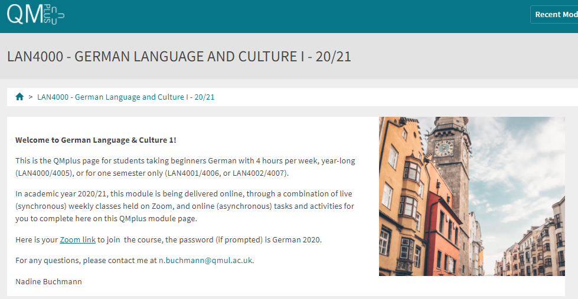

Free Language Speaking Practice

Language learners within the Queen Mary community can book 30-minute online speaking sessions with native or proficient speakers, for 15+ languages, for free. You can practise your speaking skills in the language you're learning, in an informal way. Sessions are offered by volunteers – QMUL students and staff who enjoy helping others learn. It’s a great way to practise the language, and get to know Queen Mary students from different schools and different backgrounds.

More information and booking link

FEEDBACK

- How can you check your progress throughout the module?
- What feedback can you expect from your tutor?

Language classes are highly interactive and participative, which means your tutor will give you regular instant feedback on your participation in class. Your tutor will also give you feedback on your submitted homework, and on activities that you complete on QMplus, if there is no automated feedback.

You will get feedback on the draft (formative submission) of your Writing Assignment, and will then have the opportunity to improve your writing before you submit it for summative assessment (counting towards your mark).

Your tutor is available during Feedback & Advice hours (check the times in the Tutor profile above), which you can use for a one-to-one meeting to discuss your progress. Please email your tutor beforehand.

ASSESSMENT INFORMATION

Assessment if you take the module FOR credit

If you are taking this module for credit, you need to complete and pass the assessments in order to gain the credits. The credits will count towards the total number of credits you need in each academic year (120 per year for undergraduate students).

Assessment if you take the module NOT for credit

If you are taking this module as a non-credit bearing module, it will not count towards your programme and you will not receive credits. However, if you complete and pass the module, you will receive a Certificate of Completion stating that you have passed the module, and with what grade. The requirements are that you:

- Have attended at least 65% of the taught sessions
- Take and pass the module assessment for non-credit seeking students to show that you have achieved the learning outcomes of the module
If you do not take the module assessment but meet the attendance requirement, you will receive a Certificate of Attendance, without a grade.

Assessment is carried out through formal and informal reading, writing, listening and speaking tasks. The assessment structure depends on whether you are taking the module for credit or not, and whether you take the year-long or the one-semester option. Check your module code and note the assessment structure relevant to you, below:

Assessment structure:

Please check your module code and then look for the assessment pattern that corresponds to your code, that assessment structure will apply to you.

FOR CREDIT

LAN4000: German Language & Culture 1: Students taking the module for credit, year-long (30 credits)
LAN4000  Assessment Title | Weight towards final grade % | Length | Due Date
Coursework
- Reading &Listening Test | 10% |  | Semester 1, Week 11 (December)
- Writing Assignment | 20% | 200-250 words | Submission (formative):  Semester 2, Week 7  Feedback given in Week 8  Submission (summative):  Semester 2, Week 9
Oral exam | 30% |  | Semester 2, Week 12
Written exam | 40% | 2 hours | May Examination period

LAN 4001: German Language & Culture 1a: Students taking the module for credit, Semester A only (15 credits)
LAN4001  Assessment Title | Weight towards final grade % | Length | Due Date
Coursework
- Reading &Listening Test | 10% |  | Semester 1, Week 11 (December)
- Writing Assignment | 20% | 100-125 words | Submission (formative):  Week 9  Feedback given in Week 10  Submission (summative):  First week in January
Oral exam | 30% |  | Semester 1, Week 12
Written exam | 40% | 2 hours | January Examination period

IFP4001: German Language & Culture 1a: Foundation Year and Pre-Masters Students taking the module for credit, Semester A only (15 credits), AND
Study Abroad & Visiting Students taking LAN4001: German Language & Culture 1a for credit, Semester A only (15 credits)
IFP/LAN4001  Assessment Title | Weight towards final grade % | Length | Due Date
Coursework
- Reading &Listening Test | 20% |  | Semester 1, Week 11 (December)
- Writing Assignment | 30% | 100-125 words | Submission (formative):  Week 9  Feedback given in Week 10  Submission (summative):  First week in January
Oral exam | 50% |  | Semester 1, Week 12

LAN 4002: German Language & Culture 1b: Students taking the module for credit, Semester B only (15 credits)
LAN4002  Assessment Title | Weight towards final grade % | Length | Due Date
Coursework
- Reading &Listening Test | 10% |  | Semester 2, Week 11
- Writing Assignment | 20% | 200-250 words | Submission (formative):  Semester 2, Week 7  Feedback given in Week 8  Submission (summative):  Semester 2, Week 9
Oral exam | 30% |  | Semester 2, Week 12
Written exam | 40% | 2 hours | May Examination period

NOT FOR CREDIT

LAN4005/LAN4006/LAN4007: German Language & Culture 1, 1a, 1b: Students taking the module NOT for credit, year-long. In order to get a Certificate of Completion, you need to pass the following assessments:
LAN4005/LAN4006/LAN4007  Assessment Title | Weight towards final grade % | Due Date
Coursework
- Reading &Listening Test | 20% | Week 11
- Writing Assignment | 30% | Submission (formative): Week 7  Feedback given in Week 8  Submission (summative): Week 9
- Oral test | 50% | Last week of the module

Your tutor will give you assessment briefs for each of the assessments.

MARKING CRITERIA FOR ASSESSMENT OF WRITING SKILLS

Task achievement | - How fully has the task brief been achieved? Does the text have the required length?*  - How fully, and in what breadth, has the topic been covered?  - If the task consists of description, how comprehensive is the description?  - If the task consists of argumentation, has the topic been considered from different angles?  - Have different aspects of the topic been elaborated?  - How relevant, and how correct, is the information included?
Organisation, Coherence and cohesion | - How clear is the text, and how logical is its structure?  - How appropriate, and how varied, are the connectors and cohesive devices used to link sentences?  - How well is paragraphing used, and how well are paragraphs connected to achieve a coherent text? Does the text read smoothly, or are there jumps?
Range  (Grammar, Syntax, Vocabulary) | - Are the sentence and grammatical structures appropriate for the level? (at lower levels, simple sentences will be fine, while at higher levels, the inclusion of more complex structures will be expected)  - How wide is the range of vocabulary used in the text? (simple and frequent lexical items will be fine at lower levels, while at higher levels, more varied vocabulary, use of nuance, and use of idiomatic expressions will be expected)
Accuracy (Grammar, Syntax, Vocabulary) | - How accurate are the grammar and sentence structures? If there are errors, are they minor, or do they impact the communication more severely? To what extent does the reader have to make an effort to understand what you are trying to communicate?  - How good is your command of the vocabulary? Do the words you have chosen have the right meaning to express what you want to say? If there are errors, do they just make the passage sound somewhat clumsy or do they obscure the meaning of the sentence and hinder communication?  - How well are lexical collocations used? (that is, words that normally go together, e.g. we say ‘to take a picture’ and not ‘to make a picture’, ‘to make a mistake’ and not ‘to do a mistake’, ‘to do someone a favour’ but not ‘to make someone a favour’)
*If you submit work significantly under the word limit, marks will be deducted.

MARKING CRITERIA FOR ASSESSMENT FOR SPEAKING SKILLS

Task achievement | - Have you completed the task that has been set? Have you completed it fully or only partially?
Range of vocabulary and structures | - How wide is the range of vocabulary that you use? Is it quite simple and basic, or do you master the full range of vocabulary that has been covered in the module?  - What kind of sentence structures do you use? Are they simple (such as a list of short main clauses), or are they more complex (using longer sentence structures with subordinate clauses that are well connected by conjunctions)?
Accuracy of vocabulary and grammatical structures | - How accurate is the vocabulary you are using? Are you using words with the right meaning to express what you want to say? How often do you pick words that don’t quite fit?  - How accurate are the grammar and the sentence structures that you are using? How frequently do you make mistakes? Are the mistakes minor or do they make it hard for your conversation partner to understand what you are trying to say?
Pronunciation | - How well do you pronounce the words and sounds in the target language? Is your pronunciation smooth and clear, with the correct word stress and sentence intonation, or is it difficult for the listener to recognise some of the words you produce?
Fluency | - How natural is the speed of your speech? (Note that slight hesitations, restarting a sentence, pausing to find the right word, etc., is part of natural speech). Are there many, long and ‘unnatural’, pauses and hesitations? Is there a breakdown of communication? Can you repair gaps by paraphrasing a word that you cannot find, or by reformulating a sentence?
Interactional skills | - How well can you use conversational norms when interacting with someone else: For example, opening a conversation, maintaining it, asking for clarification, giving appropriate responses to prompts from your conversation partner, taking turns in the conversation, closing (ending) the conversation.

