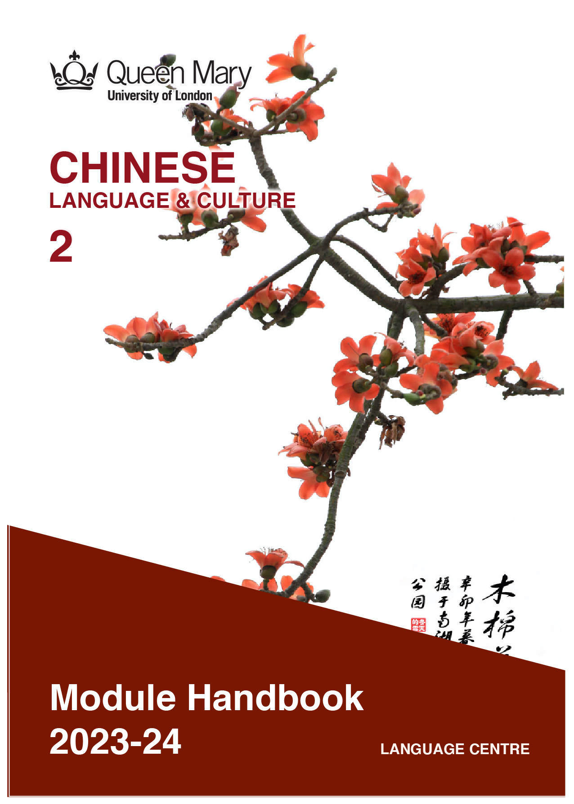

WELCOME TO LEARNING CHINESE

Welcome to the Learn a Language programme of Queen Mary. Language learning broadens the mind – you learn how different cultures and societies organize the world through language, you acquire a new vocabulary, new concepts, cultural knowledge, and become more interculturally aware. You can connect with people in another society in their language, a connection that is likely to be closer than if you make them speak your language or you communicate in a third language, such as English. You can use your language skills in your future career – employers consistently ask for better language skills in graduates. And, finally, language learning has cognitive benefits – studies show that bilinguals are more perceptive and have better memory. Speaking another language makes you more aware of language structure in general, and a better communicator.

MANDARIN CHINESE
Mandarin Chinese is offered in collaboration with Queen Mary’s Confucius Institute.
Chinese is spoken by about 1.6 billion people, with one fifth of the world's population now
using it as their mother tongue. Chinese has become more and more popular for language learners, and with the economic development of China and its overseas investments, speakers of Chinese are in high demand. Knowledge of the language can help you in a government career, but it will also be of benefit in business and in industries such as engineering, medical, and in the non-profit and international relations sectors. Speaking Chinese can help you build relationships with people in China and overseas Chinese communities.
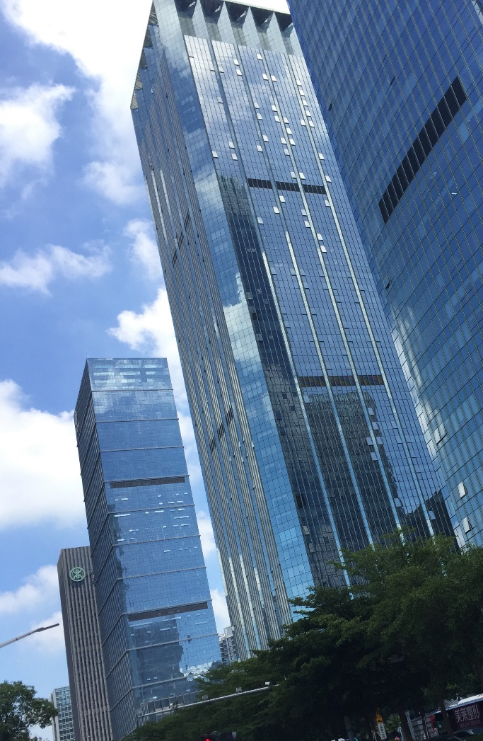

Picture by Kirsty Stage, student of Chinese 1b, 2019/20

MODULE AIMS AND LEARNING OUTCOMES

Module Aims
The overall aims of this module are to help you to develop a sound foundation of knowledge of the Chinese language, and an ability to approach communication in the language in a confident and competent manner. You will move from a lower intermediate to an intermediate level of knowledge of the language, and develop your ability to function effectively and competently dealing with language occurring in more demanding and challenging situations, within a general or a professional context (equivalent to level B1 of the Common European Framework of Reference, CEFR).
You will improve your competence towards an intermediate level through tasks designed to develop your skills in speaking and writing. You will also develop your receptive skills, by reading and listening to more complex texts. The aim is to achieve a balance between fluency and accuracy, which means grammar and structure are an integral part of this course.

How is the module structured and how will it be taught?
You will have two timetabled sessions (of two hours each) per week, over two semesters (4 hours over 22 weeks). The module is taught in-person, on campus. This means you will get 88 hours of tutor-led learning. The total learning hours for this module are 300 hours, which means that in addition to the 88 tutor-led hours, you need to invest an additional 212 hours through independent study. You will do this by doing homework set by your tutor, completing tasks online on QMplus and in the course book, revising class materials and vocabulary, preparing for assessments, and using other opportunities to speak, listen to and read Chinese outside the classroom.

The in-person and online sessions will be mainly used for interactive tasks and skills development (speaking, listening, writing), while explanations of grammar and introduction of new material will be delivered mainly via recorded video clips.
This means you will sometimes be asked to watch a video, go over a PowerPoint presentation, or read a text in preparation for a class, as well as completing exercises and tasks after sessions, for consolidation (e.g, exercises in the course book, on QMplus, recording yourself, etc.).

Module Learning Outcomes

You should develop the following outcomes related to academic content:
A1 | To achieve effective communication in Chinese at level B1 CEFR with competent speakers of the language.
A2 | To exploit, for a variety of purposes, a range of materials, written and spoken, in Chinese level B1 CEFR.
A3 | To demonstrate a knowledge and understanding of the structures, registers and, as appropriate, varieties of Chinese at level B1 CEFR.
A4 | To demonstrate a knowledge and understanding of Chinese cultures and societies gained through the study of basic written and aural texts and other cultural products in the target language.

You should develop the following disciplinary skills:
B1 | To analyze aspects of the target language and make use of them in a broadly professional context.
B2 | To gather and process information related to Chinese language and cultures from a variety of paper, audiovisual and electronic sources and communicate this information, both orally and in writing.
B3 | To use ICT effectively both as a means of communication and as an aid to learning.
B4 | To demonstrate some ability as an independent learner of the language in order to take further the study of Chinese language and cultures.

You should develop the following general attributes:
C1 | To be able to operate in more than one language, develop a global perspective and use the knowledge acquired to increase employability and engage with the professional world.
C2 | To apply analytical skills to investigate unfamiliar problems and to use the knowledge acquired to enrich research.
C3 | To be able to work effectively in diverse communities.
C4 | To work individually and in collaboration with others reflecting upon and assessing one's progress in learning the Target Language.

Picture by Shruthii Muthappan, student of Chinese 2a, 2019/20

EXPECTED STUDY TIME

If you are taking this module for credit, you will get 30 credits, which equals 300 learning hours. 88 of those will be tutor-led through synchronous sessions, the rest you are expected to invest between the weekly sessions, in your own time, via guided learning, using resources on QMplus, in your course book, and other material as advised by your tutor. Even if you are not taking the module for credit, you should invest the same amount of time in order to make the expected progress.

30 credit module – 300 learning hours
Tutor-led learning | 88 hours
Interactive classes
Self-directed learning | 212 hours
Preparations for taught sessions | 44
Completing set homework | 44
Self-study after class (QMplus, course book, etc.) | 88
Preparation for assessments | 36
Total | 300

CONTACT DETAILS AND ADVICE & FEEDBACK HOURS OF YOUR TUTOR

 | Chunhui Wang | Queens’  Building E304a | Email | Monday  2:00-3:00PM (please amend)

You can use tutor’s Advice & feedback hours for questions and feedback. Please email your tutor beforehand.

LEARNING PLAN
SEMESTER 1
week | main topic | learning outcomes | language focus | cuLTURE | SELF-STUDY (qm+)
 | What is the main topic of the week? | What will I be able to do with the language I am learning this week | What particular language features will be covered? | What cultural information will I learn this week? | What am I expected to do outside class from one week to the next?
1 | It was by bus that I came  我是坐公共汽车来的 | To describe what/and how long did someone do in a past time | 是……的 to express emphasis of a past event  S+ Verb 了 + A number of (time) | Public transportation in China  Popular hobbies of Chinese university students | Review Level 1
2 | You speak Chinese very fluently  你普通话说得很流利 | To tell and ask about abilities  To make comments or describe  To tell the duration of an action | Use Verb+得Complement to comment or describe  Use 会 to tell what you can do  V+了+Duration + O to tell how long | Languages and dialects in China  Chinese gongfu  Overseas students in China | Review level 1 and finish all exercises in the textbook
3 | What are you doing  你在干什么呢 | To tell continuous or concurrent activities  To describe one’s daily life | S+（adv）+在VO（呢）， action in progress  S 一边 V1， 一边 V2， two concurrent actions  S1 V1的时候， S2 V2. Time of happening. | Part-time job of Chinese university students  Study and exam in a Chinese university | Listening practice and handwrite the characters
4 | The computer I brought is both cheap and also good  我刚买的电脑又便宜又好 | To describe articles such as home appliances and office supplies | VP的to indicate Modifier  A 是A，就是……  又A 又 B | Train ticket APP in China | Familiarize the personal information form in Chinese and fill it in.
5 | The computer I brought is both cheap and also good  我刚买的电脑又便宜又好 | To describe articles such as home appliances and office supplies | VP的to indicate Modifier  A 是A，就是……  又A 又 B | E-commercial in China  Made in China | Log in an account in a Chinese online shopping platform and go shopping online.
6 | Have you been to the Great Wall  你去过长城吗 | To tell about one’s experience  To discuss about holiday plans | 要 + V to tell something going to happen  V + 过 to describe the experience | Tips of travel in China;  Panda; | Write about your traveling experience
7 | READING WEEK: Please complete the following work during Reading Week
8 | I am coming down right now  我马上就去 | How to express an action involving direction;  How to pass on a telephone message;  How to apologize formally | 动词：抱歉；让；  离合词：结婚；帮忙  量词：位，趟 | Wechat APP in China | Download Wechat app and add the classmates as your friends.
9 | Have you seen today’s newspaper  你看见今天的报纸没有 | How to express an action with a result;  How to describe an action with adverbials | Use of the construction 连……都/也……；要是……的话 | Skills and hobbies;  News agencies in China | Read China Daily or 人民日报 and introduce current hot reports
10 | Sichuan food is too spicy, I can’t take it  四川菜太辣了，我受不了 | To learn how to use potential compliment;  To difference potential compliment from other compliments | Use conjunctions 虽然……但是…… | Chinese cuisine of different regions | Order Chinese food for a party;  Introduce a Chinese food you made
11 | This pair of shoes are too small for me  这双鞋我穿不下 | Potential complements with directional words 上/下/起 etc.  Potential complements with 得;  A statement starting with a topical comment | Words about shoes and clothes：款式、大小、合适、老气、土气、洋气…… | Modern Chinese fashion；  旗袍 qipao and 汉服 hanfu | Organize flea market in class
12 | There is a Chinese painting on the wall in the lounge  客厅的墙上挂着一幅中国画儿 | Use 着 to indicate durative result of an action; to refer to a prolonged state of an action result; to indicate an action taking place concurrently with another actions | 存现句：place + Verb 着 + Sth  连动句：Verb1着+Verb2 | Chinese painting 中国画 | Describe a looking of a person; Describe the decoration of a room.

SEMESTER 2
week | main topic | LEARNING OUTCOMES | LANGUAGE FOCUS | CULTURE | SELF-STUDY (qm+)
 | What is the main topic of the week? | What will I be able to do with the language I am learning this week | What particular language features will be covered? | What cultural information will I learn this week? | What am I expected to do outside class from one week to the next?
1 | 新年好！  Happy New Year | Expressions of Chinese New Year activities.  In progress using正在  又……又……  Sequences with先……然后……  Rooms in the hours | Making exchanges between a host and a guest during a home visit  Talking about different rooms in a house  Understanding an article about festival activities, dishes, and customs  “uo” and “e”  Radicals 广and艹 | Being a guest in China | Handwrite the character “福”
2 | I don’t feel like eating anything  我什么都不想吃 | Use question words as indefinite pronouns; to indicate inclusiveness or exclusiveness | 什么+都……  什么+也+不^  Verb 什么，就Verb 什么； | Story of 马马虎虎  Chinese Proverb | Tell your experience of traveling and expeditions
3 | Where did I put the milk  我把牛奶放哪儿了 | Use 把 construction to tell result, changes, and disposition | S+把+sth+Veb+在……  S+把+sth+verb+adj  副词：简直、本来  连词：除了…… | Names of relatives in Chinese； | Hide-and-seek games
4 | My computer was stolen  我的电脑被偷了 | Use 被 construction to tell passiveness  Use 恐怕 to guess tentatively what may happen or may not happen | Compare 把 and 被 sentence and their uses  Sb+恐怕+something may …… | Public security in China | Report an accident you had or saw
5 | Please fill in the registration form  请填一下登记表 | Use of imperative in Chinese  Use of passive imperatives | 请……；别……  Use of cause-result construction 既然……就…… | House renting and  Visa, study application | Fill in forms of registration, application, and evaluation.
6 | It is said on TV that the temperature will be very low in Beijing  电视上说北京今天气温很低 | Indicate the source of information with 说  Express the idea of even more with 更  Express the ideas of more and more with 越来越 | 听sb说……  A比B 更……  越来越……  越A越B | Weather and climate in China | Make a resume in Chinese
7 | READING WEEK: Some students need to prepare their Writing Project for submission. And everyone will get their reading materials either online or books. |  |  |  |  |  |  | Weather and climate in China | Make a resume in Chinese
8 | I booked the ticket online  我是在网上订的票。  （Air travel and extreme weather) | Using words for air travel and extreme weather | 登机、超重、手续、靠、值机员、窗户、出示、过道、登机牌、行李票、转机、由、订票、登机口、信用卡、舱、乘坐、关闭航班、随身行李、起飞、托运、旅途愉快、传送带 | Expressions for airport check-in | Exercises and quiz on QM+  Find the most famous booking website or APP in China
9 | When is our assignment due?  什么时候交作业？（Assignments, quizzes, and deadlines) | Using words for clarification, instructions and rubrics in exam | 戏剧、吵、排演、决定、出主意、扮演、不如、表演、讨论、接下来、前排、发短信、约时间、回头见、收拾、排序、简答、说法、简要、哲学家、测验、工艺品 | 汉朝VS汉语 | Exercises and quiz on QM+  半小时漫画中国史
10 | I’ll go wherever you go  你去哪儿我就去哪儿 | Talk about traveling with:  Comparison of 又 and 再  Flexible use of interrogative pronouns哪儿 | 面试、自学、离婚 | Traveling in China  在中国各地旅行 | Make a 14 days travel plan in China and Share it with your classmates.
11 | Taste of life生活的味道 | Using a complement of direction after some verbs.  Interrogative pronouns used to refer to everyone or everything. | 疑问代词活用表任指；总的来说；出来 | A bite of China -jiaozi | To know more about Chinese food culture and Culinary arts.  To practice using chopsticks.
12 | Review & Tasks & Practices

SEMESTER DATES 2023-24

Semester 1 | Dates
Teaching Weeks 1 to 6 | 25 Sep – 5 Nov 2023
Study Week (Week 7) | 6 Nov – 10 Nov 2023
Teaching Weeks 8 to 12 | 13 Nov – 15 Dec 2023
January exam period | 4 – 19 January 2024
Semester 2 | Dates
Teaching Weeks 1 to 6 | 22 Jan – 1 Mar 2024
Study Week (Week 7) | 4 Mar – 8 Mar 2024
Teaching Weeks 8 to 12 | 11 Mar – 12 Apr 2024
Exam period | 2 May – 31 May 2024
Summer Resit period | August 2024

LEARNING MATERIALS

 | Course book | ISBN | Notes

OTHER RESOURCES:

  - Online dictionary: http://xh.5156edu.com/
  - Youtube channels: https://www.youtube.com/channel/UCSXriUqkzZmAQklQ0N9XFVw
  - Reading list for Chinese modules:
  - Cultural events in London in 2021/22 related to Chinese: Please follow the Confucius Institute website or facebook @QMULCI

QMplus Module page

The QMplus module page is the place to go to regularly before and after class, to prepare for the weekly sessions and find resources for self-study. Here you will find the materials used in class in addition to the course book, and additional resources and activities that help you consolidate and extend the material covered in class. You will also find links to web resources and videos on the language and cultural information.
https://qmplus.qmul.ac.uk/course/view.php?id=14656

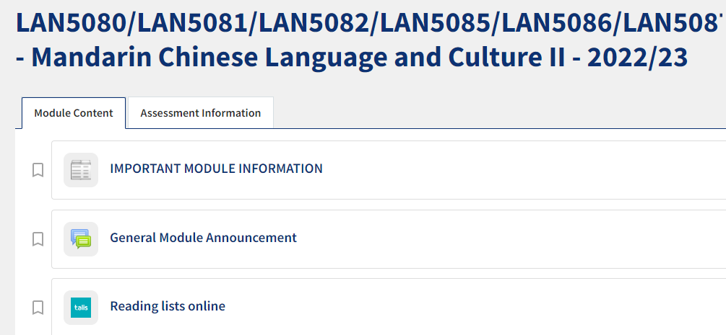

Free Language Speaking Practice

Language learners within the Queen Mary community can book 30-minute online speaking sessions with native or proficient speakers, for 15+ languages, for free. You can practise your speaking skills in the language you're learning, in an informal way. Sessions are offered by volunteers – QMUL students and staff who enjoy helping others learn. It’s a great way to practise the language, and get to know Queen Mary students from different schools and different backgrounds.

More information and booking link

FEEDBACK

- How can you check your progress throughout the module?
- What feedback can you expect from your tutor?

Language classes are highly interactive and participative, which means your tutor will give you regular instant feedback on your participation in class. Your tutor will also give you feedback on your submitted homework, and on activities that you complete on QMplus, if there is no automated feedback.

You will get feedback on the draft (formative submission) of your Writing Assignment, and will then have the opportunity to improve your writing before you submit it for summative assessment (counting towards your mark).

Your tutor is available during Feedback & Advice hours (check the times in the Tutor profile above), which you can use for a one-to-one meeting to discuss your progress. Please email your tutor beforehand.

ASSESSMENT INFORMATION

Assessment if you take the module FOR credit

If you are taking this module for credit, you need to complete and pass the assessments in order to gain the credits. The credits will count towards the total number of credits you need in each academic year (120 per year for undergraduate students).

Assessment if you take the module NOT for credit

If you are taking this module as a non-credit bearing module, it will not count towards your programme and you will not receive credits. However, if you complete and pass the module, you will receive a Certificate of Completion stating that you have passed the module, and with what grade. The requirements are that you:

- Have attended at least 65% of the taught sessions
- Take and pass the module assessment for non-credit seeking students to show that you have achieved the learning outcomes of the module
If you do not take the module assessment but meet the attendance requirement, you will receive a Certificate of Attendance, without a grade.

Assessment is carried out through formal and informal reading, writing, listening and speaking tasks. The assessment structure depends on whether you are taking the module for credit or not. Check your module code and note the assessment structure relevant to you, below:

Assessment structure:

FOR CREDIT

LAN5080: Chinese Language & Culture 2: Students taking the module for credit, year-long (30 credits)
LAN5080  Assessment Title | Weight towards final grade % | Length | Due Date
Coursework
- Reading &Listening Test | 10% |  | Semester 1, Week 11 (December)
- Writing Project | 20% | 200-250 characters | Submission (formative):  Semester 2, Week 7  Feedback given in Week 8  Submission (summative):  Semester 2, Week 9
Oral exam | 30% |  | Semester 2, Week 12
Written exam | 40% | 2 hours | May Examination period

LAN 5081: Chinese Language & Culture 2a: Students taking the module for credit, Semester A only (15 credits)
LAN5081  Assessment Title | Weight towards final grade % | Length | Due Date
Coursework
- Reading &Listening Test | 10% |  | Semester 1, Week 11 (December)
- Writing Project | 20% | 150-200 characters | Submission (formative):  Week 9  Feedback given in Week 10  Submission (summative):  First week in January
Oral exam | 30% |  | Semester 1, Week 12
Written exam | 40% | 2 hours | January Examination period

Study Abroad & Visiting Students taking LAN4081: Chinese Language & Culture 1a for credit, Semester A only (15 credits)
LAN4081  Assessment Title | Weight towards final grade % | Length | Due Date
Coursework
- Reading &Listening Test | 20% |  | Semester 1, Week 11 (December)
- Writing Project | 30% | 120 characters | Submission (formative):  Week 9  Feedback given in Week 10  Submission (summative):  First week in January
Oral exam | 50% |  | Semester 1, Week 12

LAN 5082: Chinese Language & Culture 2b: Students taking the module for credit, Semester B only (15 credits)
LAN5082  Assessment Title | Weight towards final grade % | Length | Due Date
Coursework
- Reading &Listening Test | 10% |  | Semester 2, Week 11
- Writing Project | 20% | 200-250 characters | Submission (formative):  Semester 2, Week 7  Feedback given in Week 8  Submission (summative):  Semester 2, Week 9
Oral exam | 30% |  | Semester 2, Week 12
Written exam | 40% | 2 hours | May Examination period

NOT FOR CREDIT

LAN5085/LAN5086/LAN5087: Chinese Language & Culture 2, 2a, 2b: Students taking the module NOT for credit, year-long. In order to get a Certificate of Completion, you need to pass the following assessments:
LAN5085/LAN5086/LAN5087  Assessment Title | Weight towards final grade % | Due Date
Coursework
- Reading &Listening Test | 20% | Week 11
- Writing Project | 30% | Submission (formative): Week 7  Feedback given in Week 8  Submission (summative): Week 9
- Oral test | 50% | Last week of the module

Your course teacher will give detailed instructions in advance of assessments.

MARKING CRITERIA FOR ASSESSMENT OF WRITING SKILLS

Task achievement | - How fully has the task brief been achieved? Does the text have the required length?*  - How fully, and in what breadth, has the topic been covered?  - If the task consists of description, how comprehensive is the description?  - If the task consists of argumentation, has the topic been considered from different angles?  - Have different aspects of the topic been elaborated?  - How relevant, and how correct, is the information included?
Organisation, Coherence and cohesion | - How clear is the text, and how logical is its structure?  - How appropriate, and how varied, are the connectors and cohesive devices used to link sentences?  - How well is paragraphing used, and how well are paragraphs connected to achieve a coherent text? Does the text read smoothly, or are there jumps?
Range  (Grammar, Syntax, Vocabulary) | - Are the sentence and grammatical structures appropriate for the level? (at lower levels, simple sentences will be fine, while at higher levels, the inclusion of more complex structures will be expected)  - How wide is the range of vocabulary used in the text? (simple and frequent lexical items will be fine at lower levels, while at higher levels, more varied vocabulary, use of nuance, and use of idiomatic expressions will be expected)
Accuracy (Grammar, Syntax, Vocabulary) | - How accurate are the grammar and sentence structures? If there are errors, are they minor, or do they impact the communication more severely? To what extent does the reader have to make an effort to understand what you are trying to communicate?  - How good is your command of the vocabulary? Do the words you have chosen have the right meaning to express what you want to say? If there are errors, do they just make the passage sound somewhat clumsy or do they obscure the meaning of the sentence and hinder communication?  - How well are lexical collocations used? (that is, words that normally go together, e.g. we say ‘to take a picture’ and not ‘to make a picture’, ‘to make a mistake’ and not ‘to do a mistake’, ‘to do someone a favour’ but not ‘to make someone a favour’)
*If you submit work significantly under the word limit, marks will be deducted.

MARKING CRITERIA FOR ASSESSMENT FOR SPEAKING SKILLS

Task achievement | - Have you completed the task that has been set? Have you completed it fully or only partially?
Range of vocabulary and structures | - How wide is the range of vocabulary that you use? Is it quite simple and basic, or do you master the full range of vocabulary that has been covered in the module?  - What kind of sentence structures do you use? Are they simple (such as a list of short main clauses), or are they more complex (using longer sentence structures with subordinate clauses that are well connected by conjunctions)?
Accuracy of vocabulary and grammatical structures | - How accurate is the vocabulary you are using? Are you using words with the right meaning to express what you want to say? How often do you pick words that don’t quite fit?  - How accurate are the grammar and the sentence structures that you are using? How frequently do you make mistakes? Are the mistakes minor or do they make it hard for your conversation partner to understand what you are trying to say?
Pronunciation | - How well do you pronounce the words and sounds in the target language? Is your pronunciation smooth and clear, with the correct word stress and sentence intonation, or is it difficult for the listener to recognise some of the words you produce?
Fluency | - How natural is the speed of your speech? (Note that slight hesitations, restarting a sentence, pausing to find the right word, etc., is part of natural speech). Are there many, long and ‘unnatural’, pauses and hesitations? Is there a breakdown of communication? Can you repair gaps by paraphrasing a word that you cannot find, or by reformulating a sentence?
Interactional skills | - How well can you use conversational norms when interacting with someone else: For example, opening a conversation, maintaining it, asking for clarification, giving appropriate responses to prompts from your conversation partner, taking turns in the conversation, closing (ending) the conversation.

