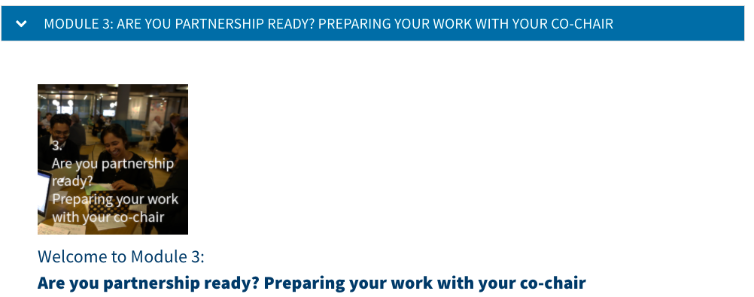

Examples created by your colleagues in previous editions of the course
co
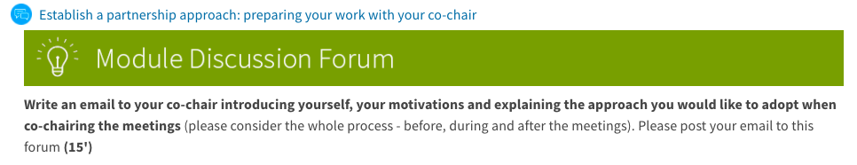
[Assuming you have never taught or met the student rep. Otherwise you would probably not introduce yourself]

Dear ...,
I am xxxxxx. In the future we will co-chair Student-Staff Liaison Committee (SSLC) meetings and I believe it would be useful to have a chat in person or over Teams to define and discuss few things before the meeting in order to be prepared and maximise the outcome of the SSLC meeting. In the past few years, I have been working towards the improvement of student voice and engagement. Therefore, I will continue working to make sure our collaboration will produce a positive impact on the university life for all of us.
I think during our meetings we should always be willing to fully listen to each other and all participants, feel free to share constructive and honest criticism while maintaining a professional approach. I will be available on Tuesday all day, Wednesday morning and Friday afternoon.

Please let me know if any of these dates work for you as well. In the meantime, if you have any questions please do not hesitate to contact me and I will be glad to respond to your queries to the best of my abilities.
Looking forward to work together with you.
All the best,

Dear ---
My name is xxx and (details of my role in the school). I have been the Staff Co-Chair of the SSLC for several years.
I want to support you and the year reps to discuss those issues that are important for you with the staff and also to receive any feedback you have on the curriculum, teaching and assessment, student welfare and other important issues that affect students.
I look forward to meeting you so that we can work out the best times and dates for meetings.
Best wishes

Dear XXX,
I hope you're well. I'm writing to introduce myself as the xxx role xxx . I'm looking forward to working with you as co-chairs of the Student-Staff Liaison Committee (SSLC). I hope our collaboration will encourage honest conversations and produce a positive impact on the University experience for both students and staff.
If you would find it useful, I would like to have an informal chat via Teams so that we can introduce ourselves before the next SSLC meeting. I have good availability on Tuesdays and Fridays between 09:00 – 17:00, please let me know whether this time would suit or not.
Kind regards,

(Context: incoming DoE (January) and the student co-chair has been appointed since the semester 1)
Dear XXX,
I hope you're well. I'm writing to introduce myself as the xx role xxx this semester. I'm looking forward to working with you as co-chairs of the SSLC.
Do you think it would be useful to have a short chat via Teams in the next two weeks so that we can say hello before the SSLC meets and you can fill me in on the conversations you've been with students recently? That way we can see if there are any items we'd like to put on the agenda for the SSLC.
I teach on Tuesday afternoons and Thursday mornings, and Wednesday afternoons are usually busy from 12-3 but otherwise my time is flexible.
Looking forward to hearing from you.
Best wishes,

[To be sent as soon as you have notification of the SSLC election]

Dear [name],
I hope you are enjoying the course so far! In case we didn't meet at the induction already, my name is xxx and we will be co-chairing the SSLC committee for the [xxx] course this year.

Co-chairing is a new approach for us at Queen Mary and it means that we - student and staff member - take equal responsibility for chairing the meeting and making sure that the action points agreed in the meeting are set realistically and followed up on. This means that neither of us is 'the boss' when it comes to running the meetings and both of our input is equally valuable in the meeting.

I think because this might be a new way of working for both of us it would be a good idea to meet up before our first meeting in [October] and decide how we would like to work together, get to know how we both work a bit more and maybe agree how we will share out the business and deal with - for example - timekeeping. Perhaps [next Monday at 1:30pm] would work for you?
I hope that sounds a good idea and very much look forward to working with you to improve the course!
Best wishes,

Hi [name],
my name is xxxxx I am [job title], I have been senior tutor for 10+ years in the department and have attended many SSLC meetings during this time, though not as co-chair.

I am always open to ideas and discussions which can best make use of the SSLC meetings in the time available.
I have seen the value of student voices, as communicated by year reps at SSLC meetings over the years in resolving issues and improving the departments educational delivery and helping create a positive student experience.

I look forward to meeting and working with you to continue this important process.

