Core Case 4: Elderly Care

Please consider this case as if you were a GP working during the Covid Pandemic.
In this scenario, NHS pressures and waiting times are the same as they are currently.

Patient:Mr. GB 87-year-old man
Social Hx: Lives with his wife, Mrs. EB who is 86 years old. They have recently moved from Essex to sheltered accommodation across the road from the practice in Muswell Hill in August 2019. They are mainly supported by their daughter CB, who is a teaching assistant and their son JB who works as a librarian. Both CB and JB have lasting power of attorney.

- Emis Consultation Dr Vardy August 2019
Mr. GB and Mrs. EB have new patient appointments with you in the surgery as recommended by your health care assistant accompanied by their daughter, CB.
GB
87-Year-old
HPC: lesion on right side of nose, increasing in size over one month
Thickened lesions on right temple and ulceration
PMH: Psoriasis and psoriatic arthritis/Rheumatoid Arthritis overlap as Rheumatoid factor positive CCP positive on methotrexate and leflunomide
Age-related macular degeneration on injections at Queens Romford
2016 Aortic aneurysm repair under 6 monthly follow up from Vascular Surgeons
IHD – one stent
His current medication is:
Atorvastatin 80mg nocte
Eplerenone 25mg one tablet once daily
Co-codamol 30/500 2 tablets four times daily
Bisoprolol 5mg once daily
Omeprazole 20mg once daily
Ramipril 10mg once daily
Methotrexate 2.5mg tablets four tablets weekly
Folic acid 5mg one tablet once daily
Rivaroxaban 20mg one tablet to be taken once daily
Leflunomide 10mg tablet one tablet once daily
Viscotears to both eyes three times daily

On examination
Scalp lesion:
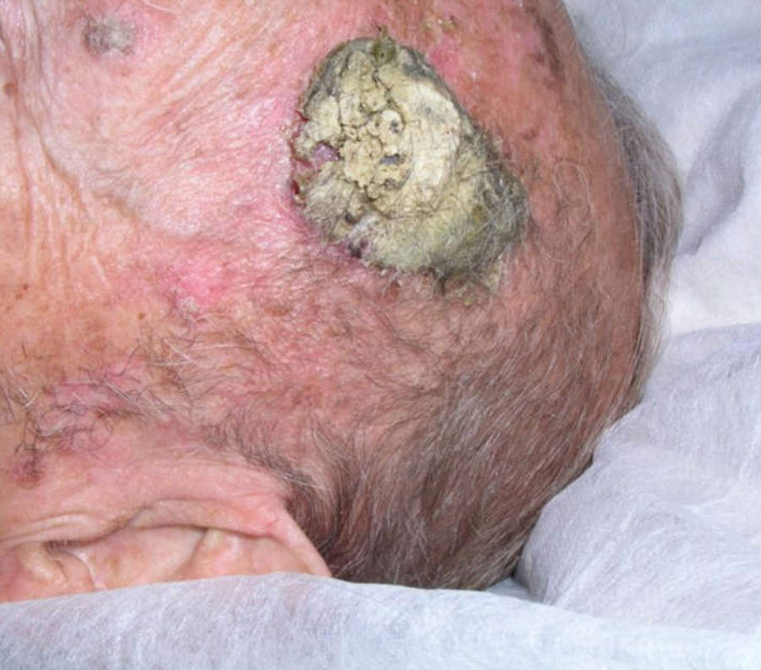
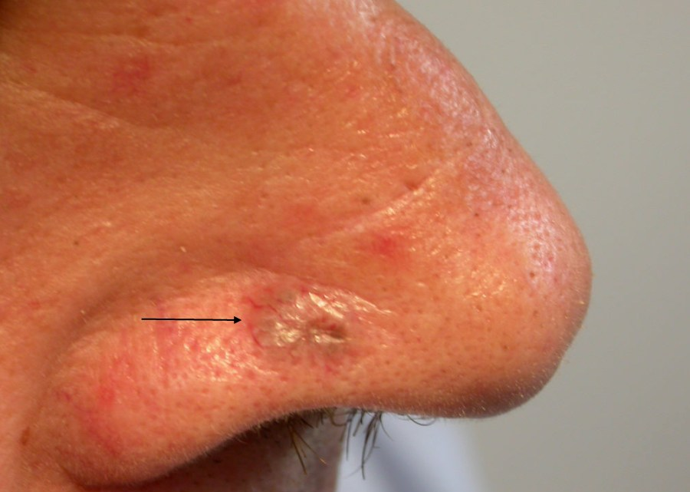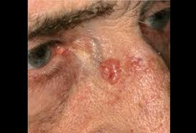
Lesions right side of nose

Discussion Points

- Given this patient’s history and examination findings, what is your immediate management of this patient?
- What may be contributing to the development of such skin lesions?
- What other management and referrals are required during this first consultation?
- What chronic disease management is required in General Practice in the longer term?
- Can you see the rationale for all his repeat prescriptions?

Year 4 Revision:
- How do you describe skin lesions? How does this help to differentiate them?

Useful Resources

- Skin Lesions - https://www.nhs.uk/conditions/non-melanoma-skin-cancer/
- Managing Multi-morbid - https://www.bmj.com/content/350/bmj.h176
- Polypharmacy – note key points in this document –
- https://www.kingsfund.org.uk/sites/default/files/field/field_publication_file/polypharmacy-and-medicines-optimisation-kingsfund-nov13.pdf

Methotrexate

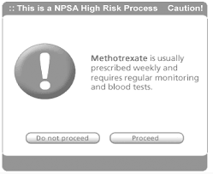

Discussion Points
- How would you write a methotrexate prescription?
- How should methotrexate prescriptions be managed between primary and secondary care.
- How do you do repeat prescriptions for methotrexate safely and when would you decide not to prescribe?

Useful Resources
Shared Care Prescribing/Contract - https://www.gmc-uk.org/ethical-guidance/ethical-guidance-for-doctors/prescribing-and-managing-medicines-and-devices/shared-care

Mr. GB is seen in the Dermatology Clinic and is found to have moderately differentiated squamous cell carcinoma of the left frontal scalp and basal cell carcinomas of the right side of the nose and right clavicle. He is treated with radiotherapy.
November 2019 – Mr. GB is reviewed by the Ophthalmologists at Queens Romford. He has a right macular scar and left age-related macular degeneration. He also has bilateral cataracts and his visual acuity is counting fingers on the right and 0.46 in the left eye. He has had intravitreal injections of aflbercept to manage his age-related macular degeneration and has had 4 injections. His macular is now stable and dry
December 2019 – He is seen by Rheumatology and chest examination reveals inspiratory crepitations in both mid and lower zones. He was not pyrexial or short of breath at rest and had no orthopnoea.
April 2020 – Mr. GB has developed ongoing cough and fever and has become more chesty over the last few days. He has suspected Covid-19
June 2020
He has now been off methotrexate and leflunomide for 6 months and has increased early morning stiffness, joint pains and back pain. His pain is stopping him from sleeping.

Discussion Points
NOV 2019
- How would you manage his eye conditions?

Dec 2019

- What is the differential diagnosis?
- What investigation is required to confirm the pulmonary diagnosis?

April 2020

- What immediate management is required?
- What is his acute management?
- How would you monitor this patient in primary care?
- What extra support may him and his wife require?

Continuing Management
- How would you manage his pain?
- How could you manage his worsening Psoriatic/Rheumatoid Arthritis?
- There is no DNAR decision in place. What next steps would you take?
Useful Resources
DNAR- https://network.healthwatch.co.uk/network-news/2020-04-09/nhs-policy-use-‘do-not-attempt-to-resuscitate-forms’
DNAR Video on tips on how to approach https://www.youtube.com/watch?v=Y52YwLcVQQs
Mrs. EB
86-year-old
August 2019 – has been newly diagnosed with Alzheimer’s Disease in Romford and seen by the Memory Clinic in Romford
Had fall in the previous week
Legs swollen
2009 CABGs x 3
2008 Type 2 Diabetes Mellitus
Her current medication is:
Atenolol 25mg once daily
Aspirin 75mg once daily
Candesartan 4mg once daily
Atorvastatin 40mg nocte
GTN spray 400mcg/dose one dose prn
You have no records about the recent visit to the Memory Clinic
Mrs. EB has Type 2 Diabetes and IHD.
November 2019 further fall and admission with fractured left neck of femur
April 2020 – Mrs. EB presents with cough and fever for 7 days and is diagnosed with suspected Covid-19
There is no DNAR decision in place and Mrs. EB is deemed to lack mental capacity
Discussion Points
- How would you manage this patient following her memory clinic visit in Romford?
- Mrs. EB has Type 2 Diabetes and IHD. What are the challenges of chronic disease management for a patient with Alzheimer’s disease?
- How should you approach making a DNAR decision for this patient?
- What is your understanding of end-of-life decisions: best interest decisions; Power of Attorney, and Advance Directives

DNAR decisions have now been made for Mr. GB and Mrs. EB.
- How are these decisions recorded?
- How are primary and secondary care services informed?

Year 4 Revision
Falls
- What history do you need to elicit about the falls?
- How would you investigate the falls?
- How would you manage the falls?

Memory

- How would you manage her Alzheimer’s Disease?
- What are key features to consider in the history of a patient with dementia

Fractured Neck of Femur
- What is the morbidity that might follow a fractured neck of femur?
- What is the associated mortality?

Useful Resources
Approach to assessing a fall- http://www.oxfordmedicaleducation.com/geriatrics/falls-assessment-management/
http://www.patient.co.uk/doctor/Recurrent-Falls.htm
http://www.patient.co.uk/doctor/Prevention-of-Falls-in-the-Elderly.htm
Memory Clinic- https://www.nhs.uk/conditions/dementia/diagnosis/
Investigations - https://www.gpnotebook.com/simplepage.cfm?ID=906362898
Advance Care Planning: https://www.goldstandardsframework.org.uk/advance-care-planning
Capacity: http://thehearingaidpodcasts.org.uk/episode-1-6-capacity/
Best interests: https://www.bma.org.uk/media/1850/bma-best-interests-toolkit-2019.pdf
Coordinate My Care: https://www.coordinatemycare.co.uk/

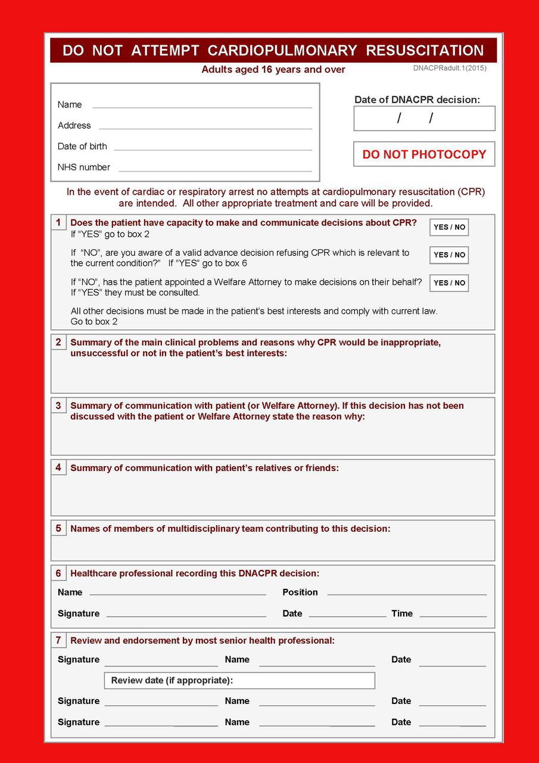
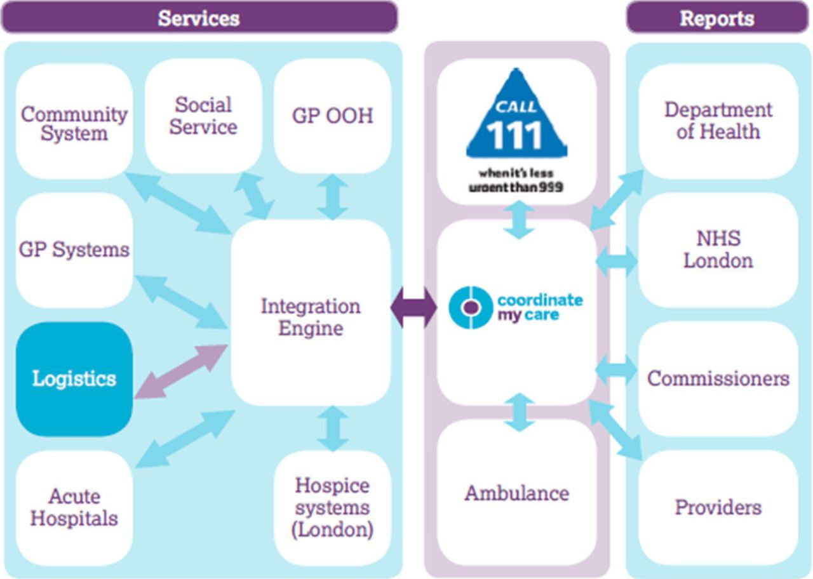

Discussion Points
As we have demonstrated, Mr. GB and Mrs. EB have complex co-morbidities. How can we support their daughter, Mrs. CB as their carer?
- What should be done as part of a carer assessment?
- How would you access a social services package of care and what does this include?
- What services/ organisations can Mrs. CB be signposted to that will help her support her parents?
At the end of May, you receive an email from their son, Mr. JB. He states that he has power of attorney with his sister. He reports that his sister thinks that his mother’s dementia is making her too unstable to make financial decisions, which concerns him. He has requested that you telephone him so that these issues can be resolved.

Discussion Points
- How would you respond to this email?

Useful Resources
Carer Assessment: https://www.carersuk.org/help-and-advice/practical-support/getting-care-and-support/carers-assessment

