NASSS-CAT (SHORT)

IDENTIFYING COMPLEXITIES IN YOUR TECHNOLOGY PROJECT

The questions below help you think about the various complexities of your project and how they all interact. Use your responses and notes as the basis for a team discussion.

Name of your project: ……………………………………………………………………………………………………………………….

THE ILLNESS OR CONDITION
Think about the illness or other condition that the technology is designed for – and what sort of person has that condition.
 | Agree |  | Disagree | Not applicable  or don’t know
There are significant uncertainties about the condition e.g. poorly-defined, variable manifestations, uncertain course
Many people with the condition have other co-existing illnesses or impairments that could affect their ability to benefit from this solution
Many people with the condition have social or cultural factors that could affect their ability to benefit from the technology or service
The population with the condition, and/or how the condition is treated, is likely to change significantly over the next 3-5 years
SUMMARY: The condition has significant complexity which is likely to affect the project’s success | Yes |  | No

THE TECHNOLOGY
Think about the technology (e.g. a tool or piece of software), and how it might affect care.
 | Agree |  | Disagree | Not applicable  or don’t know
There are significant uncertainties in what the technology is (e.g. it hasn’t been fully developed yet)
There are significant uncertainties in where the technology will come from (e.g. supply chain issues, substitutability)
There are significant uncertainties about the technology’s performance and dependability (e.g. bugs, crashing, cutting out)
There are significant uncertainties about the technology’s usability and acceptability (e.g. key people don’t trust the data it provides)
There are significant technical interdependencies
The technology is likely to require major changes to organisational tasks and routines
The technology (and/or the service model it supports) is likely to change significantly within the next 3-5 years
SUMMARY: The technology has significant complexity which is likely to affect the project’s success | Yes |  | No

THE VALUE PROPOSITION
Think about what kind of value the technology might generate for different groups of people. (‘Value’ can be financial, such as profit, or non-financial, such as control of symptoms)
 | Agree |  | Disagree | Not applicable  or don’t know
The commercial value of the technology is uncertain
The value to the intended users (e.g. patients, clinicians) is uncertain
The value to the healthcare system (e.g. from efficacy and cost-effectiveness studies) is uncertain
The value to this particular healthcare organisation, given the current situation locally, is uncertain
The technology could generate a negative value (costs are likely to outweigh benefits) for some stakeholders
The value proposition is likely to change significantly over the next 3-5 years
SUMMARY: The value proposition has significant complexity which is likely to affect the project’s success | Yes |  | No

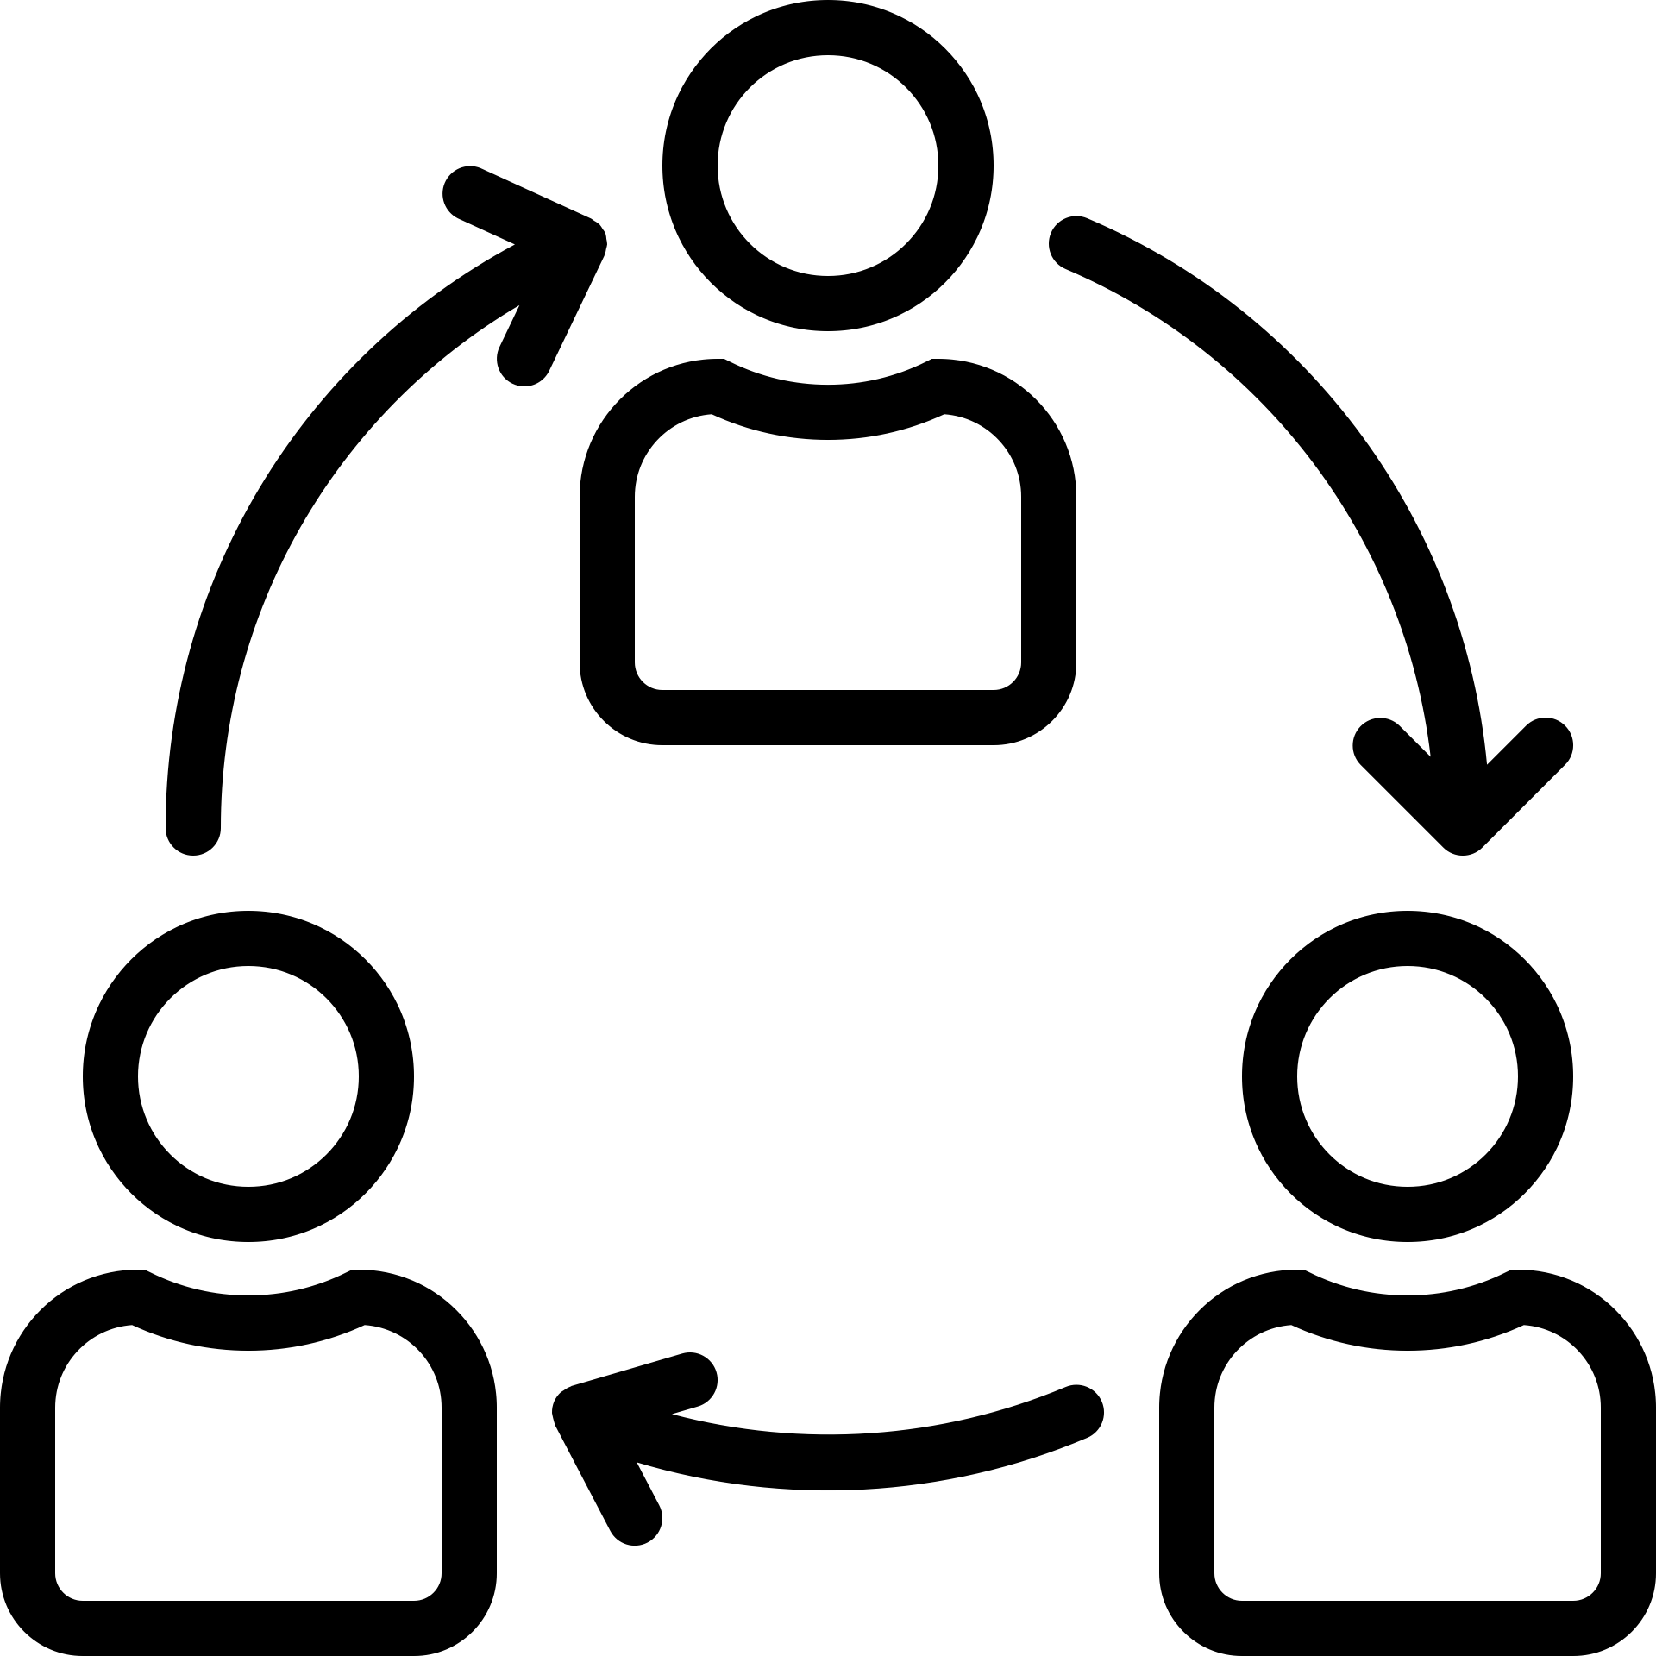
THE INTENDED ADOPTERS
Think about who is intended to use the technology and what changes it will bring for them.
 | Agree |  | Disagree | Not applicable  or don’t know
There is uncertainty about whether and how patients/citizens will adopt the technology [if applicable]
There is uncertainty about whether and how front-line staff will adopt the technology
There is uncertainty about the implications for people who might be indirectly affected by the technology
There will be significant changes to individual users’ perceptions of the technology over the next 3-5 years
SUMMARY: There is significant complexity relating to intended adopters which is likely to affect the project’s success | Yes |  | No

THE ORGANISATION(S) IMPLEMENTING THE TECHNOLOGY
Some organisations are better at taking up innovations than others. What about yours?
 | Agree |  | Disagree | Not applicable  or don’t know
The organisation’s capacity to take on technological innovations is limited
The organisation is not ready for this particular innovation
The organisation would find it hard to commission/purchase the innovation
The work needed to introduce and routinise the innovation has been underestimated and/or inadequately resourced
The organisation(s) involved are likely to have significant restructurings or changes in leadership, mission or strategy over the next 3-5 years
SUMMARY: There is significant complexity relating to one or more participating organisations which is likely to affect the project’s success | Yes |  | No

THE EXTERNAL CONTEXT FOR INNOVATION
Think about external conditions that could complicate adoption and spread of the innovation.
 | Agree |  | Disagree | Not applicable  or don’t know
The political and/or policy climate is adverse
Professional bodies are opposed to the innovation or don’t actively support it
Patient organisations and lobbying groups are opposed to the innovation or don’t actively support it
The regulatory context is adverse
The commercial context is adverse
Opportunities for learning from other (similar) organisations are limited
Introduction of the technology/innovation could be threatened by external changes that impact on the organisation
The policy, regulatory and economic context for this innovation is likely to be turbulent over the next 3-5 years
SUMMARY: There is significant complexity relating to the external context which is likely to affect the project’s success | Yes |  | No

THINGS TO EXPLORE OR DISCUSS: List the key things in each domain that you would like to look up or discuss with other team members or wider stakeholders

The value proposition
The technology
The illness or condition
The organisation
The intended adopters

The external context

