Security arrangements for staff returning to campus after 2 June 2020

Background

As more staff return following the partial reopening of lab space on the 2nd June, many parts of Queen Mary’s campuses will look quite different and operate in new ways.
Access control
In order to support a safe and properly managed return to campuses it will be necessary to make good use of access control technology, limiting access only to individuals who should be entering our buildings. This means that devices which were previously switched off during the working day will now be active and all buildings will operate behind a monitored access control system.
- Applying access control in this way will ensure that staff working in campus can feel safe and secure despite there being far fewer colleagues and students around that usual. It will also help us support the ‘track and trace’ measures being introduced by the Government by allowing us to be certain of who has been present at particular times.
Social distancing
A number of measures will be in place to support social distancing, which most staff are no doubt very familiar with. It is absolutely vital for the health and safety of our community that these measures are strictly adhered to on our campuses and that all instructions and information on signs is followed. In addition, hand sanitiser stations will be located inside all main access doors, which all staff should use frequently.
Please be reassured that any failure comply with safety measures will be treated with the utmost seriousness and all appropriate action will be taken.
Return Process

Please note that staff should only be returning to campus if they are:
  - Free from symptoms and not subject to any self-isolation obligation
  - Approved or instructed to return by their line manager and/or lab manager
All staff that are returning to campus for the first time since the lockdown period begun should report to the Security Office where the following actions will be carried out:
  - Access Card and personal Pin Code will be enabled and issued for the building a staff member is to work in
  - A personal pin code essential to operate the device on the main entrance of the building in which staff members are to work will be provided
  - An induction brief will be given and staff will be able to ask any questions
  - Staff will be advised which door they are to use to swipe in at the start of a working day and swipe out at the end of the day
Following this initial set-up and induction process, on subsequent days staff will be able to go straight to their place of work and swipe in (additionally using their personal pin code) and out.

Other Staff
Staff who have been working on campus prior to the 2nd of June and those on approved lists provided by the Lab Managers to Security will be issued with personal digital pin codes, to be additionally applied to main building entrance points. The codes can be retrieved by visiting the Security Control rooms or via email:
Mile End: mile-end-security@qmul.ac.uk
Whitechapel: whitechapel-security@qmul.ac.uk
Charterhouse Square: chsq-security@qmul.ac.uk
Security Managers: security-shift-manager@qmul.ac.uk
Signs will also be in place at all main building entrances to help staff follow this process.
It is assumed that such staff are already fully briefed regarding the arrangements that have been in place throughout the period of lockdown but questions would be welcomed either through the Security Shift Manager on security-shift-managers@qmul.ac.uk ( monitored 24/7 ) or by emailing the Head of Security and Emergency Planning on m.digby@qmul.ac.uk

Security Office Locations

Mile End Security Control room is located in the Ground floor reception area, Queens Building (Building 19), using the left hand side door entrance.
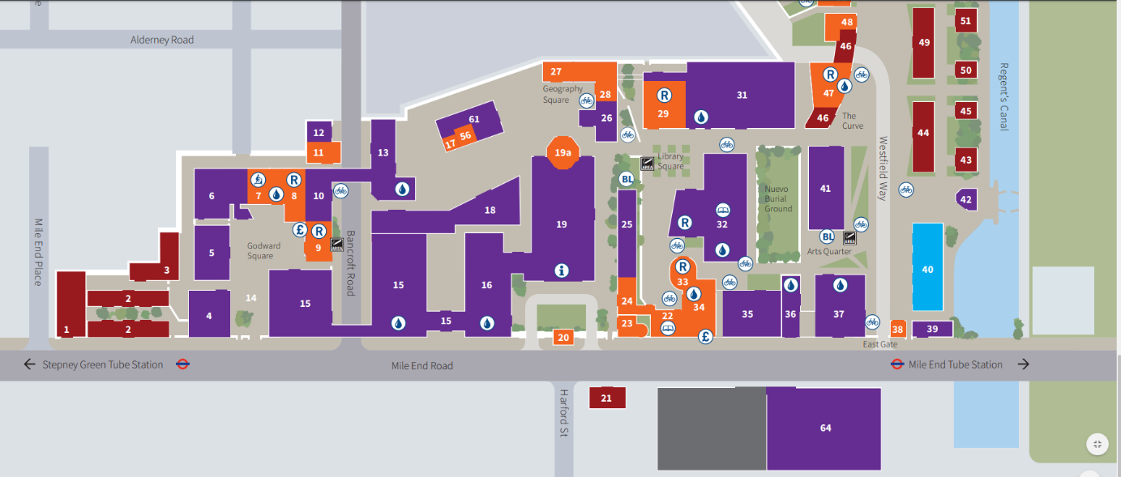

Whitechapel Security office is located in the Ground floor reception area, Garrod Building (Building 6), using the main front door entrance.
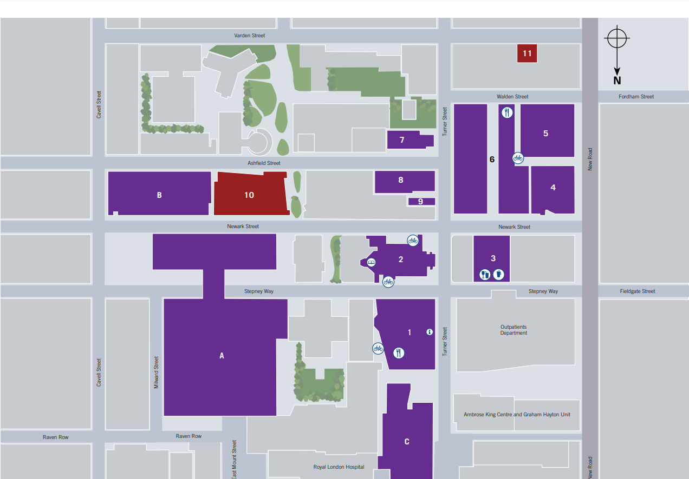
Charterhouse Square Security Office is located in the ground floor reception are of Dawson Hall (Building 4).
