# **School of Physics and Astronomy**

# **On Site Room Restrictions During Covid-19 for Research Activity**

# **October 2020**

## Ground Floor

### G3, G4, G5 and G6



1

2

3

4

1

2

3

4

1

**G3: (entry from G5)**

Contains a coordinate measuring machine and workstation for control of this.

**G4**: Gowning area for G6, no equipment; AHU air changes.

**G5: ATLAS Lab**

1. Preparation area

2. IR testing area

1. Preparation area
2. Thermal properties of material test area

**G6: PPRC Clean Room**

AHU with HEPA filters for an ISO7 clean room environment, ensures clean air and regular changes of air.

1. Probe Station
2. Wire bonder
3. Optical Coordinate Measuring Machine
4. Bond Puller and sample storage

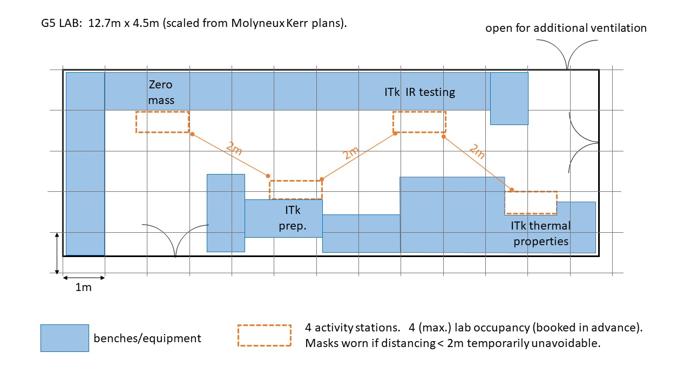

|  |  |  |  |
| --- | --- | --- | --- |
| **Room** | **Maximum No. of Staff** | **PPE Equipment** | **Cleaning** |
| G3 | 1 | Nitrile glovesSafety glassesHand sanitiserSanitiser wipes | Floor cleaned once a month by college cleanersEquipment, tools and work surfaces should be cleaned before and after each use. |
| G4 | 1 | Dedicated Gowns, hair nets and overshoesNitrile glovesSafety glassesHand sanitiserSanitiser wipes | Floor and work surfaces cleaned by cleanroom users.Equipment, tools and work surfaces should be cleaned before and after each use.Gowns, hair nets and overshoes cleaned using washing machine in room 125 (1st floor cleanroom. |
| G5 | 4 (if using stations as demonstrated in diagram above) | Nitrile glovesSafety glassesHand sanitiserSanitiser wipes | Same instructions as G3. |
| G6 | 4 (if Perspex screens between users used) | Dedicated Gowns, hair nets and overshoesNitrile glovesSafety glassesHand sanitiserSanitiser wipes | Same as G4. |

### G9: **Workshop**

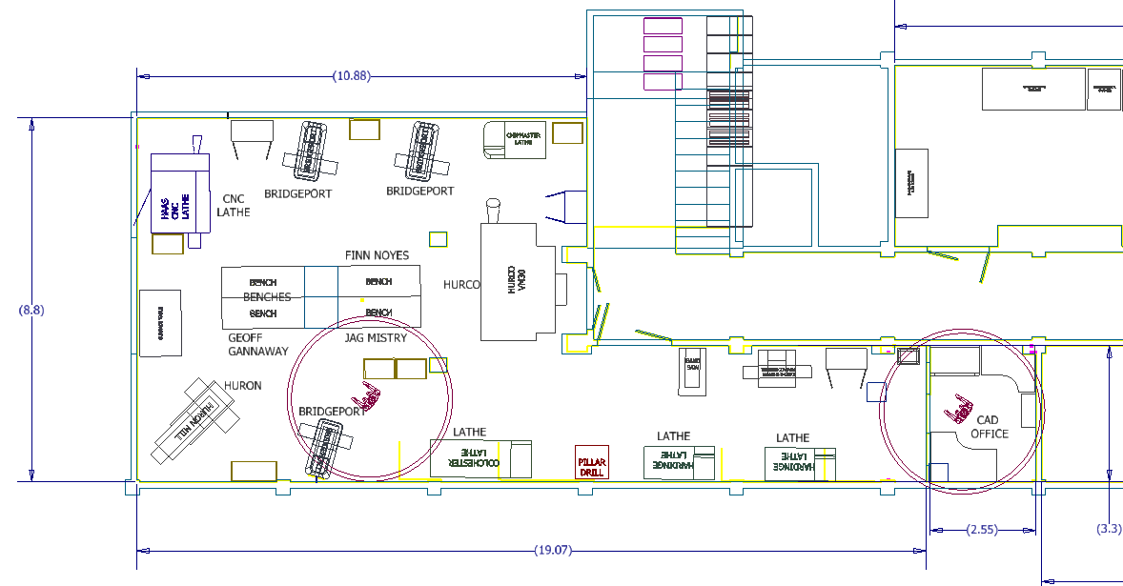

|  |  |  |  |
| --- | --- | --- | --- |
| **Room** | **Maximum No. of Staff** | **PPE Equipment** | **Cleaning** |
| G9 | 4 (Dependent on equipment being used) | OverallsSafety glassesSafety shoesHand sanitiserSanitiser wipes | Floor, equipment and work surfaces cleaned by users before and after usingEquipment, tools and work surfaces should be cleaned before and after each use.Overalls exchanged for clean ones via stores |

## First Floor

### 125/ 125A and Museum



**125: Clean Room**

**125A: Gowning Area**

**Museum: Break Out Area**

|  |  |  |  |
| --- | --- | --- | --- |
| **Room** | **Maximum No. of Staff** | **PPE Equipment** | **Cleaning** |
| 125A | 1 | Dedicated gowns and overshoesNitrile glovesSafety Glasses | Gowns and overshoes are cleaned weekly in our own washing machine located in the gowning area.Floor and all work surfaces are hovered, mopped / wiped over in a weekly general clean. This also involves emptying bins and restocking consumables.Sink is available for hand washing.All work surfaces and equipment should be cleaned before and after use. |
| 125 | 4 | Dedicated gowns and overshoesNitrile glovesSafety Glasses | Same as 125A |
| Museum | 6 | Hand Washing Hand Sanitiser  One Person per table | All users to wipe down surfaces before and after use. |

## Third Floor



**301: Main Laboratory**

**302: Chemistry Lab**

**304: Optics Lab**

**306: Sensor Lab**

**307: Development Lab**

|  |  |  |  |
| --- | --- | --- | --- |
| **Room** | **Maximum No. of Staff** | **PPE Equipment** | **Cleaning** |
| 301 | 5 | Safety GlassesNitrile glovesHand SanitiserSanitiser wipesCryo-glove for handling liquid nitrogen (Shared) | Floor cleaned once a month by college cleanersEquipment, tools and work surfaces should be cleaned before and after each use.Hand-washing sinks in lab |
| 302 | 3 | Nitrile glovesSafety glassesLab coatsHand sanitiserSanitiser wipes | Floor cleaned once a month by college cleanersEquipment, tools and work surfaces should be cleaned before and after each use.Hand-washing sinks in labOveralls exchanged for clean ones via stores |
| 304 | 5 (if equipment used allows maintenance of social distancing) | Safety Glasses  Hand Sanitiser  Sanitiser wipes  Only one user per bay | Floor cleaned once a month by college cleanersEquipment, tools and work surfaces should be cleaned before and after each use. |
| 306 | 2 | Nitrile gloves  Safety glasses  Hand sanitiser | Floor cleaned once a month by college cleanersEquipment, tools and work surfaces should be cleaned before and after each use. |
| 307 | 1 | Nitrile gloves  Safety glasses  Hand sanitiser  Sanitiser wipes | Floor cleaned once a month by college cleanersEquipment, tools and work surfaces should be cleaned before and after each use. |