Ordering Blood Tests

To order blood tests follow the step-by-step guide.

The following blood tests are commonly ordered:

Full blood count (FBC), Urea and electrolyte (Urea and electrolyte), iron serum (iron studies), Vitamin B12 serum (Vitamin B12 serum), folate serum (folate serum), lipid profile (lipids serum), cholesterol serum (cholesterol serum), HbA1C (Haemoglobin A1C), fasting glucose (fasting glucose plasma), thyroid function tests (TFTs), Vitamin D (25-Hydroxy vitamin D3 serum), C-reactive protein serum (C-reactive protein serum), liver function tests (LFT).

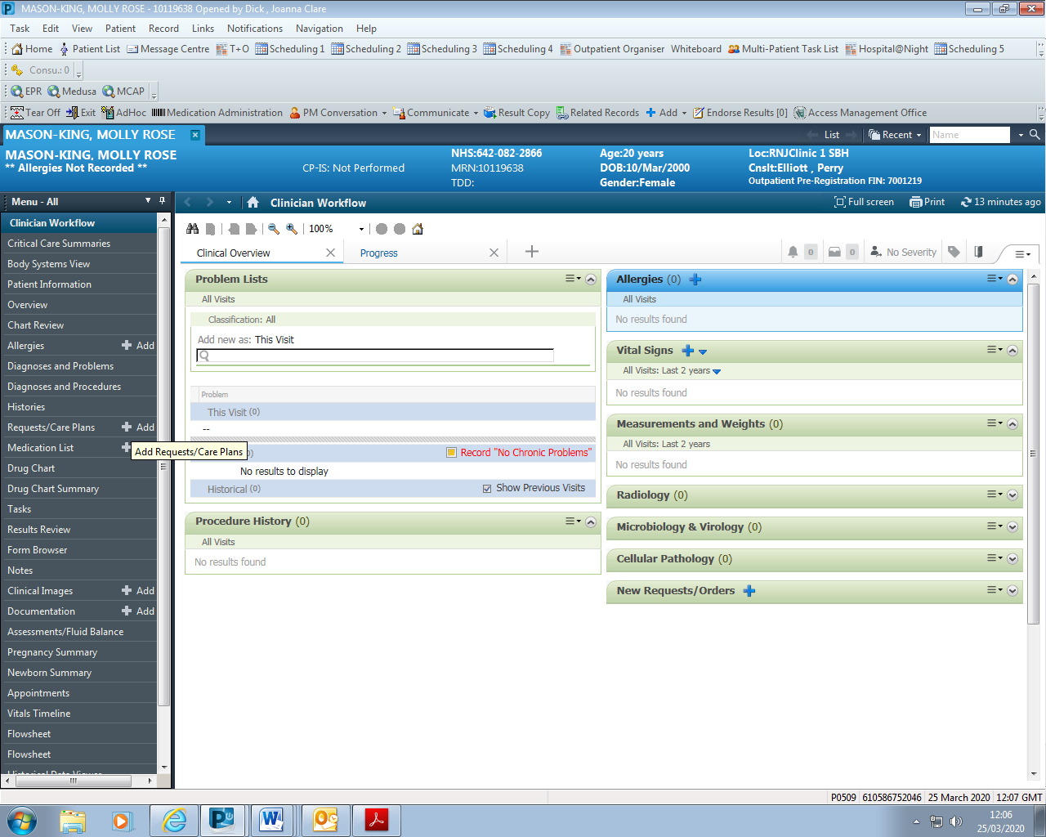

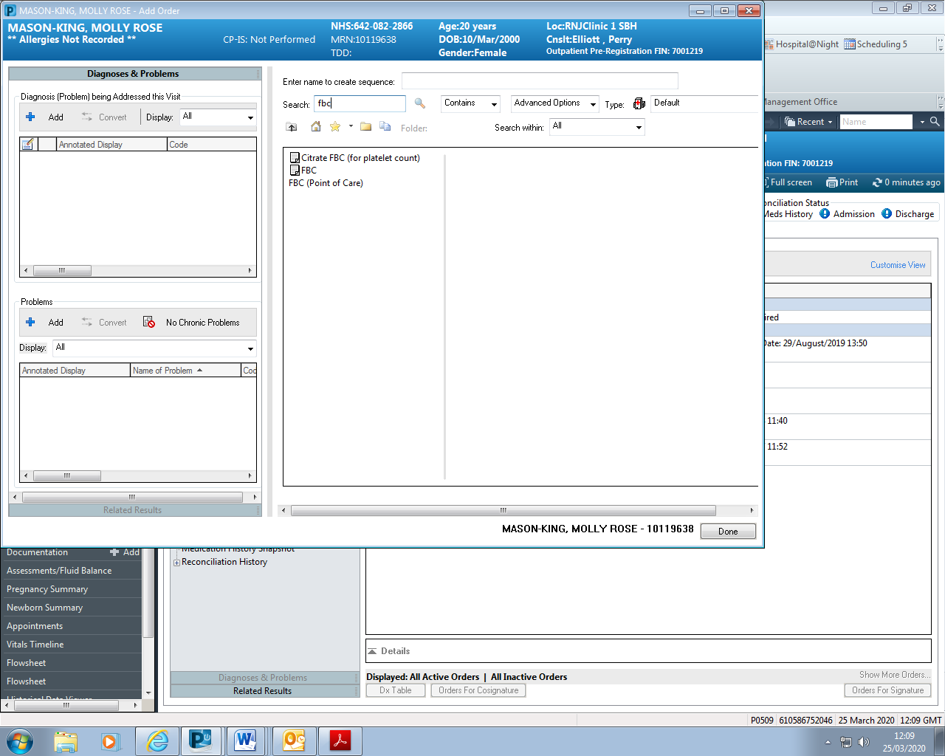

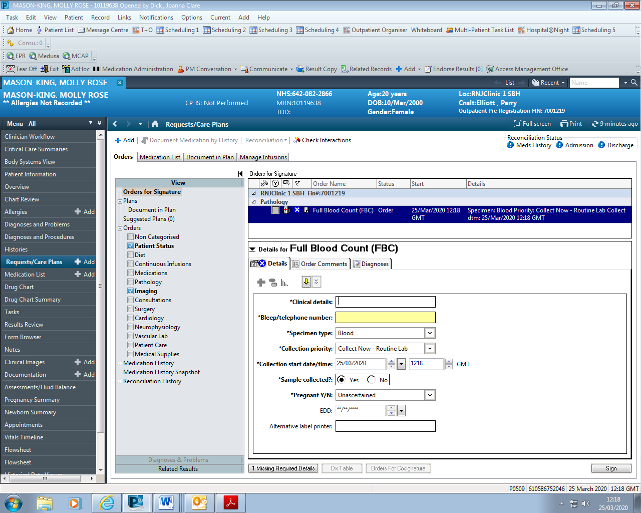

Label printers are available in each ward, department or clinic. The printer name will be displayed on the front of the printer. Some of the label printers available in dental include:

Ground floor: RNJDEN00027L

Paeds 1st floor: RNJRDEN01833L

Clinic 6: RNJDEN00031L

The label printed will display the patient’s name, MRN and date of birth. It will also detail which test is being carried out and which colour blood bottle is required.

Commonly used bottles include:

Purple 4.0ml: Haematology

Gold 5.0ml: Biochemistry

Grey 2.0ml: Fasting glucose

Once you have printed the required labels, you are ready to take the blood samples.

The equipment required can be seen below as well as the common venepuncture sites.

A video regarding the Aseptic Non-Touch Technique can be viewed here:

https://www.youtube.com/watch?v=fROeNX90tvQ



Ref: Clough S, Shehabi Z, Morgan C, Sheppey C. Blood tests for people with severe learning disabilities receiving dental treatment under general anaesthesia. Dent Update 2016; 43: 849-858.

For the process of taking bloods, please see the Trust policy on Venepuncture and Phlebotomy (attached).

The following YouTube videos may also be useful:

<https://www.youtube.com/watch?v=VqrKKXd3AEc>

<https://www.youtube.com/watch?v=-XxiRSf6n8Q>

Bloods can be sent off using the pneumatic tube system – these are situated in most wards or clinics.

To send the tubes to the laboratory, package them in a plastic bag and a place inside a yellow container, found inside the shoot cupboard below.

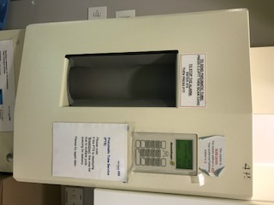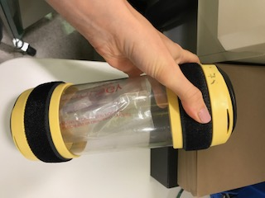

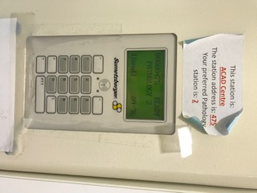

Place into the shoot, press:

C 2 and then PTT

The door will close and send the samples.

In the event that the shoot displays ‘Busy’, try again in a few minutes

Please note COVID positive patients’’ samples cannot be sent in the tube. They must be double bagged and hand-delivered.