Student Support at Barts and The London

Guide for GP Tutors

If you have concerns about a student and think they may require support, please contact the student support office on smd-student-support@qmul.ac.uk. Alternatively please contact the module lead if you want advice. Their contact details can be found on our website www.gptutorbartsandthelondon.org

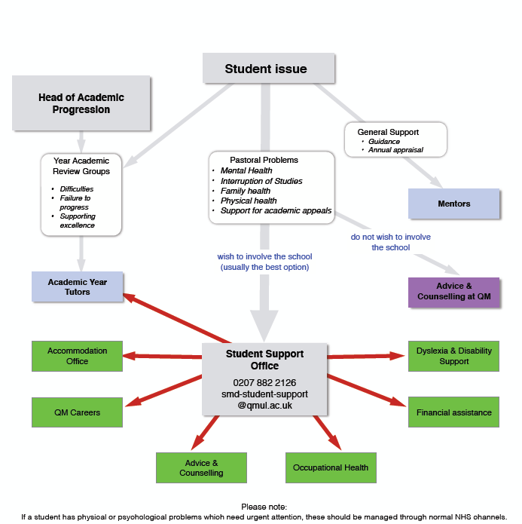

There are many reasons why students may require support during their time at medical school; these range from major life events, identification of specific learning needs, and adjustment to the demands of a challenging degree. General Practice is one of the placements on which students are most likely to be identified as being in difficulty and in need of greater support. This is due to the smaller size of the clinical team and the greater focus on the student from the GP tutor. As such, it is crucial to be aware of potential students in difficulty and direct them to the student support office where possible.

How do students in difficulty present?
- Lateness or failing to attend teaching sessions
- Handing in work late
- Lack of engagement with the course
- Aggressive or non-cooperative behaviour
- Poor communication with staff and patients
Why is it important to address the behaviour above?
There is unequivocal evidence that unprofessional behaviour in medical school is associated with subsequent disciplinary action by the medical regulatory board (Papadakis et al 2004)
Why might students resist seeking help?
- Feeling that they should be able to cope on their own
- Concerns about confidentiality
- Lack of trust
- Fears that this will affect their academic progression or future career (Chew-Graham et al 2003)
What can student support offer?
- See the flow chart above for more information
- Support with student pastoral issues
- Special circumstances for clinical placements
- Fitness-to-study problems
- Attendance issues
- Assistance with academic appeals
- Student financial support/bursary funding
- Interruptions, withdrawals and return-to-studies
- GMC declarations/professionalism issues
- References
- Mock interviews for academic foundation programme
- International students (Visas and F1-equivalent overseas training)
- Transfer of information (TOI) to GMC and declarations with Foundation Training Schools

What happens if I refer a student for support?
They will be contacted by a member of the student support team and offered an initial meeting and onward support as appropriate. All student details are kept confidential and so we cannot share this with you. However, we can acknowledge that we have received your concerns and have taken action on these. If the student is struggling with their placement and you are concerned that they may not pass then please have a considerate conversation with the student about potential changes that may help them, and let the module lead know (contact details on our website or in your tutor guide www.gptutorbartsandthelondon.org)
How can I help to support students?
GP tutors are not expected to provide student support alone. We recommend that GP tutors include a student support question in their induction to encourage openness from the students on placement. We also recommend regular two-way feedback with the students in a safe and non-judgemental environment and a one-to-one conversation may be more appropriate if you feel an individual is particularly struggling. Finally if you have concerns then we suggest contacting student support or the module lead and discussing this decision with the student if possible.

For more information on student support please contact:
Siobhan Cooke (Deputy Head of Student Support, Clinical Senior Lecturer and MBBS Year 4 Unit Convenor): s.d.cooke@qmul.ac.uk

References:
- Chew-Graham, C.A., Rogers, A., and Yassin, N., 2003. ‘I wouldn’t want it on my CV or their records’: medical students’ experiences of help seeking for mental health problems. Medical Education, 37(10), pp.873-880.
- Papadakis, M.A., Hodgson, C.S., Teherani, A. and Kohatsu, ND., 2004 Unprofessional behaviour in medical school is associated with subsequent disciplinary action by a state medical board Academic Medicine 79:244-249

