Creative enquiry collaboration, May 1st 09.30-16.00, E1 2AD

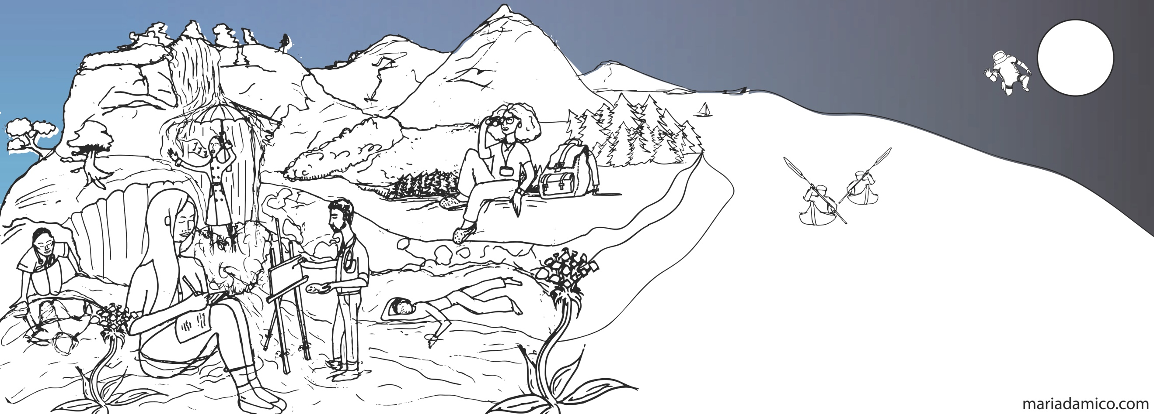

Dear Health Care Professionals, Students, Patients

We are bringing together people from across hierarchies and healthcare divides to workshop and dialogue around creative enquiry,

* What is it?
* How do we facilitate creative enquiry?
* What has creative enquiry got to offer medical education?
* What has creative enquiry got to offer medical students in terms of wellbeing and flourishing?

The programme will

* Engage in creative enquiry
* Reflect on paths to well being, flourishing and practice development through the arts
* Examine strengths, weaknesses and challenges of creative enquiry approaches

Creative capturing of ideas will be supported by Josie from [www.studiojojo.co](http://www.studiojojo.co/)

This is the launch of a venture to build a community of practice and sharing across student, faculty, health care professional staff and patients, in the field of creative enquiry in medical education linking also with social prescribing in the community. It is supported by the development of a new website which gathers creative enquiry texts, reflections and quotes from medical students and beyond as well as sharing ideas and thinking behind facilitating and engaging others in creative enquiry both for development of our practices as well as for wellbeing. <https://www.creativeenquiry.qmul.ac.uk>

If you would like to attend please book online via the following link [Eventbrite for tickets](https://www.eventbrite.co.uk/e/creative-enquiry-collaboration-tickets-59738271779) . If you have any queries please contact Louise Younie at [smd-creative@qmul.ac.uk](mailto:smd-creative@qmul.ac.uk)

This project is supported by HE Advance Small Development Project, based at Queen Mary University of London and co-ordinated by Dr Louise Younie [smd-creative@qmul.ac.uk](mailto:smd-creative@qmul.ac.uk)

