**Contemporary Russian Short Stories, Week 5 Seminar Sheet**

**Ulitskaia, ‘The Gift not Made by Human Hand’**

**Task 1**

Read the extract from the text and

i) The everyday/the higher sphere conflict

ii) Comment upon the treatment of the theme of the body in the passage

iii) Explain how these themes relate to gender? (see quotes in Task 3)

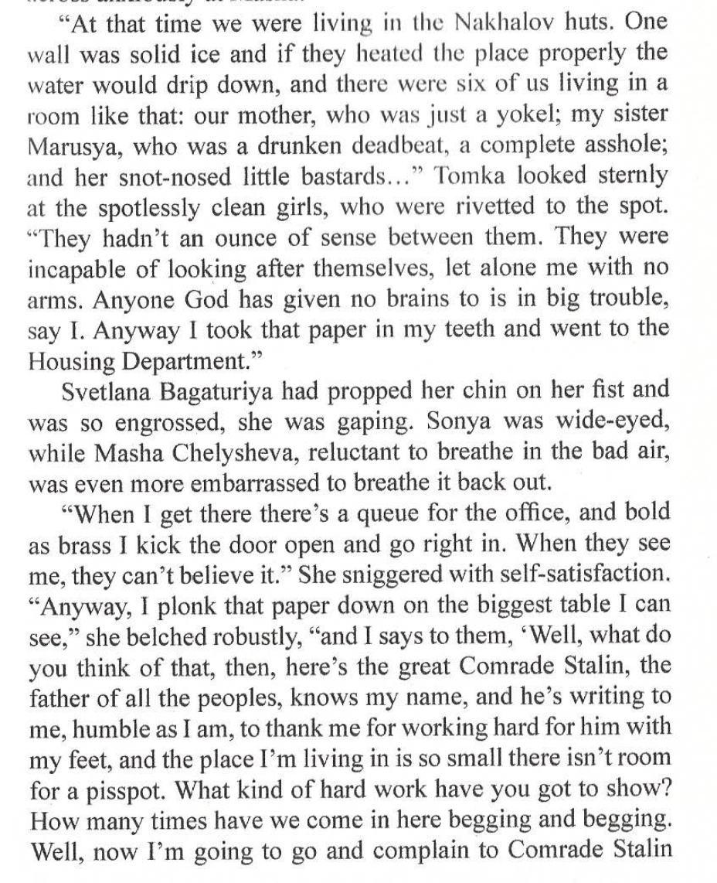

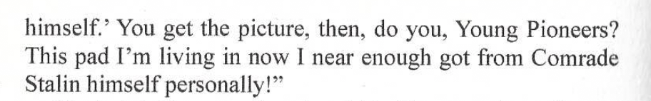

**Task 2**

In what ways is Toma an ambivalent character, according to Sutcliffe?

Why would an ‘irregular’ body cause us to reflect upon our own lives?

How does Sutcliffe’s analysis below relate to gender?

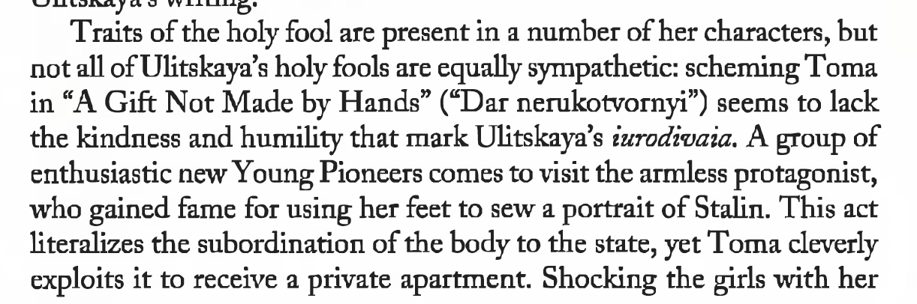

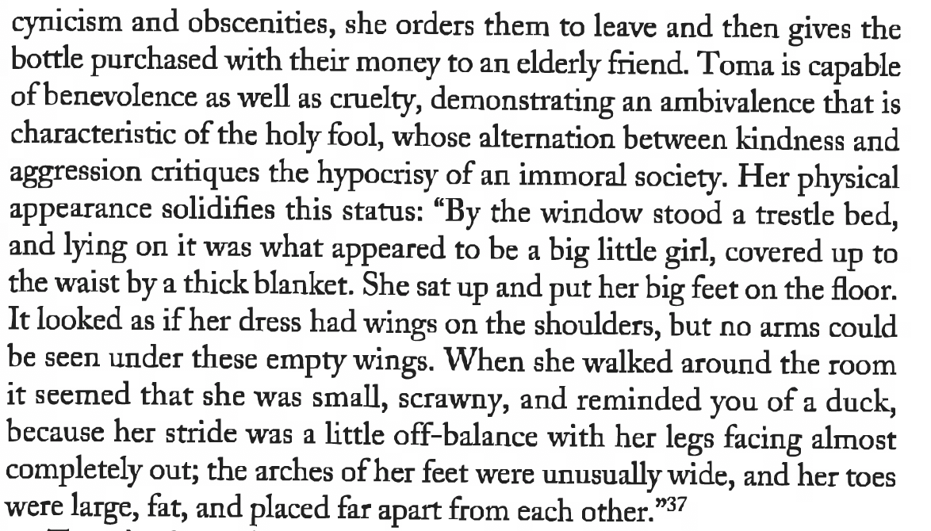

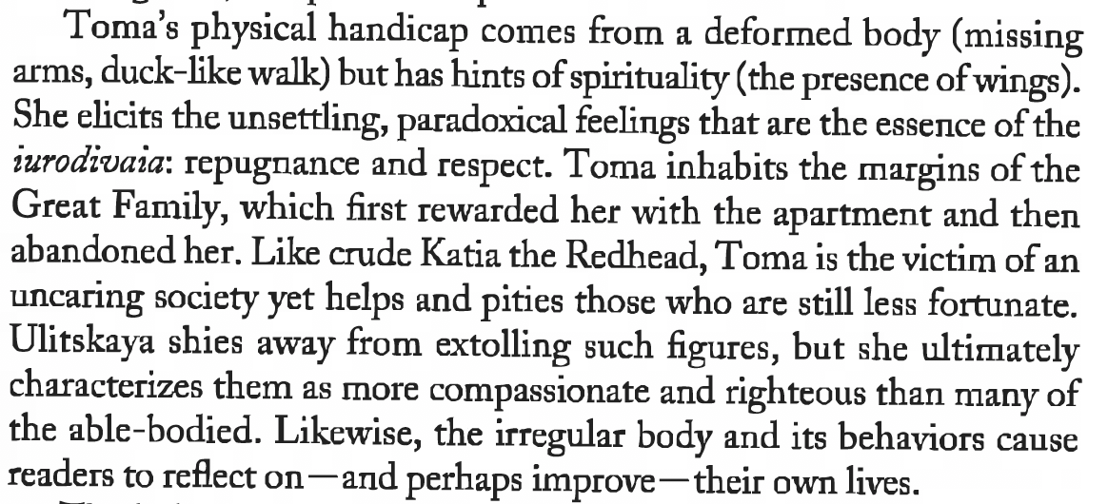

Sutcliffe, *Art of Tolerance*

**Task 3**

How do the following quotes from **(Sutcliffe, *LU and the Art of Tolerance*)** relate to **‘The Gift not Made by Human Hand’**

