

QMplus Development:   
Presenting recorded lectures (Q-Review) in a tab



**Service Name:** QMplus

**Department:** Academic Development / IT Services



**Author**

|  |  |
| --- | --- |
| **Document Owner(s)** | **Project/Organization Role** |
| Brett Lucas | QMplus |

**Distribution and Sign off List**

|  |  |
| --- | --- |
| **Name** | **Role** |
| Brett Lucas | Head of E-Learning Unit |
| Peter Watts | IT Academic Applications Manager |

**Version Control**

| **Version** | **Date** | **Author** | **Change Description** |
| --- | --- | --- | --- |
| 1 | 23 January 2018 | Brett Lucas | Initial Draft |
|  |  |  |  |
|  |  |  |  |

# Purpose

This document defines the requirements for streamlining the core module information provided within QMplus module areas to focus on providing that core information through the tabs that were introduced as part of the redesign in July 2017. This document is one of a series of three tab development requirements documents.

Specifically it covers requirements around:

1. Q-Review Recordings: The addition of the Student / or Tutor Dashboard view to a tab

# Background

In July 2017 QMUL implemented a brand new theme for QMplus. The theme was developed to update the 5 year old code, exploit the new functionality available through the CSS bootstrap 4 framework, and to meet evolving student and staff requirements.

Part of the theme development involved the updates to QMUL QMplus course formats, specifically: Collapsed topics format (QMUL), Topics format (QMUL) and the Grid format. This involved introducing the capability to add tabs to the interface, the purpose being to free up space at the top of QMplus module areas that has a tendency to become cluttered with links/files/resources. This new tab interface is accessible via the ‘settings’ for a course/module. The tab interface enables the user to change the name of the tab and to add content via the text editor.

The Q-Review lecture capture service is made available to students through an LTI integration with QMplus. The link to any Q-Reviewed lectures is usually situated at the top of topic zero as a link. (see figure 1 below)

At the beginning of each academic year clicking the Q-Review ‘LTI link’ generates one’s account on the system if one is a new user and it links them with their role with that module/courses recordings. This is done by both staff and students.

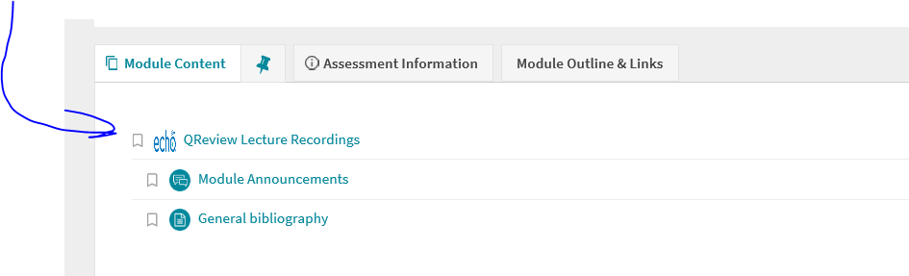

*Fig 1: The Status Quo - Q-Review lecture recordings made available in ‘topic zero’ of a QMplus Module area*

# Current Issues

* The current implementation of Q-Review does not pick up the Q-Review icon but rather an ‘echo’ icon that is slightly stretched…this conveys the impression that something is broken.
* The user is taken off into a separate dashboard view that completely obscures QMplus in the browser and thus can cause navigational confusion.
* The visibility of the lecture capture link can often be obscured particularly if there is a lot of other content in that area.
* The existence of links to key module content such as Q-Review lecture recordings within topic zero has the effect of pushing other learning materials e.g. section 1 further down the page.
* Some schools are already trying to develop their own approaches (see examples from Dentistry and SED below – fig 1 and 2) to improving the visibility of the recordings, this requirement is developing a standardised and consistent approach across the university.
* These approaches do not perform all the necessary functions that an LTI does however, such as linking their account to the appropriate Q-Review section or initial account creation in Echo360.

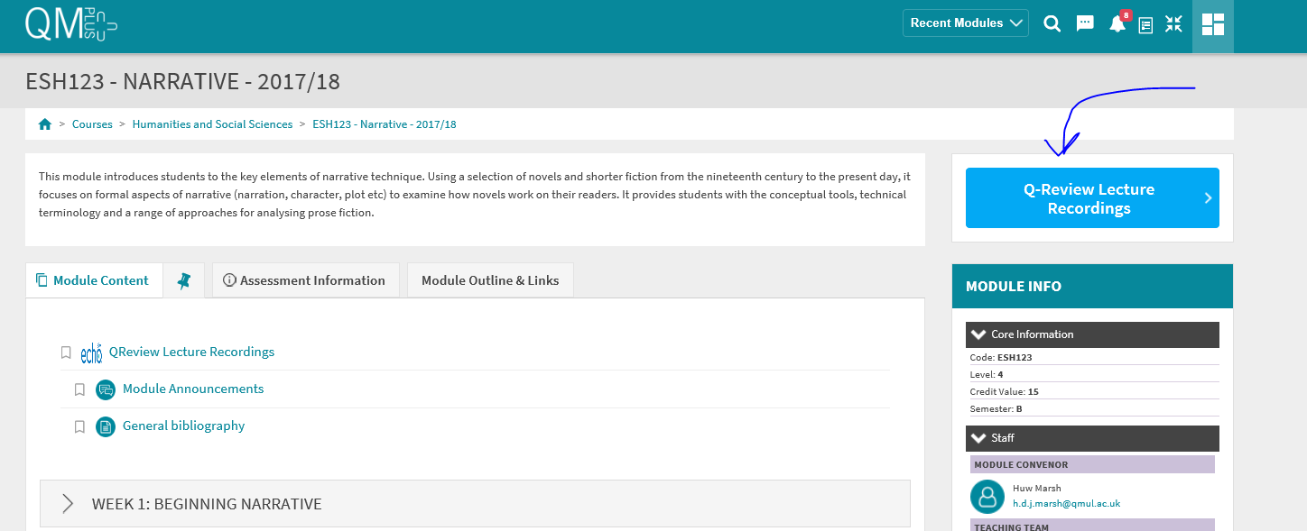

*Figure 1: Q-Review recordings made available through a block in SED*

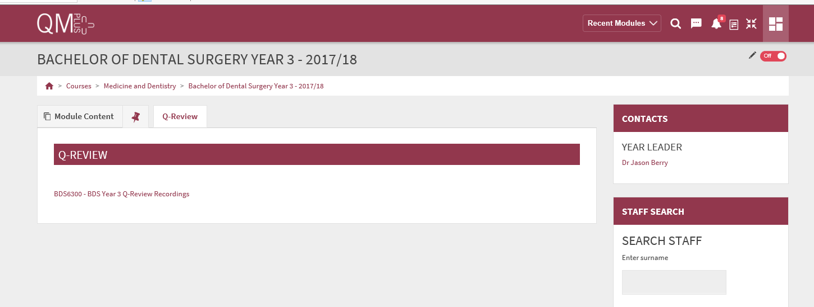

*Figure 2: Q-Review as a link within a tab in a Dentistry Programme area*

# Requirement

* The overarching requirement is to provide a seamless view of Q-Review recordings through a Q-Review tab in all course formats.
* A new Q-Review tab to be added to the course format settings.
* If a module has been Q-Review enabled then the tab would automatically appear.
* The tab heading should be ‘Q-Review’ and it should be preceded by a small ‘Q’ logo.
* When a student is logged in they should be able to access the Q-Review dashboard (figure 2 below) directly without further clicking of links and no further login should be required.
* The embedded content should show the echocentre view for the particular module they are in.

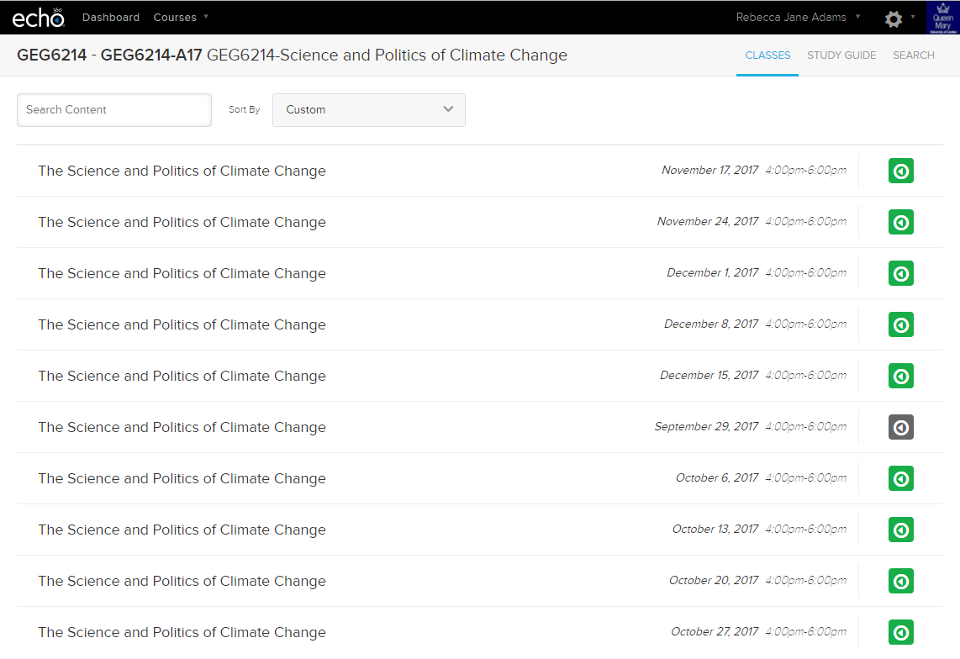

*Figure 2: Echo 360 Student dashboard*

* When administrators and teachers click on the tab they should have visibility of the tutor view.
* 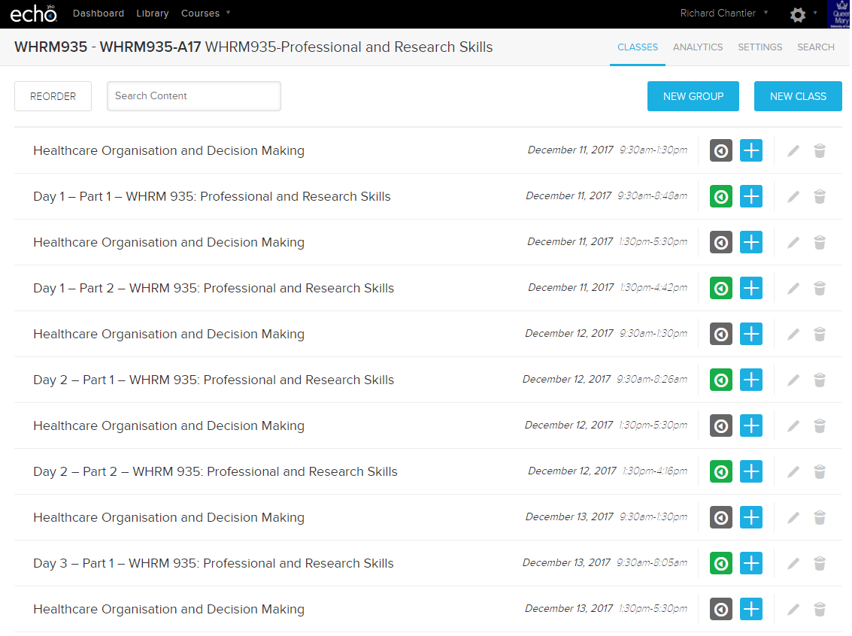

*Figure 3: Tutor view of Q-Review*