Handbook of non-drug interventions - HANDI
https://www.racgp.org.au/clinical-resources/clinical-guidelines/handi/about-handi/about-handi

HANDI is aimed at promoting effective non-drug treatments for General Practice/primary care.
Non-drug treatments, in the broadest sense, refer to any intervention that would not normally appear in a pharmacopoeia including exercise, physical therapies, diets, supplements and herbal treatments. HANDI is an online formulary of non-drug interventions in health care, which have solid evidence of their effectiveness.
Based on the idea of modern pharmacopoeias, each HANDI entry includes indications, contraindications and ‘dosing’. The aim is to make ‘prescribing’ a non-drug therapy almost as easy as writing a prescription for a drug.
HANDI enables clinicians to offer a greater choice of interventions to a patient, who may wish to avoid pharmacotherapy and the risks and life style changes often associated with drug treatment regimes.
Advances in non-drug treatments in the past few decades have been substantial and diverse: exercise for heart failure and COPD, the Epley manoeuvre for benign paroxysmal positional vertigo, knee taping for osteoarthritis, cognitive therapy for depression, ‘bibliotherapy’ (specific guided self-help books for some conditions), to name just a few. Nearly half the thousands of clinical trials conducted each year are for non-drug treatments. However, the effective non-drug methods are less well known, less well promoted, and less well used than their pharmaceutical cousins. There are well-established drugs/medications formularies such as the Australian Medicines Handbook. However, until now, no such formulary or resource for non-drug treatments (interventions) exists.
Links on https://www.racgp.org.au/clinical-resources/clinical-guidelines/handi/about-handi/about-handi See some examples on Table below – the website is extensive and excellent
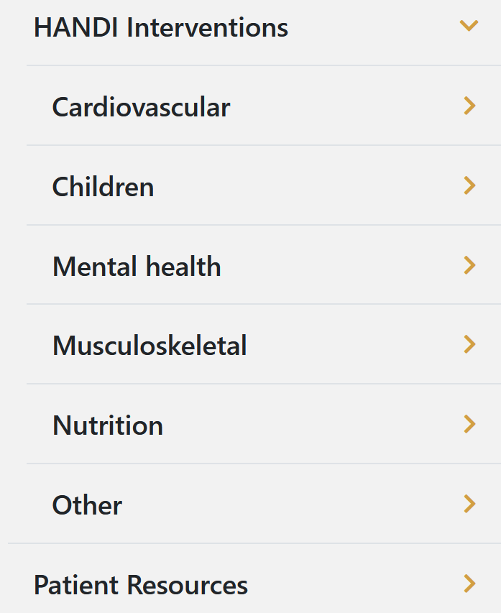 | 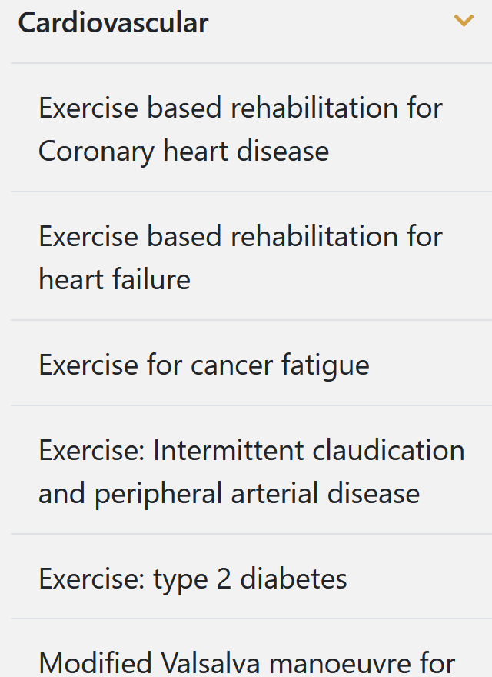 & Multiple conditions
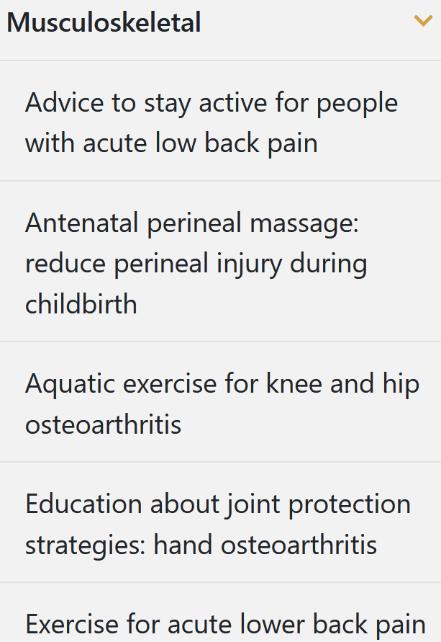 | 