[WW3 is just the beginning | Peter Zeihan | Global Macro 012](https://www.youtube.com/watch?v=nYZGlmX6HXY" \o "View original video: WW3 is just the beginning | feat. Peter Zeihan | Global Macro #12" \t "_blank)

Top Traders Unplugged 30/04/2022

**The End of the World Is Just the Beginning: Mapping the Collapse of Globalization**

**Peter Zeihan**

\_\_\_\_

**The End of the World is Just the Beginning (2022)**

**2019 was the last great year for the world economy.**

For generations, everything has been getting faster, better, and cheaper. Finally, we reached the point that almost anything you could ever want could be sent to your home within days - even hours - of when you decided you wanted it.

America made that happen, but now America has lost interest in keeping it going.

Globe-spanning supply chains are only possible with the protection of the U.S. Navy. The American dollar underpins internationalized energy and financial markets. Complex, innovative industries were created to satisfy American consumers. American security policy forced warring nations to lay down their arms. **Billions** of people have been fed and educated as the American-led trade system spread across the globe.

All of this was artificial. All this was temporary. All this is ending.

In **The End of the World is Just the Beginning,** author and geopolitical strategist Peter Zeihan maps out the **next** world: a world where countries or regions will have no choice but to make their own goods, grow their own food, secure their own energy, fight their own battles, and do it all with populations that are both shrinking and aging.

The list of countries that make it all work is smaller than you think. Which means everything about our interconnected world - from how we manufacture products, to how we grow food, to how we keep the lights on, to how we shuttle stuff about, to how we pay for it all - is about to change.

A world ending. A world beginning. Zeihan brings readers along for an illuminating (and a bit terrifying) ride packed with foresight, wit, and his trademark irreverence.

<https://www.goodreads.com/book/show/58782897-the-end-of-the-world-is-just-the-beginning>

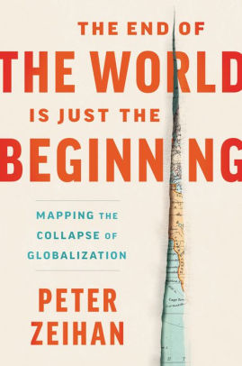

**TheGeoPolity**

The End of the World is Just the Beginning is the fourth instalment from geopolitical strategist, Peter Zeihan. The book lays out his thesis that the US sponsored Bretton Woods world order (“the Order” for short) is going to collapse. With the Cold War over and an energy independent America, the superpower is no longer supporting globalization. The bleakest prediction is around food: “…in excess of 1 billion people will starve to death, and another 2 billion will suffer chronic malnutrition”.[1] He breaks down his argument into six sections; transportation, finance, energy, industrial materials, manufacturing, and agriculture.

Zeihan’s approach lies in assessing how geography and demographics impact a nation’s political fortunes. With respect to geography, he argues that the US owes its economic wealth not just to its rich agricultural lands, but also the ability to transport food and other goods cheaply on the Mississippi River. In terms of demographics, he predicts that the “Chinese population in the year 2070 will be less than half of what it was in 2020”[2]. This imposes significant challenges on relying on cheap labour and any hope that the local Chinese population can be relied on for economic growth.

Other observations he makes range from the reigning in of risky investments due to the ageing baby boomers seeking safer investments to the challenges with green tech. With respect to the latter, he points out how the electrical grid will need heavy investment in energy storage capacity that depends on the environmentally unfriendly extraction of copper, chromium, lithium, cobalt, and other resources.

The book is also useful in appreciating the US-China rivalry. He sees the US as having the upper hand, with the ability to trade with Canada, Mexico, and others in the Western hemisphere – insulating the US from the troubles he sees on the horizon. With respect to China, he predicts the end of “Asia Inc.”. China’s low-cost labour advantage is withering away, as the cost of  labour has gone up by a factor of 15. He sees manufacturing transitioning from Asia to Mexico. He also highlights how exposed China is to the US, noting how the American ban of Huawei resulted in the company going from “the world’s largest cell phone manufacturer to not even being on the top-five list within China.”[3]

He also shares his analysis of Turkey, Iran, and Saudi Arabia. For example, he predicts Turkey will dominate the Mediterranean. However, he also points out that the country is exposed financially – with credit expanding a factor of 12 from 2000 to 2013.

His thesis is hard to reconcile with the US increasing its global footprint. With the US endorsing Sweden’s and Finland’s accession to NATO[4], the US State Department providing high-level assurances around shipping and insurance of Russian-Ukrainian wheat exports[5], or the 2022 US-Greece defence pact allowing US forces into the country[6], it can be hard to understand how the US is less involved in the world.

That being said, the book is valuable in breaking down geopolitics into tangible components that any lay person can appreciate. Moreover, it helps to see how fragile “the Order” actually is. Zeihan himself admits that the Achilles heel of Capitalism is growth. The pro-GDP consumer economy that is with us is no longer viable: “Demographics tells us that the number and collective volume of mass-consumption-driven economies has already peaked. In 2019 the Earth for the first time in history had more people aged sixty-five and over than five and under. By 2030 there will be twice as many retirees, in relative terms.”[7] Consequently, those who want to understand why the current world is unsustainable and ripe for a ‘New Order’, Zeihan is a must read – even if you disagree with his conclusions.

[1] Zeihan, Peter. The End of the World is Just the Beginning (p. 423). HarperCollins. Kindle Edition.

[2] Ibid pp. 103-104

[3] Ibid pp. 361

[4] Inside Biden’s successful six-month bid to expand NATO – CNNPolitics

[5] Russia, Ukraine Clear Way for Grain Exports to Resume Amid Fears of Global Food Crisis – WSJ

[6] Greek parliament approves defence pact change on eve of PM’s visit to U.S. | Reuters

[7] Zeihan, Peter. The End of the World is Just the Beginning (p. 73). HarperCollins. Kindle Edition.

<https://thegeopolity.com/2022/08/08/book-review-the-end-of-the-world-is-just-the-beginning/>

\_\_\_\_\_\_

**The End of the World is Just the Beginning (2022)**

**Kirkus Review**

Geopolitical strategist Zeihan argues that we are heading toward a period of deglobalization, with ensuing chaos and disaster.

The author believes that the period between 1980 and 2015 was an aberration in human history: an era of plenty, reliability, and relative stability. Going forward from 2022, he writes, everything is going to become more expensive and more difficult to obtain. He traces part of the problem to demographic struggles, as rapidly aging populations are leading to significant decreases in viable labor forces. Another issue is the withdrawal of American leadership on the global state, including the protection of the vital sea lanes that made globalization possible. The most recognizable element is climate change, undermining food production in key parts of the world. Zeihan predicts that nations will increasingly resort to aggressive tactics to ensure their own security, with the emergence of regional blocs dominated by the player with the biggest guns. Countries that depend on trade will find it tough going. The U.S. is in the best position due to its natural resources, agricultural capacity, industrial base, and inherent adaptability. However, notes the author, radical reform and increased costs are inevitable. Zeihan is enthusiastic in his writing, and he covers a great deal of territory, some of it in superficial or questionable fashion. Are countries really going to develop their own pirate fleets to seize supply ships? Will the U.S. establish a quasi-empire of the Americas, using food as a weapon of intimidation? Is China facing collapse within a decade? Predictions of world-ending resource depletion and geopolitical disaster have been made before—and often. The Club of Rome and Paul Ehrlich were saying it in the 1970s, and their fears turned out to be misplaced. Humans face significant obstacles, but that has been the case for centuries. The climate crisis, however, has never been more urgent. Zeihan captures that sense, at least, but his cynicism was more palatable in Disunited Nations.

The book has entertainment value, but some of the material should be taken with many grains of salt.

<https://www.kirkusreviews.com/book-reviews/peter-zeihan/the-end-of-the-world-is-just-the-beginning/>

\_\_\_\_\_\_\_

**Disunited Nations (2019)**

### The Scramble for Power In an Ungoverned World (2020)

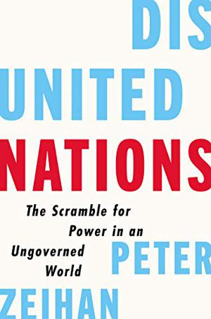

Geopolitical strategist Zeihan (The Absent Superpower: The Shale Revolution and a World Without America, 2017, etc.) delivers his latest unsettling prognostication.

The author begins after World War II, when the U.S. reigned supreme. Ramping up anti-communism efforts, the U.S. led an alliance of nations that were either like-minded or happy to go along in exchange for protection and aid. Protection took the form of a nuclear standoff, which produced a remarkably war-free era, and for the first time in history, the Navy freed sea lanes for unfettered worldwide trade. The result was an explosion of prosperity that continued until recently. In his earlier book, The Accidental Superpower (2014), Zeihan concluded that “2020 would look a lot like 1950, albeit without the whole fear-of-nuclear-war-thing.” He has changed his mind. No alliance lasts without a common threat, he admits, and this disappeared with the collapse of the Soviet Union. At the time, George H.W. Bush (the last president the author admired) launched a national conversation on what might come next. “So of course the Americans voted him out of office….Bill Clinton found foreign policy boring and did his best to avoid it,” writes Zeihan. No Bush successor has provided “the necessary guidance to American military, intelligence, and diplomatic staff as to what America’s goals actually are.” Consequently, nations are beginning to look after their own interests. As a result, writes the author, the U.S. will turn inward, and post-Brexit Britain will shrink to a U.S. client state. Russia’s demographic collapse is well under way. Zeihan’s more controversial projections will keep readers squirming, usually with pleasure, at his expert, often cynical insights. France, self-contained and with a far more “expeditionary-themed military,” will dominate a declining Germany. Absent U.S. love of its oil, Saudi Arabia (essentially a gangster state) will duke it out with Iran unless an expansive Turkey becomes the dominant local power. Hypertechnology will return Japan to preeminence in Asia when China’s unsustainable bubble economy collapses.

Another masterful, often counterintuitive, relentlessly entertaining geopolitical thrill ride.

<https://www.kirkusreviews.com/book-reviews/peter-zeihan/disunited-nations/>

\_\_\_\_\_\_

The Accidental Superpower (2014)

The Next Generation of American Pre-eminence And The Coming Global Disorder

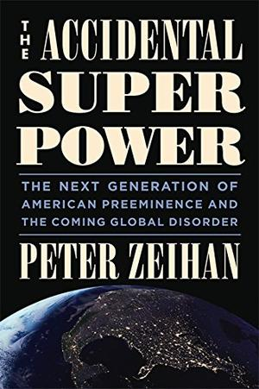

Geopolitics, the influence of geography on nations, made the United States great and will keep it there, writes the author of this ingenious, optimistic overview of America’s superpower status.

Zeihan, founder of Zeihan on Geopolitics, adds that America hit the jackpot, geopolitically speaking, inheriting “…the best lands in the world for a very low price in terms of blood, treasure, and time.” He downplays the claim that American power is declining, pointing out that in 1945, we produced one quarter of the world’s gross domestic product and spent as much on the military and controlled as much naval tonnage at the rest of the world combined. The change in 2014: zero. But some things are changing. Resources are diminishing, energy prices are rising, and demographics are inverting. Baby boomers are now retiring to collect benefits paid for by a shrinking number of younger, working taxpayers. The majority of industrialized nations face financial disaster, except America, which faces only inconvenience. Thanks to fracking, oil and gas production are skyrocketing, and America could be energy independent in five years. Thanks to immigration and vast numbers of child-friendly single-family houses, Americans remain younger than nearly every major culture. Within 30 years, Zeihan predicts, some nations (Greece, Libya, Yemen) will collapse, others (Brazil, India, Canada) will shrink, some (Britain, France, Sweden) will muddle through, and a few (Russia, Germany, Japan, Turkey) will become aggressive. Self-sufficient in food and energy, America will turn inward, reverting to the role it played before World War II: a global power without global interests.

Historical prognostication has a dismal record, but readers will find it difficult to put down this fascinating addition to the “rise and fall of nations” genre.

[https://www.kirkusreviews.com/book-reviews/peter-zeihan/the-accidental-superpower/#](https://www.kirkusreviews.com/book-reviews/peter-zeihan/the-accidental-superpower/)

\_\_\_\_\_\_\_

**Absent Superpower (2016)**

# The Shale Revolution and a World Without America

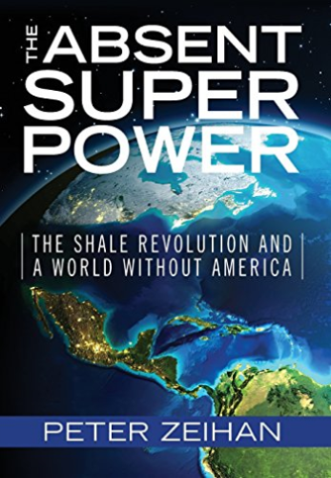

The world is changing in ways most of us find incomprehensible. Terrorism spills out of the Middle East into Europe. Russia, Iran, Saudi Arabia, China and Japan vie to see who can be most aggressive. Financial breakdown in Asia and Europe guts growth, challenging hard-won political stability.  
  
Yet for the Americans, these changes are fantastic. Alone among the world's powers, only the United States is geographically wealthy, demographically robust, and energy secure. That last piece -- American energy security -- is rapidly emerging as the most critical piece of the global picture.  
  
The American shale revolution does more than sever the largest of the remaining ties that bind America's fate to the wider world. It re-industrializes the United States, accelerates the global order's breakdown, and triggers a series of wide ranging military conflicts that will shape the next two decades. The common theme? Just as the global economy tips into chaos, just as global energy becomes dangerous, just as the world really needs the Americans to be engaged, the United States will be...absent.  
  
In 2014's The Accidental Superpower, geopolitical strategist Peter Zeihan made the case that geographic, demographic and energy trends were unravelling the global system. Zeihan takes the story a step further in The Absent Superpower, mapping out the threats and opportunities as the world descends into Disorder.