CRSS wk 4 Pelevin Handout

Extract 1
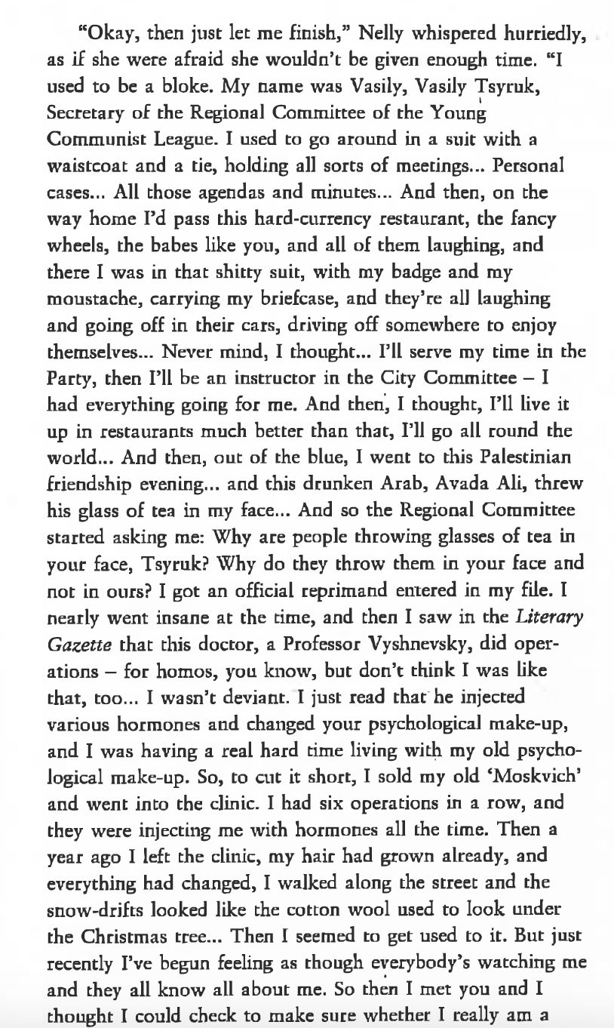

Task 1 (Read Extract)
- What motivated the sex change in the two former Young Communist officials?
- Compare and contrast them with the two sailors: in what ways are they similar/disimiliar? What is the effect of having two sets of transsexual characters?

Task 2 (Read Extract and interpretations, below)
- In the quoted passage, what points in particular indicate the instability of identity?
- To what extent can their motives be seen as indicative of the wider societal picture?
- Is gender a category in its own right here, or a metaphor for something else?
- In what sense does Pelevin depict the action in ‘Mid-game’ as taking place in the boundary between worlds?
- How can the story be seen as postmodernist? In what sense is it ludic/a text game?

Vitaly Chernetsky, Mapping Postcommunist Cultures Russia and Ukraine in the Context of Globalization
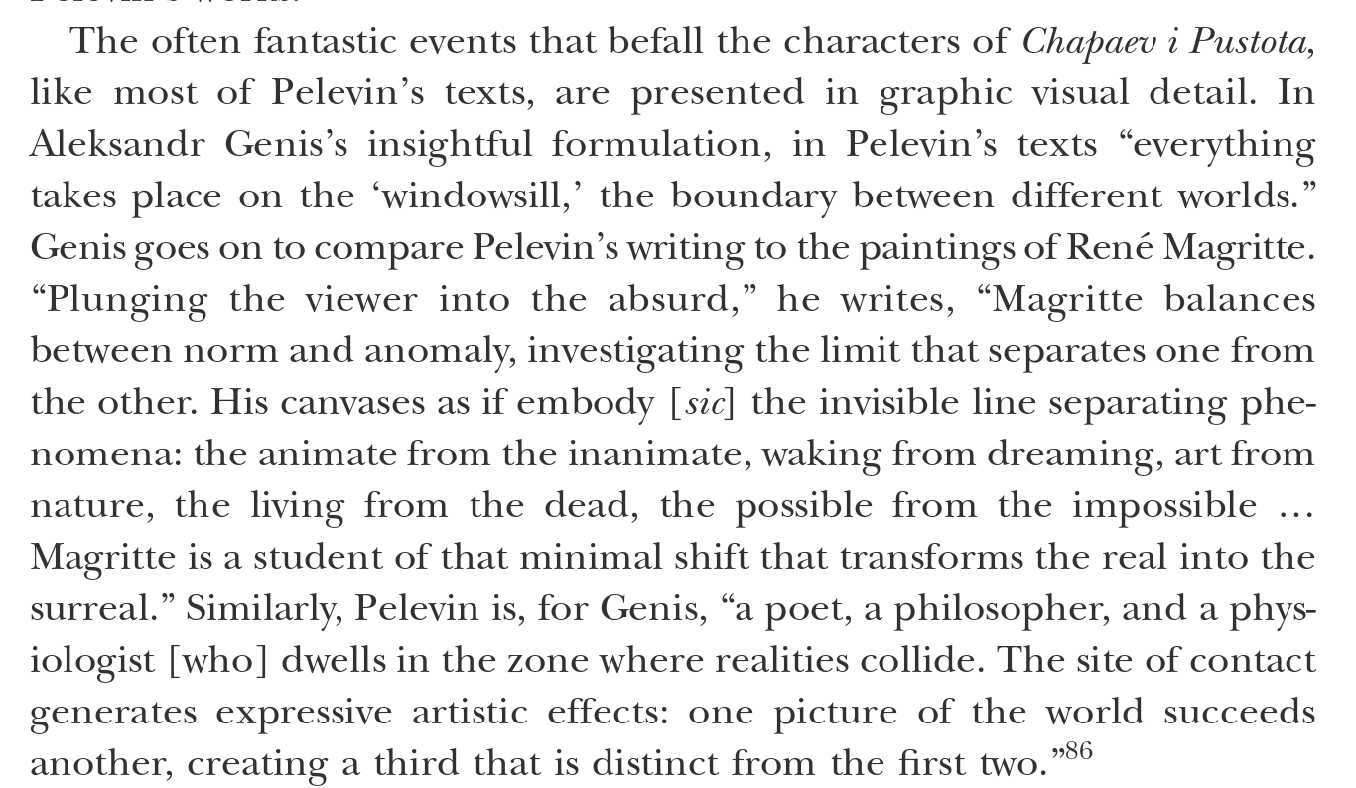
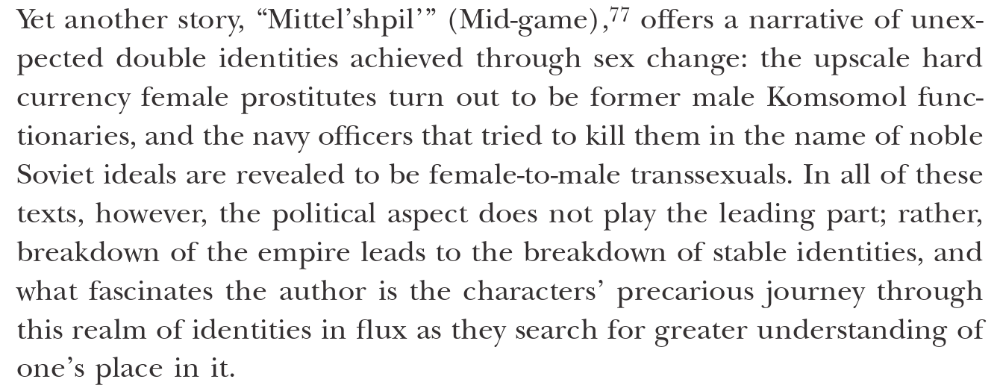
…
Dalton-Brown
