**Polianskaia, ‘Snow is Falling Ever So Quietly,’ (1994)**

**Полянская И. Н. Снег идет тихо-тихо. // Знамя. – 1994. – No 12. – С. 32-38.**

[Elena Cherniaeva (2003). ‘Literature Is a Message: Interview with Irina Polianskaia,’ *Russian Studies in Literature*, 39:4, 78-97.](https://www.tandfonline.com/doi/pdf/10.2753/RSL1061-1975390478?needAccess=true)

1. Explain how ‘Snow Falls Ever so Quietly’ relates to the following characteristics of Polianskaia’s prose mentioned below:

a) the lyric b) use of metaphor c) musical structure d) excessive detail e) close-ups of the representation of the human face

1. Polianskaia has been defined as part of Russia’s ‘new women’s prose’. In what ways can ‘Snow Falls Ever so Quietly’ be related to ‘women’s prose’?
2. What is the author suggesting about society?
3. How can the story be seen as relating to Russian society in the post-Soviet era?

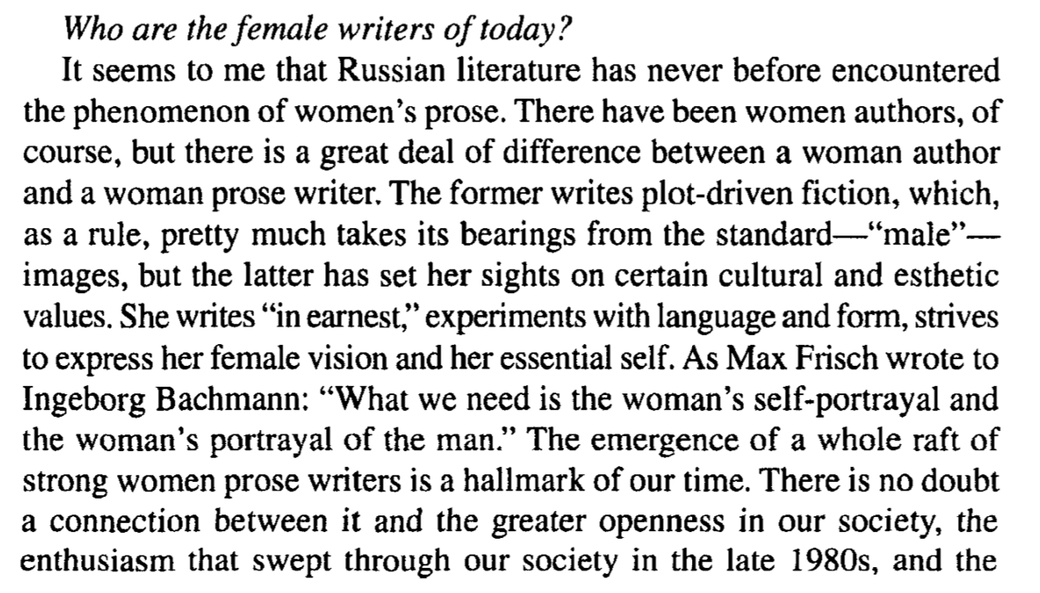

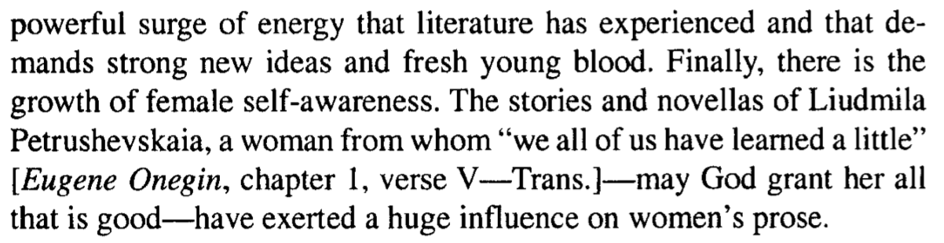

***What are, in your view, the basic distinguishing traits of women's prose?.*** ..***And what facets of the Russian soul is it apt to express?***

A woman brings to literature the natural maternal principle which is so organically inherent in her-a high degree of receptivity, of spiritual sensitivity; receptiveness to the sublime, the spiritual.

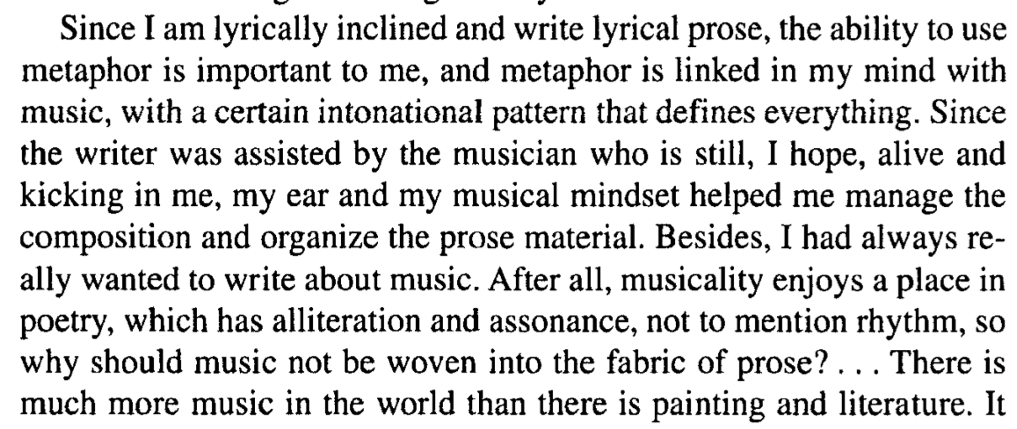

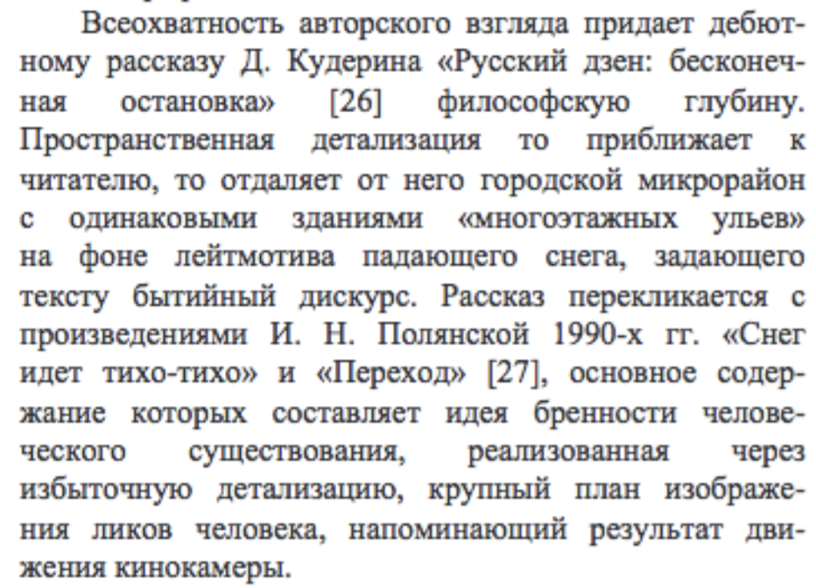

…the basic content of which [Polianskaia’s stories] is the impermanence of human existence, realised through excessive detail, close-ups of the representation of the human face recalling the movements of a film camera.

O. Sizykh, ‘[Poetika sovremennogo rossiiskogo rasskaza](https://www.docme.ru/doc/1654908/poe-tika-sovremennogo-rossijskogo-rasskaza..pdf).’