INTERNATIONAL CAPITAL MARKETS ASSOCIATION (ICMA)

It is generally accepted that the Eurobond market began with the Autostrade issue for the Italian motorway network in July 1963. This was for US$15m with a 15 year final maturity and an annual coupon of 5½%. S G Warburg was the lead manager of the issue with co-managers Banque de Bruxelles, Deutsche Bank, and Rotterdamsche Bank. The cross-border debt and bond capital markets continue to bring together borrowers and investors from all over the world to cover the funding needs of countries, supranational organisations, financial institutions and corporate bodies.

The principal trade association in the capital markets area is the International Capital Markets Association (ICMA). This was originally established as the Association of International Bond Dealers (AIBD) in 1968 which became the International Securities Market Association (ISMA) in 1992. The International Primary Markets Association (IPMA) had been set up in 1984 with the IPMA merging with the ISMA in 2005 to create the ICMA.

The ICMA has 620 members from 70 countries representing wholesale and retail debt securities markets. The ICMA operates as a not-for-profit association (*Verein*) under the Swiss Civil Code with its headquarters in Zurich and offices in London, Paris, Brussels and Hong Kong. The ICMA carries out work in three principal fixed income market areas with primary, secondary, repurchase (repo) and collateral markets with two cross-sectional areas of Sustainable Finance and Financial Technology (FinTech) and digitalisation.

<https://www.icmagroup.org/About-ICMA/>

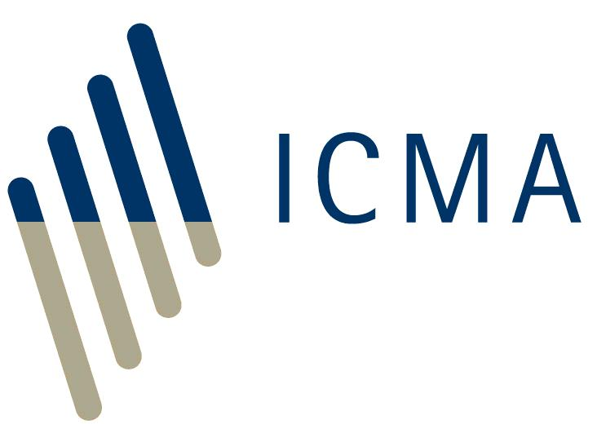 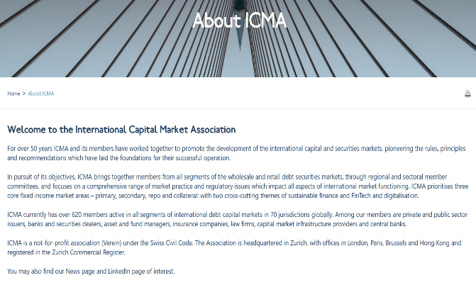

ICMA MISSION

The mission of ICMA is to promote resilient well-functioning international and globally coherent cross-border debt securities markets, which are essential to fund sustainable economic growth and development.   
  
In pursuit of its mission, ICMA is committed to:

1. building trust in the market by promoting internationally accepted standards of best practice through the development of appropriate, broadly accepted guidelines, rules, recommendations and standard documentation, aimed at maintaining and enhancing the framework of cross-border issuing, trading and investing in debt securities;
2. contributing to the development of sustainable finance through the capital markets;
3. encouraging information flows and dialogue between all participants in the international capital markets: borrowers, intermediaries and investors, and service providers, including trading platforms, clearing houses and law firms;
4. engaging with international and national regulators and policy makers and providing them with market expertise and technical knowledge across all ICMA’s core areas, to assist in ensuring that financial sregulation promotes the resilience, efficiency and cost effectiveness of international capital markets;
5. providing networking opportunities for market participants through conferences, seminars, roundtables and other events;
6. promoting high professional standards for capital market participants by providing training and education opportunities.

[HISTORY OF THE EUROBOND MARKET](https://www.icmagroup.org/About-ICMA/history/history-of-the-eurobond-market/)

|  |  |
| --- | --- |
| **1963** | First Fixed rate issue: Autostrade |
| **1969** | Launch of Association of International Bond Dealers (AIBD) |
| **1969** | Launch of Euromoney |
| **1969** | Euro-clear established (forerunner of Euroclear) |
| **1970** | Cedel established (forerunner of Clearstream) |
| **1970** | First Floating Rate Note: ENEL |
| **1979** | First bought deal: GMAC |
| **1981** | First swap: IBM/IBRD |
| **1989** | Fixed price reoffer introduced |
| **1989** | First global bond: World Bank |
| **1992** | Association of International Bond Dealers (AIBD) changes name to International Securities Market Association (ISMA) |
| **1994** | First CDS: Exxon/EBRD |
| **1999** | Pot deal introduced |
| **1999** | Euro introduced in 12 countries forming the Eurozone |
| **2005** | International Securities Market Association (ISMA) and International Primary Market Assocation (IPMA) merge to form International Capital Market Association (ICMA) |
| **2007** | Global credit crisis starts |
| **2008** | Lehman’s default |
| **2010** | European sovereign debt crisis starts |
| **2013** | 50th Anniversary of the Eurobond Market |

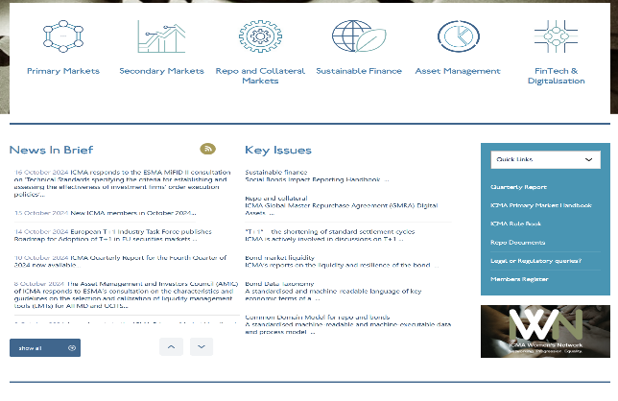 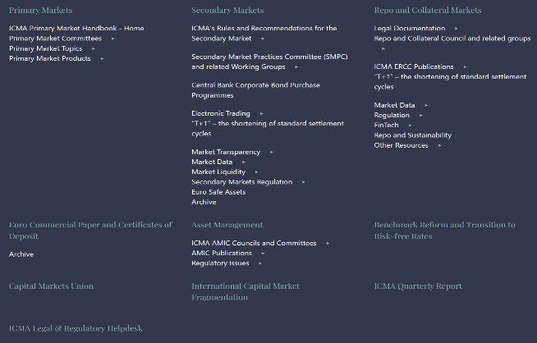

PRIMARY MARKET HANDBOOK

ICMA maintains a Primary Market Handbook although this is now only made available online in light of environmental considerations. This is based on the original ‘IPMA Handbook’ which commenced in 1985. The Handbook is continually reviewed and revised in response to market developments.  
  
The Handbook consists of ICMA Recommendations, guidance and standard language with draft documentation, relating to syndicated international bonds offers in the primary market, offer programmes and Euro-commercial paper transactions.

The Handbook is maintained by the ICMA Executive Committee which acts on the advice of the ICMA Primary Market Practices Committee and ICMA Legal & Documentation Committee.

PRIMARY MARKET HANDBOOK

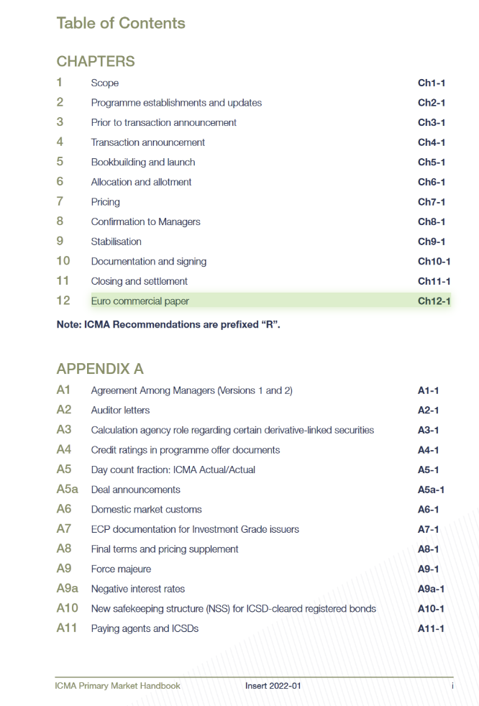 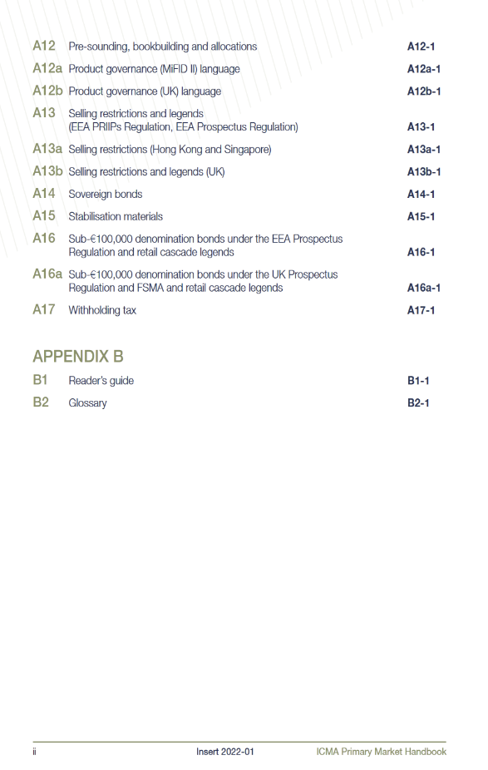

ICMA DOCUMENTATION

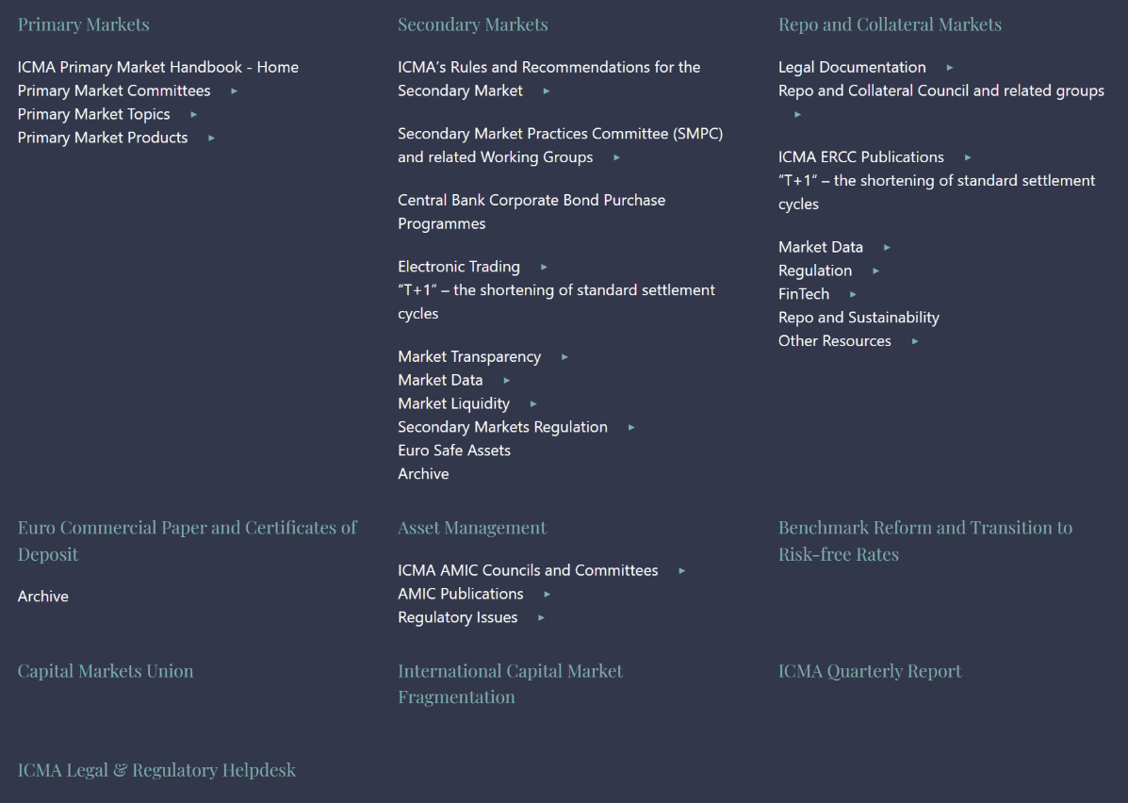

**REGIONAL** STRUCTURE

ICMA has a regional structure with each region having its own regional committee which deals with specific regional matters. The [committee of regional representatives (CRR)](https://www.icmagroup.org/About-ICMA/Governance/Committee-of-Regional-Representatives-CRR/) consists of the chairs of the regional committees and reports to the ICMA Board:

1. [**Africa**](https://www.icmagroup.org/About-ICMA/Governance/the-regions/africa/)
2. [**Asia Pacific**](https://www.icmagroup.org/About-ICMA/Governance/the-regions/asia-pacific-2/)
3. [**Austria, Eastern and South Eastern Europe**](https://www.icmagroup.org/About-ICMA/Governance/the-regions/austria-2/) ***with regional chapters in Greece, Turkey, Cyprus and the Balkan States***
4. [**Belgium**](https://www.icmagroup.org/About-ICMA/Governance/the-regions/belgium-2/)
5. [**France and Monaco**](https://www.icmagroup.org/About-ICMA/Governance/the-regions/france-2/)
6. [**Germany**](https://www.icmagroup.org/About-ICMA/Governance/the-regions/germany-2/)
7. [**Iberia**](https://www.icmagroup.org/About-ICMA/Governance/the-regions/iberia-2/)
8. [**Ireland**](https://www.icmagroup.org/About-ICMA/icma-regions/ireland/)
9. [**Italy**](https://www.icmagroup.org/About-ICMA/Governance/the-regions/italy-2/)
10. [**Luxembourg**](https://www.icmagroup.org/About-ICMA/Governance/the-regions/luxembourg-2/)
11. [**Middle East and North Africa**](https://www.icmagroup.org/About-ICMA/Governance/the-regions/middle-east-and-north-africa-2/)
12. [**Netherlands**](https://www.icmagroup.org/About-ICMA/Governance/the-regions/netherlands-2/)
13. [**Nordic**](https://www.icmagroup.org/About-ICMA/Governance/the-regions/nordic-2/)
14. **Russia and other CIS countries - Suspended**
15. [**Switzerland and Liechtenstein**](https://www.icmagroup.org/About-ICMA/Governance/the-regions/switzerland-2/)
16. [**United Kingdom and the Americas**](https://www.icmagroup.org/About-ICMA/Governance/the-regions/united-kingdom-and-americas-2/)

HISTORY ICMA

**1968**  
A meeting of the main firms active in the Eurobond market agrees to form the Association of International Bond Dealers (AIBD).  
  
**1969**  
The “Association of International Bond Dealers” (AIBD) is established as an association under Swiss law in February 1969 in Zurich  
  
**1970s**  
AIBD oversees the formation of a series of rules and recommendations governing trading and settlement in the international securities market; establishes a regional structure to reflect the geographic composition of the Association’s global membership; creates the AIBD Certificate and the Operations Certificate Programme (OCP).  
  
**1980s**  
In the UK AIBD is approved as an “International Securities Self-Regulating Organisation” (ISSRO) and recognised as a “Designated Investment Exchange” (DIE). AIBD Ltd., the Association’s wholly owned subsidiary, opens in London to provide data services to the market, and in 1989 AIBD launches TRAX, a transaction matching, confirmation and regulatory reporting system.  
  
**1990s**  
The AIBD Centre is established at the University of Reading in December 1990. The General Certificate Programme (GCP) replaces the AIBD certificate. The Global Master Repurchase Agreement (GMRA) is launched in 1992.  
  
**1992** **January** **1** AIBD changes its name to “International Securities Market Association” (ISMA). The Swiss Federal Banking Commission, the predecessor of the Swiss Financial Market Supervisory Authority FINMA, recognises ISMA as an “institution similar to an exchange” and subjects it in part to the Swiss Federal Act on Stock Exchanges and Securities Trading (SESTA) in 1998. In this capacity and to the extent of its subjection to SESTA, ISMA has been subject to supervision until December 31, 2016.  
  
**2000 to 2003**  
ISMA maintains its ISSRO status under the UK Financial Services and Markets Act 2000. The International Repo Council is formed under the Association’s auspices in 2000. ISMA launches Coredeal, a screen based order-driven exchange recognised by the FSA as an investment exchange in May 2000, and sold to MTS in November 2001. First international regulatory consultant employed in 2002.  
 **2005**  
Effective July 1, 2005 ISMA and the International Primary Market Association (IPMA) merge. As a result, the Association changes its name to “International Capital Market Association” (ICMA). The Market Practice and Regulatory Policy team is built up to provide services and expertise for members.  
  
**2006**  
ICMA adopts a new governance and management structure which clearly defines the board’s supervisory role on the one hand and the executive committee’s responsibility for the Association’s day-to-day management on the other.  
  
**2007**  
ICMA develops close working relationships with other associations, pursuing informal co-operation on regulatory policy work, co-operates with local trade associations worldwide and integrates activities of the Euro Debt Market Association (AMTE) which are now carried out by the SVT market committee within ICMA’s framework.  
  
ICMA extends membership to asset and fund managers as well as insurance companies and opens associate membership to professional advisers (such as law firms and accountants). A membership categorisation structure is introduced.  
ICMA Centre facilities are extended, accommodating an increase of 50% in physical capacity, and ICMA Executive Education is expanded with the launch of the Financial Markets Foundation Course (FMFC).  
  
**2008**  
ICMA invites investors and asset managers to join the newly created Asset Management and Investors Council (AMIC).  
  
**2009**  
ICMA sells its market services arm, Xtrakter, to Euroclear.  
ICMA opens its Paris office and takes over the business activities of the Association des Marchés Taux en Euro (AMTE).  
  
**2010**  
ICMA creates a chapter for Greece, Turkey and the Balkan States within the Austria, Eastern and South Eastern Europe region.  
**2013**  
ICMA opens its Asia Pacific office in Hong Kong to represent growing membership in the region.  
  
**2015**  
The International Repo Council (IRC) which operates under ICMA’s auspices changes its name to International Repo and Collateral Council (IRCC).  
ICMA creates a chapter for Ireland within the United Kingdom, Ireland and the Americas region.  
  
**2017**  
In January 2016 the Swiss Federal Financial Market Infrastructure Act (FMIA) enters into force which no longer provides for an “institution similar to an exchange” as one of the types of regulated institution. As a result, effective January 1, 2017 ICMA relinquishes this status and is no longer subject to supervision in Switzerland. At the same time, ICMA is one of FINMA’s national stakeholders with which FINMA maintains contact and liaises on regulatory and market matters.  
  
**2018**  
ICMA celebrates its 50th anniversary in London.

**2021**  
ICMA decides to break up the region for the United Kingdom, Ireland and the Americas into two distinct and separate regions, i.e. the region for Ireland and the region for the United Kingdom and the