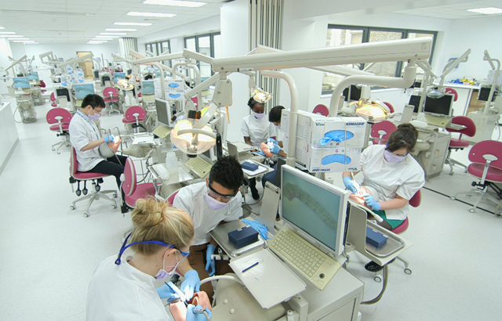

Undergraduate Dentistry Induction Handbook

Table of Contents

Student ID Cards 3
NHS ID Card 4
QMUL ID Card 4
CRS Card 4

Processes and Policies 5
Trust Network Log In 6
Attire for Clinics and Labs 7-8
Planned and unplanned absences 9
Support and Resources 10
Organisations offering support outside of QMUL 11

Contacts 12
UG Timetabling and Curriculum Support 13
Student Support Office 14
Library Services 15
UG Directors 15
BDS & BSc Leads 16& 17

Students and Locations 18
Locating the Dental Hospital 19
Navigating the Dental Hospital 20
International Students………………………………………………………………………………………………..21-24

Student ID Cards

Getting your NHS ID card
Your NHS ID card allows you to access certain parts of the Dental Hospital.

- First you must collect the prefilled application form, available from Office 5 on the 4th floor of the Dental Hospital.
- This should be completed and taken to the: Main reception of the Royal London Hospital (Stepney Way Entrance).
- Please take a form of photo identification with you upon collection.

Getting your QMUL ID card
Your QMUL ID card allows you to access the printers and the QMUL library.

- This card must be collected from the Student Enquiry Centre
- Please contact them for all queries regarding your QMUL card.

Getting your CRS card
Your CRS card allows you to use the PCs and access certain equipment on clinic.

- You will receive a link from Millennium training to complete your CRS training.
- Once complete, you must then collect two forms from Office 5 on the 4th floor of the Dental Hospital. These forms are titled:
- CIS – Position Assignment Modification
- CIS – Create New User (RA Use Only)
- Both forms must be completed and taken to the 10th Floor Reception Desk, (between Ward 10F and Ward 10E), Royal London Hospital.
Please see below their opening times:

Mondays and Wednesdays, from 8:30 – 11.30am
Tuesday - 8:30 – 11:30am
Thursday – 1:30pm – 16:00pm
Friday - 8:30 – 11:30am
- You MUST bring with you: one form of photo identification and two proof of address OR two forms of photo identification and one form of address.
- The staff on the 10th floor will then process your forms and create your card. They will provide instruction on when to collect.

Processes
and Policies

Trust Network Log In
Your Trust network log in will allow you to log into a Trust computer.

Here is a step by step process of getting your Trust network log in:
- Your log in would have already been requested for you ahead of you enrolling into QMUL.
- You should receive an email from bartshealth.dental.ed@nhs.net with your network log in details.
- If you do not receive this during your induction week, please let the Education Academy know by emailing them - bartshealth.dental.ed@nhs.net
Please log-in weekly otherwise your account will be deactivated.

Attire for Clinics and Labs
All clinical students must follow the dress code on clinics and in labs.

Planned and Unplanned Absences

Planned Absences:
When you are planning to take time off from University, please speak to your programme lead. Also complete the absence form below.
Unplanned Absences:
If you are taking an unplanned absence (e.g. if you are unwell), please complete the absence form below.
Online absence form:
This can be found on:
QMplus –
- https://qmplus.qmul.ac.uk/course/view.php?idnumber=Dentistry-Home
- In the student support area.
- Towards the right had side of the screen.
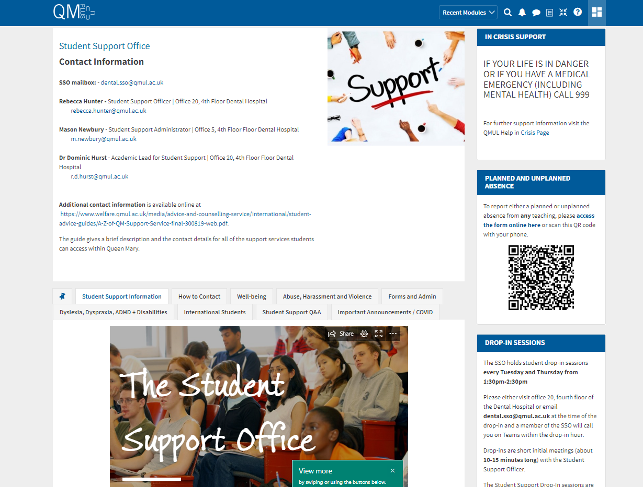
Support and Resources
Here you can find some of the support available to you within QMUL.
‘Student Support’ QMPlus area
Here you will find various types of support available in the Institute of Dentistry
https://qmplus.qmul.ac.uk/course/view.php?id=10748
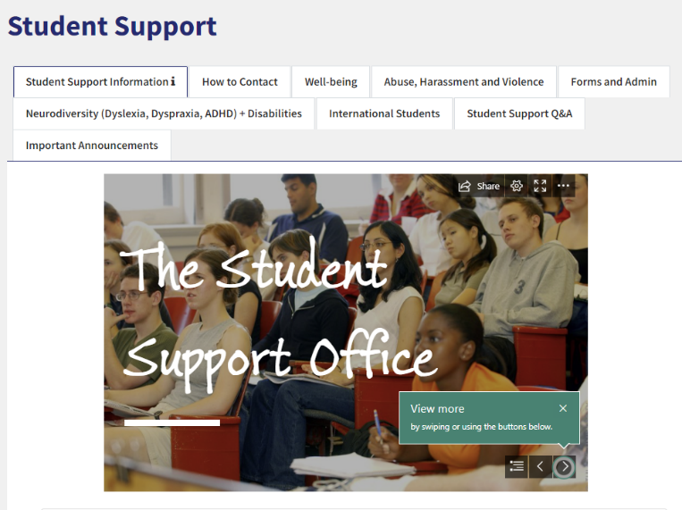
Advice and Counselling
Specialist and confidential advice and support for welfare, financial, emotional and psychological issues.
www.welfare.qmul.ac.uk

Disability and Dyslexia Service (DDS)
Confidential advice, guidance and support for students with diagnosed mental health conditions and those who have experienced a mental health crisis, disabled students and students with Autistic Spectrum Conditions (ASC)
www.dds.qmul.ac.uk

Report + Support
An online platform offering for all students to report to QMUL anonymously or with contact details) any incident of sexual violence, harassment or any hate crime. Information about local and national specialist support services is also available.
www.reportandsupport.qmul.ac.uk
Organisations offering support outside of QMUL

- The Havens
Specialist centres in London for people who have been raped or sexually assaulted
https://www.thehavens.org.uk/

- National Domestic Abuse Helpline
https://www.nationaldahelpline.org.uk/en

- Samaritans
www.samaritans.org

- CALM
The campaign against living miserably. 75% of all UK suicides are male. CALM exists to change this.
www.thecalmzone.net

- Papyrus
www.papyrus-uk.org

- Hub of Hope
UK’s leading mental health support database provided by national mental health charity, Chasing the Stigma.
https://hubofhope.co.uk/

- Maytree Respite Centre
A charity offering one-off four night residential sanctuary for people 18+ in a suicidal crisis, in a calm, safe house in north London.
www.maytree.org.uk

- PaNDAS
Postnatal depression awareness and support
https://pandasfoundation.org.uk/

- Sane
Meeting the challenge of mental illness
http://www.sane.org.uk/

Contacts

UG Timetabling and Curriculum Team
 | Jo Treadgold | Timetabling Coordinator  Office 5, Fourth Floor  Jo.treadgold@qmul.ac.uk
 | William Ng | Education Manager  Office 5, Fourth Floor  william.ng@qmul.ac.uk
Bridgette Murillo – Administrator BDS Years 1-5, Administrator to CCFS
b.e.murillo@se22.qmul.ac.uk or b.d.job@qmul.ac.uk
Office 5, Fourth Floor
Abide Soybir – PGT Timetabling Co-ordinator & Curriculum Support
a.soybir@qmul.ac.uk
Office 5, Fourth Floor
Danielle George- Earle – Programme Administrator
d.george-earle@qmul.ac.uk
Office 5, Fourth Floor
Lauren Collins – Programme Administrator
l.c.collins@qmul.ac.uk
Office 5, Fourth Floor
Antony Cuffe – PGT Timetabling Co-ordinator
a.cuffe@qmul.ac.uk
Office 5, Fourth Floor
Shared Mailbox
dentistry.ct@qmul.ac.uk

Student Support Office
 | Dr Dominic Hurst | Academic Lead for Student Support  Office 20, Fourth Floor  r.d.hurst@qmul.ac.uk
 | Rebecca (Becky) Hunter | Student Support Officer  Office 20, Fourth Floor  rebecca.hunter@qmul.ac.uk
 | Zehra Sonerman | Student Support Administrator  Office 5, Fourth Floor  z.sonerman@qmul.ac.uk
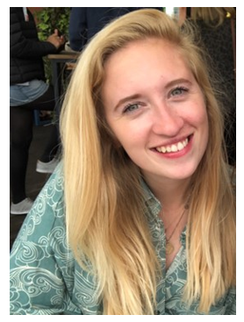 | Zara Mabey | Student Support Administrator  z.mabey@qmul.ac.uk  Office 5, Fourth Floor
Shared Mailbox
Dental.sso@qmul.ac.uk

Library Services
 | Paula Funnel | Faculty Liaison Librarian  p.a.funnell@qmul.ac.uk
 | Academic Skills  Team | Website:  https://www.qmul.ac.uk/library/academic-skills/  Email:  academicskills@qmul.ac.uk
Library Webpage
https://www.qmul.ac.uk/library/academic-skills/

UG Directors
 | (IoD)  Directors Of Undergraduate Dental Education | Sinclair Butcher | s.c.r.butcher@qmul.ac.uk
 |  | Dr Paul Ryan | p.l.ryan@qmul.ac.uk
 | (IoD)  Director of Taught Programmes | Dr John Buchanan | j.a.g.buchanan@qmul.ac.uk

BDS& BSc Year Leads
 | BDS 1 Year Lead | Dr Saroash Shahid | s.shahid@qmul.ac.uk
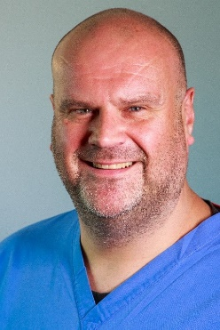 | BDS 2 Year Lead | Dr Mark Payne | m.a.payne@qmul.ac.uk
 | BDS 3 Year Lead | Amani Agha | amani.agha@qmul.ac.uk
 | BDS 4 Year Lead | Dr Sinclair Butcher | s.c.r.butcher@qmul.ac.uk
 | BDS 5 Year Lead | Dr Roy Woodhoo | r.woodhoo@qmul.ac.uk
 | BSc Programme Lead | Ioana Moraru | i.r.moraru@qmul.ac.uk
 | BSc Year 1 Lead | Sarah Murray | s.m.murray@qmul.ac.uk
 | BSc Year 2 Lead | Baldeesh Chana | b.k.chana@qmul.ac.uk
 | BSc Year 3 Lead | Jack De-Ste-Croix | j.de-ste-croix@qmul.ac.uk

Students and Locations

Locating the Dental Hospital

The address for the Dental Hospital is:

Turner Street,
Whitechapel,
London,
E1 2AD

- It is located within walking distance of Whitechapel, Shadwell and Aldgate East Underground stations.
- The main entrance on Turner Street gives you access to the main stairs and lifts.
- The dental hospital is open from 8:30AM to 5:30PM.
- There is a staff entrance on Stepney Way accessible with your NHS ID card.
- There is no staff parking available on site. Some pay and display parking is available on the surrounding streets but can get very busy.
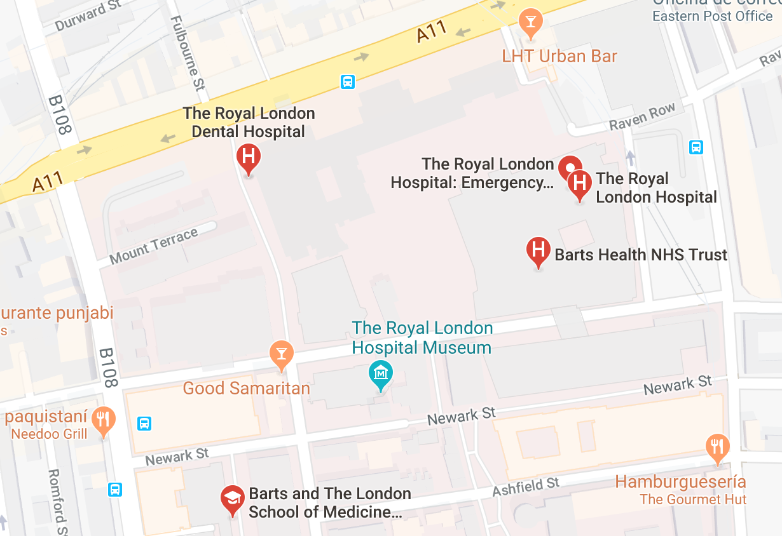

Navigating the Dental Hospital

Floor | What you’ll find
Basement | - Barts Health Education Academy  - Lecture theatres (Bearsted, John Ellis)
Ground Floor | - Restorative Dentistry  - Student bays  - Oral surgery  - Sedation clinic  - Nurse offices  - Stores  - Patient records (B9)
First Floor | - Restorative Dentistry  - Prosthodontics Lab  - Central Sterilising Department  - Oral Surgery  - Paediatric & Orthodontic Departments
Second Floor | - Oral Medicine  - Radiography  - Oral Surgery
Third Floor | - Clinical skills lab  - Pros Lab  - Changing Rooms
Fourth Floor | - Offices 1-10  - 4th floor seminar room  - Junior Staff Office (Office 1)  - Administrators; UG/PG Tutors; Consultants  - Student support office
Fifth Floor | - Dental Deans office  - Administration  - Seminar rooms  - Davenport room

International Students
Welcome to Queen Mary, University of London!
It is an honour to have you here.
Below I have attached some things that I believe are useful to helping you navigate the beginning of your journey at Queen Mary and some useful things that would be incredibly helpful to you during your time here.

Accessing Healthcare for students from outside the UK

Registering with your local GP
It is highly important if you are an international student that you register and sign up with your local GP (General Practitioner). For international students that are unaware, General Practitioner’s (GP’s) are able to help you with any healthcare related or medical issues that you might have, and it should be one of those things that you do when you first start at Queen Mary.
I’ve attached a link down below that highlights how you can access healthcare for students that come from outside of the UK.
Accessing Healthcare for students from outside the UK | Student Health | Queen Mary (qmul.ac.uk)
I’ve also attached a link down below that directs you specifically to Queen Mary’s student health services.
Student Health | Queen Mary (qmul.ac.uk)

Getting Around London
London is incredibly busy, with a significant variety of things to do and places to go to, so understandably it could be very overwhelming to get around.
Down below I’ve attached a map of the tube, so that you can have an insight into what the different trains and tube-lines consist of, and all the different journeys that you can make to get around London.
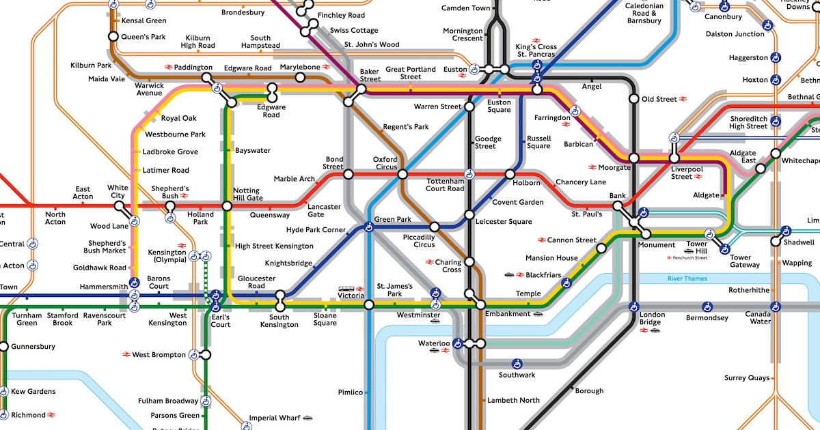

For trains to Whitechapel
There are numerous train lines and tubes that help you get into the Whitechapel campus.
The London overground, the London underground and the Elizabeth line all go to Whitechapel station, which is located incredibly close to the Whitechapel dental hospital.
Buses to Whitechapel
There are also many buses and bus routes that also can take you near the Whitechapel Royal London dental hospital such as the 25, the 205, the 254, the N25, N205 and N253 depending on where you are coming from.

General
Down below I’ve attached a link that is for all students, it is a link that directs you to a page that will help you with any enquiries that you might have.
Course: Student Support (qmul.ac.uk)
A home from home - Queen Mary University of London (qmul.ac.uk)
International students - Queen Mary University of London (qmul.ac.uk)

Student Support
The Student Support office is always here to help students.
I have attached a link below to the Queen Mary QM+ page, that has a student support page on all the support that the student support office has to offer to all students, as well as what the student support office does.
Course: Student Support (qmul.ac.uk)
The QM+ student support page highlights all the different ways the Student Support office is there to help. The student support page for QM+ also has sections that are more specific to any enquiries that you might have, for example if you were enquiring about welfare, forms, admin, intercalating and much more.
Course: Student Support (qmul.ac.uk)

Welfare, Immigration and Visas
For any welfare, finance or funding or immigration and visa issues please do contact welfare@qmul.ac.uk , as they will help solve all your visa, immigration and welfare issues, as well as being able to help you with any advice and counselling that you may require.
There is also a Queen Mary welfare page that I’ve attached down below, which will give you an insight into the different support services available from the welfare team.
Advice and Counselling Service - Advice and Counselling Service (qmul.ac.uk)
There is also a web-form that students may use to contact the welfare team, I have attached the link down below.
Contact us - Advice and Counselling Service (qmul.ac.uk)

Student Union
The Student Union is a student-led organisation that is here to represent and support you during your time here and to make sure your experience at Queen Mary is the best it can be.
I’ve attached a link down below that highlights what the Student Union is and what sources they have available.
Students' Union - Queen Mary University of London (qmul.ac.uk)

Conclusion
To conclude, it may feel very overwhelming starting university or going through any kind of new transition in your life, but here at Queen Mary we want to ease you into that transition as smoothy as possible and we want to help you as much as we possibly can.
Through creating induction handbooks, highlighting the different student support spaces available and through illustrating that we are here to support you, I hope that you feel less alone, and I hope that you that you feel much more welcomed into the new space that you are joining.

