Original Text
Renewable energy is useful energy that is collected from renewable resources, which are naturally replenished on a human timescale, including carbon neutral sources like sunlight, wind, rain, tides, waves, and geothermal heat. This type of energy source stands in contrast to fossil fuels, which are being used far more quickly than they are being replenished. Although most renewable energy is sustainable energy, some is not, for example some biomass is unsustainable. Renewable energy often provides energy in four important areas: electricity generation, air and water heating/cooling, transportation, and rural (off-grid) energy services.

Text with “!” in spaces
Renewable! energy!is!useful!energy!that!is!collected!from!renewable!resources, !which!are!naturally!replenished!on!a!human!timescale, !including!carbon!neutral!sources!like!sunlight, !wind, !rain, !tides, !waves, !and!geothermal!heat. !This!type!of!energy!source!stands!in!contrast!to!fossil!fuels, !which!are!being!used!far!more!quickly!than!they!are!being!replenished. !Although!most!renewable!energy!is!sustainable!energy, !some!is!not, !for!example!some!biomass!is!unsustainable. !Renewable!energy!often!provides!energy!in!four!important!areas: !electricity!generation, !air!and!water!heating/cooling, !transportation, !and!rural! (off-grid) !energy!services.

Text with white font colour letters in spaces
Renewableaenergybiscusefuldenergyethatfisgcollectedhfromirenewablejresources,Kwhich!arelnaturallymreplenishednonoaphumanqtimescale,rincludingscarbontneutralusourcesvlikewsunlight,xwind,yrain,ztides,awaves,bandcgeothermaldheat.eThisftypegofhenergyisourcejstandskinlcontrastmtonfossilofuels,Pwhichqarerbeingsusedtfarumorevquicklywthanxtheyyarezbeingareplenished.bAlthoughcmostdrenewablefenergygishsustainableienergy,JsomeKisLnot,MfornexampleOsomepbiomassqisrunsustainable.SRenewabletenergyuoftenvprovideswenergyxinyfourzimportantaareas:belectricitycgeneration,daireandfwatergheating/cooling,htransportation,iand!ruralj(off-grid)henergy!services.

An image of a text
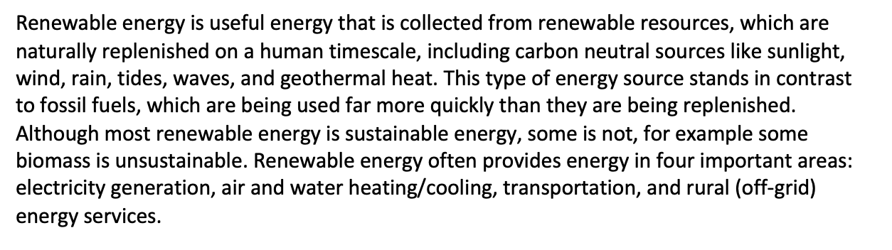

Renewable!energy!is!useful!energy!that!is!collected!from!renewable!resources, !which!are!naturally!replenished!on!a!human!timescale, !including!carbon!neutral!sources!like!sunlight, !wind, !rain, !tides, !waves, !and!geothermal!heat. !This!type!of!energy!source!stands!in!contrast!to!fossil!fuels, !which!are!being!used!far!more!quickly!than!they!are!being!replenished. !Although!most!renewable!energy!is!sustainable!energy, !some!is!not, !for!example!some!biomass!is!unsustainable. !Renewable!energy!often!provides!energy!in!four!important!areas: !electricity!generation, !air!and!water!heating/cooling, !transportation, !and!rural! (off-grid) !energy!services.

Renewableaenergybiscusefuldenergyethatfisgcollectedhfromirenewablejresources,Kwhich!arelnaturallymreplenishednonoaphumanqtimescale,rincludingscarbontneutralusourcesvlikewsunlight,xwind,yrain,ztides,awaves,bandcgeothermaldheat.eThisftypegofhenergyisourcejstandskinlcontrastmtonfossilofuels,Pwhichqarerbeingsusedtfarumorevquicklywthanxtheyyarezbeingareplenished.bAlthoughcmostdrenewablefenergygishsustainableienergy,JsomeKisLnot,MfornexampleOsomepbiomassqisrunsustainable.SRenewabletenergyuoftenvprovideswenergyxinyfourzimportantaareas:belectricitycgeneration,daireandfwatergheating/cooling,htransportation,iand!ruralj(off-grid)henergy!services.

