**Contemporary Russian Short Stories, Week 3 Handout**

**Petrushevskaia**

Compare narrative voice in the two stories (with some concrete examples from the two extracts):

1. Whose thoughts does it have access to and concentrate on?
2. How does that influence our understanding of the events?
3. Compare the emotional tone of the two stories
4. How do the two stories negotiate the relations between generations?
5. Compare the endings: how do they relate to the future?
6. What are the similarities and differences between the two situations?

**Hygiene**

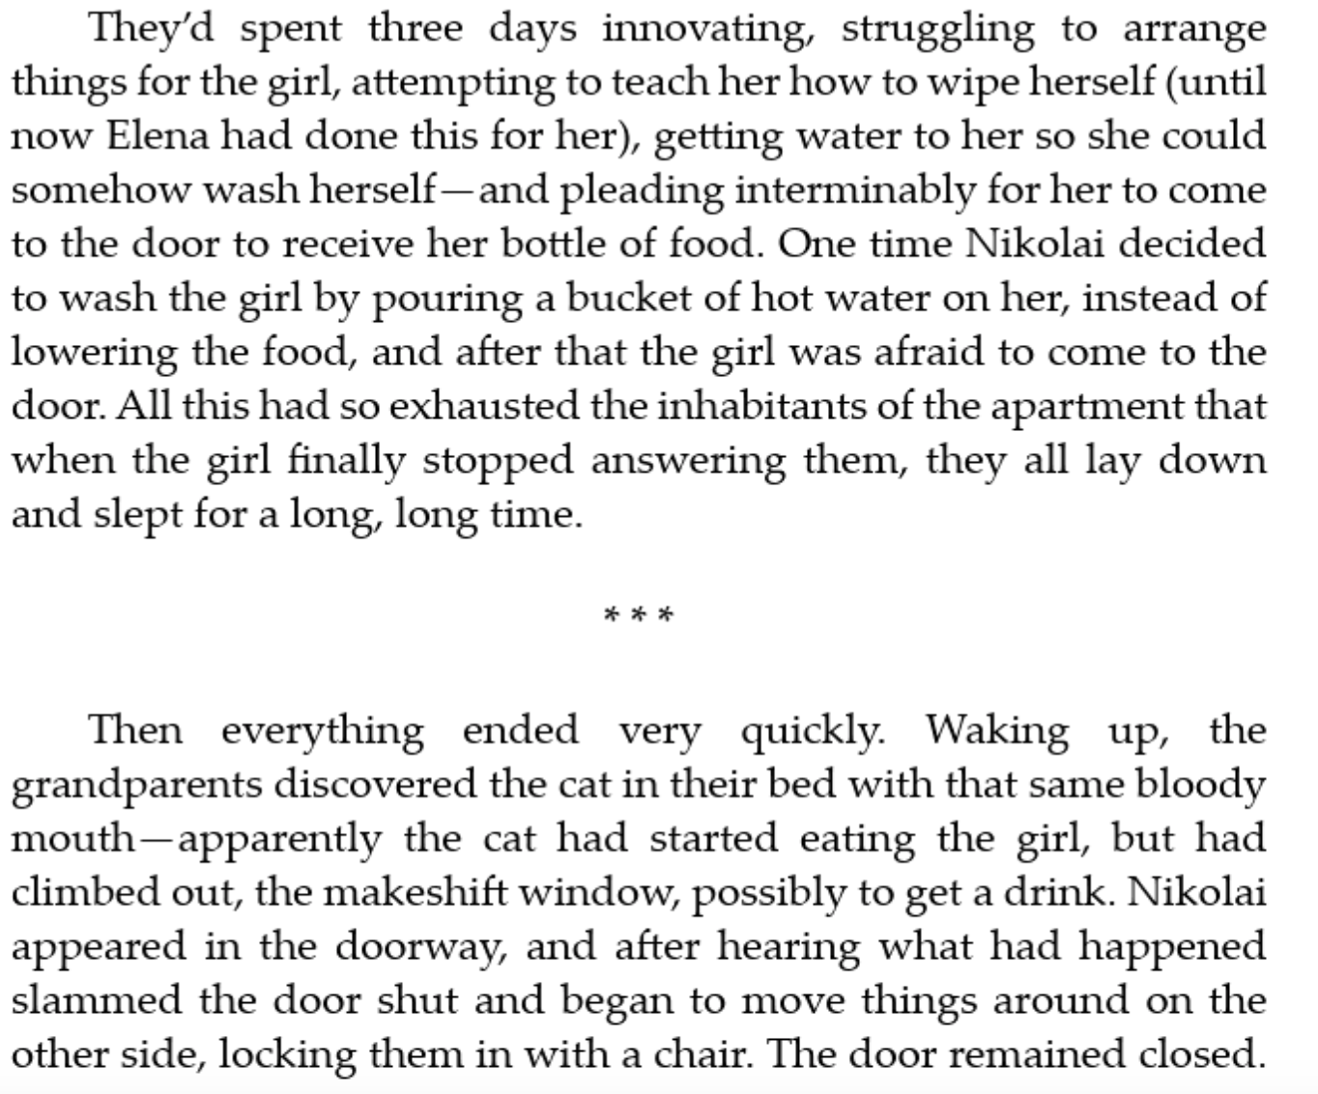

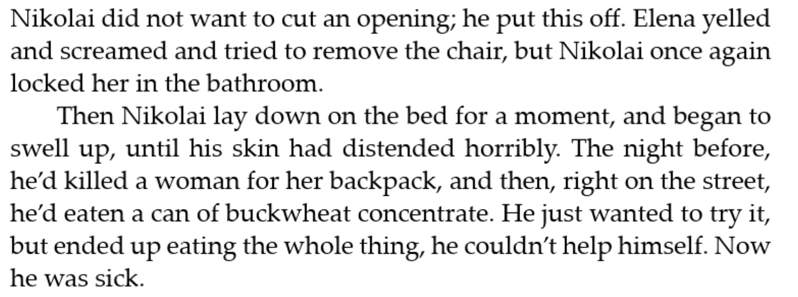

**The New Robinsons**

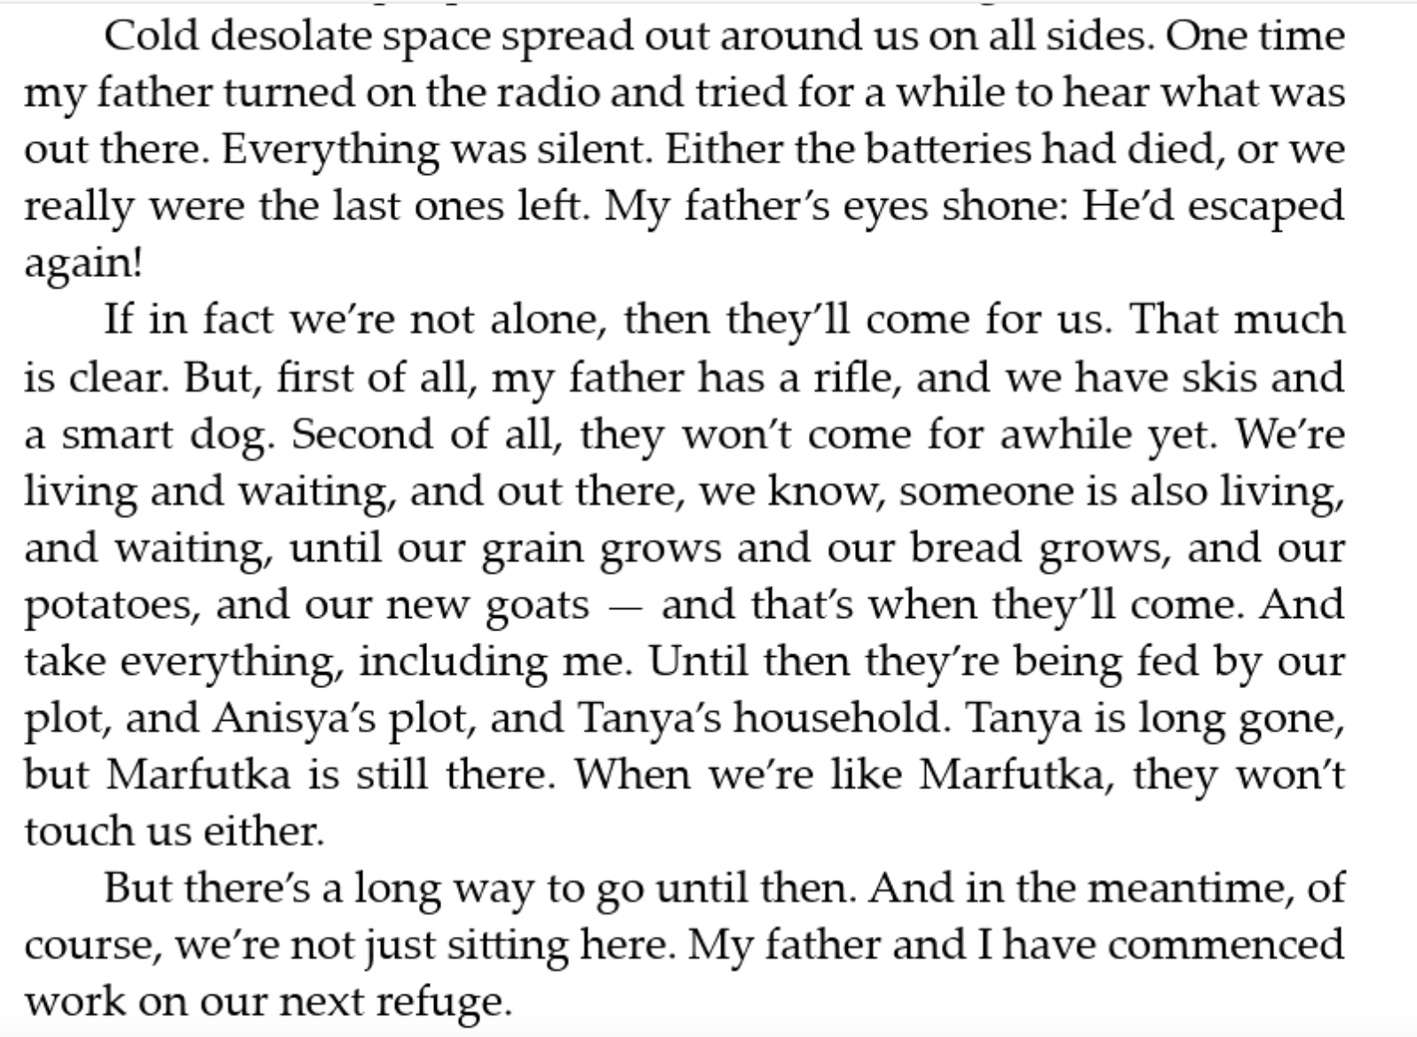

**Narrative voice in New Robinsons**

Cowes

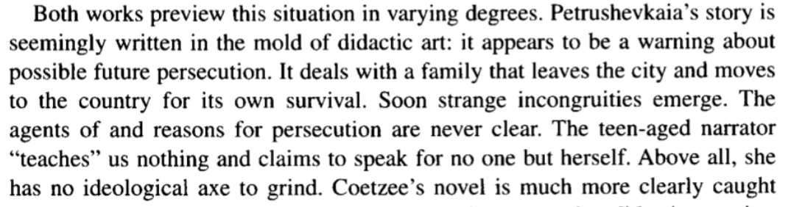

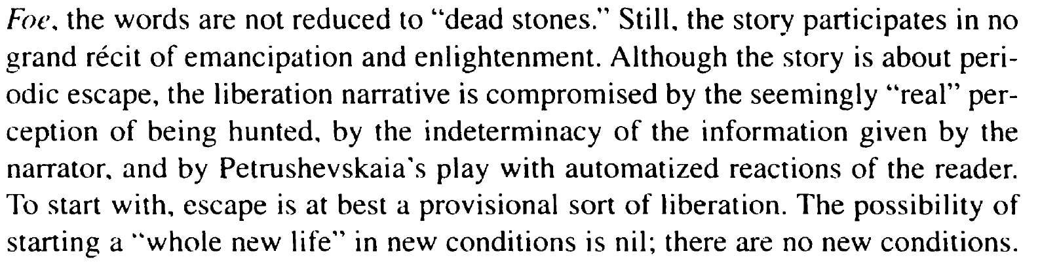

**Narrative voice in ‘Hygiene’**

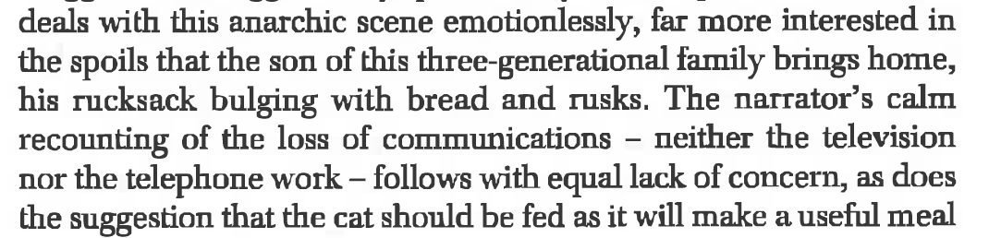

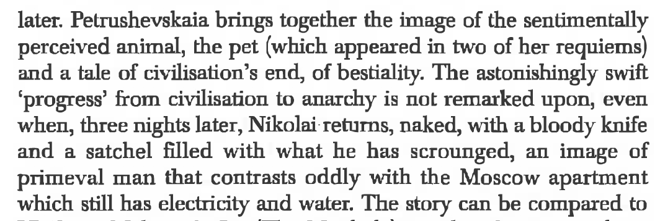

(Dalton-Brown)

**Gender**

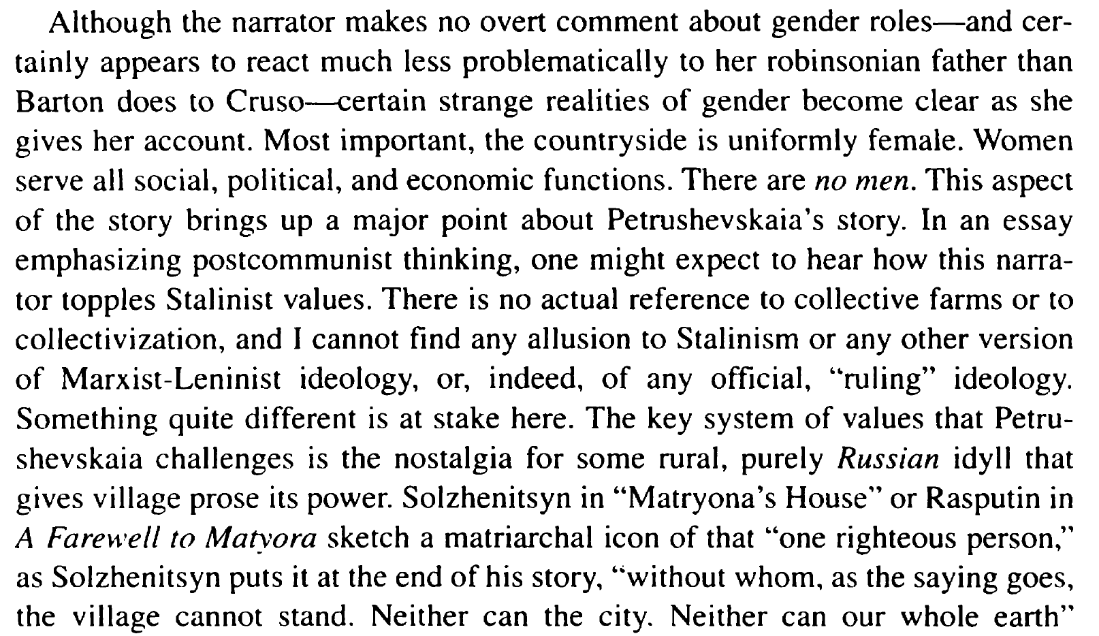

(Cowes)

* (Actually there are references to Collective Farms, also to Gulag)