Name:
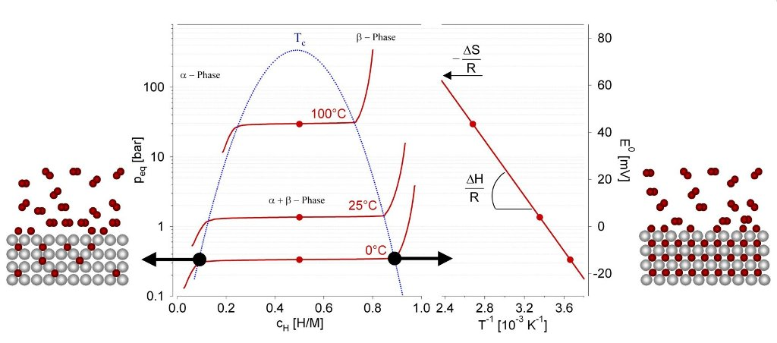
Figure from https://hydropole.ch/en/hydrogen/storage/

