**Student Support Office Contacts**

You can contact the Student Support office via email and arrange a meeting with a member of the team. We can offer support and/or signpost you to a range of more specialised services.  
  
  
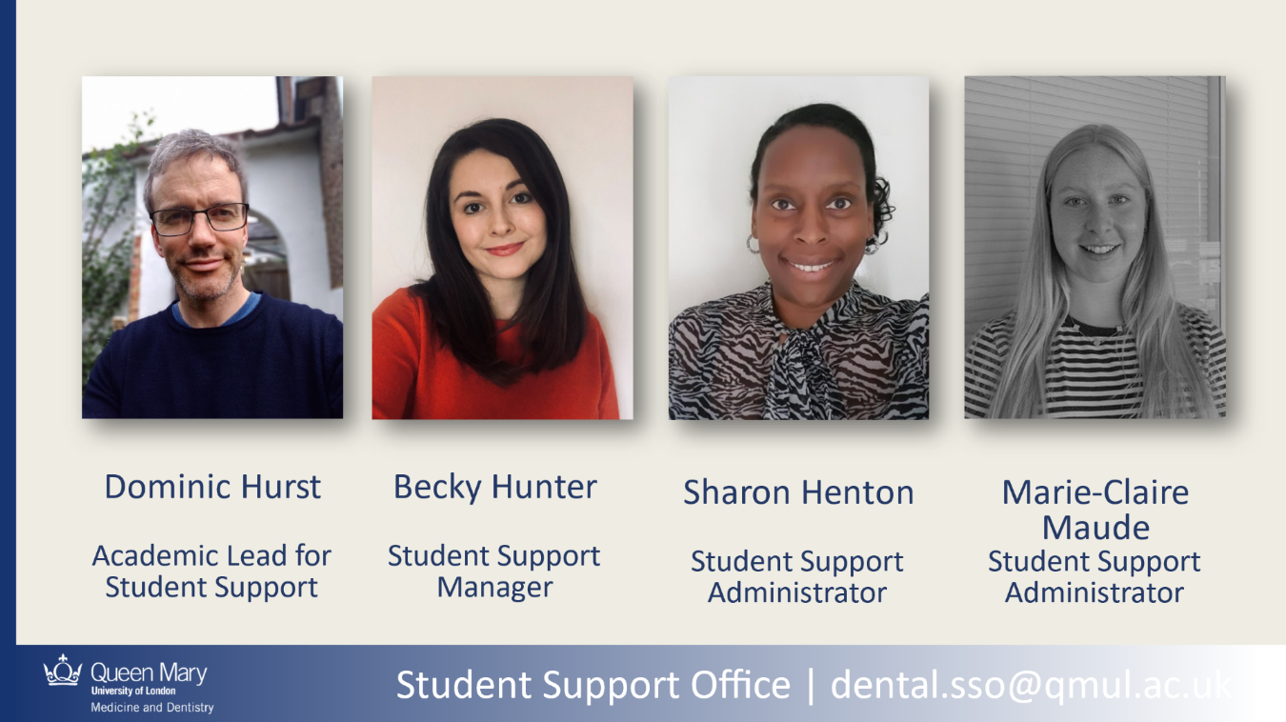

# **Office 20, 4th Floor, Dental Hospital**

# **Academic Lead for Student Support – Dr Dominic Hurst**

E-mail: [r.d.hurst@qmul.ac.uk](mailto:r.d.hurst@qmul.ac.uk)

# **Student Support Officer – Becky Hunter**

E-mail: [rebecca.hunter@qmul.ac.uk](mailto:rebecca.hunter@qmul.ac.uk)**Office 5, 4th Floor, Dental Hospital**  
  
**Student Support Administrators – Sharon Henton & Marie-Claire Maude**  
E-mail: [dental.sso@qmul.ac.uk](mailto:dental.sso@qmul.ac.uk)