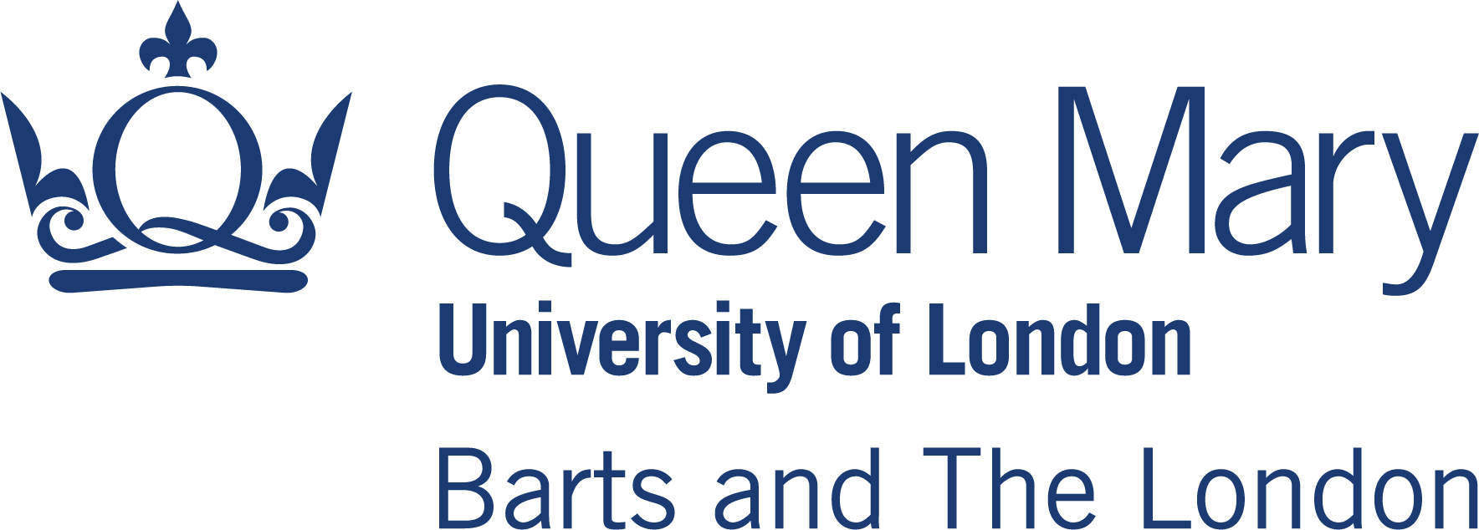

COVID19 - Clinical Students Contact & Self-isolation Advice

The following health and safety protocols for COVID19 are adapted from the national government guidance (accessed: 28th September) found here: (https://www.gov.uk/government/publications/covid-19-management-of-exposed-healthcare-workers-and-patients-in-hospital-settings/covid-19-management-of-exposed-healthcare-workers-and-patients-in-hospital-settings)

Please note that any changes to the government guidance will be reflected in the COVID19 policy for the medical school.

What do I do if I develop COVID19 symptoms?
Please refer to the online guidance: https://www.qmul.ac.uk/coronavirus/what-to-do-if-someone-presents-with-symptoms/
Should you develop any of the following three Covid-19 symptoms, you must immediately self-isolate and book a Covid-19 test by calling 119 or visiting nhs.uk/coronavirus
- a high temperature
- a new, continuous cough
- a loss or change to your sense of smell or taste.
If a student develops Covid-19 symptoms they must alert Student Life via studenthealth@qmul.ac.uk.
- Complete the self-certified absence form on QMPlus, either here or here (for year 5).

Students in Queen Mary residences will need to request a postal test kit if they are unable to walk to a testing centre. These students will be given instructions on how to arrange delivery.

Students must email again to confirm their test result.

What should I do if I have COVID19 symptoms and a positive SARS CoV-2 test result?
- You must self-isolate and stay at home for at least 10 days starting from the day you first developed symptoms.
- You must contact Student Life (studenthealth@qmul.ac.uk) and inform the relevant year administrator in the Student Office.
- **You could be fined by the government if you do not self-isolate following a positive test result, as it is a criminal offence and as such could be referred to the GMC for investigation.
- Complete the self-certified absence form on QMPlus, either here or here (for year 5).
- All members of your household must self-isolate for 14 days from when your symptoms first started or from when you first had your test, whichever is earliest.

When can I return to placement?
- If your symptoms have improved and you have not had a fever in the past 48 hours, you can return once the 10 day isolation period has ended.

What if I still have symptoms after 10 days of self-isolation?
- Inform your clinical supervisor and relevant year administrator. Remain in isolation until you have had no fever for at least 48 hours.
- If a cough or a loss of or a change in normal sense of smell (anosmia) or taste is the only persistent symptom after 10 days (and you have been afebrile for 48 hours without medication), you can return to placement if you are otherwise fit (these symptoms are known to persist for several weeks in some cases).

What should I do if I have COVID19 symptoms and a NEGATIVE SARS CoV-2 test result?
- As long as no-one else in your household has symptoms, you can return to work when you feel well enough to do so, following discussion with your clinical supervisor, who may recommend a local risk assessment.

What should I do if I have no COVID19 symptoms and a POSITIVE SARS CoV-2 test result?
- You must self-isolate for a minimum of 10 days from the date of the test. If you remain well during this period, you can return to placement on day 11. If, however, you develop symptoms during this period, you must self-isolate for 10 days from the day of symptom onset.
- Complete the self-certified absence form on QMPlus, either here or here (for year 5).
- If someone in your household has symptoms, you can only return to placement if said household member has a negative test result. Otherwise you must isolate for 14 days, beginning on the day your household member first developed symptoms.
- Any members of your household can stop isolating and return to placement if they do not have symptoms themselves.

What should I do if I have no COVID19 symptoms and a NEGATIVE SARS CoV-2 test result?
- If you are asymptomatic at the time of testing, then you can remain/return to placement (providing you are still asymptomatic).
- However, if you are tested as part of a contact-tracing investigation, please follow the guidance they provide on next steps and return to work.

I have been notified by NHS Test and Trace or QMUL Student Life that I am a contact of a confirmed case in the community (this includes student accommodation or campus facilities). Can I still continue on placement?
- You must inform the relevant year administrator and your placement supervisor and self-isolate for 14 days in line with the NHS Test and Trace guidance (https://www.gov.uk/guidance/nhs-test-and-trace-how-it-works). This guidance must be followed irrespective of the results of a COVID19 virus or antibody test result.
- Complete the self-certified absence form on QMPlus, either here or here (for year 5).

I have been informed by the NHS trust/GP practice that I have been placed at, that one of my peers on placement/a staff member on my clinical placement /a patient on my placement has tested positive for COVID19. What should I do?
- If you have been in contact with this person (defined as less than 2m distance for 15 minutes or longer) while not wearing the appropriate PPE, then you are required to self-isolate for 14 days.
- Complete the self-certified absence form on QMPlus, either here or here (for year 5).
- If you have been in contact with this person who has tested positive whilst correctly using appropriate PPE and following the local infection control protocols, then you are not required to isolate. You should follow local guidance regarding NHS staff testing.

The Student Academic and Pastoral Support (SAPS) office is responsible for student support throughout the MBBS and Physician Associate courses. The SAPS office plays a key role in student welfare, including supporting students in the management of physical and mental illness, financial difficulties and much more. To find out more about the support available, please see Academic Support.
If you have any queries or would like an appointment with a member of the SAPS team,
Email: smd-student-support@qmul.ac.uk or call: 020 7882 2126

DEFINITIONS & EXPLANATIONS

What does ‘self-isolation’ mean?
This means that you must stay at home with your household, and NOT to go outside (except in your own garden) to buy groceries, exercise, smoke or attend university activities or clinical placement. If you require help with any of these aspects of daily life, please contact (can we put in the relevant university contact details for COVID support here).

What does ‘household’ mean?
This refers to any person that you live with or with whom you share communal areas, such as a kitchen or bathroom. If you live in halls of residences, you will have been told which flats/rooms constitute your household – please contact residences if this is not the case. You must ensure you socially distance at all times, regardless of symptoms or test results, from anyone outside your household.

What does ‘a contact’ mean?
A ‘contact’ is anyone who has been close to another person who has tested positive for COVID19 anytime from two days before the person was symptomatic up to 10 days from the onset of symptoms. For further information and examples of a contact, please refer to: https://www.gov.uk/government/publications/guidance-for-contacts-of-people-with-possible-or-confirmed-coronavirus-covid-19-infection-who-do-not-live-with-the-person/guidance-for-contacts-of-people-with-possible-or-confirmed-coronavirus-covid-19-infection-who-do-not-live-with-the-person

PA administrator: Laura Debrincat (l.debrincat@qmul.ac.uk) MBBS Year 3 administrator: Rugina Monnan (r.monnan@qmul.ac.uk) MBBS Year 4 administrator: Rugina Monnan (r.monnan@qmul.ac.uk) MBBS year 5 administrator: Tom Schindler (t.schindler@qmul.ac.uk)

