CARE AND CARING RESPONSIBILITIES
Different Types of Carers Within the UK
Within the United Kingdom there are many forms of carers. In this document we will highlight three different types of carers. Those carers consist of kinship carers, adoptive carers, and foster carers. Below you will find definitions defining what those carers roles are and the different types of support available for those carers.
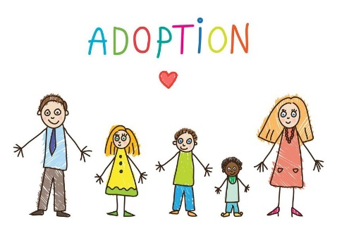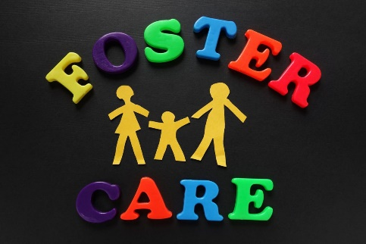
Kinship Care
What is Kinship Care?
What is kinship care? - Kinship Compass
What kind of arrangements or orders do kinship carers have?
Informal kinship care arrangements - Kinship Compass
Special guardianship orders - Kinship Compass
Child arrangements orders - Kinship Compass
What support is there available for kinship carers?
Connect with kinship carers | build meaningful relationships
Speak to a Kinship adviser - Kinship Compass
Speak to someone like you - Kinship Compass
Groups Archive - Kinship Compass
Events Archive - Kinship Compass
Kinship advice and information service | expert and friendly
There is much more support available for kinship carers, if you click on the link below you will be able to access all the support and resources that you need available.
Kinship Compass | Independent information hub for kinship carers

Adoptive Care
What is Adoptive care?
Child adoption: Overview - GOV.UK (www.gov.uk)
What kind of arrangements or orders do adoptive carers have?
Child adoption: Early stages of adoption - GOV.UK (www.gov.uk)
Child adoption: Adoption assessment - GOV.UK (www.gov.uk)
Child adoption: Adopting a stepchild - GOV.UK (www.gov.uk)
Child adoption: Adopting a child from overseas - GOV.UK (www.gov.uk)

What support is there available for adoptive carers?
Adoption support fund (ASF) - GOV.UK (www.gov.uk)
Child Trust Fund: Overview - GOV.UK (www.gov.uk)
Help if you have a disabled child: Overview - GOV.UK (www.gov.uk)
There is much more support available for adoptive carers, if you click on the link below you will be able to access all the support and resources that you need available.
Having a child, parenting and adoption - GOV.UK (www.gov.uk)

Foster Care
What is foster care?
What is foster care? | Fostering Information | UK Fostering
What kind of arrangements or orders do foster carers have?
Becoming a foster parent in England: Types of foster care - GOV.UK (www.gov.uk)
What support is there available for foster carers?
Becoming a foster parent in England: Help with the cost of fostering - GOV.UK (www.gov.uk)
Help and support for foster parents in England: Help with the cost of fostering - GOV.UK (www.gov.uk)
Training, support and development (TSD) standards for foster care - GOV.UK (www.gov.uk)
Looking after someone else's child - GOV.UK (www.gov.uk)

There is much more support available for foster carers, if you click on the link below you will be able to access all the support and resources that you need available.
Having a child, parenting and adoption - GOV.UK (www.gov.uk)

