QMplus Development:
Presenting key module information in a tab
Service Name: QMplus
Department: Academic Development / IT Services
Author
Document Owner(s) | Project/Organization Role
Brett Lucas | QMplus
Distribution and Sign off List
Name | Role
Brett Lucas | Head of E-Learning Unit
Peter Watts | IT Academic Applications Manager
Version Control
Version | Date | Author | Change Description
1 | 25 January 2018 | Brett Lucas | Initial Draft

Purpose
This document defines the requirements for streamlining the core module information provided within QMplus module areas to focus on providing that core information through the tabs that were introduced as part of the redesign in July 2017. This document is one of a series of three tab development requirements documents.
Specifically it covers requirements around:
- The ability to display links to a range of key course information on a tab near the top of all QMUL course formats

Background
In July 2017 QMUL implemented a brand new theme for QMplus. The theme was developed to update the 5 year old code, exploit the new functionality available through the CSS bootstrap 4 framework, and to meet evolving student and staff requirements.
Part of the theme development involved the updates to QMUL QMplus course formats, specifically: Collapsed topics format (QMUL), Topics format (QMUL) and the Grid format. This involved introducing the capability to add tabs to the interface, the purpose being to free up space at the top of QMplus module areas that has a tendency to become cluttered with links/files/resources. This new tab interface is accessible via the ‘settings’ for a course/module. The tab interface enables the user to change the name of the tab and to add content via the text editor.

Current Issues
- Whilst the current implementation of tabs is working, it does not allow for the ability to easily create and edit links and resources within it.
  - Users have to be able to navigate the html
  - Users cannot easily implement design elements like two columns without understanding CSS
- Do not want to display admin related information in the ‘Module content area’ but many modules do as it is much easier at present.

Requirement

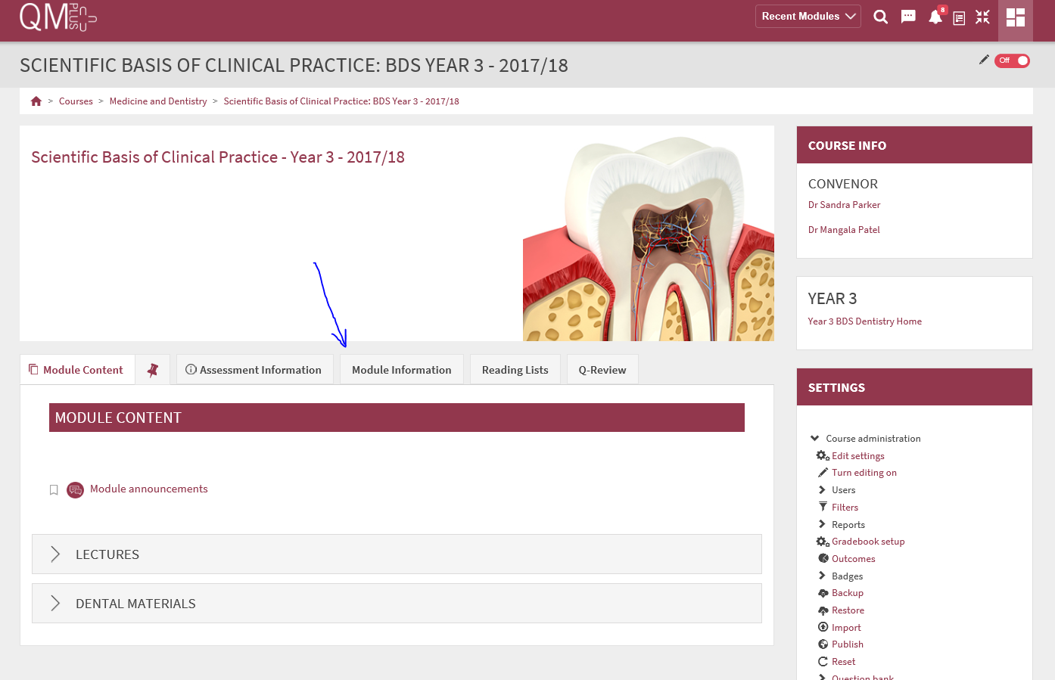
Fig 1: Tabs being used within the collapsed Topics format in the Dentistry Institute
- The ability to display Moodle activities and Moodle Resources in a tab.
- The ability to add Moodle activities and Resources within a tab.
- The flexibility to display those activities and resources in either a one or two column layout within the tab (see fig 2 below).
- The ability to add and or edit a title at the top of each column.
- The icons for each resource or activity to be displayed as per the normal Moodle course home page
- The icons displayed to reflect the appropriate child theme colour.
- The ability to add a block of text at the top of the tab that spans the entire tab e.g. where descriptive overview text could be added).
- The ability to drag and drop activities and resources around within the tab.
- A mechanism whereby learning content can be constructed easily by staff from elsewhere in the module then displayed within the tab itself e.g. Resources and activities could be added to a topic section…and then imported into the tab e.g. section 1
- A checkbox within the settings for the tab that allows the user to import content from e.g. a topic section within QMplus.
- The ability to hide, delete or duplicate content as per any other topic section.
- Attractive styling of the columns in line with the relevant child theme.

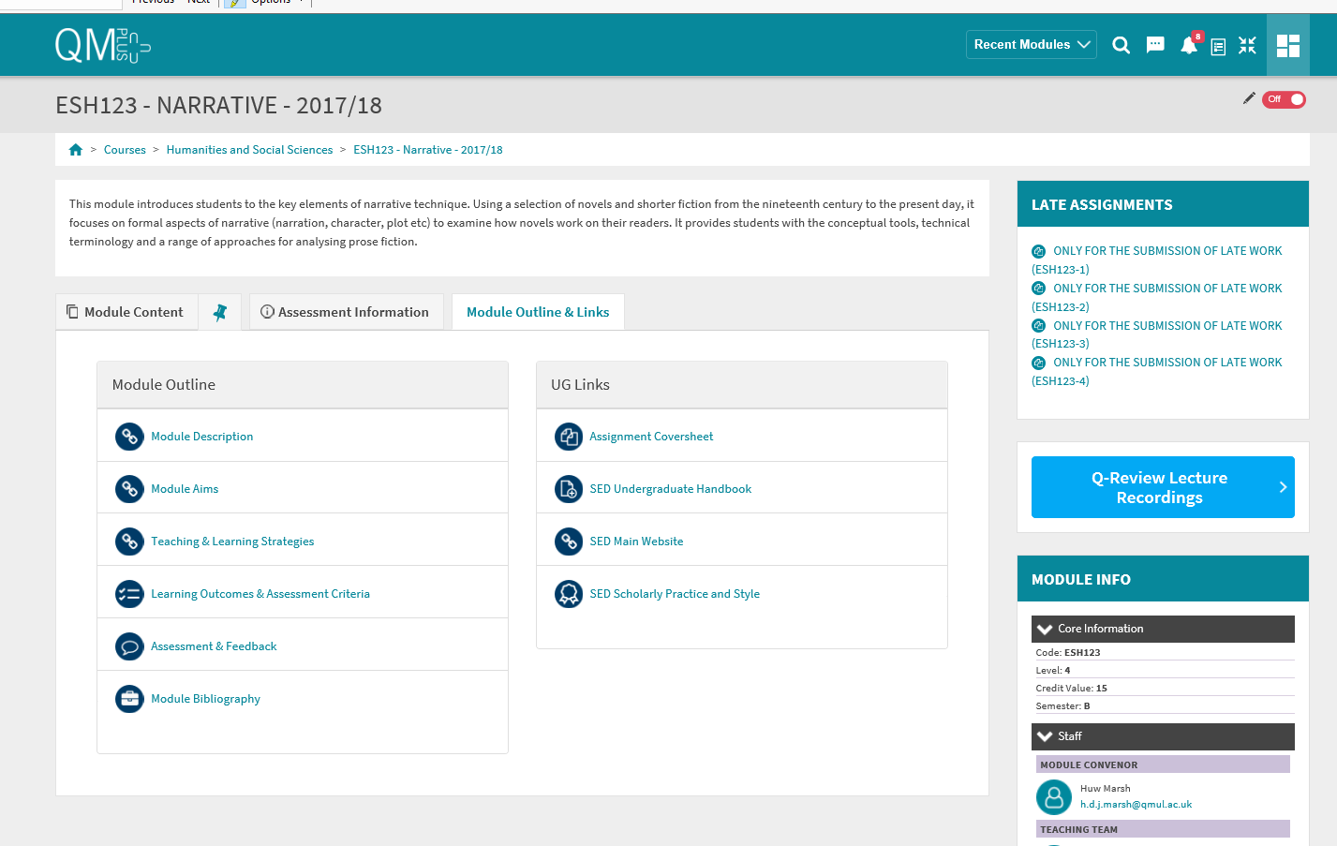
Fig 2: Links to Module resources in a tab within collapsed topics format in the Dept of English (SED)

