EXAM 1
Problem 1)
Physical transformations, phases
Consider a cooling alloy at the composition and temperature marked on the diagram. As shown on the phase diagram, the alloy is, at the given temperature, a mixture of alpha and liquid phases - but what are their exact compositions at this temperature?
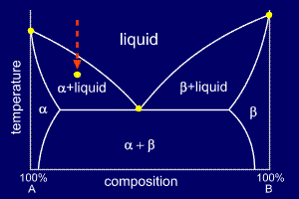

Solution
An isothermal (constant temperature) line through the alloy's position on the phase diagram when it is in a two phase field, intersecting the two adjacent solubility curves, is called a tie line (yes, that's the horizontal yellow line on the diagram).

The ends of the tie lines show the compositions of the two phases that exist in equilibrium with each other at this temperature. From the diagram we know that alpha and liquid phases will exist. The tie line shows that the alpha phase is 5.2%B and the liquid phase is 34.5%B at this temperature.

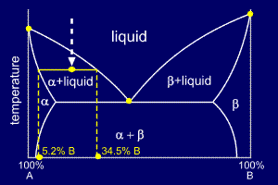
Now that we know the compositions of the two phases, we need to find how much of each phase exists at the given temperature. The ratio of the two phases present can be found by using the lever rule.

At first sight the lever rule can appear confusing. It is really invoking the conservation of mass, and can be proved mathematically, as shown below the diagram.

Essentially, we start off with an overall composition of our alloy - Co. From the tie-line we know that the two phases at a given temperature have two different compositions, but overall the amounts of these two compositions must add up to the alloy's overall composition, Co.

This is the basis for the lever rule. Using the lever rule itself is very simple, we'll show you with a diagram.
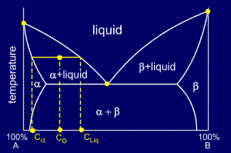
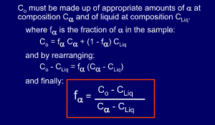

Problem 2
Mixtures, colligative properties

Explain the phenomenon of boiling point elevation using the expressions of the chemical potential. Illustrate the dependence on the chemical potential on solvent activity with the help of a graph.
Seawater is about 3.5 wt% dissolved solids, almost all of which is NaCl. Calculate the normal boiling point of seawater. Consider that NaCl is a strong electrolyte, i.e. it dissociates as NaCl -> Na+ + Cl- in an aqueous environment. The ebullioscopic constant of NaCl = 0.52 °C m¯1.

Solution
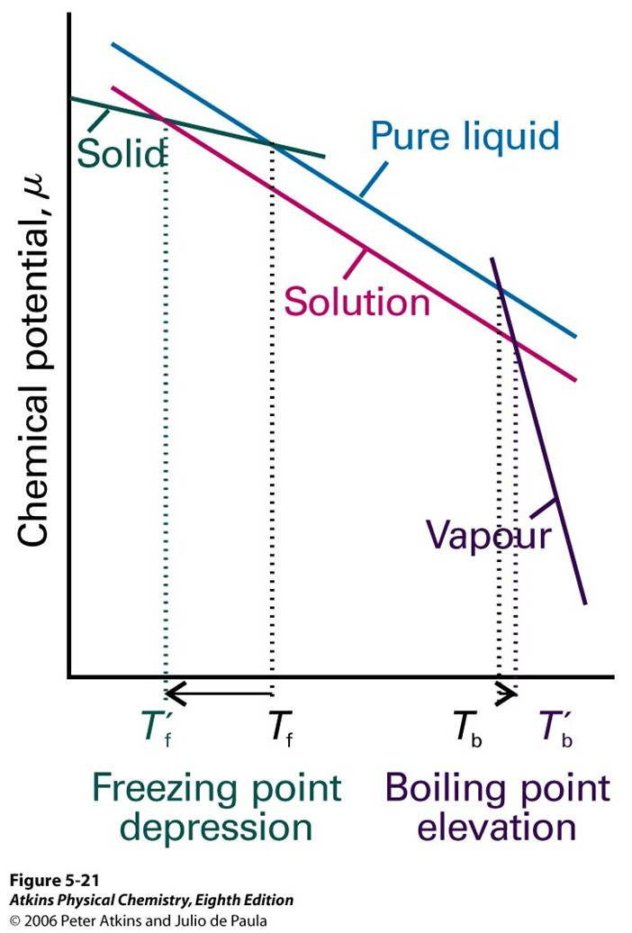
Explanation: Stems from the reduction of μ(l) as a result of the presence of solute.
For an ideal-dilute solution the reduction is from $μ_{A}^{*}$ of the pure solvent to ${μ=μ}_{A}^{*}+RT\ln{x_{A}}$ when a solute is present (N.B. $RT\ln{x_{A}}<0$ as $x_{A}<1$).
Solute is assumed to be non-volatile and insoluble in the solid solvent so it is only present in the liquid phase, i.e. no direct influence on μ.
↓μ implies that liquid-vapour equilibrium occurs at ↑T.

Some comments prior to starting:

1) Calculate moles of NaCl:

3.5 g / 58.5 g mol¯1 = 0.0598 mol

2) Calculate molality of NaCl:

m(NaCl) = 0.0598 mol / 0.0965 kg = 0.612 m
the molality of electrolytes is m(Na+ & Cl-) = 2x m(NaCl) = 1.224 m

3) use boiling point elevation constant:

ΔT = Kb m

x = (0.52 °C m¯1 ) (1.224 m) = 0.64 °C

So, the water boils at 100.64 °C

Section B: Answer 2 out of 3 questions for 50 marks
Question B1: Distillation
- Define the terms: flash distillation, rectification, downcomer and reflux ratio
[10 marks]
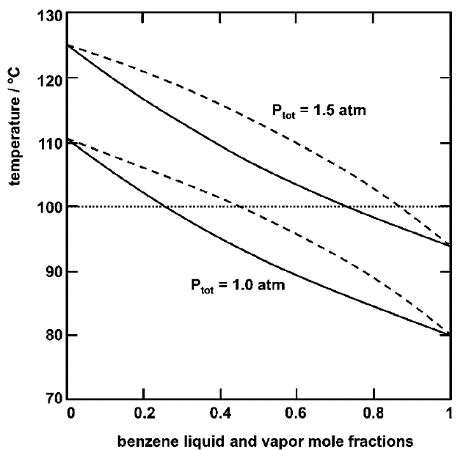
- In a flash distillation of benzene from a benzene-toluene mixture, the feed mixture has 0.5 mol fraction benzene, and pressure is 1 atmosphere (consider = 1 bar). The drum should produce a liquid with 0.40 mol fraction benzene. Using the Liquid-vapor equilibrium graph on the right, determine
- The temperature of feed in the drum
- The composition of the resulting vapour in equilibrium with the liquid
- The mol% of feed evaporated in the drum

[15 marks]
Total: [25 marks]
Solution:
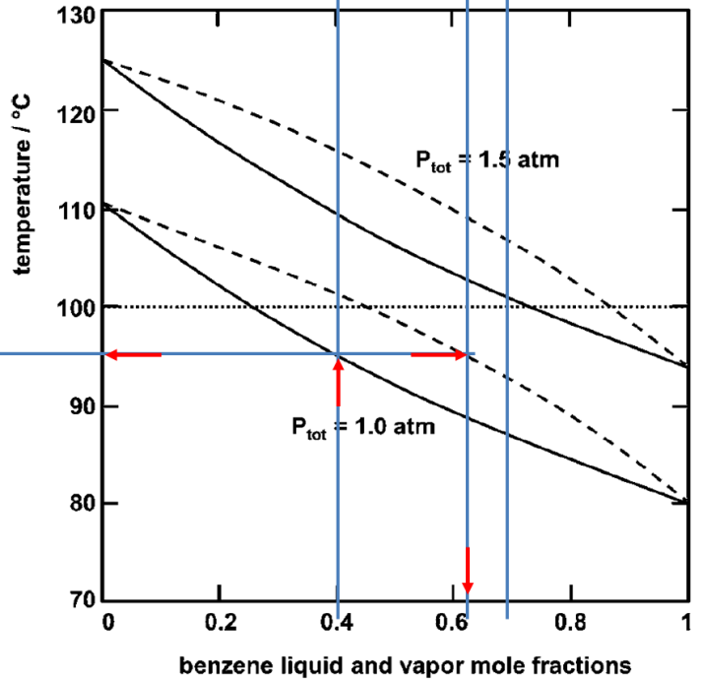
Solution:
b) From the 1 atm curve, and outlet x = 0.4
We find the bubble point = 95 ºC= 368 K
Then horizontally, we find the vapour composition
y = 0.63, and substituting these and z=0.5, into the dimensionless operating line equation =>
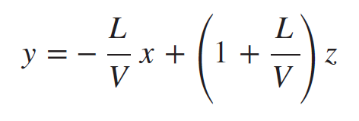
(L/v)*(z-x) = y-z, so
L/V = (y-z)/(z-x) = (0.63-0.5)/(0.5-0.4)
L/V = | 1.3
V/L= | 0.769 | V/F=1/(1+L/V)
V/F = | 0.44 | Fraction evaporated

a) flash distillation – single stage continuous distillation
rectification – separation of the lighter components of a mixture with reflux
downcomer – the condensing liquid in a stage overflowing to a lower stage
reflux ratio – the ratio of distilled liquid from the top of a column put back into the column

Question B2: Osmotic pressure
- Describe the following processes: forward osmosis, reverse osmosis, and pressure-retarded osmosis. For each draw (if any) appropriate application of pressure and specify the phase where it is applied. Compare the osmotic and applied pressures.
[12 marks]
- A patient with diarrhea has been severely dehydrated. Direct intravenous fluid delivery is necessary. An incompetent volunteer starts a fast drip of pure water into the vein. What happens to patient? Describe any
    - movement of water with respect to the red blood cells.
    - If an isotonic solution for injection is 0.9% NaCl (MW=58.5), calculate the pressure inside the red blood cells.
[13 marks]
Total: [25 marks]
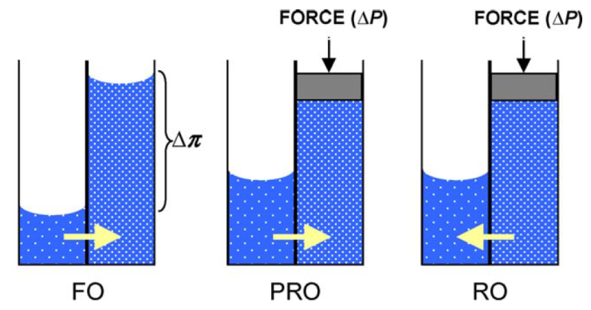
Solution:
a) Forward Osmosis ΔP = 0
For Reverse Osmosis ΔP > Δπ
For Pressure-retarded
Osmosis (PRO) Δπ > ΔP

b)
- The higher concentration of salt in the red blood cells causes the pure water from the surrounding to rush in due to osmosis to dilute it. Patient will experience haemolysis from bursting of such swollen blood cells, and if not caught in time will die.
The osmotic pressure inside the red blood cells is equal to the osmotic pressure in an isotonic solution. The pressure is: 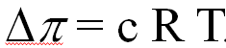
0.9% NaCl = 9g/L NaCl = 9g * (1mol/58.5g) / L NaCl = 0.154 mol/L NaCl
But NaCl in water dissociates to Na+ and Cl-, so the # of ions are twice as much.
So c = 2*[NaCl] = 0.308 Osmol/L, and since R=0.082057 L atm mol⁻¹K⁻¹, RT = 37 oC, so cRT= 0.308 Osmol/L* 0.082057*310 = 0.308 Osmol/L *25.4 L atm mol⁻¹=7.8 atm

Section B: Answer 2 out of 3 questions for 50 marks
Question B3

- Define in general for a filter, what is filter porosity, filtrate velocity, resistance (and its units), and cake
[10 marks]
A clean new filter has active area of 4 cm². Passing pure water at room temperature (η = 10⁻³ Pa.s), keeping a column of 15.3 cm above the filter (1500 Pa) through it results in collection of 1L in 1 min. Then after passing 1L contaminated water with 1 g/L particles that don’t pass through the filter, the permeability to pure water is such that with the same column of 15.3 cm only 0.5 L passes in 1 min.
- Calculate the:
- Resistance of the filter membrane
- The resistance of the cake after filtering the contaminated water.
- The amount of sugar syrup with viscosity 0.5 Pa.s that would filter in 5 min through the caked filter, again with same height column.
[15 marks]
Solution: a) filter porosity = ratio of the voids volume/ (total filter volume), filtrate velocity = rate of volume filtered per unit time per unit filter area, resistance (1/m) = ratio of pressure drop and the product of viscosity and filtrate velocity, cake = unfiltered particles that accumulate on the surface of a filter and cause increase in pressure drop at constant rate filtration, or decrease in filtrate velocity at constant pressure filtration.
[10 marks – 2.5 pts for each description]
- Calculate the:i) 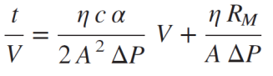, at first c=0, R_{M}=t ΔP A/(V*η)=60s*1500Pa*4cm2/(1000cm³*10⁻³ Pa.s) = 3.6x10⁵ / cm = R_{M}
ii) Half the volume filtered for the same time means half the filtrate velocity, so the resistance of the cake is the same as the original membrane – see
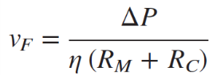.
iii)From the same formula, since pressure is the same, and viscosity is 500x higher, velocity is 500x lower. In 5 min (instead of 1min) = 100x less, so only 5ml.
[15 marks – 5 for each sub-point]
End of Paper - An appendix of 1 page follows

Problem 3
Mass transfer and diffusion

The diffusion coefficient of a particular kind of t-RNA molecule is D=1.1x10-11 m2 s-1 in the medium of a cell interior. How long does it take for the molecules produced in the cell nucleus to reach the walls of the cell at a distance of 1.0 μm, corresponding to the radius of the cell?

Solution
$〈x^{2}〉=2Dt$ gives the mean square distance travelled in any one dimension in time t. We need the distance travelled from a point in any direction. The distinction here is the distinction between the one-dimensional and three-dimensional diffusion. The mean square three-dimensional distance can be obtained from the one-dimensional mean square distance since motions in the three directions are independent.
$r^{2}=x^{2}+y^{2}+z^{2}$ [Pythegorean theorem]
$〈r^{2}〉=〈x^{2}〉+〈y^{2}〉+〈z〉=3〈x^{2}〉$ [independent motion]
$$=3×2Dt=6Dt$$

