Plan B GP4 Tutor Information Sheet – 2022-2023

We are required to change the format of GP4 for Block 1/2/3 of this year (4/5/6 TBC), this is due to a significant shortfall of recruitment of GP Practices for our large Year 4 cohort of students due to start in Sept 2022 (nearly 100 more students compared to last year). This shortfall is for a number of reasons, e.g. GP practices pausing medical student teaching due to workload/staffing issues/retirement etc.

Dates

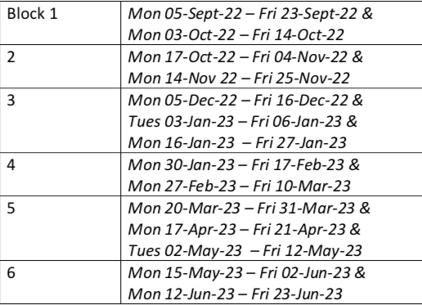

We are very regretful of this and are wholeheartedly disappointed as we were really excited about the new placement and despite great efforts to recruit we have been unsuccessful. We thank you again for bearing with us, with yet another change to these placements.

To give you an example of what this shortfall looks like, see table below…

Year 4 | No. of Students | Students yet to place
Block 1 | 76 | 28
Block 2 | 76 | 31
Block 3 | 76 | 32
Block 4 | 76 | 11
Block 5 | 76 | 9
Block 6 | 76 | 2

What does this mean for current Block 1/2/3 GP4 placements? Structure

We will be moving to a similar model that we used during COVID times, which is a hybrid module of half students attending Mon/Tue and the other half Thur/Fri. We will allocate these students to you and ask to try and not to move around, as we will teach them “centrally” when they are not with you.

The exact numbers will be worked out depending on your request of 8/6/4/2 students, we will be able to explain this further on the Training day. You will NOT have more students than your request at your practice on any given day.

Remuneration

Due to the extra workload, we have decided to pay each practice 1.5 X what they were scheduled to be paid, this will then automatically also include an increase in facility payment plus the extra supplement payment for taking more than 3 Blocks of GP4 teaching in the year.

The finer details will be sent to you in due course as each practice is different, depending on the number of students you have requested and already teach etc.

E.g.

GP4 Block 1 – GP Practice requested for 4 students = £4920
Now will be 8 Students (4 on Mon/Tue and different 4 Thur/Fri) = £7380

Mock Timetable

So if you have requested 4 students for a Block. You will have 4 students attend on Mon and Tue (ie AB group) and another 4 (DIFFERENT) students attend on Thur and Friday (ie CD group).

AB = Have Health Equity on Thur
CD = Have Health Equity on Tue
NOTE Please have WED AM SSC and PM SPORTS

AB Group
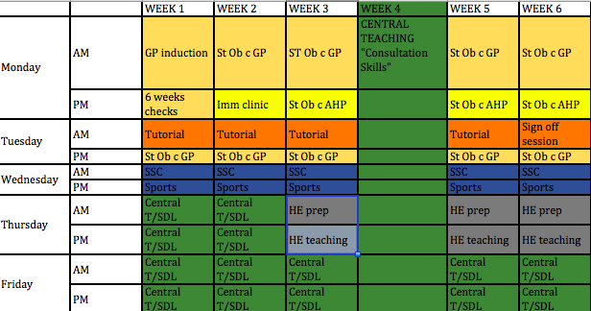

CD Group

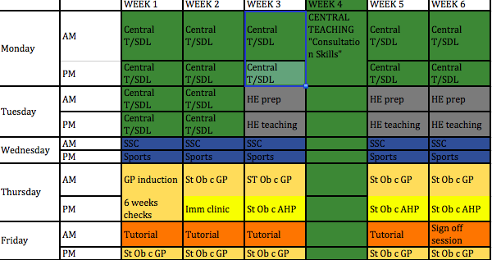
KEY

HE prep – preparation for health equity
HE teaching – health equity teaching
SSC – students selected component
SDL – self-directed learning
AHP – Allied Health Professional – Nurse, HV, PA, First response physio etc Imm –
St Ob w GP – student observed clinic with G

Other

- Learning Objectives – will stay the same (please see original Tutor Guide for details
- Assessment – will still be 5 CBDs but we are happy with some flexibility on this.
- Attendance = we ask for 90% attendance from students.

If they miss > 2.5d throughout the 6week block, please tick inadequate attendance in their sign off form and at the end of the document, tick “unsure”. At this point if “unsure” please contact us and we will decide on a case-by-case basis.

Again we apologise for any inconvenience caused and welcome you to contact us if any questions and issues.

Thank you

Dr Rohini Sabherwal and Dr Dev Gadhvi

