CRSS wk 10 Seminar Sheet — Sadulaev, ‘One Swallow Doesn’t Make a Summer’

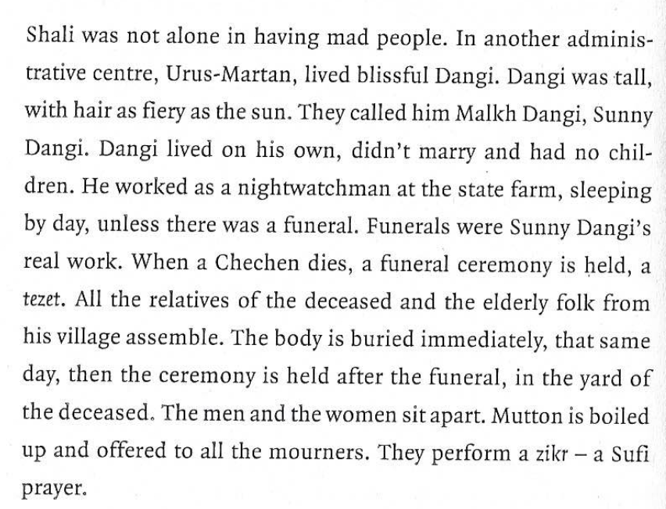
…
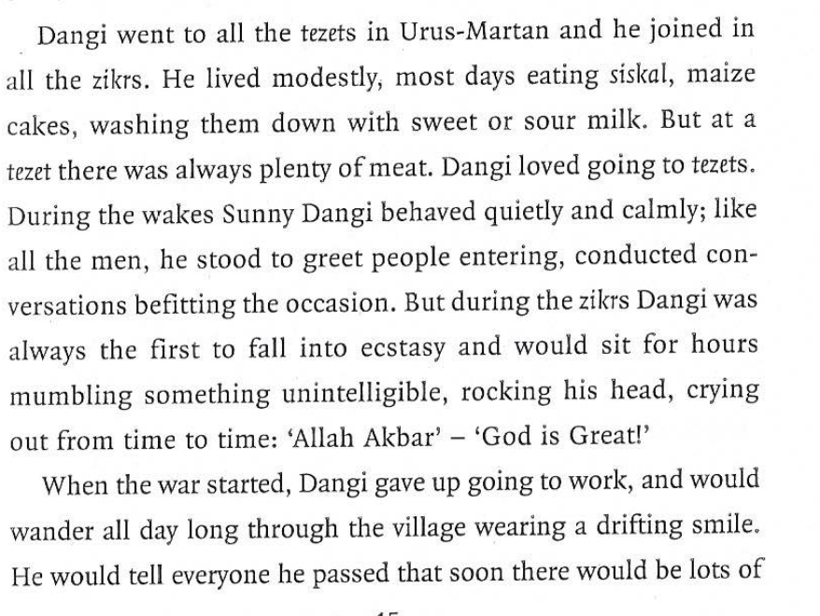
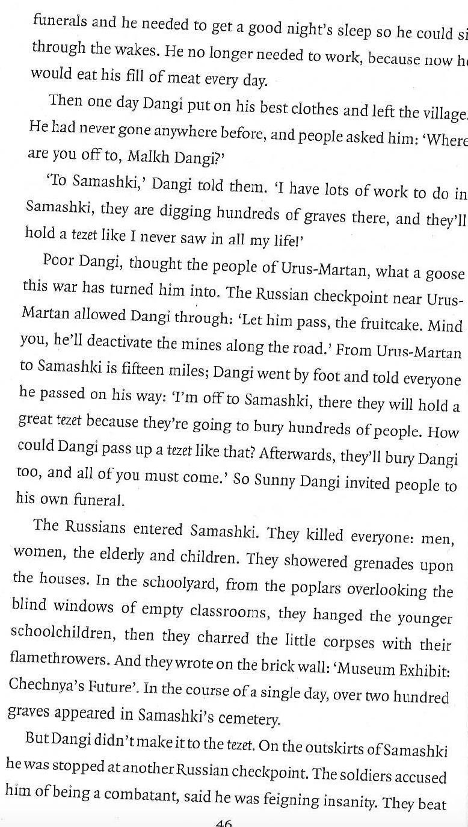
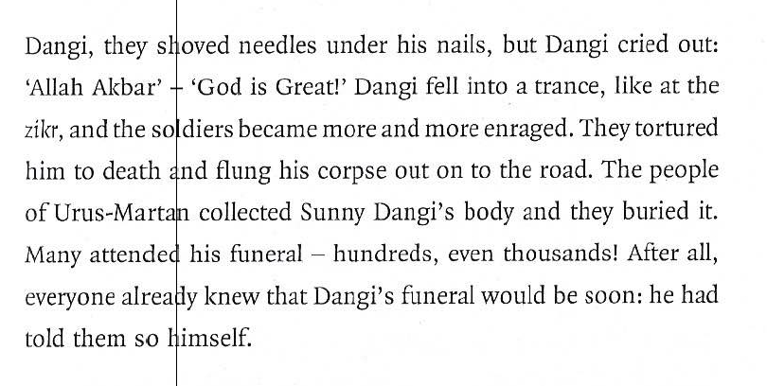
Task 1
Read the passage above. Comment on:
i) The combination of ethnography and reportage: how are they combined and what is the effect? How does the story of Sunny Danghi change the account of the atrocity in Samashki?
ii) Why does the author choose to concentrate on someone who is mentally ill (a ‘mad’ person) in this episode, and in two other cases that precede it?

Task 2
On the basis of your reading of the above passage, or the story as a whole, do you agree with the author’s statement, below, that he is not writing from the Chechen perspective, but from a ‘common’ perspective? Why do you think he say this?

Sadulaev:
I don’t like it when my texts are perceived as ‘the view from the other side,’ Sadulaev finished his story with a direct address to the readers – Because there is no ‘other side.’ There is only one side, everyone’s. There is a conceptual misunderstanding, a mixing up of positions. Or rather the construction of an opposition that doesn’t exist: ‘Chechens and Russians, them and us, our own and the others.’ Try, when you read the story, to rid yourself of the expectation that ‘they’ are writing about ‘us.’ Remember that it is ‘we’ writing about ‘ourselves.’

Alla Latynina (critic, writing about the above)
This is very politically correct, but doesn’t square with the content of the story. The opposition is after all stated by the author and not the reader. Yet Sadulaev’s great achievement is precisely the fact that the reader is filled with sympathy and empathy for the inhabitants of the far-off of previously alien Shali, the war catches in their own homes.

Task 3. Analysing the extracts below:
i) explain ways in which iWood’s quote might illustrate ‘a sense that time itself had been confounded’
ii) what are the effects (intended or not) of this play with temporal perspective

Wood
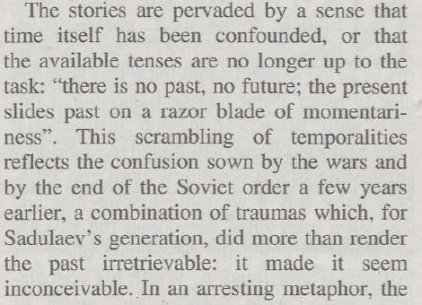

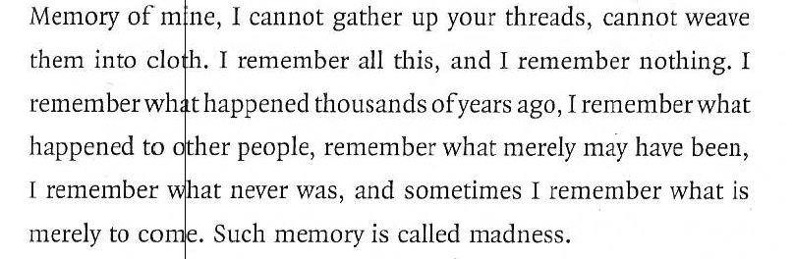
…
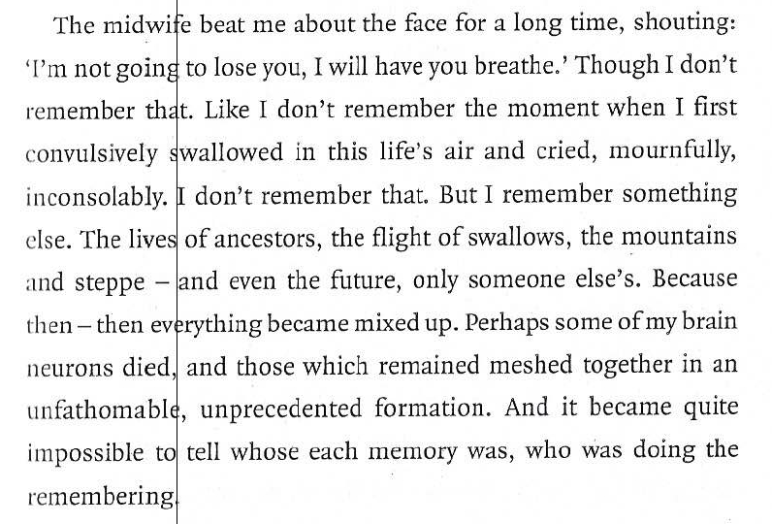
…
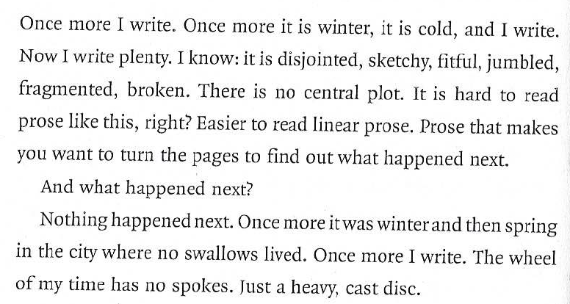

Task 4. The migrant experience in Russia
Comment on:
i) The attitudes to belonging expressed: Chechen, Russian, Soviet
ii) To what extent is this a universal migrant experience and to what extent specific?
iii) Gender in the passage
