CRSS wk 6 – Starobinets Seminar Sheet

Task 1 Comment on the following aspects of the extracts below:

i) the use of language
ii) the narrative voice: are they authorial? Character? Free Indirect Discourse?
iii) What is the effect of i) and ii), how does narrative voice and language influence our perception of events?
iv) How do the extracts relate to story’s wider themes?
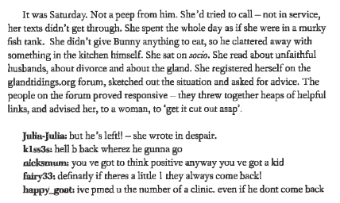

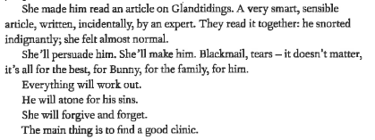

Task 2. Comment on the relation between the passages above and the author’s comments below
Q: The contemporary world in your stories is notably technological, and it is precisely here that there reside various unpleasant suprises … Where do such plots come from?
A: New technologies are bursting into our lives, and life under their influence is changing cosntantly. You can’t stop mutations occurring , ones that we aren’t able to adapt to. You could of course not reflect on the theme of these mutations, and to see only positive changes, that bring the world beauty and convenience. But, I think that even in the most positively predisposed and enlightened user, Facebook, for example, or Google-chat engenders a vague anxiety. The standard reasons for the anxiety are ‘Big Brother is watching you,’ ‘something’s happened to my memory,’ a lack of attention, and internet-dependency. But those are self-evident fears. What interests me are the deeper fears. I like to cross traditional phobias, passed through the generations over thousands of years with new technological forms, the transformation of the human being into something different; the Alien who uses cunning and tricks to lure your child into his magical world — these are all ancient fears. Only previously the came from the cellar of a medieval castle, whereas now the come from Google.’Interview with Natalia Kuchatova, Izvestiia 24 July 2013, https://iz.ru/news/554270
Task 3. To what extent do the quote from the author and view of the critic below relate to the theme of childhood important in ‘The Icarus Gland’?
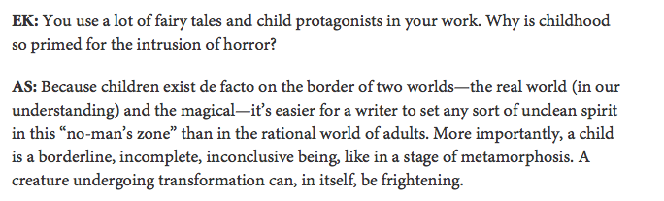
One of the reviewers remarked that with Starobinets (or rather with her characters) any fulfilment of desire ends in catastrophe. So it is dangerous to desire, sometimes fatal, and the realisation of desire is doubly dangerous. In my view, the danger here is more in the clear active intention of the characters to turn from the natural, preordained path. To put it bluntly, children should get on your nerves and create problems for grown-ups, it’s to be expected; grown-ups should grow old and die; men cheat on a woman for a younger woman, this is in his nature, and it’s in the nature of women to be jealous and suffer, to share the man with a rival; our daily bread should be earnt in the sweat of one’s brow. The attempt to change the nature of things leads to destruction. Mariia Galina, ‘Sluzhba bytiia. O novykh knigakh Anny Starobinets I Iany Dubinskoi,’ Novyi mir 8 (2014)

