Handout – Week 2 Sorokin, ‘Passing Through’

‘transformation of the intangibly discursive into the corporeal’
Lipovetsky
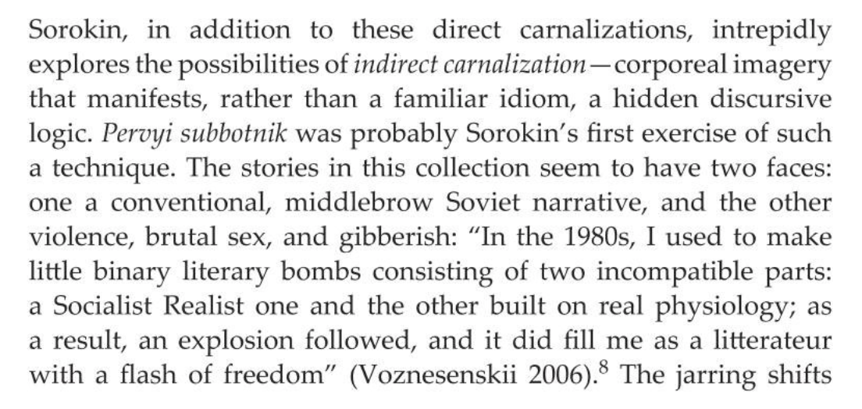
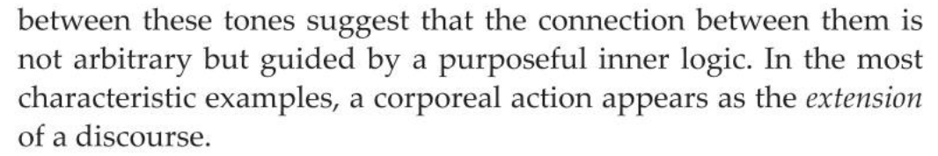
Marusenkov (in Sorokin’s Languages)
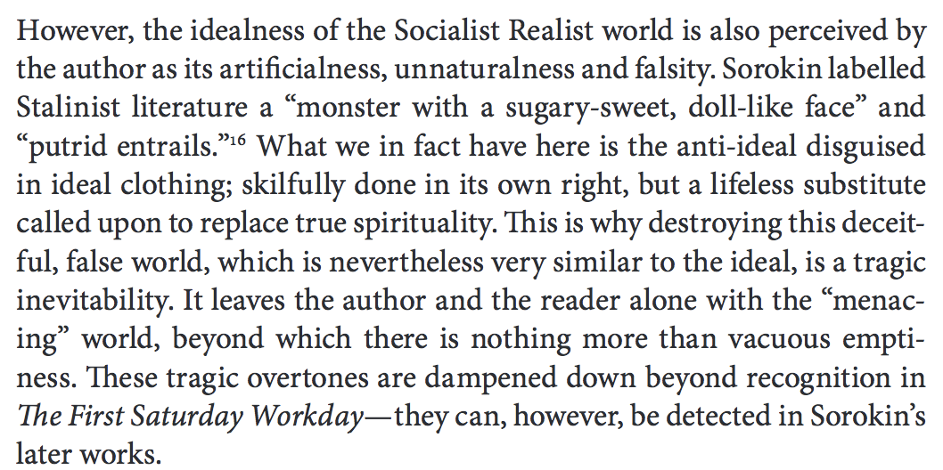

- What is the hidden discursive logic in Passing Through? How does Georgii Ivanovich’s unexpected act relate to what is unsaid? How does it relate to power relations?
- What is the relationship between Georgii Ivanovich and Fomin, of the propaganda department?
- Comment upon the language of the extract/the text
- Is it important that it’s the propaganda department? Why?
- How does this relate to a) Postmodernism b) Stalinist literature/socialist realism?

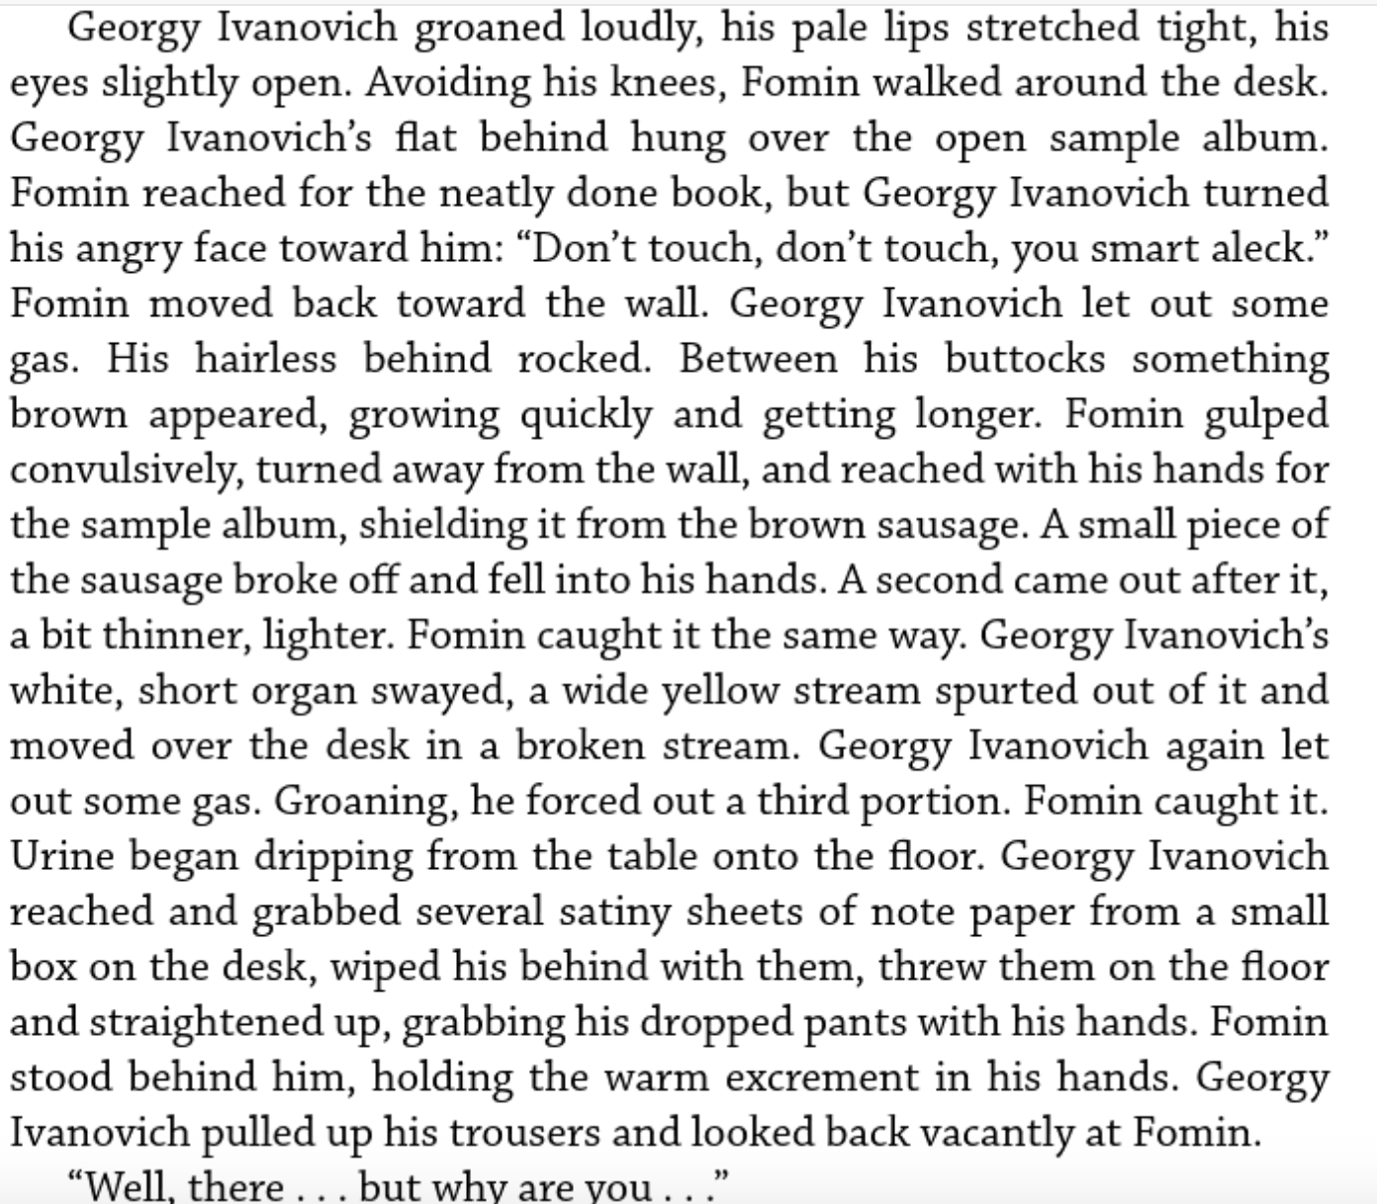

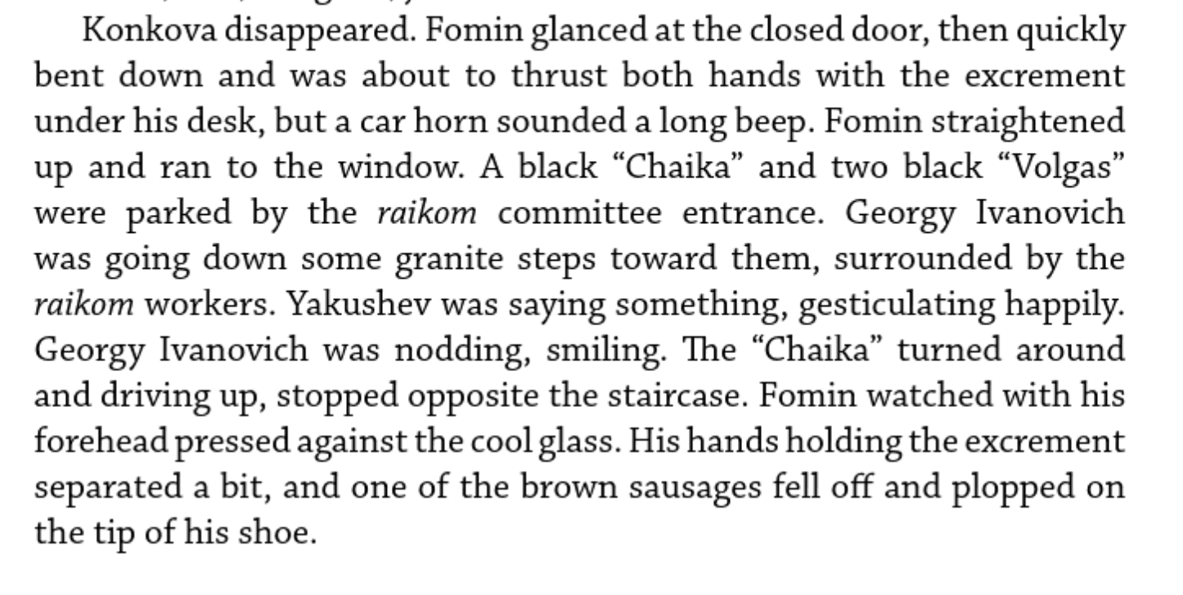

Sorokin Conceptualism and Sots-art

Dobrenko

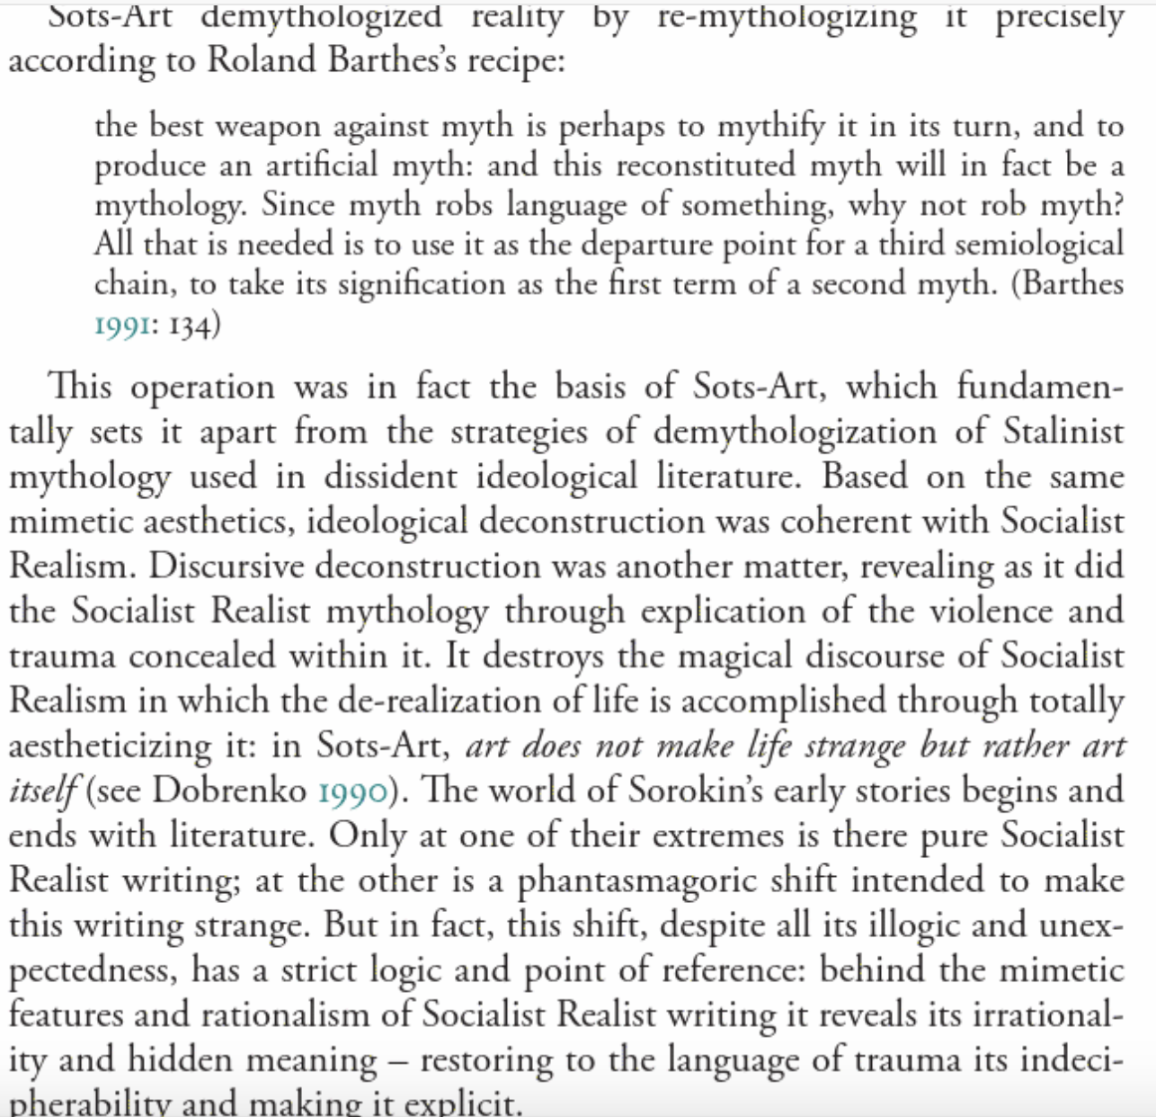
-
-
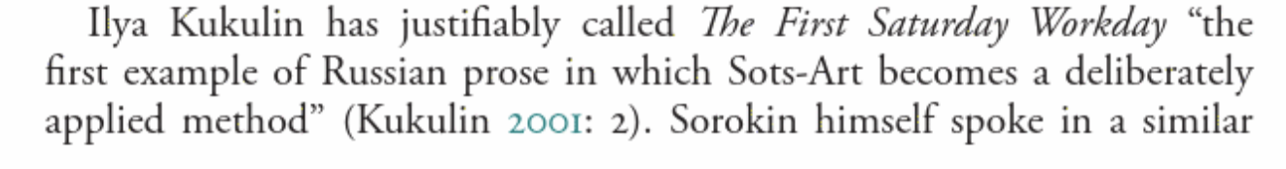
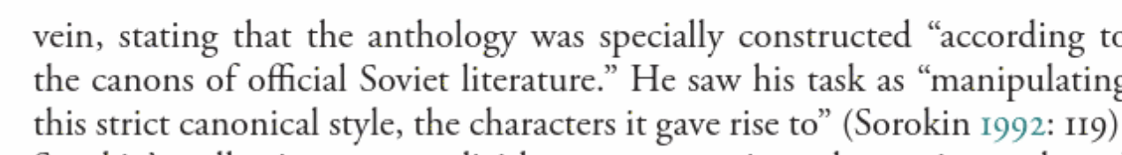
Dobrenko

