Practice:
Practice 1: The Antoine equation is often used to predict the vapor pressure of compounds at different temperatures and pressures. But often the units for constants A, B, C are non-SI. Given the equation in the form, with constants for benzene in benzene-toluene mixtures:
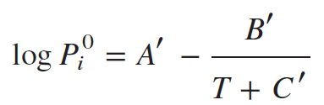 with P_{i}⁰ = saturation pressure in mmHg and temperature T in °C and(760 mmHg = 1 atm)

Convert the equation in the form 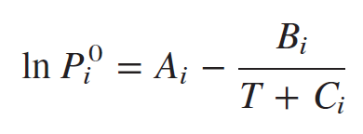, with pressure in atm, and T in oC.

First ask them how they would go about it.
Then find if there are math or conceptual stumbling blocks.
Hints/Notes: T also in oC, log - base 10, ln - base e

Solution: C stays same in units of oC.
pmm= p in mmHg, patm = p in atm
logpmm=(lnp/ln10)=(lnpatm +ln760)/(ln10)
lnpatm = logpmm*ln(10) - ln760
=>
B = B'*ln(10) =2755.641736
A=A'*ln(10)-ln760 = 9.20816767

Answer:
A = 9.2082; B = 2755.6; C = 219.16 °C

==

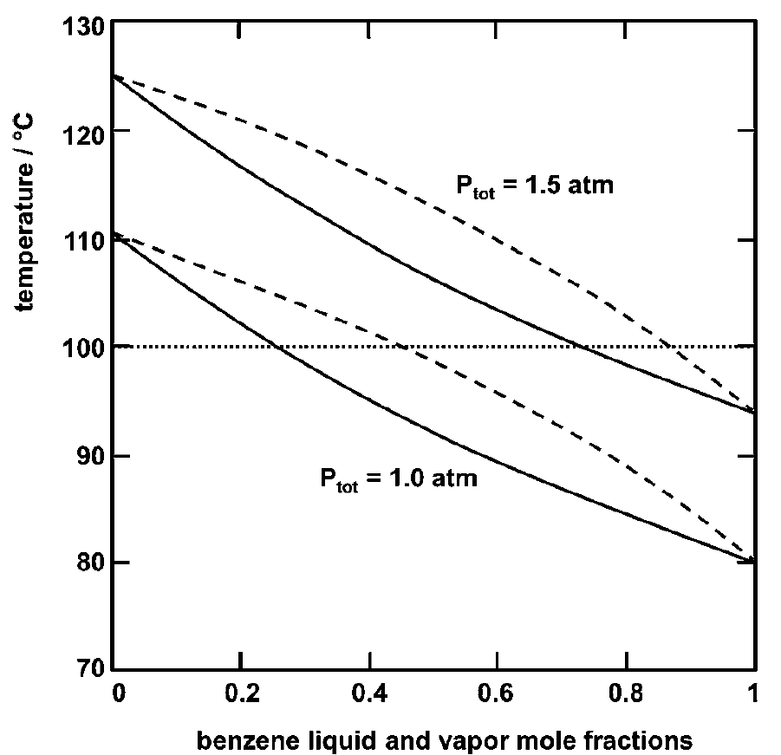
Problem 4:
4. A liquid benzene-toluene mixture with z = 0.40 should produce a liquid with x = 0.35
in a flash drum at 1.0 bar.
a. Calculate the required feed temperature
b. Calculate the equilibrium vapor-liquid ratio in the flash drum.

Z = 0.4 so from 1 mole feed, 0.4 moles is benzene

Stress, in class I said kg, but most often it is moles.
If nothing else is specified, assume moles.
P = 1 bar = 10⁵ Pa
Desired vapor to be condensed is has x = 0.35

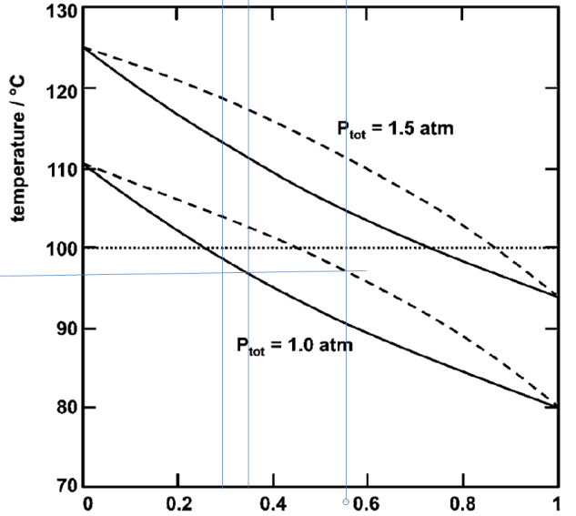
HINT: Use graphical info
Solution:
From the 1 bar curve, and outlet x = 0.35
We find the bubble point = 97oC= 370.15K
Close enough to the solution 369.9K
Then horizontally, we find the vapour composition
y = 0.55-0.56, so from 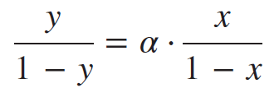
α = (0.55/0.45)/(0.35/0.65) = 2.27 or
α = (0.56/0.45)/(0.35/0.65) = 2.31

And combining these two
Fz = Vy + Lx and F = V+L into the dimensionless
Operating line equation =>
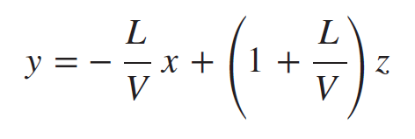
(L/v)*(z-x) = y-z
L/V = (y-z)/(z-x)
L/V = | 3.48 | 3.2
V/L= | 0.287356 | 0.3125

Check why this doesn’t work:
V= 1-L, L = 1-V
1*0.4 = V*0.55 + L*0.35, so
0.4= (1-L)*0.55 + L*0.35
0.2L= 0.15, L = 0.075, V = 1-0.075= 0.925
L/V = 0.08, V/L = 12.3

Or

--

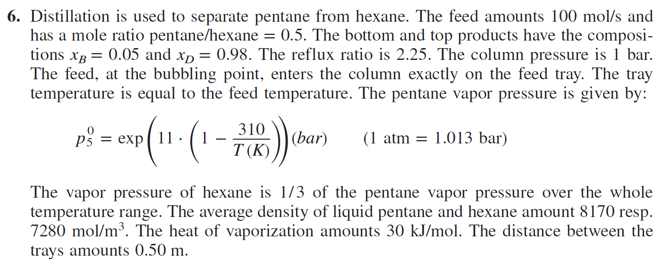
a. Calculate the feed temperature
b. Calculate the vapor stream from the reboiler
c. Calculate the required energy in the reboiler
d. Construct the y-x diagram
e. Construct the operating lines and locate the feed line
f. Determine the number of equilibrium stages
g. Determine the height of the column
feed, at the bubbling point, enters the column exactly on the feed tray??
The tray temperature is equal to the feed temperature. The pentane vapor pressure is given by:
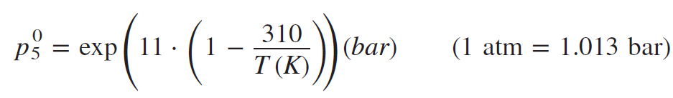
The vapor pressure of hexane is 1/3 of the pentane vapor pressure over the whole
temperature range. The average density of liquid pentane and hexane amount 8170 resp.
7280 mol/m3. The heat of vaporization amounts 30 kJ/mol. The distance between the
trays amounts 0.50 m.

Statement: subscripts 5 & 6 refer to pentane and hexane
F = 100 mol/s and z_{pent}/z_{hex} = z₅/z₆ 0.5. Bottom and top compositions are:
xB = 0.05 and xD = 0.98. The reflux ratio is 2.25 = R = L/D. P = 1 bar = 10⁵ Pa
The lower two-phase line is the liquid bubbling point boundary.
P₅⁰ = exp(11*(1-310/T(K))) bar 1 atm = 1.013 bar
P₆⁰ =(1/3)* P₅⁰
ρ₅ = 8170 mol/m3, ρ₅ = 7280 mol/m3. ΔH_{vap} = 30 kJ/mol.

Solution:
a. Calculate the feed temperature

b. Calculate the vapor stream from the reboiler
c. Calculate the required energy in the reboiler
d. Construct the y-x diagram
e. Construct the operating lines and locate the feed line
f. Determine the number of equilibrium stages
g. Determine the height of the column

