Contemporary Russian Short Stories
Week 1 (Handout)

Defining the Short Story

1. ‘classical unities’

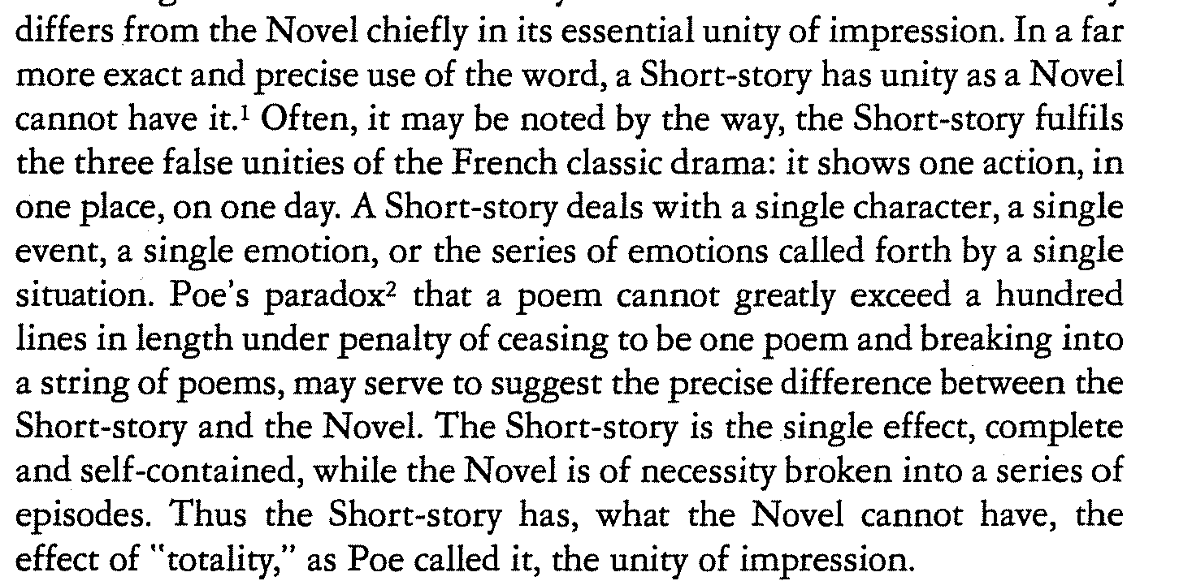

(Brander Matthews, ‘The Philosophy of the Short Story,’)

2. Subjective point of view

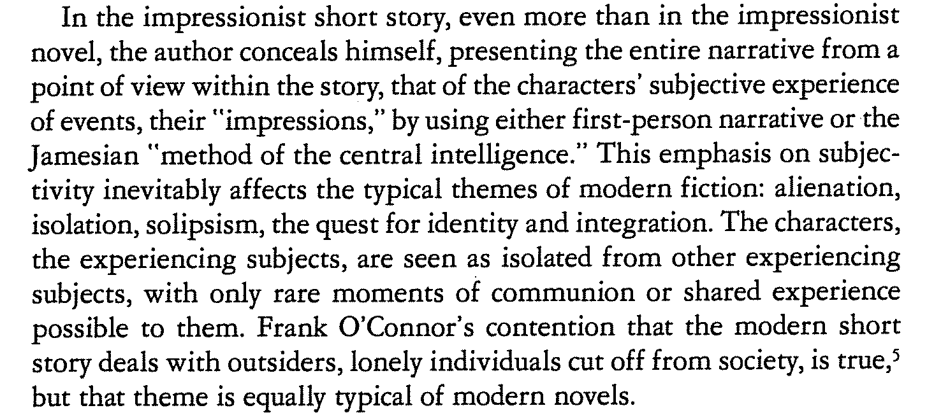

Suzanne C. Ferguson, ‘Defining the Short Story’

3. Obscuring the plot

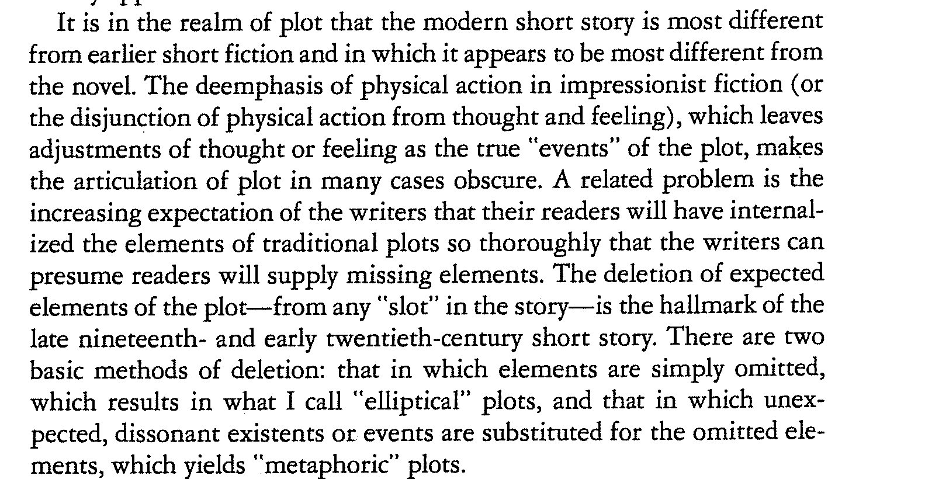

Suzanne C. Ferguson, ‘Defining the Short Story’

4. The Role of the Ending

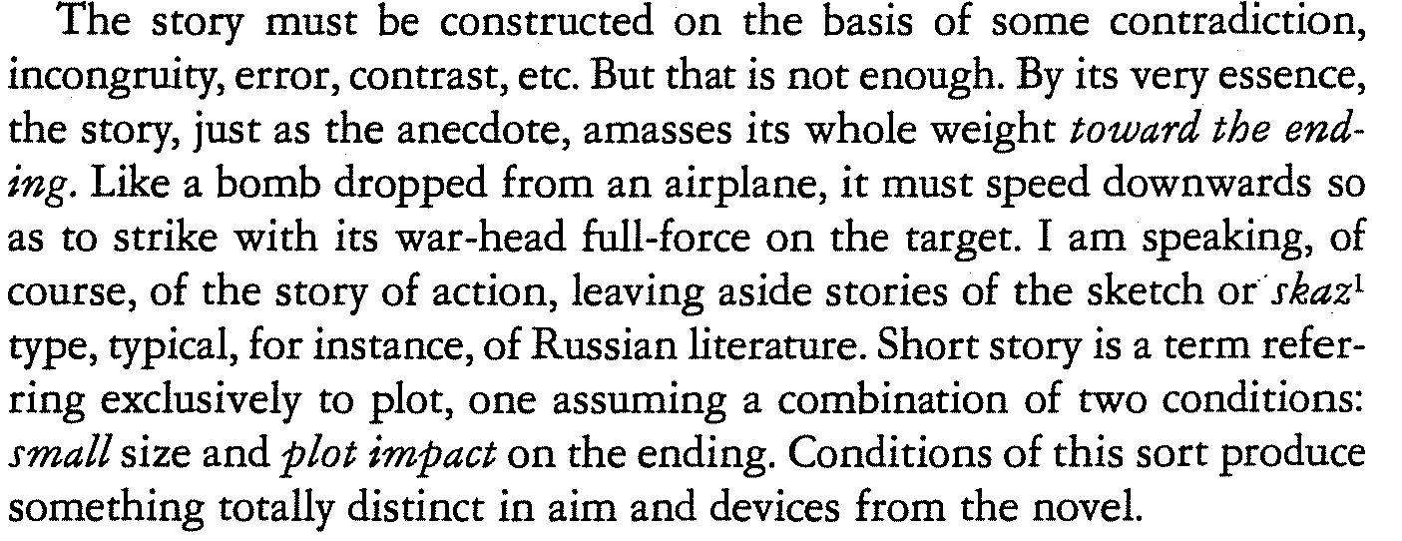

Eikhenbaum, ‘O’Henry and the Theory of the Short Story’

