QMplus Development:
Integrating the Assessment Information block and Assessment Info into a tab
Service Name: QMplus
Department: Academic Development / IT Services
Author
Document Owner(s) | Project/Organization Role
Brett Lucas | QMplus
Distribution and Sign off List
Name | Role
Brett Lucas | Head of E-Learning Unit
Peter Watts | IT Academic Applications Manager
Version Control
Version | Date | Author | Change Description
1 | 24 January 2018 | Brett Lucas | Initial Draft

Purpose
This document defines the requirements for streamlining the core module information provided within QMplus module areas to focus on providing that core information through the tabs that were introduced as part of the redesign in July 2017. This document is one of a series of three tab development requirements documents.
Specifically it covers requirements around:
- Assessment information: An integration of the existing ‘Assessment info block ’ with the new ‘Assessment information’ plugin (Synergy fig 2 below)
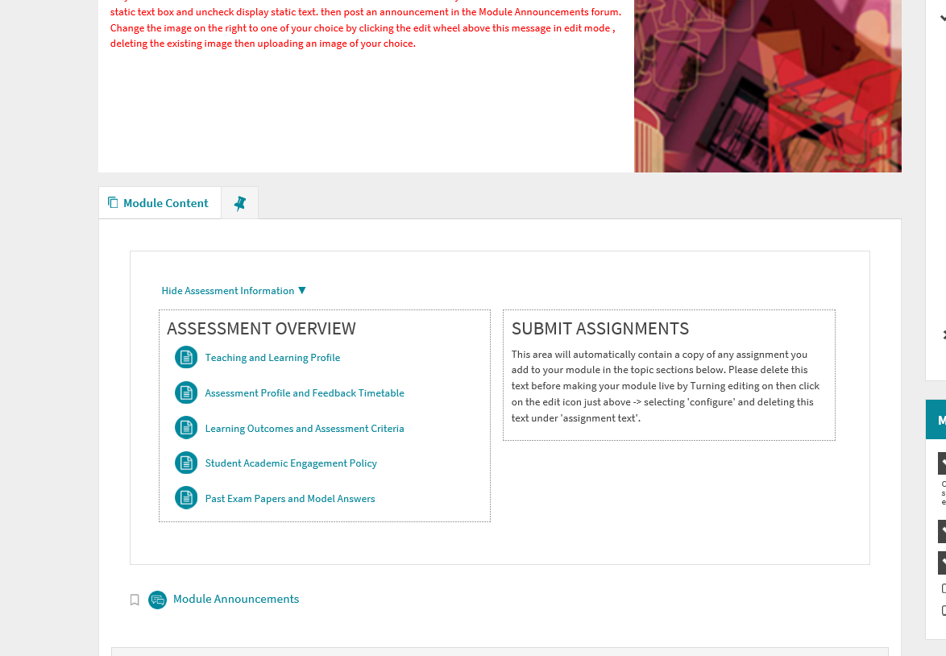
Figure 1: The QMUL authored ‘Assessment Information block’
Figure 2: Assessment information from Synergy Learning

Background
As QMplus was being developed in 2012/13 the ELU worked hard with Schools in the Faculty of Humanities and Social Sciences to develop a policy around the baseline use of Moodle. This was driven by both the College teaching and learning strategy at the time and the needs of individual schools. One of the key requirements that emerged was the need to display in a clear, consistent and easily accessible way within the learning environment two aspects of the Assessment lifecycle:
- The full Assessment Overview for a given module (whilst this information was available in the module handbook it lacked the visibility that was required)
- and an Assignment dropbox partially a legacy idea inherited from the previous VLE but primarily driven by the need to prominently show to students the assignments within a given module.
2012-2015
Initially an ‘Assessment area’ was designed in topic zero using CSS only. This area enabled competent users to add links to assessment info pages (stored in topic 52) and assignments (embedded throughout the module.
2015 -2017
In 2015 the assessment area was replaced by an Assessment plugin. The purpose of this plugin was to automate as much of the functionality of the display of assessment information as possible thus making it easier to keep up-to-date for staff at all levels of HTML competence. The block enabled activities & resources to be moved around easily, an additional section to be added and resources to be hidden if required.
2017
In the July upgrade new course formats were introduced. Part of the functionality that was introduced was a new tab structure within the course formats and an assessment information tab. The tab consisted of two areas (see fig 2 above):
- A list of assignments that are due on the course for the user in due date Ascending order. For each assignment the following is displayed: the activity icon, due date, the title of the assignment and description. This list also includes items that are overdue.
- A list of assignments that have been graded already on the course for the user
grading date Desc order. This will display for each assignment - the activity icon,
the grade, the title of the assignment and description.

Current Issues
- Two different methods for displaying assessment information can cause confusion
- The tabbed ‘assessment information area is not displaying some information correctly
- The assessment information block in topic zero takes up too much space and the show/hide cookie is frequently Not working
- Rationalisation of both would make more sense and streamline the provision of assessment and feedback information

Requirement
We are looking for a simpler way to achieve the original requirement: to display a range of assessment information – in a tab in a quickly accessible and easily visible way

Assessment Overview  Teaching and Learning Profile  Assessment Profile and Feedback Timetable  Learning Outcomes and Assessment Criteria  Student Engagement Policy  Past Exam Papers and Model Answers | Assignments

- A solution that allows for the display of a user-editable heading at the top of each column (default heading should be Assessment Overview for a one column layout or the left hand column of a two column layout, and Submit Assignments for the right hand column of a two column layout).
- A solution that allows for the addition of subheadings (as in figure 2 and figure 3 above). Sub-headings should be able to be styled with a background colour to differentiate them from the main heading (selected from a limited selection of styles based on the QMUL colour pallete) or other resources/activities.
- A solution that allows for subheadings to be renamed (user editable).
- A solution that also allows for the placement of text within the column (e.g. in a label?)( See figure 3 above)
- A solution that does not place a limit on the number of resources that can be displayed in each column.
- A solution that does NOT involve the actual resource or activity residing in an orphaned files area (currently in topic 52).
- A solution that enables additional resources and or activities to be added with ease to either column.
- A solution that automatically adds a Moodle assignment to the right hand column of topic zero no matter where it is added on the page i.e. the activity is in two places ..the location it is created and topic zero or only topic zero if it is created there.
- A solution that also allows for the auto population of the assignments area (right hand column) for other types of assignment that might be contained:
  - Lesson
  - Quiz
  - Workshop
- The ability to override the display of any particular assessed item.
- A solution that allows the resources and activities in each column to be moved around with the same ease that they can be moved around elsewhere in Moodle course pages including between the two columns.
- A solution which, by default, contains no activities or resources in the left column but contains some kind of activity chooser.
- A solution that allows a pre-configured mix of resources (e.g. 5 pages in the left column) to be added to a course area that will be saved as a template and used to restore for course creation purposes.
- A solution that is user selectable..i.e. You do not have to use the assessment info tab if you don’t want to. Many courses/modules do NOT have a requirement for this content to be in a tab.
- A solution that enables permissions to be enabled for the left hand column. i.e. Once a topic zero left hand column has been populated it could be make viewable but uneditable by teachers and module convenors.

Content that is configured as part of the course format settings (HTML editor) - this will be pre-populated on the course templates which will need further tailoring by the course tutor.
A list of assignments that are due on the course for the user in due date Ascending
order. This will display for each assignment - the activity icon, due date, the title
of the assignment and description. This will include items that are overdue
A list of assignments that have been graded already on the course for the user
grading date Desc order. This will display for each assignment - the activity icon,
the grade, the title of the assignment and description.
All course format settings should be replicated when the course

