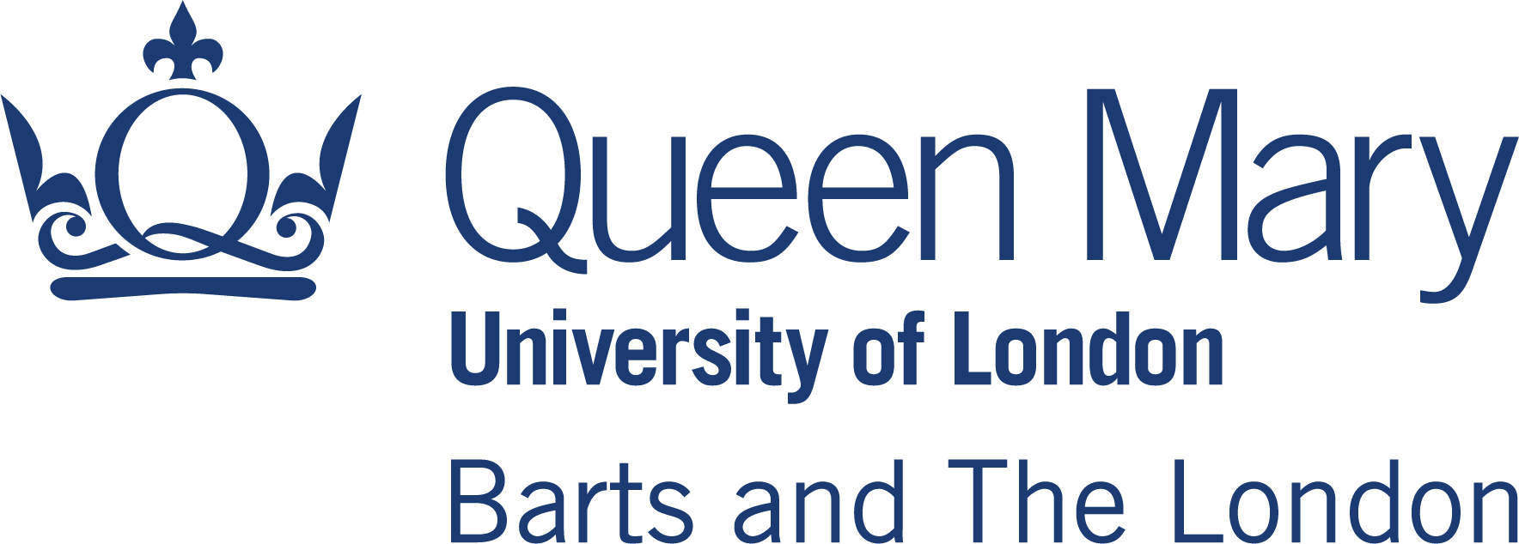

Clinical placements – Frequently-asked questions relating to COVID-19

Please read these FAQs in conjunction with the Medical Schools Council document “Returning to Clinical Placements – An Update for Medical Students”
https://www.medschools.ac.uk/media/2673/returning-to-clinical-placements.pdf

Medical students are considered ‘essential workers’ while on placements. You will be given the same protection as NHS staff and have the same professional responsibilities to protect yourself and others.

Please note the situation is changing rapidly – the information here is correct for 3 Aug 2020. Please consult official guidance if in doubt.

1) What happens if I have completed the self-assessment and have a higher risk or very high risk score?
Students who are self-assessed as at higher risk or very high risk will be referred to Occupational Health for more detailed review. Students who do not wish to return to studies given the present situation will be given the option of deferring for one year.

2) Do I have to declare my risk status to anyone else?
No – this status is used confidentially by the School of Medicine and Dentistry (hereafter termed ‘The School’) for the sole purpose of identifying COVID-19 risk for clinical placements and identifying the correct risk pathway.

3) I have had COVID-19 – does this make a difference?
No – as long as you are no longer infectious. You should not attend placement if you are symptomatic or have tested positive for COVID-19 in the past 14 days.

4) I have had a positive antibody test – does that mean I am clear to attend placement even with a positive score?
No –Scientific evidence for the duration of immunity following infection, the immune status of individuals who are seropositive for SARS-CoV2 antibodies and the probability of re-infection are not currently known. Therefore you must still follow all advice to protect yourself and others.

5) A member of my family/household is shielding/vulnerable/elderly. How can I protect them?
We understand that some of our students live at home with family members who have been shielding since lockdown. You are obviously concerned to keep them safe and reduce the risk of them being exposed to COVID-19.

Please consider what mitigation might be possible to reduce risk if you live with someone vulnerable, such as maintaining social distancing both inside and outside your home. You may consider moving out temporarily. Please read the government guidance on shielding. Please read OFFICIAL GUIDANCE HERE.

As you will be in contact with patients, it may be wise to act as if you may have asymptomatic COVID-19 infection.

Please follow the advice on protecting people at home OFFICIAL GUIDANCE HERE:
- stay on your own in one room as much as possible and keep the door closed
- avoid using shared spaces (such as the kitchen) at the same time as other people – eat your meals in your room
- use a separate bathroom - otherwise, use the bathroom after everyone else and clean it each time you use it, for example, by wiping the surfaces you've touched

Unfortunately the medical school has very reduced capacity to change the venue of your placements. If you would find it difficult to socially distance at home, then consider interrupting your studies for the academic year 2020/21 and re-join the course in September 2021. You should talk to SAPS before making this decision.

6) Would accommodation be available for hospital placements, so I do not have to risk bringing COVID-19 to my at-risk relative?
Accommodation will be available for students on ‘out firms’ as for previous years. (Broomfield, Colchester, Southend and Princess Alexandra in Harlow).
Accommodation will not be available for students on ‘in firms’.

7) Will my placement protect me adequately against the risk of COVID-19 infection?
The School has asked placement providers to undertake a risk assessment of the clinical environments in which students will be placed. Hospital Trusts and GP practices have identified and separated ‘zones’ or sites for treating COVID-19 patients and students will not be expected to work in these setting. However it is impossible to rule out all contact with asymptomatic patients.

PPE: It is accepted by Medical School Council (MSC) and others that risk cannot be entirely eliminated but can be reduced to an acceptable degree with provision of PPE and appropriate training. Health Education England (HEE) has indicated that medical students are deemed essential workers. Therefore Trusts and GP practices will be expected to provide PPE and relevant induction and supervision in the use of such equipment. Students are responsible for following the guidance.

The School expects all students to have undertaken a mandatory online ‘PREPARING FOR CLINICAL PLACEMENTS’ module prior to starting placements. This will include six essential elements (completion will be tracked):
- Infection control and PPE (with Covid update): BMJ Learning module with certificate of completion (essential)
- Handwashing instruction video (essential)
- Needle-stick information and mini interactive quiz(essential)
- Looking after your mental health – links to MindEd site, Student Advice and Pastoral Support, BMA guidance (essential)
- Social distancing guidance – current advice from UK Government and NHS (essential)
- Resuscitation in the Clinical Setting – latest protocols regarding COVID from Resuscitation Council (UK) (essential)
- Video/Remote Consultation skills(essential)

8) I would have to travel to my placement by public transport which is too risky. Can I change to a local placement?

Public transport is deemed safe for everyone in low risk groups as long as you can follow guidance: wear an appropriate face covering at all times, maintain social distancing wash hands on arriving at destination, change outer clothes before patient contact.
Please read the OFFICIAL GUIDANCE (Remember you can be fined if you do not comply. You would need to notify the Medical School.)

You may wish to consider additional ways to reduce risk, especially if you live with someone vulnerable:
- Negotiating a late/early start to your placement to avoid crowds – please discuss ASAP
- Cycling if there is a safe route

9) Can I delay going on placement until things settle down?
No – the School has identified a safe policy for students to attend placements based on the latest guidance available. If you feel unable to attend placement then the Medical Schools Council recommendation that

“…. students with underlying health conditions, or students with vulnerable dependents, may be at increased risk of contracting the virus which would make a return to clinical placement inappropriate. Such students may wish to defer the 2020/21 academic year for this reason and medical schools will be sympathetic to such requests.”

10) What happens if my placement is in an area of future local lockdown?
It is impossible to predict the future course of COVID-19 infection, either nationally or locally. If such situations develop then the School and the Trusts affected will make decisions on clinical placements which protect you the student and patients.

11) A family member has been asked to self-isolate for 2 weeks before a hospital operation. How does that affect my placement if I self-isolate too?

Where possible you should distance yourself from the family member, similar to living with someone who has been following shielding guidance (see no.5 above) so that you can continue with your placement. If this is impossible then the same rules as for no. 12 apply.

12) If I am contacted by Test & Trace Service or returning from a country which requires a period of quarantine in the UK and told to self-isolate, how does that affect my placement?

If you are contacted by Test and Trace then you should self-isolate for the required time (currently 2 weeks) and inform the Student Office.
- You will be able to join ALL GP placements remotely and participate in clinical consultations as relevant
- You may be able to participate in parts of other placements remotely

If you need to be absent, after discussion with the School Office, your placement will be contacted. Hopefully you will be able to complete the remainder of your placement or if necessary remediate at another time. This can be discussed with SAPS and the relevant Head of Year.

Please follow OFFICIAL GUIDANCE for Test & Trace (July 2020) HERE
Please follow OFFICIAL GUIDANCE for returning travellers to the UK (July 2020) HERE

13) Can I use my status as a medical student to avoid isolation rules when arriving in the UK?

Despite the status of medical students as essential workers it isn’t appropriate for them to not isolate on return to the UK. The exception is for workers who are required to travel but their absence places a burden on the NHS that outweighs risk to patients of not isolating. This isn't the case for students.

