Blended course construction kit
SD Buckingham

Purpose
This kit will take you through the steps to create a blended learning content. It can be applied to a new or an existing module. By following the steps you can create a blended design in a short time – typically about 2h for each week of your module, so 24h work for a 12-week module.

Start here

Step 1: Revise learning objectives (about 1h of work)
You will probably have to revise your learning outcomes (LOs) to better suit blended design. If you find this task difficult and would like some clarification, you could watch the video ‘Creating learning outcomes’ (online video). There is also a spreadsheet that can help you build LOs and its used is explained in the video, this sheet can be found in QMplus SEMS L&T page ( .
To do this efficiently:
- Open the ‘Bloom level calculator’ tool
- Enter your current learning outcomes into the column labelled “Current LOs”
- In the column labelled “Taxonomy”, select the dropdown that best describes the kind of learning outcome
- Reword the learning outcome until the traffic light is green (keep an eye on the bottom cell of the list)
The video and excel tool can be found on: https://qmplus.qmul.ac.uk/course/view.php?id=13523#

Step 2: follow the instructions on the next page to complete the blended design

Instructions for designing blended course
- Write and split your course learning objectives into the 12 weeks of the course (30 min). Ensure the objectives for each week cover the learning outcomes for the whole module.
  - Which are dependencies for others? They come earlier
  - Which are more challenging? They come later and maybe run over more than a week
  - Which expand upon or build upon others? They come immediately after.
  - Find any learning objectives that should be broken down into simpler steps
- You now have learning objectives assigned to each week.
  - If any week has more than 5 learning objectives, either remove some or merge them
  - If any week has less than 3, either break them down further or add supplementary ones
- For each week (30-45min work for each week):
  - Put your learning objectives for that week onto QMplus using the label item.
  - Create the core asynchronous tasks, then return to this point in the document.
  - Using the label item in QMPlus, add a statement telling the students which learning objectives and outcomes will be met with the core tasks, and which will be met by the synchronous activity.
  - Optional if you want quality:
    - From the list below, select an active learning task that will reinforce, extend and deploy the learning outcomes. Then return to this point in the document.
    - Use the label item to tell students that they should not expect to get individual feedback on anything they submit, but that it will be used in the synchronous teaching.
    - For each week, decide on the focus issues, note them down and then return to this point in the document.
  - From the list below, select one or more synchronous activities. Then return to this point in the document.
  - Put your synchronous activity onto your page as a webinar. Click here to see how.
- Your page will now have, for each week of the course, something like Figure 1.
- To your main page add:
  - A forum
  - A webinar that will be used for Q&A sessions. Set up a webinar as per the instructions, but in the date and time section indicate that it is permanently open.
  - A label item that tells students when you are available for open office and Q&A.
- Your blended is complete
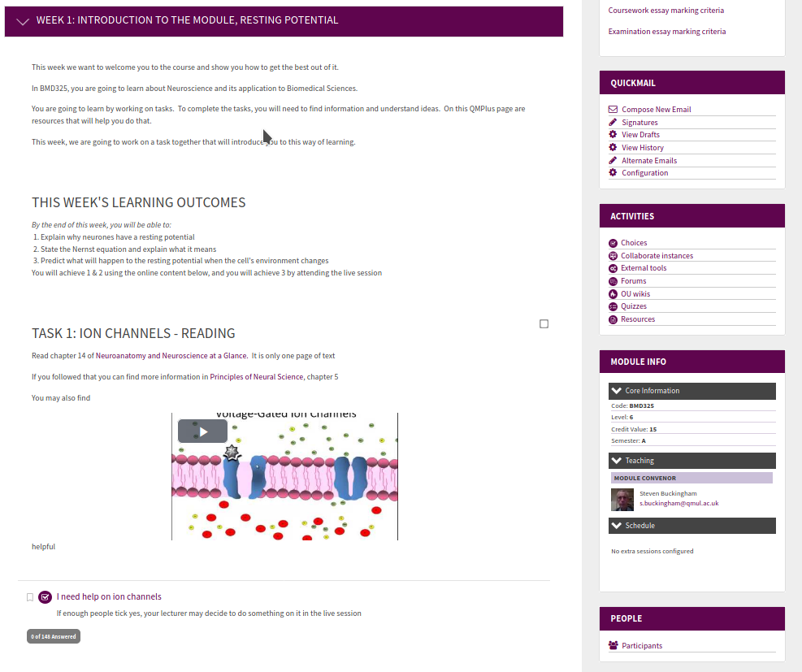

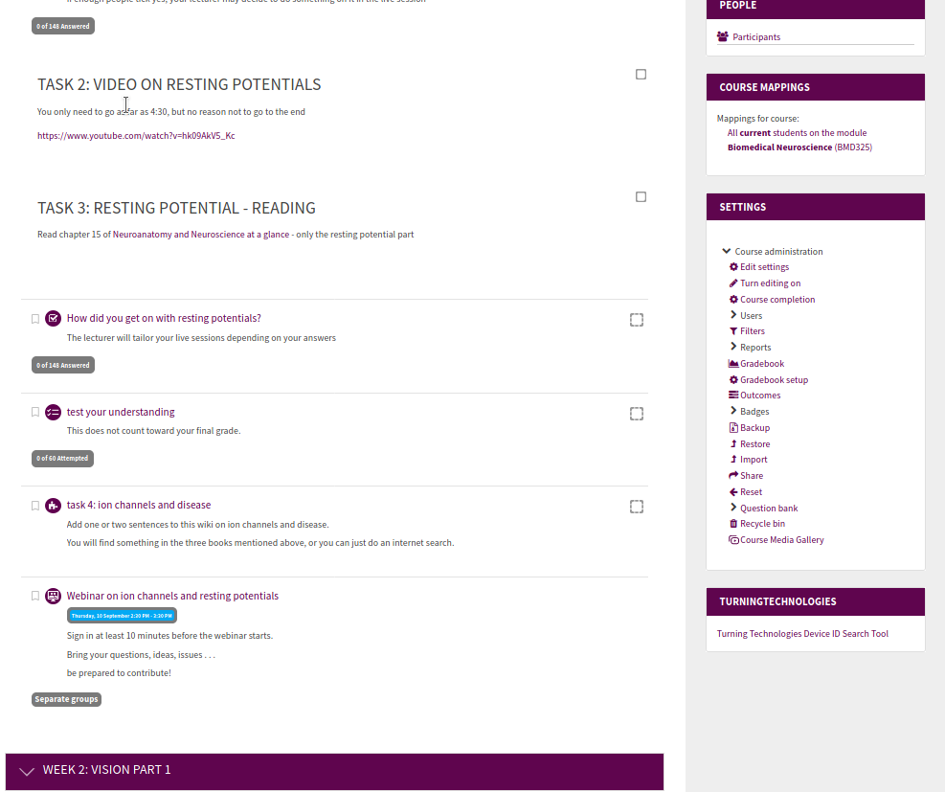
Figure 1: example of week’s online content

The components

Focus issues
Synchronous teaching (lectures, webinars) should not aim to “cover the material” – that is to be done in asynchronous space. Synchronous teaching must focus on difficult topics or resistant concepts.
- What concepts have you found students keep getting wrong in assessments?
- What concepts take a lot of interaction to get across?
- What concepts are “resistant”?
- List these as “focus topics”. Aim to have 2 or 3 focus topics for each week.

Core tasks
- Select ONE of these:
  - A passage from a textbook that is available online
  - A you-tube or other online premade video
  - Your own purpose-recorded video
  - Notes from last year’s lecture (if self-contained)
- Note which Los this activity matches to
- Select ONE of these:
  - A button to register level of understanding. This is a button so students can say, “I am completely confused”, “Sort of get it”, “got it” etc., which will inform your synchronous activity
  - Forum to post a question for the synchronous activity
- Put these 2 objects to put on QMPlus page. Just above it, use the “label” item on QMPlus to tell the students which Los this matches.
- Do this until all the Los for that week are posted.

Online how-tos (links to E-learning unit and other supporting resources)
Posting a youtube video onto QMPlus
Adding a file
Adding a web link
Putting a Kaltura video onto QMplus:
Uploading your video
Inserting it onto QMPlus
Adding a Label to QMPlus
Setting up a Group assignment
Adding a “level of understanding” button to QMplus

Active learning tasks
Select one or more of the following (more instruction on using each one will be given in the run-up to semester A):
- Annotated bibliography.
  - Students gather a fixed number of references, write couple of sentences on each one, and star them as * or ** depending on their importance
  - Works well with 2min paper, debate, peer evaluation, competition
  - Add this to your page using the essay option of a QMplus quiz: click here to see how
- Invention.
  - Students work on describing an invention. Can be a new drug, a device for measuring something, a biologically-inspired machine etc. lecturer determines degree of plausibility
  - Add this to your page using the essay option of a QMplus quiz: click here to see how
- One-paragraph text.
  - Students write paragraph on controversial topic with nuanced arguments. Work is evaluated against strength of argumentation and factual accuracy.
  - Add this to your page using the essay option of a QMplus quiz: click here to see how
- 3-minute YouTube video
  - Students produce video on difficult or controversial or often-misunderstood concept. You can have, say, 5 video topics – if you have 20 teams of 5 students then there will be 4 working on each one. in the synchronous task you have them vote on the best of each and the best ones go onto a publicly-facing YouTube channel.
  - Add this to your page by creating an assignment: click here to see how
- Blog on a news item.
  - Students write blog on current news item. Comment on each other’s blog
  - Add this to your page by creating a workshop: click here to see how
- Letter to learned journal or newspaper
- Data analysis.
  - Students given dataset to analyse. Even better if it is something the lecturer is or has been working on.
  - Add this to your page by creating an assignment: click here to see how
- Designing an experiment
  - Students are given a hypothesis and asked to design an experiment
  - Add this to your page by creating an assignment: click here to see how
- Make a Wikipedia entry.
  - Either separate groups on the same topic, or divide a topic so all students in groups work on massive wiki
  - Add this to your page by creating a wiki. Click here to see how.
- Annotated diagram
  - Add this to your page by creating an assignment: click here to see how
- Concept maps
  - Add this to your page by creating an assignment: click here to see how
- MCQ quiz.
  - Students make a set of MCQs. They are told why MCQs are difficult. Can set them on each other in the synchronous class
  - Tell the students to bring their MCQ with them to the synchronous activity
- Interview a famous scientist or a controversial one.
  - This is made up, or they can interview a postdoc or grad student.
  - Evaluated on
    - whether questions indicate understanding of what is important in science or
    - understanding of how science really works.
  - Add this to your page by creating an assignment or a blog
- Outstanding question
  - Students must identify an outstanding question not yet answered in the literature
  - Evaluated on
    - If the Q has been raised before
    - How significant the question is
  - Add this to your page by creating an assignment or a blog
- Research proposal
  - Can be very short, but following usual format
  - Add this to your page by creating an assignment or a blog
- Critique of video/paper/blog/TV show
  - Add this to your page by creating an assignment or a blog
- Nature editorial
  - Students are given nature papers (2-3) and asked to write editorial comment
  - Add this to your page by creating an assignment or a blog
- Write an abstract.
  - Students given paper without abstract, and they must write
  - Add this to your page by creating an essay within a QMplus quiz: click here to see how
- Case study
  - Students given medical or other case study. Very open-ended comments on it.
  - Add this to your page by creating a blog. Click here to see how.
- Magazine article
  - Students write article for parish magazine
  - Add this to your page by creating an assignment: click here to see how

Synchronous tasks

- Brainstorming
Work on open-ended questions, gather results on Padlet or QMplus wiki
- Discrimination
2 or more things often confused, students must identify and explain the difference between them
- Impossible question
A question that cannot be answered, such as what would happen if glutamine’s charge was increased by 50%
- Journal club
Can be scaffolded to different levels. Can be done as one large group or as teams, with lecturer visiting each team then bringing them all together to share ideas
- 2 min paper
Challenged to reduce a concept to a 2 min speech
- Debate
Either as one big hall or in teams. Formal or informal
- Case study
- Outstanding problem
Students are presented with a current outstanding problem. Brainstorm, suggest experiments, guess answers, explain to each other
- Worksheet
Sheet of homework questions
- Spot the error
Given text and they must detect as many errors as possible
- Peer instruction
Students given question that is often got wrong.
- Hardest topic
Students list what is the hardest topic in the week’s theme, rank them via audience response, discuss them
- Literature search
Collectively search literature on difficult or controversial topic – does homeopathy cure warts?
- Jigsaw
Students given wide-ranging topic or problem with several components. Groups allocated a component, then bring all together to answer the question
- Student presentation
Students present on different topics, peer feedback
- Competition
Vote on best asynchronous task that week

If you have identified focus issues, choose an activity that allow you to address those focus issues
“I have told them that 3 times in the lectures, and they still get it wrong!!”
Perhaps in the traditional lecture you have switched from your powerpoints to the whiteboard, and relied on feedback from the students (nods of the head etc) to judge when you have got it across
Educators have identified resistant concepts as those that may not be difficult to grasp (although they might be), but are not adopted by the students into their model of the world. For example, students can memorise Newton’s laws of motion and get it right in an MCQ, but the childhood belief that there must be a NET upward force on an aeroplane flying straight and level over-rides this new perspective.
You may use Qreview IF you break it into segments no longer than 10 min

