SPSS Installation Guidance
- After clicking this link - http://qm-web.its.qmul.ac.uk/spss/, you will be presented with an index of SPSS software. (See Fig.1)
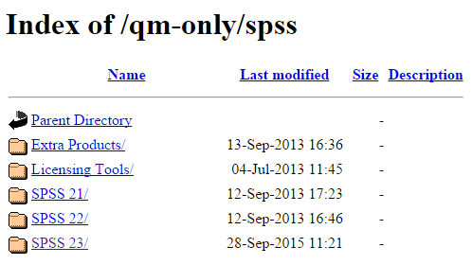
Fig.1
- Click SPSS 23/
You will be presented with a directory of executable files. (See Fig.2)
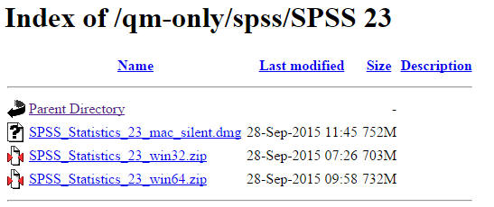
Fig.2
There are two download options for Windows users (win32_.exe and win64_.exe)(See Fig.2). For a successful installation, you must download and install the executable file from the SPSS 23 index (Fig.2) that is compatible with your Windows Operating System. You will need to identify which Windows Operating system (32-bit or 64-bit) you are using (See next page).
- After downloading the correct executable file, run the .exe file and follow the instructions to install SPSS23.

In order to identify which Windows Operating System (32-bit or 64-bit) you are using, see below.
For Windows XP:

- Click the Start button , click Run, type winver, then press Enter.

For Windows Vista and 7:

- Click the Start button , enter Computer in the search box, right-click Computer, then click Properties.
- Look under Windows edition for the version and edition of Windows that your PC is running.

For Windows 8 or RT

- On the Start screen, type Computer, press and hold or right-click Computer, then tap or click Properties.
- Look under Windows edition for the version and edition of Windows that your PC is running.

For Windows 8.1 or RT 8.1

- Swipe in from the right edge of the screen, tap Settings, then tap Change PC settings.
(If you're using a mouse, point to the bottom-right corner of the screen, move the mouse pointer up, click Settings, then click Change PC settings.)
- Tap or click PC and devices, then tap or click PC info.
- Look under Windows for the version and edition of Windows that your PC is running.

