Appendix
Useful equations and constants
n₁l₁=n₂l₂$$dG=Vdp-SdT$$
$$μ_{A}\left(l\right)=μ_{A}^{*}+RT\ln{p_{A}/p_{A}^{*}}$$
$$c\left(x,t\right)=\frac{n_{0}}{A{\left(πDt\right)}^{\frac{1}{2}}}e^{-x^{2}/4Dt}$$
ΔT=K_{b}m and ΔT=K_{f}m (m – molality)
R=8.314 J K⁻¹ mol⁻¹
k=1.381*10⁻²³ J K⁻¹
$$〈x^{2}〉=2Dt$$
$$x_{A}=p_{A}/p_{A}^{*}$$
F=C-P+2
$$F=-\frac{RT}{c}×\frac{dc}{dx}$$
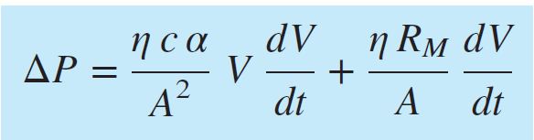 Darcy’s law, α – specific cake resistance
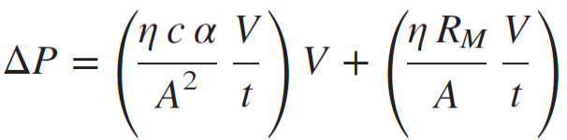Constant Rate filtration, ΔP vs time, R_{M}-filter resistance
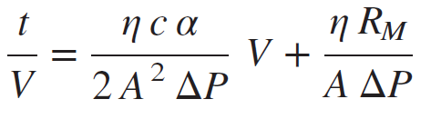Constant P filtration, linearized parabolic rate law
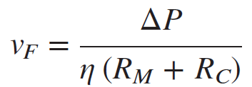Filtrate velocity
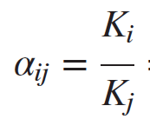Relative volatility 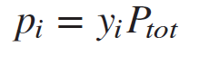Dalton’s Law 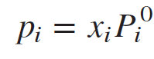Raoult’s law
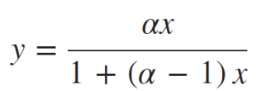Vapor composition, ideal mixtures, 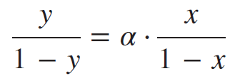, α= relative volatility
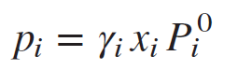 modified Raoult’s law for non-ideal mixtures, γ –liquid phase activity coeff.
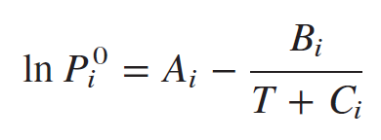Antoine equation for vapour pressure, given constants A, B, C.
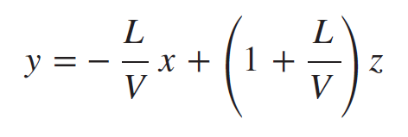Dimensionless Operating line equation for flash distillation
F = feed, L = liquid fraction, V = vapour
z conc. In feed, y conc. In liquid, x conc. In vapour
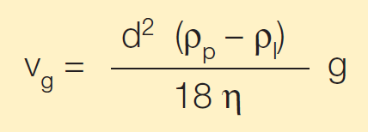 v_{g} = sedimentation velocity, d = particle diameter, ρ_{p} – ρ_{l} = difference in densities b/n particle and liquid, g = acceleration, η = viscosity of liquid.
g = r w² Relationship between rotor radius and angular velocity.

