Core Case 1

Please consider this case as if you were a GP working during in current times.
In this scenario, NHS pressures and waiting times are the same as they are currently.

Learning Objectives:
- Learning how to address polypharmacy in elderly care
- Managing medical complexity and multiple co-morbidities
- Understanding DNAR, Advanced Directives, Lasting Power of Attorney and Best Interest Decisions.
- Knowing what Coordinate my care is and how to use it
- Understanding palliative care in primary care.
- Communication Skills: (Page 4): How do you discuss your plan with the patient and his daughter and manage their expectations?
- Communication Skills (Page 5) How would you approach this DNAR conversation? (Consider who should be involved in this conversation)

Part One - Mr. Gareth Bales (GB), 87 years old
Lives with his wife, Mrs. Elizabeth Bales (EB) who is 86 years old.
They have recently moved from Essex to sheltered accommodation in Hackney.
They are mainly supported by their daughter Clare Bales (CB), who is a teaching assistant and their son Jonathon Bales (JB) who works as a librarian. Both CB and JB have lasting power of attorney.

- Emis Consultation Dr Vardy August 2022
Appointment for GB booked by HCA after new patient check due to scalp lesions.
Accompanied by daughter, CB
HPC: lesion on right side of nose, increasing in size over one month
Thickened lesions on right temple and ulceration
PMH: Psoriasis and psoriatic arthritis/Rheumatoid Arthritis overlap as Rheumatoid factor positive CCP positive on methotrexate and leflunomide
Age-related macular degeneration on injections at Queens Romford
2016 Aortic aneurysm repair under 6 monthly follow up from Vascular Surgeons
IHD – one stent
His current medication is:
Atorvastatin 80mg nocte
Eplerenone 25mg one tablet once daily
Co-codamol 30/500 2 tablets four times daily
Bisoprolol 5mg once daily
Omeprazole 20mg once daily
Ramipril 10mg once daily
Methotrexate 2.5mg tablets four tablets weekly
Folic acid 5mg one tablet once daily
Rivaroxaban 20mg one tablet to be taken once daily
Leflunomide 10mg tablet one tablet once daily
Viscotears to both eyes three times daily
On examination
Scalp lesion:
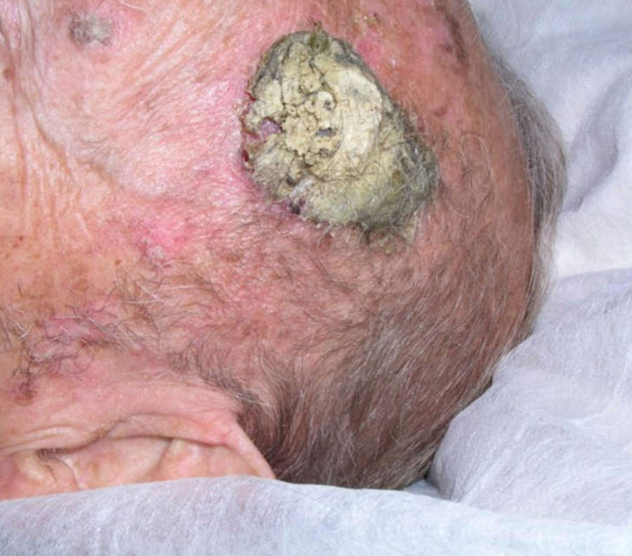
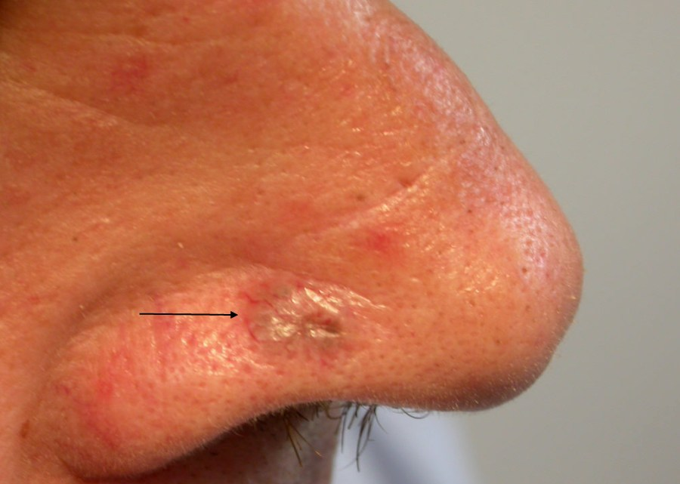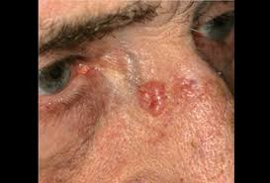
Lesions right side of nose
Discussion Points
- Given this patient’s history and examination findings, what is your immediate management of this patient?
- What may be contributing to the development of such skin lesions?
- What other management and referrals are required during this first consultation?
- What chronic disease management is required in General Practice in the longer term?
- Can you see the rationale for all his repeat prescriptions?
  - Applying STOPP / START criteria, outline amendments to his prescription that you would advise; Explain your rationale for each.
Year 4 Revision:
- How do you describe skin lesions? How does this help to differentiate them?

Useful Resources
- Skin Lesions - https://www.nhs.uk/conditions/non-melanoma-skin-cancer/
- Managing Multi-morbid - https://www.bmj.com/content/350/bmj.h176
- Polypharmacy – note key points in this document –
- https://www.kingsfund.org.uk/sites/default/files/field/field_publication_file/polypharmacy-and-medicines-optimisation-kingsfund-nov13.pdf

Methotrexate
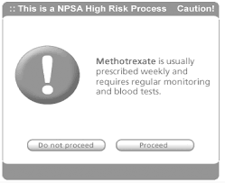
Discussion Points
- How would you write a methotrexate prescription?
- How should methotrexate prescriptions be managed between primary and secondary care.
- How should repeat prescriptions for methotrexate be safely prescribed?
- When may you decide not to prescribe?
- How do you navigate patients who see private doctors as a one off and are initiated on medications which require speciliast input?
Useful Resources
Shared Care Prescribing/Contract
https://www.gmc-uk.org/ethical-guidance/ethical-guidance-for-doctors/good-practice-in-prescribing-and-managing-medicines-and-devices/shared-care
August 2022 Dr Vardy EMIS consultation
Follow up appointment: Attending with daughter CB
Pt seen by dermatology
Diagnosis - moderately differentiated squamous cell carcinoma of the left frontal scalp and basal cell carcinomas of the right side of the nose and right clavicle.
Plan from dermatology for radiotherapy
Pt also says feeling SOB and feels he cannot walk very far
Impacting on ability to care for wife
Does not feel he has Covid, not done lateral flow as has not got any
Daughter very concerned and wants immediate referral for a CT scan of patients chest
No hx orthopnea or PND
No fever, no cough
O/E
Inspiratory creps mid and lower zones
T 36.7
RR 18
Sats 93% OA
HR 92
Discussion Points
- What is your plan?
- What is the differential diagnosis?
- What investigation is required to confirm the pulmonary diagnosis?
- ROLE PLAY: How do you discuss your plan with the patient and his daughter and manage their expectations?
Continuing Management
Mr BG is seen by the respiratory team and given a diagnosis.
He was advised to stop methotrexate and leflunomide and has been off the medications for 6 months. He now has increased early morning stiffness, joint pains and back pain. Unfortunately he has not been reviewed by the Rheumatology team. His pain is stopping him from sleeping.
- How would you manage his pain?
- How could you manage his worsening Psoriatic/Rheumatoid Arthritis?
- There is no DNAR decision in place – How should you approach making a DNAR decision for this patient?
- ROLE PLAY: How would you approach this DNAR conversation? (Consider who should be involved in this conversation)
- How do you complete a DNAR form?
- What information do you need to do this?
- How are the DNAR decisions recorded?
- How are primary and secondary care services informed?
- What is your understanding of end-of-life decisions: best interest decisions; Power of Attorney, and Advance Directives

Useful Resources
DNAR
https://www.healthwatch.co.uk/response/2021-03-18/dnacpr-review-need-personalised-honest-and-sensitive-conversations’
DNAR Video on tips on how to approach https://www.youtube.com/watch?v=Y52YwLcVQQs

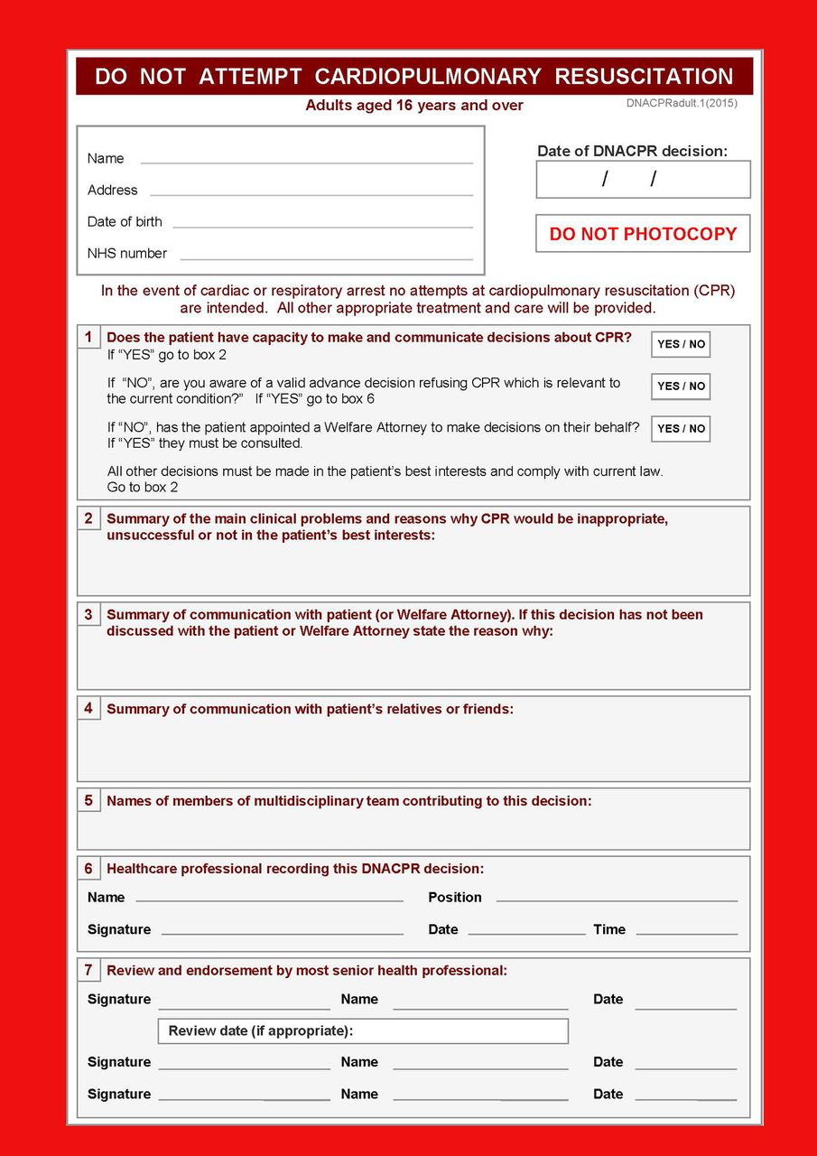

Part Two – Mrs Elizabeth Bales, 86 years old
PMH
New diagnosis - Alzheimer’s Disease, seen by Memory Clinic in Romford, no documentation from clinic
2009 CABGs x 3
2008 Type 2 Diabetes Mellitus
Her current medication is:
Atenolol 25mg once daily
Aspirin 75mg once daily
Candesartan 4mg once daily
Atorvastatin 40mg nocte
GTN spray 400mcg/dose one dose prn
Discussion Points:
- Mr. GB and Mrs. EB have complex co-morbidities. How can we support their daughter CB, their carer?
- What should be done as part of a carer assessment?
- How would you access a social services package of care and what does this include?
- What services/ organisations can the daughter be signposted to that will help her support her parents?
- What is CMC and who should fill this out?
- What are the benefits of patients having a completed CMC form?
- Would it be useful to complete a CMC for these patients?
- What would you want to include on the CMC form?

Useful Resources
- Carer Assessment: https://www.carersuk.org/help-and-advice/practical-support/getting-care-and-support/carers-assessment
- Coordinate My Care: https://www.coordinatemycare.co.uk/

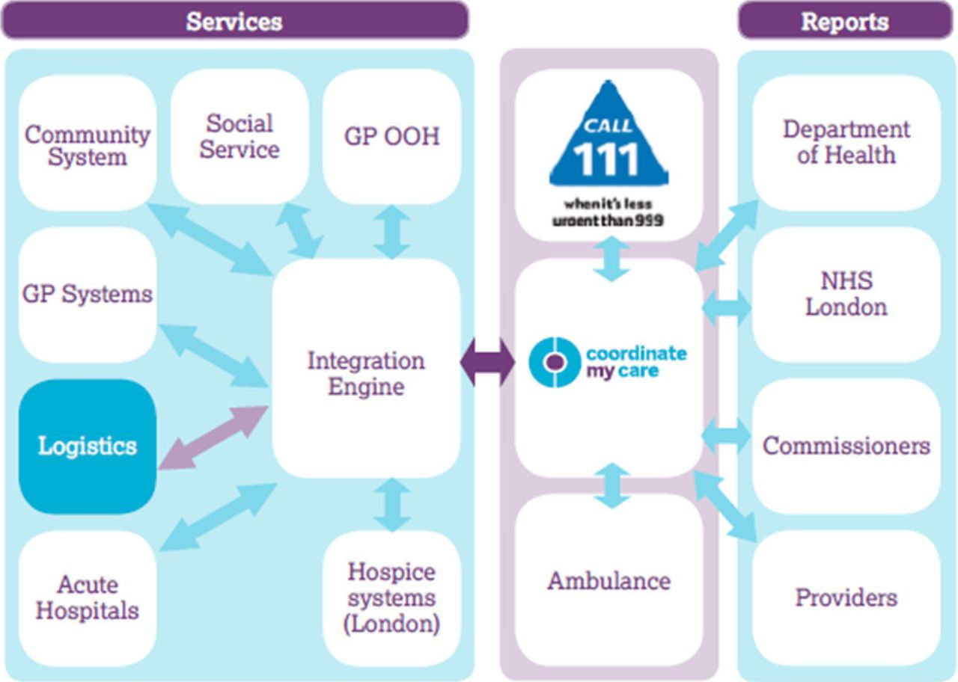

At the end of May, you receive an email from their son, Mr. JB. He states that he has power of attorney with his sister. He reports that his sister thinks that his mother’s dementia is making her too unstable to make financial decisions, which concerns him. He has requested that you telephone him so that these issues can be resolved.
Discussion Points
- How would you respond to this email?
- What is LPA and what are the different types
- Under what circumstances may LPA be overridden?
- What steps can you take if you suspect abuse or neglect (physical/financial etc) of an elderly patient?
Later that week you are on duty and asked to visit Mrs EB as she has had a fall:
EMIS Consultation Dr Vardy
HOME VISIT
PC: Fall
Had a fall today
Husband says she tripped as she was trying to go to toilet
Legs swollen and has been impacting on mobility
Unable to mobilise now
Tender ++ over Right hip
New diagnosis - Alzheimer’s Disease, seen by Memory Clinic in Romford, no documentation from clinic
Patient is not lucid, lacks capacity.
No DNAR on system
PMH
2009 CABGs x 3
2008 Type 2 Diabetes Mellitus
Her current medication is:
Atenolol 25mg once daily
Aspirin 75mg once daily
Candesartan 4mg once daily
Atorvastatin 40mg nocte
GTN spray 400mcg/dose one dose prn
Discussion Points
- You are the GP who has visited this patient at home, what are the differentials for the cause of her fall?
- What is the immediate issue here?
- How would you manage this patient in light of the acute issues?
- Mrs EB also does not have a DNAR - How should you approach making a DNAR decision for this patient given her lack of capacity?

Year 4 Revision
Falls
- What history do you need to elicit about the falls?
- How would you investigate the falls?
- How would you assess if her medications might be contributing to her falls? What actions could you advise to minimize any contribution medicines might make to her falls risk
- How would you manage the falls?
Fractured Neck of Femur
- What is the morbidity that might follow a fractured neck of femur?
- What is the associated mortality?
Useful resources
Approach to assessing a fall- http://www.oxfordmedicaleducation.com/geriatrics/falls-assessment-management/
http://www.patient.co.uk/doctor/Recurrent-Falls.htm
http://www.patient.co.uk/doctor/Prevention-of-Falls-in-the-Elderly.htm

Advance Care Planning: https://www.goldstandardsframework.org.uk/advance-care-planning
Capacity: http://thehearingaidpodcasts.org.uk/episode-1-6-capacity/
Best interests: https://www.bma.org.uk/media/1850/bma-best-interests-toolkit-2019.pdf

Mrs EB was admitted to hospital as an inpatient. She was found to have a fractured NOF. On admission they found she was in acute heart failure and would not be a candidate for surgery. Sadly whilst in hospital she developed a hospital acquired pneumonia which did not respond to treatment and the medical team made a decision with the family that she would receive palliative care.
Discussion Points:
- When a patient is in hospital what are the different options for palliative care?
- Who should be involved in looking after the patient?
- What role does a GP have in palliative care?
- How should practices monitor their palliative care patients?

https://www.macmillan.org.uk/healthcare-professionals/cancer-pathways/palliative-and-end-of-life-care
https://elearning.rcgp.org.uk/mod/book/view.php?id=12529

